**Chapter 2 Matlab Built_in Functions**

**M,m**

In addition to basic arithmetic operations, expressions in MATLAB can include functions. MATLAB has a very large library of built‐in functions. A function has a name and an argument in parentheses. For example, the function that calculates the square root of a number is **sqrt(x)**. Its name is **sqrt**, and the argument is x. The argument of the function can be a number, a variable that has been assigned a numerical value, an array, or a computable expression that can be made up of numbers and/or variables. The function can also be included in arguments, as well as in expressions.

**Examples:**

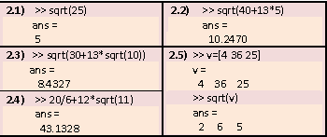

Some commonly used functions are:

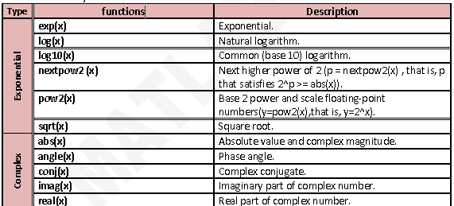

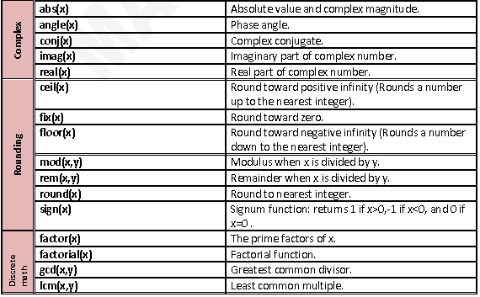

**Table (2.1): Some commonly used functions**

For more details see laboratory guide.

**Remark**

In MATLAB v7.0 and so on there are additional functions, for example:

