**Plasma membrane:-** is a membrane surrounded the cell, and the separate from the external environmental, As in the theoretically lecture.

* Bacteria as prokaryotic cell surrounded by cell wall, It is differ from cell wall of plant cell (Eukaryotic cell).

**The plant cell wall**

The membrane is surrounded in the plant cell by the cell wall, which determines the shape and rigidity of the cell and also protects the protoplasm, the cell wall is also permeated by small openings known as pits called cytoplasmic channels that connect the protoplasm of neighboring cells. It's composed of the primary wall, which consists of the middle plate, where the vesicles containing carbohydrates and protein are collected, which is characterized by flexibility and elasticity.

Then the secondary wall is gradually formed, which consists of lignin and hemi-cellulose in addition to cellulose. As the secondary wall thickens, it leads to most of the cell being filled and losing, It's elasticity completely, which causes the death and decomposition of the protoplasm.

The plasma membrane modifications:-

1-Microvilli:- they are finger shaped protrusions that vary in length and work to increase the surface area of the cell and are found in the epithelial cells of the intestinal lining.

2-Cilia & flagella :- thread-like structures that protrude above the surface of the cell and are used for movement and obtaining food, as in Paramecium.

3-Plasmodesmata:- are tiny channels that pass through the cell walls of plant cells and some aglal cells to enable transport and communication between them.

**The shape & number of nuclei**

It is a dynamic structure that can change in shape and location depending on the function and age. It's shape is often spherical, but it may take an oval, elongated, multi-lobed, or irregular shape as in leukocytes.

Most cells contain one nucleus (monocyte), and may contain two (Binucleate),such as Paramecium or more nuclei (multinucleate) as in the striated fibers of skeletal muscles, or the cells may lose their nucleus after maturation as in human red cells and also the phloem cells that transport food in plants.

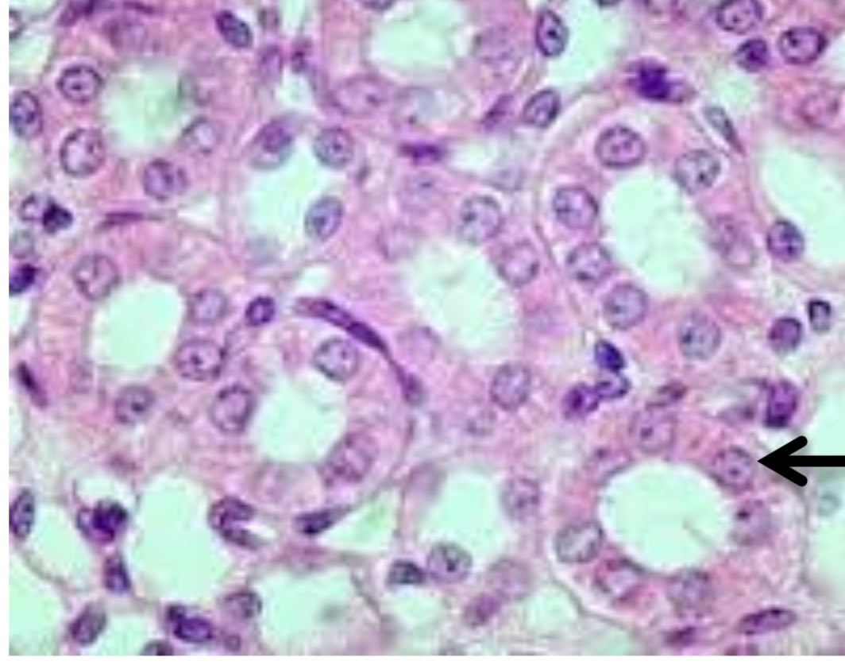

1-Spherical nucleus in cuboidal cells

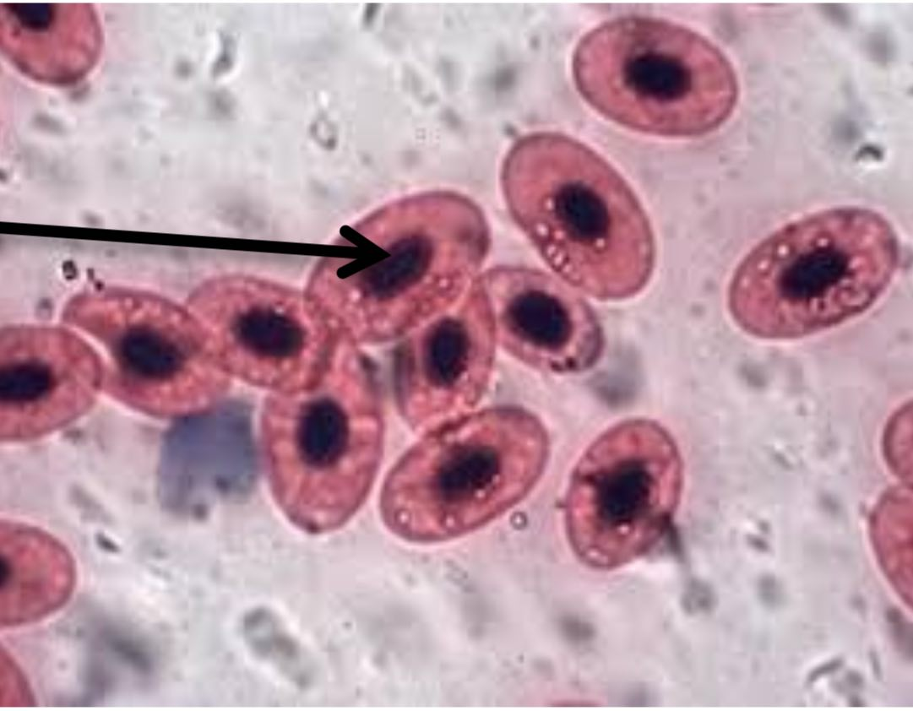

## 2-Oval nucleus un frog blood cells

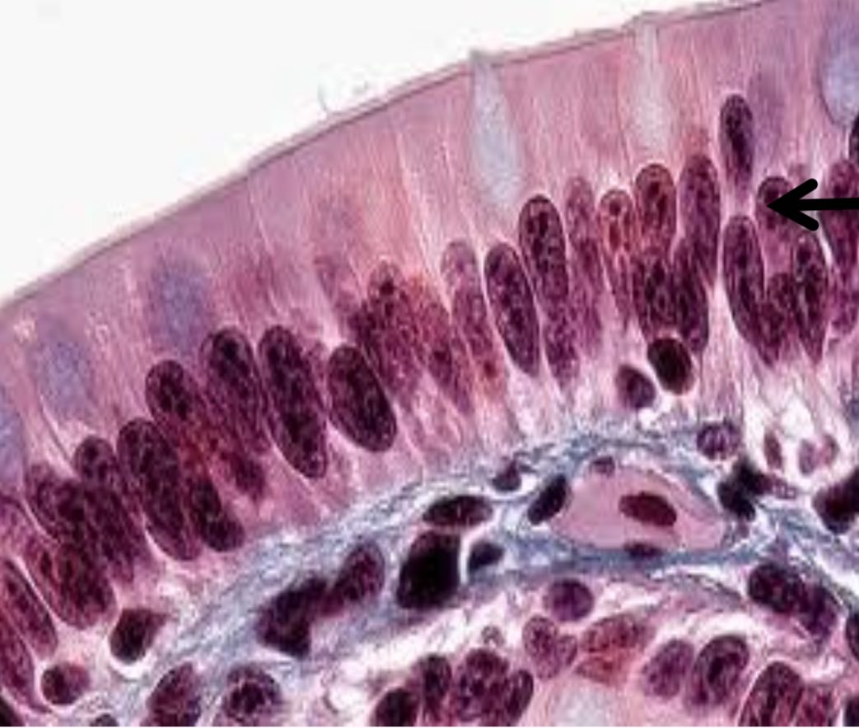

3-Elongated nucleus in columnar cells

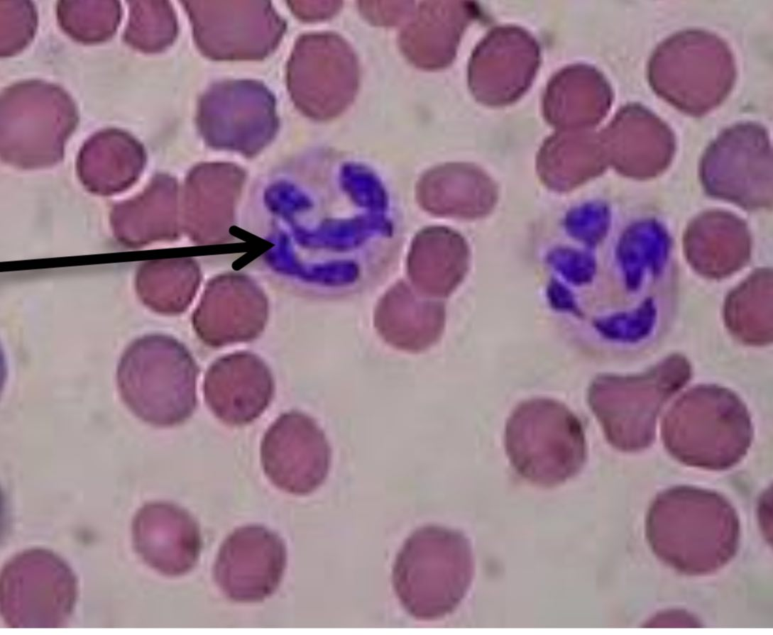

4-Lobulated nucleus in neutrophils