Invertebrates

Invertebrates animals show a great differences in morphology , internal structure , and phylogeny but all shearing character of lacking internal skeleton or backbone.

Invertebrates consist about 97% of the all known animal species , the remaining 3% are the rest of animal species.

These animals include a numerous groups with great benefits for man and others are harmful.

**Some invertebrates benefits:**

1. Crayfish , clam ,shrimp … ect.considered to be a graet resource of food for man.
2. Used in scientific research such as drosophila which used in genetics and protozoan in cytology.
3. some species acts as indicator for water pollution such as ***Daphinia* sp** (crustacean).
4. Some insect produce wax , honey , and silk. And also play on important role in plant fertilization.
5. Used in biological control as a biological a genets to control many pests such as lady beetls which used against aphids and citrus pest , and *Macrochelus* sp .(Mites) used against immature stages of house fly .
6. Invertebrate species play significant role in food chain and serve as food for other animals.

**The harms of invertebrates** :

1. Many invertebrates species are post on agriculture products in farms and stores such as grasshopper , Bettles ,Nematods ,mites.
2. Some other species with medical importance transmit and cause variable diseases to man and his animals….ex, Nematods ,Ticks , Flat worm, Plasmodium, Schistosoma , Flies ,Fleas ,Mosquetos…..ect.
3. Several group of marine invertebrates such as cnidarians, protozoan ,sponges, are accumulated on emerged parts of ship and electric generators causing in reduction of their efficiency that is called (Biofoulling).

**Classification of Animal Kingdom :**

The main purpose of classifying animals is to show the most probable evolutionary relationship of the different species to one another .

A phylum represent a broad grouping of related animals which have a common dncestry and are characterized by having similar structures.

The following characters are used to establish phyla :

1. **Number of cells** : Animal may be classify according to celluler constriction to :
2. **Protozoa** : one cell animals ( unicellular).
3. **Parazoa** : multicellular animals with loosely aggregated cells.(porifera).
4. **Metazoan** :multicellular animals in which cells are arranged in germ layers.

Metazoan are classified according to their germ layers into :

* **Diploblastea** : with two germ layers , ectoderm and endoderm ( Cnidaria and Ctenophora).
* **Triploblastea** : animals with three germ layers , ectoderm ; mesoderm and endoderm .(other animals).
* 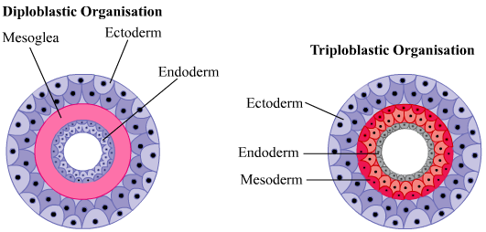

**2.Type symmetry** :

* A symmetrical animal include those animal which no plane that can be used to divide to divide their body into equivalent parts (protozoa and porifera)
* Bilaterally symmetrical :their bodies can be divided by a single plane into two equivalent parts ( Arthropoda ).
* Radially symmetrical :these animal can be divided into two equivalent parts by more than one plane ( Coelentrata ) .

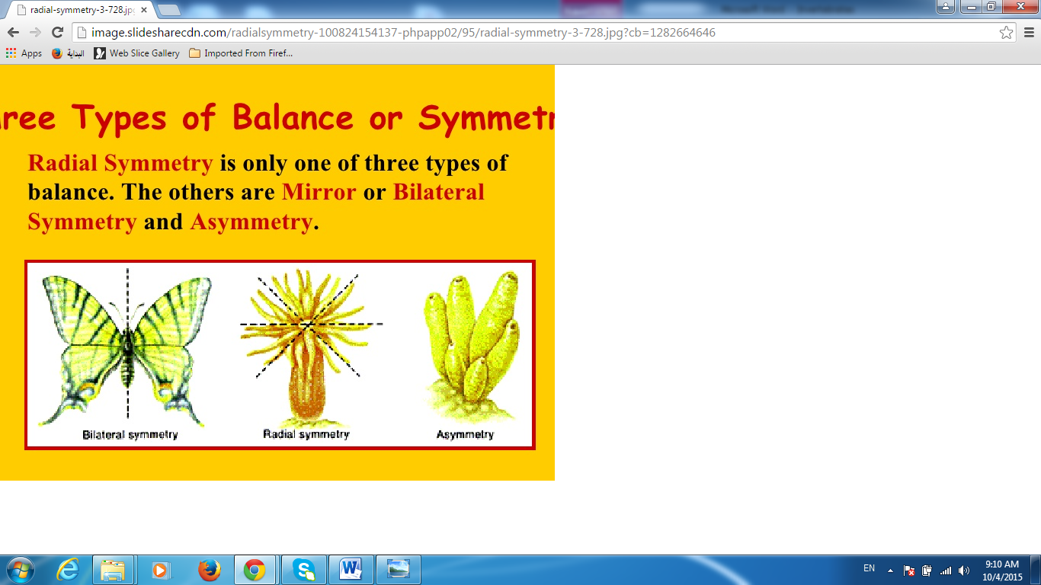

**3. Coelom** :

Presence or absence of body cavity in the bilateral phyla , some type of body cavity (space between the body wall and internal organs ) is found .

* **Acoelomate** : animals that do not have such a cavity ,where the region between their internal organs and body wall is filled with cells ( ex . platyhelminthes ).
* **Pseudocoelomate** : animal that do have a body cavity , but this cavity do not surrounding by the cells of the mesoderm and do not lined with peritoneum (ex . Aschelminthes ).
* **Coelomate** : animal with a body cavity which surrounded by the mesodermic cells and lined with peritoneum (ex Annelide ).

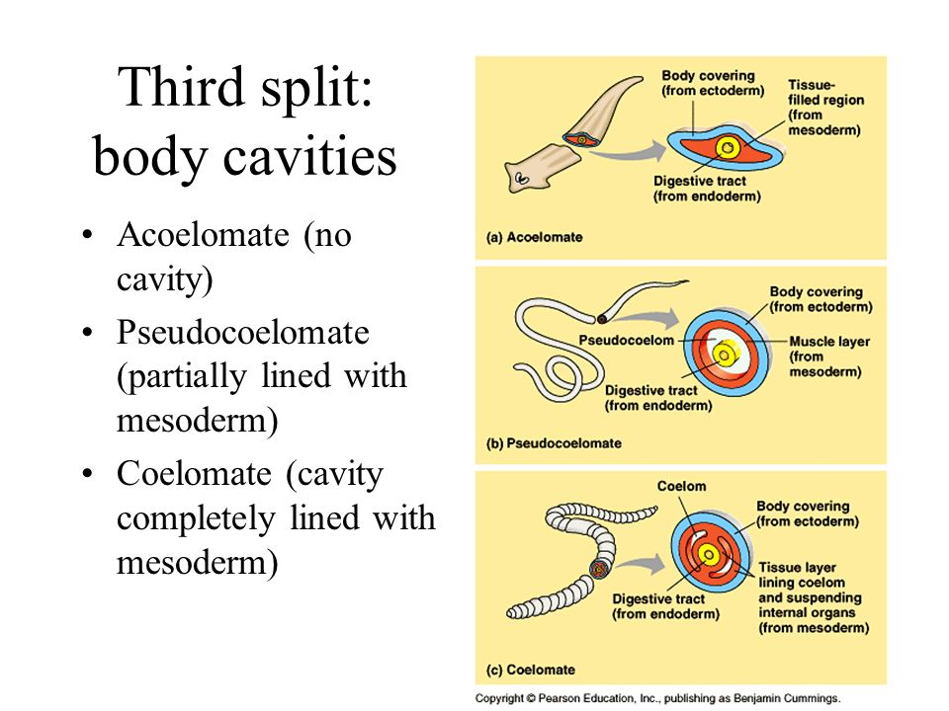

1. **Presence or absence of segmentation :**

The segmentation or ( metamerism) is a segmentation of body each segment contains one pair of some or all of the organs of the body such as nephridia , coelomoduct ,gonads and ganglia. Metamerism appear in annelida and arthropoda .

1. **Embryology :**

The embryology and development of invertebrates takes place from variety of egg types, through a number of styles of division to form a number of larval types and juveniles . there are ,however , certain lines of similarity between groups.

In general there are two of eggs:

**A .Isolicethal egg** , with small amount of yolk , with total , holoblastic cleavage.

**B.Telolicethal eggs**, with large amount of yolk , with meroblastic cleavage (only animal pole divides).

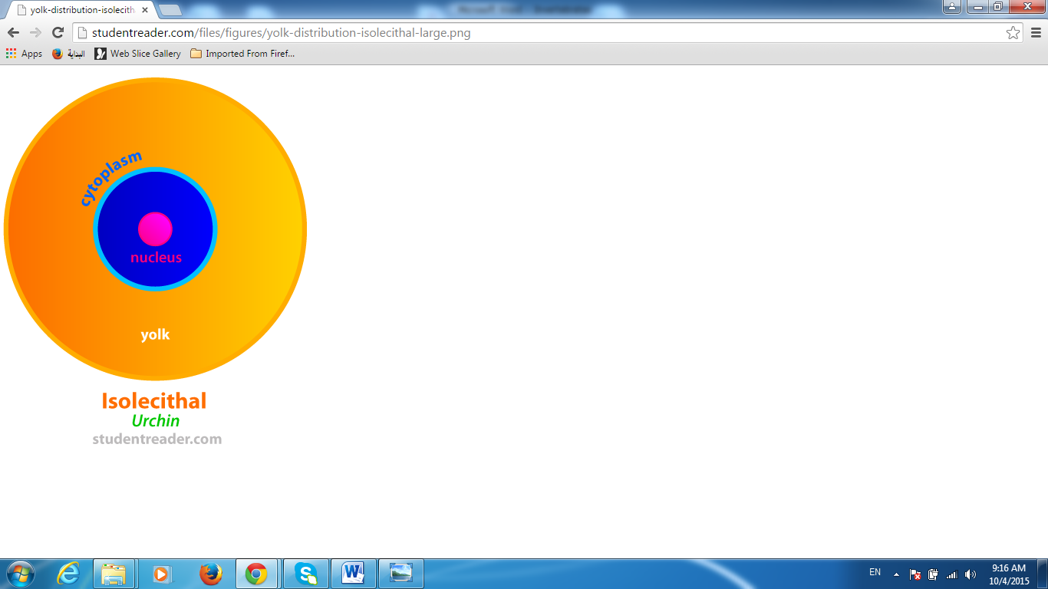 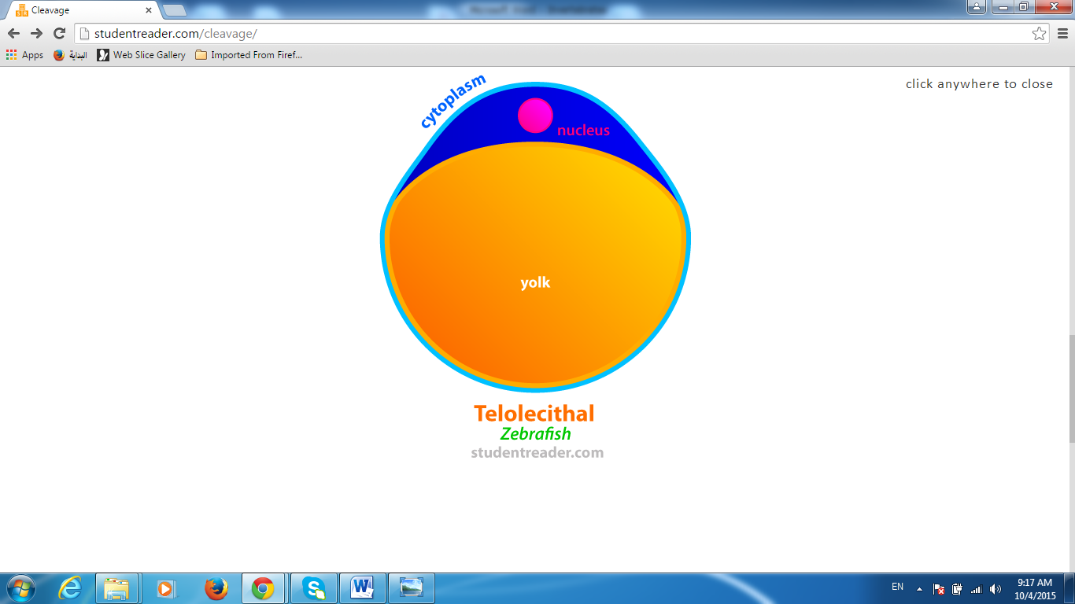

6. **Cleavage :**

The division of fertilized egg follows two major patterns amongst metazoan invertebrates. Both are holoblastic and involved the hole eggs,they are termed radial and spiral cleavage . In **Radial cleavage** the plane is always at right angle or parallel to the polar axis ,while in **Spiral cleavage** the plane of cleavage is lie an angle to polar axis , so that any cell lies between two others above or below it.

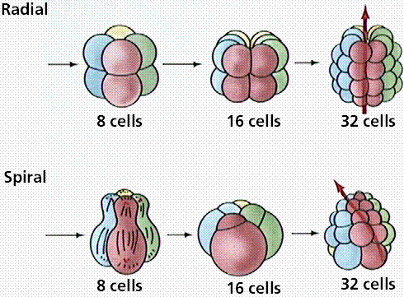

**Deuterostomia & protostomia**

Coelomate animals can divided into two group according to their mode of development.

|  |  |
| --- | --- |
| **Deuterostomia** | **Protostomia** |
| Radial cleavage  Blastopore form anus  Entrecoelic coelom  Central nervous system dorsal and superficial  **Echinodermata ; Chordate** **;Hemichordate** | Spiral cleavage  Blastopore form mouth  Schizocoelic coelom  Central nervous system ventral  **Annelida ; Arthropoda ;Mollusca** |

**Taxonomic levels**

Animal kingdom divided into 31 phyla of which 18 will be major phyla ( each phylum consists more than 1000 species). The remaining 13 phyla are the minor (each phylum consists less than 1000 species).

**Taxonomy** : thebasic rules to arranged and classify organisms .

**Classification :** the dividing of organisms into groups, groups that have a number of homologous structures in common would be placed in the same level.

The lowest level of classification is the species, each kind of animal and plant belongs to a single species, by definition species is a series of population thal are capable in nature of inter breeding with one another to produce fertile offspring ,but that are unable to interbreed with other species, this definition of species is applieable only to sexually reproduction organism , for others that reproduce a sexually species are erected on the bases of anatomical ,physiological and behavioral differences.

Species that have a number of similar structure in common comprise the genus, genera are combined into family. Families into an order a class, classes into a phylum , finally all the phyla of animals comprise the animal kingdom. Example of system of classification used are as follow:

|  |  |
| --- | --- |
| kingdom: | [Animalia](https://en.wikipedia.org/wiki/Animalia) |
| Phylum: | [Arthropoda](https://en.wikipedia.org/wiki/Arthropod) |
| Subphylum: | [Crustacea](https://en.wikipedia.org/wiki/Crustacean) |
| Class: | [Branchiopoda](https://en.wikipedia.org/wiki/Branchiopoda) |
| Order: | [Cladocera](https://en.wikipedia.org/wiki/Cladocera) |
| Family: | [Daphniidae](https://en.wikipedia.org/wiki/Daphniidae) |
| Genus:  Species : | ***Daphnia***  ***pulex***  [Müller](https://en.wikipedia.org/wiki/Otto_Friedrich_M%C3%BCller), 1785 |