University of Baghdad….College of Eng….Chemical Eng. Dept….2nd Year....MSc. Hassan A. Alwan
Material Science and Engineering
Sometimes it is useful to divide the discipline of materials science and engineering into materials science and materials engineering disciplines.

- Material Science: It involves investigating the relationships that exist between the structures and properties of materials.
- Material Engineering: On the basis of these structure-properties correlations, it is designing or engineering the structure of a material to produce a predetermined set of properties.
- Material Scientist: The role of material scientist is to develop or synthesize new materials.
- Material Engineer: The role of material engineer is create new products or system using existing material and /or to develop techniques for processing materials.
- Structure of a material: relates to the arrangement of internal components (i.e. structure involves the organization of atoms or molecules relative to another).
- Subatomic Structure: It involves the electrons within the individual atoms and interaction with their nuclei.
- Macroscopic (Macrostructure): This term is used when the structural element is described/or viewed by the naked eye.
- Microscopic (Microstructure): This term is used to describe the internal structure of an element (arrangement of atoms, grain boundary,..etc.). Observation microstructure of a material can be obtained by using some type of microscope. (i.e. you can see that structure contains large groups of atoms that normally agglomerated together)

Properties of solid material
A property: It is a material trail in terms of the kind and magnitude of response to a specific imposed stimulus. All materials are exposed to external stimuli that evoke (induce) some type of response. For example, a specimen subjected to forces will experience deformation, or polished metal surface will reflect light. “The properties of materials are independent to the materials shape and size”. Properties of solid material can be classified into six groups: mechanical, electrical, thermal, magnetic, optical, and deteriorative.

- Mechanical: It represents the response of a solid material to an applied load or force, such as elastic modulus, strength, and plastic deformation.
- Electrical: It involves the electrical conductivity and dielectric constant, the stimulus is an electric field.
- Thermal: It includes the heat capacity and thermal conductivity.
- Magnetic: It demonstrates the response of a material to the application of magnetic field.
- Optical: If a solid material transforms/reflects an applied light radiation (object), it has an optical property. The stimulu is light radiation or electromagnetic.
- Deteriorative: It relates to the chemical reactivity of materials.

Material processing
In order for materials to be useful, they must first be processed from their raw state into a final form. Thus, for example, metals are won from their ores and polymers are processed from petrochemical feed stocks.
However, processing operations, including finishing, fabrication and joining, can all influence properties, including resistance to degradation.

Relationship between processing, structure, properties, and performance
Structure of a material depends on how it is processed whereas; material performance will be a function of its properties. This relationship can be represented in the following schematic illustration:

Processing → Structure → Properties → Performance

We now present an example of these processing-structure-properties-performance principles with this Figure that showing three thin disk specimens placed over some printed matter. It is obvious that the optical properties (i.e., the light transmittance) of each of the three materials are different; the one on the left is transparent (i.e. virtually all of the reflected light passes through it), whereas the disks in the centre and on the right are, respectively, translucent and opaque. All of these specimens are of the same material, aluminium oxide, but the leftmost one is what we call a single crystal that is highly perfect which gives rise to its transparency. The centre one is composed of numerous and very small single crystals that are all connected; the boundaries between these small crystals scatter a portion of the light reflected from the printed paper, which makes this material optically translucent. Finally, the specimen on thee right is composed not only of many small, interconnected crystals, but also of a large number of very small pores or void spaces. These pores also effectively scatter the reflected light and render this material opaque.

Benefit of studying Material Science and Engineering
In order to select a suitable material for such service, it is necessary to study material science and engineering. Material selection is based on the following considerations:
- Materials are often selected for their specific properties including mechanical properties, physical properties, and durability.
- A second selection consideration is any deterioration of material properties that may occur during equipment operation. For example, significant reduction in mechanical strength may result from exposure to evaluate temperatures or corrosive environment.
- The economic consideration, it must be estimate the cost of a solid material that is utilized to fabricate (construct) equipment. A material may be found that has very good properties but it is expensive. Therefore, it must make a balance between the material properties and its cost.
- Service conditions.
- Material fabrication
- Material availability.

Types of Materials
Solid materials have been grouped into three basic classifications: metals, ceramics, and polymers. There are the composite combinations of two or more of the three basic material classes. They will be described separately:
- Metals and alloys: Metals and alloys consist of one or more metallic elements such as iron, aluminium, gold, copper, nickel, and titanium and also non-metallic elements such as carbon, nitrogen, and oxygen in relatively small amount. Metals and alloys have the following characterizations:
  - Atoms in metals and their alloys are arranged in a very orderly manner, and in comparison to the ceramics and polymers, are relatively dense. If we see the diagram (1a) that gives densities at room temperature for several types of materials we will see that the metals and their alloys lie on the top of the Figure, while composites lie on the down of the diagram.
  - Stiff (Fig.2a), strong (Fig.3a), ductile (i.e. capable of large amounts of deformation without fracture), malleability, they are readily shaped and formed mechanicals forces, and are resistant to fracture (Fig.4a).
  - Metals and their alloys have good electrical and thermal conductivities. This is due to presence non localized electrons in the metallic materials.
  - Non-transparent to visible light (i.e. Opaque). A polished metal surface has a lustrous appearance.
  - Some metals (Fe, Ni, and Co) have desirable magnetic property.

- Ceramics: There are two kinds of ceramic, engineering and traditional ceramics.
Engineering Ceramics can be defined as compounds between metallic and non-metallic materials. They are most oxides, nitrides, and carbides. For example, some of the common ceramic materials include aluminium oxide (alumina, Al₂O₃), silicon dioxide (silica, SiO₂), silicon carbide (SiC), silicon nitride (Si₃N₄).
While traditional Ceramics composed of clay minerals (i.e. Porcelain), cement and glass.
Both types have the following characterizations:
- Mechanical properties: Ceramics are stiff, strong (Fig.2a, 3a), and very hard but are extremely brittle (lack ductility). Therefore, ceramics are highly susceptible to fracture (Fig.4a).
- Physical properties: Having no or very low thermal and electrical conductivity. Therefore, they are used as thermal and electrical insulation (Fig.5a).
- Deteriorative characteristics: Ceramics resist corrosive environments.
- Optical properties: Ceramics may be transparent, translucent, or opaque.
- Some engineering ceramic exhibit magnetic behaviour

- Polymers: Polymers include the familiar plastic and rubber. They are organic compounds that are chemically based on carbon, hydrogen, and other non-metallic elements (O, N, Si). Furthermore, they have very large molecular structures, often chain-like in nature that has a backbone of carbon atoms. Some of common and familiar polymers are polyethylene (PE), nylon, silicon rubber, poly vinyl chloride (PVC) polystyrene (PS). Polymers have the following properties:
  - Mechanical properties: Polymers are not as stiff or as strong as metals.
They are easily formed into complex shapes due to their ductility and plasticity.
  - Physical properties: Polymers have low density and low electrical conductivity, tend to soften and/or decompose at modest temperatures. This means in some instances, limits their use.
  - They are nonmagnetic.
  - Polymers are inert chemically and unreactive in large number of environments.

- Composites: They are composed of two or more individual materials (metals,
ceramics, and polymers (i.e. composites are produced by different combinations of metals, ceramics, and polymers). There are also naturally composites such as wood and bone. One of the most common and familiar composites is fibreglass, which is produced by embedding small glass fibers within a polymeric material (epoxy or polyester). The glass fibers are strong and stiff, whereas the polymer is ductile. Thus, resulting fibreglass is relatively stiff, strong, flexible, and ductile and has low density. Another example, carbon fiber reinforced polymer (CFRP). The carbon fibers are embedded within the polymer to produce CFRP. It is stiffer and stronger than the fibreglass. CFRP are used in some aircraft and aerospace application.

Q: What is the goal of design composites?
A: First, is to achieve a combination of properties that is not displayed by any
single material. Second, is to incorporate the best characteristics of each of
the component materials.

Advanced Materials
Advanced materials are traditional materials whose properties have been enhanced in order to obtain high-performance materials that are utilized in high technology applications such as electronic equipment (CD/DVD players), computers, spacecraft, aircraft, and military rocketry. Some of advance materials are given below:
- Semiconductors: They have electrical properties that are intermediate between the electrical conductors (metals, and metal alloys) and insulators (ceramics, and polymers). Semiconductors are used to manufacture the integrated circuitry that is used in electronics and computers industries.
- Biomaterials: They are employed in component implanted into human body for replacement of diseased or damaged body parts. Metals, ceramics, polymers, composites, and semiconductors may be used as biomaterials.
- Materials of the future: They are divided into smart materials and nanoengineered materials.
- Smart Materials: Components of smart materials include some type of sensor (that detects an input signal), and an actuator (that performs a responsive and adaptive function). These materials are able to sense changes in their environments and then respond to these changes in predetermined manners. For example, one type of smart system is used in helicopters to reduce aerodynamic cockpit noise that is created by rotating rotor blades. Piezoelectric sensors inserted into the blades to monitor blade stresses and deformations; feedback signals from these sensors are fed into computer-controlled adaptive device, which generates noise cancelling antinoise.
- Nanoengineered Materials: With the advent of scanning probe microscopes, which permit observation of individual atoms and molecules, it has become possible to manipulate and move atoms and molecules to form new structures, and thus, design new materials that are built from simple atomic- level constituents. Dimension of the structure of these materials is on the order of nanometre (10⁻⁹). One example of these materials is the carbon nanotube.

University of Baghdad….College of Eng….Chemical Eng. Dept….2nd Year....MSc. Hassan A. Alwan
Atomic Structure
Fundamental Concepts
An element consists of a specific number of atoms (10⁻¹⁰ m radius) containing a central nucleus (10⁻¹⁵ m radius), protons, neutrons, and electrons. The positive charges (protons) and neutral charges (neutrons) are concentrated in a nucleus of the atom; while the electrons (negative charge) are arranged in energy levels that surround the atomic nucleus. Electrons and protons have the same electrical charged magnitude of is 1.60 x 10⁻¹⁹ Coulombs. Protons and neutrons have the same mass, 1.67 x 10⁻²⁷ kg. Mass of an electron is much smaller, 9.11 x 10⁻³¹ kg and can be neglected in calculation of atomic mass of an element.

Each chemical element is characterized by the atomic number Z which is equal to the number of proton in the nucleus. If the element is electrically neutral or has complete atom, the atomic number will equal to the number of electrons.

Each chemical element is also characterized by the atomic mass that is defined as the sum of the masses of protons and neutrons within the nucleus according to the following equation:
A = ZP + NN*
Where:
A: is the atomic mass
Z: number of protons
P: mass of protons
N: number of neutrons
N*: mass of neutrons
The no. of protons is the same for all atoms of a given elements, whereas the no. of neutrons may be variable. “If atoms of some elements have two or more different atomic masses, they will be called isotopes”.

Atomic Weight
The atomic weight of an element = weighted average of the atomic masses of the atoms naturally occurring isotopes. For example, the atomic mass of carbon is 12.011 amu. the atomic weight is often specified in mass per mole.

Mole
A mole is the amount of matter that has a mass in grams equal to the atomic mass in amu of the atoms. For example, a mole of carbon has a mass of 12 grams = 12 amu.

Electrons in Atoms
In order to understand the behaviour of electrons in atoms and crystalline solids, it is necessarily to study the quantum-mechanical concepts.
Quantum Mechanics: It is defined as a set of principles and laws that govern systems of atomic and subatomic.

Bohr Atomic Model
One early outgrowth of quantum mechanics was the simplified Bohr atomic model which represents an early attempt to describe electrons in atoms. This model consists of two quantum-mechanical principles:
- First principle, the electrons are assumed to revolve around the atomic nucleus in separate orbital (energy levels), and the position of any particular electron is defined by its orbital as shown in Figure1.
- Second principle, the energy of electrons is quantized. This means that electrons are permitted to have only specific values of energy. An electron may change energy by make a quantum jump either to allowed higher energy (with absorption energy) or to a lower energy (with emission energy). Figure1 shows the schematic Bohr atomic model.

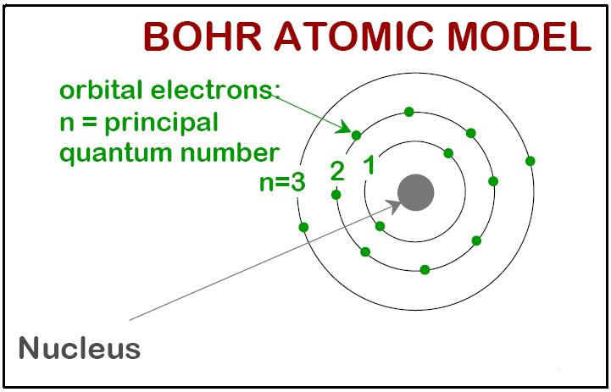
Figure1: the distribution of electrons within the principal energy shells.

Wave Mechanical Model
In this model, electron is considered to exhibit both wave and particle characteristics. Therefore, an electron is treated as a particle moving in a separate orbital and position of a particular electron is described by a probability distribution or electron cloud (i.e. probability of an electron's being at various locations around the nucleus) as explain in Figure2.
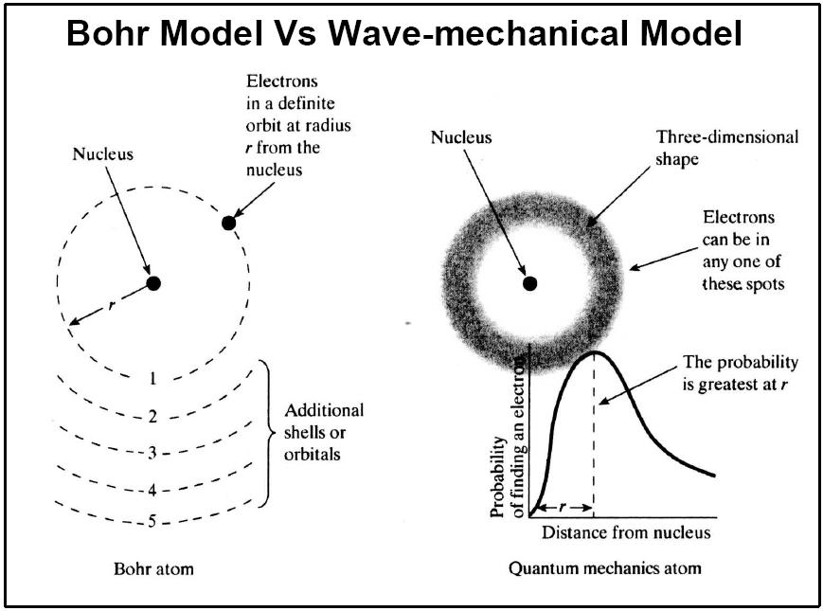
Figure2: Comparison of Bohr and Wave-mechanical models in terms of electron distribution.

Valance Electron
The valance electrons are those that occupy the outermost (farthest) shell. They participate in the bonding between atoms to form atomic and molecular aggregates. Many of the physical and chemical properties of solids are based on these valance electrons.

Types of Atomic Bonding in Solids
Atomic bonding in solids is divided into two primary and secondary bonds.

Primary or chemical bonds: They are subdivided into three types-ionic, covalent and metallic bonds. For each type, the bonding involves the valance electrons. The nature of the bond depends on the electron structures of the constituent atoms. In general, each of these three types of bonding arises from the tendency of the atoms to assume stable electron structures by completing filling the outmost electron shell.

Ionic Bonding: In ionic bonding the valence electrons are completely transferred from one atom to the other atom. Ionic bonds occur between metals and nonmetals when there is a large difference in electronegativity. Atoms of a metallic element easily give up their valence electrons to the non-metallic atoms. For example, sodium chloride (NaCl) is the classic ionic material. The sodium gives up its one valence electron to a chlorine atom. The chlorine ion has a negative charge, while the sodium ion has a positive charge as explains in figure3. The positive and negative ions attract one another by the attractive bonding forces that are coulombic bonding force.

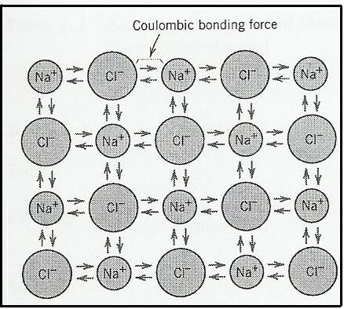
Figure3

Covalent Bonding: In covalent bonding the valence electrons are shared as pairs between the bonded atoms. Pure covalent bonding only occurs when two nonmetal atoms of the same kind bind to each other such as (H₂, Cl₂, F₂, etc.). When two different nonmetal atoms (dissimilar atoms) are bonded or a nonmetal and a metal are bonded, then the bond is a mixture of covalent and ionic bonding called polar covalent bonding. The covalent bond is directional (i.e. the covalent bond may exist only in the direction between one atom and another that participate in the electron sharing). For example, methane (CH₄), the carbon has four valence electrons, whereas each of the four hydrogen atoms has a single valence electron as shown in figure4.

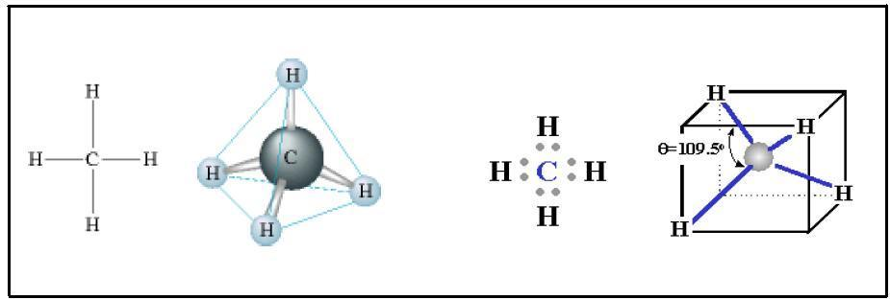
Figure4: Shows the covalent bonding that exists between hydrogen and carbon atoms.

Polar Bonding: In polar bonding the electrons are shared but NOT equally. Many compounds have the characteristics of BOTH ionic and covalent bonding. They are called polar covalent bonds and they tend to occur between atoms of moderately different electronegativities. In polar covalent bonds the electrons belong predominantly to one type of atom while they are still partially shared by the other type. Hydrogen chloride (HCl) is the best example of the polar bonding as appears in figure5.

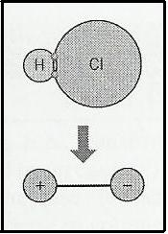
Figure5

Metallic Bonding: It is found in metals and their alloys. Metallic materials have one, two, or at most three valence electrons which are not bound to any particular atom in the solid and are free to drift throughout the entire metal (i.e the electrons are shared throughout the entire crystal, and are not localised). The remaining nonvalen electrons and atomic nuclei form what are called ion cores, which posses a net positive charge. Figure6 is a schematic illustration of metallic bonding. The free electrons shield the positively charged ion cores from repulsive electrostatic forces that can be exerted by the similar positive ions. Therefore, the free electrons act as a glue to hold the ion cores together.

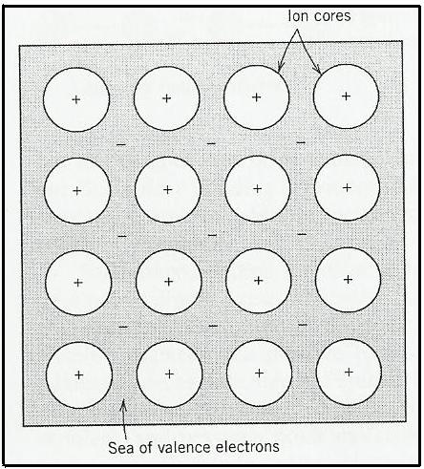
Figure6

Properties Controlled BY Chemical Bond
Chemical bonding determines the physical properties of substances. These properties are listed below for covalent, ionic and metallic bonding.

- Covalent: Gas, liquid, or a soft solid. Low melting point and low boiling point. Insoluble in H₂O Soluble in nonpolar solvents. Nonconductor of heat and electricity. Nonlustrous.
- Ionic: Crystalline solid. Very high melting point. Soluble in H2O. Insoluble in nonpolar solvents. Nonconductor of heat and electricity. Conducts electricity in aqueous solutions. Examples: NaCl, CaCO3.
- Metallic: Malleable solid (metals and their alloys). High melting point and boiling point. Insoluble in H2O. Insoluble in nonpolar solvents. Conducts heat and electricity due to that the electrons are shared throughout the entire crystal, and are not localised. Lustrous Examples: gold, copper.

Secondary or physical bonds: They are also found in the many solid materials. They are weaker than the primary ones such as Van Der Waals and hydrogen bonds.

Van Der Waals or Physical Bonds: They are weak bonds in comparison to the primary or chemical bonds. Secondary bonding (Van Der Waals bonding) exists between all atoms or molecules, but its presence may be obscured (hidden) if any of the three primary bonding types is present. Secondary bonding is evidenced for the inert gases, which have stable electron structures, and, between molecules in molecular structures that are covalent bonded.
Van Der Waals bonding forces arise from atomic or molecular dipoles. In essence, an electric dipole exists whenever there is some separation of positive and negative portions of an atom or molecule. The bonding results from the coulombic attraction between the positive end of one dipole and the negative end of the adjacent one as indicated in figure7.

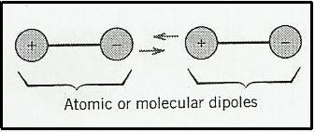
Figure7

Hydrogen Bonding: It is a special type of secondary bonding, is found to exist between some molecules that have hydrogen as one of the constituents.

The Structure of Crystalline Solids
Why Study the Structure of Crystalline solids
There are two reasons why study the structure of solids is important:
- Materials properties are fundamentally affected by the internal arrangement of atoms. This can change mechanical properties (strength etc) and chemical properties (eg corrosion). Thus an understanding of this aspect of metallurgy is important.
- Significant properties differences exist between crystalline and noncrystalline materials having the same composition. For example, noncrystalline ceramics and polymers normally are optically transparent, whereas the same materials in crystalline or semicrystalline form tend to be opaque or translucent.

Crystal Structure: If the atoms or ions of a solid are arranged in a pattern that repeats itself in three dimensions, they form a solid which is said to have a crystal structure such as metals, alloys, and some ceramic materials. In this course, consideration in these lectures will be limited to metals and alloys only.

Metals and Alloys
Physical Metallurgy: is the scientific study of the physical properties of metals. A knowledge and application of physical metallurgy allows the understanding and prediction of useful materials properties such as: strength, toughness, corrosion resistance, etc.

Structure of Metals
As it mentioned in the previous lectures, metallic bonding is a special, non-directional, type of inter-atomic force. Like all other chemical bonds, it involves an exchange or sharing of valence electrons with other near neighbours. However, unlike ionic bonding, which involves a direct exchange of electrons to form ions, or covalent bonding which usually involves the sharing of only two electrons, in a metal, the electrons are shared throughout the entire crystal, and are not localised. It is this property that results in metallic behaviour, particularly electronic and thermal conductivity. The appearance of many intermetallic phases in alloys can be explained by a study of the properties of electrons in metals.
Atoms of a Metal in the View of the Physical Metallurgy
In physical metallurgy, the atoms of a metal can be considered to be hard spheres with non-directional forces attracting them together. When the atoms are very close, they experience a repulsive force due to the approach of atomic nuclei. The interatomic distance is the equilibrium separation distance. Packing of atoms as close as possible together results in an equilibrium large-scale structure of stacked, close-packed planes. The symmetry element of these 2D planes can be pictured in terms of a hexagonal or triangular base unit.

Stacking of close-packed planes
For non-directional interatomic forces, the equilibrium structure will have the maximum number of atoms surrounding each atom. Both the close packed structures have this co-ordination number equal to 12.
There are two possible sites on which layers can be vertically stacked - on layer A, marked above at B and C. The hexagonal close-packed structure results from a stacking sequence of ..ABABABAB... or ..ACACACAC.. (the two are equivalent) as shown in figure8:
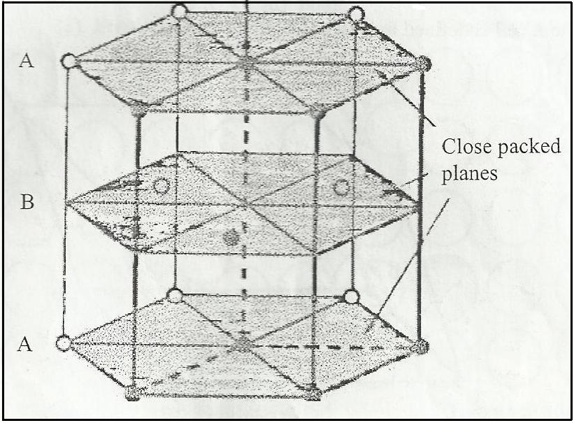
Figure8
Whereas, the cubic close-packed (or face-centred cubic) structure is produced by following the sequence ..ABCABCABCABC... as shown in figure9.

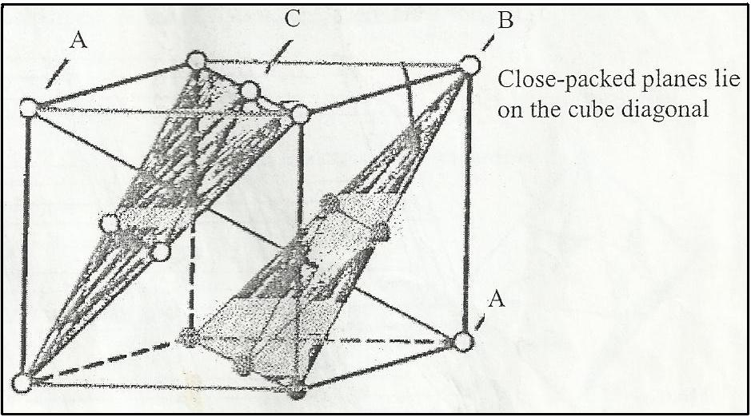
Figure9

In the HCP structure, the close-packed planes are the (100) planes (basal planes). In the FCC structure they are the (111) planes. It can be easily shown that these two structures only fill 74% (Atomic Packing Factor) of the available space.

Lattice and Unit Cells
Lattice: A lattice is a regular series of points in space, each point having identical surroundings, which is completely space-filling as shown in figure10.
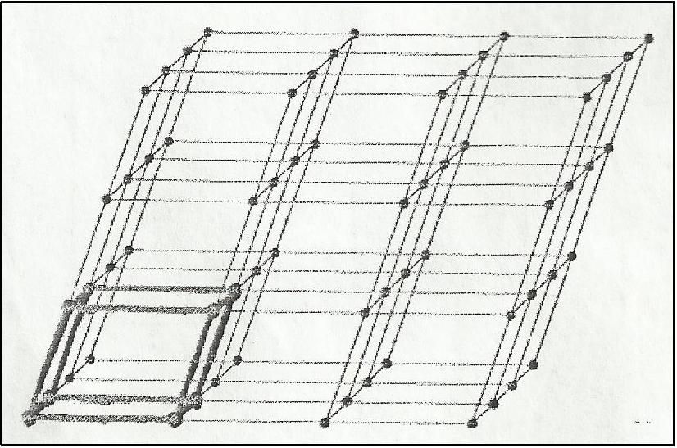
Figure10
Unit Cell: A unit cell is the smallest portion of a lattice that itself defines the entire lattice. It follows from this that a lattice is also a series of unit cells, all joined together such as the one heavily in figure10.
The size and shape of the unit cell can be described in three lattice vectors a, b, and c originating from one corner of the figure11. The axial length a, b, and c and the interaxial angles α, β, and ɤ are the lattice constant of the unit cell.
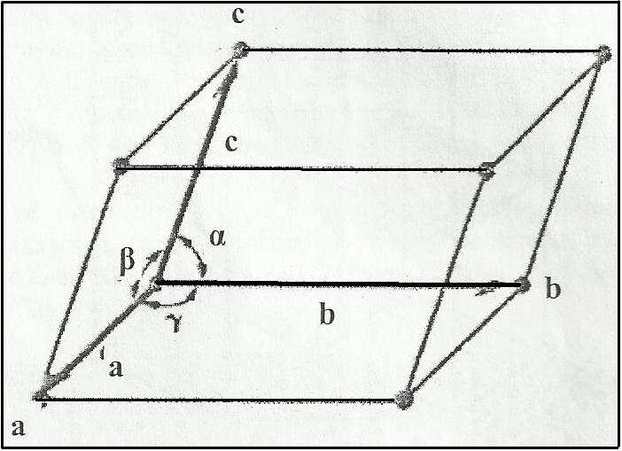
Figure11

Metallic structure and alloying
The main alloys for structural applications (requiring strength and toughness) are almost all based on iron, aluminium, copper, nickel, titanium, and magnesium (in approximate order of importance). The atoms in these metals are arranged in a periodic manner (crystal structures), which commonly consist of one of the following types:
- Face-centred cubic (fcc) e.g. Al, Ni, Cu
- Body-centred cubic (bcc) e.g. Fe
- Hexagonal close packed (hcp) e.g. Mg, Ti

The small scale structure (microstructure) of a metal consists of small crystals (called grains) of fcc, bcc or hcp crystals. These may vary in size from less than 100 nm to several cm or even, for special applications, large single crystals. The crystal grains are joined together at grain boundaries where the orientation of the crystal in space changes. Impurities are often found at these grain boundaries.

Polymorphism and Allotropy

Some nonmetals, may have more than one crystal structure, a phenomenon known as “Polymorphism”. The best example about this phenomenon is found in carbon: carbon forms stable graphite at ambient condition, whereas diamond is formed at extremely high pressure. If some metals have more than one crystal structure, this phenomenon will be termed “Allotropy”. For example, pure iron has BCC crystal structure (alpha-phase) at below 910°C. Between 910°C and 1400°C, pure iron has FCC crystal structure (gamma-phase). From 1400°C to 1539°C, the structure is BCC (delta-phase). A modification of the density and other physical properties accompanies either a polymorphic or allotropic transformation. It can be concluded that the prevailing (existing) crystal structure depends on both the temperature and external pressure.

Calculate the Length, Radius, and Volume of the Unit Cell for types of the Metals:
- Face-centred cubic (fcc): it has a unit cell of cubic geometry, with atoms located at each corner and the centre of all face of the cubic as shown in figure12.
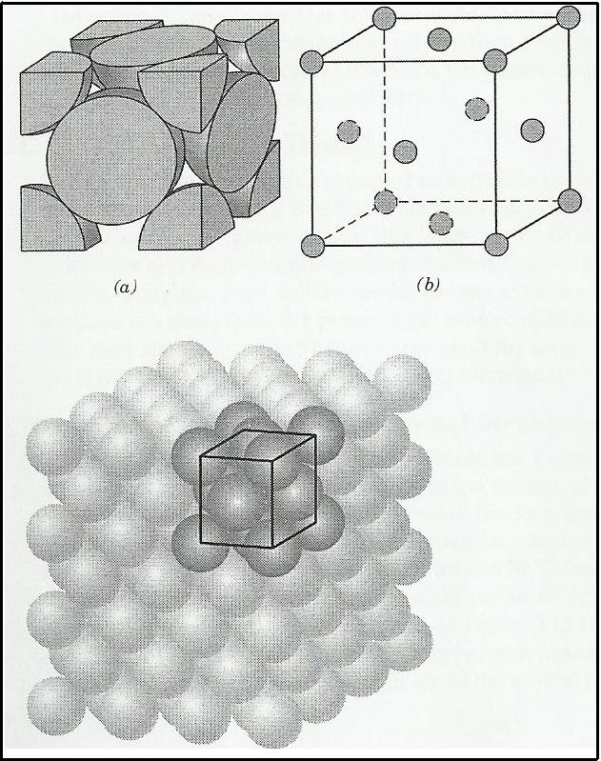
Figure12
The cubic edge length (a) and the radius (R) are related through the following equation:
Volume of the unit cell for (fcc) can be calculated from the following eq.
The Atomic packing factor (APF) for the fcc can be calculated from the following equation:
APF = V_{S} / V_{C}
There are four atoms per FCC unit cell, the V_{S} in the unit cell is:
V_{S} = (4) (4/3π R³)
Where:
V_{S}: volume of atoms in FCC unit cell
V_{C}: volume of FCC unit cell
- Body-centred cubic (bcc): it also has a cubic unit cell with atoms located at all eight corners and a single atom at the cubic centre as shown in figure13.
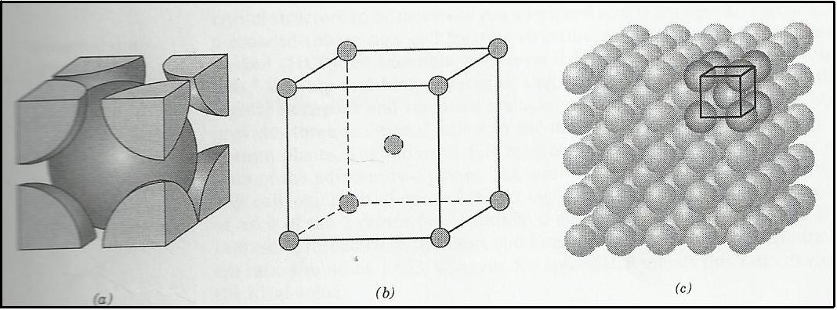
Figure13
The cubic edge length (a) and the radius (R) are related through the following equation:
Volume of the unit cell for (fcc) can be calculated from the following eq.

The Atomic packing factor (APF) for the bcc can be calculated from the following equation:
APF = V_{S} / V_{C}
There are two atoms per BCC unit cell, the V_{S} in the unit cell is:
V_{S} = (2) (4/3π R³)

- Hexagonal close-packed (HCP): is an assemblage of several HCP unit cells is presented in figure14. The top and bottom faces of the unit cell consist of six atoms that form regular hexagons and surround a single atom in the centre. Another plane that provides three additional atoms to the unit cell is situated between the top and bottom planes. The equivalent of six atoms is contained in each unit cell; one-six of each of the 12 top and bottom face corner atoms, one-half of each of the 2 centre faces atoms, and all 3 midplane interior atoms. The coordination number and the atomic packing factor (APF) for the HCP crystal structure are the same as for FCC: 12 and 0.74, respectively. The HCP include cadmium, magnesium, titanium, and zinc.
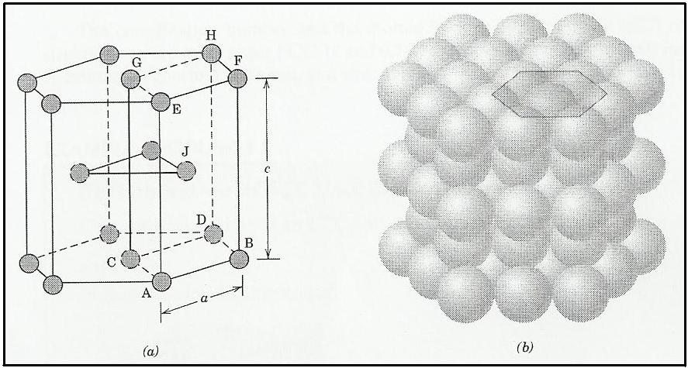
Figure14
Density Computation
Knowledge of the crystal structure of metallic solid permits computation of its theoretical density through the relationship:
Where:
= theoretical density
n = number of atoms associated with each unit cell
A = atomic weight
V_{C} = volume of the unit cell
N_{A} = Avogadro’s number (6.023 x 10²³ atoms/mol)
There another way to calculate the theoretical or volume density of a metal by follows the following steps:
Step one: calculate the volume per unit cell (V_{C}) from the above equations
Step two: calculate of the metal atoms per unit cell by using the following equation:
Step three: divide value of m by value of V_{C} by using the following equation:
Volume density of metal =

Crystal Defects
Crystals are not as perfect as their space lattices might imply. Thermodynamic considerations can easily show that the increase in entropy caused by the introduction of a defect into the structure. There are three types of defect including the point defects, dislocations, and surface defects:
First, point defects: They are localized disruptions of the lattice involving one or, possibly, several atoms. These imperfections, shown in figure15, may be introduced by movement of the atoms when they gain energy by heating, during processing of the material, by introduction of impurities, or intentionally through alloying. The point defects involve the following defects:
- Vacancies: A vacancy is produced when an atom is missing from a normal site. Vacancies are introduced into the crystal during solidification, at high temperature, or as a consequence of radiation damage. At room temperature very few vacancies are present, but this number increase exponentially as we increase temperature as shown by the following Arrhenius equation:
N_{v} = n exp(-Q/RT)
Where:
N_{v} = number of vacancies per cm³
n = number of lattice point per cm³
Q = energy required to produce a vacancy, in cal/mol
R = the gas constant, 1.987 cal/mol. K
T = the temperature, in degree Kelvin
- Interstitial defects: An interstitial defect is formed when an extra atom (impurity element) is inserted between the parent atoms in the lattice. Interstitial atoms, although much smaller than the atom located at the lattice points, are still large than the interstitial sites that occupy; consequently, the surrounding lattice is compressed and distorted. Interstitial atoms such as hydrogen are often present as impurities. Carbon atoms are also considered as interstitial atoms when they are added to iron to produce steel. The number of interstitial atoms remains constant even when the temperature is changed.
- Substitutional defects: A substitutional defect is introduced when one atom of the parent element on the normal lattice sites is replaced by a different type of atom. The substitutional atom remains at the original position. Substitutional atoms may either be larger than the normal atoms in the lattice (in this case the surrounding atoms are compressed) or smaller (causing the surrounding atoms to be in tension). Substitutional defect can be introduced either as an impurity or as on purpose alloying addition. The number of these defects is relatively independent temperature.
- Self-interstitials (or interstitialcies): are additional atoms that are present in the gaps (or interstitials) between the other atoms of the lattice.: These defects are most likely to be found in lattices having a low packing factor (APF). These defects include the following defects:
  - Frenkel defect: A Frenkel defect is a vacancy-interstitial pair formed when an ion jumps from a normal lattice point to an interstitial site, leaving behind a vacancy.
  - Schottky defect: A Schottky defect is apair of vacancies in an ionically bonded material. Both an anion and a cation must be missing from the lattice if electrical neutrality is to be preserved in the crystal. These defects are common in ceramic materials with ionic bond.

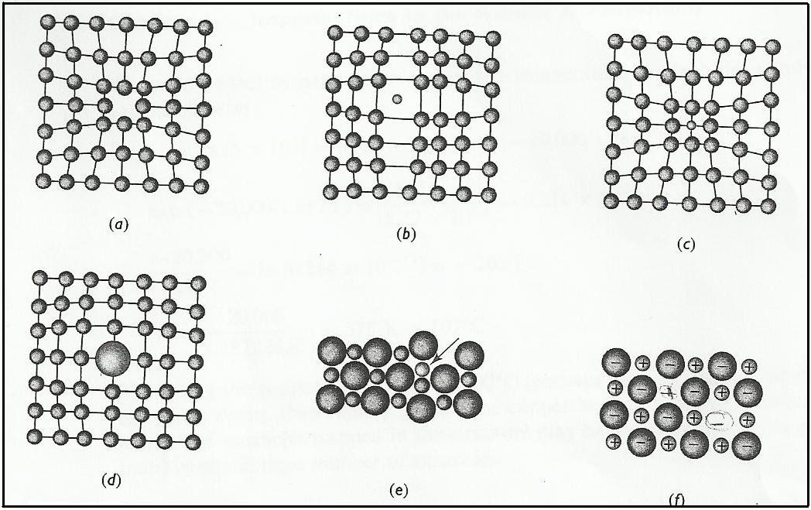
Figure15

Second, Dislocations: A dislocation is a line defect, and is responsible for plasticity (i.e. permanent deformation after removal of a load) in metals. Dislocations comprise an extra half plane of atoms inserted into a lattice. This results in a high-energy structure, however dislocations are easily generated by mechanical work (e.g. bending). There are two types of dislocations, the edge and screw types.
- Edge dislocation: an extra half plane of atoms inserted into a lattice as shown in figure21.

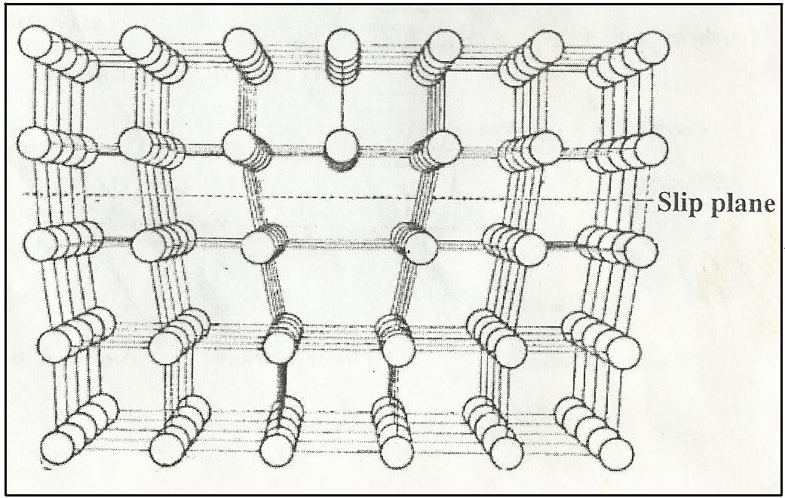
Figure16

2- Screw dislocation: is similar, but spiralled, and lies at 90° to edge dislocations.

Finally, surface defects: surface defects are the boundaries, that separate a material into regions, each region having the same crystal structure but different orientations as shown in figure.17

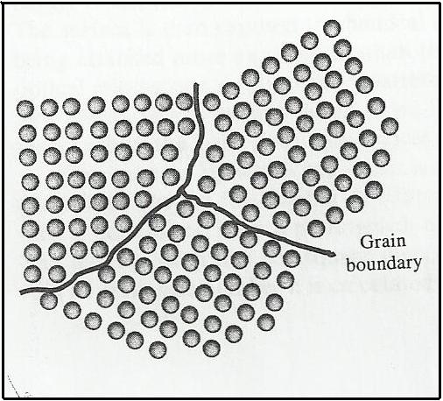
Figure17

Direction in Unit Cells
Frequently it is necessary to refer to specific direction in crystal lattices. This is important for metals and alloys that have properties which vary with crystallographic orientation. To diagrammatically indicate a direction in a cubic unit cell, we draw a direction vector from an origin which is usually a corner of the cubic cell until it emerges from cube surface. The position coordinates of the unit cell where the direction vector emerges from cube surface after being converted to integers are the direction indices. The direction indices are enclosed by square brackets with no separating commas such as [110].

Miller Indices for crystallographic Planes in Cubic Unit Cell
Sometimes it is necessary to know the crystallographic orientation of a plane or group of planes in a crystal lattice. To identify crystal planes in cubic crystal structures, the Miller notation system is used. The Miller indices of a crystal plane are defined as the reciprocals of the fractional intercepts (with fractions cleared) which the plane makes with crystallographic x, y, and z axes of three nonparallel edges of cubic unit cell. the cubic edges of the unit cell represent unit length, and the intercepts of the lattice planes are measured in terms of these unit lengths.
The procedure for determining the Miller indices for a cubic crystal plane is as follows:
- Choose a plane that does not pass through the origin at (0, 0, 0).
- Determine the intercepts of the plane in terms of crystallographic x, y, and z axes for a unit cube. These intercepts may be fractions.
- Form the reciprocals of these intercepts.
- Clear fractions and determine the smallest set of whole numbers which are in the same ratio as the intercepts. These whole numbers are the Miller indices of the crystallographic plane and are enclosed in parentheses with out the use of commas. The notation (hkl) is used to indicate Miller indices in a general sense, where h, k, and l are the Miller indices of cubic crystal plane for the x, y, and z axes respectively.

Example: Figure18 shows three planes of cubic crystal structures. The first plane is the shaded crystal plane in Fig.23a, which has the intercepts 1,, for the x, y, and z axes, respectively. Now we take the reciprocals of these intercepts to obtain the Miller indices, which are therefore 1, 0, 0, since these numbers do not involve fractions, the Miller indices for this plane are (100). The second plane is shown in Fig.23b, the intercepts of this plane are 1, 1, . The reciprocals of these intercepts are 1, 1, 0 and the Miller indices of this plane are (110). Finally, the third plane as in Fig.23c, has the intercepts 1, 1, 1, which give the Miller indices (111) for this plane.

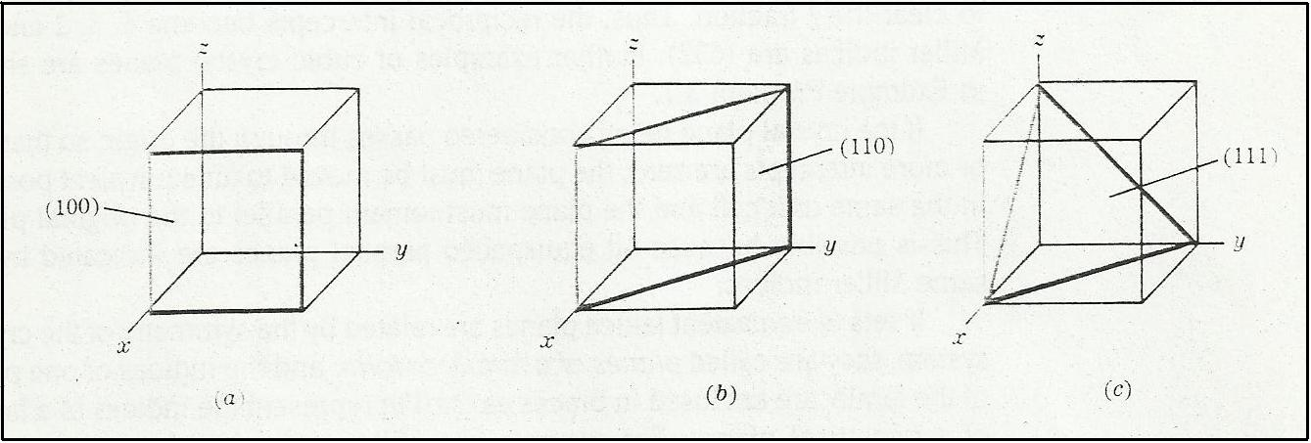
Figure18

Example: Draw the following crystallographic planes in cubic unit cells:
(a) (101) (b) (110) (c) (221)
(d) Draw a (110) plane in BCC atomic-site unit cell, and list the position
coordinates of the atoms whose centres are intersected by this plane.

(a) First determine the reciprocals of the Miller indices of the (101) plane. These are
1, , 1, the (101) plane must pass through a unit cube at intercepts x = 1 and z = 1
and be parallel to the y axis (Fig.19a).

(b) First determine the reciprocals of the Miller indices of the (110) plane. These are
1, -1,, the (110) plane must pass through a unit cube at intercepts x = 1 and y =
-1 and be parallel to the z axis (Fig.19b).

(c) First determine the reciprocals of the Miller indices of the (101) plane. These are
½, ½, 1, the (221) plane must pass through a unit cube at intercepts x = ½ and y =
½ and z = 1 (Fig.19c).

(d) Atom positions whose centres are intercepted the (110) plane are (1, 0, 0), (0. 1, 0)
(1, 0, 1), (0, 1, 1), and (½, ½, ½). These positions are indicated by the solid circles
(Fig.19d) .

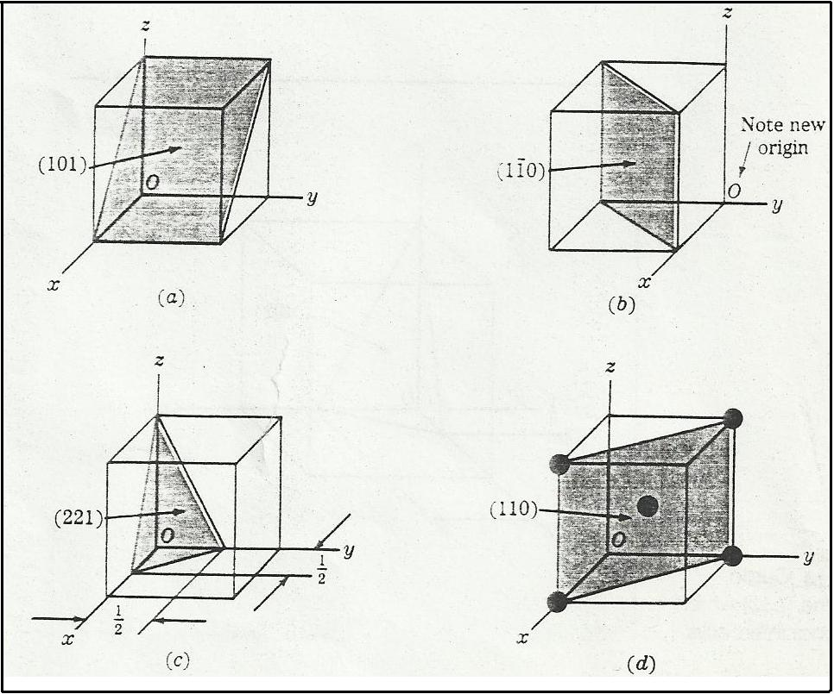
Figure19

Interplanar spacing and Diffraction Angle Computations
In cubic crystal structures the interplanar spacing between two closest parallel planes with the same Miller indices is designated d_{hkl}, where h, k, and l are the Miller of the planes. The spacing represents the distance from a selected origin containing one plane and another parallel plane with the same indices which is closest to it. Using Brags’ equation to calculate the interplanar spacing:
Where:
d_{hkl} = interplanar spacing between parallel closest planes withMiller indices h,
k, and l
a = lattice constant (edge of unit cell)
h, k, l: Miller indices of cubic planes being considered.

Crystal Structure Analysis
X–ray diffraction techniques are used to study the crystal structures. The wavelength of the x-rays is about equal to the distance between crystal lattice planes. However, before discussing the manner in which x–ray are diffracted in crystal, let us consider how x-ray are produced for experimental purposes.
- The sources of the x-ray, which is used for diffraction, are electromagnetic waves with wavelengths in the range 0.05 to 0.25 nm.
- A voltage of about 35 kV is applied between a cathode and an anode target metal (molybdenum).
- The cathode and anode are contained in a vacuum.
- Peak of radiation of varying intensities can be produced when a beam of x-ray strikes a crystalline solid.

The powder method of x-ray diffraction analysis
The most commonly used x-ray diffraction technique is the powder method. In this technique a powdered specimen is used. This is to ensure that some particles will be oriented in the x-ray beam to satisfy the diffraction conditions of Bragg’s law.
Modern x-ray crystal analysis uses an x-ray diffractometer which has a radiation counter to detect the angle and intensity of the diffracted beam. A recorder automatically plots the intensity of the diffracted beam as the counter moves on a goniometer circle as shown in figure20. Figure21 shows an x-ray diffraction recorder chart for the intensity of the diffracted beam vs. the diffraction angle 2θ for a powdered pure-metal specimen.

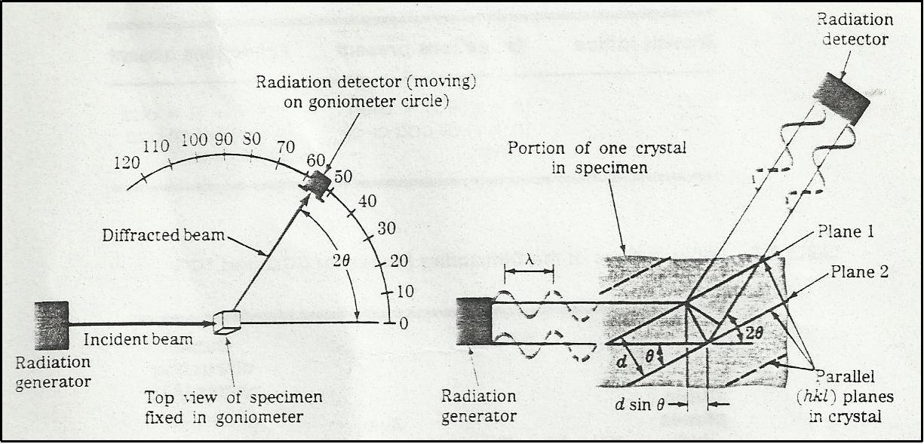
Figure20

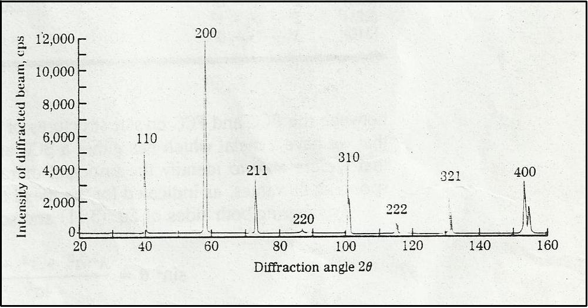
Figure21

Diffraction conditions for cubic unit cell
The analysis of x-ray diffraction data for cubic unit cells can be simplified by using the following equation:

Where:
= x-ray wavelength
θ = x-ray diffraction angle
The above equation can be used along with x-ray diffraction data if a cubic structure is body-centred or face-centred cubic. To use the above equation for diffraction analysis, we must know the principal diffraction planes for either BCC or FCC. These principal diffraction planes are given below:
For BCC:
{110}, {200}, {211}, {220}, and {310}
For FCC:
{111}, {200}, and {220}

Interpreting experimental x-ray diffraction data for metals with cubic crystal structures
We can use x-ray diffractometer data to determine crystal structures and to distinguish between the BCC and FCC crystal structures of a cubic metal by doing the following steps:
Step one: squaring both sides of the following equation:
Rearrangement the above equation:
Step two: from x-ray diffraction data we can obtain experimental values of 2θ for a series of principal diffracting planes (hkl).
Step three: substitute the experimental values of 2θ in the above equation (using the first two values)
Steps four: take the ratio of two sin² θ. If the ratio is 0.5, the structure will be the 8BCC. If the ratio is 0.75, the structure will be the FCC.

Physical Properties of Metals and Alloys
The more important physical properties of metals and alloys can be summarized in the following point:
- All metals (except mercury) are solid at normal temperatures.
- Metals generally are hard when compared with many of the non-metals, but the same time they possess properties of malleability and ductility which are not possessed by non-metals. Non-metals include gases, a liquid (bromine) and solid.
- Metals have high densities.
- Metals are good conductors of heat and electricity, whilst non-metals are poor conductors.
- Metals have low specific heats compared with non-metals.
- Most metals reflect nearly all wavelength of light, for which reason they are white, or nearly white in colour. Notable exceptions are gold and copper.
- Metals are relatively difficult to penetrate with x-rays.
- Most metals are magnetic to some slight degree, but only in the metals iron, nickel, and cobalt is magnetism strong enough. Therefore, these metals are called ferromagnetism or ferromagnetic.

Mechanical Properties
We select a material by matching its mechanical properties to the service conditions required of thee component. The first step in the selection process requires that we analyze the application to determine the most important characteristics that the material must possess. Should it be strong, or stiff, or ductile, will it be subjected to repeated application of a high force, sudden intense force, high stress at elevated temperature, or abrasive conditions. Once we know the required properties, we can select the appropriate material using data listed in handbooks. But we should know what the properties mean and realize that the properties listed are obtained from idealized tests that may not apply to real life-engineering applications. Therefore, it is necessary to know these tests.

The Tensile Test
The tensile test measures the resistance of a material to a static or slowly applied force. A test setup in figure22, a typical specimen of an aluminium alloy has a diameter of 0.505 in (12.6 mm), and a gage length of 2 in (50 mm). The specimen is placed in the testing machine and a force F, called the load, is applied. A strain gage or extensometer is used to measure the amount that specimen stretched between the gage marks when the force is applied. The results of the tensile test for a given specimen can be used to calculate the engineering stress and strain.

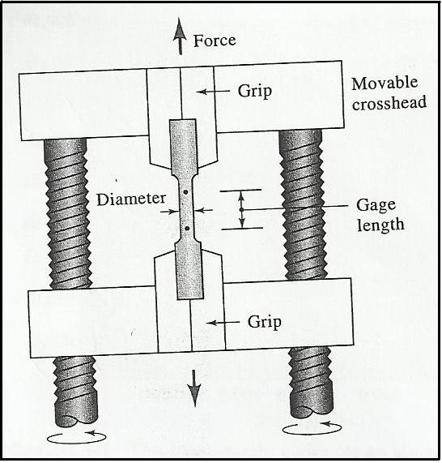
Figure22

Engineering Stress and Strain
The engineering stress and strain involve two steps:
First step: convert the applied force to engineering stress that is defined by the following equation:
Engineering stress =
The most common units for stress are pounds per square inch (psi) and megapascals (MPa).
Second step: convert the distance between gage marks engineering strain which is defined by the following equation:
Engineering strain =
The units for strain include inch/inch, centimetre/centimetre, and meter/meter. Therefore, strain is dimensionless.
Where:
= is the applied force
= is the original cross-sectional area of the specimen before the test begins
= is the original distance between the gage marks
= is the distance between the gage marks after force is applied
The results of the tensile test of a 0.505 in. diameter aluminium alloy test bar and the conversions from load to stress and from gage-length to strain are included in table2.
Then, the stress-strain curve can be plotted by draw values of stress versus values of strain as shown in figure23.

Properties Obtained from the Tensile Test
Information concerning the strength, stiffness, and ductility of a material can be obtained from a tensile test. In this section, we will try to describe the more important properties that are obtained from the engineering stress-strain curve (Figure23).
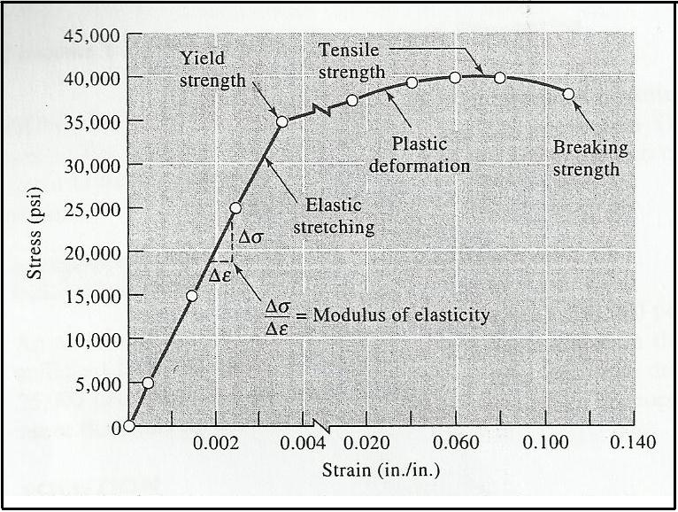
Figure23
- Yield Strength: The yield strength is the stress at which plastic deformation becomes noticeable. Therefore, the yield strength is the stress that divides the elastic and plastic behaviour of the material. In practise, alloys are designed to be used to a maximum percentage (e.g. 50% or 70%) of their yield or proof stress.
In some materials, the stress at which the material changes from elastic to plastic behaviour is not easily detected. In this case, we determine offset yield strength (proof stress) as shown in figure24. We construct a line parallel to initial portion of the stress-strain curve but offset by 0.002 in/in. (0.2%) from the origin. “The 0.2% offset yield strength is defined as the stress at which our constructed line intersects the stress-strain curve”.

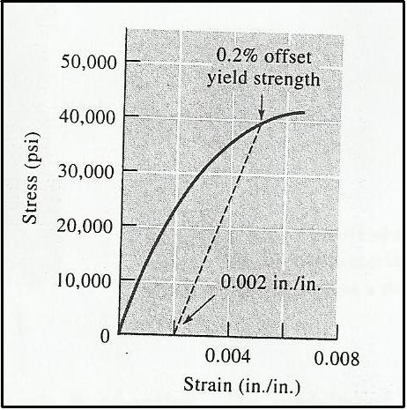
Figure24

- Tensile Strength (Ultimate Tensile Strength): The tensile strength (UTS) is the maximum (engineering) stress that an alloy can sustain before fracture (breaking).
- Necking: Is the local deformation of a tensile specimen. Necking begins at the tensile point (tensile strength). This occurs in many ductile materials.
- Strain: There are two types of strain, elastic and plastic strains.
  - Elastic Strain: Is the deformation of the material that is recovered when the applied load is removed. It means that when you remove the stress from the material, the shape of the material returns exactly to its original shape.
Elastic Properties:
First, Modulus of Elasticity, or Young’s modulus, (): is the slop of the stress-strain curve in the elastic region. The Young’s modulus, which relates the normal stress to the normal strain, is calculated by Hook's law:
The shear modulus G relates the shear stress, (τ) to the shear strain, (tanθ):
Moduli of metals are normally expressed in GPa, i.e. 10⁹ Nm⁻². The modulus of elasticity is higher for high melting point materials.
The modulus is a measure of the stiffness of the material. A stiff material, with a high modulus of elasticity, maintains its size and shape even under an elastic load. Figure25 compares the elastic behaviour of steel and aluminium. It can be seen from this figure that the iron has a modulus of elasticity three times greater than that of aluminium.

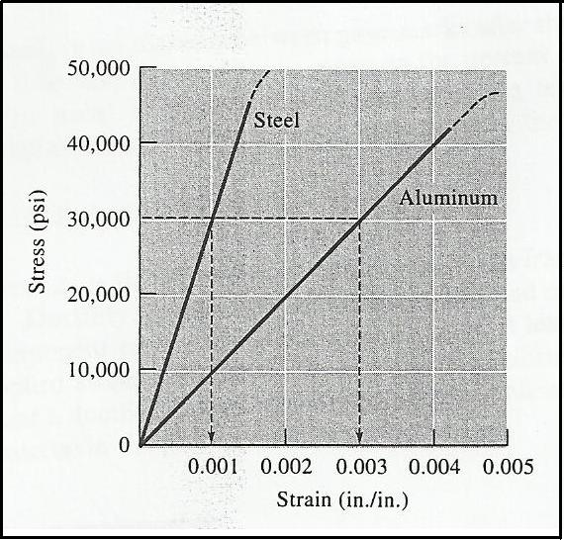
Figure25

Second, Modulus of Resilience (): The area contained under the elastic portion of a stress-strain curve, is the elastic energy that a material absorbs during loading and subsequently releases when the load is removed. For linear elastic behaviour:
(yield strength)(strain at yielding)
The ability of a spring or a golf ball to perform satisfactorily depends on a high modulus of resilience.

Third, Poisson’s Ratio,(): It is the ratio between the longitudinal elastic deformation (longitudinal strain) produced by simple tensile or compressive stress and the lateral deformation (lateral strain) that occurs simultaneously:
Poisson’s ratio is typically about 0.3.

  - Plastic Strain: when a stress is applied to a material, and this stress exceeds a certain value, the material will not return to its original shape on removing the stress - the material will have undergone a plastic deformation.
The critical stress at which the behaviour of a material changes from elastic to plastic is called the yield stress.
The plastic strain can be determined from the change in shape of the material when the stress has returned to zero. The plastic strain is expressed by the change in length of the material after removal of the stress divided by the original length of the material.
Q: Why will the metal deform plasticity if it is subjected to stress that exceeds the yield stress?
Answer: This is due to the movement of dislocations. The dislocations do not move until the stress exceeds the yield stress. When the stress reaches the yield stress the dislocations begin to move. The movement of the dislocations provides an additional displacement of atom positions. This displacement is not recovered when the stress is reduced to zero. Therefore, plastic deformation has occurred.
- Breaking Strength (ductile fracture): The fracture of a metal occurs after extensive plastic deformation. If a stress is applied to the specimen which exceeds its UTS, the specimen will fracture.
- Ductility: The ability of a material to be permanently deformed without breaking when a force (load) is applied. The amount of deformation, which a material can withstand, can be measured by calculate either the % elongation or % reduction in area of specimen.
  - % Elongation: The total percentage increase in the length of a specimen during tensile test:
% Elongation =
Where, = is the distance between gage marks after the specimen breaks.

  - % Reduction in Area: The total percentage decrease in the cross-sectional area of a specimen during the tensile test:
% Reduction in area =
Where: is the final cross-sectional area at the fracture surface.
Ductility is important to both designers and manufacturers. The designer of a component prefers a material that displays at least some ductility, so that, if an applied stress is too high, the component deforms before it breaks. Fabricators want a ductile material in order to form complicated shapes without breaking the material in the process.

Effect of Temperature
Tensile properties depend on temperatures shown in figure26. Yield strength, UTS, and modulus of elasticity decrease at higher temperature, whereas ductility commonly increases. A materials fabricator may wish to deform a material at a high temperature (known as a hot working) to take advantage of the higher ductility and lower required stress.

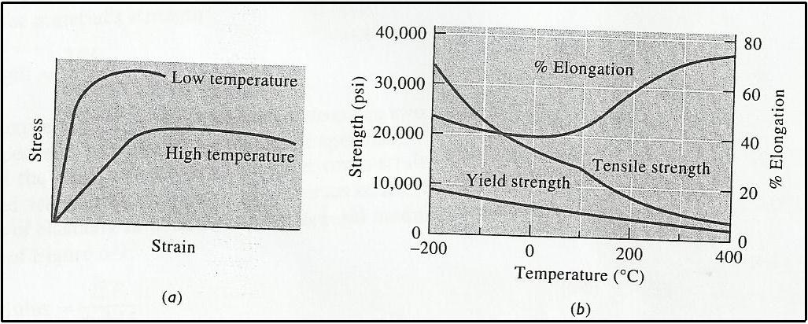
Figure26

True Stress – True Strain
The decrease in engineering stress beyond the tensile strength (UTS) occurs because of our definition of engineering stress. We used the original area in our calculations, but this is not precise because of the area of the specimen continually changes. We should define true stress and true strain.
First, True Stress: The load divided by the actual cross-sectional area of the specimen at that load according to the following equation:
True stress =
Where: = is the actual cross-sectional area at which the force is applied.

Second, True Strain: the true strain is equal to the sum of the increments of length following a small increase in stress divided by the length of the specimen at the time of the increase in stress, the sum being made as the stress increases from zero to a particular value. It is defined according to the following equation:
True strain = ∫(dl/l) = ln(l/l◦) = ln(A◦/A)
The expression ln(A◦/A) must be used after necking begins. The true stress-strain curve is compared with the engineering stress-strain curve in figure28. As can be seen from figure28, the true stress continues to increase after necking because of the area at the neck point decreases (although the load required decreases).

The Hardness Test
The hardness test measures the resistance to penetration of the surface of a material by a hard object. Common hardness tests include the Brinell test, Rockwell test, Knoop test, and Vickers test.
First, Brinell test: In this test, a hard steel sphere (usually 10 mm in diameter) is forced into the surface of the material. The impression, typically 2 to 6 mm, is measured and the Brinell hardness number (as HB) is calculated form the following equation:
Where:
= is the applied load in (kg)
D = is the diameter of the indentor in (mm)
= is the diameter of the impression in (mm)

Second, Rockwell test, the Rockwell hardness test uses a small-diameter steel ball for soft materials and a diamond cone, or Brale, for harder materials. The depth of penetration of the indentor is automatically measured by the testing machine and converted to a Rockwell hardness number (HR).

Third, Vickers (VH) and Knoop (HK) tests: There are microhardness tests; they form such small indentations that a microscopic is required to obtain the measurement.

Hardness numbers are used as a basis for comparison of materials, specification of manufacturing and heat treatment, quality control, and correlation with other properties of materials. For example, Brinell hardness is closely related to the tensile strength of stell by the relationship:
Tensile strength (psi) = 500 HB

The Impact Test
When a material is subjected to a sudden, intense blow, in which the strain rate is extremely rapid, it may behave in a much more brittle manner than is observed in the tensile test. An impact test is often used to evaluate the brittleness of a material under these conditions. There are to types of impact tests, the Cherpy test and Izod test (see Figure27). The Izod test is often used for non-metallic materials. The test specimen may be either notched or unnotched; V-notched specimens better to measure the resistance of the material to crack propagation. “The ability of a material to withstand an impact blow is often referred to as the toughness of the material.
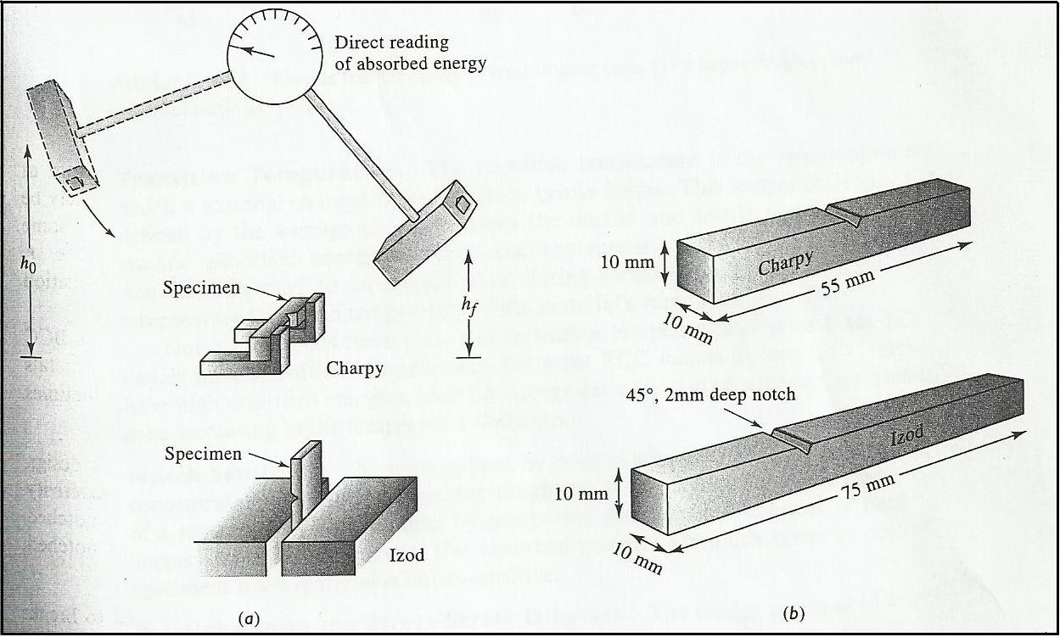
Figure27

Transition Temperature
This property is obtained from the impact test. The transition temperature is the temperature at which a material changes from ductile to brittle failure as shown in Figure28. This temperature may be defined by the average energy between the ductile and brittle regions, or by characteristic fracture appearance. A material subjected to an impact blow during service should have a transition temperature below the temperature of the material surroundings.

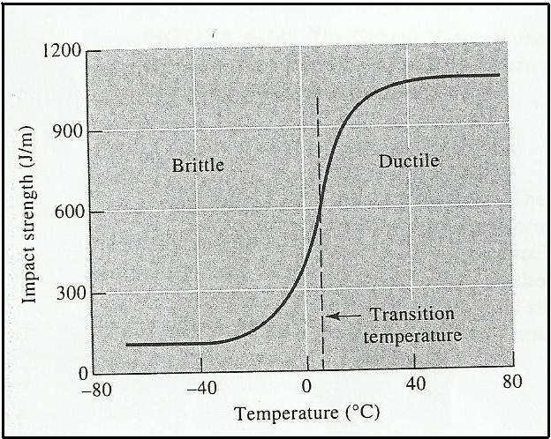
Figure28
BCC metals have transition temperature, but most FCC metals do not. FCC metals have high absorbed energies, with the energy decreasing gradually and sometimes even increasing as the temperature decreases.
For example, steel, have a ductile-to-brittle transition at low temperature. At low temperature (e.g. 0°C, dependent upon the steel), the steel fractures in a brittle manner. This because of there is little or no plastic deformation; there is only a small absorption of energy; and a shiny, cleavage-like fracture surface is produced. At higher temperature (e.g. 200°C), the steel fractures in a ductile manner. That is there is a large amount of plastic deformation; a large absorption of energy; and dull, grey 'fibrous' fracture surfaces.

Use of Impact Properties
Absorbed energy by the specimen during failure and transition temperature are very sensitive to loading conditions. For example, a higher rate of applying energy to the specimen reduces the absorbed energy and increases the transition temperature. The size of the specimen also affects the results; because it is more difficult for a thick material to deform. Smaller energy required to break a thicker material. Finally, the configuration of the notch affects the behaviour; a surface crack permits lower absorbed energy than dose a V-notch.

Fracture Toughness
Fracture Toughness is a measure the ability of a material containing a flaw to withstand an applied load. In this discipline, we wish to know the maximum stress that a material can withstand if it contains flaws of a certain size and geometry. A fracture toughness test may be performed by applying a tensile stress to a specimen prepared with a flaw of known size and geometry (see Figure29). The stress applied to the material is intensified at the flaw, which acts as a stress raiser. For a simple test, the stress intensity factor is:
Where: = is the geometry factor for the specimen and flaw (it = 1, if the specimen
have an infinite width)
= is the applied stress
= is the flaw size
If the stress intensity factor causes the flaw to grow and cause failure, it will be defined as the critical stress intensity factor (fracture toughness).
Fracture toughness depends on the thickness of the sample, as the thickness increases, fracture toughness decreases to a constant value as shown in figure29. This constant value is called the plane strain fracture toughness.
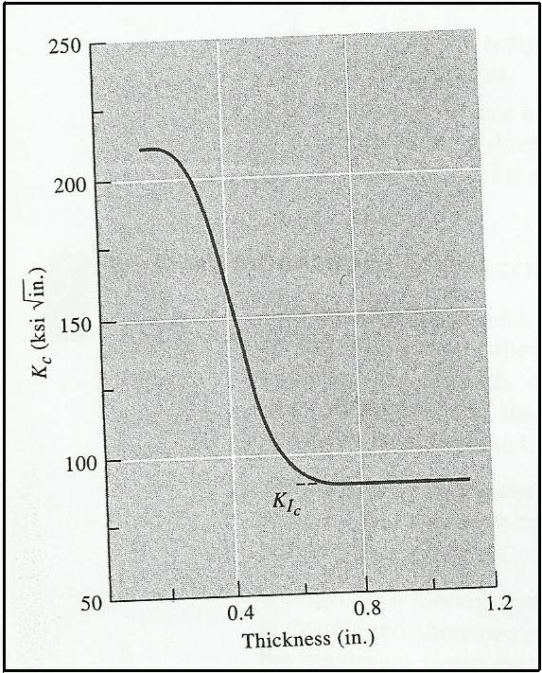
Figure29
The ability of a material to resist the growth of a crack depends on the following points:
- Size of the flaws: larger flaws reduce the permitted stress.
- The ability of a material to deform: ductile materials have high fracture toughness, while brittle materials have much lower fracture toughness.
- Thickness of specimen: thick materials have lower fracture toughness than thin materials.
- Increasing the rate of application of thee load reduces thee fracture toughness.
- Increasing temperature normally increasing the fracture toughness.

The Fatigue Test
Fatigue is an irreversible process that occurs when an alloy is subjected to a fluctuating or cyclic stress. Fatigue leads to fracture of an alloy when subjected to a cyclic stress that is below the yield strength of the material. Fatigue failures occur in three stags:
First, a tiny crack initiates at the surface, often at a time well after loading begins.
Second, the crack gradually propagates as thee load continues to cycle.
Finally, sudden fracture of the material occurs when the remaining cross-section of the material is too small to support the applied load.
A common method to measure a material's resistance to fatigue is the rotating cantilever beam test (see Figure30). One end of a machine, cylindrical specimen is mounted in a motor-driven chuck. A weight is suspended from the opposite end. The maximum stress acting on this type of specimen is given by:
Where: = is the length of the bar
= is the load
= is the diameter
After a sufficient number of cycles, the specimen may fail. A series of specimen are tested at different applied stresses. The results are presented as an S-N curve with the stress (S) plotted versus the number of cycles (N) to failure as shown in Figure31.
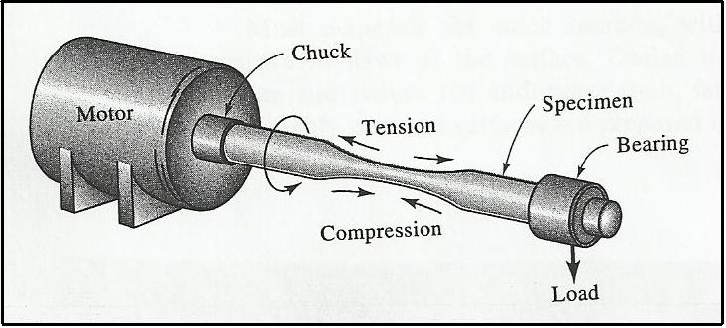
Figure30
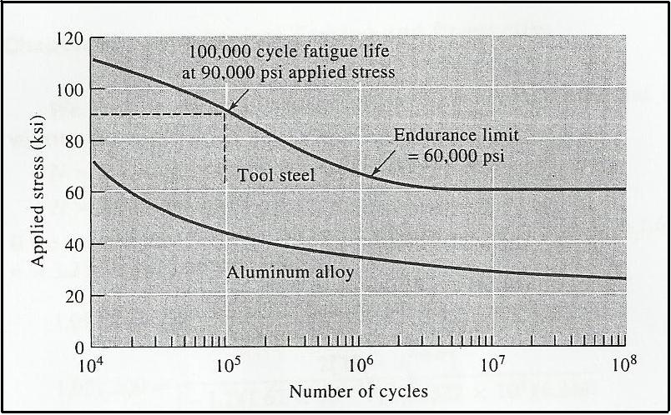
Figure31

The Creep Test
Creep is a plastic deformation at high temperature. If a material is subjected to a stress at an elevated temperature, the material may be stretch and eventually fail, even though the applied stress is less than the yield strength at that temperature.
To determine the creep characteristics of a material, a constant stress is applied to a heated specimen. As soon as the stress is applied, the specimen stretches elasticity a small amount.

Creep Rate and Rupture Time
During the creep test, strain or elongation is measured as a function of time and plotted to give the creep curve as shown in Figure32. In the first stage of creep of metals, many dislocations climb away from obstacles, slip, and contribute to deformation. Eventually, the rate at which dislocations climb away from obstacles equals the rate at which dislocations are blocked by other imperfections. This leads to second-stage, or steady state, creep. The slope of the steady state portion of the creep curve is the creep rate:
Creep rate =
Eventually, during third-stage creep, necking begins, the stress increases, and the specimen deforms at an accelerated rate until failure occurs. The time required for failure to occur is the rupture time. Either a higher stress or a higher temperature reduces the rupture time and increases the creep rate.
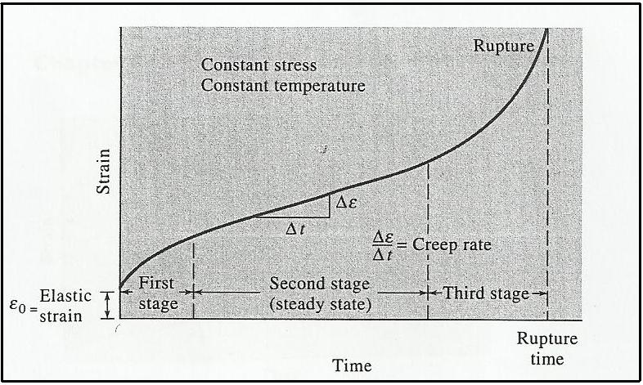
Figure32
The Bend Test for Brittle Materials
In ductile materials, the engineering stress-strain curve typically goes through a maximum; this maximum stress is the tensile strength of the material. Failure occurs at a lower stress after necking has reduced the cross-sectional area. In more brittle materials, failure occurs at the maximum load, where the tensile strength and breaking strength are the same. In very brittle materials, including many ceramics, yield strength, tensile strength, and breaking strength are all the same as shown in Figure33.

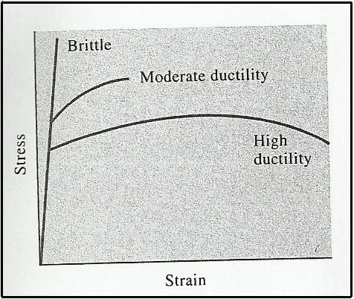
Figure33

In many brittle materials, the normal tensile test cannot easily be performed because of the presence of flaws at the surface. Often, just placing a brittle material in the grips of the tensile testing machine causes cracking. These materials may be tested by using the bend test as shown in Figure34.

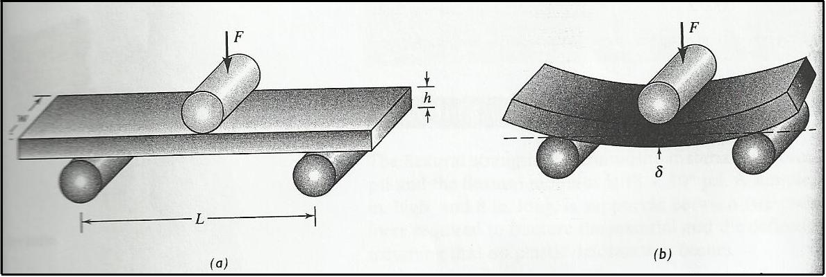
Figure34
The bind test involves applying the load at three points and causing bending, a tensile force acts on the material opposite the midpoint. Fracture begins at this location. The flexural strength, or modulus of rupture, describes the materials strength:
Flexural strength =
Where:
= is the fracture load
= is the distance between the two outer points
= is the width of the specimen
= is the height of the specimen
The results of the bend test are similar to the stress-strain curve. The stress plotted versus deflection rather than versus strain. The modulus of elasticity in bending, or the flexural modulus, is calculated in the elastic region of the figure40:
Flexural modulus =
Where = is the deflection of the beam when a force is applied.

Phase Diagram (Thermal-Equilibrium Diagram)
The phase diagram or thermal-equilibrium diagram is a chart which shows the relationship between the composition, temperature, and structure of any alloy.

Phases
A phase is defined as a state of matter which has different physical and chemical properties than other. For example, ice, water and steam are respectively the solid, liquid and gaseous phases of the substance H₂O.

A pure metal can also exist in solid, liquid or gaseous states, but of most interest is the appearance of different phases in the solid state. Pure iron for example, is stable below 910°C as a BCC structure (α-phase or Ferrite). Between 910°C and 1400°C the stable phase of pure iron is FCC (ɤ-phase or austenite). From 1400°C to 1539°C the stable phase is BCC again (- phase or Ferrite). Above 1539°C and below the boiling point of iron, the stable phase is a liquid. Above the boiling point, the stable phase is a gas. It can be seen in Figure35.

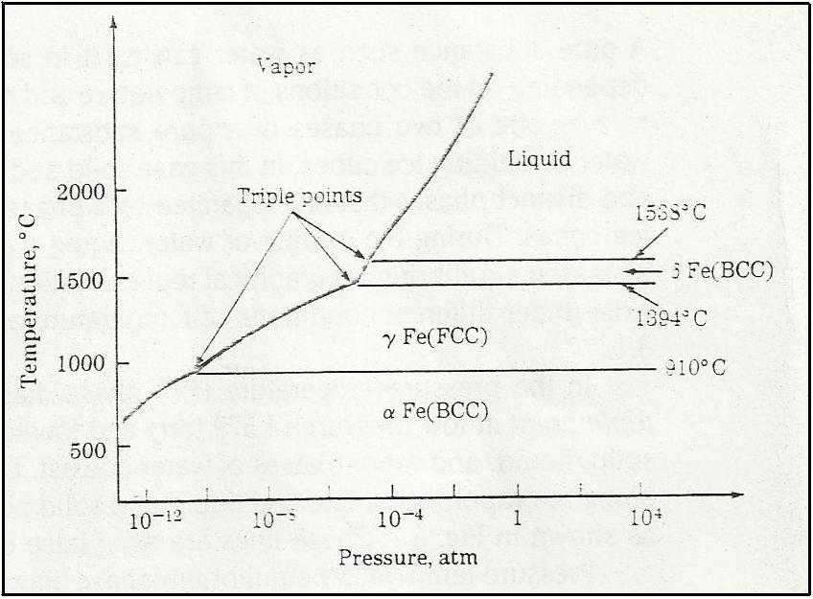
Figure35
Temperature is only one factor that affects the appearance of particular phases. Pressure and composition (i.e. if alloying additives are added) also alter those phases. A description of the stable phases that appear can be given by a PHASE DIAGRAM, which shows what to expect under EQUILIBRIUM condition.

Construct the Phase Diagram
A pure metal will complete its solidification without change of temperature, whilst an alloy will solidify over range of temperature which depends upon the composition of the alloy. The phase diagram can be constructed by using the appropriate points obtained from time-temperature cooling curve which indicate where freezing began and where it was complete. Thus, the liquidus and solidus temperatures for a number of alloys in the series between 100% metal A and 100% metal B (for a binary system) can be obtained and then plotted on temperature-composition diagram.

Example: consider a number of alloys of different composition containing the two metals A and B which forms a series of solid solutions as shown in Figure36. For compositions containing diminishing amount of the metal A, freezing commences at a₁, a₂, a₃, etc., and ends at b₁, b₂, b₃, etc. Thus, if we join all points a₁, a₂, a₃, etc., we shall obtain a line called the LIQUIDUS, indicating the temperature at which any given alloy in the series will commence to solidify. Similarly, if we join all points b₁, b₂, b₃, etc., we have a line, called the SOLIDUS, showing the temperature at which any alloy in the series will become completely solid. Hence, the liquidus “can be defined as the line above which all indicated alloy compositions represent completely homogeneous liquid”. The solidus “can be defined as the line below which all represented alloy compositions of A and B are completely solid”. For temperatures and compositions corresponding to the co-ordinates of points between the two lines both liquid solutions and solid solutions can co-exist in equilibrium. Such a system as this occurs when the two metals are soluble in each other in all proportion in both liquid and solid states as in the case of copper and nickel or gold and silver.

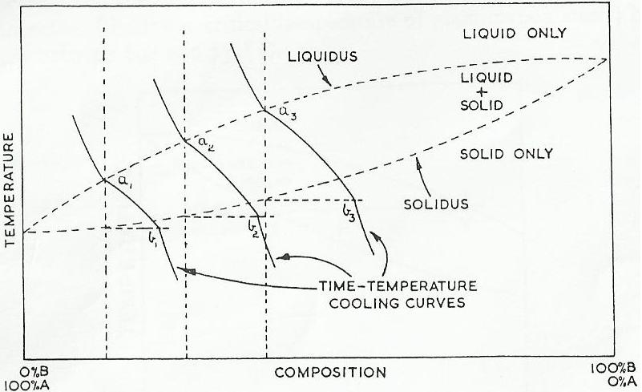
Figure36

Phase Rule
The phase rule can be used to predict the maximum number of phase that can be in equilibrium with each other. It can be derived theoretically from thermodynamic equations of state. Gibbs phase rule is:
P + F = C + 2
This equation states that the number of phases presents (P) plus the number of degree of freedom (F) equals the number of components (that is elements) in alloy (C) + 2.

The degree of freedom is thee number of variables such as temperature and pressure or concentration that can be changed independently of the number of phases present. Since we ignore pressure as a variable, the law reduces to:
P + F = C + 1

Lever Rule
The compositions of an alloy at any point in the thermal-equilibrium diagram can be predicted by using the lever rule. The lever rules can be summarized in the following points:
- The areas of the diagram are called “phase fields”. Two single-phase fields will always be separated by double-phase field containing both of the phases. In a binary system three phases can only exist together at a point, such as the eutectic point.
- At a point P (Fig. )7 in a two-phase field both liquid and solid can exist together. If a temperature horizontal is drawn through P, the composition of the solid is given by X, and the composition of the liquid solution in equilibrium with it by Y. P itself represents the overall composition of the mixture.
- The relative amounts of both liquid and solid at P are given by the relative length PX and PY:
Weight of solid solution x PX = Weight of liquid solution x PY

Or (Weight of solid solution)/(Weight of liquid solution = (PY)/(PX)

- A phase which dose not occupy a field by itself, but appears only in two-phase field, is either a pure metal or an intermetallic compound of invariable composition.
- If a vertical line, representing the composition of a given alloy, crosses some line of the diagram, it means that a change in the number of phases will occur at that point, i.e. a phase will be precipitated or absorbed.

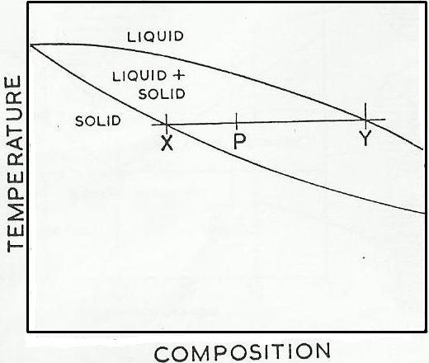
Figure37

Two Metals are Soluble in each Other in the Liquid States, Remain Soluble in the Solid State. (Cu-Ni system)
This system forms continuous solid solution alloys over the entire composition range. It is close to an ideal solution, copper and nickel having similar atomic dimension, and similar electronic structure. Consider the freezing of an alloy of composition (A) i.e. containing 60% nickel and 40% copper as shown in Figure38. Above T °C the alloy will exist as a uniform liquid solution, but as the temperature falls to T, dendrite of composition B (solid particles) of solid solution will begin to form. The dendrites which form will contain about 75% nickel, and since the original liquid contained only 60% nickel, it follows that the remaining liquid will contain lower proportion of nickel. Hence its composition will move to the left, say to A₁.
Solidification will continue when the temperature falls to T₁, and this time a layer of solid of composition B₁ will be deposited. This is less rich in nickel than the original seed crystal and, as crystallisation proceeds, successive layers will contain less and less nickel, and consequently more and more copper, until ultimately the liquid is used up. Clearly, then, a non-uniform solid solution is formed, and whilst its overall composition will be 60% nickel and 40% copper. due to the coring effect the initial skeleton of crystal will contain about 75% nickel and its outside frings only about 50% nickel.

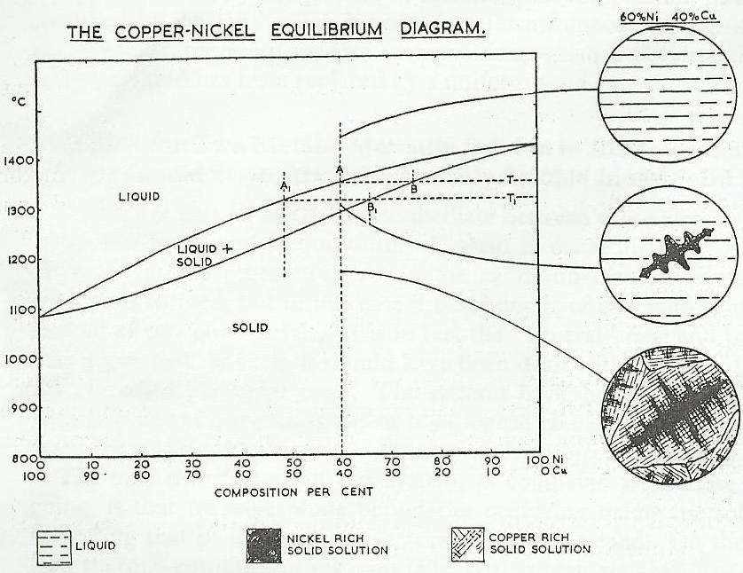
Figure38

Two Metals are Soluble in each other in Liquid State, Become Completely Insoluble in the Solid State (Forms what is called Eutectic)
It is a type of thermal-equilibrium diagram which is obtained by plot temperature versus composition. Metals, which form a eutectic point on the solidus line, are completely soluble in each other in the liquid phase but are insoluble in the solid phase. The eutectic part of the structure of any alloy in the series solidifies at the same temperature. The eutectic point is the portion of the alloy with the lowest melting point.

Example: one of the few examples in which no solubility has been detected in the solid state is supplied by the alloy system of the metals cadmium and bismuth. Let us consider the solidification of an alloy containing about 80% cadmium and 20% bismuth (i.e. composition x) as shown in Figure39. The phase diagram can be described as in the following points.
- When the temperature falls to T, crystal nuclei of pure cadmium begin to form. Since pure cadmium is deposited, it follows that the liquid which remains becomes rich in bismuth. Therefore, the composition of the liquid moves to left at x_{1.}
- When the temperature falls to T₁, more cadmium is deposited, and dendrites begin to develop from the nuclei and then the growth of the cadmium dendrites takes place. The remaining liquid is rich in bismuth.
- When the temperature falls to 140°C, the remaining liquid then contains 40% cadmium and 60% bismuth, i.e. the eutectic point E has been reached.
- At the eutectic point the two metals are in equilibrium in the liquid.
- At the eutectic point the temperature remains at 140°C until the remaining liquid has solidified. Thus, the final structure will consist of primary crystal of cadmium which formed between the temperature T and 140°C, and a eutectic consisting of alternate layers of cadmium and bismuth which formed at 140°C.

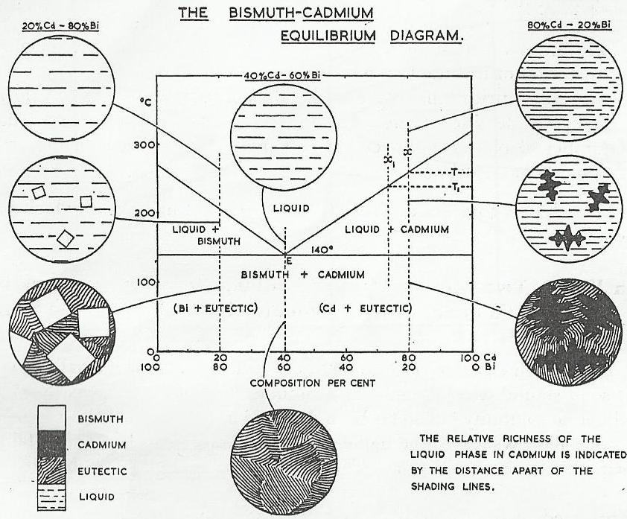
Figure39

Two Metals, which Mutually Soluble in all Proportions in the Liquid state, are only Partially Soluble in the Solid State
This case is intermediate between the case of the two metals, which are soluble in each other in the liquid and solid states, and the case of the two metals that are insoluble in the solid states and they form eutectic point. But in the currently case, we will see some dissolution of one metal in the other and there will be a eutectic point of a two solid solution instead of two pure metals.

Example: An alloy of composition X (70% lead and 30% tin) as shown in Figure40. This will begin to solidify when the temperature falls to T and dendrites of composition Y (about 92% Pb and 8% Sn) will deposit. The alloy will continues to solidify in the manner of a solid solution until 183°C the last layer of solid to form will be of composition F (80.5% lead and 19.5% tin) and the remaining liquid will be of composition of E ( the eutectic composition with 38% lead and 62% tin).

The remaining liquid now solidifies by depositing, in the form of a eutectic, alternate layers of α and β, of composition B and F respectively. If this structure now cools slowly to room temperature, the compositions of solid solutions α and β will follow the lines BC and FG, i.e. the solid solution α will become progressively poorer in lead and the solid solution β will become poorer in tin, until at 100°C α will contain less than 1% lead and β will contain less than 10% tin.

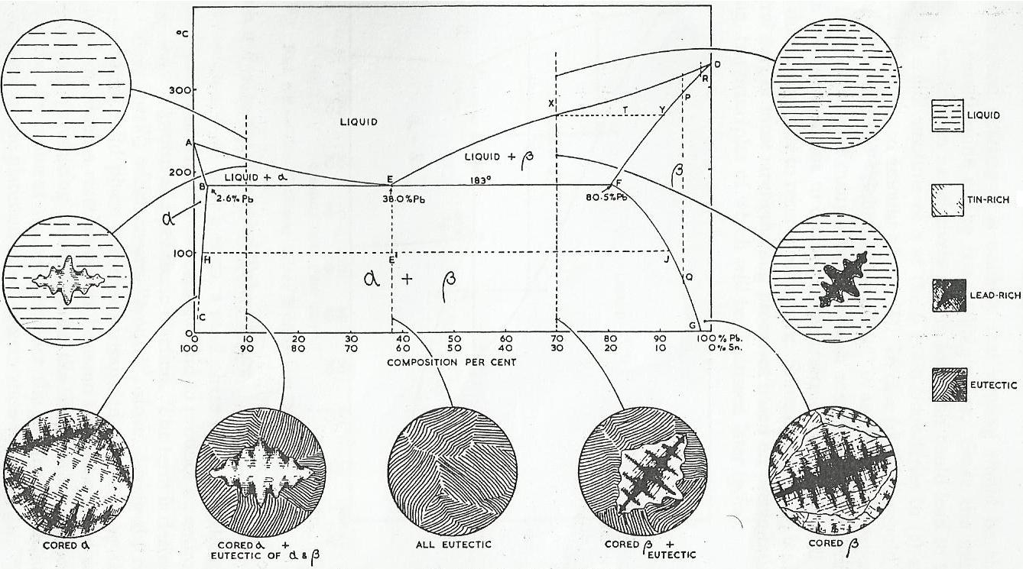
Figure40

Plain Carbon Steels
Plain carbon steels are usually regarded as being those alloys of iron and carbon which contain up to 1.7% carbon. In practice, most ordinary steels also contain appreciable amounts of manganese, residual from the deoxidation process.

As we mentioned previously, the pure metal iron has characteristic of the allotropy. This means that the pure iron has more than one crystal structure. Iron at 910°C has BCC structure, and if it is heated to above this temperature, the structure will change to FCC structure. The importance of this reversible transformation lies in the fact that up to 1.7% carbon can dissolve in FCC forming a solid solution, whereas in BCC no more than 0.03% carbon can dissolve.

Important Definitions
Austenite: A solid solution of carbon in face-centred cubic iron, containing a maximum of 1.7% carbon at 1,130°C. It is soft and non-magnetic, and only exists in plain carbon steels above the upper critical range. It may, however, occur at room temperatures in certain alloy steels.

Ferrite: A solid solution of carbon in body-centred cubic iron, containing a maximum of 0.04% carbon at 690°C. It is soft, ductile and readily cold-worked.

Cementite: A hard brittle compound of iron and carbon with the formula Fe₃C. This may exist in the free state usually as a grain boundary film, or as constituent of the eutectoid pearlite.

Martensite: Is the metastable solid solution of carbon in body-centred cubic iron formed by rapid cooling (quenching) from the upper critical range (austenite region)

Hypo-Eutectoid Steel: Is plain carbon steel which contains less than 0.83% carbon.

Hyper-Eutectoid Steel: Is plain carbon steel which contains more than 0.83% carbon.

Eutectoid Steel: Is plain carbon steel which contains exactly 0.83% carbon.

Phase Diagram of the Plain Carbon Steel
Figure46 explains the transformations which take place in the structures of three types of steels. Each type differs than other in the carbon content and iron content. If a steel containing 0.40% carbon is heated to some temperature above U₁, it will become completely austenite (Figure46 (i)). On cooling again to just below U₁ (which is called the “upper critical temperature” of the steel), the structure begins to change from one which is FCC to one which is BCC. Consequently, small crystals of BCC iron begin to separate out from the austenite. These BCC crystals (Figure46 (ii)) contain a small amount of carbon (less than 0.03%), and they are referred as crystal of ferrite. As the temperature continues to fall the crystals of ferrite grow in size at the expense of the austenite (Figure46 (iii)). Since ferrite is almost pure iron, it follows that most of the carbon present accumulates in the shrinking crystals of austenite. Thus, by the time the piece of steel has reached L₁ (which is called the “lower critical temperature” of the steel) it is composed of approximately half ferrite (containing only 0.03% carbon) and half austenite, which now contains 0.83% carbon. The composition of the austenite at this stage is represented by E (eutectic point). As the temperature falls still further, the carbon begins to precipitate as cementite. At the same time ferrite is still separating out. Ferrite and cementite continue to form the alternate layers of pearlite (i.e. pearlite composes of ferrite and cementite) until all the remaining austenite is used up (Figure41 (iv)).
It can be concluded that any steel containing less than 0.83% carbon will transform from austenite to a mixture of ferrite and pearlite. Transformation will begin at the appropriate upper critical temperature (given by appoint on CE which corresponds with the composition of the steel) and end at the lower critical temperature of 723°C. The relative amounts of ferrite and pearlite will depend upon the carbon content of the steel as shown in Figure42. However, in every case the ferrite will be almost pure iron and the pearlite will contain exactly 0.83% carbon.
On the other hand, any steel containing more than 0.83% carbon will have a structure consisting of cementite (as needle-shaped crystals) and pearlite if it is allowed to cool slowly from its austenite state.

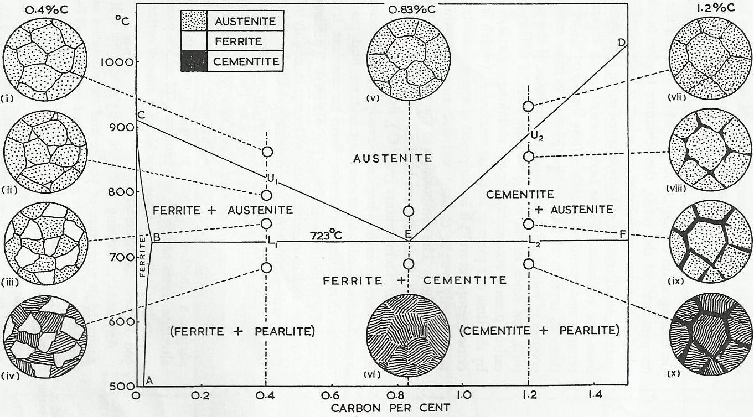
Figure41
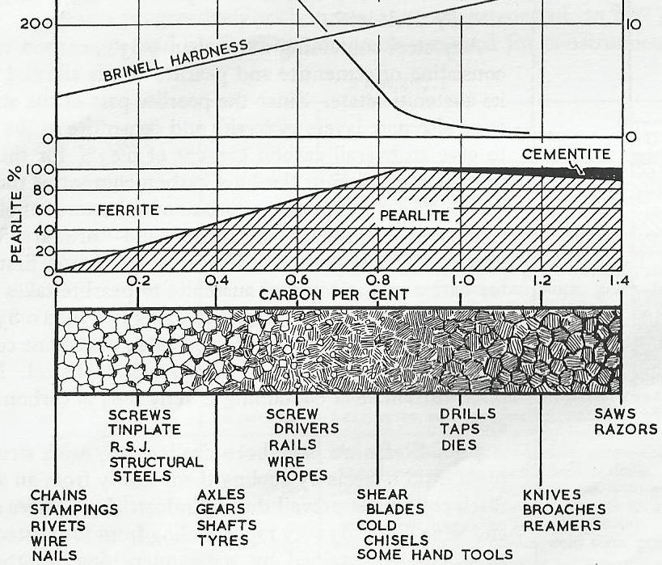
Figure42

Components within Steel Structure
As well as carbon, all plain steels contain the following elements:
Manganese - up to 1%
Silicon - up to 0.3%
Sulphur - up to 0.05%
Phosphorus - up to 0.05%
Nitrogen - 0.0%
The manganese is residual from the deoxidation process, while the rest elements are considered as impurities. The effect of such impurities on mechanical properties will depend largely upon the way in which these impurities are distributed throughout the structure of the steel.
- Manganese: Is an essential constituent since it ensures freedom from blow holes and combines with the sulphur present. In general, manganese raises the yield point, tensile strength and impact energy to fracture. It increases the depth of hardening of steel. Manganese should not exceed 0.3% in medium and high-carbon steels because of a tendency to induce quench cracks particularly during water-quenching.
- Phosphorous: Has a pronounced tendency to segregate in steel. Hence, the average composition should be kept below 0.05% to prevent the appearance of the brittle compound Fe₃P as a separate constituent.
- Silicon: In most commercial mild steels the silicon content is of the order of 0.1-0.2%. In these amounts, it has little direct effect on the mechanical properties. In high-carbon steels, it should be exceed 0.2% since it assists the breakdown of cementite into ferrite and graphite.
- Sulphur: In steel may exist in two forms:
  - As manganese sulphide (MnS) inclusions: these are soft dove-grey inclusion that readily elongate in the direction of working. Sufficient manganese is put into steel in order to react with all the sulphur and to avoid the formation of FeS.
  - As ferrous sulphide inclusion: these occur as a brown grain boundary film. It is hard and brittle and possesses a low melting point thereby giving rise to cracking during hot- and cold-working of the steel. In order to avoid the formation of ferrous sulphide inclusions manganese:sulphur ratio of at least 5:1 is maintained in plain carbon steel
- Nitrogen: Atmospheric nitrogen is absorbed by molten steel during manufacturing process. Whether this nitrogen combines with iron to form nitrides or remains dissolved interstitially after solidification, it causes serious embrittlement and renders the steel unsuitable for severe cold-work.

Heat-Treatment of Steel
The mechanical properties of plain carbon steels can be varied considerably by heat treatment. This is due to the structural changes which take place in the solid during the heating and cooling of such steels. The type of heat-treatment used will be governed by the carbon content of the steel and its subsequent application. The various heat-treatment processes can be classified as follows:
- annealing;
- normalising;
- hardening;
- tempering;

Annealing processes for steels can be classified as follows:
- Process annealing: is carried out on cold-worked low-carbon steel sheet or wire in order to relieve internal stress and to soften the material so that further cold-working can be carried out. The steel is heated to 550- 650°C, which is just below the lower critical temperature.

- Full annealing: is carried out on hot-worked and cast steels in order to obtain grain refinement in combination with high ductility. Compared with normalising, it produces a soften steel with better machinability. For hypo-eutectoid steels the treatment involves heating the steel to 30-50°C above the upper critical point, holding it at this temperature for a time depending on thickness, followed by slow cooling, usually in the furnace. For hyper-eutectoid steels the temperature is about 50°C above the lower critical point.

- Spheroidising annealing: high-carbon steels (> 0.8%C) may be softened by annealing at 650-700°C (just below the critical point), when the cementite of the pearlite balls up or spheroidises. The resulting structure is one of cementite globules in a ferrite matrix. In this condition the steels can be cold drawn and possess good machinability.

Normalizing: For hypo-eutectoid steels, normalising consists of heating the steel to 30-50°C above the upper critical point, holding it as this temperature for a time depending upon the section thickness, followed by cooling in still air. Normalising produces maximum refinement, and the steel is slightly harder and stronger than fully annealed steel. However, the properties obtained in normalising will vary with section thickness.

Hardening: For hypo-eutectoid steels, normalising consists of heating the steel to 30-50°C above the upper critical point, holding at this temperature for a time depending upon the thickness, followed by quenching in water, brine or oil. In this way austenite transforms to martensite. Martensite is the hardest structure in given steel, and therefore to harden steel fully the critical cooling rate must be exceeded. The critical cooling rate is lowered with increasing carbon and alloy content.

Tempering: this process applies to hardened steel in order to relieve the internal stress that is induced by quenching and to toughen the steel. Tempering of hardened steel involves reheating steel to just below the lower critical point. The rate of cooling after tempering is not important for plain carbon steels.

Corrosion of metals

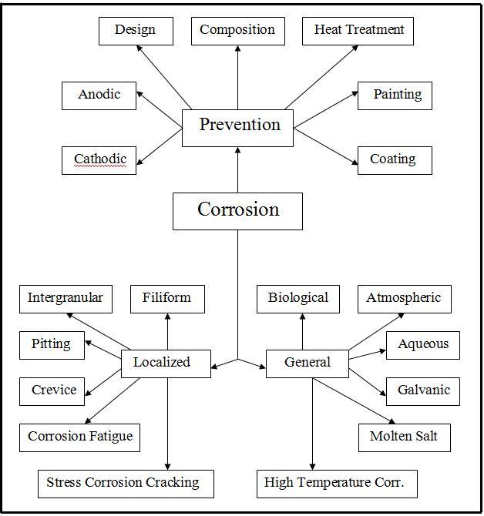

Corrosion: is a natural process. Just like water flows to the lowest level, all natural processes tend toward the lowest possible energy states”. As we know that metals are extracted from their natural ores by purified operation. This process is required for energy. As a result, metals are become at the highest energy state. Thus, they are reached to unsteady state. Therefore, metals tend toward lesser energy by combine with other chemical elements to form steady state components. Figure 1, shows the corrosion life cycle of iron. the energy that is required to refine metallic iron from the iron ore will lose when the iron react with the oxygen and water to form steady state compound which is called hydrated iron oxide (Joseph, 2000, 2).
. Figure (1) the corrosion life cycle of iron

Steel mill
Reduction
Refining
Costing
Rolling
Shopping

Iron ore
Iron oxe

Auto body
(atmosphere)
Underground
Pipeline

.

Hydrated
Iron oxide

Specific definition
Herbert H. Uhlig (2002) defines corrosion as “the destructive attack of a metal by chemical or electrochemical reaction with its environment”.
Corrosion :stands for material or metal deterioration or surface damage in an aggressive environment.
In fact, it can be understood through the general and specific definitions of the metallic corrosion that the substances react with components, which are found in its surroundings, to become in a stable state. This is related to the electronic structure of the atomic metals.

Types of Corrosion Reactions

First, Corrosion of Metals by the Chemical Reactions
Chemical reactions is defined as a reaction between one or more reactants (which may be atoms, molecules or ions), to produce one or more products.
Characteristics of the Chemical Reactions
- Chemical reactions only involve changes in the bonding between the atoms that are involved; the number of atoms of the various elements will not change.
- Chemical reactions may involve a transfer of electrons from one species to another, but overall they will not involve a change in the number of electrons.
- Chemical reactions may occur between species dissolved in a liquid (including the liquid itself) in a gas mixture, between components of a 'solid solution' or at the interface between solids and liquids, gases or other solids.
- Reactions occurring within a single phase (gas, liquid or solid) are known as homogeneous reactions
- Reactions occurring at the interface between two phases are known as heterogeneous reactions.
- Homogenous reactions occur more easily than heterogeneous reactions, because they can occur throughout the volume, rather than occurring only at the boundary. However, solid surfaces may assist in the reaction, or 'catalyse' it.
Metal Corrosion by Chemical Reactions
High temperature corrosion is a type of the corrosion by chemical reaction between the metal and its environment. It including the following corrosions:
    - The oxidation of pure metals such as oxidation of Ni to form NiO, Fe to form Fe₂O₃, Fe₃O₄, and FeO, etc…….
    - The oxidation of alloys such as oxidation of Ni-Cr alloys to form NiO and Cr₂O₃, Fe-Cr alloys to form various types of oxides, etc….
    - Sulphidation of alloys such as sulphidation of Nickel based alloy to form Ni₃S₂, NiS, etc….
    - Carburization and metal dusting.
    - Corrosion of alloys by hologens.
    - Corrosion by molten salt.
    - High temperature hydrogen attack.

Second, Electrochemical Reactions
Electrochemical reactions are heterogeneous reactions that involve the transfer of charge from a chemical species in solution to a metal.
Characteristics of the Electrochemical Reactions
- As the charge carriers in a metal are electrons, whereas free electrons cannot exist in solution, electrochemical reactions may be thought of as reactions that produce or consume electrons.
- Reactions that produce electrons result in the oxidation of the species in solution and are known as anodic reactions.
- Reactions that consume electrons result in the reduction of the species in solution, and are know as cathodic reactions. Examples of anodic and cathodic reactions are given in the table on the following page.
- Ion: An ion is an atom or molecule that has lost or gained one or more electrons, such that it has a net negative or positive charge.
- Ions that have lost electrons are positively charged and are known as cations (e.g. sodium ions, Na⁺, and ammonium ions, NH₄⁺).
- Ions that have gained electrons are negatively charged, and are known as anions (e.g. chloride ions, Cl⁻, or sulphate ions, SO₄²⁻).

Example electrochemical reactions

Anodic Reaction Cathodic Reaction
Fe → Fe²⁺ + 2e⁻ Fe²⁺ + 2e⁻ → Fe
Zn → Zn²⁺+ 2e⁻ Zn²⁺+ 2e⁻ → Zn
Fe²⁺ → Fe³⁺+ e⁻ Fe³⁺+ e⁻ → Fe²⁺
4OH⁻→ O₂+ 2H₂O + 4e⁻ O₂+ 2H₂O + 4e⁻ → 4OH⁻
2OH⁻ + H² → 2H₂O+ 2e⁻ 2H₂O + 2e⁻ → H²+ 2OH⁻
Note: that for every anodic reaction there is a cathodic reaction that is the reverse
Basic Concepts in Corrosion

For corrosion to take place, the formation of corrosion cell is essential. A corrosion cell consists of the following four components which are anode, cathode, electrolyte, metallic path.

Anode: One of the two dissimilar metal electrodes in an electrochemical cell
- It is considered the main source of the electrons (i.e. electrons are released at the anode)
- It represents the more reactive metal.
- Oxidation reaction occurs on the anode surface and electrons are released.
- Electrons are insoluble in aqueous solutions and they only move through the wire connection into the cathode
- For example, in a battery, zinc pole and carbon pole represent the anode and cathode respectively.

Cathode: It represents the second electrode in an electrochemical cell.
- It is represented the negative terminal.
- Reduction reaction takes place on the cathode electrode surface and electron are consumd.
- For example, in a Daniel cell the zinc electrode acts as anode, whereas the copper electrode represents the cathode.

Electrolyte: it is an aqueous media (e.g. salt solution)
- It is used to conduct electricity between the anode and cathode electrodes. Therefore, it must be high electrical conductibility.
- Positive electricity passes from anode to cathode through the electrolyte as cations. For example, Zn⁺⁺ ions dissolved from a zinc anode and thus carry positive current away from it, through the aqueous electrolyte.

Metallic path: the anodic electrode and cathodic electrode are connected externally by a metallic conductor.
- Electrons pass from anode to cathode through a metallic conductor.
- It also allows the current to flow through the solution (charges flow) in the opposite direction.

Current flow: the current is carried by the positive charged ions such as Zn⁺⁺ ions transfer away from the anode toward the cathode. The negative charged ions also migrate from the cathode through the electrolyte toward the anode. They form current flow in an electrochemical cell as shown the figure below.

In fact, metallic corrosion is known as an electrochemical reaction between the metal and its environment. The formation of the reaction is below:

M + BS → MB + S ↑ (general reaction)
Where:
M: represents metal
BS: acts Brine solution
MB: Metallic salt
S: free gas
The general reaction is subdivided into two reactions:
- Oxidation reaction takes place at the anode.
M → M^{n+} + ne⁻
- Reduction reaction occurs at the cathode.
S^{n+} + ne → S ↑
Where: n is number of electrons and e is the electron for example,
the electrochemical reaction on the surface iron is illustrated below
Fe + 2H2O → Fe(OH)₂ + H2↑ (general reaction)
Fe → Fe²⁺ + 2e (oxidation reaction)
2H2O → 2OH⁻ + 2H⁺
2H⁺ + 2e → H2↑ (reduction reaction)
Fe²⁺ + 2OH⁻ → Fe(OH)₂ ↓ (rust)
CU²⁺ + 2e⁻ → CU (copper will be protected)

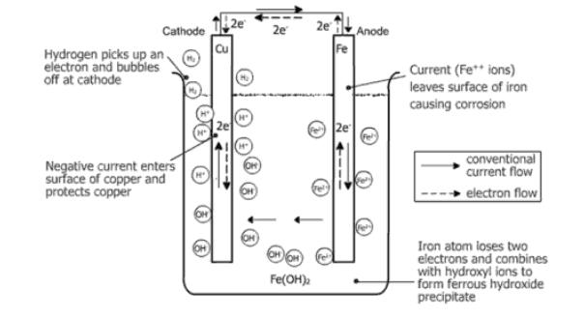
Anodic Reaction

The anode is the area where metal is lost.

At the anode, the reactions which take place are oxidation reactions.

It represents the entry of metal ion into the solution (electrolyte), by dissolution, hydration, or by complex formation.

It also includes precipitation of metal ions at the metal surface.

For example, ferrous hydroxide or rust formation on steel surface as seen in the below reaction.

Fe²⁺ + 2OH⁻ → Fe(OH)₂

Anodic Reactions Characteristics

Oxidation of metals to an ion with charge.

Release of electrons.

Shift to a higher valence state.

Cathodic Reactions Characteristics

They are reduction reactions which occur at the cathode.

Electrons released by the anodic reactions are consumed at the cathode surface.

There is a decrease in the valence state.

For example, reduction of hydrogen ions to hydrogen gas as can be seen in the below reaction:

2H⁺ + 2e⁻ → H₂ (in acid solution)

Very important information

It is required to presence a potential difference between two dissimilar metals or between metal and other species such as oxygen, hydrogen, water, and etc…in order to form an electrochemical cell or corrosion cell. Therefore it must be known the potential of each metals and substances.

Thermodynamic of the corrosion
Thermodynamic of the corrosion reaction tells whether the corrosion reaction will proceed or not. This can be achieved by calculate the Gibbs free energy of the reaction. Gibbs free energy for a chemical reaction can be calculated from below equation:
∆G = ∆G° + RTln.(K) …………………..1

K = [a_{products}/a_{reactants}] …………………….2

Where:
: Gibbs free energy change J.mol⁻¹
: Standard Gibbs free energy change J.mol⁻¹
R: Gas constant (8.314 J.mol⁻¹.K⁻¹)
: Absolute temperature
K : equilibrium constant
a_{products}: Activity of the products mol.L⁻¹
a_{reactants}: Activity of the reactants mol.L⁻¹
Note: the activities of the solid materials = 1 mol. L⁻¹
If the reaction at equilibrium state, then
∆G = 0
Then equation 1 becomes:

∆G° = - RTln.(K) …………………….3

A chemical reaction at constant temperature and pressure will only occur if there is an overall decrease in the Gibbs free energy of the system during the reaction (i.e. ∆G = - ve.). This means that the Gibbs free energy considers as the driving force of a chemical reaction.

Note: equations 1 to 3 are applied for a chemical reaction
For an electrochemical reaction the below equation will be used:

∆G = - n.F.E_{cell} ……………………..4
Where
E_{cell}: Electromotive force (emf) of the cell volts
n: Number of electrons involved in the reaction
F: Faraday's constant (96500 coulombs.mol⁻¹)

Note: the potential or emf of the corrosion cell is the driving force of the electrochemical reaction. The potential of the cell can be calculated from the below equation:

………………5

Where
: Potential of the reduction reaction at the cathode electrode volts
: Potential of the oxidation reaction at the anode electrode volts

The potential of either cathode (half cell) or anode (half cell) are be calculated by
using Nernst equation:
E = E° + [(RT)/nF]ln(K) ……………….7
Or
E = E° - [(2.303RT)/nF]log(K) ……….....8
Where
: standard potential of an electrode volts

At 25°C (298 °K), R = 8.314 J.mol⁻¹.K⁻¹ , and = 96500 C.mol⁻¹, then equation 8 becomes:

E = E° - [(0.05915)/n]log(K) ………………9

The potential of the electrochemical cell can be obtained by substitution equation 9 for anode and cathode into equation 5 as shown below:

E_{cell} = {E° - [(0.05915)/n]log(K)}_{C} + {E° - [(0.05915)/n]log(K)}_{A} ….10

When the electrochemical reaction (corrosion cell) is at equilibrium, then (= 0) and The Nernst equation gives the open-circuit potential difference (emf). Thus equation 9 becomes:
E_{ocp =} (E°_{C} + E°_{A})……………………...11

Note: The electrochemical equilibrium is achieved if current flow ceases

Standard Potential of Elements
The standard potential of elements is obtained under the standard state condition, such that the activities of the metallic ions () are equal to unity or gases are at 1 bar pressure and at temperature of 25°C. A standard potential refers to the potential of pure metal measured with reference to a hydrogen reference electrode. The standard potential of an element can be found from the table that you are obtained with this lecture sheet.
Table1: Standard reduction potentials, at 25°C
Types of Corrosion
a- General Corrosion
This is the case when the exposed metal/alloy surface area is entirely corroded in an
environment such as a liquid electrolyte (chemical solution, liquid metal), gaseous
electrolyte (air, CO₂, H₂S, etc.), or a hybrid electrolyte (solid and water, biological
organisms, etc.). Some types of general corrosion and their description are given below

1- Atmospheric Corrosion
This is a uniform and general attack, in which the entire metal surface area exposed to the
humid air is converted into its oxide form, provided that the metallic material has a
uniform microstructure. Atmospheric corrosion of a steel structure is a common example
of uniform corrosion, which is manifested as a brown-color corrosion layer on the exposed
steel surface. This layer is a ferric hydroxide compound known as Rust. The formation of
Brown Rust is as follows

Fe → Fe2+ + 2e (oxidation reaction)
O₂ + 2H₂O +4e⁻ → 4OH- (reduction reaction)
2Fe+ O₂ + 2H₂O → 2Fe⁺² + 4OH⁻ → 2Fe(OH)₂ ↓
2Fe(OH)₂ + 1/2O₂ + H₂O → Fe₂O₃ . 3H₂O ↓

Where:
2Fe(OH)₂ = Ferrous hydroxide (unstable compound)
Fe₂O₃ . 3H₂O = Hydrated Ferric hydroxide

2- Aqueous corrosion

It is also uniform attack that is occurred when surface of the metal reacts completely with an aqueous solution. As a result, there is a uniform decline in the metallic thickness. For example if a sheet of either carbon steel or zinc is exposed to the dilute acid solution it will be corroded uniformly. The steel/zinc can dissolve (oxidize) at a uniform rate according to the following anodic and cathodic reactions, respectively.

Fe → Fe⁺² + 2e⁻ (anodic reaction)

2H⁺ + 2e⁻ → H₂ (cathodic reaction)

Fe + 2H⁺ → Fe⁺² + H₂ ↑ (general reaction)

Zn → Zn⁺² + 2e⁻ (anodic reaction)

2H⁺ + 2e⁻ → H₂ (cathodic reaction)

Zn + 2H⁺ → Zn⁺² + H₂↑ (general reaction)

Where (H₂↑) is hydrogen gas. The cathodic reaction is the common hydrogen evolution process. In fact, the aggressiveness of a solution to cause a metal to oxidize can be altered by additions of water, which is an amphotetic compound because it can act as an acid or base due to its dissociation as indicated below:

H₂O → OH⁻ + H⁺

Pourbiax Diagrams

Corrosion of a metal in aqueous solution can be understood by studying its Pourbaix diagram that displays the stability of various species as a function of pH and potential
- It is obtained by plotting the Potential of a metal versus pH (acidity) of water at 25 C° and atmospheric pressure.
- Pourbaix diagram shows the electrochemical equilibrium of a metal with its ions, hydride, oxides, etc.
- It also explains thermodynamic stability of a metal in water at various acidities (pH).
- Pourbaix diagram gives important areas for designing and analyzing electrochemical systems. These areas are known as corrosion, passivation, and immunity.
- A Pourbaix diagram gives thermodynamic of corrosion (i.e. it informs us that a metal will corrode or not).
- A Pourbaix diagram does not include corrosion rate, which is essential in kinetic studies.

There are three types of region on the Pourbaix diagram:
- When the metal is the thermodynamically stable state, the metal is immune from corrosion.
- When the stable species is a soluble corrosion product, the metal is said to be active, and will corrode relatively rapidly.
- When the stable species is an insoluble corrosion product, then the metal is said to be passive, and will corrode relatively slowly.

Example: The below figure shows the electrochemical equilibrium of copper with its ions, hydride, oxides, etc. While, figure 2.3 explains thermodynamic stability of copper in water at various acidities (pH). It can be seen from Pourbaix diagrams that copper will be in immunity region if it exposed to oxygen – free solution at any pH except solution containing ammonia or nitrites. This is because of that the equilibrium potential of copper above that for hydrogen. Whereas, it corrodes at high corrosion rate if it subjected to very low or very high pH solution in the presence oxidants such as oxygen. It also can be seen that copper shows excellent corrosion resistance when it exposes to the solution at pH rang (4 – 13). This is due to its ability to form two protective layers of a black porous structure of cupric oxide (CuO) and a red crystal structure of cuprous oxide (Cu₂O) that forms as intermediate corrosion product according to the following electrochemical reactions. [1]
Eq.1 2Cu + H₂O = Cu₂O + 2H⁺ + 2e⁻ E° = 0.471 - 0.0591pH
Eq.2 Cu + H₂O = CuO + 2H⁺ + 2e⁻ E° = 0.570 - 0.0591pH
These reactions are at equilibrium state. It can be seen from the graphs that the equilibrium potential of reaction 1 raises gradually from -0.4 V to + 3 V as the pH of water decreases from 14 to 4. While, reaction 2 takes place at pH value above 6 and at equilibrium potential approximately + 0.3 V. This value extends until reach to potential at which oxygen evolve (1.229 V) as shown in figure 2.3. These corrosion products act as barriers that isolate the copper surface to contact with its surrounding. [1]

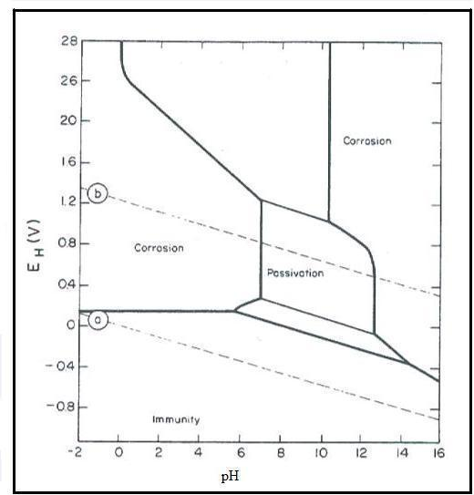
Figure: Explains theoretical condition of corrosion, immunity, and passivation regions of copper at 25 C°. [1]

3- Galvanic Corrosion
Where two dissimilar metals are connected together electrically in a solution, they are forced to adopt the same potential. This is illustrated in Figure 3.4.3, showing two connected iron and zinc electrodes in an electrolyte containing an iron salt (so that the cathodic reaction is reduction of ferrous ions to iron – this makes it easier to demonstrate the principle of galvanic corrosion on an E v. log I diagram). This shows that a current/potential diagram may be drawn showing two different metals in an electrolyte. In this case, the metal which is more noble (iron) becomes the cathode, and the less noble metal (zinc) the anode. As both metals must be at the same potential, the corrosion potential of the two metals is given by the intersection of the anodic and cathodic reactions. The rates of the other two possible reactions, dissolution of the less noble metal and the deposition of the more noble metal can also be found by looking at the diagram.
In most systems, the cathodic reactions that occur are not the reverse of the anodic reactions, but are either oxygen reduction or hydrogen evolution. In this case, the more noble metal serves only as an inert electrode on which this cathodic process occurs. In this case, the extent to which galvanic corrosion occurs depends on the efficiency of the noble metal as an electrode for the particular reaction.

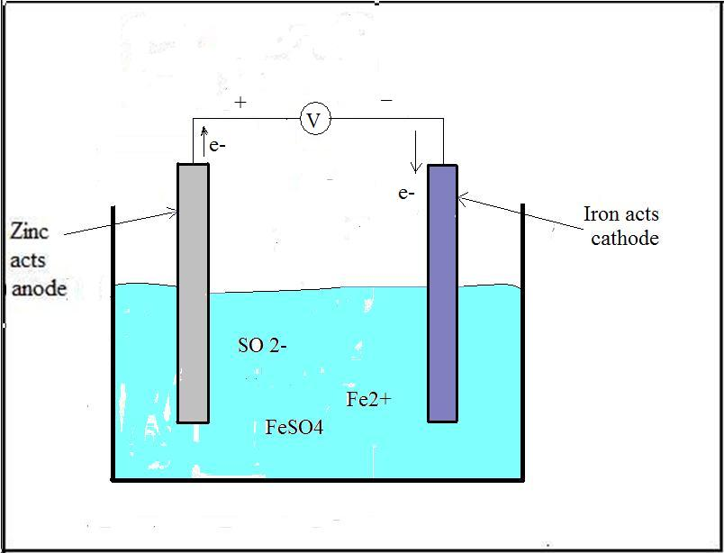
4- High Temperature Corrosion
Iron forms three iron oxide layers when it exposes to oxygen at high temperature. These scales are Wustite (FeO), Magnetite (Fe₃O₄), and Haematite (Fe₂O₃). FeO scale forms on iron surface at temperature above 570 C°, while Fe₃O₄ and Fe₂O₃ layers form at any temperature. Two diagrams below will be used to compare the modes and rate of iron oxides at 500 C° and 700 C°.

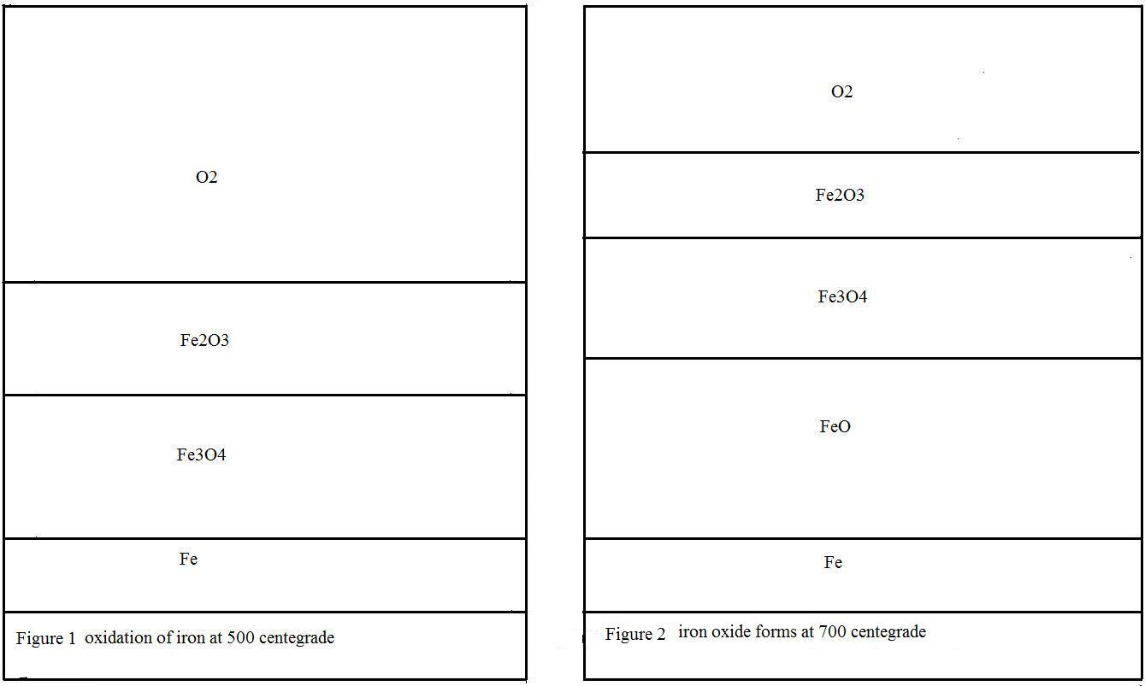

Note: a- At temperature 500 C°, Oxygen partial pressure at the iron - Fe₃O₄ interface
is lower than it at the Fe₃O₄ - Fe₂O₃ interface. Consequently, the rate of iron
oxidation with time affects by the mechanism of Fe₃O₄ lattice.
  - At temperature 700 C°, The oxygen partial pressure which requires to
Oxidise iron to FeO is lower than it requires forming Fe₃O₄ or Fe₂O_{3.}
So, Wustite (FeO) considers the rate-determining step of the oxidation
mechanism at 700 C°. This is because of it grows very fast.

Localized Corrosion
Requirements of Localized Corrosion
1- The presence of a passive, protective film (usually an oxide) on the surface of
Metal. A passive film on the surface of an alloy normally has numerous
imperfections, such as cracks, inclusions, etc. Those are preferable sites for
localised attack.
2- The presence of specific, co-called localized corrosion inducing anions, such
as the halides F-, Cl-, I-, Br-. Halide anions have a high affinity to the metal
and are capable of replacing oxide atoms. This is an important step in
preventing the repassivation of the metal.
3- The presence of oxidants. The anodic reaction of metal dissolution (an
oxidation) is supported by a cathodic reaction (a reduction).
The presence of species which are capable of being reduced, is a necessity for
any form of corrosion.

Types of Localized Corrosion
- Pitting Corrosion
Pitting is the most dangerous types of corrosion which affect the metals. This starts from inner surface of the metal and grow toward the outer surface over a period time. Pitting causes a cavity or hole in the metallic surface. As a result, equipment failed suddenly. Actually, it is difficult to predict this form of corrosion in the earlier time. This is because most pits are covered with corrosion products or look likes a rough surface.

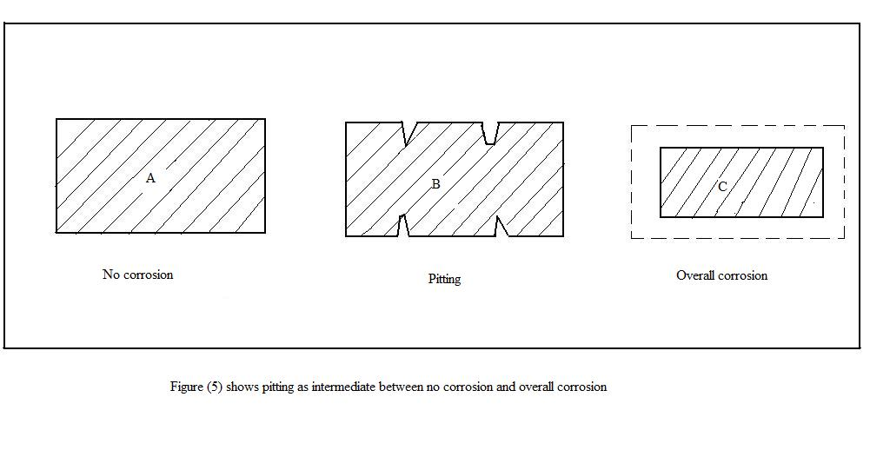
Stages of Pitting
- Pit nucleation stage.
- Meta-stable pitting, the stage where initiated pits either repassivate or become stable pit.
- Stable pit growth.

- Crevice Corrosion
Crevice corrosion; in fact, the best ground for this kind of corrosion to occur which is in the crevices of the metal surfaces. It also appears in the metallic surfaces which contain deposits as sand, dirty, corrosion products. These areas provide a stagnant condition for the corrosive solution. As a result, metal surface will be corroded.

- Intergranular Corrosion
It is a selective dissolution of grain boundaries or closely adjacent regions, without appreciable attack of the grains themselves. Intergranular corrosion is influenced by heat treatments of an alloy or by the hot or cold work of an alloy.
d- Stress Corrosion Craking
Crack growth under the simultaneous influence of a stress and a reactive
environment.
Requirements for SCC
- Stress
A material must be subject to an applied stress for Stress Corrosion
Cracking to occur. This can be high or low, dynamic or static, residual or
applied. SCC can occur at very low levels of stress

- Environment
There must be some species or combination of species in the environment that can react with the material under study. Important variables include pH, temperature, concentrations of aggressive species (e.g. Cl-) and oxidants.
- Metallurgy
The susceptibility of materials to SCC is greatly affected by their microstructure. Any factor affecting this can change a material to make SCC possible. These factors include correct quenching and tempering during the fabrication of the material

- Crack Velocity
SCC cracks may advance at rates between 10-12 to 10-7 ms-1. This means that it can take from 3 hours (104 s) to 32 years (109 s) for a 1 mm crack to grow.

Kinetic of Corrosion Reaction
Kinetics allows us to predict rates of reaction, i.e. how quickly corrosion takes place. In plant, this may be useful in prediction component life and scheduling inspections etc.

- Kinetic of Corrosion Reactions at High Temperatures
In this type of corrosion, we use either weight gain technique or scale thickness technique. In the former technique, we measure weight of the sample at various times, whereas in the later technique, we measure thickness of the sample with time. Then, the experimental results are usually presented as graphs of weight gain or scale thickness against time. From the graph, we can know that the corrosion of a metal at high temperature follows either parabolic oxidation rate law or linear oxidation rate law.

  - parabolic oxidation rate law
It is observed when the rate-controlling step is the diffusion of ions through a protective layer of a solid oxide (i.e. metals surface covers with protective layer of oxide). At the beginning the oxide layer increases with time. As the metal oxide grows thicker, the diffusion distance increases and the oxidation rate slows down (i.e. the rate of thickening of scale (dx/dt) is inversely proportional to the scale thickness (x)

X² = k_{p}.t
Or
W² = k_{p}.t
Where:
X = scale thickness of an alloy (μm)
W = weight gain per unit area of an alloy (mg.cm⁻²)
t = time (s)
k_{p} = parabolic rate constant (μm².s⁻¹ or mg².cm⁻⁴.s⁻¹)

b- Linear Oxidation Rate Law
Linear kinetic occurs when a metal surface is not protected by a barrier
layer of solid corrosion product. Alternatively the oxide layer may be
extremely thin, volatile or molten. Linear kinetic means that the scale thickness or weight gain per unit area increases linearly with time and the corrosion rate is not dependent on the amount of corrosion product formed. Linear kinetics occurs when a reaction at a boundary between two phases (metal and gas) controls the rate of oxidation.
Linear corrosion rate equation:
X = k_{l}.t
Or
W = k_{l}.t
Where: k_{l} = linear rate constant (μm.s⁻¹ or mg.cm⁻².s⁻¹)
Variation of Corrosion Rate with Temperature
Oxidation rates increase exponentially with temperature. Hence, k_{p} and k_{l} increase exponentially with temperature in accordance with the Arrhenius equation:
k_{p} = A_{p}.exp
And
k_{l} = A_{l}.exp

Where:
k_{p} = parabolic rate constant
k_{l} = linear rate constant
and are the activation energies (J.mol⁻¹)
A_{p} and A_{l} are constants

Methods of Protection
There are several methods by which corrosion of metals can be retarded. In this section we will describe the most important methods. These methods are design, anodic protection, cathodic protection, inhibitors, and coating.

- Design
Methods of protection start at the design stage. The process during the design work has to comprise the following steps:
  - At the beginning, select the proper materials which are suitable for the operation condition of the unit.
  - Then, age of the unit must be calculated by the designer. He should make a studying about all the conditions which effect on the equipment life such as environment and place where it is located.
  - The other step, construction designer should limit how the construction can be maintained. For example, does it require surface treatment or other corrosion protection?
  - Finally, the designer should be make certain that his equipment is isolated from the moisture as much as possible. It occurs by coating and maintenance.

2- Anodic Passivation
It is a phenomenon that takes place with some metals when they are polarized anodically in appropriate electrolytes in order to produce passive film on their surfaces. passive film are produces by the reaction between a metal and its environment. The films are very thin, usually 1-10 nm thickness, and are barriers to transport of the reacting species; thus limit the rate of further reaction to a low value about 0.1 mm/year. The films have low solubility. Passivity is well illustrated in polarization curves, produced by scanning the potential of a metal at a constant rate using a potentiostat.

3- Cathodic Protection
It is a technique used to reduce the corrosion of metal surface by providing it with enough cathodic current to make the metal dissolution rate become negligible. This can be achieved by introducing electrical current from external source. They are two types of the electrical source used in the cathodic protection, impressed current and sacrificial anode.

- Sacrificial Anode
It is a reactive metal which is used in order to scarify instead of the structure/metal that is required to protect from corrosion. In this type, it is not required to presence any external power. Sacrificial anode is used to protect small scale structure. The sacrificial anode should be having the following characterizations:
  - It has low electrode potential such as Zn, Al, and Mg.
  - Source of electrons.
  - Push the electrons toward the cathode.

- Impressed Current
In this method, it is used an external power supply (DC) with inert metal (not reactive metal) that acts as anode such as Pt, and Ag. Impressed current is used to protect a large scale structure.

4- Inhibitors
Inhibitor is a chemical substance that when present in the corrosion system at a suitable concentration decreases the corrosion rate without significantly changing in the concentration of any corrosive agent. Inhibitors are classified according on their characterizations:
- Organic / Inorganic
Indicates the composition of CI (corrosion inhibitors) using the conventional chemical terminology.
- Anodic / Cathodic / mixed
Specified which the electrochemical reaction is stifled by the CI; mixed inhibitors interferes with both anodic and cathodic processes.
- Oxidising / Non-oxidising
Denotes whether or not dissolved O2 is required for the inhibitors to function efficiently, this terminology is restricted to anodic inhibitors operating in near – natural solutions.
- Safe / dangerous
Refers to how corrosion proceeds at inhibitors concentration that is insufficient for effective protection.

5- Coating
It forms a barrier on the metal surface in order to prevent the flow of corrosion current between the naturally occurring anodes and cathodes or within galvanic couples. Coating should be having these below properties:
- It must has a good adhesion with the metal surface when it immersed in solution under any condition.
- Coating has a good chemical resistance toward alkalies.
- The coating must be resistant to the passage of ions.
- It should has a resistance to the passage the electrons.
- Good thickness.
- Moisture resistance.

https://meet.google.com/nov-uimp-evz
ofgwptn

