NAME : Jassim Edan Qasim 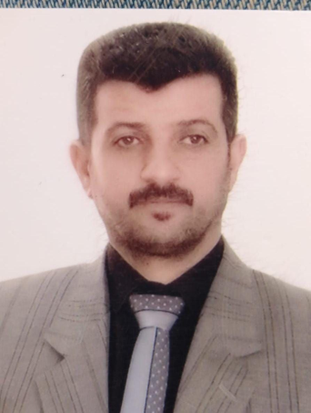

Assist.Prof. Dr. in Veterinary Medicine College/ Baghdad University

**PROFILE**

Data Birth 22/11/1975

Social State: marriage

Sex: male

Nationality**:** Iraq



**EDUCATION**

Academic teacher



**Administrative Tasks**

Manager of career center 2016-2022 ; Member of the scientific committee of the Public health branch ; Rapporteur of the Public Health Branch ; Director of the animal field at the College of Veterinary Medicine.



**Teaching Tasks in College of Veterinary Medicine / Baghdad University**

1. basic animal nutrition

2. advance animal nutrition

3. food analysis

4.cytogenetic

5. food chemistry



**The scientific Title**

assistant prof. Dr

**Supervision of Post-graduate students**

MSc Students 6

PhD Students 3



**The Discussions**

Diploma

MSc 11

PhD 6

Comprehensive examination 5



**Thanks and Appreciations**

From the Dean 21

From the assistance of university's president 2

From the university's president 4

From the minister 7

**Other Scientific Tasks**

Research evaluation : 10

Published research : 14

