Molecular Pharmacology 1/MSc 1st semester 2025-2026
Lecture 1 Tuesday 7-10-2025
General Considerations
How Drugs Act? Molecular Aspects
Molecular Pharmacology is a branch of the field of Pharmacology which is concerned with the study of Pharmacology on a molecular basis; and Molecular Pharmacologists study:
1- The molecular level of pharmaceuticals and natural compounds used in the treatment of disease,
2- The disease on a molecular basis with the goal of developing pharmacologically-active agents which could be used to address disease.
Targets for Drug Action
Figure 1 showed the protein targets for drug action on mammalian which can be divided into:
A- Receptors B- Ion channels C- Enzymes D- Transporters

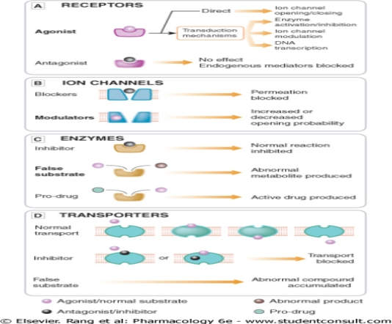

Figure 1: Types of targets for drug action(s).

A- Receptors
Receptors are the sensing elements in the system of chemical communications that coordinates the function of all the different cells in the body, the chemical messengers being the various hormones, transmitters and other mediators.
Many therapeutically-useful drugs act ether as agonists, antagonists, or as…..??? with examples on receptors for known endogenous mediators.
B- Ion Channels
Ion channels are essentially gateways in cell membranes that selectively-allow the passage of particular ions, and that are induced to open or close by a variety of mechanisms.
Two important types are 1- ligand-gated channels (ionotropic receptor) and 2- voltage-gated channels. The former open only when one or more agonist molecules are bound, and are properly classified as receptors, since agonist binding is needed to activate them; while the later channels, are gated by changes in the transmembrane potential rather than by agonist binding.
In general, drugs can affect ion channel function in several ways:
1. By binding to the channel protein itself, either to the ligand-binding (orthosteric) site of ligand-gated channels; or to other site (allosteric).
Example is the action of local anaesthetics on the voltage-gated sodium channel (orthosteric); and the drug molecule plugs the channel physically, blocking ion permeation.
Examples of drugs that bind to allosteric sites on the channel protein and thereby affect channel gating include:
– Benzodiazepine tranquillizers. These drugs bind to a region of the gamma-amino butyric acid type A (GABAA) receptor– chloride channel complex (a ligand-gated channel) that is distinct from the GABA binding site and facilitate the opening of the channel by the inhibitory neurotransmitter GABA.
– Sulfonylureas used in treating diabetes, which act on adenosine triphosphate (ATP)-gated potassium channels of pancreatic β-cells and thereby enhance insulin secretion.
2. By an indirect interaction, involving a G-protein and other intermediaries.
3. By altering the level of expression of ion channels on the cell surface. For example, gabapentin reduces the insertion of neuronal calcium channels into the plasma membrane.
C- Enzymes
Many drugs are targeted on enzymes. Often, the drug 0molecule is a substrate analogue that acts as a competitive inhibitor of the enzyme (e.g. captopril, acting on angiotensin-converting enzyme; in other cases, the binding is irreversible and non-competitive (e.g. aspirin, acting on cyclooxygenase. Moreover, the anticancer drug 5-fluorouracil (5-FU) exerts it effects through inhibition of thymidylate synthase (TS) and incorporation of its metabolites into RNA and DNA and thus, preventing cell division.
Additionally, drugs may be activated by enzyme to convert them from -an inactive to active form; or -the prodrug, to an active form (e.g. enalapril is converted by esterases enzymes to enalaprilat, which inhibits angiotensin converting enzyme (ACE). Furthermore, - drug toxicity often results from the enzymatic conversion of the drug molecule to a reactive metabolite example acetaminophen causes liver damage in this way.
D- Transporters
The movement of ions and small organic molecules across cell membranes generally occurs either through channels, or through the agency of a transport protein, because the permeating molecules are often too polar (i.e. insufficiently lipid-soluble) to penetrate lipid membranes on their own.
Many such transporters are known; examples of particular pharmacological importance include those responsible for the transport of ions and many organic molecules across the renal tubule, the intestinal epithelium and the blood–brain barrier, the transport of Na⁺ and Ca⁺⁺ out of cells, the uptake of neurotransmitter precursors (such as choline) or of neurotransmitters themselves (such as amines and amino acids) by nerve terminals, and the transport of drug molecules and their metabolites across cell membranes and epithelial barriers.
In many cases, hydrolysis of ATP provides the energy for transport of substances against their electrochemical gradient. Such transport proteins include a distinct ATP binding site, and are termed ABC (ATP-binding cassette) transporters. Important examples include the sodium pump (Na+-K⁺-ATPase; and multi-drug resistance (MDR) transporters that eject cytotoxic drugs from cancer and microbial cells, conferring resistance to these therapeutic agents. In other cases, including the neurotransmitter transporters, the transport of organic molecules is coupled to the transport of ions (usually Na+), either in the same direction (symport) or in the opposite direction (antiport), and therefore relies on the electrochemical gradient for Na+ generated by the ATP-driven sodium pump.
TYPE 1. Ligand-Gated Ion Channels
Examples:
1- The nicotinic acetylcholine receptor.
2- The GABAA and glycine receptors.
3- The 5-HT3 receptor.
4- The ionotropic glutamate receptors.
5- The purinergic P2X receptors.

