Advanced Pharmacology 2025-2026
Lectures 6 and 7

Anti-inflammatory and Immunosuppressant Drugs/CHAPTER 17 Section 2 eicosanoids/ RANG AND DALE

OVERVIEW

This chapter deals with the drugs used to treat inflammatory and immune disorders. While generally associated with disorders such as rheumatoid arthritis, it has become clear that inappropriate inflammatory or immune reactions form a significant component of many, if not most, of the diseases encountered in the clinic, and consequently anti-inflammatory drugs are extensively employed in virtually all branches of medicine.

The three major groups of drugs are the non-steroidal anti-inflammatory drugs (NSAIDs); the antirheumatoid drugs, which include the disease-modifying antirheumatic drugs (DMARDs); and the glucocorticoids.

Background
Arachidonic acid (AA) is an essential fatty acid and a precursor in the biosynthesis of prostaglandins (PGs), thromboxanes (TX), and leukotrienes (LTs), which are inflammatory chemicals the body releases after coming in contact with an allergen or allergy trigger. The stimulation of specific cell-surface receptors activates phospholipase A₂ (PA₂) enzyme leading to the release of arachidonic acid from the cell membrane. The AA is then rapidly converted into active metabolites by COX enzymes to produce PGs, prostacyclin (PGI₂) and TX; and by lipoxygenase enzyme to produce LTs.
The physiological actions of these metabolites have widespread and diverse. Briefly, PGs and PGI₂ are potent vasodilators whilst TXs are potent vasoconstrictors, whereas LTs produce bronchoconstriction.
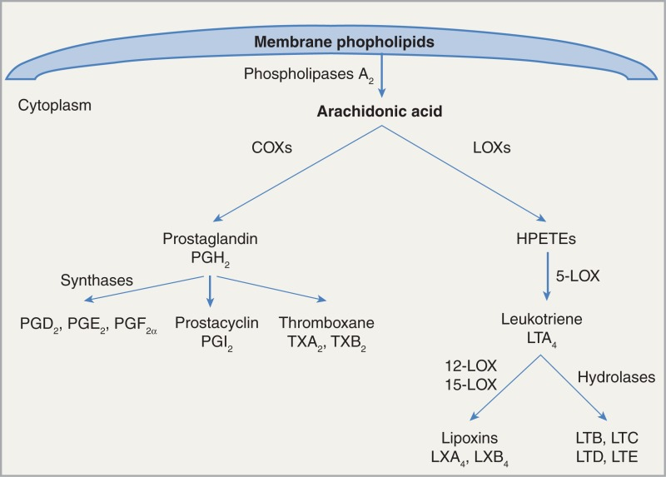

NOTE: Arachidonic acid also increases the uptake of glutamic acid through enhancement of the Excitatory amino acid transporter 2 (EAAT2) [also known as solute carrier family 1 member 2 (SLC1A2) and glutamate transporter 1 (GLT-1). Furthermore, AA also enhances activation of potassium channels such as TREK-1 and TRAAK, which Are Principal K + Channels at the Nodes of Ranvier for Rapid Action Potential Conduction on Mammalian Myelinated Afferent Nerves.

Non-Steroidal Anti-inflammatory Drugs

The NSAIDs, sometimes called the aspirin-like drugs, are among the most widely used drugs. They provide symptomatic relief from pain and swelling in chronic joint disease such as occurs in osteo- and rheumatoid- arthritis, and in more acute inflammatory conditions such as sports injuries, fractures, sprains and other soft tissue injuries. They also provide relief from post-operative, dental and menstrual pain, and from the pain of headaches and migraine. Virtually all NSAIDs, particularly the 'classic' NSAIDs, can have significant unwanted effects, especially in the elderly. Newer agents have fewer adverse actions.

Pharmacological Actions

All the NSAIDs have actions very similar to those of acetylsalicylic acid. The three main therapeutic effects are:

- An anti-inflammatory effect: Modification of the inflammatory reaction.
- An analgesic effect: Reduction of certain types of (especially inflammatory) pain.
- An antipyretic effect:

In addition, all the NSAIDs share, to a greater or lesser degree, the same types of mechanism-based side effects. These include:

- Gastric irritation, which may range from simple discomfort to ulcer formation
- An effect on renal blood flow in the compromised kidney
- A tendency to prolong bleeding through inhibition of platelet function
- Controversially, it is argued that they may also all-but especially COX-2 selective drugs-increase the likelihood of thrombotic events such as myocardial infarction by inhibiting prostaglandin (PG) I₂ synthesis.

While there are differences between individual drugs, all these effects are generally thought to be related to the primary action of the drugs-inhibition of the fatty acid COX enzyme, and thus inhibition of the production of prostaglandins (PGs) and thromboxanes (TXs). There are three known isoforms-COX-1, COX-2 and COX-3. While the first two isoforms are closely related (> 60% sequence identity) and catalyze the same reaction, it is clear that there are important differences between the expression and role of these two isoforms. COX-1 is a constitutive enzyme expressed in most tissues, including blood platelets. It has a 'housekeeping' role in the body, being involved in tissue homeostasis, and is responsible for the production of prostaglandins involved in, for example, gastric cytoprotection, platelet aggregation, renal blood flow auto-regulation and the initiation of parturition.

In contrast, COX-2 is induced in inflammatory cells when they are activated, and the primary inflammatory cytokines-interleukin (IL)-1 and tumour necrosis factor (TNF)-α are important in this regard. Thus the COX-2 isoform is responsible for the production of the prostanoid mediators of inflammation, although there are some significant exceptions. For example, there is a considerable pool of 'constitutive' COX-2 present in the central nervous system (CNS) and some other tissues, although its function is not yet completely clear. ??? others

Most 'traditional' NSAIDs are inhibitors of both isoenzymes, although they vary in the degree to which they inhibit each isoform. It is believed that the anti-inflammatory action (and probably most analgesic actions) of the NSAIDs is related to their inhibition of COX-2, while their unwanted effects-particularly those affecting the gastrointestinal tract-are largely a result of their inhibition of COX-1. Compounds with a selective inhibitory action on COX-2 are now in clinical use, but expectations that these inhibitors would transform the treatment of inflammatory conditions have received a setback because of an increase in CV risk.

The table below showed the cyclo-oxygenase-inhibitory specificity of some common NSAIDs and coxibs.
Table 1. Cyclooxygenase-inhibitory specificity (IC50) of some common non-steroidal anti-inflammatory drugs and Coxibs at therapeutic dose (GENERALLY)

Group | Description | Selectivity ratio/1 | Examples
I | Highly COX-1-selective | 100-1000 | Ketorolac
II | Very COX-1-selective | 10-100 | Flurbiprofen
III | Weakly COX-1-selective | 1-10 | Indomethacin, aspirin*, naproxen, ibuprofen
IVa | Non-selective; full inhibition of both enzymes | 1 | Fenoprofen
IVb | Non-selective; incomplete inhibition of both enzymes | 1 | Salicylate
V | Weakly COX-2-selective | 1-10 | Diflunisal, piroxicam, meclofenamate, sulindac, diclofenac, celecoxib
VI | Very COX-2-selective | 10-100 | Valdecoxib, etoricoxib
VII | Highly COX-2-selective | 100-1000 | Rofecoxibª

ªRofecoxib has been withdrawn from use and is shown here as an illustration only.

There are few significant differences in pharmacological actions among the currently used NSAIDs, but there are marked differences in toxicity and degree of patient tolerance. Aspirin, however, has other qualitatively different pharmacological actions, and paracetamol is an interesting exception to the general NSAIDs. While it is an excellent analgesic and antipyretic, the anti-inflammatory activity of paracetamol is very low and seems to be restricted to a few special cases (e.g. inflammation following dental extraction. Paracetamol has been shown to inhibit prostaglandin biosynthesis in some experimental settings (e.g. during fever) but not in others. It was hoped that the discovery of COX-3A, an isoform found in dog brain and that seemed more sensitive to paracetamol, might provide a neat explanation of this anomaly.

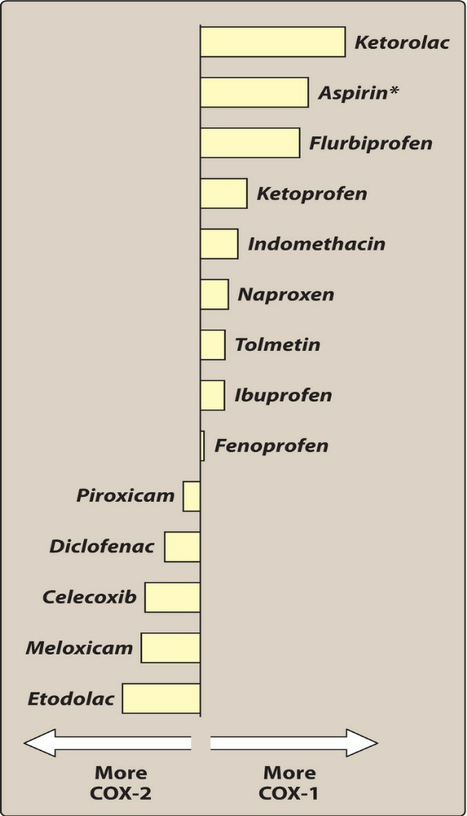
Relative selectivity of some commonly used NSAIDs. Data shown as the logarithm of their ratio of IC80 (drug concentration to achieve 80% inhibition of cyclooxygenase). *Aspirin graphed for IC50 value due to it showing significantly more COX-1 selectivity at lower doses and graph using higher concentrations does not accurately reflect the usage or selectivity of aspirin.
Lecture 4 Advance Pharmacology III 1st semester 2021-2022
Monday 8-11-2021

NSAID | Anti-inflammatory Ratio* (COX2/COX1)
Flurbiprofen | 10.27
Ketoprofen | 8.16
Fenoprofen | 5.14
Tolmetin | 3.93
Aspirin | 3.12
Oxaprozin | 2.52
Naproxen | 1.79
Indomethacin | 1.78
Ibuprofen | 1.69
Ketorolac | 1.64
Piroxicam | 0.79
Nabumetone | 0.64
Etodolac | 0.11
Celecoxib | 0.11
Meloxicam | 0.09
Mefenamic acid | 0.08
Diclofenac | 0.05

* Expressed as the ratio of the 50 percent inhibitory concentration (IC50) of cycloogenase-2 to the 50 percent inhibitory concentration (IC50) of cyclooxygenase-1 in whole blood. NSAIDs with a ratio of <1 indicate selectivity for cyclooxygenase-2.

REFERENCE:
Adapted from: Feldman M, McMahon AT. Do cyclooxygenase-2 inhibitors provide benefits similar to those of traditional nonsteroidal anti-inflammatory drugs, with less gastrointestinal toxicity? Annals of Internal Medicine 2000;132:134–43.

ANTIPYRETIC EFFECT

Normal body temperature is regulated by a centre in the hypothalamus that controls the balance between heat loss and heat production. Fever occurs when there is a disturbance of this hypothalamic 'thermostat', which leads to the set point of body temperature being raised. NSAIDs 'reset' this thermostat. Once there has been a return to the normal set point, the temperature-regulating mechanisms (dilatation of superficial blood vessels, sweating) then operate to reduce temperature. Normal body temperature in humans is not affected by NSAIDs.

The NSAIDs exert their antipyretic action largely through inhibition of prostaglandin production in the hypothalamus. During an inflammatory reaction, bacterial endotoxins cause the release from macrophages of a pyrogen-IL-1, which stimulates the generation, in the hypothalamus, of E-type prostaglandins that elevate the temperature set point. COX-2 may have a role here, because it is induced by IL-1 in vascular endothelium in the hypothalamus. There is some evidence that PGs are not the only mediators of fever, hence NSAIDs may have an additional antipyretic effect by mechanisms as yet unknown.

ANALGESIC EFFECT

The NSAIDs are effective against mild-moderate pain, especially that arising from inflammation or tissue damage. Two sites of action have been identified. First, peripherally, they decrease production of the PGs that sensitize nociceptors to inflammatory mediators such as bradykinin and they are therefore effective in arthritis, bursitis, pain of muscular and vascular origin, toothache, dysmenorrhea, the pain of postpartum states and the pain of cancer metastases in bone; where, all conditions that are associated with increased local prostaglandin synthesis. In combination with opioids, they decrease postoperative pain, and in some cases can reduce the requirement for opioids by as much as one-third. Their ability to relieve headache may be related to the abrogation of the vasodilator effect of prostaglandins on the cerebral vasculature.

In addition to these peripheral effects, there is a second, less well-characterized central action, possibly in the spinal cord. Inflammatory lesions increase prostaglandin release within the spinal cord, causing facilitation of transmission from afferent pain fibers to relay neurons in the dorsal horn.

ANTI-INFLAMMATORY EFFECTS

Many mediators coordinate inflammatory and allergic reactions. While some are produced in response to specific stimuli (e.g. histamine in allergic inflammation), there is considerable redundancy, and each facet of the response-vasodilatation, increased vascular permeability, cell accumulation, etc.-can be produced by several separate mechanisms.

The NSAIDs reduce mainly those components of the inflammatory and immune response in which prostaglandins, mainly derived from COX-2, play a significant part. These include:

- Vasodilatation.
- Oedema (by an indirect action: the vasodilatation facilitates and potentiates the action of mediators such as histamine that increase the permeability of post-capillary venules.
- Pain, again potentiating other mediators, such as bradykinin.

The NSAIDs suppress the pain, swelling and increased blood flow associated with inflammation but have little or no action on the actual progress of the underlying chronic disease itself.

MECHANISM OF CYCLOOXYGENASE INHIBITORY ACTION

Vane and his colleagues established in 1971 that the main actions of NSAIDs were bought about through inhibition of arachidonic acid oxidation by the fatty acid COXs.

Other actions besides inhibition of COX may contribute to the anti-inflammatory effects of some NSAIDs. Reactive oxygen radicals produced by neutrophils and macrophages are implicated in tissue damage in some conditions, and some NSAIDs (e.g. sulindac) have oxygen radical-scavenging effects as well as COX inhibitory activity, so may decrease tissue damage. Aspirin also inhibits expression of the transcription factor nuclear factor (NF) κB, which has a key role in the transcription of the genes for inflammatory mediators.

Clinical uses of NSAIDs

- For analgesia (e.g. headache, dysmenorrhea, backache, bony metastases, postoperative pain):
  - short-term use: aspirin, paracetamol or ibuprofen
  - chronic pain: more potent, longer lasting drugs (e.g. diflunisal, naproxen, piroxicam)
  - to reduce the requirement for narcotic analgesics (e.g. ketorolac postoperatively).
- For anti-inflammatory effects (e.g. rheumatoid arthritis and related connective tissue disorders, gout and soft tissue disorders).
  - Note that there is substantial individual variation in clinical response to NSAIDs and considerable unpredictable patient preference for one drug rather than another.
- To lower temperature (antipyretic): paracetamol.

COMMON UNWANTED EFFECTS

Because prostaglandins are involved in gastric cytoprotection, platelet aggregation, renal vascular auto-regulation and induction of labor, among other effects, it may be reasonably expected that all NSAIDs share, to some extent, a similar profile of mechanism-dependent side effects. While this is true, there may be other additional unwanted effects peculiar to individual members of the group.

NOTE: When the classic NSAIDs are used in joint diseases (which usually necessitates fairly large doses and long-continued use), there is a high incidence of side effects-particularly in the gastrointestinal tract but also in liver, kidney, spleen, blood and bone marrow. COX-2-selective drugs have less gastrointestinal toxicity.

GASTROINTESTINAL DISTURBANCES

Adverse gastrointestinal events are the commonest unwanted effects of the NSAIDs, and are believed to result mainly from inhibition of gastric COX-1, which is responsible for the synthesis of the prostaglandins that normally inhibit acid secretion and protect the mucosa.

Common gastrointestinal side effects include gastric discomfort, dyspepsia, diarrhoea (but sometimes constipation), nausea and vomiting, and in some cases gastric bleeding and ulceration. The mechanism is dependent on inhibition of COX in the gastric mucosa, and damage is seen whether the drugs are given orally or systemically. However, in some cases (aspirin being a good example) local damage to the gastric mucosa caused directly by the drug itself may compound the damage. Oral administration of prostaglandin analogues such as misoprostol can diminish the gastric damage produced by these agents.

Based on extensive experimental evidence, it had been predicted that COX-2-selective agents would provide good anti-inflammatory and analgesic actions with less gastric damage, and some older drugs (e.g. meloxicam) that were believed to be better tolerated in the clinic turned out to have some COX-2 selectivity. Two large prospective studies compared celecoxib and rofecoxib with standard comparator NSAIDs in patients with arthritis and showed some benefit, although the results were not as clear-cut as had been hoped. Less encouraging, however, was an increase in the incidence of serious cardiovascular incidents seen in these trials. At the time, it was not clear that this was connected with COX-2 inhibition, and two 'coxibs', as they came to be called, were licensed in the USA in 1998 (and in the UK shortly after). Continuing uncertainty about the cardiovascular risk led to the addition of warning labels on these drugs in 2002, but the results from a long-term trial designed to assess the anticancer activity of rofecoxib showed that the risk of cardiovascular events increased significantly after 18 months' treatment. As a result of this, the drug was voluntarily withdrawn in 2004. When another coxib, valdecoxib, apparently showed similar effects as well as serious skin reactions, this too was withdrawn. At the time of writing, only celecoxib, parecoxib and etoricoxib remain licensed in the UK.

Other ideas have been proposed to explain the gastric side effects of NSAIDs. The administration of COX-1 inhibitors themselves causes COX-2 induction and, on the basis of experimental evidence, Wallace (²⁰⁰⁰) has argued that selective inhibitors of either isozyme will cause less gastric damage than non-selective drugs.

SKIN REACTIONS

Rashes are common idiosyncratic unwanted effects of NSAIDs, particularly with mefenamic acid (10-15% frequency) and sulindac (5-10% frequency). They vary from mild erythematous, urticarial and photosensitivity reactions to more serious and potentially fatal diseases including Stevens-Johnson syndrome (which is fortunately rare).

ADVERSE RENAL EFFECTS

Therapeutic doses of NSAIDs in healthy individuals pose little threat to kidney function, but in susceptible patients they cause acute renal insufficiency, which is reversible on stopping the drug. This occurs through the inhibition of the biosynthesis of those prostanoids (PGE₂ and PGI₂=prostacyclin) involved in the maintenance of renal blood flow, specifically in the PGE₂-mediated compensatory vasodilatation that occurs in response to the action of noradrenaline or angiotensin II. Neonates and the elderly are especially at risk, as are patients with heart, liver or kidney disease, or a reduced circulating blood volume.

Chronic NSAID consumption, especially NSAID 'abuse', can cause analgesic nephropathy characterized by chronic nephritis and renal papillary necrosis. Phenacetin, now withdrawn, was the main culprit; paracetamol, one of its major metabolites, is much less toxic. Regular use of prescribed doses of NSAIDs is less hazardous for the kidney in this respect than is very heavy and prolonged use of over-the-counter analgesics in a social context.

OTHER UNWANTED EFFECTS

Other, much less common, unwanted effects of NSAIDs include CNS effects, bone marrow disturbances and liver disorders, the last being more likely if there is already renal impairment. Paracetamol overdose causes liver failure. Approximately 5% of patients exposed to NSAIDs may experience aspirin-sensitive asthma ??? WHY???. Acetylsalicylic acid is the worst offender, but there is cross-reaction with all other class members, except possibly COX-2 inhibitors. All NSAIDs (except COX-2 inhibitors) prevent platelet aggregation and therefore may prolong bleeding. Again, aspirin is the main problem in this regard.

