***English Language Lectures***

***New Headway Plus &One Step up to Sport English***

***By***

***Prof. Ansam Yaroub & Assist. Prof Mayada Zuhair***

***Inst.Dr. Ilham Ahmed & Inst. Noor Abdul Sahib***

***2023-2024***

**3rd Grade**

**1ST Lecture Headway Book p.17**

**What Do You Do**

**Simple or Continuous**

**1. Read and Listen to the conversation**

**A/ What do you do?**

**B/ I’m an interior designer. I decorate people’s homes and give them ideas for furniture and lighting.**

**A/ And what are you working on these days?**

**B/ Well, I’m not working on a home at the moment. I’m working on a hotel. I’m designing a new lobby for the plaza.**

**A/ Do you like your job?**

**B/ Yes, I love it.**

**2. Work with a partner. Have similar conversations with some of these jobs.**

**An architect - a research scientist - an artist - an actor - a musician - a web page designer – a journalist – a film director – a football player -a zookeeper**

**3: Match each of the following jobs in the first column with its correct definition in the last column.**

| Definition |  | Solution | Job | N. |
| --- | --- | --- | --- | --- |
| A person who decorates homes, giving ideas about furniture or lighting | A | 1+ | A Journalist | 1. |
| a person who plays a musical instrument like a guitar or a piano or a person that sings. | B |  | Musician A | 2. |
| A person who writes for newspapers or magazines or prepares news to be broadcast on radio or television | C |  | Football player A | 3. |
| A sports person who plays one of the different types of football. | D |  | Actor An | 4. |
| A person who designs buildings and, in many cases, also supervises their construction | E |  | An Interior designer | 5. |
| A person whose profession is acting on stage, in movies or in television | F |  | An architect | 6. |
| A person who is reading and editing scripts, directing film crews and actors, and overseeing the production of the final film. | G |  | A film director | 7. |

**2nd lecture Headway Book p.98**

**Vocabulary and Speaking**

**Birth, marriage, and death**

**1. Write these words and phrases in the correct column below.**

**(wedding / funeral / to get engaged / Bride / midwife / sympathy / groom / widow / to have a baby / bouquet / wreath pregnant / reception / to bury / to get divorced / grave / cot / cemetery / mourners / pram / honeymoon / grief / nappy / coffin / bridesmaid. )**

| **Birth** | **Marriage** | **Death** |
| --- | --- | --- |
|  |  |  |
|  |  |  |
|  |  |  |
|  |  |  |
|  |  |  |
|  |  |  |

**2. Complete These sentences with words from exercise1.**

1. They had a big wedding. Three hundred people were invited to the r-------------------afterwards.

2. The b------------ and g-----------didn’t tell anyone where they are going on h----------------after the wedding.

3. Thousands of m------------------------lined the route of the king’s f---------------.

4. When the emperor died, they decided to b---------------him in a gold c-------------------.

5. The Queen laid a w--------------of with roses on her father’s g-------------------.

6. I sent my grandmother, who’s a w----------------------, a huge b----------------------of flowers for her birthday.

7. They say old Tom died of g--------------soon after his wife died.

8. My sister has just had a b-----------------boy. She said the doctor and m----------------were wonderful at the birth.

**3rd Lecture**

**UNIT ONE**

* 1. **Introduction to Methods of Research**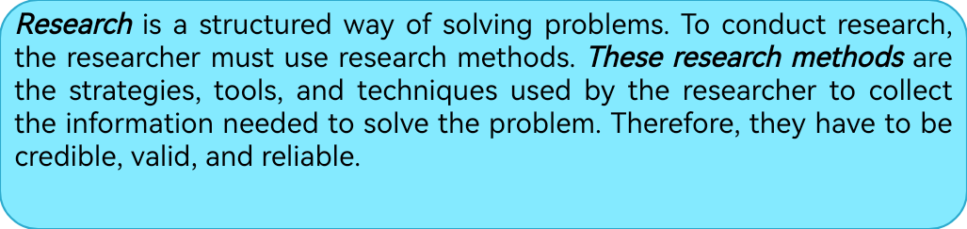

| **Terms** | Research vs. report, thesis vs. dissertation, quantitative design vs. qualitative design, data, variables, population vs. sample, controlling group vs. experimental group, pretests vs. posttests, SPSS, plagiarism. |
| --- | --- |
| **Types of research** | Analytical research, descriptive research, experimental research. |
| **Research methods** | Analytical (Review, historical, philosophical, content analysis), descriptive (questionnaire, interview, survey, case study, pilot study, correlation), experimental (proposed program, apparatus, test, measurement, etc.) |
| **Steps of writing**  **a research** | 1-Planning (choose a topic, generate ideas, create an outline),  2-Drafting (write the first draft),  3-Revising (edit and revise, proofread, submit) |
| **Parts of thesis and dissertation** | 1-Introduction, 2-Review of literature, 3-Methodology and procedures, 4-Display of results, 5-Conclusions and recommendations,( bibliography, appendix, abstract.) |
| **Information sources** | 1-Published sources (books, newspapers, scientific journals, encyclopedias, pamphlets, articles, magazines, and periodicals)  2-Electronic sources (websites, YouTube, e-books, journals, etc.) |
| **Publication information** | Book: author(s), date, book title (underlined), place of publication, publisher.  Article: author(s), date, article title, journal title(underlined), volume & issue, pages. |

| * 1. **Keywords** | | | |
| --- | --- | --- | --- |
| Research, researcher | بحث،باحث | Pilot study | دراسة استطلاعية |
| Structured way | طريقة منظمة | Correlation | علاقة ارتباط |
| Solving | حل | Proposed program | برنامج مقترح |
| problem | مشكلة | Apparatus | جهاز |
| Conduct | تنفيذ | Test | اختبار |
| Research methods | طرق بحث | Measurement | قياس |
| Strategies | ستراتيجيات | Steps of writing | خطوات الكتابة |
| Tools | ادوات | Planning | تخطيط |
| Techniques | تكنيك، اساليب | Choose a topic | اختيار موضوع |
| Collect Information | جمع معلومات | Generate ideas, | تكوين افكار |
| Credible | موثوق | Create an outline | وضع اطار البحث |
| Valid | صادق | Drafting | كتاب مسودة |
| reliable | ثابت | Revising | مراجعة، تنقيح |
| Terms | مصطلحات | Edit | تصحيح |
| Report | تقرير | Proofread | تدقيق لغوي |
| Thesis | رسالة | Submit | تقديم |
| Dissertation | اطروحة | Parts of research | اجزاء البحث |
| Quantitative  design | تصميم كمي | Introduction | المقدمة |
| Qualitative  design | تصميم نوعي | Review of literature | دراسات نظرية |
| Data | بيانات | Methodology | منهجية البحث |
| Variables | متغيرات | Procedures | اجراءات |
| Population, sample | مجتمع البحث، عينة | Display of results | عرض النتائج |
| Controlling  group | مجموعة ضابطة | Conclusions | استنتاجات |
| Experimental group | مجموعة تجريبية | Recommendations | توصيات |
| Pretest and Posttest | اختبار قبلي وبعدي | Bibliography | قائمة المراجع |
| SPSS | الحقيبة الأحصائية | Appendix(ices) | ملحق(ملاحق) |
| Plagiarism | سرقة فكرية | Abstract | مستخلص |
| Analytical | تحليلي | Published sources | مصادرة مطبوعة |
| Descriptive | وصفي | Electronic sources | مصادر الكترونية |
| Experimental | تجريبي | Publication | نشر |
| Review | نقدي | Publisher | ناشر |
| Historical | تاريخي | Author | مؤلف |
| Philosophical | فلسفي | Article | مقالة |
| Content analysis | تحليل المحتوى | Journal | مجلة |
| Questionnaire | استبيان | Title | عنوان |
| Interview | مقابلة | Underlined | تحته خط |
| Survey | دراسة مسحية | Volume | المجلد |
| Case study | دراسة حالة | Issue | العدد |

**1.3. Research Methods Pictionary Practice : *Label The terms in Arabic ☺***

| **Article publication information** | **Book Publication information** |
| --- | --- |
| **Steps of writing** | |
| **Data/information collecting** | **Study sampling** |
| **Data analysis** | **Using SPSS** |

**1.4. Reading Comprehension**

**4th Lecture Exercises**

**Q1. Put the following steps of writing in order. Check the unit and the Pictionary.**

|  |  | Submit |
| --- | --- | --- |
|  |  | edit and revise |
|  |  | create an outline |
|  |  | generate ideas |
|  |  | Proofread |
|  |  | choose a topic, |
|  |  | write the first draft |

**Q2. Every thesis or dissertation has 5 parts or chapters. Scan the unit and complete the diagram with their names.**

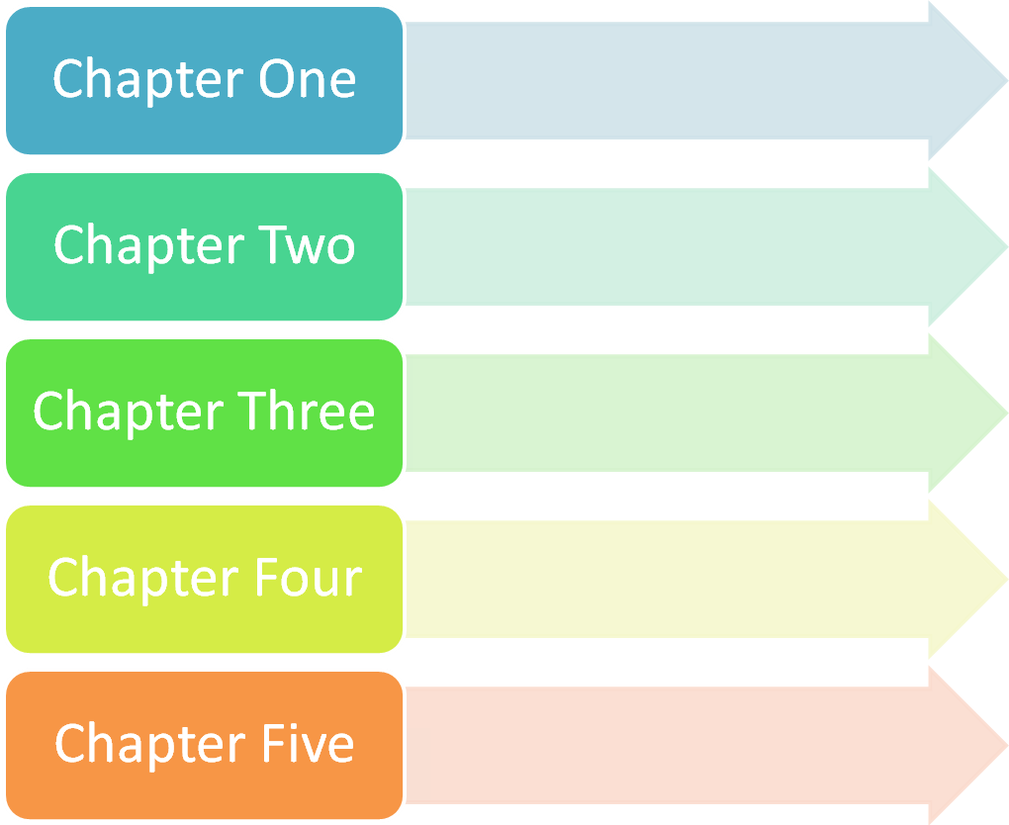**Q3. Match the Questions with their answers**

| **N** | **Answer** |  | **Question** | **Solution** |
| --- | --- | --- | --- | --- |
| 1 | A structured way of solving problems | a | What should the researcher use? |  |
| 2 | Strategies, tools and techniques used by the researcher | B | What are electronic sources ? |  |
| 3 | Websites, youTube, e – books | C | What is research? |  |

**Q4. The following terms have another term that versus it can you find them and give their meaning in Arabic?**

|  | **VS** |  |
| --- | --- | --- |
| Research |  |  |
| thesis |  |  |
| quantitative design |  |  |
| population |  |  |
| controlling group |  |  |
| pretests |  |  |

**Q5. Each term in column A came with another word from column (B) to form a new word, can you match these words then give their meaning in Arabic?**

| **A** | | **B** | | **Solution** | **Meaning** |
| --- | --- | --- | --- | --- | --- |
| 1 | Research | A | group |  |  |
| 2 | case | B | analysis |  |  |
| 3 | pilot | C | program |  |  |
| 4 | content | D | Methods |  |  |
| 5 | experimental | E | study |  |  |
| 6 | proposed | F | group |  |  |
| 7 | controlling | G | Study |  |  |

**5th Lecture** 

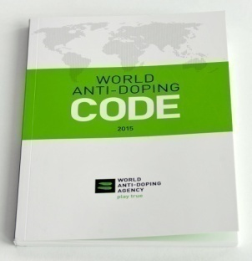

**Reading Comprehension**

**Performance Enhancing Substance[[1]](#footnote-0):**

Performance enhancing substance, sometimes called drugs (PED), is used in order to enhance performance. In the world of sport taking such drugs is called doping and it is banned by the World Anti – Doping Agency (WADA) because it is considered a form of cheating. There are many types of performance enhancing drugs and these types depend on the requirement of the performance itself for example sports like bodybuilding and American football require big muscle size thus athletes of such sports take anabolic steroids to increase their muscle size. On the other hand, athletes in sports that require relaxation and reduced anxiety like archery and shooting take alcohol to relax and decrease their stress and improve their aiming accuracy. The figure below shows some types of PED and an example on each type. 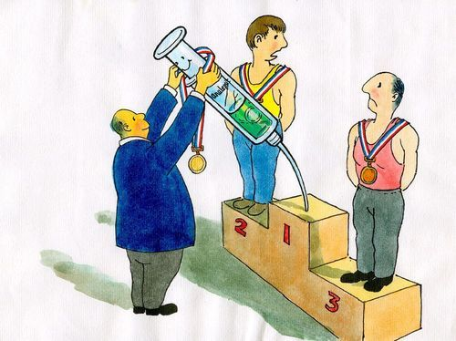

| **Types of Performance enhancing drugs** | | | |
| --- | --- | --- | --- |
| **Build muscle/ bone** | **Stimulants** | **Reduce weight** | **Relaxants** |
| Anabolic steroids | Caffeine  Cocaine | Diuretics | Alcohol |
|  | | | |
| **Increase oxygen delivery** | **Mask pain** | **Mask drug use** | |
| Blood doping | Narcotics  Local Anesthetics | Diuretics  Plasma | |

Doping can have really serious side effects some of them are temporary like headache, insomnia and boldness while many others are chronic like blood pressure and lethal like cancer and death. Due to the dangerous effects of these drugs on athletes; WADA issued an Anti-Doping Code in which a comprehensive list of all prohibited substance are listed. If an athlete is caught doping he/she is not allowed to participate for four years in any international competitions and in many cases is stripped off trophies, titles, honors or medals. 

**Focus on the words** 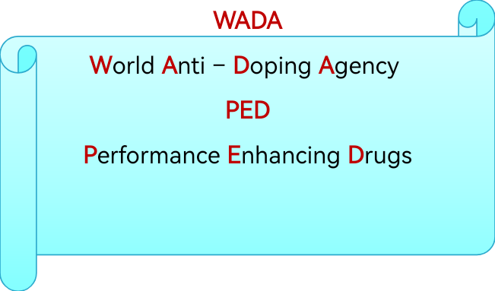

| **Prefixes making antonyms** |
| --- |
| Anti = anti – doping  De= decrease  In= increase |

| **Keywords** | | | |
| --- | --- | --- | --- |
| Performance | اداء | Stimulant | محفزات |
| Enhancing | تحسين | Diuretics | مدررات |
| Substance | مادة | Oxygen delivery | توصيل الاوكسجين |
| Drugs | منشطات / عقاقير | Blood doping | التعاطي بالدم |
| Taking | تناول | Mask pain | تخفي الالم |
| Doping | تعاطي | Narcotics | مخدرات |
| Banned | محظور | Local anesthetics | تخدير موضعي |
| World Anti – Doping Agency | الوكالة العالمية لمكافحة المنشطات | side effects | اثار جانبية |
| Cheating | غش | temporary | مؤقت |
| depend on | تعتمد على | headache | وجع الراس |
| Requirement | متطلبات | insomnia | الارق |
| bodybuilding | كمال اجسام | boldness | الصلع |
| American football | كرة القدم الامريكية | Chronic | مزمن |
| Increase | يزيد | blood pressure | ضغط الدم |
| Relaxation | استرخاء | Lethal | قاتل |
| Reduced | يقلل | Cancer | السرطان |
| Anxiety | القلق | dangerous | خطر |
| Archery | رمي السهام | Issued | يصدر |
| Shooting | الرماية | Anti-Doping Code | كتيب مكافحة التعاطي |
| Alcohol | الكحول | comprehensive list | قائمة شاملة |
| Decrease | يقلل | prohibited substance | مادة ممنوعة |
| Stress | الجهد | Caught | يمسك |
| Improve | يحسن | stripped off | يحرم من |
| aiming accuracy | دقة التصويب | Trophies | جوائز |

**6th Lecture**

**Performance Enhancing Drugs Practice:**

**Q1. Give the acronym, full form and meaning in Arabic of each picture.**

| **Image result for doping WADA** |
| --- |
| Image result for Performance enhancing drugs |





**Q2. Odd One Out : Circle the odd word ☺**

| Temporary side effects | headache / baldness / cancer |
| --- | --- |
| Chronic side effects | Insomnia / blood pressure / death |

**Q3. Choose the right answer :**

1. Due to the dangerous effects of these drugs on athletes; WADA issued an \_\_\_\_\_\_\_\_
2. Red code b. Anti-Doping Code c. anti – terrorism code

1. The Code consists of a comprehensive list of all \_\_\_\_\_\_\_\_\_\_
2. Allowed substance b. food supplements

c. prohibited substance.

1. If an athlete is caught doping he/she is \_\_\_\_\_\_\_ to participate for four years in any international competitions
2. Forced b. allowed c. not allowed

1. In many cases the athlete is \_\_\_\_\_\_ trophies, titles, honors or medals.
2. Awarded b. stripped off c. given

**Q4. Place the following words under the title to which they belong then give their meaning in Arabic :**



| N | Type of drug | Example |
| --- | --- | --- |
| 1 |  |  |
| 2 |  |  |
| 3 |  |  |
| 4 |  |  |
| 5 |  |  |
| 6 |  |  |
| 7 |  |  |

** Doping Project(مشروع المنشطات) :**



* **Educational and awareness posters**

The aim of these posters is to teach or aware people about doping, its side effects,

its types, and the sports that use certain type of drugs, athletes that are caught

cheating using drugs:

1. Make an educational poster that shows the negative side effect of doping.
2. Make a poster that shows the different types of performance enhancing drugs with examples of sports for each type.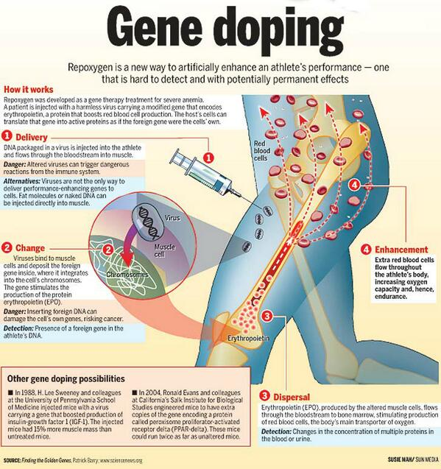
3. Make a poster of famous drug cheats in one sport or in many sports.
4. OR! Make awareness poster that is suitable for anti – doping campaign the aim of this poster is to raise awareness in the dangers of doping.

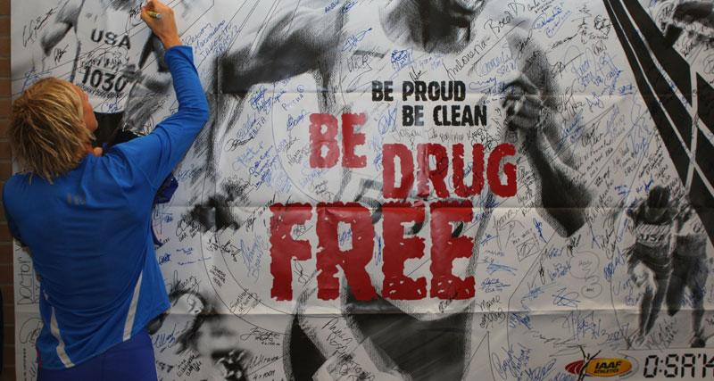

**Rubrics:**

* Follow the instructions to check a mark!

| Pivots | | Requirements | 0 | 1 | 2 |
| --- | --- | --- | --- | --- | --- |
| Submission date | | -Submit your project work on time.  -Postponing is not allowed. |  |  |  |
| Poster type and size | | -They should be on cardboard size A4. |  |  |  |
| Writing | | -Your poster should be handmade not printed. |  |  |  |
| Title position | Educational poster | -It should have a title in the middle |  |  |  |
| Awareness  poster | -The title of the slogan / motto / message/ can be anywhere according to your design) and it should be powerful. |
| Pictures and information | Educational poster | -Define your title then support it with pictures and suitable information (one information at least about each picture). |  |  |  |
| Awareness  Poster | -It should have a picture that supports the slogan/motto/message (you can draw it, or paste a picture of your choice) |
| Total marks | |  |  | | |
| Creativity  \*\*\*\*\*\*\*\*\* | | Extra marks will be awarded for creativity**.** |  | | |



**References:**

|  | **Websites** |
| --- | --- |
| 1 | <https://www.wada-ama.org/>  wada's official website (contains the latest list of prohibited substance, etc)  الموقع الرسمي للوكالة العالمية لمكافحة المنشطات (ويظم احدث قائمة بالمحظورات والتعاطي وانواعه وعقوباته وحتى الطرق المحظورة لتعاطي الادوية العادية) |
| 2. | <https://www.youtube.com/watch?v=MmqXcQW2BEI>  فيديو عن المنشطات في الرياضة |
| 3. | <https://www.youtube.com/watch?v=G7KZxIR1t-o>  blood doping (Lance Armstrong ) فيديو يوضح التنشيط بالدم ولانس ارمسترونغ الذي عوقب بسبب التعاطي |
| 4. | <https://www.theguardian.com/sport/2016/mar/07/maria-sharapova-failed-drugs-test-australian-open-2016-tennis>  Maria Sharapova banned from playing by WADA ماريا شارابوفا توقف عن اللعب بسبب التعاطي دون علم |
| 5. | <https://www.youtube.com/watch?v=mYGFpt9b3fg>  steroids in sports تعاطي المنشطات في الرياضة |

**The following are some helpful websites that offer creative and educational information and videos about WADA, champs banned from playing and steroids.**

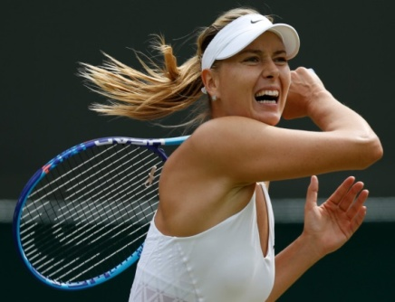

**7thLecture Headway book p.35** 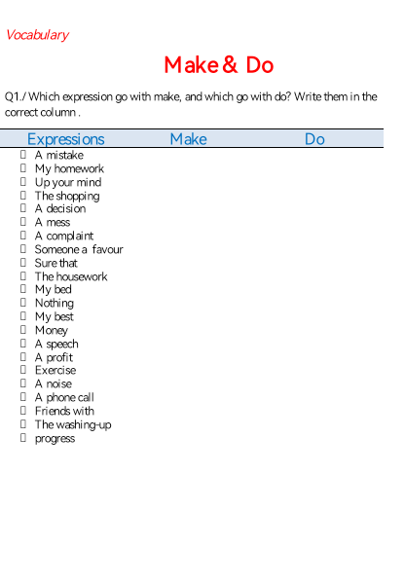

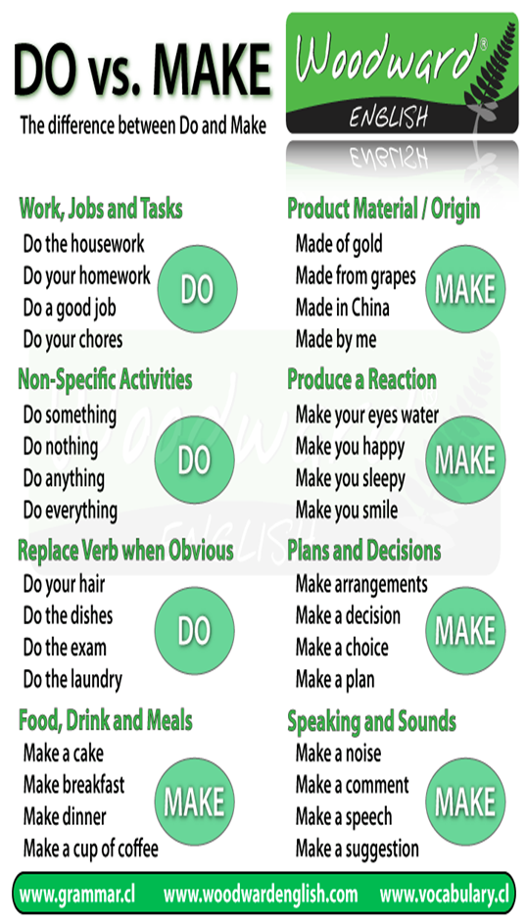

**8th Lecture**

**UNIT THREE**

**3.1. Introduction to Sport Medicine**

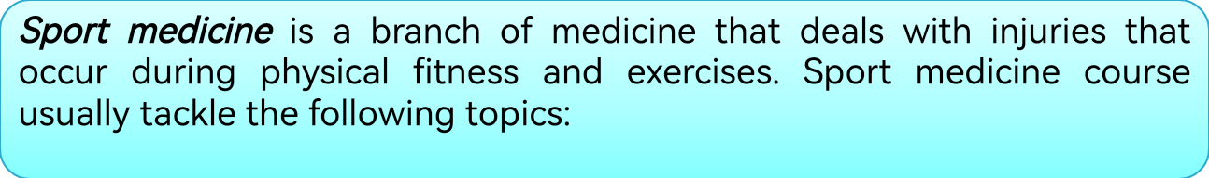

| **Sport**  **medicine terminology** | The student is introduced to anatomy, medical terms and abbreviations. |
| --- | --- |
| **Definition of the occupation and role of a physician** | The person who specializes in sport medicine is called physician. Physicians try to prevent injuries but if they occur they diagnose the injury and treat it.  Physicians work with athletes, teams, physically active individuals, and physically inactive individuals (sedentary individuals). |
| **Injury Prevention** | Physical conditioning, appropriate training method, rest and recovery, muscle soreness, protective equipment, psychological factors, and training in extreme conditions. |
| **Performance enhancement and sport nutrition** | Performance enhancing drugs, anabolic steroids, over – the counter drugs. In sport nutrition they learn about food components, their function, and eating disorders. |

**Q1. Circle the correct answer**

1. Sport medicine is a branch of \_\_\_\_\_\_\_\_\_\_\_\_

a. Physical fitness b. Physical education c. Medicine

2. Sport medicine deals with \_\_\_\_\_\_\_\_\_\_ that occur during physical fitness and exercises.

a. fights b. injuries c. technical problems

3. The person who specializes in sport medicine is called

a. magician b. physician c. nutrition

4. Physicians try to \_\_\_\_\_\_\_\_\_\_\_\_\_

a. prevent injuries b. diagnose injury and treat it c. both

**Q2. Fill in the following diagram showing who physicians work with**

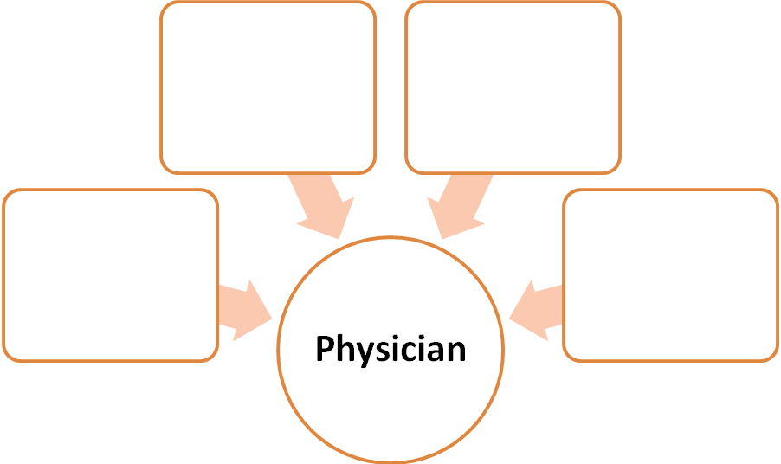

| **Keywords** | | | |
| --- | --- | --- | --- |
| Sport medicine | الطب الرياضي | Extreme conditions | الظروف القاسية  الحالات القصوى |
| Branch | فرع | Performance enhancement | تحسين الاداء |
| Medicine | طب | Sport nutrition | التغذية الرياضية |
| Deals with | يدرس | Performance enhancing drugs | العقاقير التي تحسن الاداء |
| Injuries | اصابات | Anabolic steroids | المنشطات |
| Occur | تحدث | Over the counter drug | علاج متوفر في كل الاسواق |
| Physical fitness | اللياقة البدنية | Components | عناصر |
| Exercises | التمرين | Function | وظيفة |
| Tackle | تتناول | Eating disorders | اظطرابات الاكل |
| Terminology | مصطلحات | Acute | حاد |
| Occupation | المهنة | Chronic | مزمن |
| Role | دور | Concussion | ارتجاج |
| Physician | الطبيب | Muscle cramp | التشنج العضلي |
| Anatomy | التشريح | Strain | الجهد العضلي |
| Abbreviations | مختصرات | Sprain | الالتواء |
| Specializes | يختص | Fracture | الكسر |
| Prevent | وقاية | Classified | يصنف |
| Diagnose | تشخيص | First aid | اسعافات اولية |
| Treat | معالجة | Kit | عدة/ حقيبة |
| Active individuals | نشط بدنيا | Taping | الشريط اللاصق العلاجي |
| Sedentary | خامل | Emergency procedures | اجراءات الطواريء |
| Physical conditioning | التكيف البدني | CPR cardiopulmonary resuscitation | الانعاش القلبي الرئوي |
| Appropriate | ملائم | RICE:  Rest, Ice, Compression and Elevation. | مفهوم الرايس (راحة وثلج و الضغط والرفع) |
| Recovery | استشفاء | Rehabilitation | التاهيل |
| Muscle soreness | الالم العضلي | Massage | التدليك |
| Protective equipment | المعدات الوقائية | Hydrotherapy | العلاج المائي |
| Psychological factors | العوامل النفسية | Electrical stimulation | التحفيز الكهربائي |

**9th Lecture**

| **Sport Injuries** | Acute vs. chronic injuries, common sport injuries include concussion, muscle cramp, strain, sprain, and fractures. Some injuries are classified by body part like back injuries, elbow, hand and wrist, foot and ankle, head injuries, etc. |
| --- | --- |
| **Treatment** | First aid kit, taping, wrapping, Emergency procedures, CPR, and RICE |
| **Rehabilitation** | Massage, Hydrotherapy, rehabilitation exercises, and electrical stimulation. |

**Q.1 / Place each of the following terms in the row in which it belongs :** 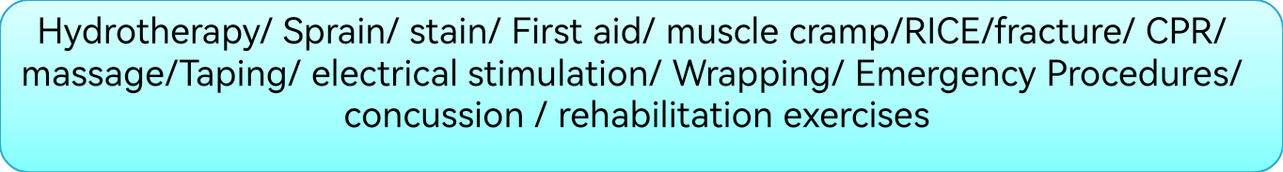

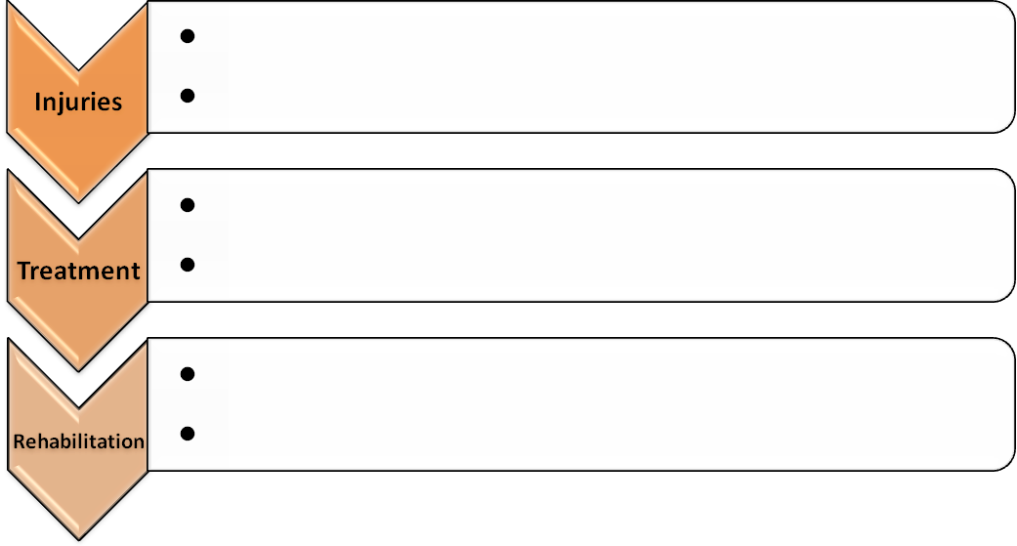

**Q2./ Sport Medicine Pictionary Practice : *label the following terms in Arabic***

| نتيجة بحث الصور عن ‪concussion‬‏ | نتيجة بحث الصور عن ‪muscle cramps‬‏ | **Image result for sprains and strains** | **Image result for sprains and strains** |
| --- | --- | --- | --- |
| **Concussion** | **Muscle cramp** | **Strain** | **Sprain** |
|  |  |  |  |
| Image result for sport injuries | Image result for sport tape | Image result for sport bandage | Related image |
| **Fracture** | **Taping** | **Wrapping** | **CPR** |
|  |  |  |  |
| Related image | Image result for athletic protective equipment |  |  |
| **Massage** | **Protective equipment** | **First aid kit** | **Eating disorders** |
|  |  |  |  |
| **C:\Users\dell\Desktop\OTC_Meds1.jpg** | **C:\Users\dell\Desktop\junior book\hydr.jpg** | **C:\Users\dell\Desktop\junior book\ELec.jpg** | **C:\Users\dell\Desktop\junior book\GeneDoping3_widec.jpg** |
| **Over – the counter – medication** | **Hydrotherapy** | **Electrical stimulation** | **Performance enhancing drugs** |
|  |  |  |  |

**Q.3 CPR means life support or life-kiss! What does each letter mean?**

**-**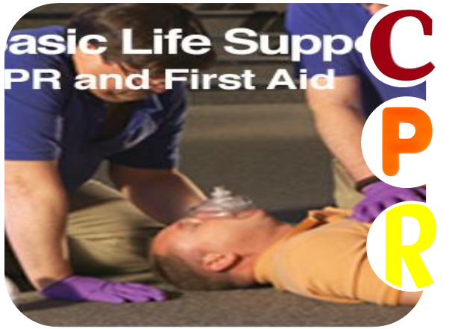





**Q4. / *RICE* is a 4-step therapy for ankle sprain. It is not food! Each letter is an initial for a word. Check the keywords and find out what each letter implies both in English and Arabic.**

|  | | | |
| --- | --- | --- | --- |
|  |  |  |  |
|  |  |  |  |

**10th Lecture**

**Phrasal Verbs**

Q1./ Match a verb in A with an object in B.

| **No.** | **Verb** | **Solution** | **Object** |
| --- | --- | --- | --- |
|  | Sort out |  | 1. Clothes in a shop |
|  | Put out |  | 1. Children |
|  | Fill in |  | 1. The answer |
|  | Try on |  | 1. A problem |
|  | Try out |  | 1. The television |
|  | Bring up |  | F)Toys in cupboard |
|  | Clear up |  | 1. something you don’t want to a shop |
|  | Take back |  | 1. A new idea , a new drug |
|  | Work out |  | 1. A fire |
|  | Put away |  | 1. A form |
|  | Turn off |  | 1. Information |
|  | Find out |  | 1. A mess |

**11th Lecture**

**Unit Four**

**4.1. Introduction to Motor Leaning**

***Motor learning*** is the study of the acquisition of motor skills as a result of practice and experience.

In Motor Learning class, the student learns the following concepts[[2]](#footnote-1):

| **Motor learning terms and concepts** | Motor Skill, fine and gross motor skills, serial, continuous and discrete, open and closed motor skills. Motor abilities which include balance, agility, and accuracy. Physical abilities that include flexibility, speed, endurance, and strength. |
| --- | --- |

**4.1. Review**

**Q1. Define Motor Learning then classify motor skills and give their meaning in Arabic.** 

**Motor Learning** ………………………………………………….……………………

…………………………………………………………………..………………….

**According to size of muscle**

**1. 2.**

**According to environment**

**1. 2.**

**According to movement**

**1. 2. 3.**

**12th Lecture**

| **4.2. Keywords** | | | |
| --- | --- | --- | --- |
| Motor learning | تعلم حركي | Anxiety | القلق |
| Acquisition | اكتساب | Arousal | الاثارة |
| Motor skills | مهارات حركية | Attention | الانتباه |
| Result | نتيجة | Sensory – motor operations | العمليات الحس حركية |
| Practice | التمرين | Conditions of practice | جدولة التمرين |
| Experience | الخبرة | Mass | تمرين مكثف |
| Concepts | مفاهيم | Distributed | التمرين الموزع |
| Terms | مصطلحات | Whole training | التمرين الكلي |
| Fine motor skills | المهارات الحركية الدقيقة | Part training | التمرين الجزئي |
| Gross motor skills | المهارات الحركية العامة | Feedback | التغذية الراجعة |
| Serial motor skills | المهارات المتسلسلة | Transfer of learning | نقل اثر التعلم |
| Continuous motor skills | المهارات المستمرة | Mental training | التدريب الذهني |
| Discrete motor skills | المهارات الوحيدة | Biorhythm | الايقاع البدني |
| Open motor skills | المهارات المفتوحة | Intrinsic | التغذية الراجعة الداخلية |
| Closed motor skills | المهارات المغلقة | Extrinsic | التغذية الراجعة الخارجية |
| Motor abilities | القدرات الحركية | Positive | ايجابي |
| Balance | التوازن | Negative | سلبي |
| Agility | الرشاقة | Mental imagery | التصور الذهني |
| Accuracy | الدقة | Relaxation | الاسترخاء |
| Physical abilities | القدرات البدنية | Physical | بدني |
| Flexibility | المرونة | Emotional | عاطفي |
| Speed | السرعة | Intellectual | ذكائي |
| Endurance | التحمل | Cycle | دورة |
| Strength | القوة | Tests | اختبارات |
| Mental operation | العمليات العقلية | Measurements | قياس |
| Memory | الذاكرة | Applied | تطبق |
| Reaction time | زمن رد الفعل | Conducting | اجراء |
| Speed of reaction time | سرعة رد الفعل | performance test | اختبار اداء |
| Anticipation | الحدس | Speed of reaction test | اختبار سرعة رد الفعل |

**4.3. Motor Leaning Pictionary Practice**

|  |  |  |  |
| --- | --- | --- | --- |
| Fine motor skills | Gross motor skill | Open skill | Closed skill |
|  |  |  |  |
|  |  |  | Image result for accuracy |
| Discrete Skill | Seriel Skill | Continous Skill | Accuracy |
|  |  |  |  |
| Image result for balance | Related image | Related image | Image result for running speed |
| Balance | Agility | Flexibility | Speed |
|  |  |  |  |
| Image result for muscular strength | Related image | Related image | Related image |
| Stregnth | Enduracne | Arousal | Biorhythm |
|  |  |  |  |

**13th Lecture Headway Book p. 14**

**Pronunciation**

**Remember the rules for the pronunciation of -s at the end of a word, then put them in the correct column.**

**Cheque / girls / places / boys / lives / hours / earns / products / loves / minutes / closes / graduates / lessons / wants / messages / hates / cooks / sandwiches / things.**

| **/s/** | **/z/** | **/iz/** |
| --- | --- | --- |
|  |  |  |
|  |  |  |
|  |  |  |
|  |  |  |
|  |  |  |
|  |  |  |
|  |  |  |
|  |  |  |
|  |  |  |
|  |  |  |

1. "performance Enhancing Substance," Wikipedia the free online encyclopedia. Retrieved 1/9/2017 [↑](#footnote-ref-0)
2. [↑](#footnote-ref-1)