

**University of Baghdad**

**College of Science**

**Department of Chemistry**

**Practical Analytical Chemistry Experiments**

**Gravimetric Methods of Analysis & Separation Methods of Analysis**

**Second Stage-First Semester**

**2024-2025**

Prepared by

Lect. Yasmeen Hikmat Muhamad

Assi.Lect. Raid Abdulmehdi Alewy

Assi.Lect. Inas Hassan Muhamad

Assi.Lect. Noor Al-Huda Ahmed

Assi.Lect. Hawraa Rahman Younis

**General laboratory instructions أرشادات مختبرية عامة**

* To take a solid substance from a bottle, use a glass or plastic spatula. Do not pour the solid over a filter paper, test tube, beaker, or glass cup. Only liquids can be poured into appropriate lab glassware.

لاخذ مادة صلبة من قنينة استعمل ملعقة زجاجية أو بلاستيكية، لا تسكب المادة الصلبة فوق ورقة الترشيح او انبوبة اختبار او دورق او كاس زجاجي، السوائل فقط هي التي تسكب في الاوعية الزجاجية المناسبة لها.

* Do not immerse a dropper or pipette in a glassware of liquid or solution and then use it in another liquid or solution glassware.

لا تغمر قطارة أو ماصة فى قنينة سائل أو محلول لتستخدمه في سائل او محلول آخر

* Never place the stopper of a bottle of liquid or solution on a shelf, a table, or a lab bench to avoid contamination.

لا تضع ابدا سداد قنينة سائل او محلول فوق الرف او المنضدة تحاشيا من التلوث

* Place all bottles of chemicals in their designated places after you have taken what you need from them, without carrying them to your workplace, as other students need them as well.

ضع جميع قناني المواد الكيميائية في الاماكن المخصصة لها بعد اخذك ما تحتاج منها دون حملها الى مكان عملك فالطلبة الاخرون هم بحاجة لها ايضا .

* Do not return the excess amount of chemicals (whether solid or liquid to its original bottle). Give it to a colleague who needs it, or inform one of the laboratory staff to find out what must be done to benefit from it.

لا تعيد الكمية الزائدة من المواد الكيميائية (الصلبة كانت ام سائلة الى قنينتها الاصلية) اعطها لزميل بحاجتها او اخبر احد مسؤولي المختبر لمعرفة ما يجب عمله للاستفادة منها .

* Never leave a bottle of chemicals open, as there are many chemicals that change their composition when exposed to the atmosphere, sunlight, or artificial light, in addition to the possibility of contamination. Make sure that the bottle is tightly closed after taking some of the contain chemicals.

لا تترك ابدا قنينة مواد كيميائية مفتوحة فهناك كثير من المواد الكيميائية التي يتغير تركيبها عند تعرضها للجو او ضوء الشمس او الضوء الاصطناعي، اضافة الى احتمال تلوثها و تاكد من ان القنينة قد سدت باحكام عند اخذ جزء من المادة التي تحتويها.

* Place the excess solid materials that cannot be used, such as the filter papers, the remains of matches, etc., in the trash container, and do not put them in the sink or in the water stream. Make sure before throwing the solid material that it does not cause a fire if it is exposed to the air, or that it gives off undesirable odors when thrown in the sink or water courses.

ضع المواد الصلبة الزائدة التي لا يمكن الاستفادة منها واوراق الترشيح وبقايا عيدان الثقاب وغيرها في وعاء المهملات ولا تضعها في الحوض او في مجرى المياه وتاكد قبل رمي المادة الصلبة انها لا تسبب اشعال النار فيما لو تعرضت للهواء او انها تعطي روائح غير مرغوب فيها عند رميها في الحوض او مجاري المياه .

* Never pour water into concentrated sulfuric acid for the purpose of diluting the acid. The correct way to dilute concentrated sulfuric acid is to add the concentrated acid slowly and carefully to the water in a glassware (a suitable test tube, a glass beaker, a glass bottle, a graduated cylinder... etc.) with continuous stirring. If The temperature of the solution approaches the boiling stage, then it must be cooled by pouring tap water on the outer walls of the glassware and continuing to stir until the temperature drops, then proceed with adding the acid as before, and so on.

لا تسكب الماء ابدا في حامض الكبريتيك المركز لغرض تخفيف الحامض الطريقة السليمة لتخفيف حامض الكبريتيك المركز هي باضافة الحامض المركز ببطئ و عناية الى الماء في وعاء زجاجي (انبوب اختبار مناسب، كأس زجاجي قنينة زجاجية ، اسطوانة مدرجة ... الخ) مع التحريك المستمر فأذا اقتربت درجة حرارة المحلول من مرحلة الغليان عند ذلك يجب تبريده بسكب ماء الحنفية على الجدران الخارجية للوعاء والاستمرار بالتحريك لحين انخفاض درجة الحرارة ثم يباشر باضافة الحامض كالسابق وهكذا.

* When heating a solid or liquid in a test tube, be careful not to have the mouth of the tube pointed toward you, at a colleague next to you, or at laboratory tools. In the event of boiling a solution or liquid, take into consideration the space that must be left empty in the boiling vessel before heating and never leave boiling solution unattended.

احذر عند تسخين مادة صلبة أو سائلة في انبوبة اختبار ان تكون فوهة الانبوبة موجهة نحوك أو نحو زميل مجاور لك او باتجاه ادوات المختبر، وفي حالة غلي محلول او سائل خذ بنظر الاعتبار الحيز الذي يجب ان تتركه فارغا في وعاء الغليان قبل التسخين ولا تترك المحلول يغلي دون مراقبة.

* Never attempt to taste any chemical substance that you work with in a lab, either liquid or solid, and never drink water from a glassware while working in a lab. Always keep in mind that there are numerous harmful compounds nearby, and it is possible that some solutions or liquids are misidentified on the bottles they are contained.

لا تحاول ابدا تذوق أي مادة كيميائية سائلة او صلبة تتعامل معها في المختبر ولا تشرب الماء في أي وعاء زجاجي تستخدمه في عملك داخل المختبر فتذكر دائما ان من حولك العديد من المواد السامة وقد يحدث سوء أن يشار الى بعض المحاليل او السوائل خطأ في القناني التي تحتويها.

* When attempting to detect a gas or liquid that rises as a result of a reaction, exercise caution. If a liquid or gas is rising from a bottle, test tube, or reaction flask, do not smell it or put the container’s mouth right up against your nose. The proper technique is to bring a stream of gas or vapor close to your nose by moving two or three fingers of your hand over the container's mouth.

كن حذرا عندما تريد شم سائل او غاز يتصاعد اثناء تفاعل ما. ولا تشم بخار السائل أو الغاز المتصاعد من قنينة او انبوبة اختبار او دورق تفاعل لتقريب الفوهة من انفك الطريقة الصحيحة: هي أن تحرك اثنين أو ثلاثة من اصابع يدك فوق فوهة الوعاء ساحبا تيار من الغاز او البخار قرب انفك.

* Any heating or heating process that involves the release of vapors or gases with an unpleasant or toxic odor must take place inside the fume hood.

يجب ان تجري داخل خزانات الغاز كل عملية تسخين او تسخين يتضمن تحرير ابخرة او غازات ذات رائحة كريهة او سامة

* Your hands should always be clean and dry. If you touch a solid or liquid chemical, wash your hands well and dry them.

يجب ان تكون يداك نظيفتان وجافتان دائما وفي حالة لمسك لمادة كيميائية صلبة او سائلة فبادر بغسل يدك جيدا وتجفيفها.

* For fear of harm, the student should not wear any jewelry while working, including silver, gold, or other precious metals. Both male and female students must adhere to the university uniform, and wearing a bracelet or necklace is inappropriate.

ينبغي على الطالب عدم لبس الحلي الفضية والذهبية وغيرها اثناء العمل خشية لتعرضها للتلف اضافة الى انه من غير اللائق أن يرتدي الطالب أو الطالبة سوار او قلادة و ينبغي الالتزام بالزي الجامعي.

**Contents of the laboratory report**

1. Name of the student, names of partners

2. Name of the experiment

3. Experiment number

4. Date the experiment was conducted

5. The purpose of conducting the experiment

6. Unknown number (if any)

7. The signed paper

8. Tools used

9. Chemicals used

10. Method

11. Results and calculations

12. Discussion

**محتويات التقرير المقدم في المختبر**

1. اسم الطالب، اسماء الشركاء
2. اسم التجربة
3. رقم التجربة
4. تاريخ اجراء التجربة
5. الغرض من اجراء التجربة
6. رقم المجهول (ان وجد)
7. الورقة الموقعة
8. الادوات المستخدمة
9. المواد الكيميائية المستخدمة
10. طريقة العمل
11. النتائج والحسابات
12. المناقشة

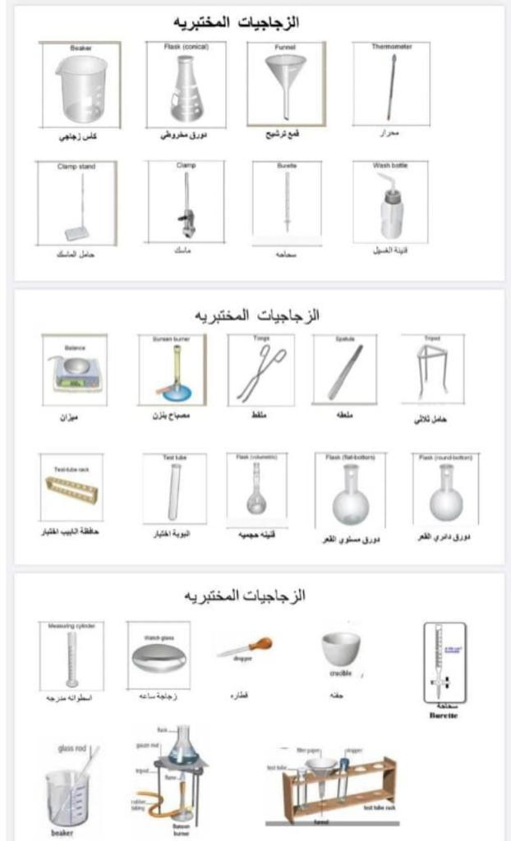

**Gravimetric Methods of Analysis**

Gravimetric method is one in which the analysis is completed by a weighing operation.

**Types of Gravimetric Methods**

There are two major types of gravimetric methods:

1- Precipitation methods.

2- Volatilization methods.

In precipitation methods, the analyte is converted to a sparingly soluble precipitate. This precipitate is then filtered, washed free of impurities, and converted to a product of known composition by suitable heat temperature, and the product is weighed.

In volatilization methods, the analyte or its decomposition products are volatilized at a suitable temperature. The volatile product is then collected and weighed or the weight of the product is determined indirectly from the loss in weight of the sample. The two most common gravimetric methods based on volatilization are those for water and carbon dioxide.

**Properties of precipitates and precipitating reagents**

A gravimetric precipitating agent should react specifically or, if not that, at least selectively with the analyte. **Specific reagents**, which are rare, react only with a single chemical species. **Selective reagents**, which are more common, react with a limited number of species. In additional to specificity or selectivity, the ideal precipitating reagent would react with the analyte to give a product that is:

1. Readily filtered and washed free of contaminants.

2. Low solubility so that no significant loss of the solid occurs during filtration and washing.

3. Unreactive with constituents of the atmosphere.

4. Of known composition after it’s dried or, if necessary, ignited.

**Desiccator**

Desiccator is a glass container, the most common desiccators are circular and made of heavy glass. There is usually a removable platform on which the sample to be stored are placed. The desiccant such as silica gel, fills the space under the platform,

* The desiccators is a convenient way to store the sample and carry it about the lab.

*Dry a material at room temperature.

*prevent absorption of moisture because it contains a drying agents.



**Desiccator**

**Drying Agent**

Phosphorus pentoxide P₂Os → HPO3

Barium oxide BaO → Bao.10H₂O

Potassium hydroxide KOH → KOH.XH₂O

Calcium chloride CaCl2.2H₂O → CaCl2.6H₂O

Silica gel SiO2 → SiO2. XH₂O

white or blue Pink

A drying agents should be available, low cost and absorb the moisture very rapidly.

|  |
| --- |
| **Experiment No. 1** |

**Determination of Water of crystallization in copper Sulfate hydrous ${CuSO}_{4}$. ${XH}_{2}O$ Using Volatilization method**

**Theory:**

Water of crystallization is the water forming part of crystal structure of certain materials, known as crystalline hydrate. The contents of such water in these hydrates correspond to definite chemical formulas such as,

${Bacl}_{2.}{2H}_{2}O;{Na}_{2}{SO}_{4.}{10H}_{2}O; {Na}_{2}{SO}_{4.}{7H}_{2}o$ etc. Accordingly, water of crystallization is sometimes called stoichiometric water.

When heated, crystalline hydrates decomposes with liberation of water. This is the basis for the method for determining water of crystallization in most crystalline hydrates by volatilization. Copper sulfate hydrate loses all its water of crystallization above 100°C (100 - 150°C ) Much higher temperatures (up to 800 - 900°C ) can be used in this dehydration, for anhydrous copper sulfate is non-volatile and stable even at fairly high temperatures.

$${CuSO}_{4.}{xH}_{2}o\underset{→}{{100-200}^{c}}{CuSO}_{4}+{xH}_{2}o$$

Blue White

In the present experiment a weighed sample of CuSO4.XH2O contained in a weighing bottle is heated at 100 - 150°C in a drying oven until its weight ceases to change (i.e. it is dried to constant weight). When the weight has become constant evidently all the water of crystallization has been removed. Its weight is equal to the weight loss of the sample

**Materials and Equipment:**

1-porcelain or silica crucible with lid

2-porcelain triangle

3-tripod and Bunsen burner

4-crucible tongs

5-desiccator

6-Analytical balance.

7-Copper sulfate crystal

8-Oven (100-200 °C)

**Procedure:**

1-Heat the crucible gently on oven (100-200 °C) and leave it for 30 minutes. Allow to cool in desiccator for 5 minutes and weight the empty crucible

2-Introduce into the crucible 0.5 g of sample (hydrated copper sulfate) using an analytical balance.

3-Heat the crucible with sample in oven at temp. (100-200°C) for 1 hour. Then cool in a desiccator for 30 min.

4- Measure the weight the crucible with the sample after heating and cooling

**Calculations:**

Weight of the crucible = W1

Weight of the crucible with sample before heating = W2

Weight of the crucible with sample after heating = W3

Weight of the volatile water = W2-W3

Weight of the sample = W2-W1

Weight of the hydrous salt (CuSO4.XH2O) = W2-W1

Weight of the non-hydrous salt (CuSO4) = W3-W1

1. Calculate the percentage of water content as follows:

% H2O

1. Find the number of water of crystallization in the structure according to the following formula.

$$\frac{ W_{2}-W_{1} }{W_{3}-W_{1}}= \frac{(M.wt of CuSO_{4})+18X}{M.wt of CuSO_{4} }$$

**Experiment No.2**

**Determination of lead as Lead Chromate PbCrO4**

**Theory:**

There are several gravimetric methods of analysis used for determination of Pb in various samples via its precipitation as lead, chromate (PbCrO4), lead sulfate (PbSO4) or lead molybdate (PbMoO4) etc...

In the case of the precipitation of lead as lead chromate, the solution should be acidified with dilute acetic acid if it is a neutral or basic. On the other hand, if the solution is acidic with nitric acid, an additional amount of sodium acetate should be added to replace nitric acid with acetic acid followed by addition of an excess of potassium chromate. 4 2- PbCrO4

Yellow (ppt)

The most important of this precipitate

1-It dissolves in the strong acids to form a soluble complex.

2Cro $4^{2-}+{2H}^{+}→{Cr}_{2}{o7}^{2-}$ + $H_{2}$ o

2-Also it dissolves in the strong basses to form a soluble complex.

$${pbCrO}_{4}+{4OH}^{-}→{pbO}_{2}^{2-}+{crO}_{4}^{--}+{2H}_{2}O$$

Although this method of precipitation is limited in its applicability because of the general insolubility of chromates it is a useful procedure for gaining experience in gravimetric analysis. The best results are obtained by precipitation from homogeneous solution utilizing the homogeneous generation of chromate ion produced by slow oxidation of + by bromate at 90-95 °C in the presence of an acetate buffer.

2Cr3+ ${BrO}_{3}^{-}+{5H}_{2}O→{2Cro}_{4}^{2-}+{Br}^{-}+{10H}^{+}$

$${BrO}_{3}^{-}+{5Br}^{-}+{6H}^{+}→{2Br}_{2}+{3H}_{2}O$$

$${Pb}^{2}+{Cro}_{4}^{2-}→{PbCrO}_{4}$$

Yellow (ppt)

**Materials and Experiment:**

1-Porcelain or silica crucible with lid

2-Porcelain triangle

3- Bunsen burner

4-Desiccator

5- Analytical balance

6- Beakers and stirring rod

7- Watch glass

8- Lead nitrate Pb(2

9- Buffer solution (pH = 6) (6M acetic acid 0.6M sodium acetate)

10- 0.1 N NaOH

11- 2% potassium bromate solution (${KBrO}_{3}$)

12- 1% Chromium nitrate

13- 1% ${HNO}_{3}$

**Procedure:**

1- Weigh out accurately 0.15 g of the lead salts (for example lead nitrate).

2-Transfer the weighed salt to a 250 mL beaker and then dissolve it in 250 mL of distilled water.

3-Add 2 drops NaOH solution

4-Add 2.5 mL from buffer solution (acetic acid and sodium acetate)

5-Add 10 mL from chromium nitrite

6-Add 10 mL of potassium bromate

7-The mixture heated (90 - 95 $℃$) during heating chromate ion will be generated, slowly which then react with lead ions to from lead chromate. Precipitation indicated when solution became clear

8-Cool the solution and filtration by used instrumental filtration then washing of precipitate with nitric acid (1%)

9-Dry the crucible with its contents in the oven at 120°C (1 hour), cool in a desiccator (30 min.) and weigh as PbCrO4.

**Calculations:**

The precipitate after drying is PbCrO4 and its weight can be found by the weight difference between empty clean sintered glass (W1) and with precipitate (W2).

% Pb in the sample = 100

Gf of Pb +2 =

**Experiment No. 3**

**Determination of Nickel as dimethylglyoxime complex**

**Theory:**

Dimethylglyoxime is considered to be the oldest well-known organic precipitant which discovered by Chugayev (1905) who first proposed the use of dimethylglyoxime as a precipitant for Ni (II) ion.

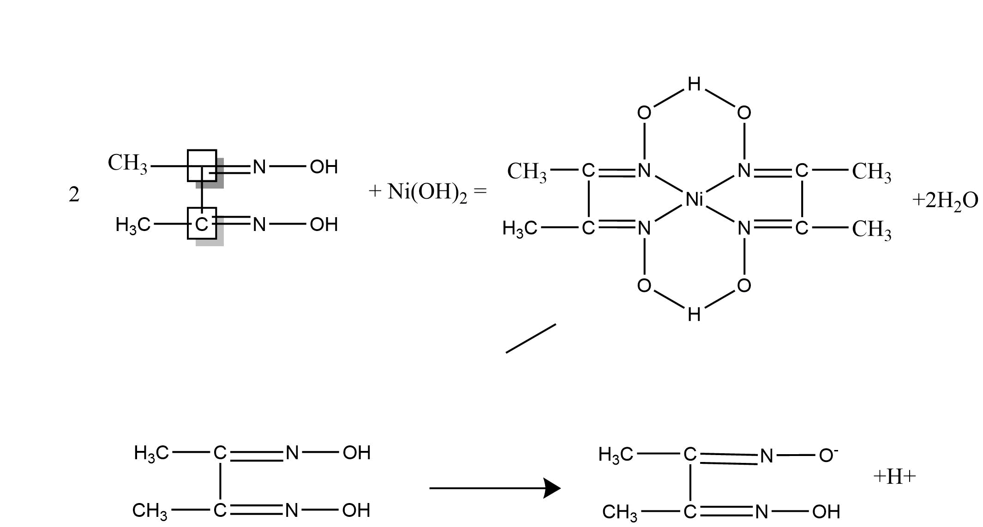This reagent is a weak acid, its formula is CH3.C(:NOH).C(:NOH).CH3 and symbolized as H2DMG, low soluble in water giving one H+ ion when dissociated as follows:

It dissolves in alcohol, so its alcoholic solution is used especially for the precipitating nickel ion quantitatively. The nickel is precipitated by addition of ethanolic solution of dimethylglyoxime to a hot, faintly acid solution of nickel salt, and then adding a slight excess of aqueous ammonia solution (free from carbonate). The precipitate is washed with cold water and then weighed as nickel dimethylglyoximate (red precipitate) after drying at 110-120 °C. With large precipitates, or in work of high accuracy, a temperature of 150°C should be used. Its formation may be represented by the following general equation:

NH4OH

And the overall reaction as follows:

Dimethylglyoxime

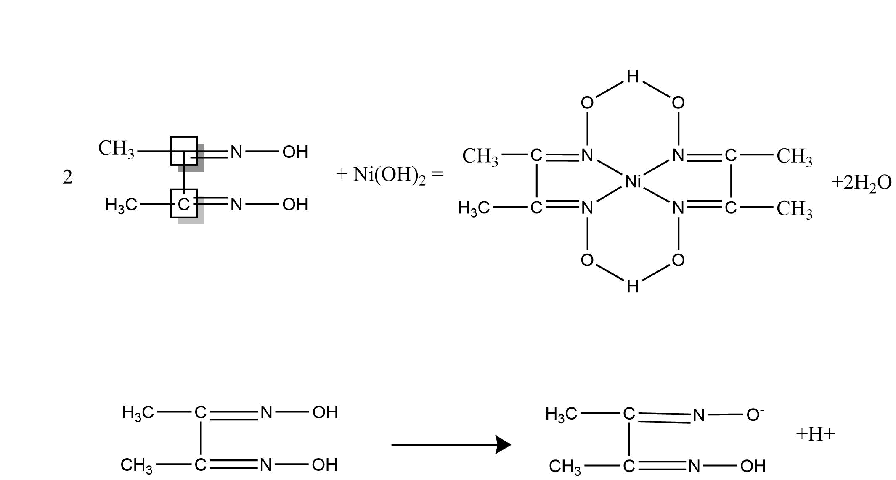

Dimethylglyoxime nickel salt

This equation shows that, in addition to replacing two hydrogen atoms in =N-OH groups of two dimethylglyoxime molecules, the Ni2+ ion also forms coordination bonds with nitrogen atoms in two more such groups. Therefore, the N-OH groups are simultaneously acidic and complex-forming.

The red precipitate has relatively low solubility in water but soluble in free mineral acids.

**Materials and Equipment**:

1- Beaker 400 mL

2- Stirring rod

3- Watch glass

4- Pipette

5- Analytical balance

6- Electric oven

7- Gooch, sintered glass or porcelain filtering Crucible

8- Ammonium nickel sulfate (${NH}_{4}$) 2 ${SO}_{4}$. ${NiSO}_{4}$. ${6H}_{2}O$

10- 1% Dimethylglyoxime solution.

11-Hydrochloric acid (1:1).

12-Dilute ammonia solution(1:4)

**Procedure:**

1-Weigh out accurately 0.2 of pure ammonium nickel sulfate (as a sample for analysis) into a 400-mL beaker provide with a watch- glass cover and stirring rod.

2- Dissolve the sample in little water, add 5 mL of dilute HCl (1:1) and dilute to 200 mL with distilled water.

3-Heat to (70 - 80) $℃$, add a slight excess of the dimethylglyoxime reagent (at least

5 mL for every 10 mg of Ni present), and,

4- Immediately add dilute ammonia solution (1:4) dropwise, directly to the solution and not down the beaker wall, and with constant stirring until the precipitate take place, and then in slight excess.

5-Allow to stand on the steam bath for 20-30 minute.

6 -Test the solution for complete precipitation when the red precipitate has settled out and allow the precipitate to stand for 1 hour, cooling at the same time.

7-Filter the cold solution through the sintered glass crucible [(No.3 or 4), previously heated to 110-120 °C and weighed after cooling in a desiccator (W₁).

8-Wash the precipitate with cold water until free chloride.

9-Dry it at 110 - 120 °C for 45-50 minutes.

10- Allow to cool in a desiccator and weigh as Ni ($C_{4}H_{7}O_{2}N_{2})_{2}$

11- Repeat the drying until constant weight is obtained (W2)

**Calculations:**

The precipitate after drying is Ni()2 and its weight can be found by the weight difference between empty clean sintered crucible ($W_{1}$) and that with precipitate ($W_{2}$).

% Ni in the sample = $\frac{\begin{aligned}Ni\left(C4H7O2N2\right)2 \\ {(W}_{2}- W_{1}) X GF\end{aligned}}{Weight of sample}$ $×$ 100

GF (Gravimetric Factor) = $\frac{At.wt of Ni}{M.wt of Ni\left(C4H7O2N2\right)2}$

***Chromatography***

**Chromatography** is an important technique for the separation, isolation and identification of the constituents of a mixture.

**Chromatography** is a physical method of separation in which the components to be separated are distributed between two phases, one of which is stationary while the other (the mobile phase) moves in a definite direction.

**Mobile phase**: Is a liquid or gas that carries analytes through a liquid or solid stationary phase.

**Stationary phase:** Is a solid or immobilized liquid in chromatography upon which analyte species are partitioned during passage of a mobile phase.

**Types of Chromatography**

1. **Column chromatography**

Column chromatography is a separation technique in which the stationary bed is within a tube. The particles of the solid stationary phase or the support coated with a liquid stationary phase may fill the whole inside volume of the tube (packed column). Differences in rates of movement through the medium are calculated to different retention times of the sample.

**Types of column chromatography:**

**①**Ion-Exchange Chromatography ②Size-Exclusion Chromatography

③Adsorption Chromatography ④Partitioning Chromatography

1. **Planar chromatography**

Planar chromatography is a separation technique in which the stationary phase is present as or on a plane. The plane can be a paper, serving as such or impregnated by a substance as the stationary bed (paper chromatography) or a layer of solid particles spread on a support such as a glass plate (thin layer chromatography).

**Types of planar chromatography: -**

1. **Paper chromatography**

Paper chromatography is a technique for separating dissolved chemical substances by taking advantage of their different rates of migration across sheets of paper.

1. **Thin Layer chromatography**

Thin layer chromatography (TLC) is a method of analysis in which the stationary phase, a finely divided solid, is spread as a thin layer on a rigid supporting plate; and the liquid mobile phase is allowed to migrate across the surface of the plate by means of capillary action.

**Ion exchange**

**Ion exchange**: is a process by which ions held on a porous, essentially insoluble solid, are exchanged for ions in a solution that is brought in contact with the solid. The solid material is called ion exchange resin.

**Ion exchange resins**

Synthetic ion-exchange resins are high-molecular weight polymers that contain large numbers of an ionic functional groups per molecule.

**There are three types of ion exchange resin:**

**1) Cation exchange resins:**

These resins contain acidic functional groups. The strong acid cation exchangers have sulfonic acid groups, (-SO3, -H+), which are strong acids. The weak -acid cation exchanger have carboxylic acid groups, (-COOH), which are only partially ionized. The protons on these groups can exchange with other cations. Cation-exchange resin is prepared by a polymerization of styrene and divinylbenzene, followed by sulfonation.

**2) Anion exchange resins:**

Anion exchangers contain quaternary ammonium [-N+ (CH3)3OH] groups (strong-base). Whereas weak-base types contain secondary or tertiary amines.

**3) Mixed exchange resins:**

These resins contain acidic and basic functional groups (HO…R….H).

**The important properties which determine the behavior of a resin can be summarized:**

1. Size of particles- rate of exchange and permeability of packed column.

2. Degree of cross-linking-rigidity, porosity, swelling.

3. Nature of functional group- kind of ion exchanged.

4. Strength of functional group- distribution coefficient.

5. Number of functional groups-capacity of resin

**Experiment No.4**

**Cation Exchange Column Preparation and Determination of Total Capacity by Used Sodium Chloride**

**Theory**

The total capacity of an ion exchange resin is defined as the total number of chemical equivalents or charged sites available for exchange per some unit weight or unit volume of resin. High capacity resins require rather concentrated eluents to elute sample ions from the column, but they do have the ability to handle large sample loads

+ HCl $→$ $NaCl$ + ${RSO}_{3}^{-}H^{+}$………………. (1) (Activation equation )

+ NaCl $→$ $HCl$ + ${RSO}_{3}^{-}{Na}^{+}$………………. (2) (Ion exchange equation )

4+ HCl *NaCl*+…………….............. (3) (Titration equation )

Colorless Pink

**Procedure**

1. Wash column containing resin cation exchange using 25 mL from HCl

(0.1 N) at flow rate (30 drops in minute).

1. Wash column by distilled water to remove all acid by using pH-paper.
2. Add sample (NaCl) and wash by distilled water (using pH-paper).
3. Titrate the flowing solution with NaOH (0.1N) using indictor [ph.ph](http://ph.ph/).

**Calculations**

1- Calculate the weight of resin

W = r² $×$ π $×$ L

2- Calculate total capacity

T.C = N $×$ V/W

N=0.1 N NaOH

V = Volume of Titration

**Unit of T.C= meq/gm**

**Experiment No.5**

**Determination of Percentage from Sulfate Ions by Used Cation Exchange Chromatography**

**Theory**

+ HCl $→$ $NaCl$ + ${RSO}_{3}^{-}H^{+}$………………. (1) (Activation equation )

+ Na2SO4  + …… …. (2) (Ion exchange equation )

4+ NaOH Na2SO4+…………… .... (3) (Titration equation )

**Procedure**

1. Wash column containing resin cation exchange using 25 mL HCI (1:10) at flow rate (20 drops in minute).
2. Wash column by distilled water to remove all acid using pH-paper.
3. Weigh 0.15 g of sample (dissolve by 10 mL distilled water).
4. Transfer the sample to column and Collect the flowing solution (acid) from the column by conical flask.
5. Wash column by distilled water and Collect the flowing solution from the column in conical flask to ensure the down flow of all acid using pH-paper.
6. Titrate with NaOH (0.1N) by using [ph.ph](http://ph.ph/).
7. Wash column by 25 mL HCI (1:10).

**Calculations**

Calculate the percentage of sulfate ion:

${\%SO}_{4}^{-2}$ = $\frac{wt.of {SO}_{4}^{-2}}{Wt.of sample }× 100$

$Wt.of {SO}_{4}^{-2}$ = $\frac{N_{NaOH × }V_{NaOH × }eq.Wt {SO}_{4}^{-2}}{1000}$

**Experiment No.6**

**Separation of Chloride by Anion Exchange Chromatography**

**Theory**

RN+(CH3)3OH- + NaNO3 RN+(CH3)3 NO3- + NaOH………..… (1)

RN+(CH3)3 NO3- + NaCl RN+(CH3)3 Cl - + NaNO3 ……….… (2)

RN+(CH3)3 Cl - + NaNO3 RN+(CH3)3 NO3- + NaCl………..……(3)

NaCl + AgNO3 AgCl + NaNO3 ……………………………… (4)

White (ppt)

AgNO3 + K2CrO4  Ag2CrO4 + KNO3 …………...………………(5)

Red (ppt)

**Procedure**

1. Wash column containing resin anion exchange by 25 mL sodium nitrate (0.5 M)
2. Wash column by distilled water to remove all sodium hydroxide to ensure using ph.ph.
3. Add sample solution contain (chloride) to column, and collect the flowing solution from the column by conical flask.
4. Wash column by NaNO3 (0.5M) to remove chloride ions and Collect the flowing solution from the column in conical flask to ensure the down flow of all chloride ions using AgNO3
5. Titrate flowing solution with AgNO3 (0.1N) using K2CrO4.

**Calculations**

Calculate the percentage of chloride ion:

$wt. {Cl}^{-}$ = $\frac{N_{AgNO3} × V_{AgNO3} × A. wt {Cl}^{-} }{1000}$

% ($wt$/ $wt$) ${Cl}^{-}$ = $\frac{ wt {Cl}^{-}}{wt sample}$ $×100$

**Paper chromatography**

Chromatography is used to separate mixtures of substances into their components. All forms of chromatography work on the same principle. They all have a ***stationary phase*** (a solid, or a liquid supported on a solid) and a ***mobile phase*** (a liquid or a gas). The mobile phase flows through the stationary phase and carries the components of the mixture with it. Different components travel at different rates. We'll look at the reasons for this further down the page. In paper chromatography, the stationary phase is a very uniform absorbent paper. The mobile phase is a suitable liquid solvent or mixture of solvents.

**Retention Factor Values**

Some compounds in a mixture travel almost as far as the solvent does; some stay much closer to the base line. The distance travelled relative to the solvent is a constant for a particular compound as long as you keep everything else constant - the type of paper and the exact composition of the solvent, for example. The distance travelled relative to the solvent is called the Rf value. For each compound it can be worked out using the formula:

**Rf**

For example, if one component of a mixture travelled 9.6 cm from the base line while the solvent had travelled 12.0 cm, then the Rf value for that component is:

$$Rf=\frac{9.6}{12.0}=0.80$$

In the example we looked at with the various pens, it wasn't necessary to measure Rf values because you are making a direct comparison just by looking at the chromatogram. You are making the assumption that if you have two spots in the final chromatogram which are the same color and have travelled the same distance up the paper, they are most likely the same compound. It isn't necessarily true of course - you could have two similarly colored compounds with very similar Rf values. We'll look at how you can get around that problem further down the page.

**Experiment No.7**

**Separation of a Mixture of Halides by Paper Chromatography**

**Procedure**

1. Take 6 clean test tubes and 6 capillary tubes.
2. Obtain 6 a rectangular pieces of Whatman filter paper and by using a pencil ( not a pen) and a ruler, draw a line 1 cm from one end of the paper represents the location of solute
3. Capillary tube is used to put a drop of four halides **(*NaI, NaBr, NaCl, NaF*)** on the three paper and put a drop of a fifth mix pigments on paper fourth, the sixth paper by putting your drop of the unknown.
4. Put in each test tubes 2 cm of solvent, which is a (Acetone 5, Water 1) and using long-leg funnel to prevent the fall of the solvent on the internal walls of the tubes.
5. Put all six papers in test tubes and take care not to touch the solvent of sites halide and leave for 30 minutes.
6. Get out the papers and leave it to dry and put them silver nitrate and leave it to dry again.

**Calculations**

Rf

**Thin layer chromatography**

The mobile phase flows through the stationary phase and carries the components of the mixture with it. Different components travel at different rates. We'll look at the reasons for this further down the page. Thin layer chromatography is done exactly as it says - using a thin, uniform layer of silica gel or alumina coated onto a piece of glass, metal or rigid plastic. The silica gel (or the alumina) is the stationary phase. The stationary phase for thin layer chromatography also often contains a substance which fluoresces in UV light - for reasons you will see later. The mobile phase is a suitable liquid solvent or mixture of solvents.

**Producing the chromatogram**

We'll start with a very simple case - just trying to show that a particular dye is in fact a mixture of simpler dyes.

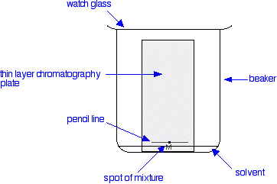

A pencil line is drawn near the bottom of the plate and a small drop of a solution of the dye mixture is placed on it. Any labelling on the plate to show the original position of the drop must also be in pencil. If any of this was done in ink, dyes from the ink would also move as the chromatogram developed. When the spot of mixture is dry, the plate is stood in a shallow layer of solvent in a covered beaker. It is important that the solvent level is below the line with the spot on it.

The reason for covering the beaker is to make sure that the atmosphere in the beaker is saturated with solvent vapor. To help this, the beaker is often lined with some filter paper soaked in solvent. Saturating the atmosphere in the beaker with vapor stops the solvent from evaporating as it rises up the plate.

As the solvent slowly travels up the plate, the different components of the dye mixture travel at different rates and the mixture is separated into different colored spots.

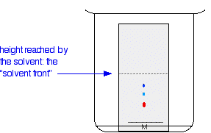

The solvent is allowed to rise until it almost reaches the top of the plate. That will give the maximum separation of the dye components for this particular combination of solvent and stationary phase.

**Measuring Rf values**

These measurements are the distance travelled by the solvent, and the distance travelled by individual spots. When the solvent front gets close to the top of the plate, the plate is removed from the beaker and the position of the solvent is marked with another line before it has a chance to evaporate. These measurements are then taken:

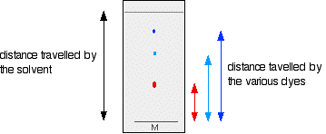

The Rf value for each dye is then worked out using the formula:

Rf

For example, if the red component travelled 1.7 cm from the base line while the solvent had travelled 5.0 cm, then the Rf value for the red dye is: **Rf**

**Experiment No.8**

**Separation of a Mixture of Dyes by TLC**

**Procedure**

1. Take 2 glass slides and clean with distilled water and acetone and wipe with a piece of cotton to dry.
2. Prepare the silica gel by dissolves silica gel 30 grams in 100 mL chloroform in a homogeneous.
3. stick the slides to each other and put him in silica gel and get out (in medium speed) and the process is repeated for six times , and then separate the slides from each other and then leave a go dry .
4. Appointed positions the solute on the slides at 0.5 cm from edge of slides by a pin, capillary tube using to put a drop of three dyes on the first slide : ***( Methylene blue - Alizarine – Fluoresciene)*** and put a drop of fourth mix pigments and the unknown on the second slide.
5. Put in beaker a small amount of solvent which is a ***(Butanol 60 – Ammonia 20 – Ethanol 20)*** then put the first and second slides in beaker and prevent contact with the solvent for dyes.
6. the put the lid on beaker to prevent evaporation of solvent and left for 20 min. and get out the slides from beaker and then left to dry

**Calculations**

Rf

**Experiment No. 9**

**Separation of Black Ink Components by Paper Chromatography**

**Procedure**

1. Take 4 clean test tube and 4 capillary tubes
2. Obtain 4 a rectangular piece of Whatman filter paper and using a pencil (not a pen) and a ruler, draw a line 1 cm from one end of the paper represents the location of solute
3. Capillary tube is used to put a drop of ink on four papers
4. Put in each test tubes 2 cm of different solvents (some suggested solvents are: ethanol, 50:50 water: methanol, 0.1 M HCl and H2O
5. Put all four papers in test tubes and leave for 30 min
6. Get out the papers and leave it to dry

**Calculations**

Rf

**University of Baghdad**

**College of Science**

**Department of Chemistry**

**Analytical Chemistry - 2nd**

**(Laboratory weakly Report)**

Name of Student:

Date:

Name of Experiment:

Unknown no:

|  |
| --- |
| Calculations and Results:  …………………………………………………………………………………………………………...  ………………………………………………………………………………………………………….  ………………………………………………………………………………………………………….  ………………………………………………………………………………………………………….  ………………………………………………………………………………………………………….  ………………………………………………………………………………………………………….  ………………………………………………………………………………………………………….  ………………………………………………………………………………………………………….  ………………………………………………………………………………………………………….  ………………………………………………………………………………………………………….  ………………………………………………………………………………………………………….  ………………………………………………………………………………………………………….  ………………………………………………………………………………………………………….  ………………………………………………………………………………………………………….  ………………………………………………………………………………………………………….  …………………………………………………………………………………………………………. |

……………………. ……………………………..

Student Signature Demonstrator Signature

**University of Baghdad**

**College of Science**

**Department of Chemistry**

**Analytical Chemistry - 2nd**

**(Laboratory weakly Report)**

Name of Student:

Date:

Name of Experiment:

Unknown no:

|  |
| --- |
| Calculations and Results:  …………………………………………………………………………………………………………...  ………………………………………………………………………………………………………….  ………………………………………………………………………………………………………….  ………………………………………………………………………………………………………….  ………………………………………………………………………………………………………….  ………………………………………………………………………………………………………….  ………………………………………………………………………………………………………….  ………………………………………………………………………………………………………….  ………………………………………………………………………………………………………….  ………………………………………………………………………………………………………….  ………………………………………………………………………………………………………….  ………………………………………………………………………………………………………….  ………………………………………………………………………………………………………….  ………………………………………………………………………………………………………….  ………………………………………………………………………………………………………….  …………………………………………………………………………………………………………. |

……………………. ……………………………..

Student Signature Demonstrator Signature

**University of Baghdad**

**College of Science**

**Department of Chemistry**

**Analytical Chemistry - 2nd**

**(Laboratory weakly Report)**

Name of Student:

Date:

Name of Experiment:

Unknown no:

|  |
| --- |
| Calculations and Results:  …………………………………………………………………………………………………………...  ………………………………………………………………………………………………………….  ………………………………………………………………………………………………………….  ………………………………………………………………………………………………………….  ………………………………………………………………………………………………………….  ………………………………………………………………………………………………………….  ………………………………………………………………………………………………………….  ………………………………………………………………………………………………………….  ………………………………………………………………………………………………………….  ………………………………………………………………………………………………………….  ………………………………………………………………………………………………………….  ………………………………………………………………………………………………………….  ………………………………………………………………………………………………………….  ………………………………………………………………………………………………………….  ………………………………………………………………………………………………………….  …………………………………………………………………………………………………………. |

……………………. ……………………………..

Student Signature Demonstrator Signature

**University of Baghdad**

**College of Science**

**Department of Chemistry**

**Analytical Chemistry - 2nd**

**(Laboratory weakly Report)**

Name of Student:

Date:

Name of Experiment:

Unknown no:

|  |
| --- |
| Calculations and Results:  …………………………………………………………………………………………………………...  ………………………………………………………………………………………………………….  ………………………………………………………………………………………………………….  ………………………………………………………………………………………………………….  ………………………………………………………………………………………………………….  ………………………………………………………………………………………………………….  ………………………………………………………………………………………………………….  ………………………………………………………………………………………………………….  ………………………………………………………………………………………………………….  ………………………………………………………………………………………………………….  ………………………………………………………………………………………………………….  ………………………………………………………………………………………………………….  ………………………………………………………………………………………………………….  ………………………………………………………………………………………………………….  ………………………………………………………………………………………………………….  …………………………………………………………………………………………………………. |

……………………. ……………………………..

Student Signature Demonstrator Signature

**University of Baghdad**

**College of Science**

**Department of Chemistry**

**Analytical Chemistry - 2nd**

**(Laboratory weakly Report)**

Name of Student:

Date:

Name of Experiment:

Unknown no:

|  |
| --- |
| Calculations and Results:  …………………………………………………………………………………………………………...  ………………………………………………………………………………………………………….  ………………………………………………………………………………………………………….  ………………………………………………………………………………………………………….  ………………………………………………………………………………………………………….  ………………………………………………………………………………………………………….  ………………………………………………………………………………………………………….  ………………………………………………………………………………………………………….  ………………………………………………………………………………………………………….  ………………………………………………………………………………………………………….  ………………………………………………………………………………………………………….  ………………………………………………………………………………………………………….  ………………………………………………………………………………………………………….  ………………………………………………………………………………………………………….  ………………………………………………………………………………………………………….  …………………………………………………………………………………………………………. |

……………………. ……………………………..

Student Signature Demonstrator Signature

**University of Baghdad**

**College of Science**

**Department of Chemistry**

**Analytical Chemistry - 2nd**

**(Laboratory weakly Report)**

Name of Student:

Date:

Name of Experiment:

Unknown no:

|  |
| --- |
| Calculations and Results:  …………………………………………………………………………………………………………...  ………………………………………………………………………………………………………….  ………………………………………………………………………………………………………….  ………………………………………………………………………………………………………….  ………………………………………………………………………………………………………….  ………………………………………………………………………………………………………….  ………………………………………………………………………………………………………….  ………………………………………………………………………………………………………….  ………………………………………………………………………………………………………….  ………………………………………………………………………………………………………….  ………………………………………………………………………………………………………….  ………………………………………………………………………………………………………….  ………………………………………………………………………………………………………….  ………………………………………………………………………………………………………….  ………………………………………………………………………………………………………….  …………………………………………………………………………………………………………. |

……………………. ……………………………..

Student Signature Demonstrator Signature

**University of Baghdad**

**College of Science**

**Department of Chemistry**

**Analytical Chemistry - 2nd**

**(Laboratory weakly Report)**

Name of Student:

Date:

Name of Experiment:

Unknown no:

|  |
| --- |
| Calculations and Results:  …………………………………………………………………………………………………………...  ………………………………………………………………………………………………………….  ………………………………………………………………………………………………………….  ………………………………………………………………………………………………………….  ………………………………………………………………………………………………………….  ………………………………………………………………………………………………………….  ………………………………………………………………………………………………………….  ………………………………………………………………………………………………………….  ………………………………………………………………………………………………………….  ………………………………………………………………………………………………………….  ………………………………………………………………………………………………………….  ………………………………………………………………………………………………………….  ………………………………………………………………………………………………………….  ………………………………………………………………………………………………………….  ………………………………………………………………………………………………………….  …………………………………………………………………………………………………………. |

……………………. ……………………………..

Student Signature Demonstrator Signature

