CHAPTER TWO
Fundamental of Correlation and Regression Analysis



Dr. Abdullah Abdulhadi Abdullah
2027-26

Introduction.
Correlation measures the strength and direction of the linear relationship between two variables, while regression creates an equation to predict the value of one variable based on the other.
Correlation shows how strongly two variables are linked. Regression shows how one variable affects or predicts another.
Correlation is completely symmetrical; swapping variables X and Y gives the exact same result. Regression is asymmetrical; swapping X and Y changes the equation and results.

Note:
Correlation results in a single coefficient (r) from -1 to +1. Regression produces a mathematical equation (Y = a + bX).

Fig 1: Correlation V.S. Linear Regression
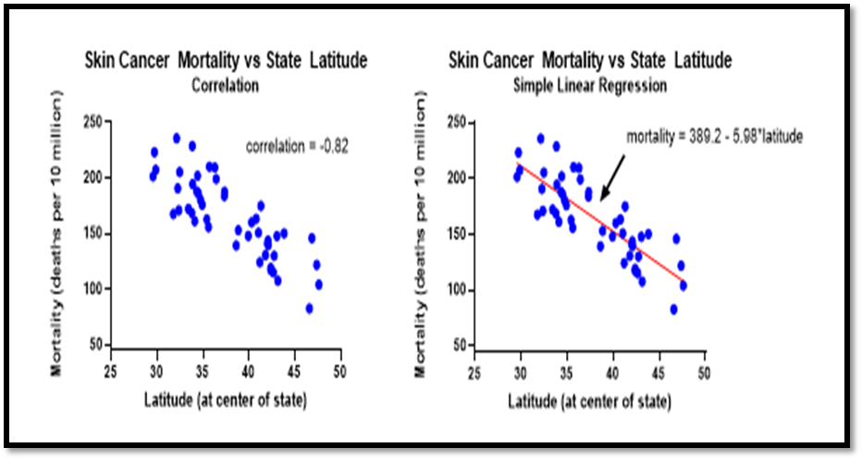

Correlation Analysis
Correlation Analysis involves various methods and techniques used for studying and measuring the extent of the relationship between the two variables. “Two variables are said to be in correlation if the change in one of the variables results in a change in the other variable”. Correlation problems which involve measuring the strength and direction of a relationship.
- When interpreting correlation, it's important to remember that just because two variables are correlated, it does not mean that one causes the other.
Types of Correlation:
Correlation describes the relationship between two or more variables and is classified by its direction, linearity, number of variables, and statistical measurement.
Type 1: Based on the direction of change of variables.
a) A positive relationship exists when both variables increase and decrease at the same time. (Study time & Exam score) Y= a + bx.

b) A negative relationship exists when one variable increases and the other variable decreases or vice versa. (Strength and age). Y= a - bx.

Example1: The following are the heights and weights of 10 students of a class. Draw a graph to indicate whether the correlation is negative or positive.

Height Cm | 170 | 172 | 181 | 157 | 150 | 168 | 166 | 175 | 177 | 165
Weight Kg | 65 | 66 | 69 | 55 | 52 | 64 | 62 | 75 | 72 | 63

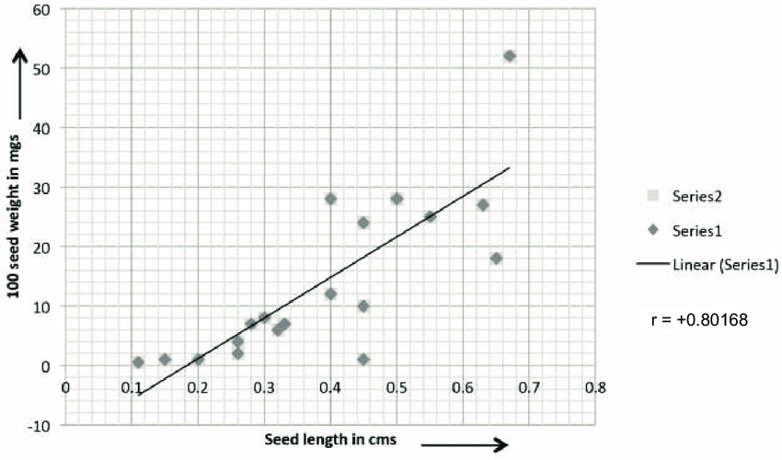
Fig 2: Positive relation between length &Weight.

Since the points are dense (close to each other) we can expect a high degree of correlation between the series of heights and weights. Further, since the points reveal an upward trend, the correlation is positive. Arrange data in increasing order of height and check that, as height increases, the weight also increases.
C) Zero (No) correlation situation in which there is no connection or relationship between two or more facts, numbers, etc. (There is no predictable relationship or pattern between the variables). Person height & exam scores.
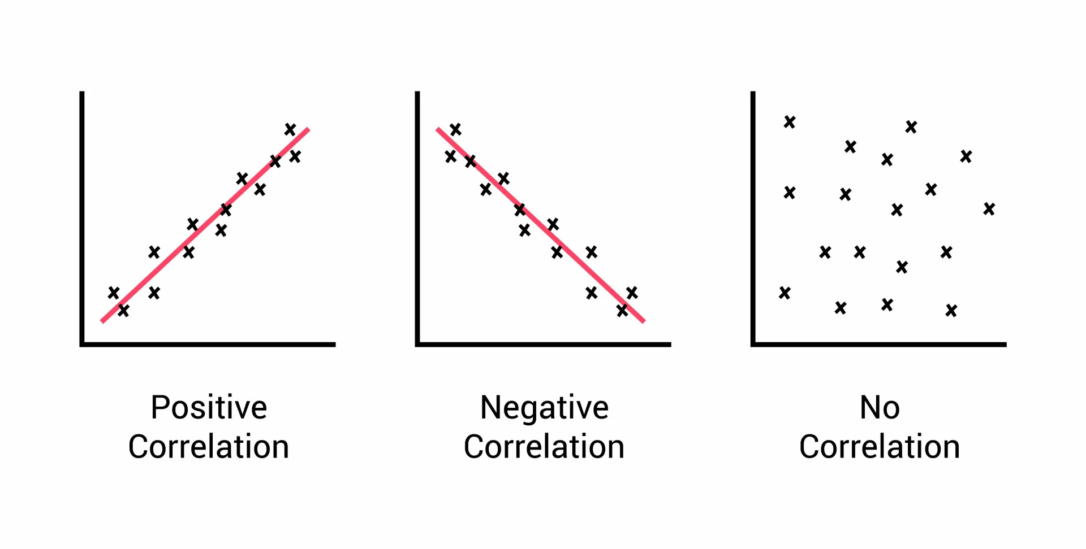

Fig 3: Direction type of correlation.

Type 2: Based upon the constancy of the ratio of change between the variables.
Correlation is divided into two types as linear correlation and Non-Linear correlation based upon the Constancy of the ratio of change between the variables.
Linear and Non - Linear correlation
- A linear correlation exists when two variables change together at a constant rate, and their relationship can be represented approximately by a straight line.
Example.
As study time increases, exam scores increase at a relatively constant rate.

- A non-linear correlation exists when two variables are related, but their relationship does not follow a straight-line pattern.
- (Corresponding to a unit change in one variable, the other variable does not change at a constant rate but changes at a fluctuating rate).
Example:
The relationship between exercise time and calories burned may change depending on the duration or intensity of exercise.
• Linear: Relationship follows a straight line.
• Non-linear: Relationship follows a curved line.
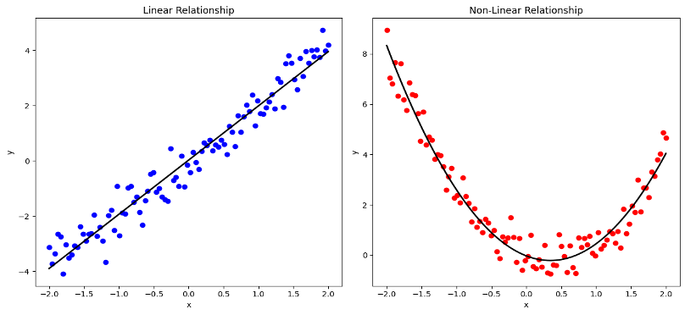
Fig 4: Linear & non-Linear correlation.

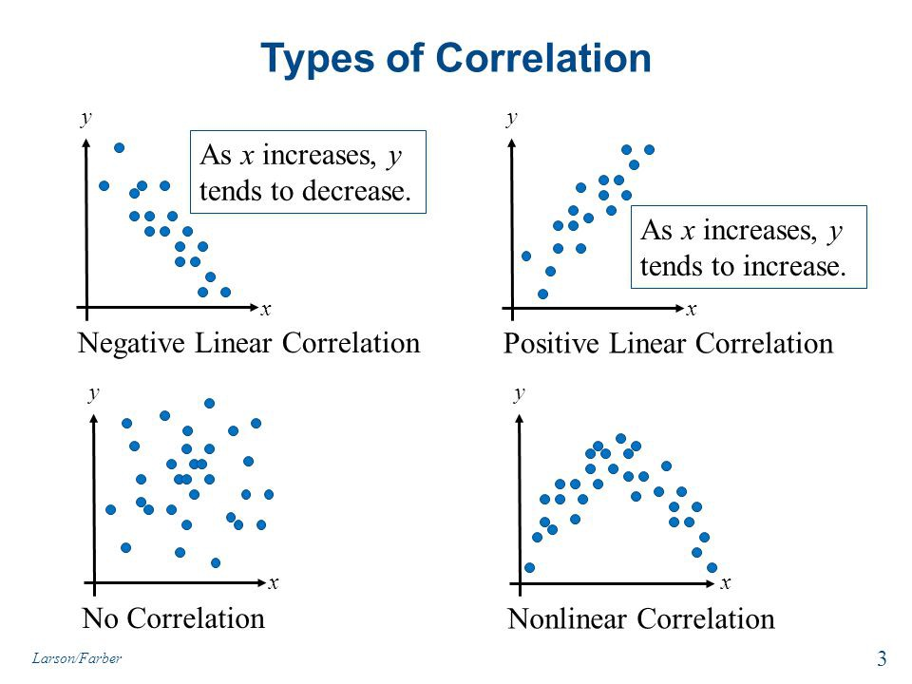
Fig 5: Type of correlation.

Type 3: Based upon the number of variables studied.
The correlation includes phenomena that can be described as quantity” numerical”. We have three kind of correlation in accordance with their variable.
- Simple Correlation: this kind of correlation study connects between independent variable(x) and dependent variable(y). Are taken for study then it is said to be simple correlation. Y= a + bx.

- Multiple Correlations: study the relation between two or more independent variables and one dependent variable. Are studied simultaneously, then it is termed as multiple correlation.

- Partial Correlation: measures the degree of association between two random variables, with the effect of a set of controlling random variables removed.

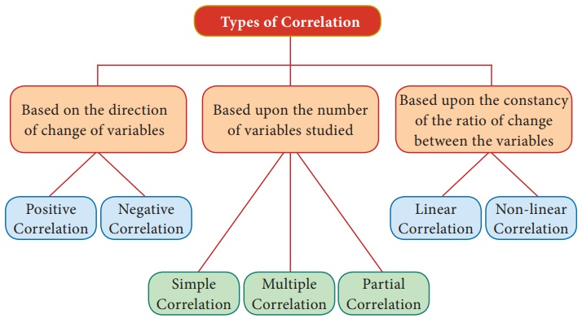
Fig 6: first three type of correlation.
Type 4: Based on Statistical Measurement Methods (Coefficients)
- Pearson Correlation: Measures the strength and direction of a linear relationship between continuous, normally distributed variables.

- Spearman's Rank Correlation: A non-parametric measure for monotonic relationships using ranked data instead of raw numbers.

- Kendall Tau: Similar to Spearman, used for assessing monotonic relationships in smaller sample sizes
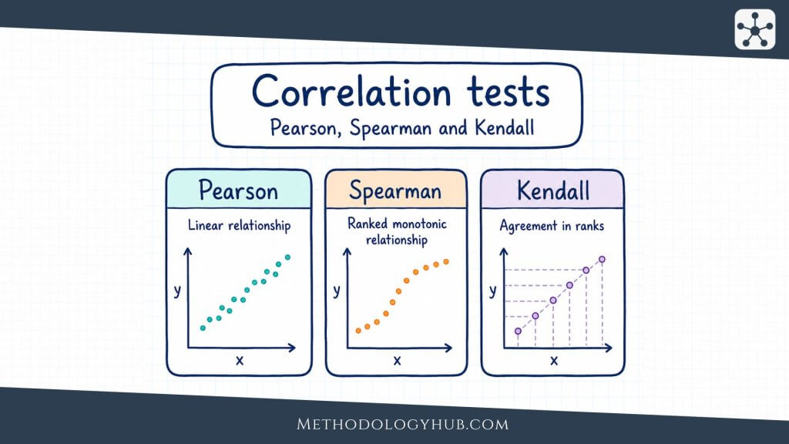
Fig 7: Correlation Test.
- A monotonic relationship is a mathematical or statistical relationship where two variables change together, but not necessarily at a constant rate.
In simple terms, as one variable increases, the other variable either always increases or always decreases. It never reverses direction.
Methods of Studying Correlation:
The various methods of ascertaining whether two variables are correlated or not are:
- Scatter diagram Method
2. Graphic Method.
3. Mathematical methods.
The first two are based on the knowledge of diagram and graphs, whereas the others are mathematical methods.

1. Scatter Diagram Method.
A simple visual graph used to show the relationship between two variables by plotting data points on a Cartesian grid.
X-Axis: Shows the independent variable (cause).
Y-Axis: Shows the dependent variable (effect).

Advantages of Scatter Diagram method.
(1) It is very simple and non- mathematical method
(2) It is not influenced by the size of extreme item.
(3) It is the first step in resting the relationship between two variables.
Disadvantages of Scatter diagram method.
It cannot establish the exact degree of correlation between the variables, but provides direction of correlation and depicts it is high or low.

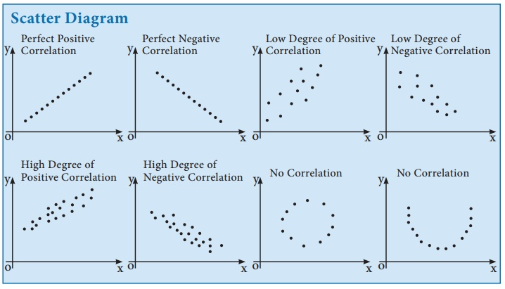
Fig 8: Scatter Diagrams.
2. Graphic method.
A visual technique used to solve mathematical and statistical problems by plotting data, lines, or curves on a coordinate grid. Instead of relying purely on algebraic or numerical formulas, it allows you to find solutions, trends, and intersections visually.
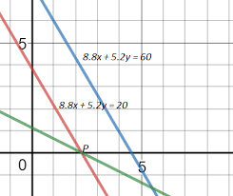
Fig 9: Graphical method.
3. Mathematical methods.
First: Measured phenomena.
a) Simple Correlation.
Karl Pearson’s Method is popularly known as Pearson’s coefficient of correlation denoted by the symbol ‘r’. The correlation coefficient computed from the sample data measures the strength and direction of a relationship between two variables.
The range of the correlation coefficient is. (- 1 to + 1 and is identified by r).
The formula is to compute a correlation coefficient:

- r = $\frac{N\sum{XY-(\sum{X)(\sum{Y)}}}}{\sqrt{N\sum{x^{2 }}-(\sum{x)^{2}}}\sqrt{N\sum{Y^{2 }}-(\sum{Y)^{2}}}}$

Where N is the number of data pairs, x is the independent variable and y the dependent variable. ‘r’ is calculated by Direct Method without taking deviation of terms either from actual mean or assumed mean.
The value of r can range between ( -1 and + 1).
r = 0 is no linear correlation
r = 1 is perfect positive (slope up from bottom left to top right) linear correlation
r = -1 is perfect negative (slope down from top left to bottom right) linear correlation.

2) r is calculated by taking the Deviation from actual mean.
r$=\frac{\sum{xy}}{\sqrt{\sum{ }x^{2}}\sqrt{y^{2}}}$ Where : x = $\sum{(x-\overline{x})}$ , y = $\sum{(y-\overline{y})}$

3) ‘r’ is calculated by taking assumed mean.
r = $\frac{N\sum{dxdy-(\sum{dx)(\sum{dy)}}}}{\sqrt{N\sum{{dx}^{2 }}-(\sum{dx)^{2}}}\sqrt{N\sum{{dy}^{2 }}-(\sum{dy)^{2}}}}$
Where dx refers to deviations of x series from assumed mean (x- x̅), dy refers to deviations of y series from an assumed mean of (y- $\overline{y}$ ) .
∑dx dy = Sum of product of the deviations x and y series from their assumed means.
∑dx² = Sum of the squares of the deviations of X series from an assumed mean
∑dy²= Sum of the squares of the deviations of x series from an assumed mean
∑dx = sum of the deviation of x series from an assumed mean of x
∑dy = sum of the deviation of y series from an assumed mean of y
Procedure for Computing the Correlation Coefficient: (For Direct and Deviation from actual mean method).
Note:
Correlation coefficient has two points (Kind of relation &Relation power).

Kind of relation:
- In case of exact positive linear relationship the value of r is +1.
In case of a strong positive linear relationship, the value of r will be close to + 1.

- In case of exact negative linear relationship the value of r is –1.
In case of a strong negative linear relationship, the value of r will be close to – 1.

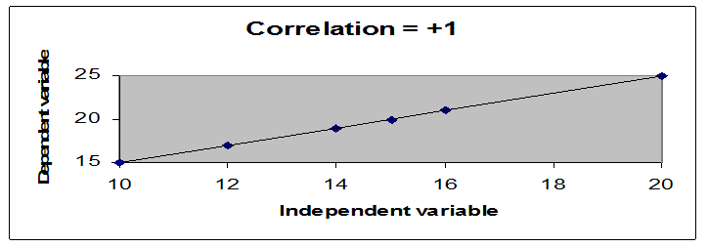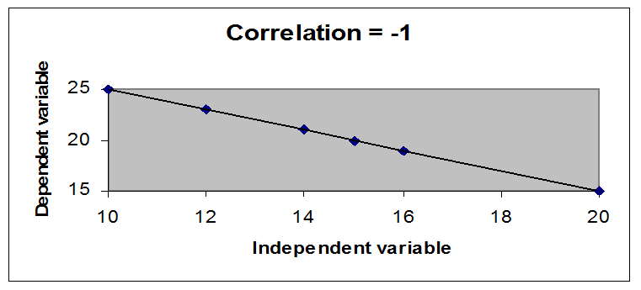

- In case of a weak relationship the value of r will be close to 0.
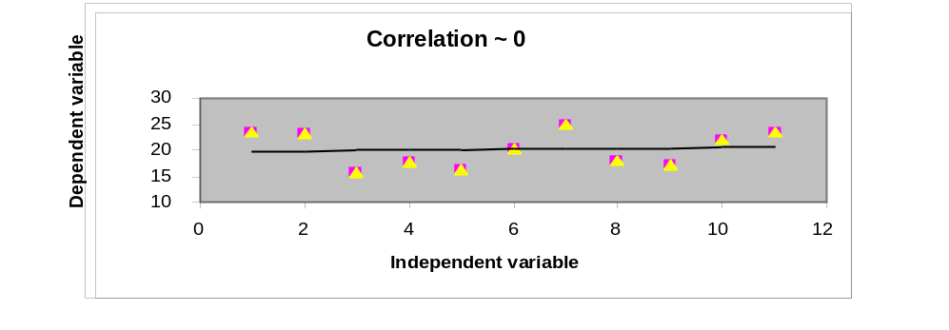
- In case of nonlinear relationship the value of r will be equal to 0.
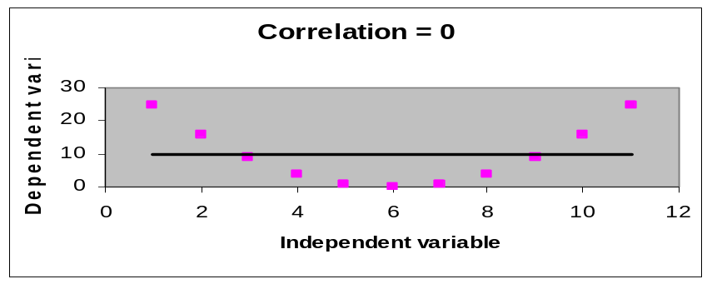

Relation Power:
The statistical scientist classified the relation power as in the table below:
Negative Correlation(-) | Positive Correlation(+)

Very strong | Strong | Medium | Weak | Very Weak | Very Weak | Weak | Medium | Strong | Very strong

 | -0.9 | -0.7 | -0.5 | - 0.3 | 0.3 | 0.5 | 0.7 | 0.9

(-1) Perfect correlation Perfect correlation (+1)

(0)
No Correlation
Table 1: The statistical scientist classified the relation power.

Example 2:
Find Relationship between HbA1c (Glycated Hemoglobin سكر الدم التراكمي ) and Fasting Blood Glucose (FBG) in diabetic patients. Use Karl Pearson Correlation

Patient | HbA1c (x) | FBG mg/dl (y)
1 | 6.2 | 125
2 | 7.0 | 145
3 | 7.8 | 165
4 | 8.5 | 185
5 | 9.2 | 205

Sol: Calculate the ∑x, ∑y, ∑xy, ∑x² and ∑y². Use the formula:
HbA1c  (x) | FBG mg/dl (y) | XY | X² | Y²
6.2 | 125 | 775 | 38.4 | 15625
7.0 | 145 | 1015 | 49 | 21025
7.8 | 165 | 1287 | 60.84 | 27225
8.5 | 185 | 1572 | 72.25 | 34225
9.2 | 205 | 1886 | 84.64 | 42025
Ʃ x=38.7 | Ʃ y=825 | Ʃ xy= 6535 | Ʃ x²= 305.13 | Ʃ y²=140125

r = $\frac{N\sum{XY-(\sum{X)(\sum{Y)}}}}{\sqrt{N\sum{x^{2 }}-(\sum{x)^{2}}}\sqrt{N\sum{Y^{2 }}-(\sum{Y)^{2}}}}$ r = $\frac{5\left(6535\right)-38.7(825)}{\sqrt{5\left(305.13\right)-{38.7}^{2} }\sqrt{5\left(140125\right)-{825}^{2} }}$
After calculation: r = +0.999
Interpretation:
a very strong positive correlation between HbA1c and fasting blood glucose in this sample. As HbA1c increases, fasting blood glucose also tends to increase.
Example 3:
(Direct Method) Calculate Karl Pearson’s Coefficient of correlation from the following data and interprets its value:
Price (x) | 10 | 12 | 14 | 15 | 19
Supply (y) | 40 | 41 | 48 | 60 | 50
Solution: Let us take price as X & supply as Y.
Price(X) | Supply (Y) | XY | X² | Y²
10 | 40 | 400 | 100 | 1600
12 | 41 | 492 | 144 | 1681
14 | 48 | 672 | 196 | 2304
15 | 60 | 900 | 225 | 3600
19 | 50 | 950 | 361 | 2560
Ʃ x=70 | Ʃ y=239 | Ʃ xy=3414 | Ʃ x²=1026 | Ʃ y²=11685

r = $\frac{N\sum{XY-(\sum{X)(\sum{Y)}}}}{\sqrt{N\sum{x^{2 }}-(\sum{x)^{2}}}\sqrt{N\sum{Y^{2 }}-(\sum{Y)^{2}}}}$ r = $\frac{5\left(3414\right)-70(239)}{\sqrt{5\left(1026\right)-{70}^{2} }\sqrt{5\left(11685\right)-{239}^{2} }}$
r = $\frac{340}{547.65}$ = + 0.621
Price of the product and supply for the product is medium positively correlated. When price of the product increases then the supply for the product also increases.
Example 4:
Using the data table on Age and Blood pressure, to find the correlation coefficient. Calculate the ∑x, ∑y, ∑xy, ∑x² and ∑y². Use the formula:
..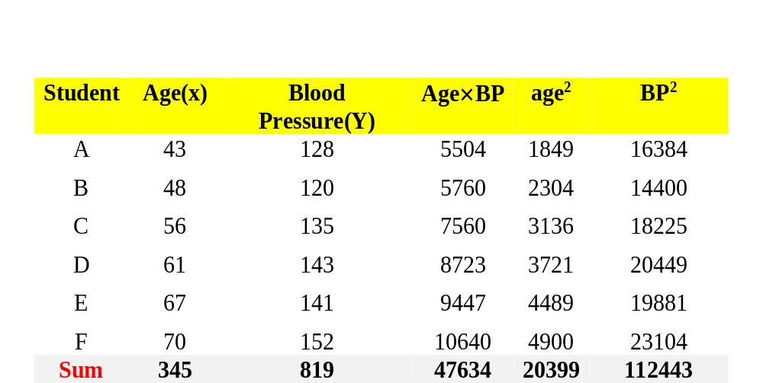
r = [n (∑xy) – (∑x)(∑y)] / {[n(∑x²) – (∑x)²][n(∑y²) – (∑y)²]}^{0.5}

Where n is the number of data pairs, x is the independent variable & y the dependent variable.
Solution: Substitute in the formula and solve for r:

r ={(6× 47634)-(345× 819)}/{[(6 ×20399)-(345)²][(6 ×112443)-(819)²]}^{0.5}

r = 0.897 $\sim 0.9$

The correlation coefficient r suggests a strong positive relationship between age and blood pressure.

Note: Correlation measures association and not causation.

b) The Multiple Correlation Coefficients(R):

A statistical measure that quantifies the strength of the linear relationship between a single dependent variable and a set of two or more independent variables.
Interpretation of R: The strength of the association is measured by the sample Multiple Correlation Coefficient; R, can be any value from 0 to +1.
  - The closer R is to one, the stronger the linear association is.
  - If R equals zero, then there is no linear association between the dependent variable and the independent variables.
Unlike the simple correlation coefficient, r, which tells both the strength and direction of the association, R tells only the strength of the association. R is never a negative value. This can be seen from the formula below, since the square root of this value indicates the positive root.
R= $\frac{\sqrt{r_{y_{x1}}^{2}+r_{y_{x2}}^{2}-2r_{{yx}_{1}}\left(r_{{yx}_{2}}\right)\left( _{r_{x1x2}}\right)}}{\sqrt{1-r_{x1x2}^{2}}}$

R value | Interpretation
1 | perfect linear relationship
0 | no linear relationship
No other values of R have precise definitions of strength. See the chart below.
R value | Interpretation
0.9 | strong association
0.5 | moderate association
0.25 | weak association

Example 5:
Suppose we want to study the relationship between Systolic Blood Pressure (Y) and two factors:
• Age (X₁)
• Body Mass Index – BMI (X₂)

Patient | Age (X₁) | BMI (X₂) | BP (Y)
1 | 25 | 22 | 115
2 | 35 | 25 | 125
3 | 45 | 28 | 135
4 | 55 | 31 | 145
5 | 65 | 34 | 155

The multiple correlation coefficients is represented by: ( R_{Y.X1X2}). It tells us how strongly Age and BMI together are associated with Blood Pressure.
- Pearson correlation (r): relationship between two variables.
- Multiple correlations (R): Relationship between one dependent variable and two or more independent variables.
Sol:
Step 1: Calculate Pearson correlation between Y & X₁

This represents the correlation between: Blood Pressure ↔ Age

Step 2: Calculate Pearson correlation between Y and X₂

This represents the correlation between: Blood Pressure ↔ BMI

Step 3: Calculate Pearson correlation between X₁ and X₂

This represents the correlation between: Age ↔ BMI

Step 4: Calculate the Multiple Correlation Coefficient Use the formula:

R= $\frac{\sqrt{r_{y_{x1}}^{2}+r_{y_{x2}}^{2}-2r_{{yx}_{1}}\left(r_{{yx}_{2}}\right)\left( _{r_{x1x2}}\right)}}{\sqrt{1-r_{x1x2}^{2}}}$
Substitute the three correlation coefficients into the formula:

Step 5: Interpret the result. The value of R ranges from: 0≤ R ≤1

• R closes to 0 → Weak multiple relationships.

• R closes to 1 → Strong multiple relationships.

• R = 1 → Perfect multiple relationship.

- Multiple correlation coefficient (R) tells us how strongly two or more independent variables together are related to one dependent variable.
Example:

Age + BMI Blood Pressure

Unlike Pearson correlation, which examines the relationship between two variables only.

c) Partial correlation.
Partial correlation is a measure of the strength and direction of a linear relationship between two continuous variables whilst controlling for the effect of one or more other continuous variables (also known as 'covariates' or 'control' variables).
Partial correlation measures the degree of association between two random variables, with the effect of a set of controlling random variables removed.

r_{xy.z} = $\frac{r_{xy}-\left(r_{xz}r_{yz}\right)}{\sqrt{\left(1-r_{xz}^{2}\right)\left(1-r_{yz}^{2}\right)}}$

What is a partial correlation?
Partial correlation is the relationship between two variables while controlling for a third variable. The purpose is to find the unique variance between two variables while eliminating the variance from a third variable.
To find the partial correlation coefficient:
- Find simple correlation coefficient (r) between the variables.
- Find partial correlation coefficient from two formulas.

Suppose Y is a dependent variable, depending on other variables X₁, X₂… Xn.. Partial correlation is a measure of the relationship between Y and any one of the variables X₁, X₂,…, Xn, as if the other variables have been eliminated from the situation.

The partial correlation coefficient is defined in terms of simple correlation coefficients as follows:

Let r_{12. 3} denote the correlation of X₁ and X₂ by eliminating the effect of X₃.

Let r₁₂ be the simple correlation coefficient between X₁ and X₂.

Let r₁₃ be the simple correlation coefficient between X₁ and X₃.

Let r₂₃ be the simple correlation coefficient between X₂ and X₃.

Then we have:

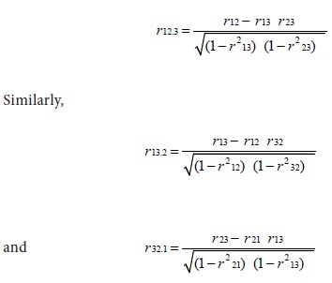

Second: Unmeasured phenomena.
Phenomena cannot be measured directly using a numerical or digital scale. Can be classified into (ordered categories or ranked) according to degree or severity of a particular characteristic.
For example, health status may be classified into ordered categories such as poor, good, and excellent. These categories have a natural order, ranging from the lowest to the highest level of health status. Similar approaches can be applied to other phenomena that are assessed through ordinal or ranked data.
The most important measures are:
- Spearman’s Rank correlation coefficient.$(ρ)$
- Kendall’s Rank correlation coefficient.$(τ)$

Note:
Unlike Pearson’s correlation, there is no requirement of normality and hence it is a nonparametric statistic.
Normal data | Non- Normal
Linear | Linear or Not

Pearson’s correlation Spearman’s correlation
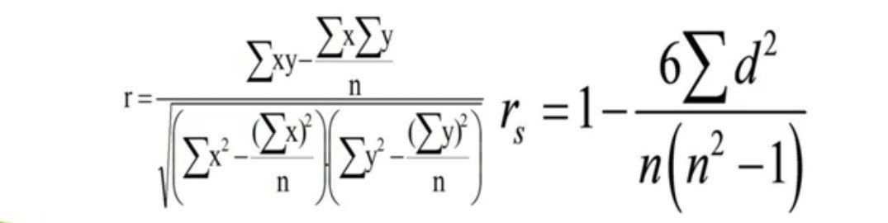
- Spearman’s Rank correlation coefficient.$(ρ)$
A non-parametric statistical measure that calculates the strength and direction of a monotonic relationship between two ranked or continuous variables.

- $r_{s}=ρ=1- \frac{6\sum{d_{i}^{2}}}{n(n^{2}-1)}$ $r_{s}=ρ=Spearman correlation$
$r_{s}=$𝝆 = Spearman’s rank correlation coefficient
di = Difference between the two ranks of each observation
n = Number of observations
- Monotonic relationship is one in which two variables consistently move in the same direction (positive) or in opposite directions (negative), without necessarily changing at a constant rate.
For example as the severity of a disease increases, quality of life tends to decrease. This represents a negative monotonic relationship. علاقه رتيبه سالبه
- Spearman’s rank correlation measures the strength and direction of association between two ranked variables (-1 to 1)
- A value of 0 means that there is no association between ranks.

Example 6: Consider the score of 5 students in Math's &Science are mentioned in the table.
Step 1: Create a table for the given data.
Students | Math’s | science
A | 35 | 24
B | 20 | 35
C | 49 | 39
D | 44 | 48
E | 30 | 45

Step 2: Rank both the data in descending order. The highest marks will get a rank of 1 and the lowest marks will get a rank of 5.
Step 3: Calculate the difference between the ranks (d) and the square value of d.
Step 4: Add all your $d^{2}$ values.
Students | Math’s | Rank | science | Rank | d | $$d^{2}$$
A | 35 | 3 | 24 | 5 | 2 | 4
B | 20 | 5 | 35 | 4 | 1 | 1
C | 49 | 1 | 39 | 3 | 2 | 4
D | 44 | 2 | 48 | 1 | 1 | 1
E | 30 | 4 | 45 | 2 | 2 | 4
 |  |  |  |  |  | Tot =14
Step 5: Insert these values into the formula.
$r_{s}=ρ=1- \frac{6\sum{d_{i}^{2}}}{n(n^{2}-1)}$ = 1- $\frac{6×14}{5(25-1)}$ = 0.3
The Spearman’s Rank Correlation for the given data is 0.3 the value is near 0, which means that there is a weak positive correlation between the two ranks.
Medical Example
Suppose we want to investigate the relationship between disease severity and CRP (C-reactive protein) levels in 10 patients.
After ranking the data and calculating r_{s} = + 0.70
Interpretation:
a strong positive correlation between disease severity and CRP levels (r_{s} = 0.70). This means that as disease severity increases, CRP levels tend to increase as well.

- Kendall’s Rank correlation coefficient.$(τ)$
A non-parametric statistic that measures the strength and direction of association between two ordinal or ranked variables. Unlike the Pearson correlation, which looks for a linear relationship in continuous data, Kendall's Tau evaluates data based on relative rankings. This makes it ideal for data that is skewed, contains outliers, or is purely ordinal.
$τ=$ $\frac{C-D}{\frac{n\left(n-1\right)}{2}}$

Where:
C = Number of concordant pairs
D = Number of discordant pairs
n = Number of observations

Example 7: A researcher wants to examine the association between disease severity and pain severity in 5 patients. Both variables are ranked from 1 to 5.
هذا المثال للاطلاع
Pain severity (Rank) | Disease severity (Rank) | Patient
1 | 1 | A
3 | 2 | B
2 | 3 | C
5 | 4 | D
4 | 5 | E

We compare every pair of patients and classify each pair as:
• Concordant pair: The patient with the higher disease-severity rank also has the higher pain-severity rank.
• Discordant pair: The patient with the higher disease-severity rank has the lower pain-severity rank.
For this example:
• Number of concordant pairs (C) = 8 • Number of discordant pairs (D) = 2

- Total pairs: عدد المقارنات الكلي
$\frac{ n\left(n-1\right)}{2}$ = $\frac{5\left(5-1\right)}{2}$ = 10
$τ= \frac{C-D}{10}=\frac{8-2}{10}$ = 0.6
Indicating a moderate positive association between disease severity and pain severity. Patients with greater disease severity tend to have higher pain severity.

توضيح

1. Concordant pair (C)
A pair is concordant when the two variables move in the same direction.
• If X increases → Y also increases
• If X decreases → Y also decreases

Example:
Patient A: X = 2, Y = 5
Patient B: X = 4, Y = 8
Since X increases (2 → 4) and Y also increases (5 → 8), the pair is concordant.

2. Discordant pair (D)
A pair is discordant when the two variables move in opposite directions.
• If X increases → Y decreases
• If X decreases → Y increases
Example:
Patient A: X = 2, Y = 8
Patient B: X = 4, Y = 5
Since X increases (2 → 4), but Y decreases (8 → 5), the pair is discordant.

Regression analysis

A regression is a statistical analysis assessing the association between two variables. It is used to find the relationship between two variables. The regression statistics can be used to predict the dependent variable when the independent variable is known. Regression goes beyond correlation by adding prediction capabilities. The regression line is the line that best fits the data:

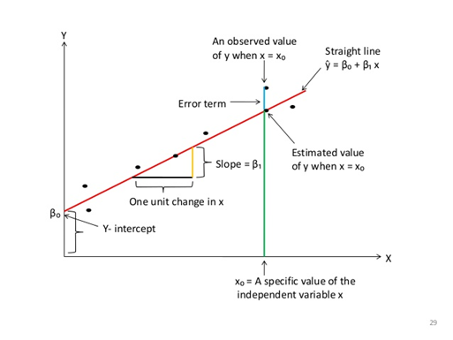
Fig 10: Explain the Straight-line equation.
Types of regression analysis
Regression analysis includes several variations, such as linear, multiple linear, and nonlinear. The most common models are simple linear and multiple linear. Nonlinear regression analysis is commonly used for more complicated data sets in dependent & independent variables show a nonlinear relationship. Regression analysis offers numerous applications in various disciplines, including finance.
Regression Models
A model of the relationship is hypothesized, and estimates of the parameter values are used to develop an estimated regression equation. Various tests are then employed to determine if the model is satisfactory. If the model is deemed satisfactory, the estimated regression equation can be used to predict the value of the dependent variable given values for the independent variables.
- Regression Analysis – Linear model -
Linear regression analysis is based on six fundamental assumptions:
- The dependent and independent variables show a linear relationship between the slope and the intercept.
- The independent variable is not random.
- The value of the residual (error) is zero.
- The value of the residual (error) is constant across all observations.
- The value of the residual (error) is not correlated across all observations.
- The residual (error) values follow the normal distribution.

Simple linear regression model (1st order linear model)
The model used to describe the relationship between a single dependent variable y and a single independent variable x is:
y = a + bx + k
a = y-intercept, b =slope of the line, k = probabilistic error

Both a & b are referred to as the model parameters. k is a probabilistic error term that accounts for the variability in y that cannot be explained by the linear relationship with x.
If the error term were not present, the model would be deterministic; in that case, knowledge of the value of x would be sufficient to determine the value of y.
In a simple regression analysis, one dependent variable is examined in relation to only one independent variable. The analysis is designed to derive an equation for the line that best models the relationship between the dependent and independent variables. This equation has the mathematical form: y = a + bx
Where, y is the value of the dependent variable, x is the value of the independent variable, a is the intercept of the regression line on the y axis when x = 0, and b is the slope of the regression line.
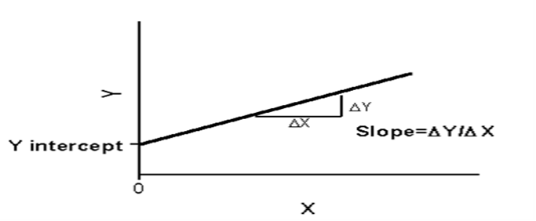
Regression Equation y = a + bx
Slope (b) = (nΣxy - (Σx)(Σy)) / (nΣx² - (Σx)²)
Intercept (a) = (Σy - b(Σx)) / n
Where x and y are the variables.
b = is the gradient, slope or regression coefficient
a = is the intercept of the line at Y axis or regression constant
n = number of values or elements
x = First Score
y = Second Score
Σxy = Sum of the product of first and Second Scores
Σx= Sum of First Scores
Σy = Sum of Second Scores
Σx² = Sum of square First Scores

Medical Example of Regression
A researcher wants to study the relationship between BMI (Body Mass Index) and systolic blood pressure (SBP) in 10 patients.
• Independent variable (X): BMI
• Dependent variable (Y): Systolic Blood Pressure (mmHg)
Suppose the regression equation is: Y = 80 + 2.5X
Interpretation:
For every 1-unit increase in BMI, systolic blood pressure is expected to increase by approximately 2.5 mmHg.

Prediction:
If a patient has a BMI of 28:
Y = 80 + (2.5$×$ 28) Y = 150 mmHg
So, the predicted systolic blood pressure is 150 mmHg.

Example 8:
Use the data in below table to find Simple Linear Regression equation.
X value | Y value
60 | 3.1
61 | 3.6
62 | 3.8
63 | 4
65 | 4.1

To find regression equation, we will first find slope, intercept and use it to form regression equation.
Step 1: Count the number of values.
n = 5
Step 2: Find xy, x² See the below table
x value | y value | x*y | X²=x*x
60 | 3.1 | 60 * 3.1 = 186 | 60 * 60 = 3600
61 | 3.6 | 61 * 3.6 = 219.6 | 61 * 61 = 3721
62 | 3.8 | 62 * 3.8 = 235.6 | 62 * 62 = 3844
63 | 4 | 63 * 4 = 252 | 63 * 63 = 3969
65 | 4.1 | 65 * 4.1 = 266.5 | 65 * 65 = 4225

Step 3: Find Σx, Σy, Σxy, Σx².
Σx = 311
Σy = 18.6
Σxy = 1159.7
Σx² = 19359
Step 4: Substitute in the above slope formula given.
Slope (b) = (nΣxy - (Σx)(Σy)) / (nΣx² - (Σx)²)
= ((5)*(1159.7)-(311)*(18.6))/((5)*(19359)-(311)²)
= (5798.5 - 5784.6)/(96795 - 96721)
= 13.9/74 = 0.19
Step 5: Now, again substitute in the above intercept formula given.
Intercept (a) = (Σy - b(Σx)) / n
= (18.6 - 0.19(311))/5
= (18.6 - 59.09)/5
= -40.49/5 = -8.098
Step 6: Then substitute these values in regression equation formula
Regression Equation (y) = a + bx
= -8.098 + 0.19x.
Suppose if we want to know the approximately value for the variable x = 64. Then we can substitute the value in the above equation.
Regression Equation (y) = a + bx
= -8.098 + 0.19(64).
= -8.098 + 12.16
= 4.06

This example will guide you to find the relationship between two variables by calculating the Regression from the above steps.

Example 9:
The data represents the number of open-heart operations that were made in a private hospital and the number of doctors involved the period from 2010 to 2019.

No. of operation (Y) | 112 | 128 | 130 | 158 | 162 | 140 | 138 | 175 | 125 | 142
No. of doctors (X) | 35 | 40 | 38 | 67 | 64 | 59 | 44 | 69 | 25 | 50

Find:
- Estimation the regression equation.
- How many operations are expected if the number of doctors in hospital increases to 80?

Solution:
To find regression equation, we will first find slope, intercept and use it to form regression equation.

Year | $$x_{i}$$ | $$y_{i}$$ | $$\sum{x_{i}y_{i}}$$ | $$\sum{x_{i}^{2}}$$
2010 | 35 | 112 | 3920 | 1225
2011 | 40 | 128 | 5120 | 1600
2012 | 38 | 130 | 4940 | 1444
2013 | 44 | 138 | 6072 | 1936
2014 | 67 | 158 | 10586 | 4489
2015 | 64 | 162 | 10368 | 4096
2016 | 59 | 140 | 8260 | 3481
2017 | 69 | 175 | 12075 | 4761
2018 | 25 | 125 | 3125 | 625
2019 | 50 | 142 | 7100 | 2500
Total | 491 | 1410 | 71566 | 26157

Σx = 491 | Σy = 1410 | Σxy = 71566 | Σx² = 26157
Substitute in the slope formula given.
Slope (b) = (nΣxy - (Σx)(Σy)) / (nΣx² - (Σx)²)
b = (10$×$71566 - 491$×1410 )$/(10$×$26157 – (491)²)
b = (715660 – 692310) / (261570 – 241081)
b = 23350 / 20489 = 1.140
Now, again substitute in the intercept formula given.
Intercept (a) = (Σy - b(Σx)) / n
a = 1410- 1.140(491) / 10
a = 1410 – 560 /10 = 850/ 10 = 85
Regression Equation (y) = a + bx
(y) = 85 + 1.140 x.
From the equation if the number of doctors stay constant not increase then the number of operations will be 85.
The number of operations that is expected to take place in hospital operations by increasing the number of doctors to 80 is:
(y) = 85 + 1.140 x= 85 + 1.140(80)
(y) = 85 + 91 = 176 Expected Operations.
Example 10:
We will look at how Hours of Exercise per week (X) affect a patient's Resting Heart Rate (Y). A lower resting heart rate generally indicates better cardiovascular fitness. The Medical Case:A cardiologist tracks the weekly exercise habits of 5 patients and measures their resting heart rate. We want to find the linear regression equation to predict the resting heart rate of a new patient who exercises for 5 hours a week.
- Independent Variable (X): Exercise Time (Hours/Week)
- Dependent Variable (Y): Resting Heart Rate (Beats Per Minute - BPM)

$$X^{2}$$ | $$XY$$ | - (Y) Resting Heart Rate | Exercise Hours (X) | Patient
1 | 80 | 80 | 1 | 1
4 | 148 | 74 | 2 | 2
9 | 216 | 72 | 3 | 3
16 | 264 | 66 | 4 | 4
36 | 372 | 62 | 6 | 5
$$\sum{X^{2}=66}$$ | $$\sum{XY=1080}$$ | $$\sum{y=354}$$ | $$\sum{x=16}$$ | $$\sum{sum}$$

n= 5, Calculate the slope Slope (b) = (nΣxy - (Σx)(Σy)) / (nΣx² - (Σx)²)
b = $\frac{5\left(1080\right)-\left(16\right)\left(354\right)}{5\left(66\right)-{\left(16\right)}^{2}} = \frac{5400-5664}{330-256}= \frac{-264 }{74}≈ -3.57$
Now, again substitute in the intercept formula given.
Intercept (a) = (Σy - b(Σx)) / n
a = $\frac{354-(-3.57×16)}{5} = \frac{354-(-57.12×16}{5} = \frac{411.12}{5} ≈82.22$
Then substitute these values in regression equation formula
Regression Equation (y) = a + bx
= 82.22 +( - 3.57 x).
For predictable: y= 82.22 +( - 3.57( 5) = 82.22 – 17.85 = 64.37
- The medical interpretation of the final result is that regular physical exercise has a strong cardio protective effect by lowering the resting heart rate.

- Regression Analysis – Multiple linear regression
Multiple linear regression analysis is essentially similar to the simple linear model, with the exception that multiple independent variables are used in the model. The mathematical representation of multiple linear regressions is:
Y = a + bX₁ + cX₂ + dX₃ + ϵ
Where:
Y – dependent variable.
X₁, X₂, X₃ – Independent (explanatory) variables.
a – Intercept on y-axis.
b, c, d – Slopes.
ϵ – Residual (error).

Multiple linear regressions follow the same conditions as the simple linear model. However, since there are several independent variables in multiple linear analyses, there is another mandatory condition for the model:
Non-collinearity: Independent variables should show a minimum of correlation with each other. If the independent variables are highly correlated with each other, it will be difficult to assess the true relationships between the dependent and independent variables.
Example 11: The following represents the independent variables Age (years) & weight (Kg) and dependent variable blood pressure for six men. Find the multiple linear regression equation. Using the data below.

People | Blood pressure(Y) | Age (X₁) | Weight (X₂)
1 | 130 | 43 | 102
2 | 120 | 48 | 85
3 | 135 | 56 | 95
4 | 143 | 61 | 110
5 | 141 | 67 | 98
6 | 162 | 70 | 122
Σ | 831 | 345 | 612
Mean | 138.5 | 57.5 | 102

The mathematical representation of multiple linear regressions is:
Y = a + bX₁ + cX₂ + dX₃ + ϵ
We neglected the error (ϵ) Then Y = a + bX₁ + cX₂ + dX₃

The table below (2 parts) prepared all the required calculation for: Part 1
B. P  Y_{i} | Age  X_{1i} | Weight  X_{2i} | (Y_{i} - $\overline{Y}$) | $$\left(X_{1i} -\overline{X_{1i}}\right)$$ | $$\left(X_{2i} -\overline{X_{2i}}\right)$$
130 | 43 | 102 | -8.5 | -14.5 | 0
120 | 48 | 85 | -18.5 | -9.5 | -17
135 | 56 | 95 | -3.5 | -1.5 | -7
143 | 61 | 110 | 4.5 | 3.5 | 8
141 | 67 | 98 | 2.5 | 9.5 | -4
162 | 70 | 122 | 23.5 | 12.5 | 20
Ʃ 831 | Ʃ 345 | Ʃ 612 | 0 | 0 | 0
Mean =138.5 | Mean =57.5 | Mean =102

Part 2:
Y_{i}X_{1i} | Y_{i}X_{2i} | X_{1i} X_{2i} | $$Y_{i}^{2}$$ | $$X_{1i}^{2}$$ | $$X_{2i}^{2}$$
123.25 | 0 | 0 | 72.25 | 210.25 | 0
175.75 | 314.5 | 161.5 | 342.25 | 90.25 | 289
5.25 | 24.5 | 10.5 | 12.25 | 2.25 | 49
15.75 | 36 | 28 | 20.25 | 12.25 | 64
23.75 | -10 | -38 | 6.25 | 90.25 | 16
293.75 | 470 | 250 | 552.25 | 156.25 | 400
Ʃ 637.5 | Ʃ 835 | Ʃ 412 | Ʃ 1005.5 | Ʃ 561.5 | Ʃ 818

Using the data in table above (2 Parts). Regression equation constant (a, b, c) can be estimated using the formula:
b = $\frac{\left(ƩYiX1i\right)\left( Ʃ X_{2i}^{2} \right)-\left(ƩYiX2i\right)( Ʃ X1i X2i )}{\left( ƩX_{1i}^{2} \right)\left(Ʃ X_{2i}^{2} \right)-( Ʃ X1i X2i )^{2}}$
b = $\frac{\left(637.5\right)\left(818\right)-(835)(412) }{\left(561.5\right)\left(818\right)-(412 )^{2} }$ = $\frac{177455}{289563}$ = 0.613
c = $\frac{\left(Ʃ YiX2i\right)\left( Ʃ X_{1i}^{2} \right)-\left(ƩYiX1i\right)( Ʃ X1i X2i )}{\left( ƩX_{1i}^{2} \right)\left(Ʃ X_{2i}^{2} \right)-( Ʃ X1i X2i )^{2}}$
c = $\frac{\left(835\right)\left(561.5\right)-(637.5)(412)}{\left(561.5\right)\left(818\right)-(412 )^{2}}$ = $\frac{2062025}{289563}$ = 0.712
a = $\overline{Y}$ – b ${\overline{x}}_{1}$ – c ${\overline{x}}_{2}$
a = 138.5 – (0.613)(57.5) – (0.712)(102) = 30.626
The estimated regression equation would be:
Y = a + bX1 + cX2
Y = 30.626 + (0.613) (Age) + (0.712) (Weight).

- Regression Analysis – Non-Linear Regression.
In statistics, nonlinear regression is a form of regression analysis in which observational data are modeled by a function which is a nonlinear combination of the model parameters and depends on one or more independent variables. The data are fitted by a method of successive approximations.
Nonlinear regression uses logarithmic functions, trigonometric functions, exponential functions, power functions, Lorenz curves, Gaussian functions, and other fitting methods.
The simplest statistical relationship between a dependent variable Y and one or more independent or predictor variables X₁, X₂, ... is
Y = B₀ + B₁X₁ + B₂X₂ + ... + e
Where (e) represents a random deviation from the mean relationship represented by the rest of the model. With a single predictor, the model is a straight line. With more than one predictor, the model is a plane or hyperplane. While such models are adequate for representing many relationships (at least over a limited range of the predictors), there are many cases when a more complicated model is required.
There are several procedures for fitting nonlinear models. The models that may be fit include:
1. Transformable nonlinear models: models involving a single predictor variable in which transforming Y, X or both results in a linear relationship between the transformed variables.
2. Polynomial models: models involving one or more predictor variables which include higher-order terms such as B₁,₁X₁² or B₁,₂X₁X₂.
3. Models that is nonlinear in the parameters: models in which the partial derivatives of Y with respect to the predictor variables involve the unknown parameters.
While the first 2 types of models may be fit using linear least squares techniques, the third requires a numerical search procedure.
Non-Linear Regression Attributes Data Analysis is organized into discrete data types (groups or categories.). Simple Linear regression is use to predict the relationship between two variable (x & y) with a straight line y= mx +b.
While nonlinear regression aka Attributes Data Analysis is used to explain the nonlinear relationship between a response variable and one or more than one predictor variable (mostly curve line).

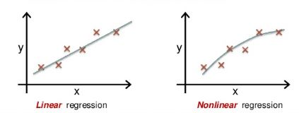
Fig 11: Linear V.S. Nonlinear regression.

Dr. Abdullah Abdulhadi Abdullah
2026-27

