**Video Compression**

**Compression** is a technique of reducing the amount of storage required to hold a digital file to reduce the disk space the file requires and allows it to processed and transmitted more quickly.

**Why we need video compression?**

• Occupies less disk space.

• Reduce bandwidth for transmission through a network.

• Lower communication cost.

• It leads to emergence of new applications.

• Make Reading and writing is faster.

**Video compression based on two principles**

**1- Intra-frame** refers to the fact that the various lossless and lossy compression techniques are performed relative to information that is contained only within the current frame, and not relative to any other frame in the video sequence, is concern with the **spatial redundancy** that exists in each frame.

**2- Inter-frame** is a frame in a video compression stream which is expressed in terms of one or more neighboring frames. The "inter" part of the term refers to the use of Inter frame prediction. This kind of prediction tries to take advantage from **temporal redundancy** between neighboring frames allowing achieve higher compression rates, it should encode each successive frame by identifying the diﬀerences between the frame and its predecessor, and encoding these diﬀerences. If the frame is very diﬀerent from its predecessor, it should be coded independently of any other frame.

**Video compression is typically achieved by exploiting two types of redundancies:**

1. **Temporal redundancy**
2. **Spatial redundancy**

**1-Temporal Redundancies**

Since a video is essentially a sequence of pictures sampled at a discrete frame rate, two successive frames in a video sequence look largely similar. The extent of similarity between two successive frames depends on how closely they are sampled and the motion of the objects in the scene. If the frame rate is 30 frames per second, two successive frames of video are likely to be very similar. So temporal redundancy can be used in reducing the differences between frames (B and P frame) by removing the temporal redundancy of a set of frames

**2-Spatial Redundancies**

Is reduced by registering differences between parts of a single frame (I- frames). The reason is that the correlation between one pixel and its neighbor pixels is very high, so the values of one pixel and its adjacent pixels are very similar. Once the correlation between pixels is reduced, we can reduce the storage quantity.

So spatial redundancy aims to compress still images (I-frames) by removing spatial redundancy that exist in each frame in video sequence

**Frame types**

***Intra coded Frame (I-frame):*** I-frame is a “key-frame”, like a conventional static image file. I-frame is entirely coded in one frame by intra-frame technique such as DCT. This type of frame no need for previous information.

***Predictive Frame (P-frame):*** P-frame is coded using one-directional motion-compensated prediction from a previous frame, which can be either I-frame or P-frame. P-frame holds only the changes in the image from previous I or P fame. P-frame is generally referred to as inter-frame.

***Bidirectional predictive frame (B-frame):*** B-frame is coded using bi-directional motion-compensated prediction from a previous frame and future frame. The reference can be either I-frame or P-frame. B-frame is also referred to as inter-frame. B-frame can save even more space by using differences between the current frame and both the preceding and following frames

The distance between two nearest I-frame is denoted by N, and the distance between the nearest I-frame and P-frame is denoted by M. see figure below

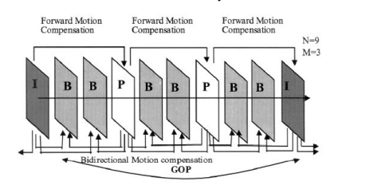

**Figure: Frame Types**

The GOP ([Group of pictures](https://docs.aws.amazon.com/elemental-live/latest/ug/vq-gop.html)) is the distance between two key-frames, measured in the number of frames, or the amount of time between key-frames.