C.V
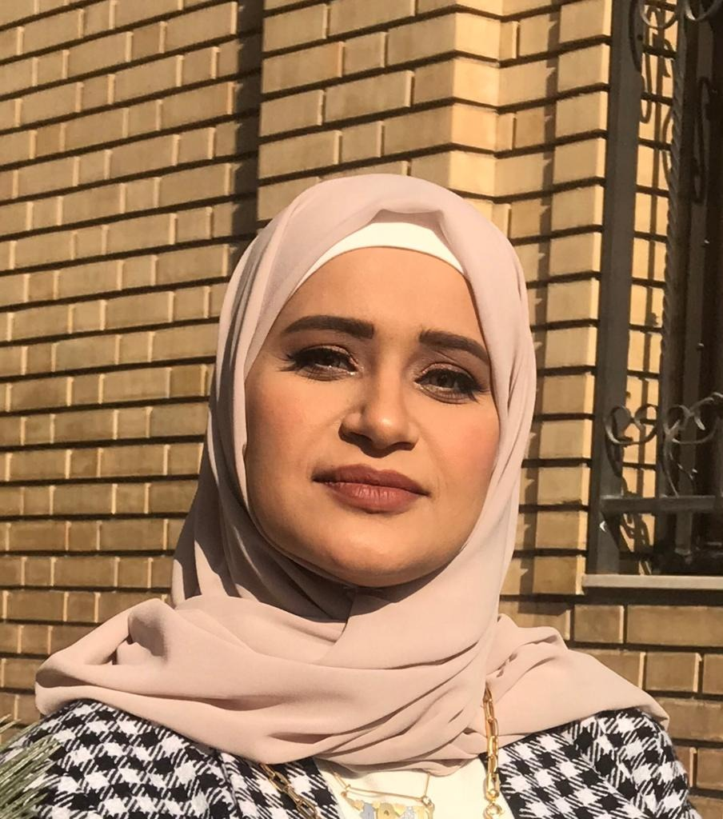

Photo

Link of Scopus: https://www.scopus.com/authid/detail.uri?authorId=57455557300
Name: Dr. Sarah Salman Abdul Al-Rahman
Date of Birth: 27/4/1979
Religion: Muslim
Martial statues: Married
No. of children: 3
Specialization: Polymer Chemistry
Position: Teaching Staff
Scientific Degree: Lecturer
Work Address: University of Baghdad / College of Education for Pure Science - Ibn Al-Haitham / Department of Chemistry
Mobile: 00964- 07740613081
E-mail: sarah.s.a@ihcoedu.uobaghdad.edu.iq
- First, Scientific Certification:
Date | College | University | Degree science
2001 | College of Education for Pure Science-Ibn Al-Haitham | Baghdad | B.Sc.
2007 | College of Education for Pure Science-Ibn Al-Haitham | Baghdad | M.Sc.
2015 | College of Education for Pure Science-Ibn Al-Haitham | Baghdad | Ph.D.

From -To | Workplace | Career | No.
2001-2007 | College of Education for Pure  Science- Ibn Al-Haitham  Department of Chemistry | Chemical Assistant | 1
2007-2010 | College of Education for Pure  Science- Ibn Al-Haitham  Department of Chemistry | Assistant Lecturer | 2
2010-2015 and until now | College of Education for Pure  Science- Ibn Al-Haitham  Department of Chemistry | Lecturer (Instructor) | 3
- Second, Career:

- Third, University Teaching.
From -To | The (Institute / College) | University | No.
and 2001  until now | College of Education for Pure  Science Ibn Al-Haitham  Department of Chemistry | University of Baghdad | 1

- Fourth, Courses Which You Teach:

Year | Subject | Department | No.
2001-2004 | Practical Organic Chemistry / Second Stage | Chemistry | 1
2007-2010 | Practical industrial chemistry /  Third Stage | Chemistry | 2
2015 and  until now | Theoretical industrial chemistry /  Third Stage | Chemistry | 3
2020-2021 | Private chemistry /  Environmental chemistry /  Third Stage | Chemistry | 4

- Fifth, Thesis which was supervised by :

Year | Department | Thesis Title | No.
 |  |  | 1
 |  |  | 2
 |  |  | 3
 |  |  | 4
 |  |  | 5
 |  |  | 6
 |  |  | 7

- Sixth, Conferences which you participated:
Type of Participation | Place | Year | Conferences Title | No.  ( بحث / بوستر حضور)
Participate | Malaysia | 2020/7/4 | IOP Conference Series: Materials Science and Engineering | 1
 |  |  |  | 2
 |  |  |  | 3
 |  |  |  | 4
 |  |  |  | 5
 |  |  |  | 6
 |  |  |  | 7

- Seventh, Scientific Activities:
Outside the College | Within the College
Visits to schools to supervise fourth-stage students during school application | Supervision of graduate research for initial students

- Eighth, Research Projects in The Felid of Specialization to The Environment and Society or the Development of Education:
No. | Research Title | Place of Publication | Year
1 | Some 3,4,5-Trisubstituted-1,2,4-triazole Synthesis, Antimicrobial Activity, and  Molecular Docking Studies | Egypt. J. Chem. | Vol. 65, No. 3 pp. 387 - 393 (2022)
2 | Synthesis and Characterization and Thermal Properties of New Linked Azo Phenol -Formaldehyde Resins | Egypt. J. Chem. | Vol. 65 No. 4 pp. 643-649 (2022)
3 | Synthesis of anti-corrosion polymers from thiadiazole | IOP Conference Series: | 2020
- Ninth, Membership:

- Tenth, Awards and Certificates of Appreciation:

Year | Donor | Name of Awards and Certificates | No.
2020-2004 | Dean of the College of Education for Pure ScienceIbn Al-Haitham | Acknowledgements, No. 25 | 1
2020-2004 | President of the University of Baghdad | Acknowledgements, No.6 | 2
2021-2014 | Minister of higher education and scientific research | Acknowledgements, No.4 | 3
2018 | Prime Minister | Acknowledgements, No.1 | 4
 |  |  | 5
 |  |  | 6

- Eleventh, Scientific literature:

Year of The Publication | Scientific Literature Title | No.
 |  | 1
 |  | 2
 |  | 3

- Twelfth, languages:
- Arabic
- English

*Note: - Make a copy on CD.

