امن البيانات

ا.م.د. زيد منذر جواد

One time Pad (OTP)

In OTP cipher the Key sequence of letters (bits) are randomly generated and used only once مرة واحدة يستخدم with a substitution cipher.

OTP used baudat code (based on coding 32 bits ) with a non repeated keys such as punched on paper tape, process it bit by bit mod 2.
في حال تكرار المفتاح سوف يتم تشفير النص وفتح التشفير بنفس المفتاح لجميع الرسائل وبالتالي في حال اكتشاف المفتاح سوف يكون بالإمكان فتح تشفير جميع الرسائل.

C = (P + K) mod 2
or C = P  K

C K = ( P K ) = P

Ex: P= 1 1 1 0 0
K= 1 0 0 1 0
C= 0 1 1 1 0

Type of cryptosystems depend on encryption and decryptionms keys انواع الانظمة

تعتمد انواع الانظمة على مفاتيح التشفير وفك التشفير وهناك نوعان :

- Symmetric algorithms الخوارزميات المتماثلة

Symmetric-key algorithms require both the sender and the recipient of a message to have the same secret key.
C = E_{k} (P) , P = D_{k} (C)
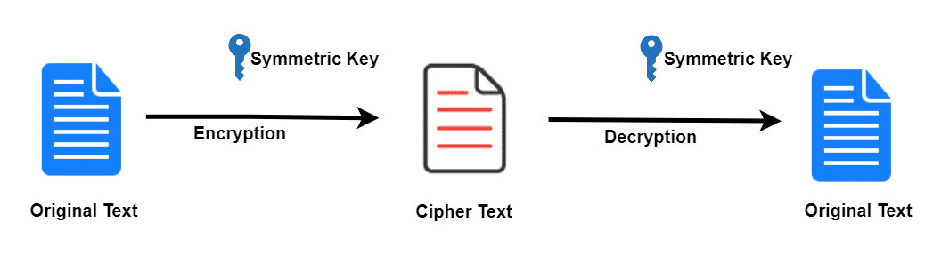

- Asymmetric Algorithm (Public key algorthim) الغير متماثلة

Asymmetric Algorithm uses pairs of keys. Each pair consists of a public key (which may be known to others) and a private key (which may not be known by anyone except the owner.
C = E_{k1} (P) , P = D_{k2} (c)
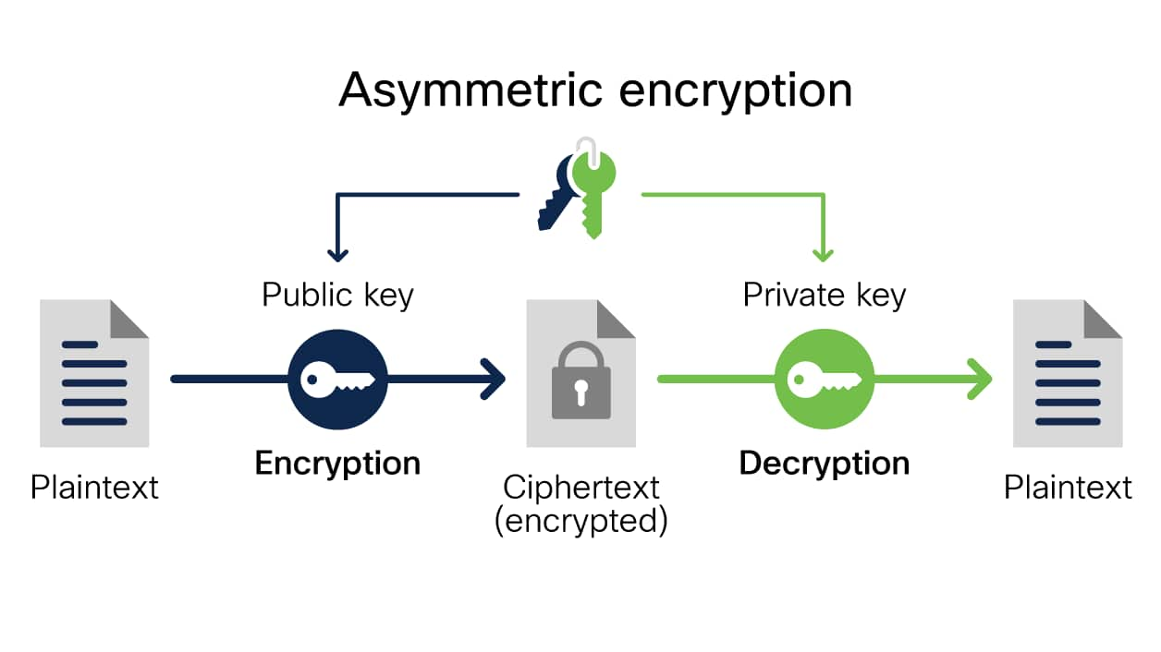

Normally, K1 uses as public Key and K2 uses as secret key.
Cryptographic techniques

Block ciphers Stream Ciphers

- Block ciphers: Breaks P into blocks P1, P2, ..., Pn and enciphers each block Pi with the same key.

C= E_{k}(p) = E_{k}(p1) E_{k}(p2) E_{k}(p3) …… E_{k}(pn)
C1 C2 C3 Cn

p1= 0 0 0 1 0
k= 1 0 1 0 1
c= 1 1 1

Examples of block cipher algorithms:
- playfair algorthim: it is a block cipher of size 2 letter.
- Hill algorthim: it is a block cipher of size d letter.
- DES algorthim: it is a block cipher of size 64 bits.
- Electronic code book /code book (ECB): The input plaintext is broken into numerous blocks.

This mean each block of plaintext has a defined corresponding ciphertext value, and vice versa. So, identical plaintexts with identical keys always encrypt to identical ciphertexts. This means that if plaintext blocks P1, P2 and so on are encrypted multiple times under the same key, the output ciphertext blocks will always be the same.
- Some Advantages of Block ciphers:
- It considers mostly faster than stream ciphers.
- Transmission errors in one cipher blocks have no effect on other blocks.
- Some Disadvantages of Block ciphers:
- Identical block of plaintext produce identical blocks of ciphertext.
- Easy to insert ,delete or modyifying blocks.

Cipher block chaining mode (CBC) is suggested For enhancing the block cipher:
In CBC mode, each block of plaintext is XORed with the previous ciphertext block before being encrypted. This way, each ciphertext block depends on all plaintext blocks processed up to that point. To make each message unique, an initialization vector must be used in the first block.
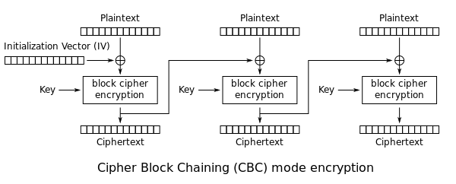
the first block has index 1, the mathematical formula for CBC encryption is
- Advantages of CBC :
- Can’t add, delete or modify a block.
- Identical plaintext blocks encrypted produce different ciphertext blocks based on initilization vector (IV) (time stamp is a good IV).

- Problems of CBC :
- Error in one block will effect all other blocks in the same plaintext.

2-Stream ciphers : each plaintext digit is encrypted one at a time with the corresponding digit of the keystream, to give a digit of the ciphertext stream. In other words, it breaks plaint text into (bits/bytes) p1,p2 ,..,pn and encipher each (p) with (key i) of key stream.

K=k1,k2,…Kn P=p1,p2,…,Pn
C=E_{k}(p) = E_{k1}(p1) E_{k2}(p2) ... E_{kn}(pn) C1 C2 …Cn

P=D_{k}(C) = D_{k1}(C1) D_{k2}(C2) … D_{kn}(Cn) P1 P2… Pn

- Stream cipher called periodic if key stream repeated fixed (d) characters alse called non periodic.
Examples: OTP and running-key ciphers are non periodic,while
vigenere cipher is periodic.

The short period is like Block cipher than stream cipher.
Most stream ciphers use simple XOR operation for enc/dec.
C = E_{k}(p) = K P

أنواع Types of Stream Cipher

synchronous Self- synchronous
متزامن ذاتي متزامن
Synchronous stream cipher: - The sender and receiver must be exactly in step for decryption to be successful. The key stream is generated indepently of the plain text using a deterministic algorithm. The keys must have some random properties. The keys generator starts with initial seeds numbers. The If digits are added or removed from the message during transmission, synchronisation is lost and the sender & receiver must resynchronize.
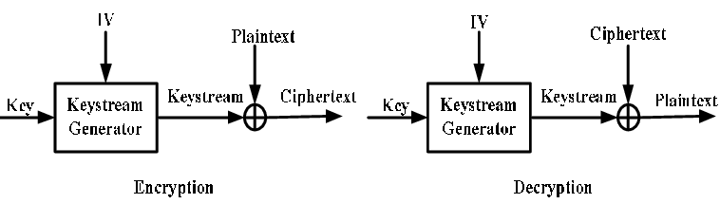
- يجب ان يحتوي المرسل والمستلم على نفس الخطوات.
- المفتاح يتم توليده بصورة مستقلة عن النص بواسطة خوارزمية محددة لتوليد المفاتيح.
- المفاتيح يجب ان تحتوي على خصائص العشوائية.
- ( خوارزمية ) مولد المفاتيح يجب ان يحتوي على ارقام ابتدائية (IV ) لتوليد مفاتيح محددة.
- اذا تم اضافة او حذف اي رقم من الرسالة خلال العملية التزامن سوف يتوقف ويجب على المرسل والمستلم باعادة التزامن.
- Notice: identical Parts of plaintext encipher with different parts of Keystream.يتم تشفير اجزاء متطابقة من النص الصريح مع اجزاء مختلفة من المفتاح

Self- Synchronous stream cipher (ciphertext autokey):- Each key character (bit or byte) is derived from a fixed number n of preceding cipher text. making it easier to recover Synchronous if digits are dropped or added to the message stream.
- يُشتق كل بت او بايت من المفتاح من رقم ثابت n للنص المشفر السابق
- يسهل عملية استرداد التزامن إذا تم حذف الأرقام أو إضافتها إلى تدفق الرسائل

