**Principles of Pharmacy Practice Chapter 3: Pharmaceutical Measurement 2024 – 2025**

**Dr. Zainab Thabit Saleh**

# Objectives:

Upon successful completion of this chapter, the student will be able to:

* Describe instruments for volumetric measurement and characterize their differences in application and accuracy.
* Describe the correct procedure when using a pharmaceutical balance.
* Define *sensitivity requirement* and apply it in calculations.
* Perform calculations by the aliquot method.
* Demonstrate an understanding of *percentage of error* in pharmaceutical measurement.

# Why we need to learn about pharmaceutical measurements?

The role of the pharmacist in providing pharmaceutical care includes the ability and responsibility to ***compound***—that is, to accurately weigh, measure volume, and combine individual therapeutic and pharmaceutical components in the formulation and preparation of prescriptions and medication orders

# Measurement of volume

The selection of measuring instrument should be based on the level of precision required

Select the graduate with a capacity equal to or just exceeding the volume to be measured

* The narrower the bore or chamber, the lesser the error in reading the meniscus and the more accurate the measurement

# Measurements of weight

**Sensitivity requirement:** The load that will cause a change of one division on the index plate of the balance.

* Class A prescription balance has a ***sensitivity requirement (SR)*** of 6 milligrams or less with no load and with a load of 10 grams in each pan.
* *To avoid errors of greater than 5*% *when using this balance, the pharmacist should not weigh less than 120 milligrams of material (i.e., a 5*% *error in a weighing of 120 milligrams is 6 milligrams)*.

**sensitivity requirement** may be determined by the following procedure:

1. Level the balance.
2. Determine the rest point of the balance.
3. Determine the smallest weight that causes the rest point to shift one division on the index plate.

* Most commercially available Class A balances have a maximum capacity of 120 grams

# Electronic analytical balance

* Capable of weighing accurately 0.1 milligram
* Self-calibrating
* Equipped with convenient digital readout features.
* The usual maximum capacities for balances of this precision range from about 60 grams to 210 grams depending upon the model

# Aliquot method of weight and measurement

Why use this method?

When a degree of precision in measurement required is beyond the capacity of the available instrument.

**Aliquot** is a fraction, portion, or part that is contained an exact number of times in another.

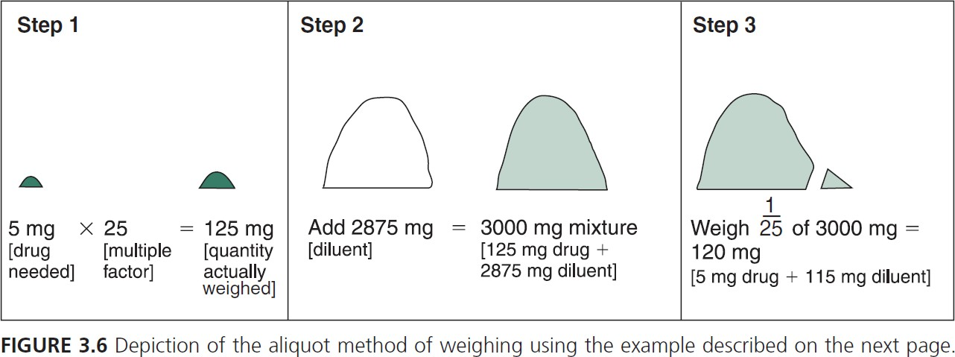

Step 1: Calculate the smallest quantity of a substance that can be weighed on a balance with the desired precision

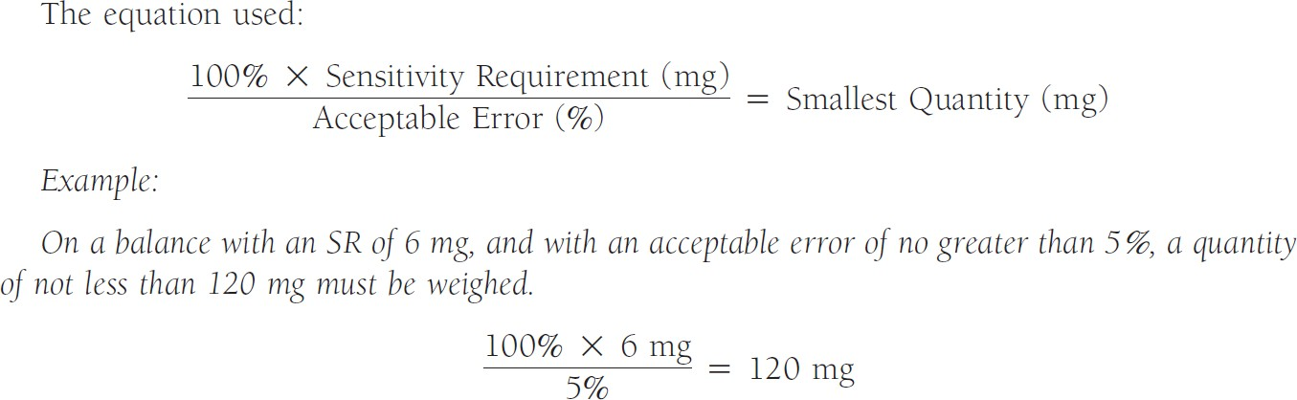

Step 2: Weigh an amount of the drug equal to or greater than the least weighable amount and calculate the enlargement factor: weighed amount/desired amount

Step 3: choose aliquot weight equal to or larger than the smallest weighable amount

Step 4: determine mixture weight = aliquot X factor

Step 5: calculate weight of diluent needed = mixture – drug



100% ×6 = 125 mg, error % = 4.8%

ⅇrror %

↑amount to be weighed → ↓error

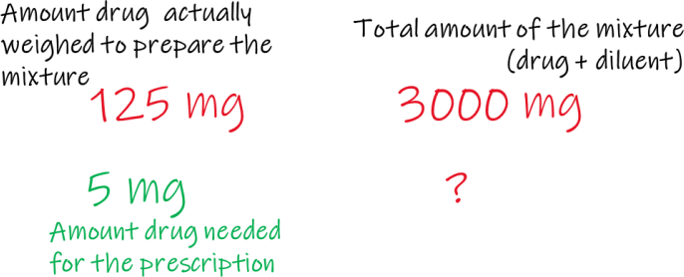

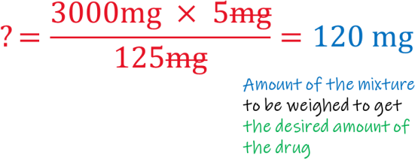

Step 2: weigh 125 mg, factor = 125/5 = 25

Step 3: choose aliquot weight equal to or larger than the smallest weighable amount, choose 120 mg

Step 4: determine mixture weight = aliquot X factor = 120 X 25 = 3000

Step 5: calculate weight of diluent needed = mixture – drug = 3000 – 125 = 2875 mg



Sensitivity requirement = 6.5 mg

𝑠𝑚𝑎𝑙𝑙𝑒𝑠𝑡 𝑞𝑢𝑎𝑛𝑡𝑖𝑡𝑦 = 100% ×𝑆𝑅 = 130 mg

ⅇrror %

1. Smallest amount = 130 mg
2. Weight 150 mg atropine sulfate (130/15 = 8.6 so we choose 150 to get an easy-to-use factor) factor =150/15 = 10
3. Choose aliquot weight 130 mg
4. Mixture weight = aliquot X factor = 130 X 10 = 1300
5. Calculate weight of diluent needed = mixture – drug = 1300 mg – 150 = 1150 mg
6. Check to make sure 130 mg contains 15 mg drug: 150 mg drug 1300 mg mixture

? 130 mg mixture ? = 150 X 130 /1300 = 15 mg Important note: You can choose to weigh

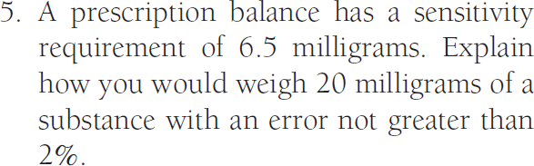

SR = 6.5

Error 2%

Amount drug needed = 20 mg

1. Least weighable amount = 100 X 6.5 / 2 = 385 mg
2. Weight 400 mg atropine sulfate (400/20 = 20)
3. Choose aliquot weight 385 mg (you can choose 400 mg)
4. Mixture weight = aliquot X factor = 385 X 20 = 7700
5. Calculate weight of diluent needed = mixture – drug = 7700 mg – 400 = 7300 mg
6. Check to make sure 385 mg contains 20 mg drug:

400 mg 3700 mg

20 mg ? , aliquot = 7300 X 20 /400 = 385 mg of the mixture to contain

20 mg substance

Or: if you choose to use 400 mg as the aliquot weight

(20 X 400) – 400 = 8000 – 400 = 7600 mg diluent,

400g 8000 mg

20 mg ? aliquot = 8000 X 20 /400 = 400 mg

# Measuring volume by the aliquot method



*Step 1.* Select a multiple of the desired quantity that can be measured with the required precision.

*Step 2.* Dilute the multiple quantity with a compatible diluent (usually a solvent for the liquid to be measured) to an amount evenly divisible by the multiple selected.

*Step 3.* Measure the aliquot of the dilution that contains the quantity originally desired

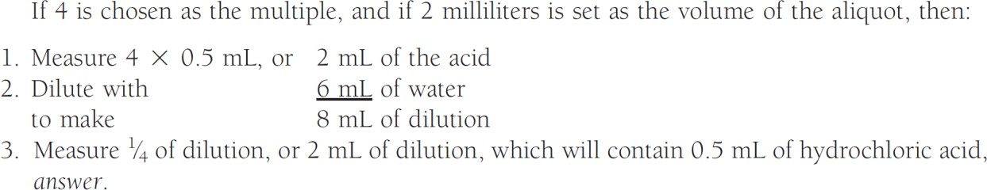

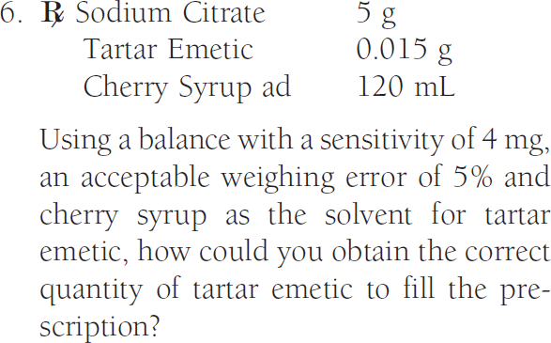

Amount drug to be weighed > 80 mg, weigh 90 mg Dissolve in 12 ml

12 ml 90 mg

? 15 mg ? = 12 ml X 15 mg / 90 mg = 2 ml

* Weigh 90 mg drug
* Dissolve on 12 ml cherry syrup
* Use 2 ml to fill the prescription

# Percentage of error

measurements in the community pharmacy are never *absolutely* accurate

* Need to recognize the limitations of the instruments used and the magnitude of the errors that may be incurred.
* Need to know

1. the *apparent* weight or volume measured
2. the possible excess or deficiency in the actual quantity obtained.

*Percentage of error the maximum potential error multiplied by 100 and divided by the quantity desired.*

𝐸𝑟𝑟𝑜𝑟 × 100%

𝑃𝑒𝑟𝑐𝑒𝑛𝑡𝑎𝑔𝑒 𝑜𝑓 𝑒𝑟𝑟𝑜𝑟 = 𝑄𝑢𝑎𝑛𝑡𝑖𝑡𝑦 𝑑𝑒𝑠𝑖𝑟𝑒𝑑

## Using a graduated cylinder, a pharmacist measured 30 milliliters of a liquid. On subsequent examination, using a narrow-gauge burette, it was determined that the pharmacist had actually measured 32 milliliters. What was the percentage of error in the original measurement?

Answer:

32 ml - 30 ml = 2 ml, the volume of error (2 mL X 100%)/30 mL = 6.7%

## A prescription calls for 800 milligrams of a substance. After weighing this amount on a balance, the pharmacist decides to check by weighing it again on a more sensitive balance, which registers only 750 milligrams. Because the first weighing was 50 milligrams short of the desired amount, what was

***the percentage of error?***

Answer:

50 mg the weight of error

(50 mg X 100%)/800 mg = 6.25%

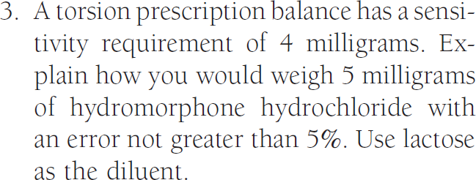

The smallest quantity that should be weighed on the balance:

Quantity desired: 5 mg

100% × 4 𝑚𝑔

5% = 80 𝑚𝑔

Multiple factor selected: 20, weigh 100 mg of the drug (20X5 = 100)

Aliquot portion selected: 90 mg

Hydromorphone hydrochloride (20 X 5) = 100 mg

Lactose = 1700 mg Aliquot mixture = 1800 mg

Proof: 1/20 of the drug 100 mg/20 = 5 mg 1/20 of the diluent 1700 mg /20 = 85 mg

90 mg aliquot

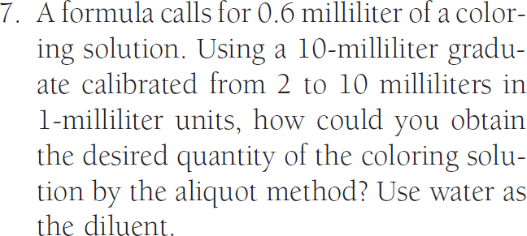

Multiple factor selected: 5 Aliquot volume selected: 2 ml

Measure 3 ml of the coloring solution (0.6 ml X 5 = 3 ml) Dilute to 10 ml

Measure 2 ml Proof:

10 ml dilution 3 ml coloring agent

? 0.6 ml coloring agent

? = 10 ml X 0.6 ml/ 3 ml = 2 ml

# HW: A pharmacist needed to weigh 20 mg of a drug using a balance with a sensitivity requirement of 6.5 mg and error not greater than 2%. This was his plan: weigh 340 mg drug, dilute with 5440 mg diluent to make 5780 mg, weigh 325 mg. Is his work correct?

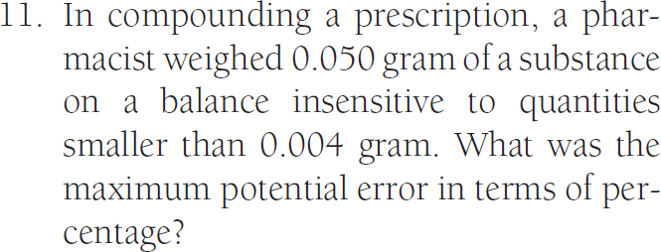

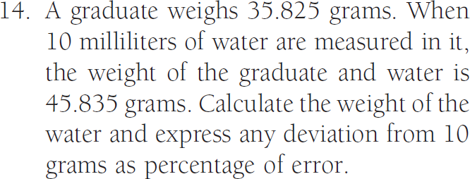

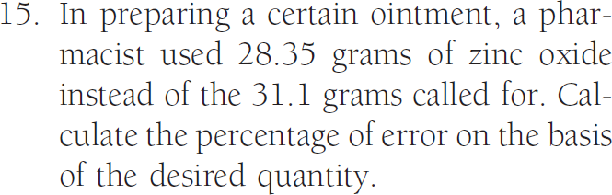

Error = quantity measured – desired quantity

= 28.35 g – 31.1 g = - 2.75 g = 2.75 g (negative sign means we are measuring less than needed)

Percentage of error = (error X 100%) / desired quantity

= (2.75 g X 100% ) / 31.1 g = 8.84 %

