**Practical 1**

**What are Statistics?**

##### Statistics are the methods for organizing, summarizing, presenting, & interpreting information (data).

Advantages of statistics:

1. Carry out your own research.
2. Evaluating published papers.
3. Ethical consideration (e.g. through statistics you can compare between old & new drugs choosing the most appropriate).
4. Professional & personal satisfaction (to value a result of a particular work if it is good or not).

**Branches of Statistics**

##### 1. Descriptive Statistics: Tools for summarizing, organizing & simplifying data can be either:

* Tables
* Graphs
* Numerical (Mathematical)

- Measures of Central Tendency

- Measures of Variability

2. Inferential Statistics: Data from sample used to draw inferences about a population.

It is the tools for generalizing beyond actual observations

**WHAT ARE DATA? → Collection** of information comprised of 2 parts:

(1) Individuals (also called cases or observations)

(2) Variables; are characteristics recorded on/from the individuals

**A variable** is something that varies—has at least 2 values, something that changes over time OR, something that varies across individuals.

**Sources of data:**  1- Experiment. 2- Routinely kept records.

3- Survey. 4- External sources e.g. published reports, Internet.

Types of Data

1. **Quantitative:** a true numerical value; it indicates an amount; often obtained from a measuring instrument; it makes sense to perform arithmetic on these types of variables, which can be either:

a- ***Discrete*,** characterized by a gap or interruption (have no fraction) e.g. No. of teeth, No. of admissions, Number of children, Number of attacks of asthma per week….etc.

b- ***Continuous*,** doesn’t posses a gap or interruption (have a fraction) e.g. WT, HT, Serum cholesterol, Blood sugar….etc.

1. **Categorical (qualitative):** records which group or category an individual/observation belongs in; it classifies; doesn’t make sense to perform arithmetic on this type of variable

a- **Nominal**, no ordered e.g., color of the eye, blood group, sex, marital state….etc.

(Nominal variable with only two probabilities is called dichotomous variable e.g., life or death, sick or not ….etc.)

b- **Ordinal**, E.g., educational state categorized into primary, secondary and higher education, Ca staging I, II, III……etc. E.g., gender (Female or Male)

* Numerical variables can be converted to Categorical one by using "cut off points".

**Ex: Type of variables:** For each of the following, identify the type of variable.

1. **Gender**:

(Qualitative, nominal, dichotomous).

1. **Serum bilirubin**:

(Quantitative, continuous).

1. **Severity of hemophilia, mild- moderate-sever**:

(Qualitative, ordinal).

1. **Height in cm**:

(Quantitative, continuous).

1. **Number of X-ray films taken in week**:

(Quantitative, discrete).

1. **Ethnic group**:

(Qualitative, nominal).

1. **Age as categorized as young-middle age- old**:

(Qualitative, ordinal).

1. **Age in years**:

(Quantitative, continuous).

1. Blood pressure in mm Hg:

(Quantitative, continuous).

j- **Blood pressure** **categorized as hypotensive-nomotensive-hypertensive:**  (Qualitative, ordinal).

k- Reduction of blood pressure following anti hypertensive drug: (Quantitative, continuous).

l- Educational status primary-secondary- higher education:

(Qualitative, ordinal).

m- Has patient visited their dentist in the last year? Yes or No.

This is a dichotomous variable.

**Ordered array;** When we arrange our data in order of magnitude from the smallest value to the largest value ((organization of the data)).

**Grouped data;** A technique used for systematically arranging a collection of observations to indicate the frequency of occurrence of the different values of these observations ((summarization of the data)).

**Frequency distribution:**

1- The following are fasting blood glucose level (mg\dl) of 20 children: **56**, 61, 57, **79**, 62, 75, 63, 58, 64, 60, 60, 57, 61, 57, 67, 62, 69, 67, 68, &59. From these data construct a frequency distribution, a relative frequency distribution, a cumulative frequency and a cumulative relative frequency.

We input the data in the SPSS program

Then use the path :

Analyze --- Descriptive Statistics --- Frequencies

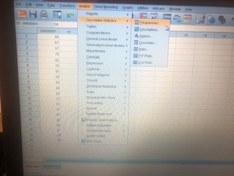

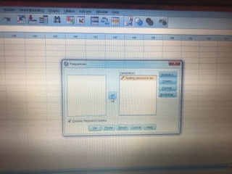

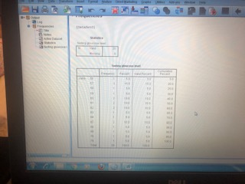

To make classes we follow :

Transform ----- record into different variables

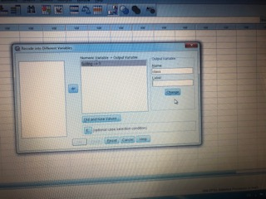

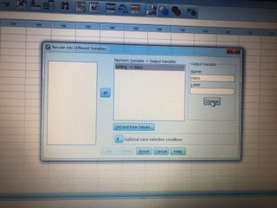

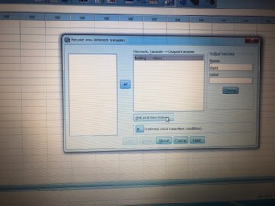

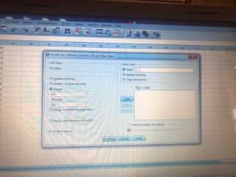

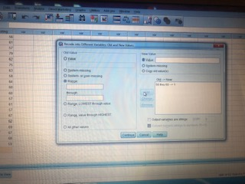

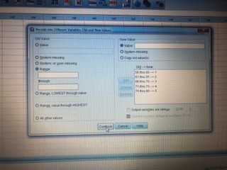

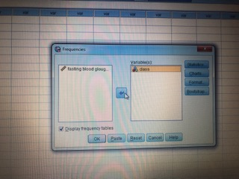

Ok ----- The result will be

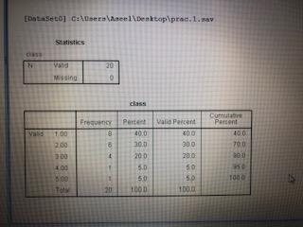

**Thank you**

**Dr. Aseel Sameer**