**Practical 4**

**2- Measures of Dispersion(unlikeness, scattering, variation)**

1. **Range :**

**R = Maximum value – Smallest Value**

1. **Variance (S2 )**
2. **Standerd Deviation ( SD)**

* **Knowing the mean is not enough**
* **A key issue is how alike or “unlike” each other the individual observations are**

Analyze ___ Descriptive Statistics ___ Descriptives ______Select variable ____

Options ______select ( standard Deviation, variance , range , minimum , maximum )

As follows :

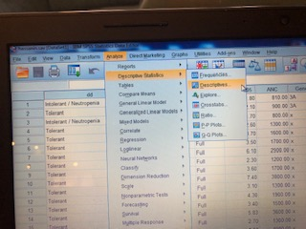

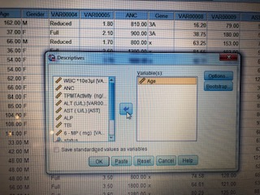

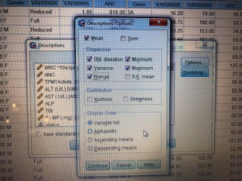

The result will be :

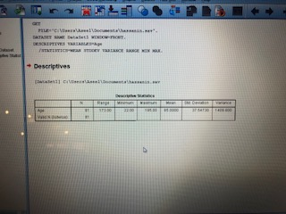

Or

Analyze ___ Descriptive Statistics ________ Frequencies ______Select variable ______Statisrics _________ select Percentiles ( Quartiles) ________select Dispersion ( std. Deviation , variance , range , min , max ) ____ select Central Tendency ( mean , median , mode )

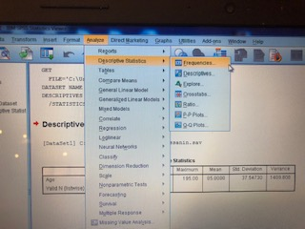

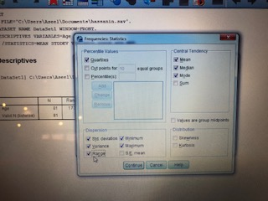

The result will be :

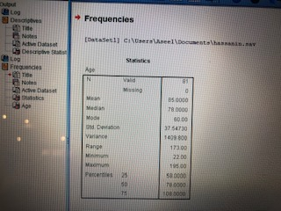

Thank you

***Coefficient of Variation* (CV)**

Useful for comparing two or more data with different units of measurement because it is expressed in percentage Ex: Suppose the 2 samples of males

n1 age 25 years, mean Wt=145 lb,S=10

n2 age 11 years, mean Wt=30 Kg, S=2 Different units

CV for group 1= (10/145) X 100 = 6.9

CV for group 2= (2/30) X 100 = 6.7 Same variability