Quantitative and Qualitative Analysis of Piperine Alkaloid :

***Quantitative Analysis:***

This is done by weighing the crystals of piperine alkaloid.

***Qualitative Analysis:***

***The General Chemical Tests :***

1. ***Mayer 's Test:***

***Aim:*** to indicate in ***general*** the alkaloid as other alkaloids.

***Equipments and Reagents:***

* Petri dish.
* Ethanol.
* HCl.
* Mayer's reagent.

***Procedure:***

Take few crystals of ***piperine alkaloid*** and dissolve in few mls of ***ethanol***, in Petri dish then add ***2 drops*** of ***HCl***. Then add ***2 drops*** of ***Mayer'sreagent***.

***Result:***

***White*** precipitate will occur.

1. ***Wagner 's Test:***

***Aim:*** to indicate in ***general*** the alkaloid as other alkaloids.

***Equipments and Reagents:***

* Petri dish.
* Ethanol.
* HCl.
* Wagner's reagent.

***Procedure:***

Take few crystals of ***piperine alkaloid*** and dissolve in few mls of ***ethanol***, in Petri dish then add ***2 drops*** of ***HCl***. Then add ***2 drops*** of ***Wagner's reagent***.

***Result:***

***Brown*** precipitate will occur.

1. ***Dragendorff's Test:***

***Aim:*** to indicate in ***general*** the alkaloid as other alkaloids.

***Equipments and Reagents:***

* Petri dish.
* Ethanol.
* HCl.
* Dragendorff's reagent.

***Procedure:***

Take few crystals of ***piperine alkaloid*** and dissolve in few mls of ***ethanol***, in Petri dish then add ***2 drops*** of ***HCl***. Then add ***2 drops*** of ***Dragendorff's reagent***.

***Result:***

***Orange*** precipitate will occur.

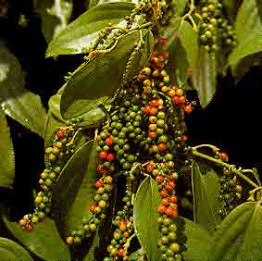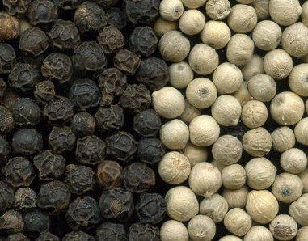

**Black pepper**

The Identification of Piperine Alkaloid By Chromatography (TLC) :

* By the use of thin layer chromatography **(T.L.C)**
* The stationary phase = *Silica gel G****.***
* The mobile phase =***Toluene: Diethylether: Diaxon (62.5:21.5:16).***
* The standard compound =
* The spray reagent =***Dragendorff's reagent.***
* Mechanism of separation = *Adsorption*.
* Developing = *Ascending****.***
* ***Other mobile phases :***

***Toluene: Ethyl acetate (70:30), Acetone Water: Ammonia (90:7:3).***

***Procedure:***

1. Prepare ***100ml*** of mobile phase, and place it in the glass tank.
2. Cover the tank with glass lid and allow standing for ***45 minutes*** before use.
3. Apply the sample spots, and the standard spot on the silica gel plates, on the base line.
4. Put the silica gel plate in the glass tank and allow the mobile phase to rise to about *two-third* the plate.
5. Remove the plate from the tank, and allow drying, and then detecting the spots by the use of the spray reagent.

***Result:***

Orange spot will appear.

***Study problems:***

***Q1***. Give the botanical name of black pepper and mention its alkaloids?

***Q2.*** What is the pharmacological activity of piperine alkaloids?

***Q3.*** Give the reasons off the use of alcoholic KOH in the extraction procedure of black pepper?

***Q4.*** How can you identify an extract containing piperine alkaloids?