Identification of Datura Alkaloids By Chromatography:

* By the use of thin layer chromatography **(T.L.C)**
* The stationary phase = *Silica gel G****.***
* The mobile phase = ***Butanone: Methanol: Ammonia (60:70:10)***

*Or* ***Acetone: Water: Ammonia (90:7:3).***

* The standard compound = atropine or hyoscine.
* The spray reagent = ***Dragendorff's reagent.***
* Mechanism of separation = *Adsorption*.
* Developing = *Ascending****.***
* ***Other mobile phases :***

***Chloroform: Acetone: Diethyl amine (50:40:10),***

***Chloroform: Diethyl amine (90:10).***

***Procedure:***

1. Prepare ***100ml*** of mobile phase, and place it in the glass tank.
2. Cover the tank with glass lid and allow standing for ***45 minutes*** before use.
3. Apply the sample and the standard spots on the silica gel plates, on the base line by the use of capillary tube.
4. Put the silica gel plate in the glass tank and allow the mobile phase to rise to about *two-third* the plate.
5. Remove the plate from the tank, and allow drying, and then spray with the spraying reagent.

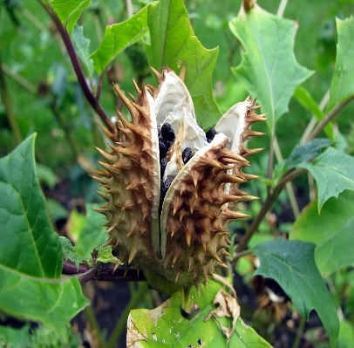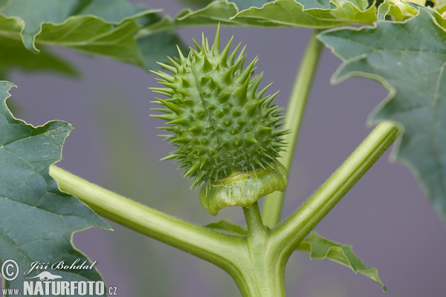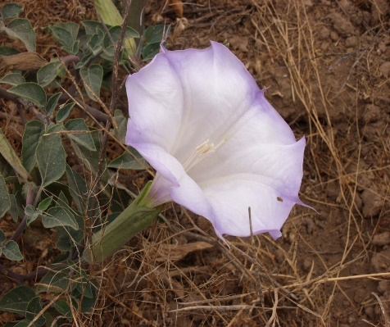

**Datura stramonium**

***Study problems:***

Give the reason of :

1. Using the reflux in extraction the tropane alkaloid from datura stramonium.
2. Making the evaporation step after filteration?
3. Addition of 2% HCl to the alcoholic extract?
4. Addition of ammonium hydroxide?
5. Using of chloroform in partitioning step?