
University of Baghdad
College of Pharmacy
Department of Pharmacognosy

Done by :
- lecturer Pharmacists Dhuha A. Abdul Hussain Zahra’a S. Nassir

Supervised by:
L. Maha N. Hamad
Head of department of Pharmacognosy and Medicinal plants

2014
The Alkaloids
Alkaloids (alkali-like) are defined as organic nitrogenous compounds of plant origin that are physiologically active, ending in the suffix "ine".
Plants have been a rich source of alkaloids but some are found in animals, fungi, and bacteria. Among the plants, the angiosperms are rich in alkaloids.
The following families represent good examples of plants which contain alkaloids:
- Leguminosae.
- Papaveraceae.
- Ranunuclaceae.
- Rubiaceae.
- Solanaceae.
- Berberidaceae.
The Labiatae and Rosaceae are almost free of alkaloids; the gymnosperms only rarely contain alkaloids.
The names of alkaloids are obtained in various ways:
- From the generic name of the plant yielding them as atropine.
- From the specific name of the plant yielding them as cocaine.
- From the common name of the drug yielding them as ergotamine.
- From their physiologic activity as emetine.
- From the discoverer as pelletrine.

Alkaloids usually contain one nitrogen atom , but some may contain up to 5.
The nitrogen may exist as a primary amine (RNH2), as secondary amine (R2NH), or as a tertiary amine (R3N).
As the nitrogen atom bears an unshared pair of electrons, such compounds are basic and resemble ammonia's chemical properties. The degree of basicity varies greatly, depending on the structure of the molecule and the presence and location of other functional groups.
Like ammonia, the alkaloids are converted into their salts by aqueous mineral acids, and when the salt of an alkaloid is treated with a hydroxide ion, nitrogen gives up a hydrogen ion, and the free amines are liberated. The quaternary ammonium compound has no proton to give up and thus is not affected.

The alkaloids, like other amines, form double salts with the heavy metals that appear as precipitates and are used in their identification. These reagents include:
- Wagner's reagent (iodine in potassium iodine).
- Mayer's reagent (potassium mercuric iodide).
- Dragendroff's reagent (potassium bismuth iodide).
- Hagger's reagent (saturated solution of picric acid).

Types of alkaloids:
- True alkaloids: these characterized by contain nitrogen atom in the heterocyclic ring and derived from amino acids. Example is Atropine.
- Proto alkaloids: which contain nitrogen atom without a heterocyclic ring and also derived from amino acids. Examples include Adrenaline and Ephedrine.
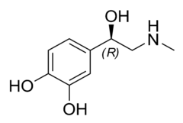
- Pseudo alkaloids: These are characterized by heterocyclic rings with a nitrogen atom, but are not derived from amino acids. Example
Caffeine.
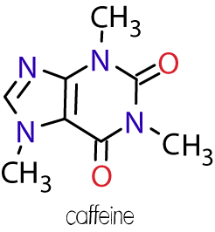

In General the Alkaloids are Alassified According to Chemical Structure in to two Broad Divisions:
- Non-heterocyclic or atypical alkaloids or biological amines.
- Heterocyclic or typical alkaloids, divided in to 14 groups according to their ring structure ,as follows:
- Pyrrol and pyrrolidine.
- Pyrrolizidine.
- Pyridine and piperidine.
- Tropine.
- Quinolone.
- Isoquinolone.
- Aporphine.
- Norlupinane.
- Indole.
- Indolizidine.
- Imidazole.
- Purine.
- Steroids.
- Terpenoids.

Exp. No.1
[Lab.1] Black Pepper
The botanical name: Pipper nigrum of the family Piperaceae. It belongs to the third group of typical alkaloids, which is the pyridine and piperidine group.
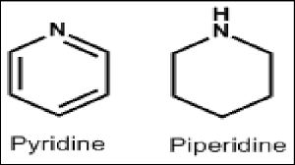
This plant is a perennial plant producing berry –like and aromatic pungent fruits, that are green when unripe and becomes red at maturity, then the dried berries become black and wrinkled producing black pepper.
The pepper yields both, black and white pepper according to the method of drying. In that when the ripe and unripe fruit is dried directly under the sun, black pepper is the result. If the fruit is first soaked, and then removed the outer skin, before drying, and then the result is white pepper.
The alkaloid extracted from the black pepper is piperine.
Piperine alkaloid is a solid substance essentially insoluble in water. It is a weak base that is tasteless at first but leaves a burning after taste. The molecular formula is C₁₇H₁₉NO₃, and the chemical structure of piperine is:
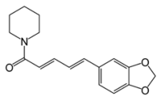
Piperine

The Pharmacological Activity of Piperine :
- Piperine aid in the digestion of food due to its stimulation to the digestive enzymes.
- There is some evidence that it has an anticonvulsant activity in the treatment of epilepsy.
- There is some evidence that it has an anticancer and anti-inflammatory activity due to its antioxidant properties.
The Isolation and Identification of Piperine from Black Pepper:
- Extraction:
Aim: to isolate the piperine alkaloid from black pepper.
Equipments:
- Large beaker & medium size beakers.
- Soxhlet instrument.
- Funnel & filter paper.
- Water bath.
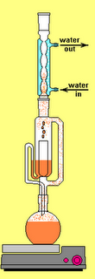
Soxhlet

Reagents:
- 90% ethanol.
- 10% alcoholic potassium hydroxide.

Procedure:
Method of extraction: Soxhlet extraction.
Plant used: Piper nigrum.
Part used: Seeds.
10 gm fine powdered black pepper in 150 ml of 90% ethanol for 2 hrs. In Soxhlet extractor

Hot filtration

30 ml of extract solution concentrated in a water bath at 60⁰C
Add

2 ml of 10% Alcoholic KOH

Filtrate, and alcoholic extract is left over night

Results:
Yellow needles with melting point of 125⁰C are deposited. Yielding 0.3 gm of piperine alkaloids.

Discussion:
- The plant is affected by heat; therefore, Soxhlet apparatus is used in its extraction.
- The use of 90% ethanol is to extract both, the alkaloid and the alkaloidal salt that might be present. (This is true for the extraction of most alkaloids).
- The use of alcoholic KOH is to precipitate the isomers of piperine that are chuvacine, isochuvacine and piperic acid.
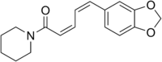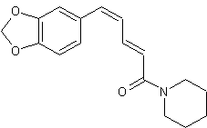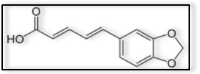
Chuvacine isochuvacin Piperic acid
- Alcohol was used in the preparation of KOH instead of water, since water will hydrolyzed to piperidine and piperic acid as shown below:

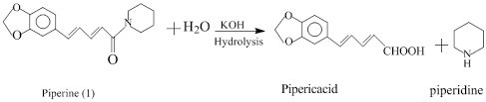

Quantitative and Qualitative Analysis of Piperine Alkaloid :
Quantitative Analysis:
This is done by weighing the crystals of piperine alkaloid.
Qualitative Analysis:
The General Chemical Tests :
- Mayer 's Test:
Aim: to indicate in general the alkaloid as other alkaloids.
Equipments and Reagents:
- Petri dish.
- Ethanol.
- HCl.
- Mayer's reagent.

Procedure:
Take few crystals of piperine alkaloid and dissolve in few ml_{s} of ethanol, in Petri dish then add 2 drops of HCl. Then add 2 drops of Mayer'sreagent.
Result:
White precipitate will occur.
- Wagner 's Test:
Aim: to indicate in general the alkaloid as other alkaloids.
Equipments and Reagents:
- Petri dish.
- Ethanol.
- HCl.
- Wagner's reagent.
Procedure:
Take few crystals of piperine alkaloid and dissolve in few ml_{s} of ethanol, in Petri dish then add 2 drops of HCl. Then add 2 drops of Wagner's reagent.
Result:
Brown precipitate will occur.
- Dragendorff's Test:
Aim: to indicate in general the alkaloid as other alkaloids.
Equipments and Reagents:
- Petri dish.
- Ethanol.
- HCl.
- Dragendorff's reagent.
Procedure:
Take few crystals of piperine alkaloid and dissolve in few ml_{s} of ethanol, in Petri dish then add 2 drops of HCl. Then add 2 drops of Dragendorff's reagent.
Result:
Orange precipitate will occur.
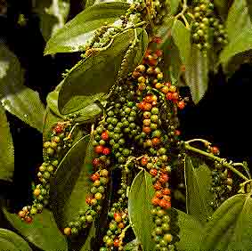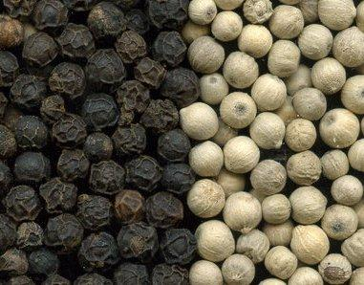
Black pepper

The Identification of Piperine Alkaloid By Chromatography (TLC) :
- By the use of thin layer chromatography (T.L.C)
- The stationary phase = Silica gel G.
- The mobile phase =Toluene: Diethylether: Diaxon (62.5:21.5:16).
- The standard compound =
- The spray reagent =Dragendorff's reagent.
- Mechanism of separation = Adsorption.
- Developing = Ascending.
- Other mobile phases :
Toluene: Ethyl acetate (70:30), Acetone Water: Ammonia (90:7:3).
Procedure:
- Prepare 100ml of mobile phase, and place it in the glass tank.
- Cover the tank with glass lid and allow standing for 45 minutes before use.
- Apply the sample spots, and the standard spot on the silica gel plates, on the base line.
- Put the silica gel plate in the glass tank and allow the mobile phase to rise to about two-third the plate.
- Remove the plate from the tank, and allow drying, and then detecting the spots by the use of the spray reagent.
Result:
Orange spot will appear.
Study problems:
Q1. Give the botanical name of black pepper and mention its alkaloids?
Q2. What is the pharmacological activity of piperine alkaloids?
Q3. Give the reasons off the use of alcoholic KOH in the extraction procedure of black pepper?
Q4. How can you identify an extract containing piperine alkaloids?
Exp.No. 2
[Lab.3] Tropane Alkaloids
Datura stramonium, known by the common names Jimson weed or datura, is a plant in the Solanaceae (nightshade) family. For centuries, datura has been used as a herbal medicine to relieve asthma symptoms and as an analgesic during surgery or bone setting. It is also a powerful hallucinogen and deliriant, which is used spiritually for the intense visions it produces. However, the tropane alkaloids which are responsible for both the medicinal and hallucinogenic properties are fatally toxic in only slightly higher amounts than the medicinal dosage, and careless use often results in hospitalizations and deaths.
Constituents of datura are:
Hyoscyamine and its isomer atropine, which is formed during extraction procedure. Also it contains hyoscine (scopolamine) alkaloid, which is found in trace amounts.
The medicinal use is mostly due to the hyocsyamine (atropine), used as mydriatic, antispasmodic, antidote to the toxicity of cholinergic compound, decrease in the secretion (upper and lower respiratory tract) before surgery. While the use of scopolamine mostly in motion sickness. The tropane alkaloids (hyocsyamine and hyoscine) have the following structures:

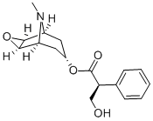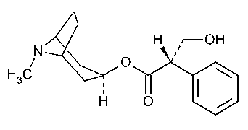
Hyoscine (scopolamine) Hyoscyamine

These alkaloids are also present in other plants as Hyoscyamus niger of the family Solanaceae, Atropa belladona of the same family, and others.

Isolation and Identification of the Datura Alkaloids:
- Extraction:
Aim: to isolate datura alkaloids.
Equipments:
- Reflex apparatus.
- Conical flasks.
- Stirrer.
- Funnel.
- Separatory funnel.
- Water bath.
- Filter paper.
- Litmus paepr.

Reagents:
- 90% ethanol.
- 2% HCl.
- Ammonium hydroxide solution.
- Chloroform.

Procedure:
Method of extraction:.
Plant used: Datura stramonium.
Part used: fruits.

Extract 50 gm of the datura fruits in 150 ml of 90% ethanol under Reflex condenser for 1 hrs.

Filtration

Take 20 ml of alc. Extract in conical flask and concentrate on the water bath to about 2 ml to remove all of ethanol

Pour the concentrated in to 10 ml of 2% HCl

Heat gently
(5 min_{s.})
Cool and filter the Acidic extract and place in a separatory funnel

[Wash with 5 ml of Chloroform] two times

Take supernatant (upper layer) and made alkaline by addition of

Ammonium hydroxide solution (check by litmus paper)

[Partition with 5 ml of Chloroform] two times

Take the lower layer, dehydrate by adding anhydrous sod. Sulphate filter (or decant) , evaporate to dryness
2. Results:
Product containing the mixture of the alkaloids.
The Identification of Datura Alkaloids:
Qualitative Analysis:
- The specific tests for tropane alkaloids:
- Vitalli Marine Bu Test:
Aim : to identify the tropane alkaloids from other alkaloids.
Equipments and Reagents:
- Small beaker.
- Fuming nitric acid.
- Alcoholic KOH.

Procedure:
Take few ml_{s} of the extract, add to it drops of fuming nitric acid and evaporate, then add 2 ml of alc. KOH.
Result:
A violet color will be developed.
- Gerhard's Test:
Aim: to identify the tropane alkaloids from other alkaloids.
Equipments and Reagents:
- Small beaker.
- 2% HgCl₂ in 50% aqueous ethanol.

Procedure:
Add 2% HgCl₂ in 50% aqueous ethanol to 0.0006 g of atropine.
Result : A deep red color will be developed.

- General tests for tropane alkaloids:
All reagents used for tests of alkaloids could be applied on tropane alkaloids since they are true alkaloids.
Identification of Datura Alkaloids By Chromatography:
- By the use of thin layer chromatography (T.L.C)
- The stationary phase = Silica gel G.
- The mobile phase = Butanone: Methanol: Ammonia (60:70:10)
Or Acetone: Water: Ammonia (90:7:3).
- The standard compound = atropine or hyoscine.
- The spray reagent = Dragendorff's reagent.
- Mechanism of separation = Adsorption.
- Developing = Ascending.
- Other mobile phases :
Chloroform: Acetone: Diethyl amine (50:40:10),
Chloroform: Diethyl amine (90:10).
Procedure:
- Prepare 100ml of mobile phase, and place it in the glass tank.
- Cover the tank with glass lid and allow standing for 45 minutes before use.
- Apply the sample and the standard spots on the silica gel plates, on the base line by the use of capillary tube.
- Put the silica gel plate in the glass tank and allow the mobile phase to rise to about two-third the plate.
- Remove the plate from the tank, and allow drying, and then spray with the spraying reagent.

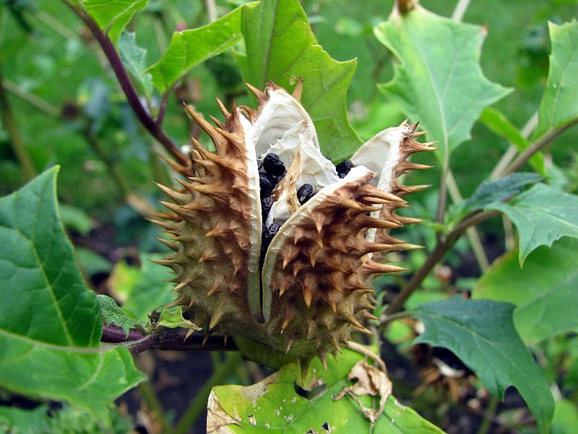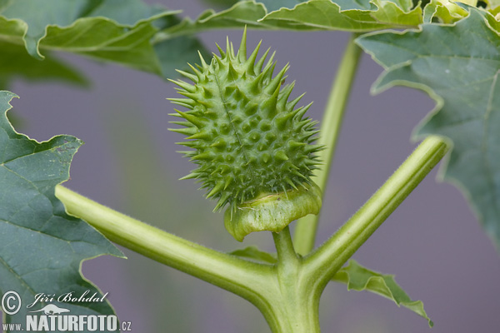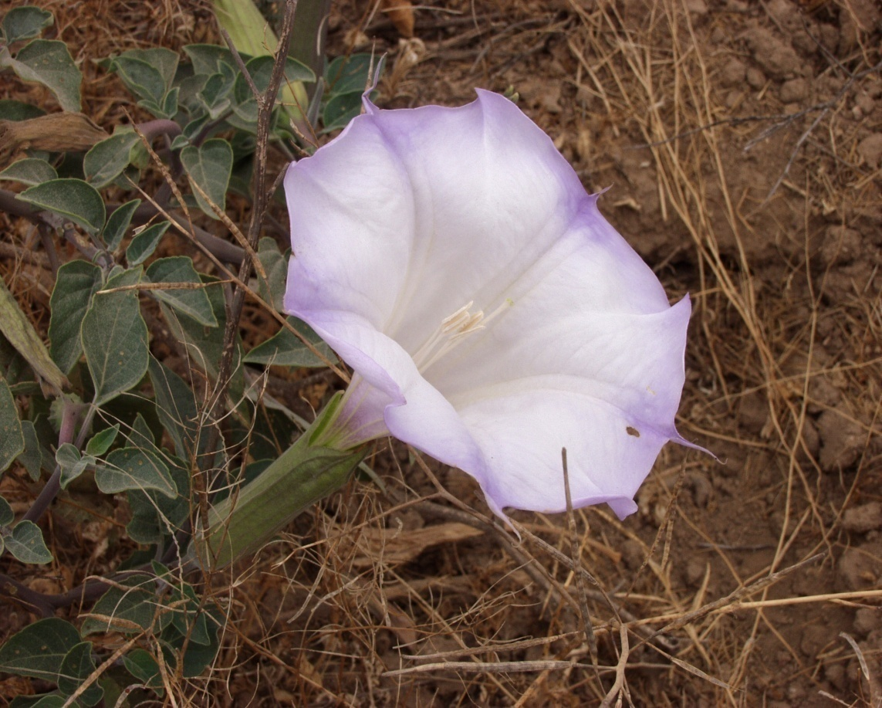
Datura stramonium

Study problems:
Give the reason of :
- Using the reflux in extraction the tropane alkaloid from datura stramonium.
- Making the evaporation step after filteration?
- Addition of 2% HCl to the alcoholic extract?
- Addition of ammonium hydroxide?
- Using of chloroform in partitioning step?

Exp.No. 3
[Lab.4] Indole Alkaloids
Harmala Alkaloids
Peganum harmala of the family Zygophyllaceae.
It is a woody, perennial, succulent shrub native to arid regions. The leaves are bright green, finely divided and about 1 cm long. Both the roots and seeds contain significant quantities of Beta- carbolines (indole) alkaloids, which are absent in the rest of the plant.
The Traditional and Medical Uses:
The traditional uses including as the dye "turkey red", and as incense from ancient times.
Peganum harmala was claimed to be an important medical plant. Its seeds were known to possess hypothermic and essentially hallucinogenic properties since it is MAO inhibitor agent .
Various authors have under taken studies on the antibacterial, anti fungal and antiviral effects of Peganum harmala seeds. In Moroccan traditional medicine , seed powder is sometimes used on skin and subcutaneous tumors.
This work was designed to investigate some aspects of the anti neoplastic properties of Peganum harmala in that the active principle at a dose of 50 mg / kg given orally to mice for 40 days was found to have significant anti tumor activity. Peganum harmala alkaloids thus posses significant anti tumor potential, which could prove useful as novel anticancer therapy. The pharmacologically active compounds of Peganum harmala are several alkaloids ,which are found especially in the seeds (2-7% total) and the roots.
These include beta-carbolines such as: harmaine , harmaline and Harman.
Peganum harmala also contains the quinazoline derivatives vasicine and vasicinone. It is believed that these quinazoline alkaloids are responsible for the abortifacient activity of Peganum harmala extracts. It has been reported that these chemicals have a uterine stimulatory effect, apparently through the release of prostaglandin. Peganum harmala alkaloids are characterized by the fluorescence property.

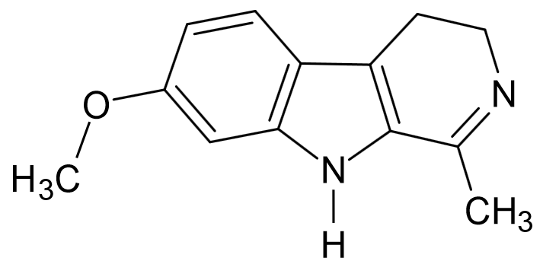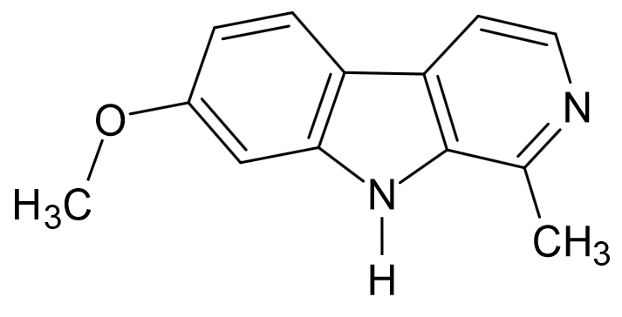
Harmaline Harmine

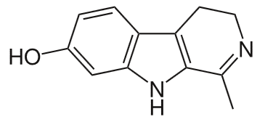
Harmalol

Isolation of The Harmala Alkaloids:
Extraction:
Aim: to isolate the Harmala Alkaloids.
Equipments:
- Large beaker.
- Small conical flask.
- Reflux apparatus.
- Separatory funnel.
- Water bath.
- Litmus paper.
- Funnel.
- Filter paper.

Reagents:
- Petroleum ether.
- 90 % Ethanol.
- Ammonium hydroxide solution.
- 2%HCl.
- Chloroform.
- Methanol.

Procedure:
Method of extraction: Reflux.
Plant used: Peganum harmala
Part used: Seeds.
Maceration 50 gm of the harmala seeds in 500 ml of petroleum ether for 24 hrs (over night).
Filter

Reflux with 90% ethanol for 1 hr.
Cool & Filter
Take 20 ml of Extract in conical flask

Evaporate the filterate on water bath to about 2 ml

Add

5ml of 2% HCl
(Filter if necessary.)

Partition with Chloroform (10 ml x 2), take the acidic layer (upper layer)

Add

Ammonium hydroxide solution (check by litmus paper)

Place the basic solution in the separatory funnel

Add

[10 ml of Chloroform] two times

(Shake & stand)

Take the organic lower layer and put it in the conical flask

Add

Small amount of Anhydrous sodium Sulphate & allow standing for few minutes until get a clear solution , decant and concentrate by evaporation to give the product crude alkaloids.

[Lab.5]
Identification of Harmala Alkaloids
Quantitative Analysis:
By weighing the residue obtained.
Qualitative Analysis:
The General Chemical Tests :
The same as for other alkaloids.

The Identification of Harmala Alkaloids By Chromatography :
- By the use of thin layer chromatography (T.L.C)
- The stationary phase = Silica gel GF₂₅₄.
- The mobile phase = Chloroform : Methanol: Acetone (35:15:10)
Or Chloroform: Methanol: 10% Ammonium hydroxide (80:20:15).
- The standard compound = any harmala alkaloids.
- The spray reagent = Dragendorff's reagent.
- Mechanism of separation = Adsorption.
- Developing = Ascending.
- Other mobile phases :
Chloroform: Acetone: Diethyl amine (50:40:10),
Chloroform: Diethyl amine (90:10).
- UV instrument.

Procedure:
- Prepare mobile phase, and place it in the glass jar.
- Cover the jar with glass lid and allow standing for 45 minutes before use.
- Apply the sample and the standard spots on the silica gel plates, on the base line by the use of capillary tube.
- Put the silica gel plate in the glass jar and allow the mobile phase to rise to about two-third the plate.
- Remove the plate from the jar, dry and identified first by U.V. 254 ,366 nm.
- Spray the plate with spraying reagent (Dragendorff's reagent) and then calculate the Rf values.
Results:
Fluorescence spot appears under the U.V. while an orange spots are seen when sprayed with the sprayer.
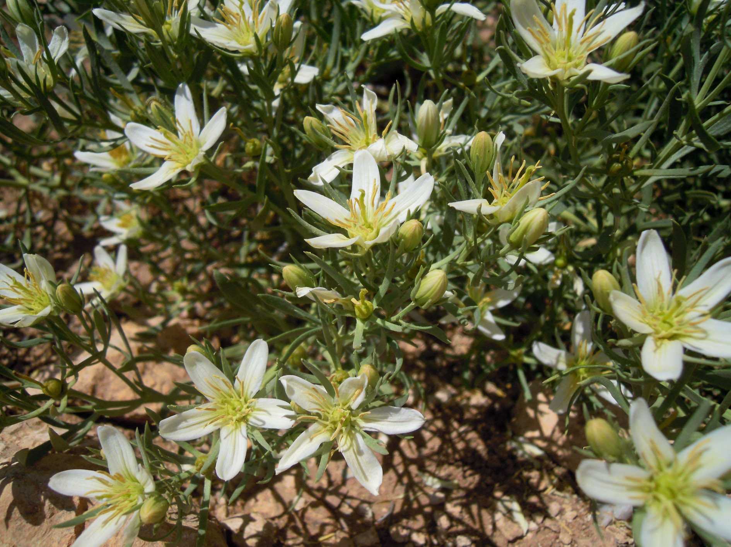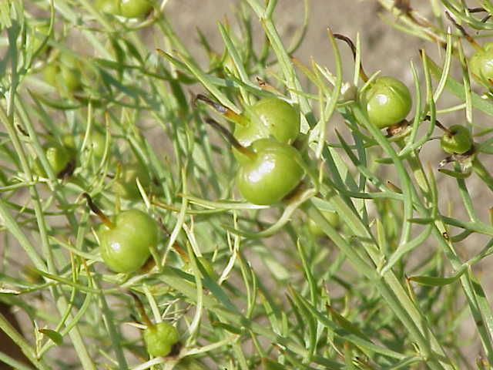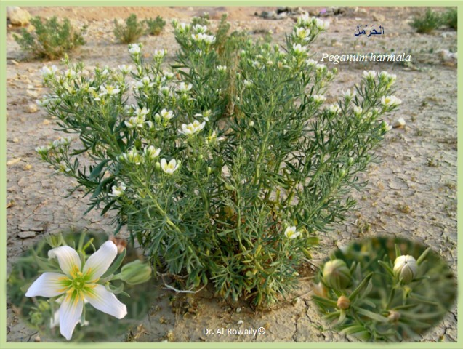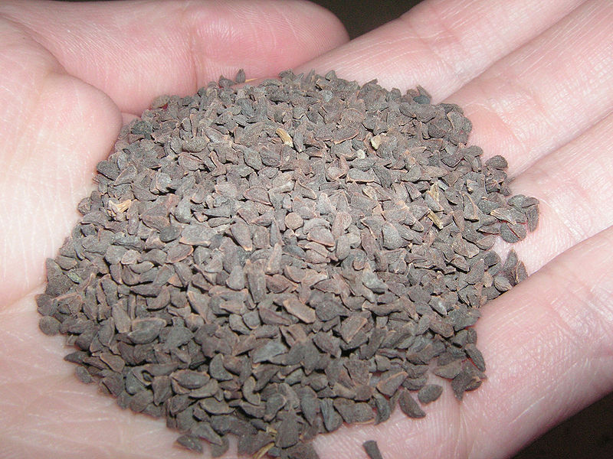
Peganum harmala
Exp.No. 4
[Lab.5] Purine Bases
Purines nucleus is a heterocyclic nucleus consisting of pyrimidine ring fused to 5-membered imidazole ring known as xanthine.
Purines unlike other alkaloids don’t give positive results with the general tests of alkaloids, instead muroxide test is used in its identification.
Purines are present as methylated compounds,which are:
- Caffeine (1, 3,7- tri methyl xanthine).
- Theophylline (1,3-di methyl xanthine).
- Theobromine (3,7- di methyl xanthine).
The following are their structures:
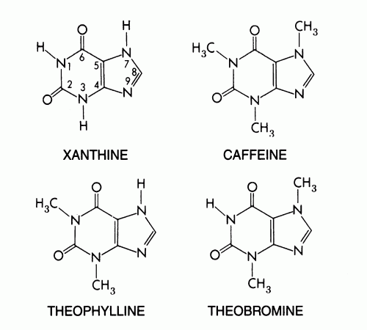

Generally the pharmacological activities of these methylated compounds are:
- Stimulation of the CNS.
- Diuretic effects.
- Increase gastric acid secretion.
- Relaxation of the bronchial smooth muscle (theophylline).
- Positive inotropic and chronotropic effects on the heart.

The most important plants in this group are :
- Coffee (Coffea arabica of the family Rubiaceae).
Contain about 1-2 % of caffeine.
- Tea (Camellia sinensis of the family Theaceae).
Contain about 1-4 % of caffeine.
- Cola (Cola nitida of the family Sterculiaceae).
Contain about 3.5 % of caffeine.

Isolation of The Caffeine From Tea:
- Extraction:
Aim: to isolate caffeine from tea leaves.
Equipments:
- Large beaker & two medium size beakers.
- Two conical flasks.

- Centrifuge tubes & Centrifuge.
- Separatory funnel.
- Water bath.
- Muslin.
- Conical flask.
Reagents:
- Sulphuric acid.
- Basic Lead acetate.
- Chloroform or methylene chloride.
- Hot 60 ⁰C ethanol.

- Procedure:
Method of extraction: digestion.
Plant used: Camellia sinensis
Part used: dry leaves.
Place 10 gm of the powdered tea leaf in 50 ml of water

Boil for (15 min_{s} )
(Constant stirring)
Strain the resulting hot extract through muslin, express well

Wash the mass remains on the muslin with 10 ml of boiling water and express again

Add (carefully)

5drops of lead sub acetate
(Heat the mixture to boiling)

Centrifuge
(5 min_{s.})

Decant and take the supernatant (upper layer)

Cool & transfer to separatory funnel

[Extract with 15 ml of methylene chloride OR chloroform] two times

(Shake & stand)

Take the lower layer and put it in the conical flask

Add

Small quantity of Anhydrous sod. Sulphate & allow standing for few minutes until get a clear solution

Decant

Evaporation to dryness

- Results :
Pure crystals with a white color will be obtained.

- Discussion:
- Purines differ from other alkaloids in that they are soluble in hot water, which is used in its extraction, and this is the cause why all the time you should heat the mixture (to prevent the precipitation of caffeine in cold water).
- Lead sub acetate is added to precipitate tannins and other unwanted material.
- The centrifugation is used to isolate the decant containing unwanted materials from the desired supernatant.
- Use of methylene chloride is to extract the caffeine from other component of the mixture.

Quantitative and Qualitative Analysis of caffeine Crystals :
Quantitative Analysis:
This is done by weighing the crystals of caffeine alkaloid.
Qualitative Analysis:
The Specific Chemical Tests :
The Murexide Test:
Aim: to identify the caffeine alkaloid (purine alkaloids) from other alkaloids.
Equipments and Reagents:
- Porcelain dish.
- Water bath.
- Potassium chlorate (KClO₃).
- Conc .HCl.
- Ammonia vapor.

Procedure:
Take few crystals of caffeine alkaloid in porcelain dish and add small amount of potassium chlorate (KClO₃), then add 2 drops of conc. HCl . Evaporate to dryness, then expose to ammonia vapor.
Result:
Purpule color is produced with caffeine and other purine derivatives .

H.W/ What is the mechanism of muroxide test?

The Identification of purine (caffeine) Alkaloids By Chromatography :
- By the use of thin layer chromatography (T.L.C)
- The stationary phase = Silica gel GF₂₅₄ .
- The mobile phase = ethyl acetate : Acetic acid (95:5)
Or Acetone: Water: Ammonia (90:7:3).
- The standard compound = caffeine
- Mechanism of separation = Adsorption.
- Developing = Ascending.
- Detection: by UV instrument.
Procedure:
- Prepare mobile phase, and place it in the glass jar.
- Cover the jar with glass lid and allow standing for 45 minutes before use.
- Apply the sample and the standard spots on the silica gel plates, on the base line by the use of capillary tube.
- Put the silica gel plate in the glass jar and allow the mobile phase to rise to about two-third the plate.
- Remove the plate from the jar, dry and identified by U.V. 245 ,366 nm. Then calculate Rf values.

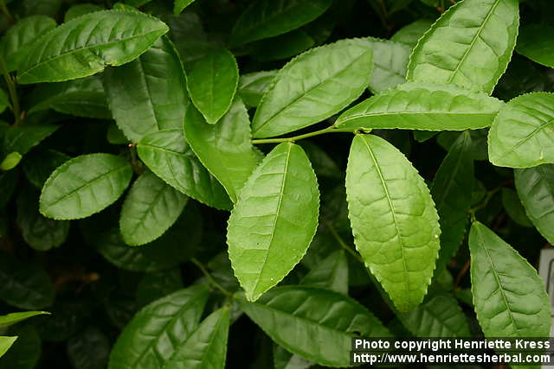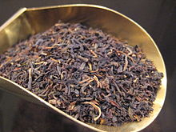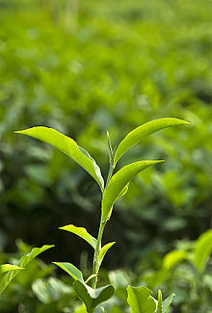
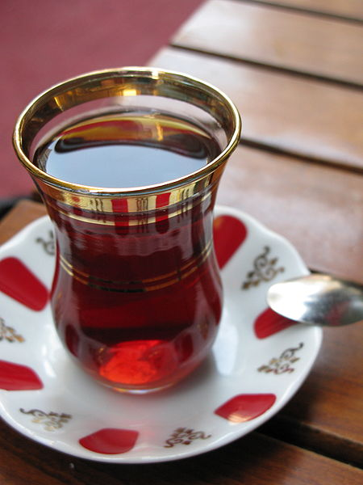

Exp.No. 5
[Lab.6] Isoquinoline Alkaloids
Botanical Name: Fumaria densiflora DC
Family name: Fumariaceae
Active components: Protopine (% 0.29-0.27), fumariline (% 0.21-0.20), β-allocrptopine (% 0.32-0.30)

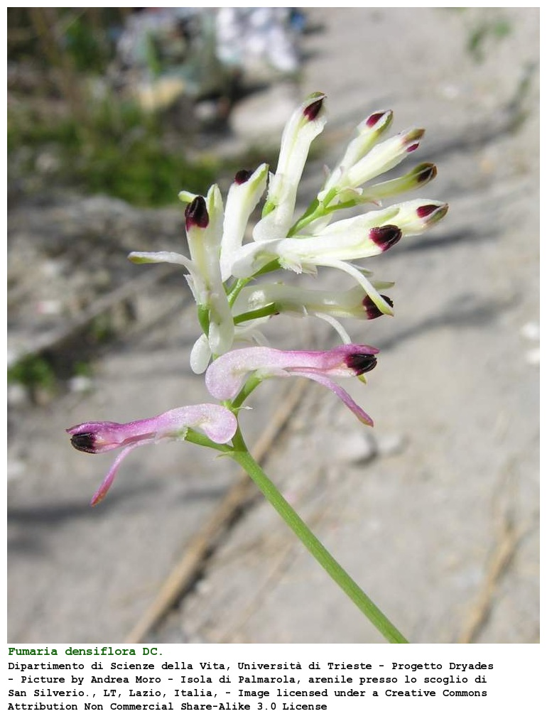
Fumaria species have been used in traditional medicine as antihypertensives, diuretics, hepatoprotectants and laxatives (to treat gastrointestinal disorders), as well as in the treatment of raches and conjunctivitis. The biological activity of Fumaria is mostly associated with the presence of isoquinoline alkaloids in the plant. In the last few
years, a large number of scientific reports have been described the properties of Fumaria. There are seventeen wild-growing species belonging to this genus in Turkey.
The extracts of F. officinalis L. have been used in traditionalmedicine for varied purposes treatment of digestive problems, certain metabolic diseases, liver disorders and to purify blood. Phytochemical investigation revealed the presence of several alkaloids such as adlumidiceine, copticine, fumariline, perfumine, protopine, fumaranine, fumaritine, paprafumicin and paprarine. The plant has also been evaluated pharmacologically and shown to possess antihelmintic, antipyretic and hypoglycemic properties.Fumaria densiflora is annual herb that reaches up to 10-25 cm long Leaves are 2-6 cm. Flowers are with pink and blackish-red tipped petals.

Extraction Method:
Arial parts of plants (25 g) were dried, powdered and extracted with ethanol in a Soxhlet apparatus until Mayer’s test was negative, and then evaporated in vacuum. The ethanolic residue was taken up in % 1 hydrochloric acid (50 ml), filtered and the aqueous acid solution brought to pH 9-9.5 with % 25 ammonium hydroxide and extracted with chloroform (5 x 150 ml). The extracts were dried with anhydrous sodium sulphate and the solvent evaporated to afford a crude extract of alkaloids.
Identification of isoquinoline Alkaloids
TLC: Mobile phase TLC-densitometry two different solvent systems as:
- toluene : chloroform : methanol : % 25 ammonium hydroxide (5:3:1:1)
- chloroform : methanol (8:2)
Spray reagent: Dragendorff’s reagent

Exp.No. 6
[Lab.7] Citric acid
Botanical Name: Citrus limonum
Synonyms and local names: Citrus Limonum, Leemoo, Limoun, Limone.
Family Name: Rutaceae
Genus: Citrus

The lemon is a small evergreen tree native to Asia, and produces a yellow fruit. The fruit is used primarily for its juice, though the pulp and rind (zest) are also used in cooking and baking. The juice of the lemon is citric acid, which gives lemons a sour taste. The distinctive sour taste of lemon juice makes it a key ingredient in drinks and foods such as lemonade.
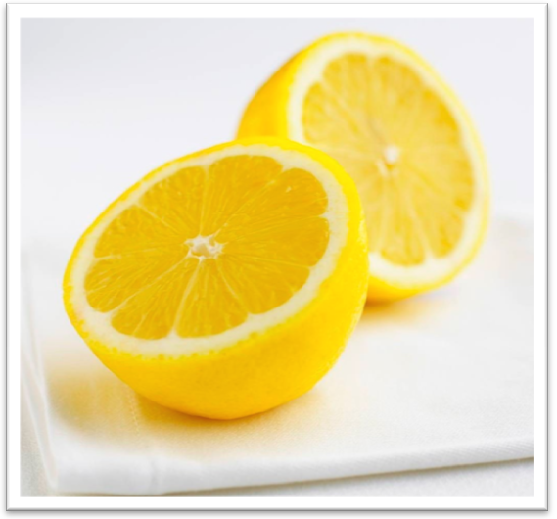
Therapeutic Uses:
1- Aromatherapy, as it boosts the immune system and enhances the mood.
2-Strong antibacterial and antiviral agent
3-Aids in digestion and liver cleanser: As it eliminate waste more quickly from your body.
4-Anticancer properties.
5-A rich source for many vitamins and minerals mainly (5-6) % citric acid and offers 80mg of potassium. Also, calcium, vitamin C, bioflavonoids, pectin and limonene which promotes immunity and fights infections.

Extraction:
Measure 90 Ml of lemon juice concentrate it to 250 ml in a beaker and carefully add a sufficient quantity of 10% NaOH solution. Filtrate by using filter paper to remove all the access large particles and pulp.
Measure the filtrate place in a beaker and add 5 ml of 10% Calcium Chloride solution for each 10 ml of the filtrate. Then wash twice with small quantities of boiling water. Then resuspend in a minimum quantity of cold water, heat to boiling and once again collect the insoluble calcium citrate by filtration. Allow The salt to dry, weight calculate the yield and turn in the product to the laboratory instructor. Citric acid may be prepared from the citrate salt as in the following:
Weight the air-dried salt, place in a beaker and add the calculated amount of IN sulphuric acid required to convert the salt to acid. Allow the mixture to stand for few minutes, filter off the insoluble calcium sulphate and concentrate the filtrate to a small volume by steam bath. Citric acid crystallization out, because of its relatively great water solubility citric acid is somewhat difficult to recrystallize in small amounts. Collect the crystals, dry and calculate the final product what is citric acid.

