***The Alkaloids***

***Alkaloids*** (alkali-like) are defined as organic nitrogenous compounds of plant origin that are physiologically active, ending in the suffix "***ine***".

Plants have been a rich source of alkaloids but some are found in animals, fungi, and bacteria. Among the plants, the ***angiosperms*** are rich in alkaloids.

The following families represent good examples of plants which contain alkaloids:

* Leguminosae.
* Papaveraceae.
* Ranunuclaceae.
* Rubiaceae.
* Solanaceae.
* Berberidaceae.

The Labiatae and Rosaceae are almost free of alkaloids; the ***gymnosperms*** only rarely contain alkaloids.

The names of alkaloids are obtained in various ways:

* From the ***generic*** name of the plant yielding them as ***atropine***.
* From the ***specific*** name of the plant yielding them as ***cocaine***.
* From the ***common*** name of the drug yielding them as ***ergotamine***.
* From their ***physiologic*** ***activity*** as ***emetine.***
* From the ***discoverer*** as ***pelletrine***.

Alkaloids usually contain one nitrogen atom , but some may contain up to 5.

The nitrogen may exist as a primary amine (RNH2), as secondary amine (R2NH), or as a tertiary amine (R3N).

As the nitrogen atom bears an unshared pair of electrons, such compounds are basic and resemble ammonia's chemical properties. The degree of basicity varies greatly, depending on the structure of the molecule and the presence and location of other functional groups.

Like ammonia, the alkaloids are converted into their salts by aqueous mineral acids, and when the salt of an alkaloid is treated with a hydroxide ion, nitrogen gives up a hydrogen ion, and the free amines are liberated. The quaternary ammonium compound has no proton to give up and thus is not affected.

The alkaloids, like other amines, form double salts with the heavy metals that appear as precipitates and are used in their identification. These reagents include:

1. Wagner's reagent (iodine in potassium iodine).
2. Mayer's reagent (potassium mercuric iodide).
3. Dragendroff's reagent (potassium bismuth iodide).
4. Hagger's reagent (saturated solution of picric acid).

*Types of alkaloids:*

1. ***True alkaloids*:** these characterized by contain nitrogen atom in the heterocyclic ring and derived from amino acids. Example is ***Atropine.***
2. ***Proto alkaloids:*** which contain nitrogen atom without a heterocyclic ring and also derived from amino acids. Examples include ***Adrenaline*** and ***Ephedrine***.

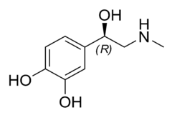

1. ***Pseudo alkaloids:*** These are characterized by heterocyclic rings with a nitrogen atom, but are not derived from amino acids. Example

Caffeine.

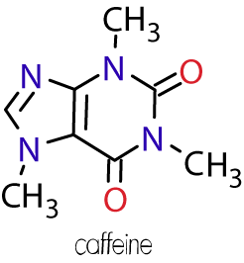

*In General the Alkaloids are Alassified According to Chemical Structure in to two Broad Divisions:*

1. Non-heterocyclic or atypical alkaloids or biological amines.
2. Heterocyclic or typical alkaloids, divided in to 14 groups according to their ring structure ,as follows:
3. Pyrrol and pyrrolidine.
4. Pyrrolizidine.
5. Pyridine and piperidine.
6. Tropine.
7. Quinolone.
8. Isoquinolone.
9. Aporphine.
10. Norlupinane.
11. Indole.
12. Indolizidine.
13. Imidazole.
14. Purine.
15. Steroids.
16. Terpenoids.