***Exp. No.1***

***[Lab.1]* Black Pepper**

***The*** botanical name: **Pipper** **nigrum** of the family **Piperaceae**. It belongs to the third group of typical alkaloids, which is the *pyridine* and *piperidine* group.

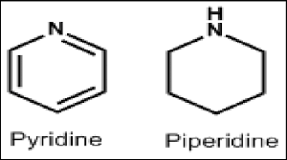

This plant is a perennial plant producing berry –like and aromatic pungent fruits, that are green when unripe and becomes red at maturity, then the dried berries become **black** and wrinkled producing ***black pepper***.

The pepper yields both, black and white pepper according to the method of drying. In that when the ripe and unripe fruit is dried directly under the sun, ***black pepper*** is the result. If the fruit is first soaked, and then removed the outer skin, before drying, and then the result is ***white pepper***.

The alkaloid extracted from the black pepper is ***piperine***.

Piperine alkaloid is a solid substance essentially insoluble in water. It is a weak base that is tasteless at first but leaves a burning after taste. The molecular formula is C17H19NO3, and the chemical structure of piperine is:

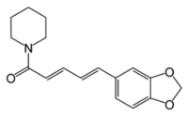

Piperine

*The Pharmacological Activity of Piperine :*

1. Piperine aid in the digestion of food due to its stimulation to the digestive enzymes.
2. There is some evidence that it has an anticonvulsant activity in the treatment of epilepsy.
3. There is some evidence that it has an anticancer and anti-inflammatory activity due to its antioxidant properties.

**The Isolation and Identification of Piperine from Black Pepper:**

1. ***Extraction:***

***Aim***: to isolate the piperine alkaloid from black pepper.

***Equipments:***

* *Large beaker & medium size beakers.*
* *Soxhlet instrument.*
* *Funnel & filter paper.*
* *Water bath.*

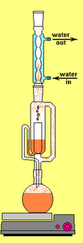

***Soxhlet***

***Reagents:***

* *90% ethanol.*
* *10% alcoholic potassium hydroxide.*

***Procedure:***

***Method of extraction:*** Soxhlet extraction.

***Plant used***: Piper nigrum.

***Part used***: Seeds.

***10 gm*** fine powdered black pepper in ***150 ml*** of *90%* ***ethanol*** for **2 hrs.** In Soxhlet extractor

Hot filtration

***30 ml*** of extract solution concentrated in a water bath at ***60***0C

Add

***2 ml*** of *10%* ***Alcoholic KOH***

Filtrate, and alcoholic extract is left over night

***Results:***

Yellow needles with melting point of ***1250C*** are deposited. Yielding ***0.3*** ***gm*** of piperine alkaloids.

***Discussion:***

1. The plant is affected by heat; therefore, Soxhlet apparatus is used in its extraction.
2. The use of ***90% ethanol*** is to extract both, the alkaloid and the alkaloidal salt that might be present. (This is true for the extraction of most alkaloids).
3. The use of ***alcoholic KOH*** is to precipitate the isomers of piperine that are ***chuvacine,*** ***isochuvacine*** and ***piperic acid***.

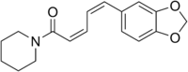 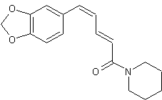 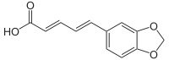

***Chuvacine isochuvacin Piperic acid***

1. Alcohol was used in the preparation of KOH instead of water, since water will hydrolyzed to piperidine and piperic acid as shown below:

