Experimental for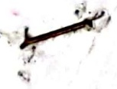

Instrumental analysis methods

The second course

Dr.Saadiyah Ahmed Dhahir

University of Baghdad,Iraq

College science for women

Chemistry department

**Experience(7)**

**Experiment name:**

**A-The calibration of phosphoric acid with a strong base (NaOH)**

**B- The calibration of a mixture of phosphoric acid and hydrochloric with a** **strong base by measurement effort.**

**Theoretical** **part**: During the process of titration adding OH solution will not increase pH of the solutions significantly until most of HCl has been neutralized and the H3PO4 has been change into H2PO4 by the following equation:

**H3PO4+OH** **H2PO4+H2O........(1)**

Further addition of OH will increase the pH solution yielding the first bend for titration curve at the point of equivalent. And then reacts additional OH Ion with the second hydrogen ion converted H2PO4 in to HPO42 by the following equation: $H_{2}PO_{4}^{-}+OH$ $HPO_{4}+H_{2}O$**.......(2)**

Until this conversions is almost completely, the only a small change seen in pH in the solution at added the base .as conversion is completed , The third ion hydrogen reacts only partially with the OH product PO-3 by the following equation

$HPO_{4}+OH$ $PO_{4}^{-3}+$ +H2 **(3)**

**Materials and equipment**

|  |  |  |  |
| --- | --- | --- | --- |
| Equipment | S | Materials | S |
| 100ml Volumetric flask | .1 | phosphoric acid | 1 |
| Graduated Cylinder | .2 | sodium hydroxide (1M) | 2 |
| 50 ml Burette | .3 | distilled water | 3 |
| pipette | .4 | mixture of hydrochloric acid and phosphoric | 4 |
| pH meter | .5 |  |  |

**Procedure**

1.Prepare of the (0.1M) (NaOH) solution from the stock solution (1M).

2. drew (?) ml of phosphoric acid and then diluted to 25 ml of distilled water to the mark an end and then titrate solutions with (0.1M) of NaOH with record pH before adding the titrant.

3. Add the base with 1 ml with the pH reading, when reach at the point of equivalent and added drops (0.1MM) of titrant with continue of adding to make pHI=12.

4-take (?)ml of the mixture (HCI + H3PO4) dilute to 25 ml distilled water to the mark,then the solution titrate with (0.1M) of NaOH.

5.Repeat paragraph 3.

**Accounts**

1-plotted NaOH versus pH and and detect the concentration of the acid unknown

2-Draw the first derivative and the second derivative.

**Questions**

1-What is the purpose for doing this experiment?

2-why use the first derivative and second derivative?

3- why the last bend of calibration curve was not clear after calibration the phosphoric acid with sodium hydroxide?

3-who are first reacted? after calibration of mixture phosphoricacid and hydrochloric acid?

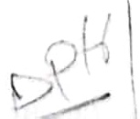

**No Experience (8)**

Figure above shows the spectrum of compounds x and y When the collection of these spectrums get a compound x+y To resolve this issue, has been chosen as the best two wavelengths showed the highest absorbance for two compounds represents λ 1 and λ2 and the total the absorption represents the sum of absorption for each, and can be in writing the following equations

$A_{T}=A_{1}+A_{2}+A_{3}+A_{n}$ c8

Although volumetric and gravimetric mass analyses are commonly used,spectroscopy is the technique most often used for modern chemical analysis.Spectroscopy is the study of electromagnetic radiation emitted or absorbed by a given chemical species. Since the quantity of radiation absorbed or emitted can be related to 0.04the quantity of the absorbing or emitting species present, this technique can be used 0.08for quantitative analysis. There are many spectroscopic techniques available from X- 0.42rays, ultraviolet, infrared,and visible light, to name a few. We will consider one form 0.16here which is based on the absorption of visible light. If a liquid is colored, it is 0.18because some component of the liquid absorbs visible light. In a solution, the greater the concentration of the light-absorbing substance, the more light absorbed and the more intense the color of the solution. The quantity of light

**Experiment name: spectroscopy in the visible region (absorption spectrum and** **Peer law and the analysis mixtures of two component at the same time).**

**Theoretical part**: -in most cases we can often determination each component in the mixture by the spectrometer even if when the overlap of the absorption spectrum of these compounds and the reason for this is that the values of absorption are to the gathering.

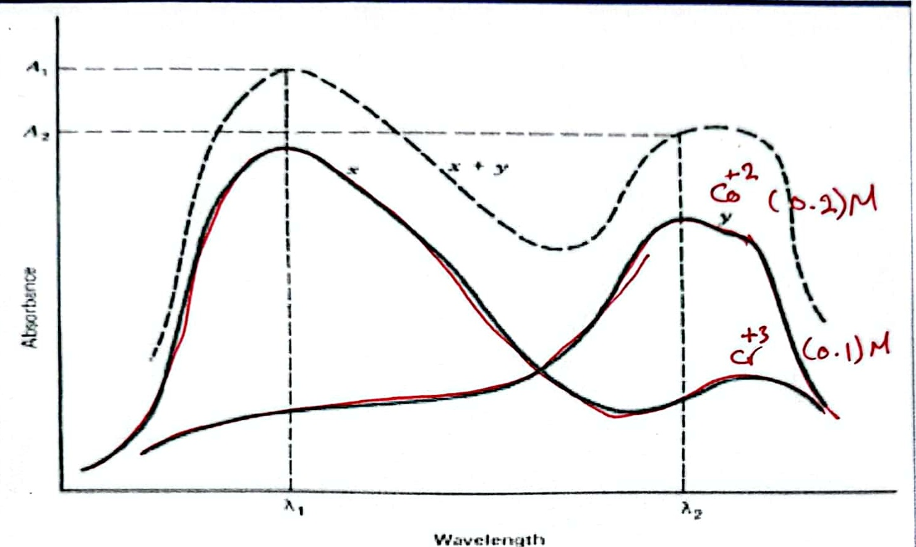

**A two-component mixture with significant spectral overlap**

Figure shows a simulated two-component mixture with significant overlap of the u1o spectra at the absorbance maxima. us0

510

540

575

630

When λ1 we get the **Multi-component mixture:** C5.2 Cさ3

$A_{T}=ϵbc_{X}+ϵbc_{Y}+.$.εnbcn

Where:n=x,y,z ,n-refer to absorbing Components 0.2 0-1

400-66010m원느

absorbed by a substance can be measured using a spectrophotometer. The instrument consists of:(1) a source that emits all wavelengths of light in the visible region (wavelengths 400 to 700 nm); (2) a monochromator which selects a given wavelength of light; (3) a sample holder for the solution being measured; and (4) a detector which compares the intensity of incident light Io to the intensity of light after it has passed through the sample I. When a beam of light passes through a substance, some of the energy is often absorbed by the substance. This causes a decrease in the intensity of the transmitted beam. The ratio I/Io is called the transmittance, T, a measure of the fraction of light that passes through the sample holder (or cuvette) which contains the absorbing solution. The amount of light absorbed by the solution is given by the absorbance,A,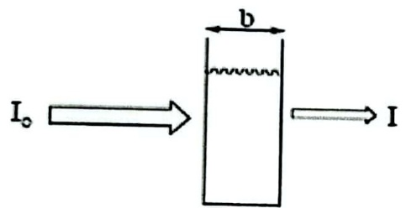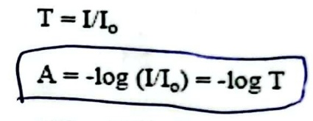

**where:**

A=-log(I/Io)=-logT (1)

Absorbing Solution %T=100%T

of concentration c

The distance, b, the light travels through the solution (in cm) and the concentration,c,of the absorbing species (in mol/L) are represented in the schematic above. A beam of parallel radiation with an intensity is shown before (Io) and after (I) it has passed through a layer of solution with a measured thickness at a certain concentration.The Beer-Lambert law is the basis for using spectroscopy in quantitative analysis which relates absorbance (A) to the concentration of the absorbing solution (c) and the path length of the cuvette (b). That is:

A=εbc **(2)**

where ε is the molar absorptivity or the molar extinction coefficient (in L/mol·cm).Each pure substance has its own unique extinction coefficient. Note that during the experiment, the same cuvette should be used for all measurements. With the same cuvette, the path length (b) and the extinction coefficient (ε) remain constant.Therefore, we can mathematically say that ε b = k (constant). If we write the concentration (c) as M for molarity, our new equation becomes:

**A=kM** (3)

Once absorption values for different concentrations are obtained, a Beer's law plot of absorbance (vertical axis) versus concentration (horizontal axis) is made. A best-fittingline of the data points is constructed, from which you can determine your equation in slope-intercept form

A=(εb)c+0orA=kM+0.

By measuring the path length of your cuvette, the extinction coefficient can then be calculated. In this experiment, there will be three basic tasks to accomplish using the spectrophotometer. First,students will collectively determine the wavelength at which 0.100 M Co(NO3)2 will absorb best. Next, a standard absorbance curve from which the

extinction coefficient can be calculated will be constructed. Finally, an unknown Co(NO3)2 solution will be analyzed for concentration determination.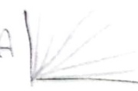

$S=OS_{Δ}E$ ≈0.605001230

**Materials and Equipment**

|  |  |  |  |
| --- | --- | --- | --- |
| Equipment | S | Materials | S |
| Spectrophotometer | 1 | (0.08M) Co+2 and (0.02M)Cr+*3 Nitrate solutions | 1 |
| Pipette | 2 | distilled water | 2 |
| Absorption cells | 3 |  |  |
| Conical Flasks | 4 |  |  |
| Volumetric flasks | 5 |  |  |

**Procedure**

**Experience(A):**Prepare the following solutions:- λ=uoo-630

1-Take 3ml from a stock solution Cr+3(0.02M) in 25 ml volumetric

2-Take 3ml from a stock solutionCO+2(0.08M) in 25 mal volumetric

3-put of the solutions in each cell and Read the absorption (A) of each solution.

4 -put rotary disk wavelength at 400 nm and thus carry an increase of 10 nm even reach to read 630 nm A

**Experience(b)**

1-Prepare series of chromium solutions (0.05,0.04,0.03,0.02,0.01 M) through take certain amount volumes of from chromium solutions in 25 ml volumetric flasks and dilute with distilled water.

2-Prepare series of cobalt solutions of( 0.18,0.16,0.12,0.08,0.04 M)) through take certain amount volumes from cobalt solutions in 25 ml volumetric flasks and dilute with distilled water.

3- Take stored solution as the blank solution (zeroing solution).

4-By returning to the forms obtained by the experiment (A) of the chromium Solution then choose wavelength to study absorption as a function of the concentration, Use the same wavelengths to study the solution of cobalt (II)

5-Use the same previous cells and the same arrangement of the first for distilled water and the second for chromium and third for cobalt.

**Experience (C)**

1-Take the values in the experiment (B) for the mixture Co".,Cr"

2-To determined the values of ε in Peers law schemes in experience (B) go back to the absorption spectrum of chromium and cobalt, and then find two wavelengths, to analyze the combination of Co and Cr, preferably to be between (510-575) nm, and then the determine the slope which equal of ε of chromium and cobalt..

A=abc+abc

d-abc+abc

**Experience(9)**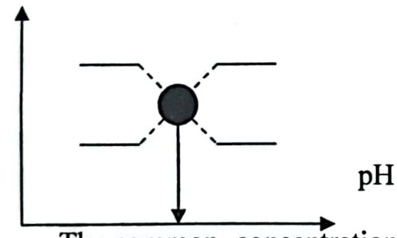

**Experiment name: Determination of dissociation thermodynamic constant** **indicator**

**Theoretical part**: It is well known that indicator is the acids and bases identified the symbol (HI-n) or (HOIn), respectively, indicates (In) to the brief of the word indicator. The indicator is dissociate as the following equation when the indicator (HIn).

$$HIn→H^{+}+I^{-}n$$

It is dissociation constant

$$Ka=\frac{[H^{+}]I^{-}}{[HI]}$$

And can be extracted from the following equation PKa

pH=pKa+log $log⁡\frac{[I^{-n}]}{[I^{-n}}]$

It can be plotted pH versus log [In] [HI-n] should give a straight line intersects that [In] = [HI-n] is equal to pKa, can also use the spectral method to estimate PK indicator of acid base when plotted the values of absorption(A) for indicator Solution at different values of pH have the following format.

Amax

Amax

Amin

The common concentration at the values of Amax is the concentration of In ions,As Amin, the common concentration is the concentration of HI-n, and the average distance between the Amax, Amin represent absorb a solution containing the same concentration of In, HI-n.

$$[HI^{-}]=[I^{-}]$$

**Materials and equipment**

|  |  |  |  |
| --- | --- | --- | --- |
| Equipment | S | Materials | S |
| Spectrophotometer | 1 | Bromo phenol Blue indicator | 1 |
| Absorption cell | 2 | HCI Conc | 2 |
| Volumetric flask | 3 | NaOH Conc | 3 |
| Test tubs | 4 | Distilled water | 4 |
| pipettes | 5 | Sodium acetate 0.2M | 5 |
| Graduated cylinder | 6 | Acid anhydride 0.2M | 6 |

**Procedure**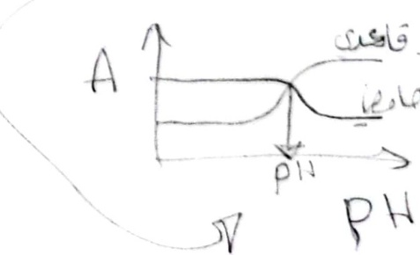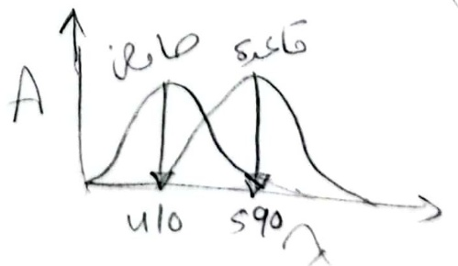

1-Measure absorption of the solution prepared from indicator at the(350-700) nm,up 10 nm for each of the following solutions:-

A-Take exactly 0.5 ml of indicator solution and then add a drop of the HCI acid and dilute with distilled water to 25 ml Volumetric flask., with continuous addition until obtain yellow color.

B-Take exactly 0.5 ml of indicator solution and then add a drop of the ConC.NaOH and then dilute with distilled water to 25 ml Volumetric flask., with continuous addition until obtain violet color.

2-Choose the highest peak absorptionλ max which shows the highest wavelength absorption of the indicator in the acid and base medium and then prepare a series of buffer solutions to give a change in color from the color indicator to the other materials used are sodium acetate (0.2N) and acetic acid (0.2N), and then measure the absorption and pH for each of the solutions prepared.

|  |  |  |  |  |  |  |  |  |  |  |  |  |
| --- | --- | --- | --- | --- | --- | --- | --- | --- | --- | --- | --- | --- |
| pH | 3.42 | 3.72 | 4.05 | 4.27 | 4.45 | 4.63 | 4.8 | 4.99 | 5.23 | 5.37 | 5.57 | 5.89 |
| 0.2N Sodium Acetate (ml) | 0.5 | 1 | 2 | 3 | 4 | 5 | 6 | 7 | 8 | 8.5 | 9 | 9.5 |
| 0.2N acetic acid (ml) | 9.5 | 9 | 8 | 7 | 6 | 5 | 4 | 3 | 2 | 1.5 | 1 | 0.5 |

0.5 0.5 0.5 05

**Accounts**

1-plotted Absorption versus( λ max) and then determine the highest wavelength.

2-plotted chart between Absorption and pH and detected pKa indicator

**Questions**

·write formulas of indicator and the expected colors?

·What is absorption spectrum?

·What is the buffer solution?

Geoditin A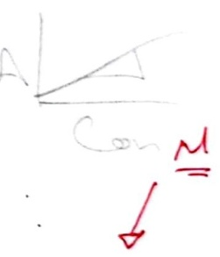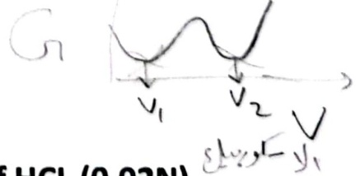

Experience (10) )

A-Quantative analysis of Ascorbic acid by using UV spectrum

B-Determine content of Vitamin C in tablets of two different manufacturers with conductometry.

Procedure $N_{1}V_{1}=N_{2}V_{2}$ MVN

100*1=N2x50Am

1-take 1ml of stock solution ascorbic acid 100 ppm and dilute to 50ml volumetric flask using distilled water.

200

2-Measured absorbance of solution extend record (200-300) nm 5nm up period to detected the max. $N_{1}V_{1}=N_{2}V_{2}$

yá $U_{1}=2^{1}×50$

3-prepare series of ascorbic acid by (1,2,3,4,6,8 ) ppm from the stoke solution (100) in the volumetric flask 50ml and complete to the mark with distilled water and measure the absorbance to each solution at max detected.

4-measure the absorbance of unknown sample at max detected.Account M eS PpmadSes?

1-draw absorption versus wave length and detectmax.PPm=Mx3/ykmdx10

2-draw absorption versus concentration and determine the concentration for unknown.

G

B-Determine content of Vitamin C in tablets of two different manufacturers with conductometry.

Procedure

1-take (1) table of vitamin C and dissolves in 20ml of HCL (0.02N) $N_{1}V_{1}=N_{2}V_{2}$ NaOH $N_{1}×50=0.1×(V_{2}-$

2-filter the solution and take the filterant then dilute in volumetric flask 50ml of distilled water.

3-Titrate the prepared solution in step (2) with 0.1M NaOH.

4-add the base (1ml)with conductivity reading when reach at the equivalent point.

Account

Draw the conductivity verse volume of NaOH and find the

concentration of ascorbic acid.

Calculation

Plot the measured conductivity (G) versus added base volume. All points can be plot on the same paper using different notation (four curves). Determine equivalence points. Calculate the exact concentration of NaOH solution. (Titration 1.) For Vitamin C samples consider that ascorbic acid is a weak organic acid. One of the samples contains sodium ascorbate, too. Molecular weight data for ascorbic acid and for sodium ascorbate are Mw= 176 g/mol and Mw=198g/mol, respectively.Compare the ascorbic acid content determined by the two different method and specification.

**No Experience (11)**

Molecular species (uncharged substances) do not contribute to the conductance of a solution.

Relative conductances of the species which are involved in the experiment.

After the end point, no H+ is available to react, and the conductance of the solution increases as a result of the addition of Na+ and OH-.Consequently the titration curve has a V-shape as shown in the figure. The end point of the titration corresponds to the intersection of the extrapolated linear portions of the titration curve.

**A-Name of Experiment: Conductometric Titration of Hydrochloric Acid with** **Sodium Hydroxide**

**B-Name of Experiment: Conductometric Titration of Hydrochloric Acid and** **Acetic Acid with Sodium Hydroxide**

**Theoretical part:**

Conductance (G) is the reciprocal of electrical resistance (R).G=1/R

It is a measure of the ability of a solution to conduct electricity. The conductance of a solution is the sum of the conductances of all of the ions that are in the solution.

G=ΣGi

The conductance of a particular ion in solution depends upon the concentration of the ion,the charge on the ion, and the size of the ion. As the concentration or the charge of the ion increases, the conductance of the solution increases. In general as the size of the solvated ion decreases, its mobility through the solution increases and consequently the conductance of the solution increases. In water the ion which has the greatest conductance is H+. of the common, negative ions, OH has the greatest conductance. The relative conductances (relative to acetate) of the species that are involved in the experiment are listed in the table.

|  |  |
| --- | --- |
| Species | Relative conduct |
| H+ | 8.5 |
| OH- | 4.8 |
| C1- | 1.9 |
| $$Na^{+}$$ | 1.2 |
| $$C_{2}H_{3}O_{2}^{-}$$ | 1.0 |
| $$HC_{2}H_{3}O_{2}$$ | 0 |
| $$H_{2}O$$ | 0 |

During the titration of hydrochloric acid with sodium hydroxide, the reaction that takes place in the titration vessel is

$H^{+}+Cl^{-}$ $\frac{Na+OH^{-}}{}>$ $H_{2}O+Cl^{-}+Na^{+}$

Before the end point, H+ is removed from the solution byreaction with OH,and Na+is added to the solution. Since the relative conductance of H+ is about seven times that of Na+, the conductance of the solution decreases prior to the end point.

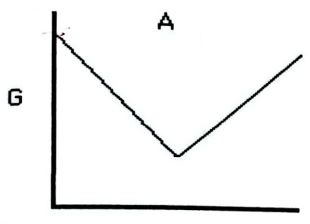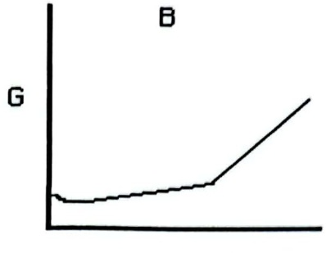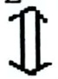

HCl

Volume (mL) **Volume(mL)**

Diagrams of the conductometric titrationcurves. A, the titration of HCI with NaOH; B, the titration of HC2H3O2 with NaOH. The slight decrease in conductance at the start of the acetic acid titration is due to suppression of the acid dissociation by the common-ion effect. Since acetic acid is dissociated slightly (Ka=1.8 x 10-5)in aqueous solution, the conductance of the acetic acid solution is initially small. As sodium hydroxide is added, the hydroxide reacts with the acid to form water and acetate

$HC_{2}H_{3}O_{2}$、 $H_{2}O+Na++C_{2}H_{3}O_{2}^{-}H^{+}+C_{2}H_{3}O_{2}^{-}$

The addition of C2H3O2- and Na+ to the solution causes the conductance of the solution to increase. After the end point, Na+ and OH- are added to the solution.Since the relative conductance of OH- is nearly five times that of C2H3O2-, the conductance of the solution after the end point increases more rapidly than it did before the end point. The end point corresponds to the intersection of the extrapolated linear portions of the curve.

Conductance is usually measured with an alternating current between two identical,platinized platinum electrodes. Use of an alternating current prevents the buildup of reaction products around either electrode and consequently prevents polarization of the solution. The electrodes must be rigidly held at a fixed distance apart during the titrations in order to prevent changes in conductance that result from an altered solution volume between the electrodes. The addition of C2H3O2- and Na+ to the solution causes the conductance of the solution to increase. After the end point, Na+and OH- are added to the solution. Since the relative conductance of OH- is nearly five times that of C2H3O2 -, the conductance of the solution after the end point increases more rapidly than it did before the end point. The end point corresponds to the intersection of the extrapolated linear portions of the curve.

Conductance is usually mneasured with an alternating current between two identical,platinized platinum electrodes. Use of an alternating current prevents the buildup of reaction products around either electrode and consequently prevents polarization of the solution. The electrodes must be rigidly held at a fixed distance apart during the titrations in order to prevent changes in conductance that result from an altered solution volume between the electrodes.

**Reference**

**R.D. Braun, "Introduction to Chemical Analysis”,McGraw-Hill,** NewYork,1982,pp.329-335.



6. After the titrations have been completed,. Switch off the device then clean the tools of glass and conductance meter cell (store the electrodes in water) as instructed by supervisor.

Conductivity of a Weak acid Conductivity of a Strong Volume of add base

3. Use the endpoint volumes and the mean sodium hydroxide concentration to calculate three values of the concentration of the original hydrocholoric acid solution and three values of the concentration of the original acetic acid solution.

**Tools and materials:**

**Materials nameS**

Hydrochloric acid 1Conductance meter 1**Tools nameS** Sodium hydroxide 2Burette capacity of 25 ml 2

Acetic acid anhydride 3Pipette capacity of 10 ml 3

Distilled water 4 Volumetric flasks capacity of 250 ml 4

Cylinder capacity of 100 ml 5

**Experimental method:**

1.Add about 6 ml of 50% sodium hydroxide solution to a 1 L volumetric flask Dilute the solution to near the mark with distilled or deionized water. The resulting solution contains 0.1 M sodium hydroxide.

3-Fill the 50 ml burette with the 0.1M sodium hydroxide solution.

2-Obtain at least 35 ml of an acetic acid solution and at least 35 ml of a hydrochloric acid solution from the instructor. Record the sample numbers.

3-Use a pipette to add 10 ml of the hydrochloric acid solution to the tall beaker. Add about 140 ml of distilled or deionized water and a stirring bar to the beaker. Place the beaker on a magnetic stirrer. Use a clamp to suspend the electrodes in the soution.The platinum electrodes must be completely submerged in the solution,but they should not interfere with operation of the stirring bar. Adjust the stirring rate to yield a smoothly stirred solution.

4-Measure the initial conductance of the stirred solution. Add 0.5 ml portions of the sodium hydroxide solution to the stirred solution. Record the conductance of the titrand solution and the total volume (to the nearest 0.01 ml) of the added titrant solution after each addition.Continue the titration until the end point has been passed

5- Similarly dilute and titrate two, more 10 ml portions of the hydrochloric acid solution, and three, 10 ml portions of the acetic acid solution.

**Accounts:**1-Regulated your results as follows table:

acid(μS)

(μS) =0.0

= 0.5

=

= 1

=

=

2. For each conductometric titration, plot conductance (y axis) as a function of the volume of the added sodium hydroxide solution. Draw a straight line through each of the two, linear portions in each titration curve. Determine the endpoint volume of each titration from the intersection of the two straight lines.

4.Determine the mean hydrochloric acid concentration and the standard deviation of the results. Determine the mean acetic acid concentration and the standard deviation of the results.

**1.European Pharmacopoeia 4,Council of Europe,Strassbourg,2001,p.52.,p.674.**

**Rf.Chemistry M01B Laboratory Manual pp.32**

**Rf.EXPERIMENT FEST,HANDBOOK Chemistry 2008.Prof.Bill Hogarth Pro**

**Vice-Chancellor-Faculty of Science and Information TechnologyUniversity of** **Newcastle**

www.newcastle.edu.au

**Chemistry experimental for instrumental analysis methods**

Donald T.Sawyer

Professor,department of Chemistry

University of California

William R.Heineman

Professor,department of Chemistry

University of Cincinnati

Professor,department of Chemistry

Frostburg state college Copy rights 1984,by john Wiley &sons, Inc., Canada