**Enzyme-Linked Immunosorbant Assay (ELISA)** is also known as an enzyme immunoassay (EIA).

ELISA is a biochemical technique used to detect the presence of an antibody or antigen in a sample.

ELISA has been used as a diagnostic tool in medicine, plant pathology and in the food industry as a quality control check.

In an ELISA

* an unknown amount of antigen is affixed to a surface
* a specific antibody is applied over the surface so that it can bind to the antigen. This antibody is linked to an enzyme
* in the final step a substrate is added that the enzyme can convert to some detectable signal, most commonly a color change in a chemical substrate.

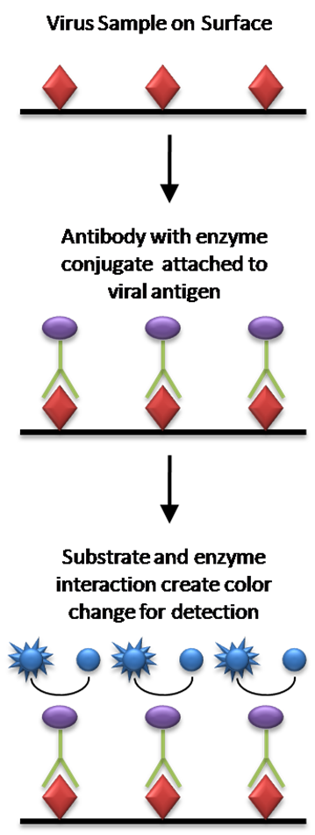

**COMPONENTS OF AN ELISA**

* **Antibody: IgG fraction of serum purified by affinity chromatography**
* **Enzyme: Horse Radish Peroxidase (HRP) MW 44, 000, glycoprotein with 4 lysine residues**
* **Substrate: TMB (3,3',5,5', tetramethylbenzidine) The enzyme acts as a catalyst to oxidize substrate in the presence of Hydrogen peroxide to produce a blue color. Reaction stopped with dilute acid to cause complex to turn yellow.**

**Types of ELISA assays may you use**

(1) **The direct ELISA** uses the method of directly labeling the antibody itself. Microwell plates are coated with a sample containing the target antigen, and the binding of labeled antibody is quantitated by a colorimetric, chemiluminescent, or fluorescent end-point.

**Advantages of Direct Detection**

* Quick methodology since only one antibody is used.
* Cross-reactivity of secondary antibody is eliminated.

**Disadvantages of Direct Detection**

* Immunoreactivity of the primary antibody may be reduced as a result of labeling.
* Labeling of every primary antibody is time-consuming and expensive.
* No flexibility in choice of primary antibody label from one experiment to another.

Little signal amplification.

(2) **The indirect ELISA** utilizes an unlabeled primary antibody in conjunction with a labeled secondary antibody. Since the labeled secondary antibody is directed against all antibodies of a given species (e.g. anti-mouse), it can be used with a wide variety of primary antibodies (e.g. all mouse monoclonal antibodies).

**Advantages of indirect detection**

* Wide variety of labeled secondary antibodies are available commercially.
* Versatile, since many primary antibodies can be made in one species and the same labeled secondary antibody can be used for detection.
* Immunoreactivity of the primary antibody is not affected by labeling.
* Sensitivity is increased because each primary antibody contains several epitopes that can be bound by the labeled secondary antibody, allowing for signal amplification.

**Disadvantages of indirect detection**

* Cross-reactivity may occur with the secondary antibody, resulting in nonspecific signal.
* An extra incubation step is required in the procedure.

(3) **The third type of ELISA is the Competition Assay,** which involves the simultaneous addition of 'competing' antibodies or proteins. The decrease in signal of samples where the second antibody or protein is added gives a highly specific result.

(4) **The Sandwich ELISA** involves attachment of a capture antibody to a solid phase support. Samples containing known or unknown antigen are then added in a matrix or buffer that will minimize attachment to the solid phase. An enzyme-labeled antibody is then added for detection.

Sandwich ELISA is a less common variant of ELISA, but is highly efficient in sample antigen detection. Moreover, many commercial ELISA pair sets are built on this sandwich ELISA.

The sandwich ELISA quantify antigens between two layers of antibodies (i.e. capture and detection antibody). The antigen to be measured must contain at least two antigenic epitope capable of binding to antibody, since at least two antibodies act in the sandwich. Either monoclonal or polyclonal antibodies can be used as the capture and detection antibodies in Sandwich ELISA systems. Monoclonal antibodies recognize a single epitope that allows fine detection and quantification of small differences in antigen. A polyclonal is often used as the capture antibody to pull down as much of the antigen as possible. The advantage of Sandwich ELISA is that the sample does not have to be purified before analysis, and the assay can be very sensitive (up to 2 to 5 times more sensitive than direct or indirect ELISA).

**Sandwich ELISA advantages:**

* High specificity, since two antibodies are used the antigen/analyte is specifically captured and detected
* Suitable for complex samples, since the antigen does not require purification prior to measurement
* Flexibility and sensitivity, since both direct and indirect detection methods can be used

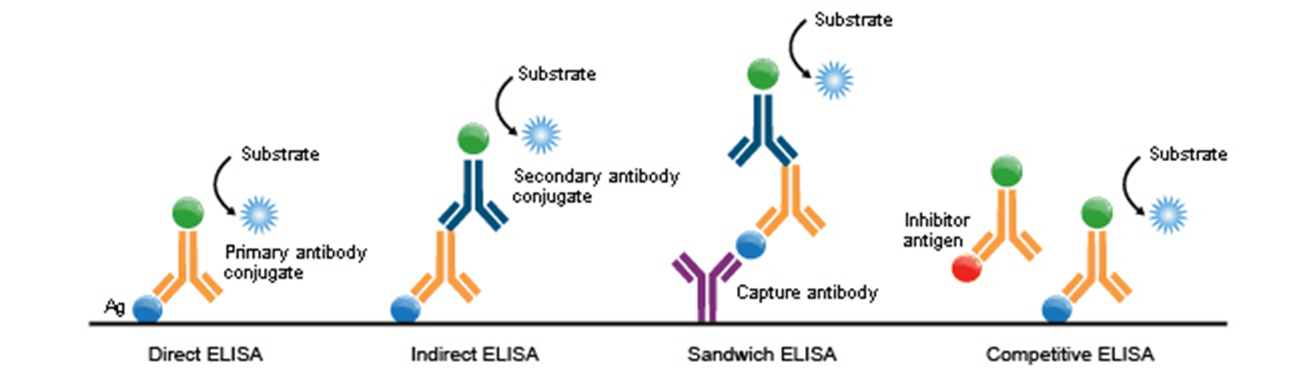

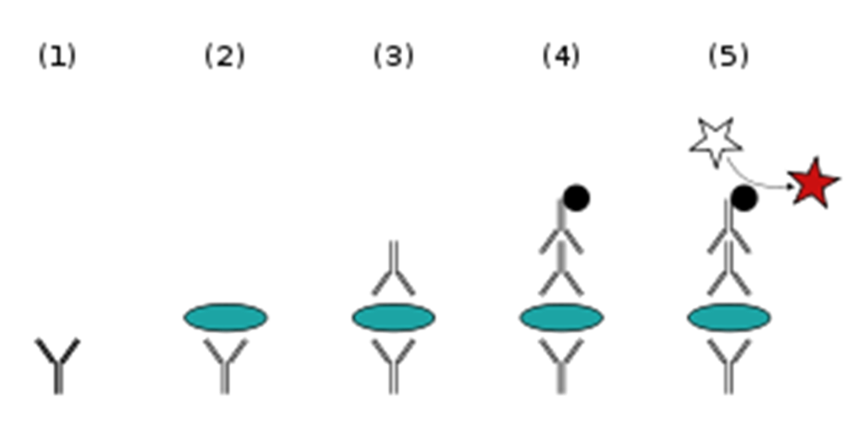 Sandwich ELISA

1) Plate is coated with a capture antibody; (2) sample is added, and any antigen present binds to capture antibody; (3) detecting antibody is added, and binds to antigen; (4) enzyme-linked secondary antibody is added, and binds to detecting antibody; (5) substrate is added, and is converted by enzyme to detectable form.

**MATERIALS REQUIRED:**

**1.ELISA plate 2. Positive control 3. Negative control 4. Dilution Buffer (In dilution tubes) 5. Conjugate (secondary antibody) 6. Substrate solution 7. Stop solution 8. Washing detergent**

**(ELISA Protocol) Assay Procedure**

1.Add 100 μL of sample or standards in sample dilution buffer per well. Seal the plate and incubate 2 hours at room temperature.

2.Repeat the aspiration/wash as in step 2 of plate preparation.

3.Add 100 μL of the detection antibody, diluted in antibody dilution buffer, to each well. Seal the plate and incubate 1 hour at room temperature.

4.Repeat the aspiration/wash as in step 2 of plate preparation.

5.Add 200 μL of substrate solution to each well. Incubate for 20 minutes at room temperature ( if substrate solution is not as requested, the incubation time should be optimized ). Avoid placing the plate in direct light.

6.Add 50 μL of stop solution to each well. Gently tap the plate to ensure thorough mixing.

7.Determine the optical density of each well immediately, using a microplate reader set to 450 nm.

**(ELISA Protocol) Calculation of Results**

1.Calculate the mean absorbance for each set of duplicate standards, controls and samples. Subtract the mean zero standard absorbance from each.

2.Construct a standard curve by plotting the mean absorbance for each standard on the y-axis against the concentration on the x-axis and draw a best fit curve through the points on the graph.

3.To determine the concentration of the unknowns, find the unknowns’ mean absorbance value on the y-axis and draw a horizontal line to the standard curve. At the point of intersection, draw a vertical line to the x-axis and read the concentration. If samples have been diluted, the concentration read from the standard curve must be multiplied by the dilution factor.

4.Alternatively, computer-based curve-fitting statistical software may also be employed to calculate the concentration of the sample.

**APPLICATIONS**

Screening donated blood for evidence of viral contamination by

HIV-1 and HIV-2 (presence of anti-HIV antibodies)

hepatitis C (presence of antibodies)

hepatitis B (testing for both antibodies and a viral antigen)

Measuring hormone levels

HCG (as a test for pregnancy)

LH (determining the time of ovulation)

TSH, T3 and T4 (for thyroid function)

Detecting infections

(sexually-transmitted agents like HIV, syphilis and chlamydia

hepatitis B and C

Toxoplasma gondii

Detecting allergens in food and house dust

Measuring "rheumatoid factors" and other autoantibody in autoimmune diseases like lupus erythematosus

Measuring toxins in contaminate