

**University of Baghdad**

**College of Pharmacy**

**Department of Pharmacognosy**

Practical Pharmacognosy

Thid year

1st term

**Done by :**

1. **lecturer Pharmacists**

**Dhuha A. Abdul Hussain Zahra’a S. Nassir**

**Supervised by:**

**L. Maha N. Hamad**

**Head of department of Pharmacognosy and Medicinal plants**

**2013**

***Glycosides***

***Glycosides*** are compounds that yield on hydrolysis, one or more sugar part and another non-sugar part. The sugar part is known as **glycone** ,and the non-sugar part is the **aglycone.** In general there are four *basic classes* of glycosides:*C- glycosides*, in which the sugar is attached to the aglycone through C-C bond, and the *O- glycosides* in which the sugar is connected to the aglycone throughoxygen –carbon bond,S-glycosides and N-glycosides.

Chemically the glycosides are acetals in which the hydroxyl group (OH) of the glycone is condensed with the hydroxyl group of aglycone. More simply the glycosides may be considered as sugar ether. Two forms of glycosides are present, the α-form and the β-form, but the β-form is the one that occur in plants, even the hydrolytic enzymes act on this type.

O OH ORe

Re C H Re C ORe Re C ORe

H H

HemiacetalAcetal Acetal

Inside the body the glycosides will be cleaved to glycone and aglycone parts, the glycone part confers on the molecule solubility properties, thus is important in the absorption and distribution in the body, while the aglycone part is responsible for the pharmacological activity.

Generally all glycosides are hydrolyzed by boiling with mineral acids , on the other hand the presence of specific enzyme in the plant tissue, but in different cells from those that contain the glycosides, are able to hydrolyzed the glycosides, such as the emulsin enzyme which is present in the almond kernel, and the myrosin enzyme which is found in the black mustard seeds.

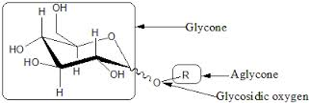

**(Fig.1) General Structure of Glycosides**

*Generally in the extraction of glycosides we have to consider thefollowing points:*

1. Apolar solvent , which is mostly alcohol ,but not water ,since water may

induce fermentation , in addition water need high temperature due to its

high boiling point.

1. Neutralization of the extract with base, since the presence of acid lead

to hydrolysis of the glycoside.

1. Use of heat is to inhibit the activity of hydrolytic enzymes that present in

the plant cell.

*The glycosides are classified according to the chemical structure of the aglycone to****:***

1. Cardioactive glycosides. **7.**Alcohol glycosides.
2. Anthraquinone glycosides . **8.** Aldehyde glycosides.
3. Saponin glycosides**. 9.**Lactone glycosides.
4. Cyanophore glycosides. **10.**Phenol glycosides.
5. Isothiocyanate glycosides. **11**. Miscellaneous glycosides.
6. Flavonoid glycosides.

***Exp. No.1***

***[Lab.1]* Cardioactive Glycosides**

***They*** are named so, due to their action on the heart muscle. Theaglycone part here is steroid, which is chemically cyclopenta phenanthrene .C:\Users\owner\Pictures\cyclopenta.gif

**cyclopentaphenanthrene nucleus**

The steroidalaglycones are of two types:

1. Cardinolides(α-β unsaturated 5 – member lactone ring).
2. Bufadienolides (doubly unsaturated 6-member lactone ring).

The more prevalent in nature is cardinolides type.

*For maximum activity ofcardioactivce glycosides the following points are important:*

1. 17 -β –lactonering (cardinolide or bufadinolide).
2. 3 -β - OH.
3. 14 -β-OH .
4. CATSC (C= ***cis*** between two rings (A&B). A= ***Anti*** one ring (5&19).

T=***Trans*** between two rings (B&C). S= ***Syn*** in one ring (8&18).

As represented bellow:

[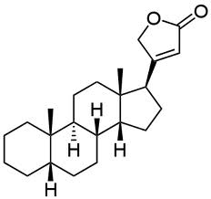](http://www.google.iq/imgres?imgurl=http://upload.wikimedia.org/wikipedia/commons/7/7a/Cardenolide.svg&imgrefurl=http://commons.wikimedia.org/wiki/File:Cardenolide.svg&h=310&w=330&sz=14&tbnid=I3h0G07yWf5BbM:&tbnh=87&tbnw=93&zoom=1&usg=__dj1sWb3LSCEfWYuiOmPsloJMUao=&docid=2gspCPPSu9K6AM&sa=X&ei=RG8rUrDXCsKItQbN2oCYCg&ved=0CDAQ9QEwAQ&dur=4233)[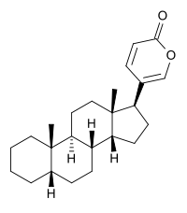](http://en.wikipedia.org/wiki/File:Bufadienolide_skeletal.svg)

Cardenolide Bufadienolide

*Plants Containing CardioactiveGlycosides:*

1. Digitalis (digitalis or foxglove) **Digitalis purpurea** of the family Scrophulariaceae.

Thename digitalis is from Latin *digitus* which means finger refers to finger – shaped, while *purprea* refers to *purple*color of their flower. This plant contains anumber of glycosides as digitoxin ,gitoxin and getaloxine.

1. **Digitalis lanata** of the same family,from which the digoxin is obtained.
2. The plant used in our laboratory is **Nerium oleander** of the family **Apocyanaceae**. The main glycoside of which is oleandrin.

[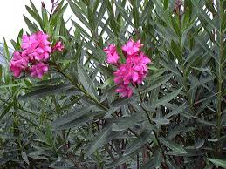](http://www.google.iq/url?sa=i&source=images&cd=&cad=rja&docid=GrSTsFhzs4Vj8M&tbnid=awjLnIo856bMDM:&ved=0CAgQjRwwAA&url=http://www.empowernetwork.com/zacodumes/blog/nerium-international/&ei=6H0rUrTJKIqG4gT8r4DIAQ&psig=AFQjCNGgJUEJfnCNXvlc4IMBM_T-djPd6Q&ust=1378668392717634)

**Nerium oleander**

**Isolation and Identification of the CardioactiveGlycosides:**

1. ***Extraction:***

***Aim***: To isolate the cardio active glycosides*.*

***Equipments:***

* *Large beaker & two medium size beakers.*
* *Two conical flasks.*
* *Centrifuge & Centrifuge tubes.*
* *Separatory funnel.*
* *Water bath.*

***Reagents:***

* *70% ethanol.*
* *Lead sub acetate.*
* *10% sodium phosphate solution.*
* *Chloroform:Ethanol (3:1 v/v).*
* *Anhydrous sodium sulphate.*
* *4N HCl acid.*
* *Chloroform.*

***Procedure:***

***Method of extraction:*** Maceration.

***Plant used***: Nerium oleander.

***Part used***: dry leaves.

Maceration ***10 gm*** of the powdered leaf in ***100 ml*** of *70%* ***ethanol*** for **24 hrs. (**Prepared previously)

Take ***10 ml*** of alc. Extract in conical flask

Add

***10 ml*** of ***lead sub acetate*** solution

(Mixing& standing for **5 mins.)**

Centrifuge

*(****5 mins.)***

Decant and take the supernatant (upper layer)

Add

***10 ml*** of *10%****sodium sulphate*** solution

Centrifuge

(***5 mins*.)**

Take supernatant and divide in to ***two***divisions

***Fraction A***

Take one division and put in the separatory

Add

[***10 ml*** of ***Chloroform: Ethanol*** *(3:1 v/v)*] two times

(Shake& stand)

Take the organic lower layer and put it in the conical flask

Add

Small quantity of ***Anhydrous sod. Sulphate*** & allow standing for few minutes until get a clear solution, decants and we get:

***Fraction A***

***Fraction B***

Place the other division of the extract in the conical flask

*Add*

***3 ml*** of ***4N HCl***

*Boiling in water bath*

*(****15 mins***)

Cool &transfer to a separatory funnel

*Add*

[***10 ml*** of ***Chloroform***] tow times

*Combine the chloroform extracts (lower layers)*

*Add*

Small quantity of ***Anhydrous sod. Sulphate***& allow standing for few minutes until get a clear solution thendecant the chloroform layer and concentrated on water bath to about 1ml. and we get:

***Fraction B***

***2.Results:***

Fraction A : Contain the whole glycosides.

Fraction B : Contain the aglycone (genin) part only.

***[Lab.2] TheChemical Tests***

**1. Baljet'sTest**

***Aim:*** The identification of the cardioactive glycosides in ***general***.

***Equipments& Reagents:***

* Test tube.
* Picric Acid.
* Sodium hydroxide solution.

***Procedure :***

Take ***1ml*** of fraction A , add ***2 drops*** of ***Picric acid*** then make it alkaline with ***Sod.Hydroxide*** solution.(litmus paper).

***Results:***

Turbid **yellow** to **orange** in color.

**2. Keller- Killian's Test**

***Aim:*** The identification of the cardioactive glycosides in ***general***.

***Equipments& Reagents:***

* Test tube.
* Glacial acetic acid
* 0.1 % of ferric chloride solution.
* Conc. H2SO4.

***Procedure:***

Take ***1ml*** of fraction A, and ***2ml*** of ***glacial acetic acid*** , add ***1 drop*** of ***0.1 %*** of  ***ferric chloride solution.***

Take ***1ml*** of conc***. H2SO4***and add to the above mixture in drops so as to make two layers.

***Results:***

Two layers are formed; the upper one has ***light bright green*** color. The lower layer has transparent clear color (H2SO4 layer).The junction appears as a ***reddish –brown*** ring.

***Other Chemical Tests for the Identification of Sterol Glycosides:***

1. ***Raymond 's Reaction:***

***Aim :*** To identify the ***sterol*** nucleus.

***Equipmentsand Reagents:***

* Test tube.
* 10% sodium hydroxide solution.
* 1% m-dinitrobenzene.

***Procedure:***

To 1ml of fraction A add ***1-2 drops*** of ***10% sodium hydroxide*** and few drops of analcoholic solution of ***1%m-dinitrobenzene.***

***Result:***

***Pink*** color.

1. ***Kedde's Reaction :***

***Aim :*** To identify the ***sterol*** nucleus.

***Equipments and Reagents:***

* Test tube.
* 1% 3,5-dinitrobenzoic acid.
* 0.5 N aqueous methanolic KOH (50 %).

***Procedure:***

To a solution of glycoside add asolution of ***1% 3,5-dinitrobenzoic acid*** in 0.5N aqueous ***methanolic KOH (50%)***.Report the color.

***Result:***

***Pink*** color.

1. ***Lieberman's Sterol Reaction:***

***Aim :*** To identify the ***sterol*** nucleus.

***Equipments and Reagents:***

* Test tube.
* Porcelain dish.
* Anhydrous acetic acid.
* Conc.H2SO4.

***Procedure:***

Take ***1ml*** of fraction A in a test tube then add ***5ml*** of***anhydrous acetic acid***and shake well. Take ***4 drops*** of the above mixture and place in a porcelain dish, then add ***one drop*** of***conc.H2SO4.***

***Result:***

A change of color from **rose**, through **red**, **violet** and **blue** to **green**. The colors are slightly different from compound to compound.

***Discussion:***

This reaction is due to the steroidal part of the molecule and it is characteristic of the ***aglycone*** of the scillarenin type (unsaturated steroidal part).

1. ***Legal'sReaction:***

Few mls of the glycoside or the purified extract of the crude drug is dissolved in pyridine. When sodium hydroxide and sodium nitroprusside are added alternatively, a transient blood-red color develops. This is atest for the unsaturated lactone ring of the genin.

Identification of Cardioactive Glycosides By Chromatography:

By the use of thin layer chromatography **(T.L.C)**

* The stationary phase = *Silica gel G****.***
* The mobile phase =***Chloroform: Ethanol: Water (7:3:1)***

*Or****Ethyl acetate: Methanol: Water (75:10:5).***

* The standard compound = ***Oleandrin.***
* The spray reagent = Lieberman's ***reagent.***
* Mechanism of separation =*Adsorption*.
* Developing = *Ascending****.***
* ***Other mobile phases :***

***Butanone: Xylene: Formamide(50:5:4),***

***Chloroform:tetrahydrofuran: Formamide(50:50:6).***

***Procedure:***

1. Prepare ***100ml*** of mobile phase, and place it in the glass tank.
2. Cover the tank with glass lid and allow standing for ***45 minutes*** before use.
3. Apply the sample spots (fraction A & fraction B), and the standard spot on the silica gel plates, on the base line.
4. Put the silica gel plate in the glass tank and allow the mobile phase to rise to about *two-third* the plate.
5. Remove the plate from the tank, and allow drying , and then detecting the spots by the use of the spray reagent and heat the plates at ***105 -110 0C*** for ***5-10 mins*** in the oven.
6. Note the spots, and calculate the Rf value for each spot.

***Note***/ the Rf value should be ***less than 1***,because if the Rfvalue= **1**, this means that there is no separation ,and the sample moved with the solvent*.*

***Study problems:***

***Q1***. What is the meaning of CATSC, explain with structure?

***Q2.***Give the reasons for:

1. The addition of lead sub acetate, sodium phosphate and anhydrous sodium sulphate to the extract?
2. The use of chloroform: ethanol in partitioning of fraction A?
3. The use of HCl in the extraction procedure of cardioactive glycosides

(Fraction B)?

1. The use of chloroform alone in partitioning of fraction B?
2. The use of picric acid in the performance of Baljet's test?
3. The use of glacial acetic acid in Keller Killian test procedure?
4. The use of dinitrobenzene in Raymond and Kedde's reactions to identify the sterol nucleus?
5. The addition of conc.H2SO 4 in Keller-Kellian test& Lieberman's sterol reactions?

***Q3.***How can you identify an extract containing cardioactiveglycosides.?

*Exp.No. 2*

***[Lab.3]* Anthraquinone Glycosides**

***Anthraquinone*** and related glycosides, are stimulant cathartics, and exert their action by increasing the tone of the smooth muscle in the wall of colon and stimulate the secretion of water and electrolytes into the large intestine.

After the oral administration, the anthraquinone glycosides are hydrolyzed in the colon by the action of enzymes of the micro flora, to the pharmacologically active free ***aglycones*** which usually produce their effect in ***8 -12 hrs***. After administration, these agents are indicated for constipation in patient who do not respond to milder drugs and for bowel evacuation before investigational procedure or surgery.

*Stimulant laxative are habit forming so the long-term use may result in laxative dependence and loss of normal bowel function.*

The glycosides of *anthranols*and*anthrones*elicit a more drastic reaction than do corresponding anthraquinone glycosides and cause discomforting and gripping action.

The drugs mostly used are***cascara***,***frangula***,***hypericum*** and ***Senna.***

***Aloe*** and ***Rhubarb*** are not recommended due to their irritating actions which increase the chance for gripping effect.

The anthraquinone hydrolyzed to give ***aglycone***whichare***di***, ***tri***, or ***tetra –hydroxyanthraquinone*** .Also there are ***antherone, dianthrones and oxanthrones***.

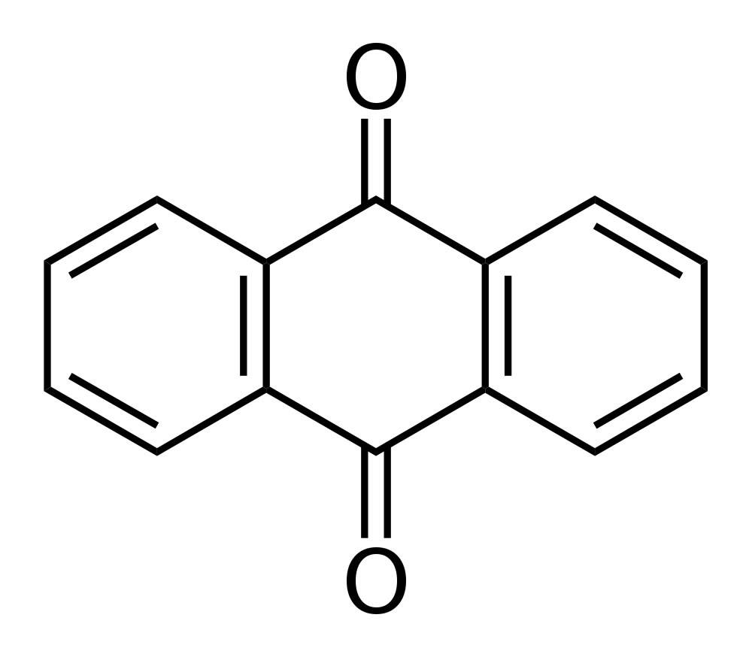

Fig (2): Chemical Structure of Anthraquinone

**Isolation and Identification of the Anthraquinone Glycosides:**

***1. Extraction:***

***Aim***: To isolate the anthraquinone glycosides.

***Equipments:***

* *Large beaker & two medium size beakers.*
* *Two conical flasks.*
* *Centrifuge & Centrifuge tubes.*
* *Separatory funnel.*
* *Water bath.*
* *Round bottom flask.*
* *Filter paper.*
* *Reagent bottle.*

***Reagents:***

* *Conc.HCl acid.*
* *Chloroform.*
* *60% w/v ferric chloride solution.*

***Procedure:***

***Method of extraction:*** Decoction.

***Plant used***: Senna **Cassia acutifolia** , **Cassia angustifolia**

Family Leguminosaea.

***Part used***: Dry leaves.

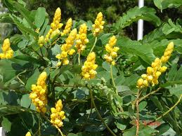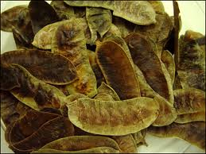

**Senna**

Place ***0.5 gm*** of powdered dry leaves of Senna in ***50 ml***of***water***

*Boiling (****15 mins)***

Cool & filter

Place the filtrate in separatoryfunneland extract by shaking with

[***10 ml*** of ***Chloroform***] two times

Upper layer Combine lower layer

(***Aqueous layer***) (***Chloroform layer***)

[Free aglycone (dianthrone)] ***Fraction B***

The upper aqueous layer will be divided into two parts

(Whole Glycosides)

***Fraction A***

[Put in reagent bottle]

Other part of the aq. Layer (***10 ml***)

Reflux (***20mins***)

Add

1. ***3.5 ml***of ***Ferric Chloride sol.(60 %w/v*** ).

(2)***2ml***of***Conc.HCl acid***.

Cool

Place in a separatory funnel and extract with

[***10 ml***of***Chloroform***] two times

Aqueous layer Chloroform layer

***Glycone part Aglycone part (monoanthrone)***

***Fraction C***

***2.Results:***

Fraction A : Contain the whole glycosides.

Fraction B : Contain the aglycone (dianthrone) .

Fraction C: Contain the aglycone part (monoanthrone).

***[Lab.4] TheChemical Tests***

**A.General Reaction:**

For the following tests, boil***1 gm***of the crude drugs (***Aloe)*** given with***100 ml*** of water ,add a little of ***kieselghur***, filter and use the solution for the following tests:

[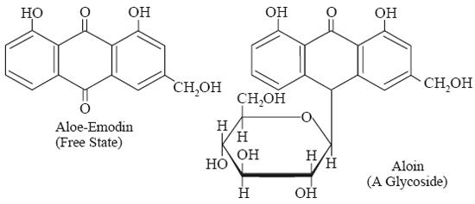](http://www.google.iq/url?sa=i&source=images&cd=&cad=rja&docid=ZZqKrz0TypkZvM&tbnid=SzYrX4IKhYlm6M:&ved=0CAgQjRwwAA&url=http://www.epharmacognosy.com/2012/03/aloes.html&ei=w8IsUr2VLoOrhAfgyYCgBQ&psig=AFQjCNEWPYIwe5kIz0HIDwQePyceJckbpA&ust=1378751555837159)

**1. Schontetens Reaction (Borax test):**

***Aim:*** Identification of the anthraquinone glycosides in ***general***.

***Equipments& Reagents:***

* Test tube.
* Small beaker.
* Water bath.
* Borax.

***Procedure:***

To ***2ml*** of the Aloe extract, add ***0.1gm*** of ***Borax*** and heat until dissolved. Pour a fewdrops of the liquid into test tube nearly full of water.

***Results:***

A ***green fluorescence*** is produced.

***Discussion :***

This ***green fluorescence*** is due to ***aloe- emodinanthranols*** liberated from ***barbaloin*** by hydrolysis with Borax giving this reaction.

**2. Bromine Test for Aloin:**

***Aim:*** Identification of the anthraquinone glycosides in ***general***.

***Equipments& Reagents:***

* Test tube.
* Bromine solution.

***Procedure:***

Take ***2ml*** of the Aloe extract, add an equal volume or an excess of freshly prepared solution of ***bromine***. Record the color.

**B.Specific Reaction:**

**Borntrager'stest :**

***Aim:*** Identity test for aglycone part of anthraquinone glycosides.

***Equipments& Reagents:***

* Separatory funnel.
* Test tube.
* Dilute HCl.
* Benzene.
* Dilute ammonia (10%).

***Procedure:***

To***5ml***of the Senna extract (***fraction A***), add ***5ml diluteHCl***, then place the mixture in a separatory funnel and partitioing with ***5ml*** of ***benzene*** for ***1min***.

Take the upper benzene layer (***free aglycone***) and shake it with ***dilute ammonia (10%).***Check the intensity of the color.

***Results:***

Pink color will be produced which is very clear with monoanthrones than dianthrones.

***Discussion :***

The benzene extracts the ***aglycone*** ,and with ammonia ,forms anthraqunone salts, which have pink color.

The Identification ofAnthraquinone Glycosides By Chromatography:

By the use of thin layer chromatography **(T.L.C)**

* The stationary phase = *Silica gel G****.***
* The mobile phase = ***n-propanol: Ethyl acetate: Water (60:30:30).***
* The standard compound =Sennoside.
* The spray reagent = Alcoholic KOH 5%w/v.
* Mechanism of separation = *Adsorption*.
* Developing = *Ascending****.***
* ***NOTE/ for the best result spray first with 25%w/v nitric acid then heat in the oven after that spray with KOH reagent. This step is done to intensity the color of the spot.***

***Procedure:***

1. Prepare ***100ml*** of mobile phase, and place it in the glass tank.
2. Cover the tank with glass lid and allow standing for ***45 minutes*** before use.
3. Apply the sample spots (fraction A, fraction B& fraction C), and the standard spot on the silica gel plates, on the base line.
4. Put the silica gel plate in the glass tank and allow the mobile phase to rise to about *two-third* of the plate.
5. Remove the plate from the tank, and allow drying at room temperature, spray first with ***25%nitric acid*** solution and heat for ***10 minutes*** at ***110 0C***.
6. Allow to cool, and then spray with ***5% w/v*** alcoholic ***KOH*** solution. Detect the spot formed and calculate the Rf values.

***Study problems:***

***Q1***. What are the main differences between three fractions ( A, B and C) of anthraquenone glycosides? Explain with structures?

***Q2.***Give the reasons for:

1. The use of Borax in Shontetens reaction?
2. The use of 10% dilute ammonia in Borntrager's test?

***Q3.***How can you identify an extract containing anthraquinone glycosides?

*Exp.No. 3*

***[Lab.5]* Saponin Glycosides**

***This***group of glycoside is widely distributed in higher plants. Saponin glycosides form colloidal solution in water that foam uponshaking, this is due to **a decrease in the surface tension action done by saponin glycosides,**as a result of the hydrophobic/hydrophilic characteristics of the saponin,and due to this property the saponins are used in the manufacturing of beer, and soap.

Saponins have a bitter, acrid taste, and drugs containing them are usually sternutatory and otherwise irritating the mucus membrane.

They destroy red blood corpuscles by hemolysis and are toxic especially to cold blooded animals therefore many saponins are used as fish poisins. The more poisonous saponin is often called ***sapotoxin,*** many are toxic to insects and mollusks, and some are used to control schistosomiasis snails.

Saponin upon hydrolysis yield an aglycone known as ***sapogenin*** ,which are crystallized upon acetylation, therefore this process is used for purification .

According to the structure of the aglycone, two kinds of saponin are recognized:

**1**. Pentacyclictriterpenoidsaponins (acidic, and the C-atom is C30)

**2.** Steroidal saponins(neutral C- atom is C27).

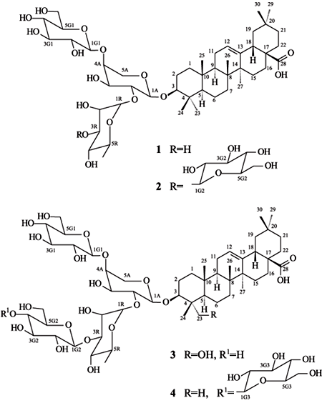Pentacyclictriterpenoidsaponin

[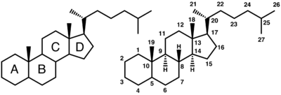](http://en.wikipedia.org/wiki/File:Steroid_numbering.png)

Steroidal saponin

***Isolation &Identification of the Saponin Glycosides:***

***Procedure:***

***Method of extraction:***Decoction.

***Plant used***: Saponaria officinalis family Caryophyllaceae.

Part ***used***: Dry root.

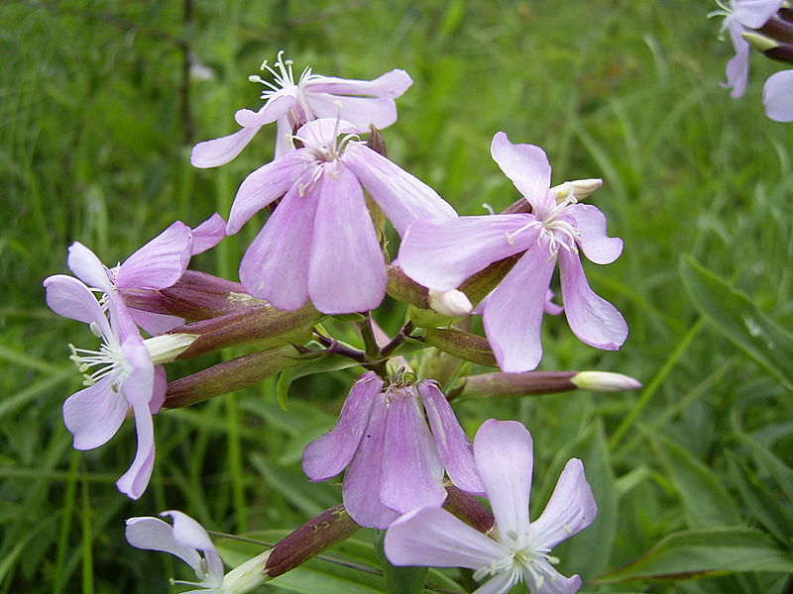

Saponaria officinalis

Add ***0.1 gm*** of saponaria root in coarse powder to ***20 ml*** distilled water in a beaker and boil gently for ***2-3 minutes***. Filter hot and allow cooling:

1. Dilute ***5ml*** of the filtrate with water and shake vigorously.
2. To the remaining of the filtrate add ***5ml*** of ***dilute H2SO4acid***and boil gently for ***3-5 mins*** .The aglycones are obtained by acid hydrolysis and are insoluble in water but are soluble in ***90% alcohol.***
3. Make the filtrate obtained from (b) alkaline with ***NaOH***, (litmus paper) and then carry ***Fehling'stest***or ***Benedict's test*** (***5ml*** filtrate + ***2ml*** of Benedict's reagent heat for ***10mins***on boiling water bath ).

**Specific Reaction:**

***1.TheHemolytic Test***

***Aim:***Identity test (***specific***) for saponinglycosides

***Equipments& Reagents:***

* Two test tube.
* 10% solution of blood in normal saline.
* Normal saline.

***Procedure:***

Take two test tubesand place in each one ***5ml*** of a ***10% solution of blood*** in normal saline. To oneof them, add***5ml*** of ***normal saline*** solution and to the other one add ***5ml***of the extract of Saponaria root .Shake both tubes gently and notice the result.

***Results:***

The test tube containing 5ml of the extract of Saponaria will cause ***blood hemolysis.***

***2.Foam Index(according to Kofler)***

***Foam index*** is a value, which is used to express the quantity of the saponin glycosides in the crude drugs.

The method is based upon the property of saponin to form foam when shaken with water. The foam index signifies the dilution of the substance or drug to be tested which gives alayer of foam ***1cm*** high if the aqueous solution is shaken for ***15 seconds***, and then allow standing for ***15 minutes*** before reading is made.

***Foam Index***

***Aim:*** Identity test (***specific***) for saponin glycosides

***Equipments& Reagents:***

* 10 Test tubes having the same diameter.
* Graduated pipette.
* 0.1% decoction from the powdered drug.
* 1% solution of sodium carbonate.

***Procedure:***

1. Prepare ***0.1%*** decoction from the powdered drug,neutralized it by adding solution of***1%sodium carbonate*** drop wise (litmus paper) and filter.
2. Into 10 test tubes having the same diameter, ***1 to 10 ml*** of this decoction is added respectively using a graduated pipette, complete the volume to ***10 ml*** with***distilledwater.***
3. Shake the content of each test tube thoroughly for ***15 seconds*** and allowto stand for ***15 minutes.***
4. After this time, the reading is made in the test tube containing the most dilute solution with a ring of foam***1 cm***height.

For example: When this is occur in the test tube number 8, which contains 8ml of the decoction and 2 ml of water, then 8 ml of 0.1% decoction corresponds to 0.008 gm of the drug and the dilution is calculated from the following calculation:

Gmml

* 1. 100

X 8 X= 0.008 gm. of saponin in 8ml of decoction.

Gmml

.008 10

1 X X= 10/0.008

X=1250

.

That means the ring of foam 1cm high is formed by a solution diluted 1:1250. The foam index is therefore 1250.

***Note/***The addition of sodium carbonate is to convert the acidic saponins that may be present in the decoction, to salts, which are soluble in water.

***Study problems:***

***Q1***. How many kinds of sapogenin are found in the medicinal plants? Explain with structures?

***Q2.***Give the reasons for:

1. The addition of H 2SO 4 and boiling during the extraction of Saponaria root?
2. Alkalinization with NaOH in Fehling's or Benedict's tests?

***Q3.***How can you identify an extract containing saponin glycosides?

*Exp.No. 4*

***[Lab.6]* Tannins**

***Tannins*** compromise a large group of complex substances that are widely distributed in the plant kingdom. Chemically tannins are complex substances; they usually occur as mixtures of poly hydroxyphenols that are difficult to separate because they do not crystallize. Tannins are divided according to the identity of the phenolic nuclei involved, and on the way they are joined into two classes:

*1 .Hydrolysable tannins*:

This class consists of ***gallic acid*** and related polyhydroxy compounds ***(hexahydroxydiphenic acid)*** and theirderivatives esterified with glucose. They are termed hydrolysable tannins due to ease of esters to hydrolyze to phenolic acids and sugar. They were formerly known as pyrogallol tannins.

[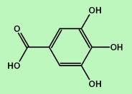](http://www.google.iq/imgres?imgurl=http://www.phytochemicals.info/pictures/phytochemicals/gallic-acid.gif&imgrefurl=http://www.phytochemicals.info/phytochemicals/gallic-acid.php&h=165&w=230&sz=4&tbnid=pWwtej1OsHAEKM:&tbnh=78&tbnw=109&zoom=1&usg=__ren24uVlzE42Cde0peWCLCl7NpY=&docid=fOA7__brJX-ViM&sa=X&ei=zQ8uUszlA4KytAbzwoGoBQ&ved=0CDYQ9QEwAw&dur=9180)[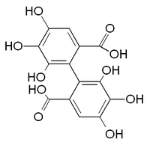](http://en.wikipedia.org/wiki/File:HHDP.PNG)

**Gallic acid Hexahydroxydiphenic acid**

*2. Nonhydrolysable tannins or condensed tannins:*

This class contains only ***phenolic nuclei*** but frequently linked to carbohydrates or proteins. When treated with hydrolytic agents, these tannins tend to polymerize, yield insoluble usually **red**-colored products known as ***phlobaphenes.***

The name (condensed tannins) is due to the fact that on the treatment with hot acid some of C-C bonds are broken yielding ***anth ocyanidin*** monomers. These tannins are sometimes called catechol tannins.

[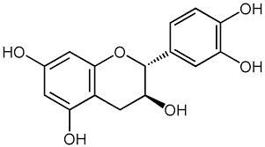](http://www.google.iq/imgres?imgurl=http://upload.wikimedia.org/wikipedia/commons/f/f0/Catechin_structure.png&imgrefurl=http://commons.wikimedia.org/wiki/File:Catechin_structure.png&h=634&w=1140&sz=5&tbnid=a1WXPxwGlnl3FM:&tbnh=73&tbnw=132&zoom=1&usg=__VRODUFa--GvDpjv3KiMd6MgXq8M=&docid=PWLRKrTaNyxuvM&sa=X&ei=FhQuUsO5B4mRtQah-4DADA&ved=0CCgQ9QEwAA&dur=2217)[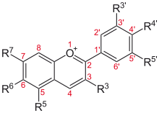](http://en.wikipedia.org/wiki/File:Anthocyanidine.svg)

**Catechine Anthocyanins**

**(are** [**glucosides**](http://en.wikipedia.org/wiki/Glucoside) **of** [**anthocyanidins**](http://en.wikipedia.org/wiki/Anthocyanidin)**)**

***General properties of Tannins:***

* Tannins are non–crystallizable compounds that, with ***water*** .form ***colloidal solution*** possessing acid reaction and sharp "***puckering*** "taste.
* They cause precipitation of solution of ***gelatin*** as well as ***alkaloids***.
* They form dark ***blue***, ***greenish***black soluble compounds with ***ferric salts.***
* They produce deep ***red*** color with ***potassium ferricyanide*** and ***ammonia.***
* They are precipitated by salts of ***copper***, ***lead*** and ***tin*** by strong aqueous ***potassium dichromate*** or ***1%chromic acid*** solution. In alkaline solutions; many of their derivatives readily absorb oxygen.
* Tannins precipitate ***proteins*** from solution and can combine with proteins, rendering them resistant to proteolytic enzymes .when applied to living tissue this action is known as an"***astringent"*** action and form the basis for therapeutic application of tannins.

*Uses of tannins:*

1. Astringents, used in the gastrointestinal tract and on the skin abrasion.
2. In the treatment of burns, the proteins of the exposed tissue are precipitated and form amildly antiseptic protective coat under which the regeneration of new tissue may take place.
3. Use in the process of vegetable- tanning which converts animal hides to leather (leather industry).
4. Antidote treatment of alkaloids poisoning.
5. Ink industry.

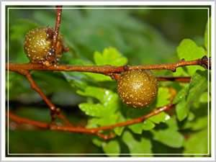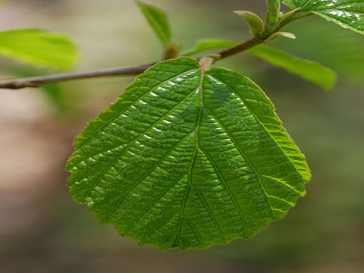

Pyrogalloltannins(Nut gall) Catechole tannins(*Hamamelis leaf*)

***Tests on Tannins***

***I.Catechole tannins:***

***Plant used***:***Hamamelis leaf or witch hazel leaves:***

Is the dried leaf of **Hamamelis virginiana** of the family **Hamamelidaceae**.

1. ***Microscopically Examination:***

Examine the powder drug microscopically for the ***trichomes*** and notice the type of stellate, the form-brabched stellate trichomes consisting of 4-12 unicellular branches united by their bases.

***B.Chemical Tests:***

***Aim:*** Identity test for ***Catechol Tannins***.

***Procedure:***

Boil ***5gm*** hamamelis leaf ,coarsely powdered with ***50 ml*** of water. Cool and filter. To***2 ml*** portions add the following reagents and notice the results:

1. Few drops solution of ***ferric chloride***.
2. ***1ml*** solution of ***lead sub acetate***.
3. ***1ml*** solution of ***potassium dichromate***.
4. ***2ml*** solution of ***gelatin***.
5. ***2ml*** solution of ***quinine dihydrochloride***. (or any alkaloid).
6. ***0.5ml*** solution of ***sodium acid phosphate***, warm, cool and filter. To the filtrate add solution of ***phenazone***.
7. ***Bromine*** solution.
8. ***5mlMitchell's reagent*** (***5 ml*** of a ***0.2%solution of iron*** and ***ammonium citrate***) and add ***1gmsodium acetate***. Boil,cool and filter.

***Results:***

Notice the colors and precipitates obtained.

***II.PyrogallolTannins:***

***Plant used***: ***Gulls, Nutgall:***

Is the excrescence obtained from the young twigs of **Quercus infectoria** of the family **Fagaceae**.

1. ***Microscopically Examination:***

Examine the powdered drug microscopically and notice the following:

1. Fairly numerous sclerenchymatous cells.
2. Lignin bodies.
3. The presence of only a few small vessels.
4. A few starch grains.
5. Tannin flakes, visible in clove oil mount.
6. Thick -walled,pitted parenchyma with both cluster and prismatic crystals of calcium oxalate.
7. Occasional insect fragments.

***B.Chemical Tests:***

***Aim:*** Identity test for ***Pyrogallol Tannins***.

***Procedure:***

Prepare ***0.1%*** suspension of powdered nutgall in water and is treated with:

1. A saturated solution of***potassium dichromate*** plus a trace of ***acetic acid.***
2. A ***1%*** solution of ***sodium carbonate.***
3. A ***5%ferric sulphate*** solution.
4. A ***1%ferric acetate*** solution.
5. Shake ***0.1gm*** powdered nutgall with ***1ml*** of water, micro filter one drop into an evaporating dish. Add one drop of a ***5%ferric chloride*** solution.
6. Repeat the test no.5 with ***bromine*** water.

***Results:***

Notice the colors and precipitates obtained.

***Study problems:***

***Q1***. How many kinds of Tannins according to the phenolic nuclei ? Explain with structures?

***Q2 .***How can you identify anextract containing Pyrogallol tannins?

***Q3 .***How can you identify an extract containing Catechol tannins?

*Exp.No. 5*

***[Lab.7]* Volatile Oils**

***They*** are odorous principles found in various plant parts. Because they evaporate when exposed to the air at room temperatures, they are called ***volatile oils***; they are also called *essential* or *etherical oils*.

Volatile oils are colorless as a rule, particularly when they are fresh, but on long standing they may oxidize and resinify, thus darkening in color, to prevent this darkening, they should be stored in a *cool*, *dry* place in tightly stopperd , preferably full ,amber glass containers.

As a rule, volatile oils are immiscible with water, but they are sufficiently soluble to impart their odor to water. They are soluble in *ether,alcohol* and most *organic* solvents.

Many volatile oils consist largely of ***terpenes*** (terpenes are natural products whose structures may be divided into isoprene units).

[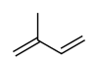](http://en.wikipedia.org/wiki/File:Isoprene.svg)[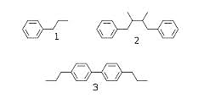](http://www.google.iq/imgres?imgurl=http://upload.wikimedia.org/wikipedia/commons/thumb/e/e7/Lignan.svg/300px-Lignan.svg.png&imgrefurl=http://en.wikipedia.org/wiki/Lignan&h=146&w=300&sz=4&tbnid=3uDUhOiUA83gPM:&tbnh=57&tbnw=117&zoom=1&usg=__ZjuwOdBkEP-kNKFK1LjovAgMkGw=&docid=mB4hDksT7H8ffM&sa=X&ei=8xkuUuqWBMjTswaVr4HIDA&ved=0CFcQ9QEwBw&dur=20967)

**Isoprene unit Phenylpropanoids**

Another major group of volatile oil constituents are the ***phenylpropanoids.*** (These compounds contain the C6 phenyl ring with an attached C3 propane side chain).

***Generally*** volatile oils and volatile oil-containing drugs are divided in to the following classes:

1. Hydrocarbons.
2. Alcohols.
3. Aldehydes.
4. Ketones.
5. Phenols.
6. Phenolic ethers.
7. Oxides.
8. Esters.

***Essential oils are derived from various sections of plants:***

* ***Leaves***- Rosemary, Basil, Eucalyptus.
* ***Flowers-*** Rose, Lavender, Clove.
* ***Seeds***- Fennel, Anise, cumin.
* ***Bark***- Cinnamon.
* ***Rhizome***- Ginger.

***Pharmacological Uses of Volatile Oils:***

* Carminative as for ***Rosemary oil.***
* Antitussive as for ***Eucalyptus.***
* Antiseptic as ***Clove oil***.
* Aromatherapy, alternative medicine as ***Lavender Oil.***

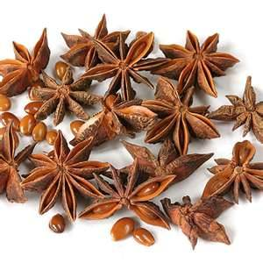

Anise

**Isolation and Identification of the Volatile Oils:**

***Aim***: Determination of the volatile content of crude drugs by water distillation method.

***Equipments: Clavenger type as an apparatus.***

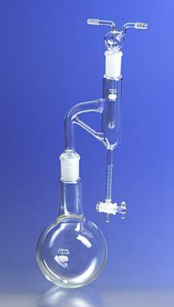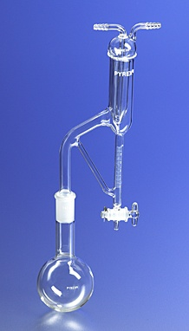

**Clevenger Apparatus Clevenger Apparatus**

**(Oil heavier than Water) (Oil lighter than water)**

***Procedure:***

1. Weigh out ***20 gm*** of the plant material (coarse powder) and place into a distilling flask; add few pieces of porous earthenware.
2. Add ***200 ml*** distilled water to the flask and shake well. Add another ***200ml*** of water by rinsing the neck of the flask.
3. Connect the distilling flask with the still head of the apparatus. By the means of the pipette or washing bottle, fill the receiver with water until over flows.
4. Connect the condenser of the apparatus with the cooling water (from the tap).
5. Heat the distilling flask until the boiling starts. Record the time of the beginning of distillation, and continue the distillation for one hour.
6. Switch off heating. Allow the graduated receiver to cool. Read off the volume of the volatile oil (count all small divisions in the receiver of the layer of oil).
7. Calculate the ***%v/w*** of the volatile oil content of drug.

Identification of Volatile Oils By Chromatography:

**By the use of thin layer chromatography (T.L.C).**

* The stationary phase = *Silica gel G****.***
* The mobile phase = ***Chloroform: Benzene (3:1).***
* The standard compound = ***Peppermint Oil.***
* The spray reagent =***Vanilline _Sulphuric acid/Ethanol(10%v/v).***
* Mechanism of separation = *Adsorption*.
* Developing = *Ascending****.***

***Procedure:***

1. Prepare ***100ml*** of mobile phase, and place it in the glass tank.
2. Cover the tank with glass lid and allow standing for ***45 minutes*** before use.
3. Apply the sample spot and the standard spot on the silica gel plates, on the base line.
4. Put the silica gel plate in the glass tank and allow the mobile phase to rise to about *two-third* the plate.
5. Remove the plate from the tank, and allow drying, and then detecting the spots by the use of the spray reagent and heat the plates at ***120◦C*** until the spot’s color intensity is reached in the oven. Detect the spot and calculate the Rf value.

Determination of the Refractive Index of the Volatile Oils:

Refractive index:

When a ray of light passes from a less dense to a denser medium, it will bend or refract toward the normal. If (e) represents the angle of refraction and (i) the angle of incidence according to law of refraction:

Sin i/ Sin e =N/n

Where (n) is the index of refraction of the less dense and (N) is the index of the refraction of the denser medium.

***Procedure:***

1. Connect the abberefractomteter with the cooling water system and record the temperature.
2. Wash the prism of the apparatus with absolute alcohol and dry it.
3. Illuminate the field so that the cross is clear.
4. Introduce ***2 drops*** of volatile oil carefully on the surface of the prisms and cover it with another prism.
5. Turn the knob so that the line of the dark field reaches the center of the intersection bars of the cross.
6. Read off the refractive index ***(nD)*** on the scare at a given temperature.
7. Calculate the refractive index at ***200C (nD20*)** corrections for the temp.

***Study problems:***

***Q1***. How many kinds of Volatile-oil according to the basic nuclei? Explain with structures?

***Q2 .***How can you determine the volatile content of crude drugs?

***Q3 .***How can you identify an extract containing Volatile oils?

***Q4.*** Define the Refractive index? How it can be measured?

*Exp.No. 6*

***[Lab.8]* Flavonoid glycosides**

**Flavonoids** (from the Latin word *flavus* meaning [yellow](http://en.wikipedia.org/wiki/Yellow), their colour in nature) are polyphenols of plant origin that are among the most important compounds in human diet due to their widespread distribution in foods and beverages. They can occur both in the free form (aglycones) and as glycosides, and differ in their substituents (type, number and position) and in their insaturation. The most common classes are the flavones, flavonols, flavanones, catechins, isoflavones and anthocyanidins, which account for around 80 % of flavonoids.AllflavonoidsshareabasicC6-C3-C6phenyl-benzopyranbackbone.Thepositionofthe phenyl ring relative to the benzopyranmoiety allows a broad separation of these compoundsintoflavonoids(2-phenyl-benzopyrans),isoflavonoids(3-phenyl-benzopyrans) andneoflavonoids (4-phenyl-benzopyrans).Divisionintofurthergroupsismade.



**Fig.1.**Structureof the structural back bones of themain flavonoid groups (flavan,isoflavan andneoflavan)and ofrelevantflavonoidclasses.Atomnumberingandring nomenclature are also included.

.

They have been used extensively as chemotaxonomic markers and are abundant in the Polygonaceae, Rutaceae, Leguminosae, Umbellifereae and Compositae.They occur both in the free state and as glycosides; most are O-glycosides but a considerable number of flavonoid C-glycosides are known.The glycosides are generally soluble in water and alcohol, but insoluble in organic solvents; the genins are only sparingly soluble in water but are soluble in ether. Flavonoids dissolve in alkalis, giving yellow solutions which on the addition of acid become colorless.

***Pharmacological activity of flavonoids:***

A number of flavonoid-containing herbs have now been included in the BP/ EP, examples are Birch leaf, Calendula Flower and Elder flower.The group is known for its anti-inflammatory and anti- allergic effects, for antithrombotic and vasoprotective properties, for inhibition of tumor promotion and as protective for the gastric mucosa. Some of these pharmacological properties can be explained on the bases of antioxidant activity. Many flavonoid -containing plants are diuretic (e.g. buchu and broom) or antispasmodic (e.g. liquorice and parsley). Some flavonoids have antitumour, antibacterial or antifungal properties.

**Isolation and Identification of Flavonoids:**

***Aim:*** Isolation method of flavonoids from Ruta graveolens.

***Equipments:***

* Large beaker.
* Water bath.
* Two medium size beakers.

***Reagent:***

* Petroleum ether.
* 70 % aqueous methanol.
* 5 % HCl.
* Chloroform.

***Procedure:***

***Method of extraction*:** Maceration.

***Plant used*:** Ruta graveolens family Rutaceae.

***Part used*:** Dry leaves.

[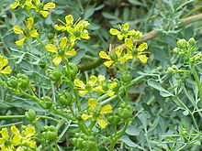](http://www.google.iq/url?sa=i&source=images&cd=&cad=rja&docid=ASer8d_TcuwG6M&tbnid=CVLQmQqBKqb47M:&ved=0CAgQjRwwAA&url=http://ar.wikipedia.org/wiki/%D8%B3%D8%B0%D8%A7%D8%A8_%D8%B4%D8%AF%D9%8A%D8%AF_%D8%A7%D9%84%D8%B1%D8%A7%D8%A6%D8%AD%D8%A9&ei=woMxUq2UKYGWtQaD84HgBQ&psig=AFQjCNEz0rRiW9ouYWuQc0puuh5MIJM9zw&ust=1379063106879330)

**Ruta graveolens**

Maceration ***10 gm*** of the powdered leaves in ***100ml*** of petroleum ether over night (prepared previously)

Filter & dry the plant

Macerate again with ***70 %*** **aqueous methanol** over night ( prepared previously)

Filter

Concentrate the extract to small volume (***15ml***)

Devided into two parts

***5ml*** ***10ml***

***Fraction A*** Add ***5ml*** of ***5%*** ***HCl***

Boil for ***20min.***

Cool and shake with

(***15ml*** of Chloroform)

**Twice**

Aqueous layer Chloroform layer

(Concentrated)

***Fraction B***

***Results:***

Fraction A : Contain the whole glycosides.

Fraction B : Contain the aglycone part.

***[Lab.9] TheChemical Tests***

**A.General Reaction:**

1. **Reaction of flavonoids with two o-oxygroups in B cycle with lead acetate causes precipitation**. Flavones produce intensive **yellow**, aurones - **red,**anthocyanes **red** or **blue** precipitates.
2. **Wilson’s reaction:** 5-oxyflavones and 5-oxyflavonoles with Wilson's reagent (boric and citric acids in anhydrous acetone) develop brightly **yellow** colour with **yellowish-green** fluorescense.
3. **alkaline solution:**  In alkaline solutions flavanones produce uncoloured or yellow precipitates, that for some time become brightly yellow or yellow (isomerization to formation of chalkones); chalkones and aurones develop red or purple (it's their specific reaction), flavones and flavonoles produce yellow coloured precipitates.
4. **Mineral acids:** Flavones and flavonoles with mineral acids form oxonic (flavic) salts of brightly yellow or red colour, chalkones and aurones produce intensive colour of raspberry or red.
5. **Other methods:**Other methods of identification include chromatography,.colorimetric or spectrophotometric analysis after reaction with aluminium chloride.

**A.Special Reaction:**

**1-Shinoda test**

Four pieces of magnesium fillings (ribbon) are added to the ethanolic extract followed by few drops of concentrated [hydrochloric acid](http://en.wikipedia.org/wiki/Hydrochloric_acid). A pink or red colour indicates the presence of flavonoids.Colours varying from orange to red indicated [flavones](http://en.wikipedia.org/wiki/Flavone), red to crimson indicated flavonoids, crimson to magenta indicated [flavonones](http://en.wikipedia.org/wiki/Flavonone).

**2-Sodium hydroxide test**

About 5 mg of the compound is dissolved in water, warmed and filtered. 10% aqueous [sodium hydroxide](http://en.wikipedia.org/wiki/Sodium_hydroxide) is added to 2 ml of this solution. This produces a yellow coloration. A change in color from yellow to colorless on addition of dilute hydrochloric acid is an indication for the presence of flavonoids.

**3-p-Dimethylaminocinnamaldehyde test**

A colorimetric assay based upon the reaction of A-rings with the chromogen[p-dimethylaminocinnamaldehyde](http://en.wikipedia.org/wiki/P-dimethylaminocinnamaldehyde) (DMACA) has been developed for flavanoids in beer that can be compared with the [vanillin](http://en.wikipedia.org/wiki/Vanillin) procedure.

Identification of Flavonoids By Chromatography:

**1-By the use of Paper chromatography (P.C):**

* The stationary phase = Filter paper(*Whatman no****.1).***
* The mobile phase = ***n-BuOH:HOAc:H2O (4:1:5).***
* The standard compound =***Rutin*** and ***quercetin.***
* The spray reagent =***5% alcoholic KOH.***
* Mechanism of separation = *Partition*.
* Developing = *Ascending****.***

**2-By the use of Thin layer chromatography (T.L.C):**

* The stationary phase =***Silica gel G.***
* The mobile phase =**Ethyl acetate :formic acid :glacial acetic acid :water (100:11:11:26).**
* The standard compound =***Rutin*** and ***quercetin.***
* Detection = flavonoids spot on TLC plates produce a yellow-brown

Spots when reacted with Iodine vapor.

* Mechanism of separation = *Adsorption*.
* Developing = *Ascending****.***
* Detection: Flavonoids may appear as dark spots on a green background fluoresce when observed in UV light at 254 nm UV-plates containing fluorescent indicator (such as silica gel F254). If under 365 nm UV light, spot colors depending on the structure of flavonoids, can be yellow, green or blue fluorescent. It would be more clear and intense after being sprayed with the reagent.
* Spray reagent: 5% alcoholic KOH.

***Study problems:***

***Q1***. How many types of flavonoids are their according to the conjugation ofbasic nuclei? Explain with structures?

***Q2 .***How can you identify anextract containing flavonoids?