**Chapter 16**

**Basic Concepts of Endocrine Regulation**

In general, endocrine physiology is concerned with maintaining various aspects of homeostasis. The mediators of such control mechanisms are soluble factors known as hormones. The word hormone was derived from the Greek horman, meaning to set in motion.

The endocrine system differs from other physiological systems in that it cannot be distinctly defined based on anatomical boundaries. It operates as a distributed network comprising glands and circulating messengers, often under the influence of the central nervous system, the autonomic nervous system, or both.

**Evolution of Hormones &Their Actions on Target Cells**

Hormones comprise steroids, amines, and peptides. Peptide hormones are by far the most numerous. Many hormones can be grouped into families reflecting their structural similarities as well as the similarities of the receptors they activate. However, the number of hormones and their diversity increases as one moves from simple to higher life forms, reflecting the added challenges in providing for homeostasis in more complex organisms. For example, among the peptide hormones, several are heterodimers that share a common α chain, with specificity being conferred by the β-chain. In the specific case of thyroid-stimulating hormone (TSH), follicle-stimulating hormone (FSH), and luteinizing hormone (LH), there is evidence that the distinctive β-chains arose from a series of duplications of a common ancestral gene. For these and other hormones, moreover, this molecular evolution implies that hormone receptors also need to evolve to allow for the spreading of hormone actions/specificity. This was accomplished by co-evolution of the basic G-protein–coupled receptors (GPCR) and receptor tyrosine kinases that mediate the effects of peptide and amine hormones that act at the cell surface.

Steroids and thyroid hormones are distinguished by their predominantly intracellular sites of action, since they can diffuse freely through the cell membrane. They bind to a family of largely cytoplasmic proteins known as nuclear receptors. Upon ligand binding, the receptor–ligand complex translocates to the nucleus where it either homodimerizes, or associates with a distinct liganded nuclear receptor to form a heterodimer. In either case, the dimer binds to DNA to either increase or decrease gene transcription in the target tissue.

**HORMONE SECRETION**

**SYNTHESIS & PROCESSING**

The regulation of hormone synthesis depends on their chemical nature. For peptide hormones as well as hormone receptors, synthesis is controlled predominantly at the level of transcription. For amine and steroid hormones, synthesis is controlled indirectly by regulating the production of key synthetic enzymes as well as by substrate availability.

Interestingly, the majority of peptide hormones are synthesized initially as much larger polypeptide chains, and then processed intracellularly by specific proteases to yield the final hormone molecule. In some cases, multiple hormones may be derived from the same initial precursor, depending on the specific processing steps present in a given cell type. Presumably, this provides for a level of genetic “economy.” It is also notable that the hormone precursors themselves are typically inactive. This may be a mechanism that provides for an additional measure of regulatory control, or, in the case of thyroid hormones, may dictate the site of highest hormone availability.

The synthesis of all of the proteins/peptides discussed above is subject to the normal mechanisms of transcriptional control in the cell. In addition, there is provision for exquisitely specific regulation by other hormones, since the regulatory regions of many peptide hormone genes contain binding motifs for the nuclear receptors discussed above. For example, thyroid hormone directly suppresses TSH expression via the thyroid hormone receptor. These specific mechanisms to regulate hormone transcription are essential to the function of feedback loops, as will be addressed in greater detail below. In some cases, the abundance of selected hormones may also be regulated via effects on translation. For example, elevated levels of circulating glucose stimulate the translation of insulin mRNA. These effects are mediated by the ability of glucose to increase the interaction of the insulin mRNA with specific RNA-binding proteins, which increase its stability and enhance its translation. The net effect is a more precise and timely regulation of insulin levels, and thus energy metabolism, than could be accomplished with transcriptional regulation alone.

The precursors for peptide hormones are processed through the cellular machinery that handles proteins destined for export, including trafficking through specific vesicles where the propeptide form can be cleaved to the final active hormones. Mature hormones are also subjected to a variety of posttranslational processing steps, such as glycosylation, which can influence their ultimate biological activity and/or stability in circulation. Ultimately, all hormones enter either the constitutive or regulated secretory pathway.

**SECRETION**

The secretion of many hormones is via a process of exocytosis of stored granules. The exocytotic machinery is activated when the cell type that synthesizes and stores the hormone in question is activated by a specific signal, such as a neurotransmitter or peptide-releasing factor. One should, however, contrast the secretion of stored hormones with that of those that are continually released by diffusion (eg, steroids). Control of the secretion of the latter molecules occurs via kinetic influences on the synthetic enzymes or carrier proteins involved in hormone production. For example, the steroidogenic acute regulatory protein (StAR) is a labile protein whose expression, activation, and deactivation are regulated by intracellular signaling cascades and their electors, including a variety of protein kinases and phosphatases. StAR traffics cholesterol from the outer to the inner membrane leaflet of the mitochondrion. Because this is a rate-limiting first step in the synthesis of the steroid precursor, pregnenolone, this arrangement permits changes in the rate of steroid synthesis, and thus secretion, in response to homeostatic cues such as trophic hormones, cytokines, and stress (Figure 16–1).

An additional complexity related to hormone secretion relates to the fact that some hormones are secreted in a pulsatile manner. Secretion rates may peak and ebb relative to circadian rhythms, in response to the timing of meals, or as regulated by other pattern generators whose periodicity may range from milliseconds to years. Pulsatile secretion is often related to the activity of oscillators in the hypothalamus that regulate the membrane potential of neurons, in turn secreting bursts of hormone releasing factors into the hypophysial blood flow that then cause the release of pituitary and other downstream hormones in a similar pulsatile manner. There is evidence that these hormone pulses convey different information to the target tissues that they act upon compared to a steady exposure to a single concentration of the hormone. Therapeutically, pulsatile secretion may pose challenges if, due to deficiency, it proves necessary to replace a particular hormone that is normally secreted in this way.

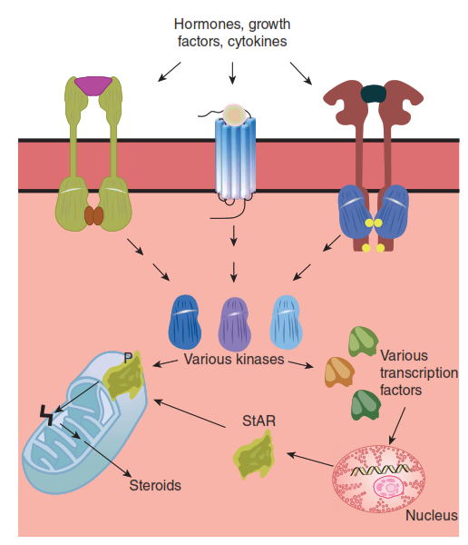

**FIGURE 16–1 Regulation of steroid biosynthesis by the steroidogenic acute regulatory protein (StAR).** Extracellular signals activate intracellular kinases that, in turn, phosphorylate transcription factors that upregulate StAR expression. StAR is activated by phosphorylation, and facilitates transfer of cholesterol from the outer to inner mitochondrial membrane leaflet. This then allows conversion of cholesterol into pregnenolone, which is the first intermediate in the steroid biosynthetic pathway.

**HORMONE TRANSPORT IN THE BLOOD**

In addition to the rate of secretion and its nature (steady vs. pulsatile), several factors influence the circulating levels of hormones. These include the rates of hormone degradation and/or uptake, receptor binding and availability of receptors, and the affinity of a given hormone for plasma carriers (Figure 16–2). Stability influences the circulating half-life of a given hormone and has therapeutic implications for hormone replacement therapy, in addition to those posed by pulsatile secretion as discussed above.

Plasma carriers for specific hormones have several important physiologic functions. First, they serve as a reservoir of inactive hormones and thus provide a hormonal reserve.

Bound hormones are typically prevented from degradation or uptake. Thus, the bound hormone reservoir can allow fluctuations in hormonal levels to be smoothed over time. Plasma carriers also restrict the access of the hormone to some sites. Ultimately, plasma carriers may be vital in modulating levels of the free hormone in question. Typically, it is only the free hormone that is biologically active in target tissues or can mediate feedback regulation (see below) since it is the only form able to access the extravascular compartment.

Catecholamine and most peptide hormones are soluble in plasma and are transported as such. In contrast, steroid hormones are hydrophobic and are mostly bound to large proteins called steroid binding proteins (SBP), which are synthesized in the liver. As a result, only small amounts of the free hormone are dissolved in the plasma. Specifically, sex hormone–binding globulin (SHBG) is a glycoprotein that binds to the sex hormones, testosterone and 17β-estradiol. Progesterone, cortisol, and other corticosteroids are bound by transcortin.

The SBP-hormone complex and the free hormone are in equilibrium in the plasma, and only the free hormone can diffuse across cell membranes. SBP have three main functions: they increase the solubility of lipid-based hormones in the blood; they reduce the rate of hormone loss in the urine by preventing the hormones from being altered in the kidney; and as mentioned above, they provide a source of hormone in the bloodstream that can release free hormone as the equilibrium changes. It follows that an additional way to regulate the availability of hormones that bind to carrier proteins, such as steroids, is to regulate the expression and secretion of the carrier proteins themselves. This is a critical mechanism that regulates the bioavailability of thyroid hormones, for example.

In a pathophysiologic setting, some medications can alter levels of binding proteins or displace hormones that are bound to them. In addition, some binding proteins are promiscuous and bind multiple hormones (eg, SHBG). These observations may have clinical implications for endocrine homeostasis, since free hormones are needed to feedback and control their rates of synthesis and secretion (see below).

Finally, the anatomic relationship of sites of release and action of hormones may play a key role in their regulation. For example, several hormones are destroyed by passage through the pulmonary circulation or the liver. This may markedly curtail the temporal window within which a given hormone can act.

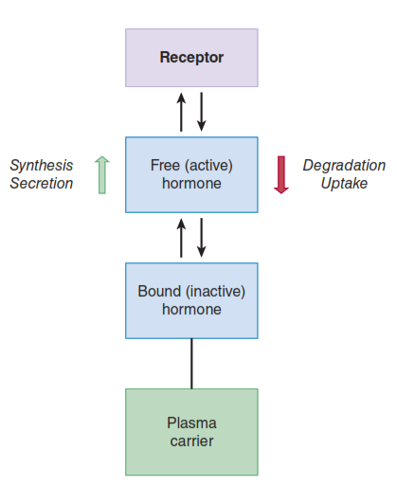

**FIGURE 16–2 Summary of factors that determine the level of free hormones circulating in the bloodstream.** Factors that increase (green upward arrow) or decrease (red downward arrow) hormone levels are shown. Free hormones also equilibrate with the forms bound to either receptors or plasma carrier proteins.

**HORMONE ACTION**

Hormones exert a wide range of distinctive actions on a huge number of target cells to effect changes in metabolism, the release of other hormones and regulatory substances, changes in ion channel activity, and cell growth, among others. Ultimately, the concerted action of the hormones of the body ensures the maintenance of homeostasis. Indeed, all hormones affect homeostasis to some degree. However, a subset of the hormones, including thyroid hormone, cortisol, parathyroid hormone, vasopressin, mineralocorticoids, and insulin, are the key contributors to homeostasis (Table 16–1).

Hydrophilic hormones, including peptides and catecholamines, exert their acute effects by binding to cell surface receptors. Most of these are from the GPCR family. Hydrophobic hormones, on the other hand, predominantly exert their actions via nuclear receptors. Two classes of nuclear receptors are important in endocrine physiology.

**TABLE 16–1 Major hormonal contributors to homeostasis.**

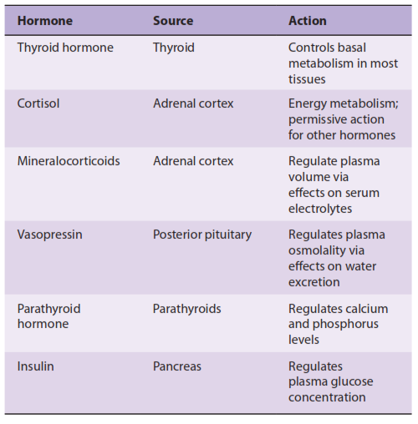

The first class provides direct stimulation of transcription via induction of the binding of a transcriptional co-activator when the hormonal ligand is bound. In the second class, hormone binding triggers simultaneous dislodging of a transcriptional co-repressor and recruitment of a co-activator. The latter class of receptor allows for a wider dynamic range of regulation of the genes targeted by the hormone in question.

**PRINCIPLES OF FEEDBACK CONTROL**

A final general principle that is critical for endocrine physiology is that of **feedback regulation**. This holds that the responsiveness of target cells to hormonal action subsequently “feeds back” to control the inciting endocrine organ. Feedback can regulate the further release of the hormone in either a negative feedback or (more rarely) a positive feedback loop. Positive feedback relates to the enhancement or continued stimulation of the original release mechanism/stimulus. Such mechanisms are only seen in settings that need to gather momentum for an eventual outcome, such as parturition. Negative feedback is a far more common control mechanism and involves the inhibition or dampening of the initial hormone release mechanism/stimulus. A general scheme for feedback inhibition of endocrine axes is depicted in Figure 16–3.

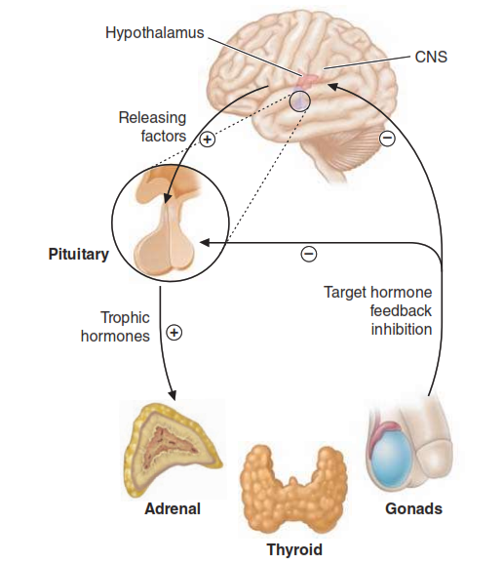

**FIGURE 16–3 Summary of feedback loops regulating endocrine axes.** CNS, central nervous system.

In general, the endocrine system uses a network of feedback responses to maintain a steady state. Negative feedback control systems such as those described are the most common feedback/homeostatic systems in the body. Feedback control loops also provide for diagnostic strategies in evaluating patients with suspected endocrine disorders. For example, in a patient being evaluated for hypothyroidism, normal levels of TSH tend to rule out a primary defect at the level of the thyroid gland itself, and rather suggest that a defect at the level of the anterior pituitary should be sought. Conversely, if TSH is elevated, it suggests that the normal ability of circulating thyroid hormone to suppress TSH synthesis has been lost, likely due to a reduction in the ability of the thyroid gland to synthesize the hormone.