***Analytical chemistry***

Analytical chemistry is the study of the separation, identification, and quantification of the chemical components of natural and artificial materials. ***Qualitative analysis*** gives an indication of the identity of the chemical species in the sample and ***quantitative analysis*** determines the amount of one or more of these components. The separation of components is often performed prior to analysis.

**Analytical methods** can be separated into ***classical and instrumental***.

**Classical methods** (also known as wet chemistry methods) include:

***1. Qualitative analysis*** A qualitative analysis determines the presence or absence of a particular compound,( by color, odor, or melting point) but not the mass or concentration. That is, if it is not related to quantity

qualitative analysis tests are

* Chemical tests ex. ( violet colour results from reaction of salicylic acid with Fecl3).
* Flame test ex. (The presence of copper in this qualitative analysis is indicated by the bluish-green color of the flame).

***2. Volumetric analysis***  Titration involves the addition of a reactant to a solution being analyzed until some equivalence point is reached. Often the amount of material in the solution being analyzed may be determined. Most familiar to those who have taken chemistry during secondary education is the acid-base titration involving a color changing indicator. There are many other types of titrations, for example potentiometric titrations. These titrations may use different types of indicators to reach some equivalence point.

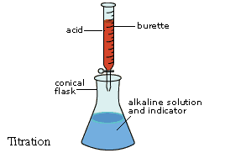

***3. Gravimetric analysis***

**Instrumental methods include:**

***1. Spectroscopy 2. Mass spectrometry 3. Electrochemical analysis***

***4.Thermal analysis*** Calorimetry and thermogravimetric analysis measure the interaction of a material and heat.

***5. Separation (TLC***, Chromatography, electrophoresis,….etc)

***Spectroscopy*** measures the interaction of the molecules with electromagnetic radiation. Spectroscopy consists of many different applications such as atomic absorption spectroscopy, atomic emission spectroscopy, ultraviolet-visible spectroscopy, x-ray fluorescence spectroscopy, infrared spectroscopy, Raman spectroscopy, dual polarization interferometry, nuclear magnetic resonance spectroscopy, photoemission spectroscopy, Mössbauer spectroscopy and so on.

***Gravimetric methods*** are quantitative methods that are based on determining the mass of a pure compound to which the analyte is chemically related.

Gravimetric analysis is based upon mass measurements, i.e. the measurement of the weight of a substance of known composition that is chemically related to analyte.

**Two types of gravimetric analysis ( classical ) are existed :**

* ***Precipitation method***, the analyte is separated from a solution of the sample as a precipitate and is converted to a compound of known composition that can be weighed.
* ***Volatilization*** ***method***, the anallyte is separated from other constituents of a sample by conversion to a gas of known chemical composition. The weight of this gas then used as a measure of the anallyte concentration.

***Electrogravimetry***, the analyte is separated by deposition on an electrode by an electrical current. The mass of this product then provides a measure of the analyte concentration.

***Gravimetric titrimetry***, the mass of a reagent, of known concentration, required to react completely with the analyte provides the information needed to determine the analyte concentration.

***Atomic mass spectrometry*** uses a mass spectrometer to separate the gaseous ions formed from the elements making up a sample matter. The concentration of the resulting ions is then determined by measuring the electrical current produced when they fall on the surface an ion detector.

***In precipitation gravimetry***, the analyte is converted to a sparingly soluble precipitate. This precipitate is then filtered, washed free of impurities. converted to a product of known composition by suitable heat treatment. and weighed. For example, a precipitation method for determining calcium in natural waters . Here, an excess of oxalic acid.

H2C2O4. is added to an aqueous solution of the sample. Ammonia is then added, which neutralizes the acid and causes essentially all of the calcium in the sample to precipitate as calcium oxalate. The reactions are

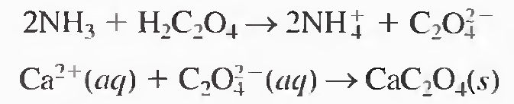

The precipitate is filtered using a weighed filtering crucible. then dried and ignited. This process converts the precipitate entirely to calcium oxide. The reaction is



After cooling. the crucible and precipitate are weighed. and the mass of calcium oxide is determined by subtracting the known mass of the crucible.

**Properties of Precipitates and Precipitating Reagents**

Ideally, a gravimetric precipitating agents should react specifically or at least selective1y with the analyte. Specific reagents, which are rare, react only with a single chemical species. Selective reagents, which are more common, react with a limited number of species. In addition to specificity and selectivity, the ideal precipitating reagent would react with the analyte to give a product that is

1. easily filtered and washed free of contaminants:

2. of sufficiently low solubility that no significant loss of the analyte occurs during filtration and washing:

3. unreactive with constituents of the atmosphere;

4. of known chemical composition after it is dried or. if necessary, ignited.

**Calculation of resuilts from gravimetric data**

A gravimetric analysis required two experimental measurements:

1. The weight of sample taken, and
2. The weight of a product of known composition determined from the sample.

Ordinarily, these data are converted to a percentage of analyte by a simple mathematical manipulation.

If A is the analyte , we may write

% A = $\frac{wt A }{wt sample}$ $× 100 \%$

***Gravimetric Factor*** **(G.f.)** is needed to convert the weight of the precipitate to the corresponding weight of analyte (A).

**wt A = wt ppt. $×$ G.f.**

**G.f. = $\frac{gfw (sought)}{gfw (ppt.)}$ $× \frac{a}{b}$**

G.f. = ratio of gfws

a = number of moles of A ( from eq.)

b = number of moles of ppt. ( from eq.)

***Example* 1** How many grams of Cl (fw = 35.45) are comtained in a ppt. .  of Agcl (fw = 143.3) that weighs 0.204 gram ?

Ag+(aq) + Cl-(aq) → AgCl (ppt.)

**wt Cl = wt AgCl (ppt.) $×$ G.f.**

**= 0.204 g $×$ $\frac{gfw Cl (sought)}{gfw AgCl (ppt.)}$ $× \frac{a}{b}$**

**= 0.204 g $×$ $\frac{35.45}{143.3}$ $× \frac{1}{1}$**

**= 0.0505 g**

***Example* 2** To what weight of AlCl3 (fw = 133.3) would o.204 g of .  .  AgCl corresspond ?

AlCl3 3AgCl Al 3+ + 3Cl- → AlCl3

Ag+ + Cl- → AgCl (ppt.)

**wt AlCl3 = 0.204 g AgCl $×$ $\frac{gfw AlCl3 (sought)}{gfw AgCl (ppt.)}$ $× \frac{a}{b}$**

**= 0.204 g $×$ $\frac{133.3}{143.3}$ $× \frac{1}{3}$**

**=** **0.066 g**

***Example*** **3** The calcium in a 200 mL sample of a natural water was deterrnined by precipitating the cation as CaC204 . The precipitate was filtered. washed, and ignited in a crucible with an empty mass of 26.6002 g. The mass of the crucible plus CaO (56.077 g/moI) was 26.7134 g. Calculate the concentration of Ca (40.078 g/mol) in water in units of grams per 100 ml of the water.

The mass of CaO is

26.7134 g - 26.6002 g = 0.1132 g

**wt Ca2+ = wt CaO**

**= 0.1132 g**

**=** **0.0809 g Ca2+ per 200 ml H2O**

**0.0809 g ----------------------- 200 ml**

**X g ----------------------- 100 ml**

**X =**

**= 0.04045 g Ca2+ / 100 ml H2O**

********

***Example* 4** An iron ore was analyzed by dissolving a 1.1324g sample in concentrated HCl.The resulting solution was diluted with water. and the iron(lII) was precipitated as the hydrous oxide Fe203 . x H2O by the addition of NH**3**' After filtration and washing. the residue was ignited at a high ternperature to give 0.5394 g of pure Fe203 (159.69 g/mol). Calculate

(a) the % Fe (55.847 g/mol) . (b) the % Fe304 (231.54 g/mol) in the sample.

**a. wt Fe = wt Fe2O3**

**= 0.5394 g** = **0.377 g**

**% Fe** = $\frac{wt Fe}{wt sample}$ $×$**100 %**

=  **100 = 33.32 %**

**b.** **3Fe2O3 → 2Fe3O4 +**  **O2**

**wt Fe3O4 = wt Fe2O3**

**= 0.5394 g** = **0.5214 g**

**% Fe3O4** =  **100 %**

=  **100 = 46.04 %**

***Example*** **5** A 0.2356 g sample containing only NaCI (58.44 g/mol) and BaCl2 (208.23 g/mol) yielded 0.4637 g of dried AgCl (143.32 g/rnol). Calculate the percent of each halogen compound in the sample.

If we let **x** be the mass of NaCI in grams and **y** be the mass of BaCI2 in grams. we can write as a first equation

**x + y = 0.2356** **g** sample **……………………… 1**

**AgCl** **NaCl** + **AgCl** **BaCl2** = **0.463 g AgCl ………….2**

To obtain the mass of AgCI from the NaCl

**wt X (**NaCI) **= wt AgCl** **NaCl**

**wt AgCl** **NaCl**  **= 2.4524**  **X** g ……***substituted in*** ….**2**

To obtain the mass of AgCI from the BaCl2

**wt Y (**BaCl2) **= wt AgCl** **BaCl2**

**wt AgCl** **BaCl2 = 1.3766**  **Y** g ……***substituted in*** ….**2**

**2.4524**  **X** g + **1.3766**  **Y** g = 0.4637 g……..**3**

**Rearrangment of ….1 Y = 0.2356 g – X ……4**

**Substituting …4 in ….3**

**2.4524**  **X** g + **1.3766 (0.2356 g – X)** g = **0.4637** g

**X = mass of NaCl = 0.1296 g**

**%NaCl = $\frac{0.1296 NaCl }{0.2356 sample}$ $×$ 100 % = 55.01 %**

**% BaCl2  = 100 % - 55.01 % = 44.99 %**

**Particle Size and Filterability of Precipitates**

Precipitates consisting of large particles are generally desirable for gravimetric work because these particles are easy to filter and wash free of impurities. In addition. precipitates of this type are usually purer than are precipitates made up of fine particles.

**Factors That Determine the Particle Size of Precipitates**

***Colloidal suspensions (ppt.)***, whose tiny particles are invisible to the naked eye (10**-7** to 10**-4** cm in diameter). Colloidal particles show no tendency to settle from solution and are not easily filtered.

***Crystalline suspensions (ppt.)*** are particles with dimensions on the order of tenths of a millimeter or greater. The particles of a crystalline suspension tend to settle spontaneously and are easily filtered.

The particle size of a precipitate is inf1uenced by such experimental variables as precipitate solubility, temperature, reactant concentrations, and rate at which reactants are mixed.

The net effect of these variables can be accounted for, at least qualitatively, by assuming that the particle size is related to a single property of the system called the relative supersaturation, where

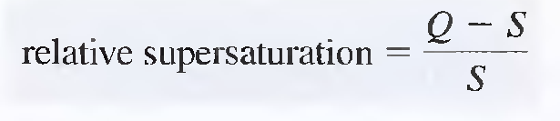 ***( Von Wiemarn)***

In this equation, Q is the concentration of the solute at any instant and S is its equilibrium solubility.

when (Q - S)/S is large, the precipitate tends to be colloidal; when (Q - S)/S is small. a crystalline solid is more likely.

***A supersaturated solution*** is an unstable solution that contains a higher solute concentration than a saturated solution. With time. supersaturation is relieved by precipitation of the excess solute .

**Mechanism of Precipitate Formation**

The precipitates form in two ways; by ***nucleation*** and by ***particle growth***In **nucleation**, a few ions, atoms, or molecules (perhaps as few as four or five) come together to form a stable solid. Often, these nuclei form on the surface of suspended solid contaminants, such as dust particles. Further precipitation then involves a competition between additional nucleation and growth on existing nuclei (**particle growth**). ***If nucleation predominates***. a precipitate containing a large number of small particles results: if growth predominates, a smaller number of larger particles is produced.

***The rate of nucleation*** is believed to increase enormously with increasing relative supersatuation. In contrast. the rate of particle growth is only moderately enhanced by hIgh relatIve supersaturations.

**Colloidal Precipitates**

Individual colloidal particles are so small that they are not retained by ordinary filters. Moreover, Brownian motion prevents their settling out of solution under the influence of gravity. Filteration could abtained by process calld ***Coagulation of colloids.***

**Coagulation of Colloids**

Coagulation can be hastened by heating, by stirring, and by adding an electrolyte to the medium. To understand the effectiveness of these measures, we need to look into why colloidal suspensions are stable and do not coagulate spontaneously. Colloidal suspensions are stable because all of the particles of the colloid are either positively or negatively charged. This charge results from cations or anions that are bound to the surface of the particles. We can easily demonstrate that colloidal particles are charged by observing their migration when placed in an electrical field. The process by which ions are retained on the surface of a solid is known as adsorption.

***Adsorption*** is a process in which a substance (gas, liquid, or solid) is held on the surface of a solid. In contrast, absorption involves retention of a substance within the pores of a solid.

***The kind of ions*** retained on the surface of a colloidal particle and their number depend. in a complex way, on several variables. For a suspension produced in the course of a gravimetric analysis, however, ***the species adsorbed***, and hence ***the charge on the particles***, can be easily predicted because lattice ions are generally more strongly held than others. For example. when silver nitrate is first added to a solution containing chloride ion. the colloidal particles of the precipitate are negatively charged as a result of adsorption of some of the excess chloride ions. This charge, however, becomes positive when enough silver nitrate has been added to provide an excess of silver ions. The surface charge is at a minimum when the supernatant liquid contains an excess of neither ion.

***The extent of adsorption and thus the charge*** on a given particle increase rapidly as the concentration of a common ion becomes greater. Eventually, however, ***the surface of the particles*** becomes covered with the adsorbed ions. and the charge becomes constant and independent of concentration.

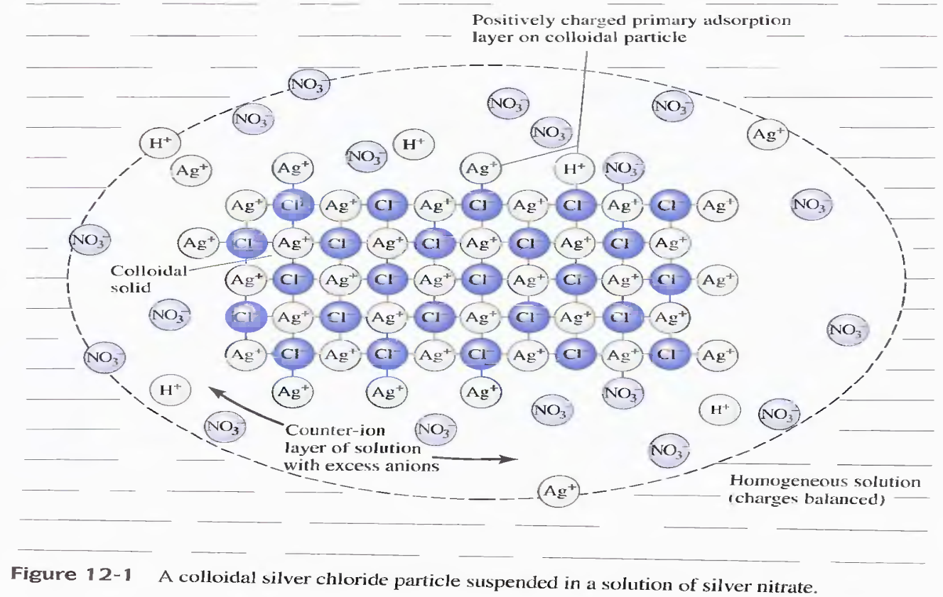

***adsorption layer***, which consists mainly of adsorbed silver ions. Surrounding the charged particle is a layer of solution. called the ***counter-ion layer***, which contains sufficient excess of negative ions (principally nitrate) to just balance the charge on the surface of the particle. The primarily adsorbed silver ions and the ***negative counter-ion layer*** constitute an electric double layer that impacts stability to the colloidal suspension. As colloidal particles approach one another, this double layer exerts an electrostatic repulsive force that prevents particles from colliding and adhering.

***Increasing the electrolyte concentration*** has the effect of decreasing the volume of the counter-ion layer, thereby increasing the chances for coagulation.

**Peptization of Colloids**

Peptization is the process by which a coagulated colloid reverts to its original dispersed state. When a coagulated colloid is washed, some of the electrolyte responsible for its coagulation is leached from the internal liquid in contact with the solid particles. Removal of this electrolyte has the effect of increasing the volume of the counter-ion layer. The repulsive force responsible for the original colloidal state are then reestablished. The washings become cloudy as the freshly dispersed particles pass through the filter.

On the one hand. washing is needed to minimize contamination: on the other. there is a risk of losses resulting from peptization if pure water is used. The problem is commonly solved by washing the precipitate with a solution containing an electrolyte that volatilizes when the precipitate is dried or ignited.

***For example***. silver chloride is ordinarily washed with a dilute solution of nitric acid. While the precipitate undoubtedly becomes contaminated with the acid, no harm results, since the nitric acid is volatilized during the ensuing drying step.

***Practical Treatment of Colloidal Precipitates***

Colloids are best precipitated from ***hot, stirred*** solutions containing ***sufficient electrolyte*** to ensure coagulation. The filterability of a coagulated colloid frequently improves if it is allowed to stand for an hour or more in contact with the hot solution frorn which it was formed. During this process. which is known as digestion, weakly bound water appears to be lost from the precipitate: the result is a denser mass that is easier to filter.

***Digestion*** is a process in which a precipitate is heated for an hour or more in the solution from which it was formed (the mother liquor).

***Mother liquor*** is the solution from which a precipitate was formed.

**Coprecipitation**

Coprecipitation is a phenomenon in which otherwise soluble compounds are removed from solution during precipitate formation.

***There are four types of coprecipitation***: surface adsorption, mixed-crystal formation, occlusion, and mechanical entrapment.

Surface adsorption and mixed crystal formation are equilibrium processes, whereas occlusion and mechanical entrapment arise from the kinetics of crystal growth.

***Surface Adsorption***

Adsorption is a common source of coprecipitation and is likely to cause significant contamination of precipitates with large specific surface areas-that is, coagulated colloids. ***Although adsorption does occur in crystalline* *solids***. its effects on purity are usually undetectable because of the relatively small specific surface area of these solids.

Coagulation of a colloid does not significantly decrease the amount of adsorption because the coagulated solid still contains large internal surface areas that remain exposed to the solvent.

The coprecipitated contaminant on the coagulated colloid consists of the lattice ion originally adsorbed on the surface before coagulation plus the counter-ion of opposite charge held in the film of solution imrnediately adjacent to the particle.

***For example***. the coagulated silver chloride formed in the gravimetric determination of chloride ion is contaminated with primarily adsorbed silver ions with nitrate or other anions in the counter-ion layer. As a consequence, silver nitrate. a normally soluble compound, is coprecipitated with the silver chloride.

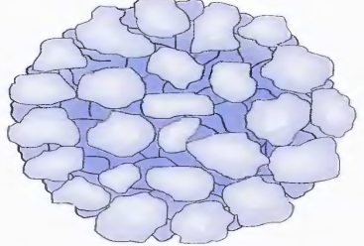

***Minimizing Adsorbed Impurities on Colloids***

The purity of many coagulated colloids is improved by ***digestion***. During this process, water is expelled from the solid to give a denser mas, that has a smaller specific surface area for adsorption.

***Washing a coagulated colloid with a solution containing a*** ***volatile electrolyte*** may also be helpful because any nonvolatile electrolyte added earlier to cause coagulation is displaced by the volatile species. Washing generally does not remove much of the prirnarily adsorbed ions because the attraction between these ions and the surface of the solid is too strong. Exchange occurs, however, between existing counter-ion and ions in the wash liquid.

***Reprecipitation*** A drastic but effective way to minimize the effects of adsorption is reprecipitation. In this process. the filtered solid is redissolved and reprecipitated. The first precipitate ordinarily carries down only a fraction of the contaminant present in the original solvent. Thus. the solution containing the redissolved precipitate has a significantly lower contaminant concentration than the original. and even less adsorption occurs during the second precipitation. Reprecipitation adds substantially to the tirne required for an analysis but is often necessary for such precipitates as the hydrous oxides of iron(llI) and alurninurn, which have extraordinary tendencies to adsorb the hydroxides of heavy-metal cations such as zinc, cadrnium, and manganese.

***Mixed-crystal formation*** is a type of coprecipitation in which a contaminant ion replaces an ion in the lattice of a crystal.

The extent of rnixed-crystal contamination is governed by the law of rnass action and increases as the ratio of contaminant to analyte concentration increases. This problem is encountered with both colloidal suspensions and crystalline precipitates.

***Occlusion*** is a type of coprecipitation in which a compound is trapped within a pocket formed during rapid crystal growth.

***Mechanical entraprnent*** occurs when crystals lie close together during growth. Several crystals grow together and in so doing trap a portion of the solution in a tiny pocket.

***Mixed-crystal formation*** may occur in both colloidal and crystalline precip- itates. whereas ***occlusion and mechanical entrapment*** are confined to crys- talline precipitates,

***Coprecipitation Errors***

Coprecipitated impurities may cause either negative or positive errors in an analysis. If the contaminant is not a compound of the ion being determined, a positive error will always result.

***For example***. in the deterrnination of barium by precipitation as barium sulfate, occlusion of other barium salts occurs. If the occluded contaminant is barium nitrate, a positive error is observed because this compound has a larger molar mass than the bariurn sulfate that would have formed had no coprecipitation occurred. If barium chloride is the contaminant, the error is negative because its molar mass is less than that of the sulfate salt.

**APPLICATIONS OF GRAVIMETRIC METHODS**

Gravimetric rnethods have been developed for rnost **inorganic anions** and **cations,** as well as for such **neutral species** as ***water, sulfur dioxide, carbon dioxide, and iodine***. A variety of **organic substances** can also be easily determined gravimetrically. Examples include ***lactose in milk products, salicylates in drug preparations***, phenolphthalein in laxatives. nicotine in pesticides. cholesterol in cereals, and benzaldehyde in almond extracts. Indeed, gravimetric methods are among the most widely applicable of all analytical procedures.

***Inorganic Precipitating Agents***

Table 12-2 lists cornmon inorganic precipitating agents. These reagents typically form sIightly soluble salts or hydrous oxides with the analyte. As you can see frorn the many entries for each reagent, few inorganic reagents are selective.

***Reducing Agents***

Table 12-3 lists several reagents that convert an analyte to its elemental form for weighing.

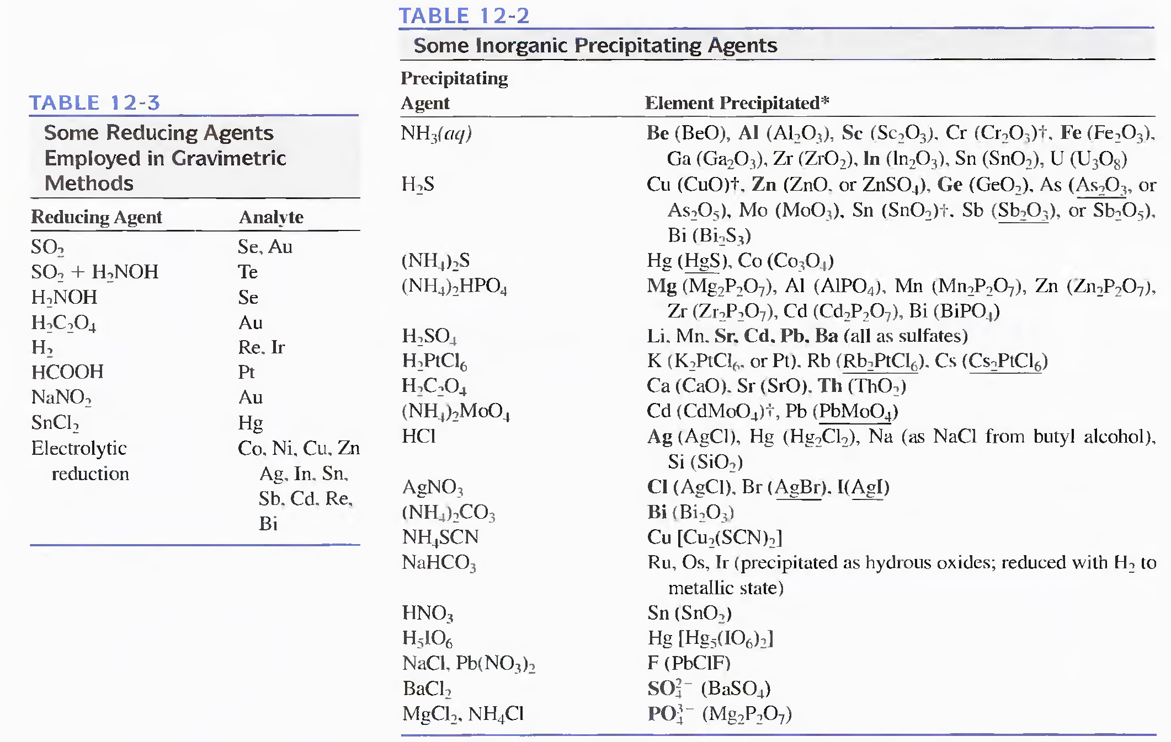

***Organic Precipitating Agents***

Numerous organic reagents have been developed for the gravimetric determination of inorganic species. Some of these reagents are significantly more selective in their reactions than are most of the inorganic reagents listed in Table 12-2.

We encounter two types of organic reagents. ***One forms slightly soluble non- ionic products*** called **coordination compounds**; the other ***forms products in which the bonding between the inorganic species and the reagent is largely ionic.***

Organic reagents that yield sparingly soluble coordination compounds typically contain at least two functional groups. Each of these groups is capable of bonding with a cation by donating a pair of electrons. The functional groups are located in the molecule such that a five- or six-membered ring results from the reaction.

Reagents that form compounds of this type are called chelating agents, and their products are called chelates (see Chapter 17).

**Metal chelates** are relatively nonpolar and. as a consequence, have solubilities that are low in water but high in organic liquids. Usually. these compounds possess low densities and are often intensely colored. Because they are not wetted by water, coordmatlon compounds are easily freed of moisture at low temperatures. Two

widely used chelating reagents are described in the paragraphs that follow.

***8-Hydroxyquinoline (oxine)***

Approximately two dozen cations form sparingly soluble chelates with 8-hydroxyquinoline. The structure of magnesium 8-hydroxyquinolate is typical of these chelates.

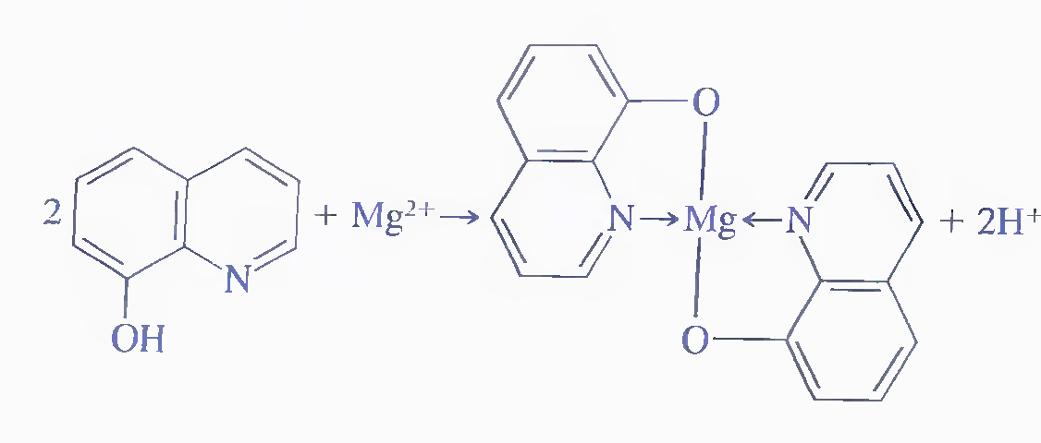

The solubilities of metal 8-hydroxyquinolates vary widely from cation to cation and are pH dependent because 8-hydroxyquinoline is always deprotonated during chelation reaction. Therefore. we can achieve a considerable degree of selectivity in the use of 8-hydroxyquinoline by controlling pH.

***Dimethylglyoxime***

Dimethylglyoxime is an organic precipitating agent of unparalleled specificity Only nickel(ll) is precipitated from a weakly alkaline solution. The reaction is

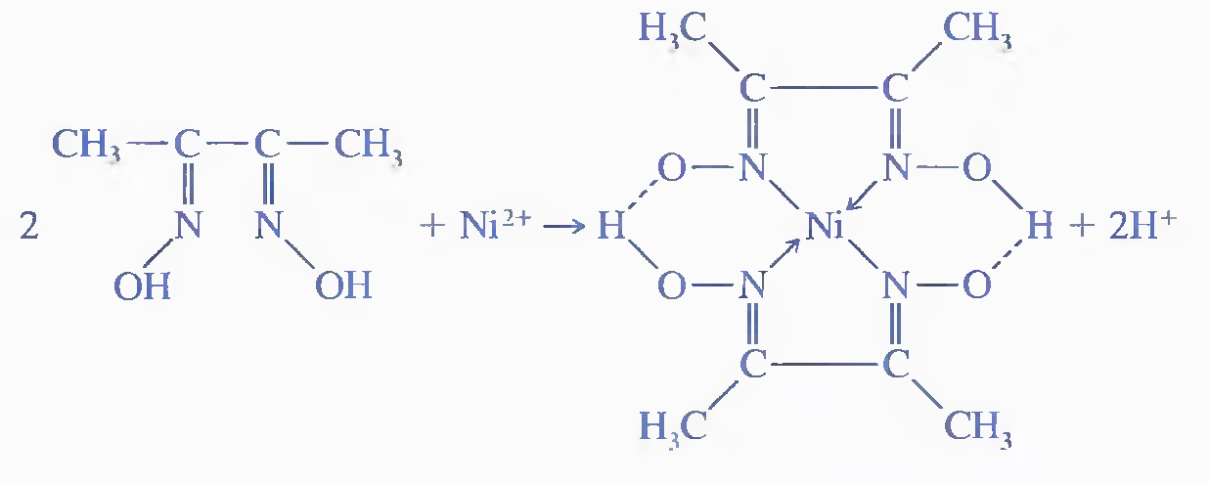

This precipitate is so bulky that only small amounts of nickel can be handled conveniently. It also has an exasperating tendency to creep up the sides of the container as it is filtered and washed. The solid is conveniently dried at I10°C and has the composition indicated by its formula.

***Sodium Tetraphenylborate***

Sodium tetraphenylborate, (C6H5) B-Na+, is an important example of an organic precipitating reagent that forms salt-like precipitates. In cold mineral acid solutions, it is a near-specific precipitating agent for potassium and ammonium ions. The precipitates have stoichiometric composition and contain one mole of potassium or ammoniurn ion for each mole of tetraphenylborate ion: these ionic compounds are easily filtered and can be brought to constant mass at lO5°C to 120°C.

Only mercury(II), rubidium. and cesiurn interfere and must be removed by prior treatment.

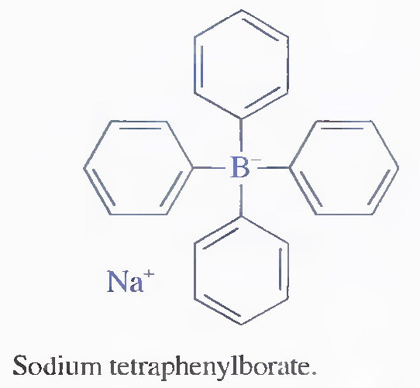

***Volatilization Gravimetry***

The two most common gravimetric methods based on volatilization are thme for determining water and carbon dioxide.

Water is quantitatively distilled from many materials by heating. In direct determination, water vapor is collected on any of several solid desiccants, and its rnass is determined from the mass gain of the desiccant. The indirect method, in which the arnount of water is deterrnined by the loss of mass of the sample during heating, is less satisfactory because it must be assumed that water is the only component volatilized. This assumption is frequently unjustified. however. because heating of many substances results in their decomposition and a consequent change in mass. irrespective of the presence of water. Nevertheless. the indirect method has found wide use for the determination of water in items of commerce. ***For example***. a semiautomated instrument for the determination of moisture in cereal grains can be purchased. ***An example of a gravimetric procedure*** involving volatilization of carbon dioxide is the deterrnination of the sodium hydrogen carbonate content of antacid tablets. Here, a weighed ;"sarnple of the finely ground tablets is treated with dilute sulfuric acid to convert the sodium hydrogen carbonate to carbon dioxide:



As shown in Figure 12-8, this reaction is carried out in a flask connected to a weighed absorption tube containing the absorbent Ascarite Il,1 which consists of sodiurn hydroxide absorbed on a nonfibrous silicate. This material retains carbon dioxide by the reaction

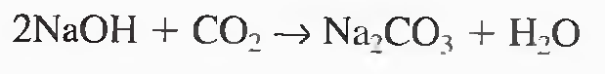

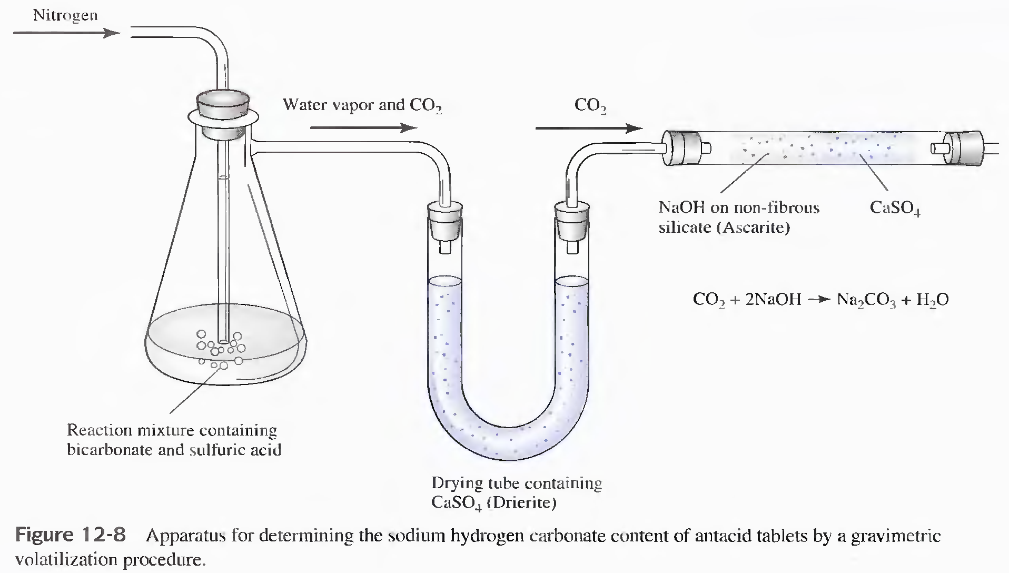

The absorption tube must also contain a desiccant to prevent loss of the water produced by the reaction.

***Sulfides and sulfites*** can also be determined by volatilization. Hydrogen sulfide or sulfur dioxide evolved from the sample after treatment with acid is collected in a suitable absorbent.

Finally, the classical method for the determination of carbon and hydrogen in organic compounds is a gravimetric volatilization procedure in which the combustion products (H2O and CO2) are collected selectively on weighed absorbents. The increase in mass serves as the analytical parameter.

**Solubility and Ksp**

It is important to distinguish carefully between solubility and solubility product. The solubility of a substance is the quantity that dissolves to form a saturated solution. Solubility is often expressed as grams of solute per liter of solution. The molar solubility is the number of moles of the solute that dissolve in forming a liter of saturated solution of the solute. The solubility product constant is the equilibrium constant for the equilibrium between an ionic solid and its saturated solution. The solubility of a substance changes as the concentration of other solutes change. In contrast the solubility product for a given solute is constant at a specific temperature.

Most, but not aIL sparingly soluble salts are essentially cornpletely dissociated in saturated aqueous solution. For exarnple, when an excess of barium iodate is equilibrated with water, the dissociation process is adequately described by the equation

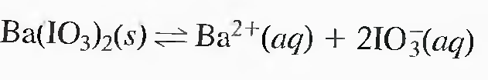

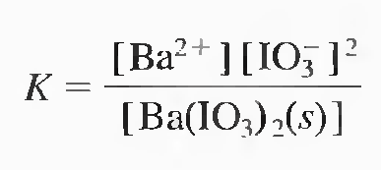

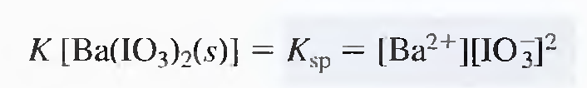

The solubility product constant is the equilibrium constant for the equilibrium between an ionic solid and its saturated solution. The solubility of a substance changes as the concentration of other solutes change. In contrast the solubility product for a given solute is constant at a specific temperature.

**The Common Ion Effect**

The solubility of insoluble substances can be decreased by the presence of a common ion . The common-ion effect is a mass-action effect predicted from ***The Le Chatelier principle*** ( If a chemical system at equilibrium experiences a change in concentration, temperature, volume, or partial pressure, then the equilibrium shifts to counteract the imposed change and a new equilibrium is established ). **AgCl** will be our example.

Present in silver chloride are silver ions (Ag+) and chloride ions (Cl¯). Silver nitrate (which is soluble) has silver ion in common with silver chloride. Sodium chloride (also soluble) has chloride ion in common with silver chloride.

In fact, mixing sufficiently concentrated solutions of AgNO3 and NaCl will produce a precipitate of AgCl. In order to be sufficiently concentrated, the product of the [Ag+] and the [Cl¯] must exceed the Ksp of 1.77 x 10¯10.

**Example 1**: AgCl will be dissolved into a solution with is ALREADY 0.0100 M in chloride ion. What is the solubility of AgCl?

By the way, the source of the chloride is unimportant (at this level). Let us assume the chloride came from some dissolved sodium chloride, sufficient to make the solution 0.0100 M. So, on to the solution . . .

***The dissociation equation for AgCl is:***

AgCl (s) <===> Ag+ (aq) + Cl¯ (aq)

***The Ksp expression is:***

Ksp = [Ag+] [Cl¯]

This is the equation we must solve. First we put in the Ksp value:

1.77 x 10¯10 = [Ag+] [Cl¯]

Now, we have to reason out the values of the two guys on the right. The problem specifies that [Cl¯] is already 0.0100. I get another 'x' amount from the dissolving AgCl. Of course, [Ag+] is 'x.'

Substituting, we get:

1.77 x 10¯10 = (x) (0.0100 + x)

This will wind up to be a quadratic equation which is solvable via the quadratic formula. However, there is a chemical way to solve this problem. We reason that 'x' is a small number, such that '0.0100 + x' is almost exactly equal to 0.0100. If we were to use 0.0100 rather than '0.0100 + x,' we would get essentially the same answer and do so much faster. So the problem becomes:

1.77 x 10¯10 = (x) (0.0100)

and

x = 1.77 x 10¯8 M

There is another reason why neglecting the 'x' in '0.0100 + x' is OK. It turns out that measuring Ksp values are fairly difficult to do and, hence, have a fair amount of error already built into the value. So the very slight difference between 'x' and '0.0100 + x' really has no bearing on the accuracy of the final answer. Why not? Because the Ksp already has significant error in it to begin with. Our "adding" a bit more error is insignificant compared to the error already there.

**Example 2**: The Ksp for silver carbonate is 8.4 x 10¯12. The concentration of carbonate ions in a saturated solution is 1.28 x 10¯4 M. What is the concentration of silver ions?

***Solution:***

Dissociation equation:

Ag2CO3 (s) <===> 2 Ag+ (aq) + CO32¯ (aq)

***Ksp expression:***

Ksp = [Ag+]2 [CO32¯]

Let us substitue into the Ksp expression:

8.4 x 10¯12 = (x)2 (1.28 x 10¯4)

Note: I could have used (1.28 x 10¯4 + 0.5x) for the carbonate. See above discussion for why the 0.5x can be dropped.

Divide both sides by 1.28 x 10¯4 and then take the square root:

[Ag+] = x = 2.56 x 10¯4 M

**Example 3:** The molar solubility of a generic substance, M(OH)**2** in 0.10 M KOH solution is 1.0 x 10¯**5** mol/L. What is the Ksp for M(OH)**2**?

**Solution:**

In this case, we are being asked for the Ksp, so that is where our 'x' will be. That means the right-hand side of the Ksp expression (where the concentrations are) cannot have an unknown.

Dissociation equation:

M(OH)2 (s) <===> M2+ (aq) + 2 OH¯ (aq)

Ksp expression:

Ksp = [M2+] [OH¯]2

Let us substitue into the Ksp expression:

x = (1.0 x 10¯5) (0.10)2

The 1.0 x 10¯**5** comes from the molar solubility information, coupled with the fact that for every one M(OH)2, one M2+ is produced.

Also, we could have used (0.10 + 2.0 x 10¯5) M for the [OH¯]. However, the 2.0 x 10¯5 M, being much smaller than 0.10, is generally ignored.

The answer:

Ksp = 1.0 x 10¯7

**Example 4:** What is the solubility of AgI in a 0.274-molar solution of NaI. (Ksp of AgI = 8.52 x 10¯**17**)

**Solution:**

Dissociation equation:

AgI (s) <===> Ag+ (aq) + I¯ (aq)

Ksp expression:

Ksp = [Ag+] [I¯]

Let us substitue into the Ksp expression:

8.52 x 10¯17 = (x) (0.274)

The answer:

[Ag+] = 3.11 x 10¯16 M

**Example 5**: What is the solubility of Ca(OH)2 in 0.0860 M Ba(OH)2?

(Ksp for Ca(OH)2 is known to be 4.68 x 10¯6)

**Solution:**

Ba(OH)2 is a strong base so [OH¯]= 2 times 0.0860 = 0.172 M

Dissociation equation:

Ca(OH)2 (s) <===> Ca2+ (aq) + 2OH¯ (aq)

Ksp expression:

Ksp = [Ca2+] [OH¯]2

The Ksp for Ca(OH)2 is known to be 4.68 x 10¯6. We set [Ca2+] = x and [OH¯] = (0.172 + 2x). Substituting into the Ksp expression:

4.68 x 10¯6 = (x) (0.172 + 2x)2

Ignoring the "2x," we find x = 1.58 x 10¯4 M

Comment: There are several different values floating about the Internet for the Ksp of Ca(OH)2. I got mine from the CRC Handbook, 73rd Edition, pg. 8-43.

**Example 6:** The solubility product of Mg(OH)2 is 1.2 x 10¯11. What minimum OH¯ concentration must be attained (for example, by adding NaOH) to decrease the Mg2+ concentration in a solution of Mg(NO3)2 to less than 1.1 x 10¯10 M?

**Solution:**

Ksp expression:

Ksp = [Mg2+] [OH¯]**2**

We set [Mg2+] = 1.1 x 10¯10 and [OH¯] = x. Substituting into the Ksp expression:

1.2 x 10¯11 = (1.1 x 10¯10) (x)2 x = 0.33 M

Any sodium hydroxide solution greater than 0.33 M will reduce the [Mg2+] to less than 1.1 x 10¯10 M.

**Example 8:** What is the solubility, in moles per liter, of AgCl (Ksp = 1.77 x 10-10) in 0.0300 M CaCl2 solution?

**Solution:**

1) Concentration of chloride ion from calcium chloride:

0.0300 M x 2 = 0.0600 M

from here:

CaCl2(s) ---> Ca2+(aq) + 2Cl¯(aq)

2) Calculate solubility of Ag+:

Ksp = [Ag+] [Cl¯]

1.77 x 10**-10** = (x) (0.0600)

x = 2.95 x 10**-9** M

Since there is a 1:1 ratio between the moles of aqueous silver ion and the moles of silver chloride that dissolved, 2.95 x 10**-9** M is the molar solubility of AgCl in 0.0300 M CaCl2 solution.

**Example 9:** Calculate the number of moles of Ag2CrO4 that will dissolve in 1.00 L of 0.010 M K2CrO4 solution. Ksp for Ag2CrO4 = 9.0 x 10-12.

Solution:

1) Concentration of dichromate ion from potassium chromate:

0.010 M

2) Calculate solubility of Ag+:

Ksp = [Ag+]2 [CrO42¯]

9.0 x 10-12 = (x)2 (0.010)

x = 3.0 x 10-5 M

Since there is a 2:1 ratio between the moles of aqueous silver ion and the moles of silver chromate that dissolved, 1.5 x 10-5 M is the molar solubility of Ag2CrO4 in 0.010 M K2CrO4 solution.

Since we were asked for the moles of silver chromate that would disolve in 1.00 L, the final answer is:

1.5 x 10-5 mol

**pH and Solubility**

The solubilities of many substances depend on the pH of the solution.

There is two types of effect:

1. Common ion :

Consider the solubility equilibrium of calcium hydroxide, Ca(OH)2:

Ca(OH)2(s) <==> Ca2+(aq) + 2 OH**-**(aq)

Increasing the pH (adding OH-) shifts the equilibrium from right to left, decreasing the solubility of Ca(OH)2.

1. Anion and cation that reacting with OH- & H+

On the other hand adding H+ ions or decreasing the pH shifts the equilibrium to the right, and the solubility of Ca(OH)2 increases. This is because the H+ ions remove OH- ions from the right hand side of the equilibrium expression to form water, and according to Le Chatelier's principle the equilibrium will shift toward the side where something is removed.

other example : CaF2 ↔ Ca2+ + 2F**-**

H3O+

2HF + H2O

***Electrolytes and Solubility***

Electrolyte = A solute that produces ions in solution.

Electrolytic Solution = A solution that conducts electricity.

Non-electrolyte = A solute that dissolves without producing ions.

The solubility of ppt. is generally greater in solutions of electrolytes ( have no ion in common ) than in pure water . the figure below demonstrate the increasing in the solubility of barium sulfate twofolds when potassium nitrate conc. of the solvent is increased from zero to 0.02 m.

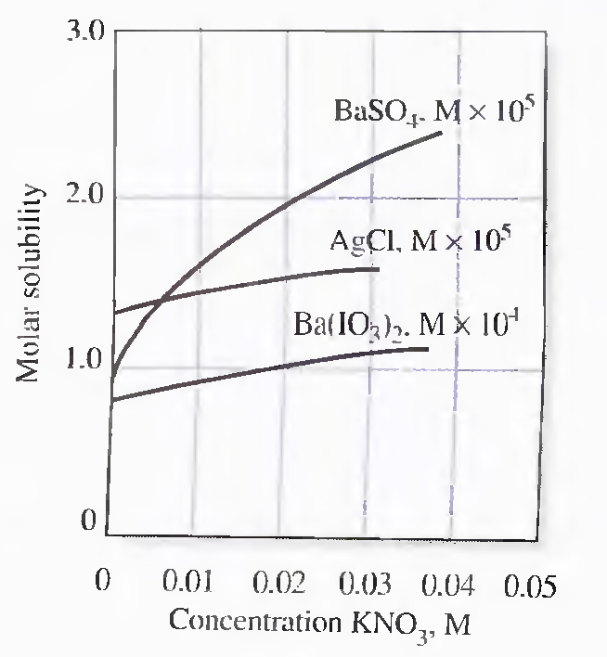

The effect of electolytes conc. on solubility arises from an increased attraction for ions of the solute by the dissolved elelectrolyte in the solvent.

**Ionic Strength**

Systernatic studies have shown that the effect of added electrolyte on equilibria is independent of the chemical nature of the electrolyte but depends on a property of the solution called the ionic strength. This qumltity is defined as

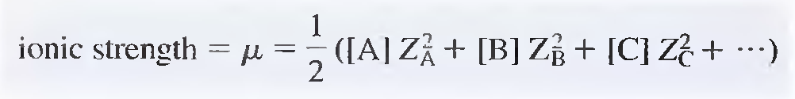

where [A]. [B]. [C]. ... represent the species rnolar concentrations of ions A, B, C, ... and ZA, ZB, Zc, ... are their charges.

Ionic Strength depend on conc. of electrolyte, the charge of ions and the number of charges.

Example 1

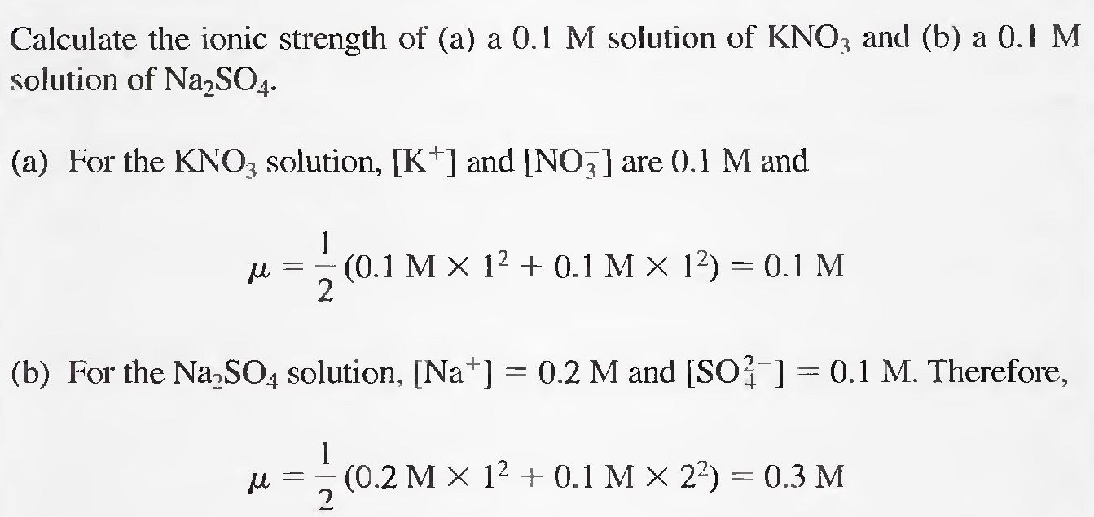

Example 2

