

**Chapter Four**

**Qualitative Solutions to Models for**

**Two Interacting Species**

In this chapter we develop some powerful theory, which allows us to predict the dynamics of a system in general terms. It provides the means by which we can establish the phase plane behavior of a system and predict the outcome for any possible parameter combination.

**Linear theory**

Both the analytic form of the solution and the solution’s stability depend on the eigenvalues of the matrix A where the linear system is $\dot{X}=AX$.

Two distinct real eigenvalues

1. 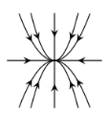If $λ_{1}<λ_{2}<0$ then the equilibrium point is stable node (sink).

**Stable node (sink)**

1. 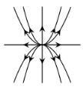 If $λ_{1}>λ_{2}>0$ then the equilibrium point is unstable node (source).

**Unstable node (source)**

1. 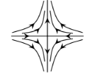If $λ_{1}<0<λ_{2}$ then the equilibrium point is saddle.

**Saddle**

**Real eigenvalues with algebraic multiplicity two**

1. If $λ_{1}=λ_{2}<0$ then the equilibrium point is degenerate stable node.

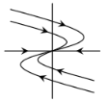

**Degenerate stable node**

1. If $λ_{1}=λ_{2}>0$ then the equilibrium point is degenerate unstable node.

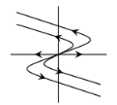

**Degenerate unstable node**

**Eigenvalues with nonzero imaginary part**

1. 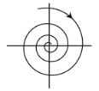If we have $λ=μ±iw$ where $μ<0$ then the equilibrium point is stable focus (spiral).

**Stable focus (spiral)**

1. 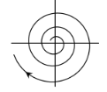If we have $λ=μ±iw$ where $w>0$ then the equilibrium point is unstable focus (spiral).

**Unstable focus (spiral)**

1. If $λ_{1,2}=μ±iw (μ=0)$ then the equilibrium point is center.

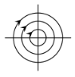

**Center**

**Computational shortcuts for two-dimensional system**

Although the classification of $2×2$ systems in the previous section depended on the eigenvalues of the matrix $A$, one does not usually need to compute them as there are equivalent conditions that are easier to check. To see this being by writing out the characteristic polynomial of $A$ in terms of its elements

$$\det\left(A-λI\right)=\det\left[\begin{matrix}a_{11}-λ & a_{12} \\ a_{21} & a_{22}-λ\end{matrix}\right]$$

$$=\left(a_{11}-λ\right)\left(a_{22}-λ\right)-a_{12}a_{21}$$

$$=λ^{2}-\left(a_{11}+a_{22}\right)λ+\left(a_{11}a_{22}-a_{12}a_{21}\right)$$

$$=λ^{2}-Trλ+∆ …(7)$$

where $Tr=Trace \left(A\right)=a_{11}+a_{22}$ is the trace of the matrix and $∆=a_{11}a_{22}-a_{12}a_{21}$ is its determinant. The eigenvalues of $A$ are the roots of this quadratic and so satisfy

$$λ=\frac{-Tr±\sqrt{{Tr}^{2}-4∆}}{2} …(8)$$

if we call the two roots $λ_{1}$ and $λ_{2}$ we can use them to factor the characteristic polynomial and obtain

$$\det\left(A-λI\right)=\left(λ-λ_{1}\right)\left(λ-λ_{2}\right)=λ^{2}-\left(λ_{1}+λ_{2}\right)λ+λ_{1}λ_{2} …(9)$$

Comparing Eq. (7) with the last line of Eq. (9), we obtain

$Tr=λ_{1}+λ_{2}$ and $∆=λ_{1}λ_{2}$

And this, along with Eq.(8), allows us to make the following observations, which are summarised in figure

* If $∆<0$ then the eigenvalues are real, nonzeroand have opposite sign:

the equilibrium is thus a saddle

* The eigenvalues are distinct real number if $Tr^{2}-4∆>0, (∆<\frac{Tr^{2}}{4})$, but form a complex conjugate pair if $Tr^{2}-4∆<0, (∆>\frac{Tr^{2}}{4})$.
* If $∆>0$ and $Tr<0$ then the eigenvalues are either a pair of negative real number or a complex conjugate pair with negative real part. In either case, the equilibrium is stable.
* If $∆>0$ and $Tr<0$ then the eigenvalues are either a pair of postive real number or a complex conjugate pair with postive real part. In either case, the equilibrium is unstable.

The various special cases at the boundaries between the regions described are:

$*∆=0$: then there are one or (if $Tr=0$) two zero eigenvalues and linear stability analysis is inconclusive and the pattern of solutions will be determined by higher-order terms in the taylor series in Eq.(3).

$*∆={\left(\frac{Tr}{2}\right)}^{2}$: the characteristic polynomial has a repeated real root and the phase portraits will be degenerate source (in case $Tr>0$) or degenerate sink (in case $Tr<0$).

$*∆=0$: and $∆>0$: the eigenvalues are a pure imaginary pair and the phase portrait will be center.

**Degenerate stable node (sink)**

$$∆=\frac{Tr^{2}}{4}$$

$$<0$$

**Saddle**

$$<0$$

**Stable node (sink)**

$$∆<\frac{Tr^{2}}{4}$$

**Line of stable**

**fixed points**

**Stable spiral**

$$<0$$

$$∆>\frac{Tr^{2}}{4}$$

$$=0$$

**Center**

**Degenerate unstable node (source)**

$$∆=\frac{Tr^{2}}{4}$$

**Unstable node (source)**

$$∆<\frac{Tr^{2}}{4}$$

$$∆>\frac{Tr^{2}}{4}$$

$$>0$$

$$=0$$

$$=0$$

**Uniform motion**

$$>0$$

**Line of unstable**

**fixed points**

$$Tr (A)$$

$$Tr (A)$$

$$det A$$

**Unstable spiral**

$$>0$$

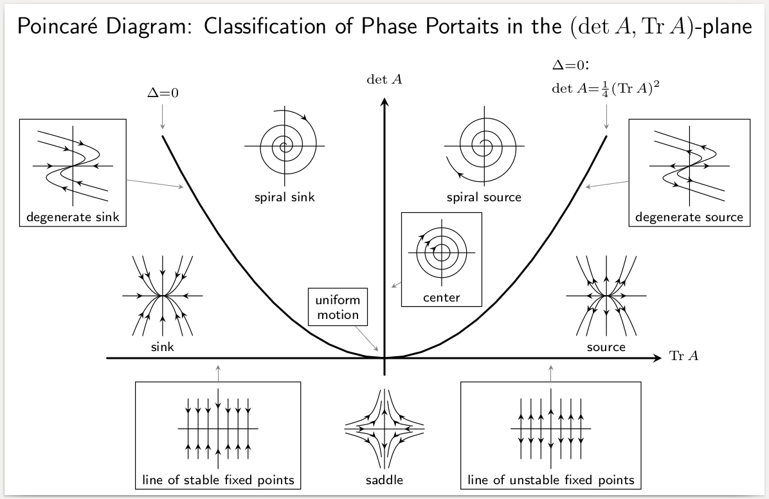

**Example:**

1. Determine the phase portrait of the dynamical system

$$\left[\begin{matrix}x^{'}(t) \\ y'(t)\end{matrix}\right]=\left[\begin{matrix}-2 & -2 \\ 1 & -5\end{matrix}\right]\left[\begin{matrix}x(t) \\ y(t)\end{matrix}\right]$$

**Solution:**

$$detA=10-\left(-2\right)=12>0$$

$$Tr\left(A\right)=-2-5=-7<0$$

$$\frac{Tr{\left(A\right)}^{2}}{4}=\frac{49}{4}=12.2>\det\left(A\right)$$

$$∴∆<\frac{Tr^{2}}{4}$$

$∴$ we have stable node.



$A=\left[\begin{matrix}-2 & -5 \\ 0 & -2\end{matrix}\right]$

$$∆=detA=4>0$$

$$Tr\left(A\right)=-2-2=-4<0$$

$$\frac{Tr{\left(A\right)}^{2}}{4}=\frac{16}{4}=4∆$$

$∴$ we have degenerate stable node.



$A=\left[\begin{matrix}-1 & 2 \\ -1 & -1\end{matrix}\right]$

$$∆=1-\left(-2\right)=3>0$$

$$Tr\left(A\right)=-1-1=-2<0$$

$$\frac{Tr{\left(A\right)}^{2}}{4}=\frac{4}{4}=1<∆$$

$∴$ we have stable spiral.



$A=\left[\begin{matrix}2 & 3 \\ -2 & -2\end{matrix}\right]$

$$∆=-4-\left(-6\right)=2>0$$

$$Tr\left(A\right)=2-2=0$$

$∴$ we have center.

$A=\left[\begin{matrix}1 & 2 \\ -1 & 1\end{matrix}\right]$

$$∆=1-\left(-2\right)=3>0$$

$$Tr\left(A\right)=1+1=2>0$$

$$\frac{Tr{\left(A\right)}^{2}}{4}=\frac{2^{2}}{4}=1<∆$$

$∴$ we have unstable spiral.

$A=\left[\begin{matrix}1 & 1 \\ 0 & 2\end{matrix}\right]$

$$∆=2>0$$

$$Tr\left(A\right)=1+2=3>0$$

$$\frac{Tr{\left(A\right)}^{2}}{4}=\frac{9}{4}=2.5>∆$$

$∴$ unstable node.

$A=\left[\begin{matrix}2 & -5 \\ 0 & 2\end{matrix}\right]$

$$∆=4>0$$

$$Tr\left(A\right)=4>0$$

$$\frac{Tr{\left(A\right)}^{2}}{4}=\frac{16}{4}=4=∆$$

$∴$ degenerate unstable node.

$A=\left[\begin{matrix}1 & 1 \\ 0 & -2\end{matrix}\right]$

$$det A=-2<0$$

$∴$ Saddle.

$A=\left[\begin{matrix}0 & 0 \\ 0 & -1\end{matrix}\right]$

$$∆=0$$

$$Tr\left(A\right)=-1<0$$

$∴$ we have lines (star) of stable fixed points.

$A=\left[\begin{matrix}0 & 0 \\ 0 & 1\end{matrix}\right]$

$$∆=0$$

$$Tr\left(A\right)=1>0$$

$∴$ we have line of unstable fixed points.

$A=\left[\begin{matrix}2 & -4 \\ 1 & -2\end{matrix}\right]$

$$∆=-4-\left(-4\right)=0$$

$$Tr\left(A\right)=0$$

$∴$ we have uniform motion.

**Applications of Linear Theory**

**Example:**

Find all equilibrium points associated with the system

$X^{'}=Y$ and $Y^{'}=-w^{2}X$

and determine their classification(s).

**Solution:**

In matrix form, the system is

$X^{'}=AX$ where $A=\left[\begin{matrix}0 & 1 \\ -w^{2} & 0\end{matrix}\right]$

$Y=0$ and $-w^{2}X=0 ⟼ X=0$

$∴$ The only equilibrium point is $\left(x_{e},y_{e}\right)=(0,0)$.

To classify this point, we need the characterist eq.

$$λ^{2}-tra\left(A\right)+\det\left(A\right)=0$$

$$λ^{2}-0λ+w^{2}=0 ⟼{{ λ}^{2}+w}^{2}=0$$

$$∴ λ=±wi$$

Now, with $trac\left(A\right)=0$ and $det=w^{2}$

This implies that the equilibrium point $(0,0)$ is a center.

**Example:**

Classify the equilibrium points for the system

$$\frac{dR}{dt}=-a_{1}B, \frac{dB}{dt}=-a_{2}R$$

**Solution:**

the system can be written in matrix form

$X^{'}=AX$, $A=\left[\begin{matrix}0 & -a_{1} \\ -a_{2} & 0\end{matrix}\right]$

and

$$\begin{matrix}-a_{1}B=0⟼B=0 \\ -a_{2}R=0⟼R=0\end{matrix} \}→\left(R_{e},B_{e}\right)=(0,0)$$

The characterist equation is

$$λ^{2}-tra\left(A\right)+\det\left(A\right)=0$$

$$λ^{2}+\left(-a_{1}a_{2}\right)=0$$

with $\det{(A)}=-a_{1}a_{2}<0$

$∴$ The equilibrium point is a saddle point.

**A mathematical Interlude (Non Linear Theory)**

Suppose we are considering a model for two interacting species that has the general form

$$\frac{du}{dt}=f\left(u,v\right) and \frac{dv}{dt}=g\left(u,v\right) …(1)$$

where $f$ and $g$ are continuous and continuously differetiable. If $(u_{*},v_{*})$ is an equilibrium of Eq. (1), so that

$$f\left(u_{*},v_{*}\right)=0=g(u_{*},v_{*})$$

then we can investigate its stability by defining perturbation $x(t)$ and $y(t)$ such that

$$u\left(t\right)=u_{*}+x\left(t\right) and v\left(t\right)=v_{*}+y(t) …(2)$$

**Linearisation near an equilibrium**

$$\frac{du}{dt}=\frac{d}{dt}\left(u_{*}+x(t)\right)=\frac{dx}{dt}$$

But then on the other hand

$$\frac{du}{dt}=\frac{dx}{dt}=f\left(u_{*}+x\left(t\right),v_{*}+y\left(t\right)\right)$$

Zero

$≈f\left(u_{*},v_{*}\right)+x\left(t\right)\frac{∂f}{∂u} |_{u_{*},v_{*}}+y\left(t\right)\frac{∂f}{∂v} |_{u_{*},v_{*}}$

$$=x\left(t\right)\frac{∂f}{∂u} |_{u_{*},v_{*}}+y(t)\frac{∂f}{∂v} |_{u_{*},v_{*}} …(3)$$

In the same manner

$$\frac{dv}{dt}=\frac{dy}{dt}=x\left(t\right)\frac{∂g}{∂u} |_{u_{*},v_{*}}+y\left(t\right)\frac{∂g}{∂v} |_{u_{*},v_{*}} …(4)$$

It’s convenient to combine the results (3) and (4) in matrix form as follows

$$\frac{d}{dt}\left[\begin{matrix}x \\ y\end{matrix}\right]=A\left[\begin{matrix}x \\ y\end{matrix}\right] …(5)$$

where $A={\left[\begin{matrix}\frac{∂f}{∂u} & \frac{∂f}{∂v} \\ \frac{∂g}{∂u} & \frac{∂g}{∂v}\end{matrix}\right]}_{u_{*},v_{*}} …(6)$

when derived form an ecological model such as the Lotka-Volterra system the matrix $A$ defined above is called the community matrix. The stability of the equilibrium then depends on the nature of the solutions to the linear system of ODEs (1) and this depends on the eigenvalues of the matrix $A$

**Applications of nonlinear theory**

**Example:**

Find the linearised for model

$$X^{'}=β_{1}X-c_{1}XY$$

$$Y^{'}=-α_{2}Y+c_{2}XY$$

and hence classify all equilibrium points of the basic predator-prey model.

$$β_{1}X-c_{1}XY=0⟼X\left(β_{1}-c_{1}Y\right)=0$$

either $X=0$ or $β_{1}-c_{1}Y=0→Y=\frac{β_{1}}{c_{1}}$

$$-α_{2}Y+c_{2}XY=0⟼Y(-α_{2}+c_{2}X)$$

either $Y=0$ or $-α_{2}+c_{2}X=0→X=\frac{α_{2}}{c_{2}}$

$∴\left(0,0\right)$ and $(\frac{α_{2}}{c_{2}},\frac{β_{1}}{c_{1}})$ are equilibrium points.

$$F\left(X,Y\right)=β_{1}X-c_{1}XY G\left(X,Y\right)=-α_{2}Y+c_{2}XY$$

$$\frac{∂F}{∂X}=β_{1}-c_{1}Y \frac{∂G}{∂X}=c_{2}Y$$

$$\frac{∂F}{∂Y}=-c_{1}X \frac{∂G}{∂Y}=-α_{2}+c_{2}X$$

$*$ For $\left(X_{e},Y_{e}\right)=\left(0,0\right)$

$$J=\left[\begin{matrix}β_{1}-c_{1}Y & -c_{1}X \\ c_{2}Y & -α_{2}+c_{2}X\end{matrix}\right]$$

$$=\left[\begin{matrix}β_{1} & 0 \\ 0 & -α_{2}\end{matrix}\right]$$

with $det\left(A\right)=-β_{1}α_{2}<0 ⟼ (0,0)$ is saddle point.

$*$ For $\left(X_{e},Y_{e}\right)=(\frac{α_{2}}{c_{2}},\frac{β_{1}}{c_{1}})$

$$J=\left[\begin{matrix}β_{1}-c_{1}\frac{β_{1}}{c_{1}} & -c_{1}\frac{α_{2}}{c_{2}} \\ c_{2}\frac{β_{1}}{c_{1}} & -α_{2}+c_{2}\frac{α_{2}}{c_{2}}\end{matrix}\right]$$

$$=\left[\begin{matrix}0 & -\frac{c_{1}α_{2}}{c_{2}} \\ \frac{β_{1}c_{2}}{c_{1}} & 0\end{matrix}\right]$$

$$Tr\left(A\right)=0 and \det\left(A\right)=\frac{c_{1}α_{2}}{c_{2}}.\frac{β_{1}c_{2}}{c_{1}}= α_{2}β_{1}$$

$$∴ \left(\frac{α_{2}}{c_{2}},\frac{β_{1}}{c_{1}}\right) is center.$$

**Example:**

Classify the equilibrium points of the epidemic model

$$\frac{dS}{dt}=-βSI ,$$

$$\frac{dI}{dt}=βSI-γI$$

**Solution:**

$-βSI=0⟼$ either $S=0$ or $I=0$

$βSI-γI=0 ⟼I\left(βS-γ\right)=0$

$∴$ either $I=0$ or $S=\frac{γ}{β}$

$∴(0,0)$ and $(\frac{γ}{β},0)$ are equilibrium points.

$$F\left(S,I\right)=-βSI G\left(S,I\right)=βSI-γI$$

$$\frac{∂F}{∂S}=-βI \frac{∂G}{∂S}=βI$$

$$\frac{∂F}{∂I}=-βS \frac{∂G}{∂I}=βS-γ$$

The Jacobian matrix is

$$J=\left[\begin{matrix}\frac{∂F}{∂S} & \frac{∂F}{∂I} \\ \frac{∂G}{∂S} & \frac{∂G}{∂I}\end{matrix}\right]=\left[\begin{matrix}-βI & -βS \\ βI & βS-γ\end{matrix}\right]$$

For $\left(S_{e},I_{e}\right)=\left(0,0\right)$

$$J=\left[\begin{matrix}0 & 0 \\ 0 & -γ\end{matrix}\right]$$

$Tr\left(A\right)=-γ and det\left(A\right)=0$

We have a line of stable fixed points.

For $\left(S_{e},I_{e}\right)=(\frac{γ}{β},0)$

$$J=\left[\begin{matrix}0 & -β.\frac{γ}{β} \\ 0 & β.\frac{γ}{β}-γ\end{matrix}\right]$$

$$=\left[\begin{matrix}0 & -γ \\ 0 & 0\end{matrix}\right]$$

$Tr\left(A\right)=0 and det\left(A\right)=0$

We have a uniform motion.