**CHROMOSOMES**

**DEFINITION OF CHROMOSOME**

It is a combination of two words, i.e., “Chroma”-means ‘colour’ and “Somes”-means ‘body’.So the coloured thread like bodies present in the nucleoplasm of the living cells, which helps in the inheritance (transmission) of characters in form of Genes from generation to generation are known as CHROMOSOMES.

 NUMBER OF CHROMOSOMES The number of chromosomes per organism is always a definite number, Which is said as Diploid (2n) no., but gametes, sperms, ova etc. carry Haploid (n) number.

* Chromosomes within the cell nuclei of higher organisms typically are linear.
* The chromosomes of mitochondria and some bacteria are circular.
* **The Chromosome**
* Each chromosome of a living cell is a DNA double helix. The atoms that make up DNA are organized into two primary molecular components: bases and pentose sugars with attached phosphate groups. The bases are the key informational components of DNA, the letters of the DNA alphabet. The bases of DNA include adenine (A), cytosine (C), guanine (G), and thymine (T). Each base consists of a nitrogen-containing component called an amine. The side groups attached to the amines differ among the bases. The pentose sugars and phosphate groups serve as the links that connect the bases in a string, or strand, of DNA. When DNA strands form a double-stranded molecule, two strands of DNA are joined together through hydrogen bonds that form between the bases. In the double-stranded DNA molecule, an A base always pairs with a T base and a C base always pairs with a G base. Once joined, the bases are referred to as base pairs.
* Embedded within the DNA sequence of each chromosome are the organism’s genes. The chromosome can be thought of as the DNA scaffolding within which the genes reside. An organism’s set of chromosomes is called its genome**.** Genes are interspersed unevenly along the lengths of most eukaryotic chromosomes. Across the human genome, for example, there are gene-rich regions and gene-poor regions.
* The genomes of most eukaryotes are fairly large and often complex. In addition to genes themselves, most eukaryotic genomes also contain a variety of non-coding structural and regulatory elements and introns. Some of the genetic material also serves as a fossil record, a history book written in biological terms and handed down from generation to generation.
* In addition to the DNA inside the cell nucleus, eukaryotic cells have separate genetic material in certain organelles such as mitochondria and, in plants, chloroplasts. In general, organelles, prokaryotes and viruses have greater biological constraints than nuclei on the tolerable sizes of their genomes because of the small genome size that can be incorporated into the organelle, bacterial cell, or viral capsid. As such, the genes of mitochondria, bacteria and viruses typically lack many of the complex non-coding elements commonly found in the nuclear genes of eukaryotes.
* Each chromosome within a living cell is a DNA double helix.
* 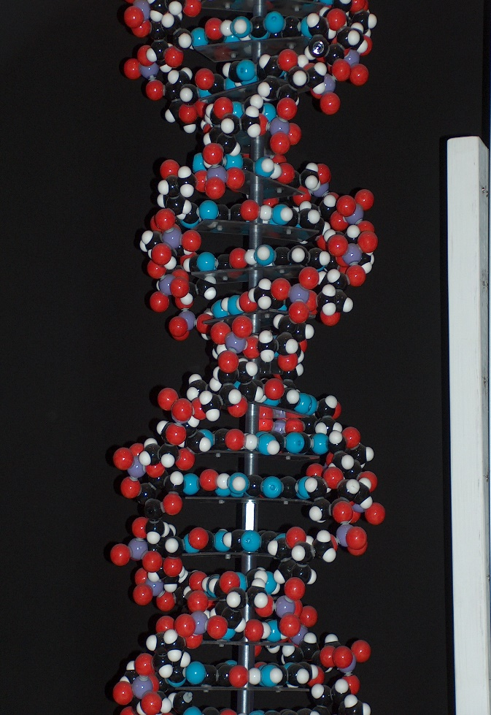

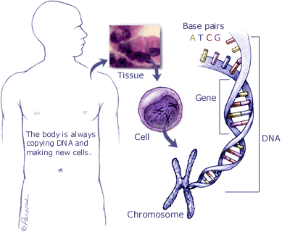 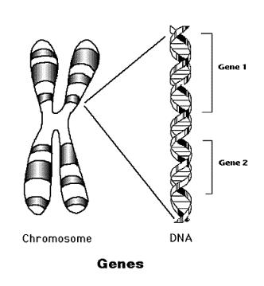

**TYPES OF CHROMOSOMES TELOCENTRIC:- The centromere is**  
present at the end of the chromosomes.LONG ARMCENTROMERESHORT ARMCENTROMERE2. ACROCENTRIC:-The centromere is almost terminal. It has one large and another very small arm.LONG ARM

[6](https://slideplayer.com/slide/15350543/92/images/6/TYPES+OF+CHROMOSOMES+%28CONTINUED%29.jpg) **TYPES OF CHROMOSOMES (CONTINUED)**  
3. SUB-METACENTRIC:- Here the centromere is not at the middle position of the chromosomes. So the arms are unequal and it is ‘L-Shaped’ in appearance.SHORT ARMCENTROMERELONG ARMTWO EQUAL ARMS4. METECENTRIC:- The centromere is at the middle position. So the arms are equal and it is ‘V-Shaped’ in appearance.CENTROMERE

[7](https://slideplayer.com/slide/15350543/92/images/7/CHEMICAL+STRUCTURE+Chemically+the+chromosomes+are+made+of+proteins+and+nucleic+acids..jpg) CHEMICAL STRUCTUREChemically the chromosomes are made of proteins and nucleic acids.PROTEINS It is mainly Protamines, Histones and smaller amount of acidic proteins.NUCLEIC ACIDS It is de-oxy ribose Nucleic Acids (DNA). Genes are nothing but the segments of DNA.NB:- For brief notes about DNA structure, “Open the Hyperlink at Right End.”CLICKHYPERLINK

[8](https://slideplayer.com/slide/15350543/92/images/8/FUNCTION+OF+CHROMOSOMES.jpg) **FUNCTION OF CHROMOSOMES**  
[I]- The chromosomes are capable of self-duplication. During duplication process the DNA strands unwind. As unwinding starts, each template of DNA forms its complementary strand in double-helix nature. The conversion of the old DNA molecule into two new molecules, helps in duplicating the chromosomes.

[9](https://slideplayer.com/slide/15350543/92/images/9/SELF+DUPLICATION+OF+DNA+MOLECULE.jpg) **SELF DUPLICATION OF DNA MOLECULE**  
(IT HELPS IN THE DUPLICATION OFCHROMOSOMES )Two separate DNA molecules formed having an old and a new strandSingle DNA molecule in double helical structureMother templates unwind and new complementary strands originateUnwinding continues along with new template formation

[10](https://slideplayer.com/slide/15350543/92/images/10/Function+of+chromosomes+%28continued%29%E2%80%A6.jpg) **Function of chromosomes (continued)…**  
[II]- They help in expression of different characters in an organism by synthesizing proteins in cells. A definite protein is accumulated to produce a definite character.NB:- To see the process of protein synthesis by DNA of chromosome, CLICK the “Hyperlink Button” below.CLICKHYPERLINK

[11](https://slideplayer.com/slide/15350543/92/images/11/Function+of+chromosomes+%28continued%29%E2%80%A6.jpg) **Function of chromosomes (continued)…**  
[III]- As carrier of genes they transmit characters from generation to generation , i.e. parents to offspring.[IV]- The chromosomes control the physiological and biochemical processes in the body of the organism.

**Chromosomes &** [**Karyotyping**](https://image3.slideserve.com/5465455/karyotyping-l.jpg)

1. Most chromosome structures (nucleosomes, chromatin fibres, and scaffold loop domains) form from virtually any DNA sequence, but centromeres and telomeres are both composed of specific DNA sequences complexed with specific binding proteins.

PHYSICAL STRUCTURE

* 1. Size varies from 1 to 30 micron in length and diameter from 0.2 to **2 micron**.

1. CENTROMERE:- The non-stainable part of the chromosome making a primary constriction.
2. CHROMATIDS:- Two chromatids join at the centromere to form a chromosome.
3. CHROMONEMA: - In each chromatid, there are two longitudinal chromonemata coiled with each other.
4. CHROMOMERES: - In each chromonemata, there are “bead” like chromomeres present throughout the coil.
5. GENES:- Each chromomeres contains genes, the unit of inheritance of character.
6. SATELLITE:- In some chromosomes a round and elongated satellite is present.
7. CONSTRICTION:- Presence of centromere shows the primary constriction.

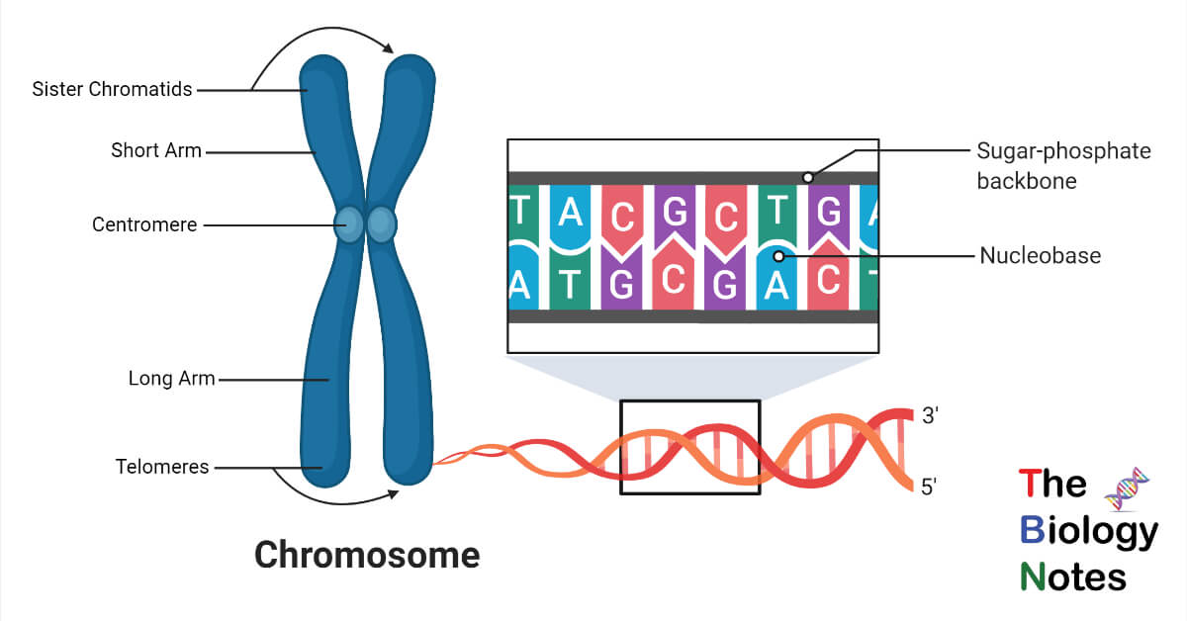

Chromosomes are composed of double-stranded DNA associated with specific proteins. The nuclei of normal human somatic cells each contain 23 pairs of chromosomes.1 set came from the mother “maternal ”, 1 set came from the father ” paternal ”. During metaphase, chromosomes become condensed and stain intensely with basic dyes.

1. **Human Chromosomes 1 set are the sex chromosomes**  
   22 of these sets are called autosomes (or “self-chromosomes”) chromosomes, are numbered from 1 to 22 approximating decreasing size order.1 set are the sex chromosomes A female carries two X chromosomes (XX)A male carries an X chromosome and a Y chromosome (XY)
2. [5](https://slideplayer.com/slide/16507255/96/images/5/Why+do+scientists+look+at+chromosomes.jpg) **Why do scientists look at chromosomes?**  
   Scientists can diagnose or predict genetic disorders by looking at chromosomes. This kind of analysis is used in prenatal testing and in diagnosing certain disorders, such as Down syndrome, or in diagnosing a specific types of leukemia.
3. [6](https://slideplayer.com/slide/16507255/96/images/6/Chromosome+abnormalities.jpg) **Chromosome abnormalities**  
   Chromosome abnormalities can be numerical, as in the presence of extra or missing chromosomes Structural as in translocations, inversions, large scale deletions or duplications.
4. [11](https://slideplayer.com/slide/16507255/96/images/11/Situations+where+analysis+is+strongly+recommended.jpg) **Situations where analysis is strongly recommended**  
   Problems with early growth & development Fertility problems Neoplasia Pregnancy in older women Chorionic villus sampling (CVS) is a form of prenatal diagnosis to determine chromosomal or genetic disorders in the fetus. It entails getting a sample of the chorionic villus (placental tissue) and testing it.
5. [12](https://slideplayer.com/slide/16507255/96/images/12/What+is+a+Karyotype.jpg) What is a Karyotype? A display or photomicrograph of an individual’s somatic-cell metaphase chromosomes that are arranged in a standard sequence (usually based on number, size, and type)
6. [13](https://slideplayer.com/slide/16507255/96/images/13/Performing+a+Karyotype.jpg) **Performing a Karyotype**  
   The slides are scanned for metaphase spreads and usually 10 to 30 cells are analyzed under the microscope by a cytogeneticist. When a good spread (minimum number of overlapping chromosomes) is found, a photograph is taken or the analysis is done by a computer.The chromosomes are arranged in a standard presentation format of longest to shortest.Actually chromosome 21 is smaller than chromosome 22.
7. **How Do Scientists Identify Chromosomes?**  
   Three key features to identify their similarities and differences:

Size. This is the easiest way to tell two different chromosomes apart.

Banding pattern. The size and location of Giemsa bands on chromosomes make each chromosome pair unique.

Centromere position. Centromeres are regions in chromosomes that appear as a constriction.Using these key features, scientists match up the 23 pairs

1. [15](https://slideplayer.com/slide/16507255/96/images/15/In+metacentric+chromosomes%2C+the+centromere+lies+near+the+center+of+the+chromosome..jpg) In metacentric chromosomes, the centromere lies near the center of the chromosome. Submetacentric & very Submetacentric chromosomes, have a centromere that is off-center, so that one chromosome arm is longer than the other. In acrocentric chromosomes, the centromere resides very near one end.

What are all 4 types of chromosomes?

On the basis of the location of the centromere, chromosomes are classified into four types: metacentric, submetacentric, acrocentric, and telocentric ?. As previously mentioned, the centromere is easily visualized as the most constricted region of a condensed mitotic chromosome.

1. Chromosomes
2. [**Objective**](https://image3.slideserve.com/5465455/objective-l.jpg) • Define Karyotype • Explain reasons why it is done • Describe the process • Name 3-4 diseases caused by a chromosomal abnormality. • Describe what most often causes this abnormal number of chromosomes?
3. [**Questions**](https://image3.slideserve.com/5465455/questions-l.jpg) • How many chromosomes come from your Father? • How many chromosomes come from your Mother? • What are chromosome pairs 1-22 called? • What is chromosome pair 23 called?
4. [**Parts of a chromosome**](https://image3.slideserve.com/5465455/parts-of-a-chromosome-l.jpg) • All human chromosomes have two arms • the short arm is referred to as the \_\_P\_\_ arm (petite) • the long arm as the \_\_q\_arm • The central region where the chromatids are joined is called the centromere • The ends are called telomeres P Q
5. [**Why is karyotyping done?**](https://image3.slideserve.com/5465455/why-is-karyotyping-done-l.jpg) • Determine if an adult has a genetic defect that can be passed down • Determine if a genetic defect is preventing pregnancy or causing miscarriages • Determine if a genetic defect is present in a fetus • Determine the cause of a stillbirth • Determine the cause of a birth defect
6. [**How is karyotyping done?**](https://image3.slideserve.com/5465455/how-is-karyotyping-done-l.jpg) • Cells are collected (blood, amniotic fluid or placental cells) • Go to cytogenetics lab • Isolate dividing cells • Grow cells in culture for 1 week • Treat cell culture with chemical that stops cells in Metaphase
7. [**How to karyotype, cont.**](https://image3.slideserve.com/5465455/how-to-karyotype-cont-l.jpg) 6. Put cells on microscope slide and treat with a solution that bursts cells 7. Wash cell debris away, chromosomes stick to slide 8. Stain chromosomes with dye 9. Take picture of chromosomes and analyze for number, sex, size, etc
8. [**Normal Karyotype**](https://image3.slideserve.com/5465455/normal-karyotype-l.jpg)
9. [**Terms to Know**](https://image3.slideserve.com/5465455/terms-to-know-l.jpg) • Any abnormal chromosome number is called aneuploidy. • A trisomy karyotype has one extra chromosome (2n +1). • A monosomy karyotype has one missing chromosome (2n - 1)
10. [**Some Aneuploid Chromosomal Disorders**](https://image3.slideserve.com/5465455/some-aneuploid-chromosomal-disorders-l.jpg) • Patau Syndrome • Edward Syndrome • Klinfelter’s Syndrome • Turner Syndrome • Super Male Syndrome • Super Female Syndrome
11. [**47, XY, +13**](https://image3.slideserve.com/5465455/47-xy-13-l.jpg) • serious eye, brain, circulatory defects as well as cleft palate. 1:5000 live births. Children rarely live more than a few months. • Patau Syndrome
12. [**Cleft Palate**](https://image3.slideserve.com/5465455/cleft-palate-l.jpg)
13. [**Edward Syndrome**](https://image3.slideserve.com/5465455/edward-syndrome-l.jpg) • almost every organ system affected 1:10,000 live births. Children with full Trisomy 18 generally do not live more than a few months.
14. [**Klinefelter’s Syndrome**](https://image3.slideserve.com/5465455/klinefelter-s-syndrome-l.jpg) • Male sex organs; unusually small testes, sterile. Breast enlargement and other feminine body characteristics. Normal intelligence.

**[Turner Syndrome](https://image3.slideserve.com/5465455/turner-syndrome-l.jpg" \t "_blank" \o "turner syndrome)** • the ONLY viable monosomy **Down’s** syndrome – (Trisomy 21) **47** chromosomes, extra chromosome at pair **#21**

1. [**Super Male and Super Female**](https://image3.slideserve.com/5465455/super-male-and-super-female-l.jpg) • - Has an XXX- Fertile females with normal intelligence • Has an XYY- Tall male with heavy acne- Some tendency to mental retardation • Aggressive tendency???
2. Typical human cells contain 23 pairs of chromosomes.
3. Variations in the number or structure of human chromosomes can cause a variety of genetic disorders.
4. Variations in the number of chromosomes within a cell are called aneuploidies.