FOUR ORDERS OF PROTEIN STRUCTURE
The modular nature of protein synthesis and folding are embodied in the concept of orders of protein structure. The primary structure of proteins involves the sequence of amino acids in a polypeptide chain.
SECONDARY STRUCTURE OF PROTEIN
The conformation of polypeptide chain by twisting or folding is referred to as secondary structure. The amino acids are located close to each other in their sequence. Two types of secondary structures, α-helix and β-sheet, are mainly identified.

α-Helix
α-Helix is the most common spiral structure of protein. It has a rigid arrangement of polypeptide chain. The prominent features of α-helix are given below:
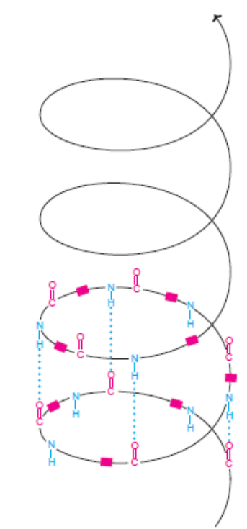

Diagrammatic representation of secondary structure of protein—a right handed α-helix
( -Indicate 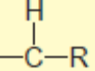groups of amino acids; dotted lines are hydrogen bonds; Note that only a few hydrogen bonds shown for clarity).

1. The α-helix is a tightly packed coiled structure with amino acid side chains extending outward from the central axis.
2. The α-helix is stabilized by extensive hydrogen bonding. It is formed between H atom attached to peptide N, and O atom attached to peptide C. The hydrogen bonds are individually weak but collectively, they are strong enough to stabilize the helix.
3. All the peptide bonds, except the first and last in a polypeptide chain, participate in hydrogen bonding.
4. α-Helix is a stable conformation formed spontaneously with the lowest energy.
5. The right handed α-helix is more stable than left handed helix (a right handed helix turns in the direction that the fingers of right hand curl when its thumb points in the direction the helix rises).
6. Certain amino acids (particularly proline) disrupt the α-helix. Large number of acidic (Asp, Glu) or basic (Lys, Arg, His) amino acids also interfere with α-helix structure.
β-Pleated sheet
β-Pleated sheets (or simply β-sheets) are composed of two or more segments of fully extended peptide chains. In the β-sheets, the hydrogen bonds are formed between the neighbouring segments of polypeptide chain(s).

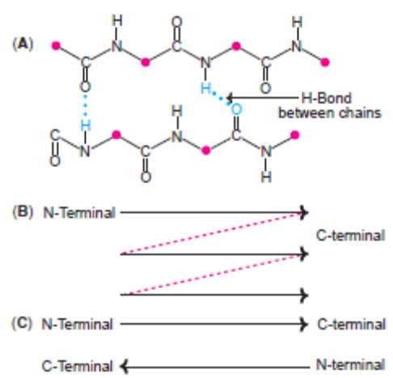

Structure of β-pleated sheet (A)Hydrogen bonds between polypeptide chains (B)Parallel β-sheet (C)Antiparallel β-sheet.

(Note : Small circles in A represent amino acid skeleton ).

Parallel and anti-parallel β-sheets
The polypeptide chains in the β-sheets may be arranged either in parallel (the same direction) or anti-parallel (opposite direction). β-Pleated sheet may be formed either by separate polypeptide chains (H-bonds are interchain) or a single polypeptide chain folding back on to itself (H-bonds are intrachain).

The α-helix and β-sheet can be found in the same protein structure. In the globular proteins, β-sheets form the core structure.

TERTIARY STRUCTURE OF PROTEIN
The three-dimensional arrangement of protein structure is referred to as tertiary structure. It is a compact structure with hydrophobic side chains held interior while the hydrophilic groups are on the surface of the protein molecule. This type of arrangement ensures stability of the molecule.
Bonds of tertiary structure : Besides the hydrogen bonds, disulfide bonds (-S-S-), ionic interactions (electrostatic bonds), hydrophobic interactions and van der Waals forces also contribute to the tertiary structure of proteins.

QUATERNARY STRUCTURE OF PROTEIN
A great majority of the proteins are composed of single polypeptide chains. Some of the proteins, however, consist of two or more polypeptides which may be identical or unrelated. Such proteins are termed as oligomers and possess quaternary structure. The individual polypeptide chains are known as monomers, protomers or subunits. A dimer consits of two polypeptides while a tetramer has four.

DENATURATION
The phenomenon of disorganization of native protein structure is known as denaturation. Denaturation results in the loss of secondary, tertiary and quaternary structure of proteins. This involves a change in physical, chemical and biological properties of protein molecules.
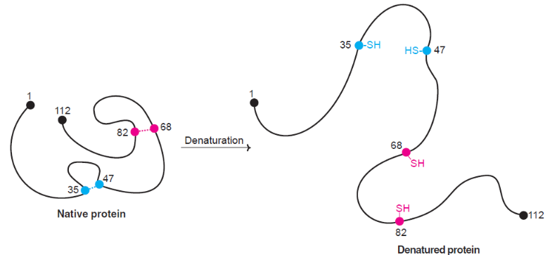
Agents of denaturation
Physical agents : Heat, violent shaking, X-rays, UV radiation.
Chemical agents : Acids, alkalies, organic solvents (ether, alcohol), salts of heavy metals (Pb, Hg), urea, salicylate, detergents (e.g. sodium dodecyl sulfate).

Characteristics of denaturation
1. The native structure of protein is lost.
2. The primary structure of a protein with peptide linkages remains intact i.e., peptide bonds are not hydrolysed.
3. The protein loses its biological activity.
4. Denatured protein becomes insoluble in the solvent in which it was originally soluble.
5 The viscosity of denatured protein (solution) increases.
6. Denaturation is associated with increase in ionizable and sulfhydryl groups of protein. This is due to loss of hydrogen and disulfide bonds.
7. Denatured protein is more easily digested. This is due to increased exposure of peptide bonds to enzymes. Cooking causes protein denaturation and, therefore, cooked food (protein) is more easily digested. Further, denaturation of dietary protein by gastric HCl enchances protein digestion by pepsin.
8. Denaturation is usually irreversible. For instance, omelet can be prepared from an egg (protein-albumin) but the reversal is not possible.
9. Careful denaturation is sometimes reversible (known as renaturation). Hemoglobin undergoes denaturation in the presence of salicylate. By removal of salicylate, hemoglobin is renatured.
10. Denatured protein cannot be crystallized.

Coagulation : Basically, coagulation is a process of addition of coagulant to destabilize a stabilized charged particle. The term ‘coagulum’ refers to a semi-solid viscous precipitate of protein. Irreversible denaturation results in coagulation. Albumins and globulins (to a lesser extent) are coagulable proteins. Heat coagulation test is commonly used to detect the presence of albumin in urine.
Casein (milk protein) can be easily precipitated when the isoelectric pH (4.6) is disturbed by dilute acetic acid.

CLASSIFICATION OF PROTEINS
Proteins are classified in several ways. Three major types of classifying proteins based on their function, chemical nature and nutritional importance are discussed here.
A. Functional classification of proteins
Based on the functions they perform, proteins are classified into the following groups 1. Structural proteins : Keratin of hair and nails, collagen of bone.
2. Enzymes or catalytic proteins : Hexokinase, pepsin.
3. Transport proteins : Hemoglobin, serum albumin.
4. Hormonal proteins : Insulin, growth hormone.
5. Contractile proteins : Actin, myosin.
6. Storage proteins : Ferritin.
7. Genetic proteins : Nucleoproteins.
8. Defense proteins : Immunoglobulins.
9. Receptor proteins for hormones, viruses.
B. Protein classification based on chemical nature
This is a more comprehensive and popular classification of proteins. It is based on the amino acid composition, structure, shape and solubility properties. Proteins are broadly classified into 3 major groups:
1. Simple proteins : They are composed of only amino acid residues.
2. Conjugated proteins : Besides the amino acids, these proteins contain a non-protein moiety known as prosthetic group or conjugating group.
3. Derived proteins : These are the denatured or degraded products of simple and conjugated proteins.
The above three classes are further subdivided into different groups.

C. Nutritional classification of proteins
The nutritive value of proteins is determined by the composition of essential amino acids. From the nutritional point of view, proteins are classified into 3 categories.
1. Complete proteins : Have all the ten essential amino acids in the required proportion by the human body to promote good growth. e.g. egg albumin, milk casein.
2. Partially incomplete proteins : Partially lack one or more essential amino acids, and can promote moderate growth. e.g. wheat and rice proteins (limiting Lys, Thr).
3. Incomplete proteins : Completely lack one or more essential amino acids. Hence they do not promote growth at all e.g. gelatin (lacks Trp), zein (lacks Trp, Lys).

