D. Targeting Apoptosis as a Therapeutic Approach in Cancer:
Programmed cell death; apoptosis is a normal physiological process which is critical for life. Its significance relies in tumor suppression, maintaining tissue homoeostasis and infection resistance. The balance between cell proliferation and death must be maintained throughout life.Apoptosis; a strictly controlled complex process at the molecular level regulated by the balance between the pro- and anti-apoptotic proteins has the liability of clearing any damaged DNA containing cells out of the body. Both, the extrinsic and intrinsic initiators of the apoptotic pathways which lead to changes of cell morphology that undergoing apoptosis.
- Morphological Features of Apoptosis
Apoptotic cells can be recognized by stereotypical morphological changes: the cell shrinks, shows deformation and looses contact to its neighboring cells. Its chromatin condenses and marginates at the nuclear membrane, the plasma membrane is blebbing or budding, and finally the cell is fragmented into compact membrane-enclosed structures, called 'apoptotic bodies' which contain cytosol, the condensed chromatin, and organelles.
The apoptotic bodies are engulfed by macrophages and thus are removed from the tissue without causing an inflammatory response. Those morphological changes are a consequence of characteristic molecular and biochemical events occurring in an apoptotic cell, most notably the activation of proteolytic enzymes which eventually mediate the cleavage of DNA into oligonucleosomal fragments.
Apoptosis is in contrast to the necrotic mode of cell-death in which case the cells suffer a major insult, resulting in a loss of membrane integrity, swelling and disrupture of the cells.
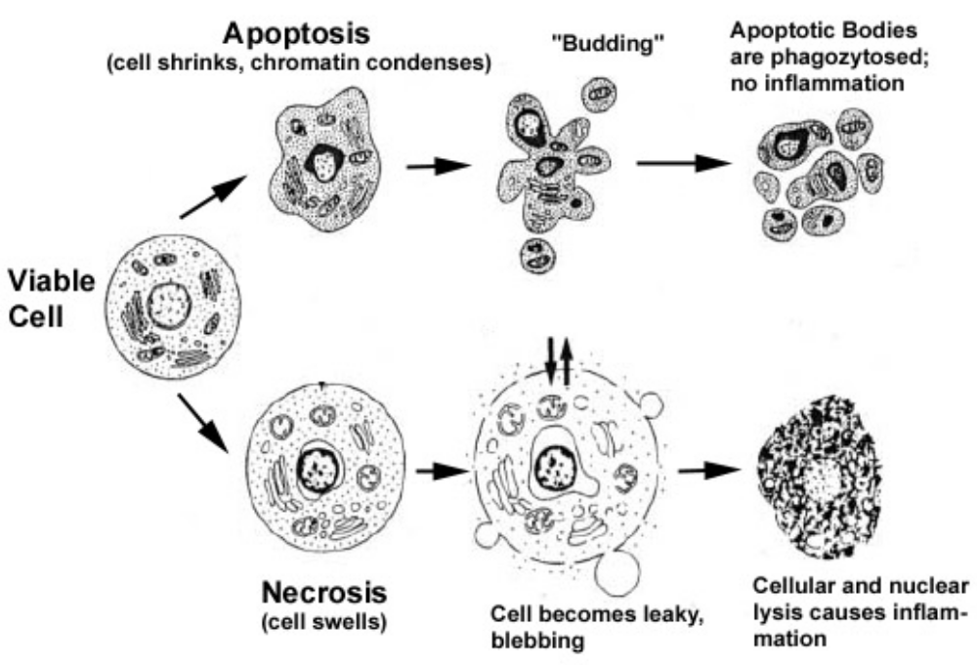

- Molecular Mechanisms of Apoptosis Signalling Pathways
- Caspases and Apoptosis
The caspases are a family of proteins that are one of the main executors of the apoptotic process. So far, 14 different members of the caspase-family have been described in mammals.
Induction of apoptosis via death receptors typically results in the activation of an initiator caspase such as caspase 8 or caspase 10. These caspases can then activate other caspases in a cascade. This cascade eventually leads to the activation of the effector caspases, such as caspase 3 and caspase 6. These caspases are responsible for the cleavage of the key cellular proteins, such as cytoskeletal proteins, that leads to the typical morphological changes observed in cells undergoing apoptosis.
Via their prodomains, the initiator caspases are recruited to and activated at death inducing signalling complexes either in response to the ligation of cell surface death receptors (extrinsic apoptosis pathways).
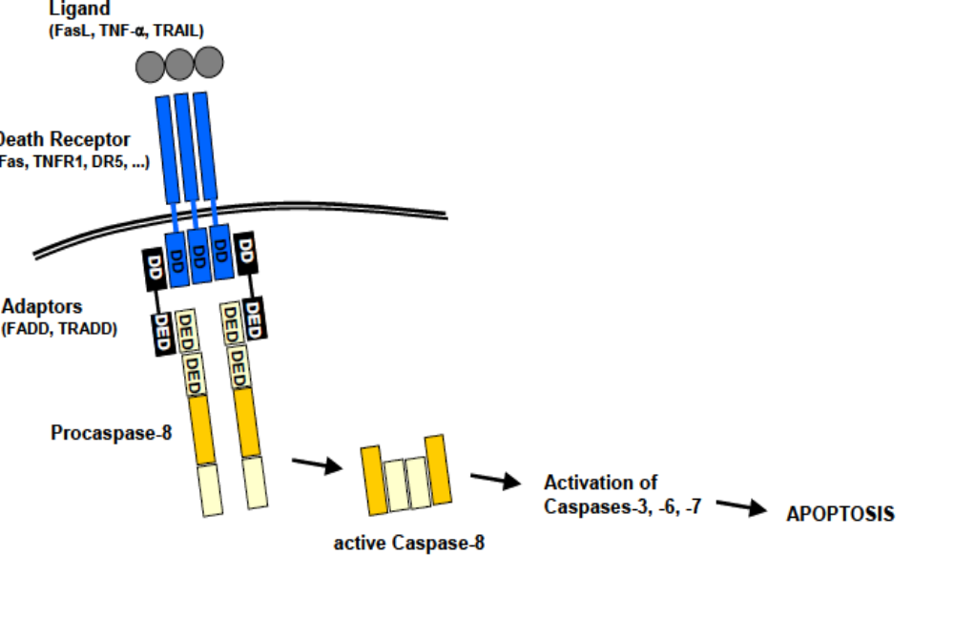

Intrinsic apoptosis pathways involve procaspase 9 which is activated downstream of mitochondrial proapoptotic events called apoptosome.
In this case it is the dimerization of procaspase 9 molecules at the Apaf-1 scaffold that is responsible for caspase 9 activation. Once the initiator caspases have been activated, they can proteolytically activate the effector procaspases 3, 6, and 7 which subsequently cleave a specific set of protein substrates, including procaspases themselves, resulting in the mediation and amplification of the death signal and eventually in the execution of cell death with all the morphological and biochemical features usually observed .


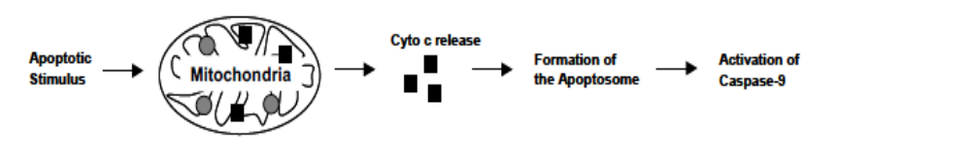

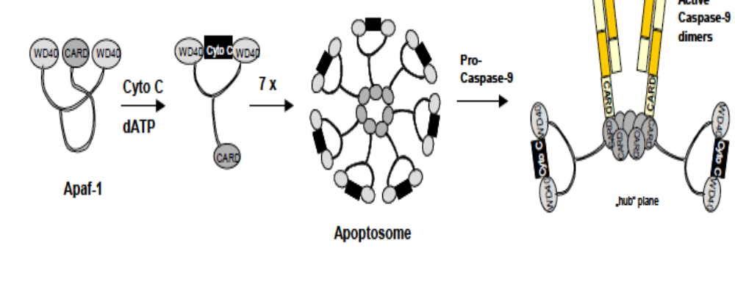

2- Extrinsic Apoptosis Pathway
Extrinsic apoptosis signalling is mediated by the activation of so called “death receptors” which are cell surface receptors that transmit apoptotic signals after ligation with specific ligands. Death receptors belong to the tumor necrosis factor receptor (TNFR) gene superfamily, including TNFR1, Fas/CD95 and the TRAIL receptors.

3- Mitochondria as Central Regulators of Intrinsic Apoptosis Pathways
Mitochondria play an important role in the regulation of cell death. They contain many pro-apoptotic proteins such as Apoptosis Inducing Factor (AIF) and cytochrome C. These factors are released from the mitochondria following the formation of a pore in the mitochondrial membrane called the Permeability Transition pore. These pores are thought to form through the action of the pro-apoptotic members of the bcl-2 family of proteins, which in turn are activated by apoptotic signals such as cell stress, DNA damage, oxidative stress, starvation as well as growth factor deprivation .
The bcl-2 proteins are a family of proteins involved in the response to apoptosis. Some of these proteins (such as bcl-2 and bcl-XL) are anti-apoptotic, while others (such as Bad, Bax or Bid) are pro-apoptotic. The sensitivity of cells to apoptotic stimuli can depend on the balance of pro- and anti-apoptotic bcl-2 proteins. When there is an excess of pro-apoptotic proteins the cells are more sensitive to apoptosis, when there is an excess of anti-apoptotic proteins the cells will tend to be more resistant. An excess of pro-apoptotic bcl-2 proteins at the surface of the mitochondria is thought to be important in the formation of the PT pore.
The pro-apoptotic bcl-2 proteins are often found in the cytosol where they act as sensors of cellular damage or stress. Following cellular stress they relocate to the surface of the mitochondria where the anti-apoptotic proteins are located. This interaction between pro- and anti-apoptotic proteins disrupts the normal function of the anti-apoptotic bcl-2 proteins and can lead to the formation of pores in the mitochondria and the release of cytochrome C and other pro-apoptotic molecules from the intermembrane space. This in turn leads to the formation of the apoptosome and the activation of the caspase cascade.
The release of cytochrome C from the mitochondria is a particularly important event in the induction of apoptosis. Once cytochrome C has been released into the cytosol it is able to interact with a protein called Apaf-1. This leads to the recruitment of pro-caspase 9 into a multi-protein complex with cytochrome C and Apaf-1 called the apoptosome. Formation of the apoptosome leads to activation of caspase 9 and the induction of apoptosis .
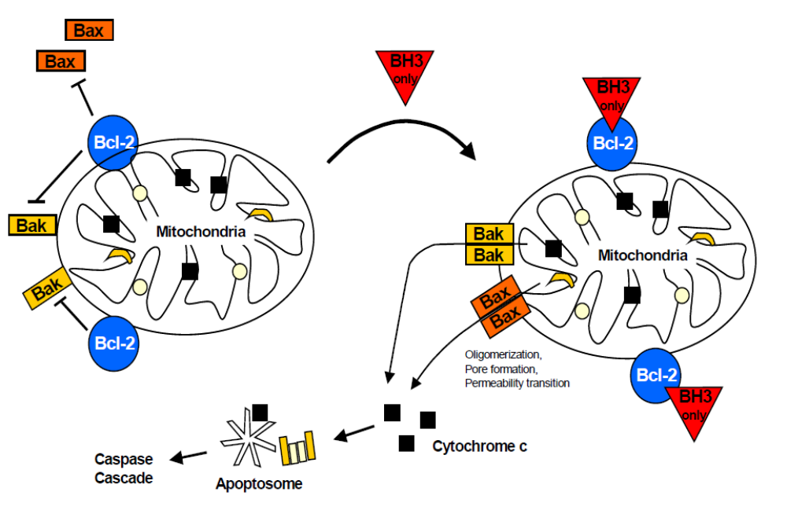
Regulation of apoptosis by the Bcl-2 family. In a viable cell, the proapoptotic Bcl-2 family members Bax, Bak, and BH3-only proteins are antagonized by antiapoptotic members such as Bcl-2.

- Therapeutic Approach of Targeting Apoptosis in Cancer
a.Targeting Bcl-2 Family:
One of the foremost vital pathways of apoptosis is mitochondria-dependent intrinsic pathway. Thus, targeting this pathway is practical approach to induce apoptosis. Bcl-2 family is the key player of the intrinsic pathways, which either promote or suppress the permeability of mitochondrial membrane as needed for the release or blocking of cytochrome-c and other apoptotic proteins. Since anti-apoptotic proteins work by inhibiting apoptosis and increasing the viability and the proliferation of the cells, it was reported in several studies that their over-expression is in correlation with tumor progression and development. Bcl-2 antisense (oblimersen sodium) is the first drug reported to target Bcl-2 pathway that entered clinical trials, Bcl-2 antisense decreased the mortality and increased the survival of chronic lymphocytic leukemia patients by increasing the sensitivity to chemotherapy drugs when both used in combination.
b.Targeting the Tumor Suppressor Gene P53:
There are multiple anticancer drugs would target p53 mediated pathways as it is an important tumor inhibitor and also proapoptotic protein that would initiate apoptosis. For decades, p53 has been known for its ability to initiate DNA repair by increasing the expression of specific target genes through binding to their regulatory sequences. It is primary goal to repair damaged DNA, but if DNA is extensively damaged, cell cycle arrest or apoptosis will occur due to the activation of p53.
P53 function is essential to inhibit tumorgenesis. Thus, many new anti-cancer strategies target the stimulation or the refolding of the mutant p53 pathway to induce cell death. Also, aiming its target gene products, such as the pro-apoptotic Bax protein, which show ability to mediate apoptosis, inhibit Bcl-2 expression and initiate the intrinsic apoptotic pathway. P53 mutation and inactivation is observed in different tumor tissue, cells biopsies and cell lines which represent a relation between p53 mutation and tumor progression. Based on a recent study investigated the use of CRISPER/Cas system to restore the TP53 in tumor cells by completely replacing the mut-p53 with the functional copy in the human genome showed promising results in induction of cell suicide and apoptosis.
- Targeting the Extrinsic Cell Death:
Pro-apoptotic membrane receptors; death domain (DD)-containing receptors present on the cell surface such as DR4 and DR5 binds to specific pro-apoptotic ligands such as TNF related apoptosis-inducing ligand (Apo2L/ TRAIL) in order to initiate and activate the extrinsic apoptotic pathway.
Utilizing the natural ligands that selectively activate pro-apoptotic receptors such as DR4 and DR5 has been applied in the market. It has developed various monoclonal antibodies that also act on pro-apoptotic receptors such as the fully human DR5 agonistic antibody Apomab and Recombinant human TRAIL (rhTRAIL); which known as dulanermin is TRAIL receptor agonist that showed promising activity in apoptosis induction in cancer cells.
- Targeting miRNA to Induce Apoptosis:
They are non-coding short RNAs of 18–25 nucleotides in length. They were found to govern gene expression at post-transcriptional level, either by degradation of mRNA or stop the translation process. miRNAs contribute in multiple cellular functions, such as cell cycle regulation, cell differentiation, stem cell self-renewal and apoptosis. Furthermore, it was reported that the decreased expression of miRNA causes eradication of apoptosis, which lead to carcinogenesis and resistance to the therapy. Therefore, restoring miRNA levels especially those esponsible for apoptosis signaling could be a promising approach for developing effective treatment against tumorgenesis.
Astrategy is to introduce miRNA mimic; synthetic double stranded RNA aimed to imitate the endogenous miRNAs as tumour-suppressor genes has been found to induce apoptotic pathways. Several studies documented the beneficial effect of transfection tumor suppressive miRNAs such as anti-miR-24 oligonucleotides to inhibit proliferation and initiate cell suicide.

