E. Therapeutic Applications of Stem Cells
The term ‘stem cell’ encompasses a broad spectrum of cells, which can be derived from embryonic tissues, adult tissues, or generated by reprogramming differentiated cells. These cells, applied across numerous medical disciplines including cardiovascular, neurological, and hematological disorders, as well as wound healing, demonstrate varying therapeutic applications based on their differentiation capacities, each presenting unique advantages and limitations.Stem cells have recently gained prominence as a promising therapeutic approach.
These unspecialized cells possess the remarkable ability to differentiate into any specific cell type within an organism. This characteristic enables them to self-renew and be utilized in the treatment of various diseases.

- Classification of Stem Cells
Stem cells are categorized based on their differentiation potential, ranging from highest to lowest potency, as totipotent, pluripotent, multipotent, oligopotent, and unipotent .
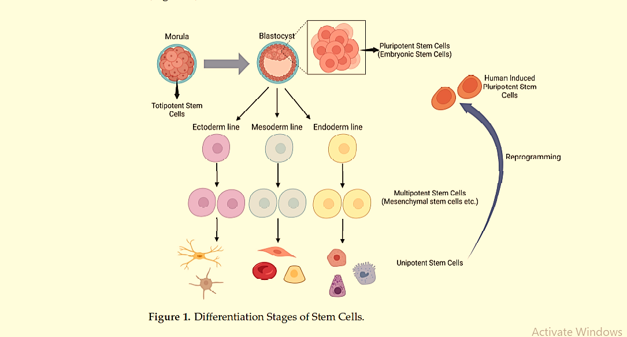

1. Totipotent Stem Cells:
Totipotent cells represent the stem cells with the highest differentiation potential, capable of giving rise to both the embryo and extra-embryonic structures. A prime example of a totipotent cell is the zygote, which forms immediately following fertilization.

2. Pluripotent Stem Cells:
During the blastocyst stage, two distinct cell groups are present: the trophectoderm and the inner cell mass. The trophectoderm develops into the placenta, while the stem cells within the inner cell mass, which are pluripotent, form the fetus. Pluripotent stem cells have the ability to differentiate into endoderm, ectoderm and mesoderm cells. Unlike totipotent stem cells, these pluripotent cells do not give rise to extraembryonic structures .Embryonic stem cells are derived from the pluripotent cells of the inner cell mass.

3. Multipotent Stem Cells:
Pluripotent cells differentiate into multipotent stem cells following the formation of germ layers. The differentiation capacity of multipotent stem cells is more restricted compared to pluripotent stem cells, as they can only generate cell types within their specific germ layer. Hematopoietic stem cells and mesenchymal stem cells serve as examples of it.

4. Oligopotent Stem Cells:
Multipotent cells further differentiate into oligopotent cells. As the name implies, oligopotent cells have a more restricted differentiation capacity, capable of developing into only a few cell types. Myeloid progenitor cells are an example of oligopotent cells
.
5.Unipotent Stem Cells:
Unipotent stem cells can differentiate into a single specific cell type, possessing the most limited differentiation capacity. However, their ability to repeatedly divide underscores their potential use in regenerative medicine.
6. Induced Pluripotent Stem Cells:
Differentiated cells can be reprogrammed to generate pluripotent stem cells, known as induced pluripotent stem cells. These cells possess properties similar to embryonic stem cells and are used in drug development, disease modeling, and regenerative therapy.
Table 1 presents a comparison of various developmental stages of stem cells.
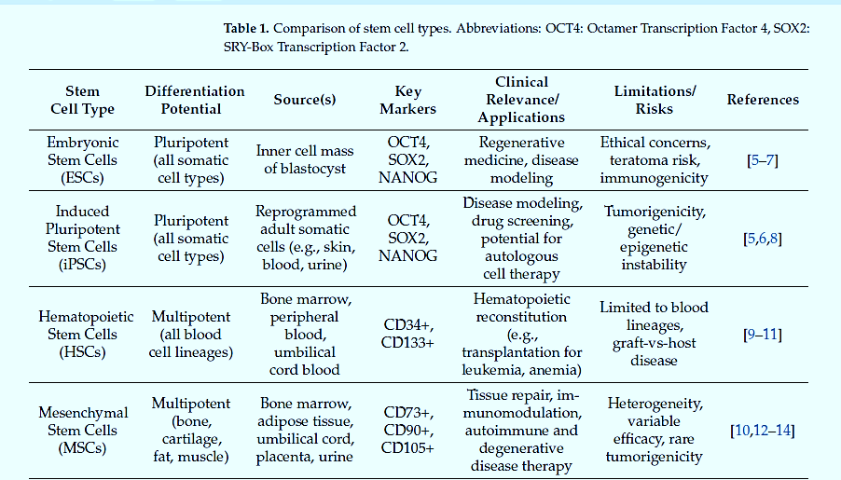

- Therapeutic Applications of Stem Cells-Oncology
Cancer remains one of the leading causes of mortality worldwide. Despite advances in chemotherapy, radiotherapy, and immunotherapy, challenges like systemic toxicity, tumor resistance, and limited drug penetration hinder treatment efficacy. Stem cell-based therapies can address these limitations through their tumor-homing capabilities and ability to deliver therapeutic agents directly to tumor sites.

1. Induction of Tumor Cell Apoptosis:
A major strategy involves engineering MSCs to express pro-apoptotic ligands such as Tumor Necrosis Factor-Related Apoptosis-Inducing Ligand (TRAIL) or FasL, which selectively trigger cell death in malignant cells. MSCs, adipose- and iPSC-derived MSCs expressing TRAIL showed tumor suppression across models of squamous cell, cervical, lung, and glioma cancers.

2. Stem Cell-Derived Exosomes as Anti-Tumor Agents:
Modified stem cells can release exosomes- extracellular vesicles carrying bioactive molecules that shape the tumor microenvironment. MSC-derived exosomes loaded with microRNAs have enhanced chemosensitivity and immune response. In hepatocellular carcinoma, exosomes carrying miR-374c-5p suppressed epithelial–mesenchymal transition.

3. Immunomodulation of Tumor Microenvironment:
Solid tumors often evade immunity through immunosuppressive microenvironments.Genetically engineered stem cells can reverse this by delivering immune-activating cytokines. For example, MSCs expressing interferon-alpha increased T cell infiltration and synergized with checkpoint inhibitors. A phase I clinical trial in ovarian cancer, intraperitoneally delivered IFN-β-secreting MSCs activated immune responses without infusion-related toxicity, while IL-7/IL-12-expressing MSCs enhanced T cell responses in solid tumor models.

F- Gene therapy
Gene therapy is an innovative treatment approach that uses genes or short DNA sequences as therapeutic agents instead of traditional drugs. It targets and treats defective genes responsible for diseases by introducing foreign DNA into the body using a "vector," which enables cells to express therapeutic proteins with minimal toxicity.
The first FDA-approved gene therapy trial was conducted in 1990 on a patient with ADA-SCID (Ashanti DeSilva). Since then, around 1,700 clinical trials have explored gene therapy for various conditions, including ADA-SCID, X-linked SCID, Parkinson’s disease, multiple myeloma and leukemia. Though many trials showed promising results, most therapies are still not FDA-approved
Types of gene therapy:
There are several approaches for correcting faulty genes; the most common being the insertion of a normal gene into a specific location within the genome to replace a non-functional gene. Gene therapy is classified into the following two types:
- Somatic gene therapy: In somatic gene therapy, the somatic cells of a patient are targeted for foreign gene transfer. In this case the effects caused by the foreign gene is restricted to the individual patient only, and not inherited by the patient's offspring or later generations.
- Germ Line Gene Therapy here, the functional genes, which are to be integrated into the genomes, are inserted in the germ cells, i.e., sperm or eggs. Targeting of germ cells makes the therapy heritable.

Gene Therapy Strategies:
- Targeted Inhibition of Gene Expression
This is to block the expression of any diseased gene or a new gene expressing a protein which is harmful for a cell. This is particularly suitable for treating infectious diseases and some cancers.
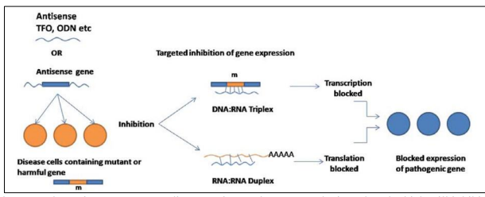
Figure 2: The antisense mRNA coding gene inserted vector can be introduced which will inhibit the gene expression either by forming DNA: RNA triplex inside the nucleus or forming RNA: RNA duplex by forming complementary mRNA strand of disease protein coding mRNA. This may lead to blocking of disease causing protein expression.
- Targeted Gene Mutation
Correction It is used to correct a defective gene to restore its function which can be done at genetic level by homologous recombination or at mRNA level by using therapeutic ribozymes or therapeutic RNA editing
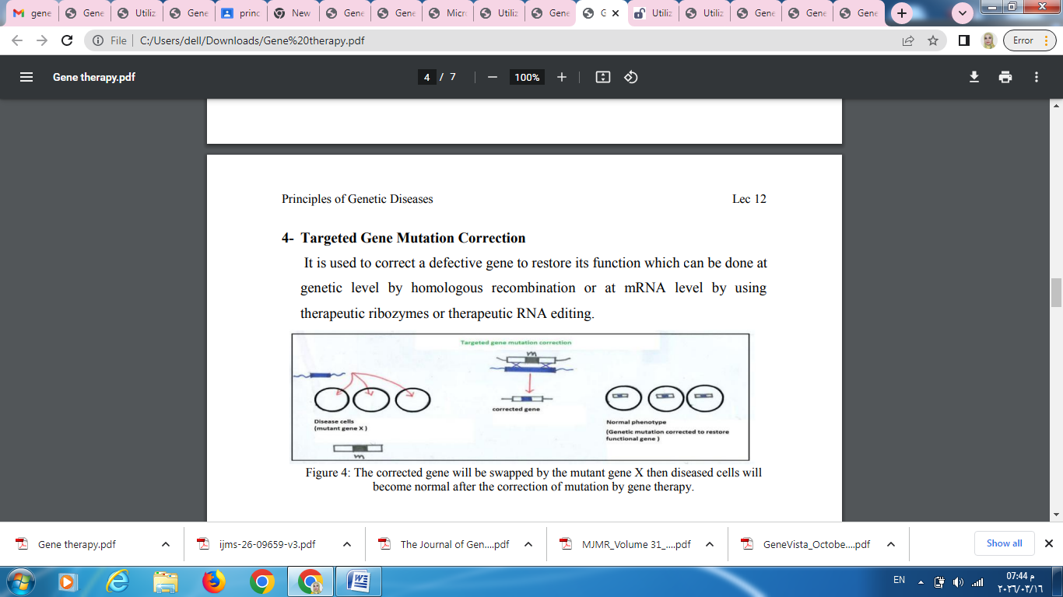
Figure 3: The corrected gene will be swapped by the mutant gene X then diseased cells will become normal after the correction of mutation by gene therapy.

Methods of gene therapy:
There are mainly two approaches for the transfer of genes in gene therapy:
1- EX vivo gene therapy
• In this mode of gene therapy genes are transferred to the cells grown in culture, transformed cells are selected, multiplied and then introduced into the patient.
• The use of autologous cells avoids immune system rejection of the introduced cells.
• The cells are sourced initially from the patient to be treated and grown in culture before being reintroduced into the same individual.
• This approach can be applied to the tissues like hematopoietic cells and skin cells which can be removed from the body.

2- In Vivo Gene Therapy
• In vivo method of gene transfer involves the transfer of cloned genes directly into the tissues of the patient.
• This is done in case of tissues whose individual cells cannot be cultured in vitro in sufficient numbers (like brain cells) and/or where re-implantation of the cultured cells in the patient is not efficient.
• Liposomes and certain viral vectors are employed for this purpose because of lack of any other mode of selection.
• The efficiency of gene transfers and expression determines the success of this approach.

Vectors for Gene Therapy:
1- Viral Vectors Viruses are modified to remove their disease-causing ability and used to deliver therapeutic genes. The below table show the types of viral vectors:

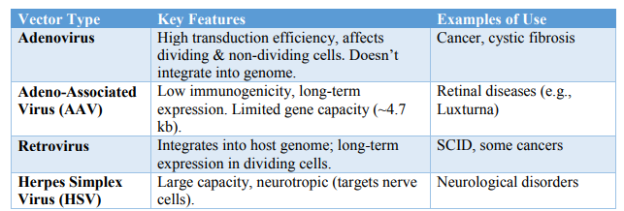
2- Non-Viral Vectors
These are synthetic or natural compounds used to transfer genes without using viruses. For example:

