

.

**College of Pharmacy – Baghdad University –**

**Department of Clinical Pharmacy**

**Manual of Surgery**

**خاص بتدريب طلبة كلية الصيدلة \ المرحلة الخامسة \ ردهة الجراحية**

**- : أعداد**

**فرع الصيدلة السريرية**

**2022**

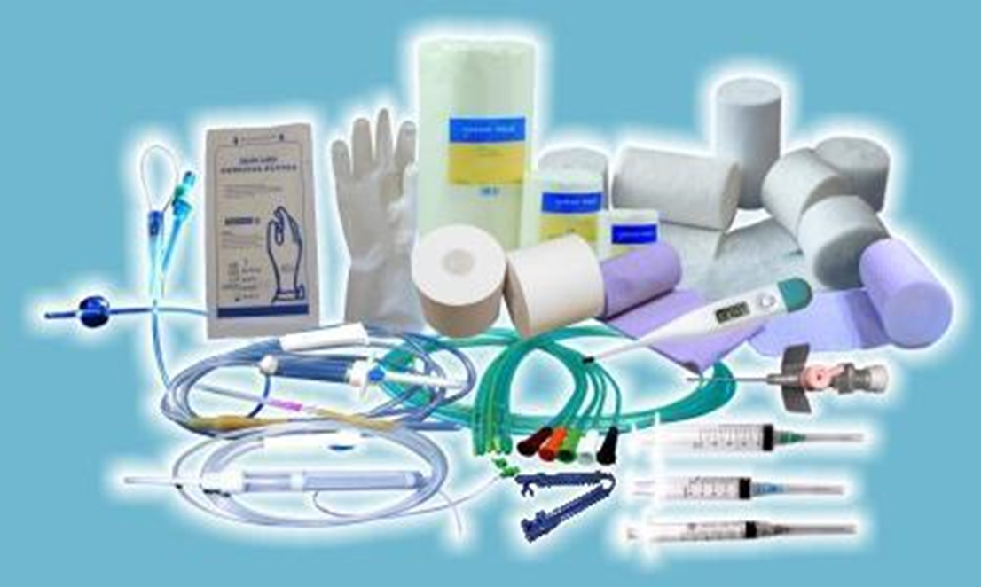

**1-1: Language of Surgery (1)**

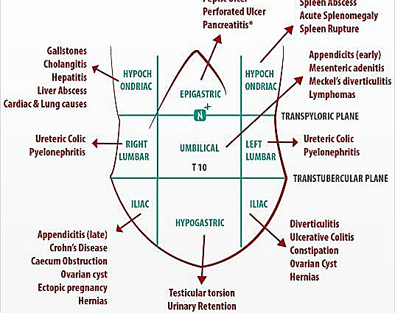

**Abdominal area**

1 **Right upper quadrant (RUQ) or hypochondrium**2 Epigastrium  
3 **Left upper quadrant (LUQ) or hypochondrium**4 **Right flank (merges posteriorly with right loin)**5 **Periumbilical or central area**6 **Left flank (merges posteriorly with left loin)**7 **Right iliac fossa (RIF)**8 **Suprapubic area**9 **Left iliac fossa (LIF)**

|  |  |
| --- | --- |
| **-ectomy** | **Cutting something out.** |
| **-gram** | **A radiological image.** |
| **-pexy** | **Anchoring of a structure to keep it in position.** |
| **-plasty** | **Surgical refashioning in order to regain good function** **/cosmesis.** |
| **-scopy** | **Procedure with instrumentation for looking into the body.** |
| **-stomy** | **An artificial union between a conduit and the outside world or another conduit.** |
| **-tomy** | **Cutting something open to the outside world.** |
| **-tripsy** | **Fragmentation of an object.** |

|  |  |  |  |
| --- | --- | --- | --- |
| **epi-** | **Upon** | **Per-** | **Going through** |
| **End-** | **Inside** | **peri-** | **Around** |
| **mega-** | **Enlarged** | **Sub-** | **Beneath** |
| **Pan-** | **Whole** | **trans-** | **Across** |
| **para-** | **Alongside** |  |  |

|  |  |
| --- | --- |
| **abscess** | **A cavity containing pus. Remember: *if there is pus about, let it out*.** |
| **cyst** | **Fluid-filled cavity lined by epi/endothelium.** |
| **fistula** | **An abnormal connection between two epithelial surfaces. Fistulae often close**  **spontaneously, but will not do so in the presence of malignant tissue, distal obstruction, foreign bodies, chronic inflammation, and the formation of a muco- cutaneous junction (eg stoma).** |
| **hernia** | **The protrusion of a viscus/part of a viscus through a defect of the wall of its containing cavity into an abnormal position.** |
| **colic** | **Intermittent pain from over-contraction/obstruction of a hollow viscus.** |
| **ileus** | **Used in this book as a term for adynamic bowel.** |
| **sinus** | **A blind-ending tract, typically lined by epithelial or granulation tissue, which opens to**  **an epithelial surface.** |
| **stent** | **An artificial tube placed in a biological tube to keep it open.** |
| **stoma** | **An artificial union between conduits or a conduit and the outside.** |
| **ulcer** | **Interruption in the continuity of an epi/endothelial surface.** |
| **volvulus** | **Twisting of a structure around itself. Common GI sites include the sigmoid colon and**  **caecum, and more rarely the stomach.** |

|  |  |  |  |
| --- | --- | --- | --- |
| **angio-** | **Tube or vessel** | **lith-** | **Stone** |
| **appendic-** | **Appendix** | **mast/mammo** | **Breast** |
| **chole-** | **Relating to gall/bile** | **meso-** | **Mesentery** |
| **colp-** | **Vagina** | **Nephr-** | **Kidney** |
| **cyst-** | **Bladder/fluid-filled sac** | **Orchid-** | **Testicle** |
| **-doch-** | **Ducts** | **oophor-** | **Ovary** |
| **enter-** | **Small bowel** | **Phren-** | **Diaphragm** |
| **eschar-** | **Dead tissue, eg from burn** | **pyloromy-** | **Pyloric sphincter** |
| **gastr-** | **Stomach** | **pyel-** | **Renal pelvis** |
| **hepat-** | **Liver** | **proct-** | **Anal canal** |
| **Hyster-** | **Uterus** | **salping-** | **Fallopian tube** |
| **lapar-** | **Abdomen** | **splen-** | **Spleen** |
|  |  | **thoraco-** | **Chest** |

**References:**

**1-Longmore, Murray; Wilkinson, Ian B; Baldwin, Andrew: Wallin, Elizabeth. Oxford Handbook of**

**Clinical Medicine, 9th Edition. Copyright 2014 © Oxford University Press.**

**1-2: Surgical Prophylaxis**

**Definition**

Antibiotics administered before contamination of previously sterile tissues or fluids are considered prophylactic. The goal of prophylactic antibiotics is to prevent an infection from developing (1).

**Common surgical pathogens**

**\***The predominant organisms causing SSIs after clean procedures are skin flora, including S. aureus

and coagulase-negative staphylococci (e.g., Staphylococcus epidermidis)

*In clean-contaminated procedures, including abdominal procedures and heart, kidney, and liver transplantations, the predominant organisms include gram negative rods and enterococci in addition to skin flora (6)

**Antimicrobial selection**

• The choice of the prophylactic antimicrobial depends on the type of surgical procedure, most likely pathogenic organisms, safety and efficacy of the antimicrobial, current literature evidence supporting its use and cost.

• Typically, gram-positive coverage is included in the choice of surgical prophylaxis because organisms such as *S. aureus* and *S. epidermidis* are common skin flora.  
• Parenteral antibiotic administration is favored because of its reliability in achieving suitable tissue concentrations.  
• First-generation cephalosporins (particularly cefazolin) are the preferred choice.

Antianaerobic cephalosporins (eg, cefoxitin or cefotetan) are appropriate choices when broad-spectrum anaerobic and gram negative coverage is desired.  
• Vancomycin may be considered for prophylactic therapy in surgical procedures involving implantation of a prosthetic device in which the rate of methicillin-resistant *S. aureus* (MRSA) is high. If the risk of MRSA is low and a β-lactam hypersensitivity exists, clindamycin can be used instead of cefazolin in order to limit vancomycin use. Current literature evidence supporting its use and cost (1).

**1-3: Types of Surgical Operations**

Surgical operations are classified as clean, clean -contaminated, contaminated, or dirty.

Antimicrobial prophylaxis is appropriate for clean, clean-contaminated, and contaminated operations. (3). (Table 1).

|  |  |  |  |
| --- | --- | --- | --- |
| **Table -1. Wound Classification, Risk of SSIb, and Indication for Antibiotics (1,3,6)** | | | |
| **Classification** | **Description** | **SSI**  **risk** | **Antibiotics** |
| **Clean** | An uninfected operative wound in which  no inflammation is encountered and the respiratory, alimentary, genital, or uninfected urinary tracts are not entereddrainage. | **Low** | **Not indicated**  **unless high- risk procedure** |
| **Clean-**  **contaminated** | Operative wounds in which the  respiratory, alimentary, genital, or urinary tracts are entered under controlled conditions and without unusual contamination. Specifically, operations involving the biliary tract, appendix, vagina, and oropharynx are included in this category. | **Medim** | **Prophylactic**  **antibiotics indicated** |
| **Contaminated** | Open, fresh, accidental wounds. In  addition, operations with major breaks in sterile technique (e.g., open cardiac massage) Technique break during clean- contaminated. procedure. | **High** | **Prophylactic**  **antibiotics indicated** |
| **Dirty** | Obvious preexisting infection present  (abscess, pus, or necrotic tissue present). |  | **Therapeutic**  **antibiotics required** |

**Principles of Antimicrobial Prophylaxis**

**1-Route of Administration**

Intravenous administration is preferred because it produces a more reliable and predictable serum and tissue concentration than intramuscular administration (4), with the exception of ophthalmic surgery where topical administration is the preferred route. Serum antibiotic levels after oral administration depend on the rate of absorption from the gastrointestinal tract which varies between individuals and is therefore not reliable (7).

But oral administration is used in some bowel operations. Non-absorbable compounds like erythromycin base and neomycin are given up to 24 hours prior to surgery to reduce microbial concentrations in the bowel. Note that oral agents are used adjunctively and do not replace IV agents (3).

**2-Timing of First Dose**

Most guidelines recommend administration of the antibiotic within 60 minutes of skin incision Administration times closer to incision may possibly decrease the risk of SSI for certain procedures.

Exceptions to this guideline are made for the fluoroquinolones and glycopeptides (e.g. vancomycin) which should be started 120 minutes before skin incision due to the need to administer them as an infusion over one to two hours (7), and also to avoid infusion-related reactions. Beginning the infusion after the first incision is of little value in preventing SSI (3).

**3-Dosing and Redosing**

The goal of antimicrobial dosing for surgical prophylaxis is to maintain antibiotic concentrations above the MIC of suspected organisms for the duration of the operation (3).

If an operation exceeds two half-lives of the selected antimicrobial, then another dose should be administered. Repeat dosing has been shown to lower rates of SSI.

**4-Duration**

The National Surgical Infection Prevention Project and published evidence suggest that the continuation of antimicrobial prophylaxis beyond wound closure is unnecessary. The duration of antimicrobial prophylaxis should not exceed 24 hours (24-48 hours for cardiothoracic surgery) (3)(7).

**Combination antimicrobial therapy**• Combinations of antimicrobials are generally used to broaden the spectrum of coverage for empiric therapy, achieve synergistic activity against the infecting organism, and prevent the emergence of resistance.

**Disadvantages of Combination Therapy**• including increased cost, greater risk of drug toxicity, and superinfection with even more resistant bacteria (3).

**References:**

**1- Joseph T. DiPiro, Robert L. Talbert. Pharmacotherapy: A Pathophysiologic Approach, Tenth Edition. Copyright © 2016.**

**2- Joseph T. DiPiro, Robert L. Pharmacotherapy: A Pathophysiologic Approach, Sixth Edition. Copyright 2005, by The McGraw-Hill Companies, Inc.**

**3-Marie A. Chisholm-Burns, Terry L. Schwinghammer, Barbara G. Wells, Patrick M. Malone, Joseph T. DiPiro. Pharmacotherapy principles and practice, Fourth Edition. Copyright © 2016**

**4- Mohamed H. Rahman and James Anson. Peri-operative antibacterial prophylaxis. Pharmaceutical Journal .12 June 2004 The (Vol 272): 743 -745.**

**5- Longmore, Murray; Wilkinson, Ian B; Baldwin, Andrew: Wallin, Elizabeth. Oxford Handbook of**

**Clinical Medicine, 9th Edition. Copyright 2014 © Oxford University Press.**

**6- Re/Dale W. Bratzler, e. Patchen Dellinger, Keith M. Olsen, trish M. Perl. Clinical practice guidelines for antimicrobial prophylaxis in surgery. Am J Health-Syst Pharm. 2013; 70:195-283.**

**7-** **Jocum, J. "Surgical antibiotic prophylaxis: Are you doing it right?." *Southern African Journal of Anaesthesia and Analgesia* (2018): S49-S53.‏**

**TABLE 2. Most Likely Pathogens and Specific Recommendations for Surgical Prophylaxis (2) .** للاطلاع

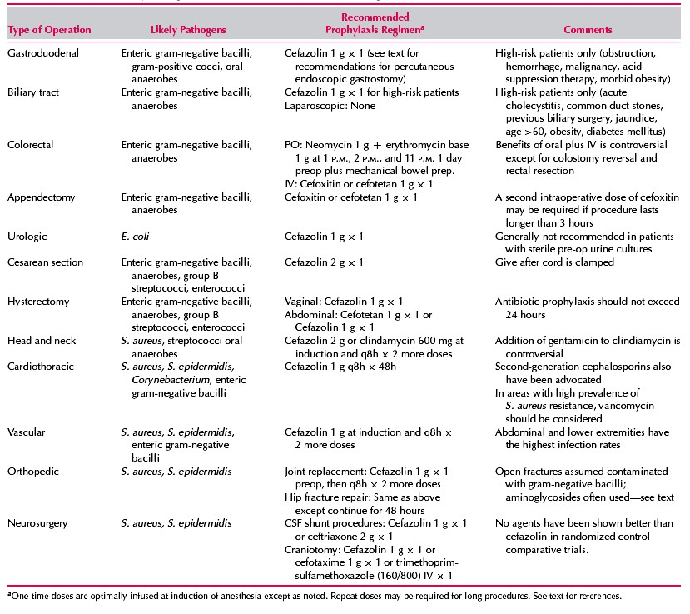

**1-4: Thromboprophylaxis**

Deep venous thrombosis (DVT) is most common in patients over 40 years of age who undergo major surgery. **A postoperative increase in platelets** coupled with **venous endothelial trauma and stasis** all contribute. If no prophylaxis is given, 30% of these patients will develop DVT and 0.1-0.2% will die from pulmonary thromboembolism (PTE) (1).

**Types of thromboprophylaxis (1).**

**1-Mechanical devices: Thromboembolic deterrent stockings (TEDS).**

**2-Drugs acting on the clotting cascade: Heparin and Low molecular weight heparin (LMWH).**

**Regimen**

**heparin** 5000U SC 2h pre-op, then every 8-12h SC for 7d or until ambulant. **Low molecular weight**

**heparin** (**LMWH, eg enoxaparin**20mg/24h SC, increased to 40mg for high-risk patients, starting 12h pre-op) (2).

**Fondaparinux**(a factor Xa inhibitor) reduces risk of DVT over LMWH without increasing the risk of bleeding. (2).

**Risk groups (1)**

All patients are -at risk of developing deep vein thrombosis just as is the general population. National requirements for VTE prophylaxis require all patients to be assessed for risk factors on admission and after 24h in hospital. Risk is judged according to:

**• Procedure factors.** Prolonged anesthetic time, lower limb or pelvic surgery.  
**• Patient factors.** Immobility, malignancy, age, dehydration, obesity, diabetes, cardiorespiratory disease, inflammatory pathologies, oral contraceptive pill or hormone replacement therapy (HRT), past or family history of thromboembolic disease.

Balanced against:

• **Bleeding risks.** Active bleeding, stroke, invasive procedures, bleeding disorders (liver disease, thrombocytopenia, inherited disorders).

**• Risks of compression devices.** Peripheral vascular disease (PVD).

**References:**

**1-McLatchie, Greg; Borley, Neil; Chikwe, Joanna. Oxford Handbook of Clinical Surgery, 4th Edition.**

**Copyright 2014 © Oxford University Pres*s*.**

**2-Longmore, Murray; Wilkinson, Ian B; Baldwin, Andrew: Wallin, Elizabeth. Oxford Handbook of Clinical Medicine, 9th Edition. Copyright 2014 © Oxford University Press.**

**1-6: Preoperative bowel preparation**

**A-Elective colon operation:**

The human colon and distal small intestine contain a numerous reservoir of aerobic and anaerobic

bacteria that are excluded from the body by a mucous membrane barrier, if this barrier is disturbed by disease, trauma, or if the colon is opened to the peritoneal cavity during operation, bacteria may escape into adjacent tissues and causes serious infection, this risk can be minimized by two ways:

**1-Mechanical preparation:** This is done by one or both of the following procedures:

**A-**Whole gut lavage with an electrolyte solution, mannitol 10%, or poly ethylene glycol the day before surgery.

**B-**Standard mechanical cleansing, which utilizes dietary restriction, catheters, and sometimes enemas

1- 2 days before the operation.

**2-Antibiotic preparation:**

Either oral or parenteral antibiotic

**Two oral regimens** are now used**:**

**A- An aminoglycoside with erythromycin base.**

**B- An aminoglycoside with metronidazole.**

**Parenteral regimen**

**That is now used is cefoxitin IV before induction of anesthesia.**

**Combination of parenteral and oral antibiotics show low incidence of infection.**

**B-Emergency colon preparation:**

The following is recommended:

1-Intraoperative lavage performed by introducing of saline in the colon through balloon catheter.

2-Parenteral antibiotic, they should be given IV shortly before operation and continues for 1-7 days postoperatively.

**1-7: Intravenous fluid therapy**

**Intravenous fluids**

Are given if sufficient fluids cannot be given orally. About 2500mL fluid containing roughly 100mmol Na+ and 70mmol K+ per 24h are required.

**Special cases**

**Acute blood loss**Resuscitate with colloid or 0.9% saline via large-bore cannulae until blood is available.  
**Children**Use dextrose-saline for fluid maintenance: 100mL/kg for the first 10kg, 50mL/kg for the next 10kg, and 20mL/kg there after—all per 24h.  
**Elderly**More prone to fluid overload, so use IV fluids with care.  
**GI losses**(diarrhoea, vomiting, NG tubes, etc) Replace lost K+ as well as lost fluid volume.  
**Heart failure**Use IV fluids with care to avoid fluid overload.  
**Liver failure**Patients often have a raised total body sodium, so use salt-poor albumin or blood for resuscitation, and avoid 0.9% saline for maintenance.  
**Acute pancreatitis**Aggressive fluid resuscitation is required due to large amounts of sequestered ‘third space’ fluid.  
**Poor urine output**Aim for >1 mL/kg/h; the minimum is >0.5mL/kg/h. Give a fluid  
challenge, eg 500mL 0.9% saline over 1h (or half this volume in heart failure or the elderly), and recheck the urine output. If not catheterized, exclude retention; if catheterized, ensure the catheter is not blocked!  
**Post-operative**Check the operation notes for intraoperative losses, and ensure you chart and replace added losses from drains, etc.  
**Shock**Resuscitate with colloid or 0.9% saline via large-bore cannulae. Identify the type of shock. **Transpiration losses**(fever, burns) Beware the large amounts of fluid that can be lost unseen through transpiration. Severe burns in particular may require aggressive fluid resuscitation (1).

**Types of fluid according to isotonicity**

**A- Isotonic:** Isotonic crystalloids have a tonicity equal to the body plasma. When administered to a normally hydrated patient, isotonic crystalloids do not cause a significant shift of water between the blood vessels and the cells. Thus, there is no (or minimal) osmosis occurring (4).

**B-Hypertonic:** crystalloids have a tonicity higher than the body plasma. The administration of a hypertonic crystalloid causes water to shift from the extravascular spaces into the bloodstream, increasing the intravascular volume.

**C-Hypotonic:** crystalloids have a tonicity lower than the body plasma. The administration of a hypotonic crystalloid causes water to shift from the intravascular space to the extravascular space, and eventually into the tissue cells. Because the IV solution being administered is hypotonic, it creates an environment where the extravascular spaces have higher concentrations of electrolytes (4).

**Types of IV fluid**

**A-Crystalloids:** Crystalloids are composed of water and electrolytes(3).

**1- 5% glucose**

(=dextrose) is isotonic, but contains only a small amount of glucose (50g/L) and so provides little energy (~10% daily energy per litre). The liver rapidly metabolizes all the glucose leaving only water, which rapidly equilibrates throughout all fluid compartments. It is, therefore, useless for fluid resuscitation (only 1/9 will remain in the intravascular space), but suitable for maintaining hydration. Excess 5% glucose IV may lead to water overload and hyponatraemia (1).

**2- Hypertonic glucose (10% or 50%)**

may be used in the treatment of hypoglycaemia. It is irritant to veins, so care in its use is needed. Infusion sites should be inspected regularly, and flushed with 0.9% saline after use (3).

**3- 0.9% saline (normal saline)**

has about the same Na+ content as plasma (150mmol/L) and is isotonic with plasma. 0.9% saline will equilibrate rapidly throughout the extracellular compartment only, and takes longer to reach the intracellular compartment than 5% glucose. It is, therefore, appropriate for fluid resuscitation, as it will remain predominantly in the extracellular space (and thus ⅓ of the given volume in the intravascular space), as well as for maintaining hydration (1).

**4- Half-Normal Saline (0.45% NaCl or ½ NS)**Half-normal saline is a hypotonic fluid that provides free water in relative excess when compared with the sodium concentration. This crystalloid is typically used to treat patients who are hypertonic due to primary depletion of the ECF. Because half normal saline is hypotonic, serum sodium must be closely monitored during administration (3).

**5- Hypertonic Saline (3% NaCl)**Hypertonic saline is obviously hypertonic and provides a significant sodium load to the intravascular space. This solution is used very infrequently given the potential to cause significant shifts in the water balance between the ECF and the ICF. It is typically used to treat patients with severe hyponatremia who have symptoms attributable to low serum sodium (3).

**6- 5% Dextrose/Half-Normal Saline (D5 ½ NS)**

D5 ½ NS is a hypotonic fluid that is commonly used as a maintenance fluid. This crystalloid is typically used once fluids deficits have been corrected with normal saline or lactated Ringer’s solution. Because half-normal saline is hypotonic, serum sodium must be closely monitored during administration (3).

**7- Dextrose-saline (one-fifth normal saline)**

is isotonic, containing 0.18% saline and 4% glucose . It has roughly the quantity of Na+ required for normal fluid maintenance, when given 10-hourly in adults, but is now most commonly used in a pediatric setting (1).

**Intravenous 0.18% saline/4% glucose solution (‘hypotonic saline’regarding to sodium content) in children: reports of fatal hyponatraemia – do not use in children aged 16 years or less, except in specialist settings under expert medical supervision such as renal, cardiac, liver, high dependency and intensive care units.(5)**

**8- Hartmann's solution**

contains Na+ 131mmol, Cl– 111mmol, lactate 29mmol, K+ 5mmol, HCO3– 29mmol, and Ca2+ 2mmol per litre of fluid. It is an alternative to 0.9% saline, and some consider it more physiological (1).

**9-Ringer's lactate solution**

technically the closest fluid to serum composition although theoretical advantages are of limited practical value (2). Lactated Ringer's solution is often used for fluid resuscitation after a blood loss due to trauma, surgery, or a burn injury. [4] It has been used to induce urine output in patients with renal failure (4)**.**

Lactated Ringer's solution is used because the by-products of lactate metabolism in the liver counteract acidosis, which is a chemical imbalance that occurs with acute fluid loss or renal failure [4]. Lactated Ringer's solution should also not be used in patients with a pH level above 7.5 (alkalosis) and in anuria or renal failure due to accumulation of K (4)**.**

**Potassium in IV fluids:**

**•**Potassium ions can be given with 5% glucose or 0.9% saline, usually 20mmol/L or 40mmol/L.

**•** K+ may be retained in renal failure, so beware giving too much IV.

**•** Gastrointestinal fluids are rich in K+, so increased fluid loss from the gut (eg diarrhoea, vomiting, high-output stoma, intestinal fistula) will need increased K+ replacement.

**•**The maximum concentration of K+ that is safe to infuse via a peripheral line **is 40mmol/L,** at a maximum rate of **20mmol/h**. Fluid-restricted patients may require higher concentrations or rates in life-threatening hypokalaemia. Faster rates risk cardiac dysrhythmias and asystole, and higher concentrations thrombophlebitis, depending on the size of the vein, so give concentrated solutions >40mmol/L via a central venous catheter, and use ECG monitoring for rates over >10mmol/h (1) .

**B-Colloids** Resuscitation fluids that restore and/or increase the intravascular oncotic pressure (3).

Colloids (especially blood) produce a more lasting expansion of intravascular volume than crystalloid, which rapidly enters the interstitial tissues (2).

**1-Gelofusine** is succinylated gelatin (a bovine collagen).

**2-Dextran** is a glucose polymer mixture; it has been associated with anaphylactic reactions and profound coagulopathy.

**3-HES** preparations are derived from hydroxyethyl starch.

**4-Albumin** is a naturally occurring plasma protein, sterilized by ultrafiltration: 5% albumin is isotonic; 20% albumin is hypertonic. Indications for use of albumin as a volume expander are very limited (2).

**5-Blood, platelets, FFP (fresh Frozen Plasma), and cryoprecipitate.**

**Intravenous Fluid Packaging**

Most IV fluids are packaged in soft plastic or vinyl bags of various sizes (10, 50, 100, 250, 500, 1,000,

2,000, and 3,000 milliliters).

**IV fluids on the surgical ward**

**Notes:**

1* Fluid required = pre-existing deficit + normal maintenance + ongoing losses

**3*Too many fluids can lead to (4):**

**-**Lungs stiffer - > gas exchange impaired

-Cardiac failure

-Peripheral oedema

-Inhibition of wound healing

**4*Not enough fluid can lead to:**

**-**Renal damage

-Cardiovascular damage

-Tissue hypoperfusion

**What fluids to use**

**1-Haemorrhagic/hypovolaemic shock:**

Insert 2 large IV cannulae, for fast fluid infusion. Start with crystalloid (eg 0.9% saline) or colloid (eg

Gelofusineآ®) until blood is available. The advantage of crystalloids is that they are cheap but they do not stay as long in the intravascular compartment as colloids, as they equilibrate with the total extracellular volume (dextrose is useless for resuscitation as it rapidly equilibrates with the enormous intracellular volume). In practice, the best results are achieved by combining crystalloids and colloids. Aim to keep the haematocrit at ~0.3, and urine flowing at >30mL/h. Monitor pulse and BP often (1).

**2- Septicemic shock: e.g. Gelofusine like substance**

**3-Heart or liver failure:**

Avoid sodium loads: use 5% dextrose (1). Or one-fifth normal saline (4).

**4-Excessive vomiting:**

Use 0.9% saline: replace losses, including K+ (1).

**Risks of intravenous therapy** (6)

**1-Infection** infection of IV sites is usually local, causing easily visible swelling, redness, and fever. If bacteria do not remain in one area but spread through the bloodstream, the infection is called septicemia and can be rapid and life-threatening. An infected central IV poses a higher risk of septicemia, as it can deliver bacteria directly into the circulation.

**2-Phlebitis** is irritation of vein that is not caused by infection, but from the mere presence of a foreign body (the I.V catheter) or the fluid or medication being given . Symptoms are swelling, pain and redness around the vein site.

**3-Infiltration** this occurs when the tip of the IV catheter withdraws from the vein or pokes through the vein into surrounding tissue, or when the vein wall becomes permeable and leaks fluid. It requires replacement of the IV at different location.

**4-Fluid overload** this occurs when fluids are given at higher rate or in larger volume than the system can absorb or excrete. Possible consequences includes Hypertension, heart failure, and pulmonary edema.

**5-Embolism** a blood clot or other solid mass, or an air bubble, can delivered into the circulation through an IV line and end up with blocking vessel. Peripheral I.V has a lower risk of embolism. This risk is greater with a central I.V line.

**References:**

**1- Longmore, Murray; Wilkinson, Ian B; Baldwin, Andrew: Wallin, Elizabeth. Oxford Handbook of**

**Clinical Medicine, 9th Edition. Copyright 2014 © Oxford University Press.**

**2- McLatchie, Greg; Borley, Neil; Chikwe, Joanna. Oxford Handbook of Clinical Surgery, 4th Edition .Copyright 2014 © Oxford University Press.**

**3- Marie A. Chisholm-Burns, Terry L. Schwinghammer, Barbara G. Wells, Patrick M. Malone, Joseph T. DiPiro. Pharmacotherapy principles and practice, Fourth Edition. Copyright © 2016.**

**4-Harold Ellis, Sir Roy Calne, Christopher Watson. General Surgery, 11th Edition. Blackwell publishing2006.**

**5- Drug safety update.Volume 6, Issue 3 October 2012.**

**6-** **Nicolae Sfetcu,** **Health & Drugs: Disease, Prescription & Medication, 1st Edition, February 22, 2014.**

**1-8: Blood transfusion and blood products** (**1)**

**1-Whole blood**

Rarely used e.g. for exchange transfusion: use crossmatched blood if possible, but if not, use universal

donor group ( O Rh-ve blood) changing to crossmatched blood as soon as possible. Blood >2d old has no effective platelets.

**2-Red cells**

(packed to make haematocrit ~70%) Use to correct anaemia or blood loss. 1U Hb by 1-1.5g/dL. In

anaemia, transfuse until Hb ~8g/dL.

**3-Platelets**

Not usually needed if not bleeding or count is >20 x 109/L. 1U should platelet count by >20 x 109

/L. Failure to do so suggests refractoriness.

**4-Fresh frozen plasma (FFP)**

Use to correct clotting defects: e.g. DIC (disseminated intravascular coagulation); warfarin overdosage

where vitamin K would be too slow; liver disease; thrombotic thrombocytopenic purpura . It is expensive and carries all the risks of blood transfusion. Do not use as a simple volume expander.

**5-Human albumin solution**

is produced as 4.5% or 20% protein solution and is for use as protein replacement. 20% albumin can be

used temporarily in the hypoproteinaemic patient (eg liver disease; nephrosis) who is fluid overloaded, without giving an excessive salt load. Also used as replacement in abdominal paracentesis.

**6-Others**

**Cryoprecipitate** (a source of fibrinogen); coagulation concentrates **(self-injected in haemophilia);**

**Immunoglobulin (anti-D).**

**Complications of transfusion:**

**• Early (within 24h):**

Acute haemolytic reactions (eg ABO or Rh incompatibility); anaphylaxis; bacterial contamination; febrile reactions; allergic reactions (itch, urticaria, mild fever); fluid overload; transfusion-related acute lung injury.

**• Delayed (after 24h):**

Infections; iron overload; graft-versus-host disease; post-transfusion purpura.

**Transfusing patients with heart failure**

**If Hb < 5g/dL** with heart failure, transfusion with packed red cells is vital to restore Hb to safe level, eg

60–80g/L, but must be done with great care. Give each unit over 4h with furosemide (eg 40mg slow

IV/PO; don't mix with blood).

**References:**

**1- Longmore, Murray; Wilkinson, Ian B; Baldwin, Andrew: Wallin, Elizabeth. Oxford Handbook of**

**Clinical Medicine, 9th Edition. Copyright 2014 © Oxford University Press.**

**1-5: Preoperative prophylaxis against aspiration pneumonia (1)**

Patients at greatest risk for regurgitation and aspiration include those with increased gastric acid, elevated intragastric pressure, gastric or intestinal hypomotility, digestive structural disorders,  
neuromuscular incoordination, and depressed sensorium. These can include pregnant women, obese patients, and patients with diabetes, as well as patients with a hiatal hernia, gastroesophageal reflux, esophageal motility disorders, or peptic ulcer disease.

**A- Antacid agents**

should be given as a single dose (30 mL) approximately 15 to 30 minutes before induction of anesthesia, antacids has two major **advantages:**

1-Rapid onset of activity.

2-Effective on the fluid already present in the stomach.

The major **disadvantages** are:

1-a short-acting buffering effect that is not likely to last as long as the surgical procedure.

2-the potential for emesis (owing to their lack of palatability);   
3-the possibility of incomplete mixing in the stomach; and

4-their administration adds fluid volume to the stomach.

**B- Gastric motility stimulants (prokinetic agents)**

The gastric motility stimulant, metoclopramide, has no effect on gastric pH or acid secretion, this agent reduces gastric volume by promoting gastric emptying. Metoclopramide should be administered 60 minutes before induction of anesthesia when given orally. When given by the IV route, metoclopramide should be slowly administered 15 to 30 minutes before induction of anesthesia.

**C- H2 receptor antagonists**

H2-receptor antagonists reduce gastric acidity and volume by decreasing gastric acid secretion. Unlike antacids, the H2-receptor antagonists do not produce immediate effects. Onset time for these agents when administered orally is 1 to 3 hours; good effects will be seen in 30 to 60 minutes when administered IV. After IV administration, the cimetidine dose should be repeated in 6 hours if necessary, whereas therapeutic concentrations of ranitidine and famotidine persist for 8 and 12 hours, respectively.

**D- Proton pump inhibitors**

Act at the final site of gastric acid secretion, making these agents very effective in suppressing acid secretion.

**References:**

**1-** **Alldredge, Brian K.; Corelli, Robin L.; Ernst, Michael E.; Guglielmo, B. Joseph; Jacobson, Pamala A.; Kradjan, Wayne A.; Williams, Bradley R.,** **Applied Therapeutics: The Clinical Use of Drugs, 10th Edition.**

**2013.**

**1-9: The control of pain (1)**

**Guidelines for success:**

**1-Give regular doses rather than on an as required basis.**

**2-Choose the best route: PO, PR, IM, epidural, SC, inhalation, or IV.**

**A-Non-narcotic (simple) analgesia**

Paracetamol 0.5-1.0g/4h PO (up to 4g daily) :Caution in liver impairment.

NSAIDs, eg ibuprofen 400mg/8h PO . or diclofenac 50mg/8h PO, or 100mg PR/IM ; these are good for musculoskeletal pain and renal or biliary colic.

CI: peptic ulcer, clotting disorders, anticoagulants. Cautions: asthma, renal or hepatic impairment, pregnancy, and the elderly. Aspirin is contraindicated in children due to the risk of Reye's syndrome.

**B-Opioid drugs for severe pain**

Morphine (eg 10-15mg/2-4h IV/IM) or diamorphine (5-10mg/2-4h PO, SC, or slow IV, but you may

need much more) are best.

**Side-effects of opioids: These include nausea (so give with an antiemetic, eg prochlorperazine**

**12.5mg stat IM), respiratory depression, constipation, cough suppression, urinary retention, and sedation (do not use in hepatic failure or head injury). Dependency is rarely a problem. Naloxone may be needed to reverse the effects of excess opioids.**

**C-Epidural analgesia**

Opioids and anesthetics are given into the epidural space by infusion or as boluses.

**D-Adjuvant treatments e.g.**

1-Anticonvulsants, antidepressants, gabapentin or steroids for neuropathic pain.

2-Antispasmodics, eg hyoscine butylbromide (Buscopan20-10 ®آmg/8h PO/IM/IV) for intestinal, renal tract colic.

**References:**

**1-Longmore, Murray; Wilkinson, Ian B; Baldwin, Andrew: Wallin, Elizabeth. Oxford Handbook of**

**Clinical Medicine, 9th Edition. Copyright 2014 © Oxford University Press.**

**1-10: Nausea and vomiting (1)**

This affects up to 75% of patients. It predisposes to increased bleeding, incisional hernias, aspiration

pneumonia, low absorption of oral medication, poor nutrition, and low K+.

**Causes include:**  
• Prolonged surgery; anaesthetic agents;

• Post-operative ileus; bowel obstruction; constipation; gastric reflux; peptic ulceration or bleeding; medications, and hyponatraemia.

**Classification of antiemetics**

Combining two different types of antiemetic increases efficiency.

**A-Antidopaminergic agents**

1-Good against opioid nausea and vomiting, sedative, extrapyramidal side-effects

2-e.g. prochlorperazine 12.5mg IM, metaclopramide 10mg IV/IM/PO tds.

**B-Antihistamines**

1-Sedation, tachycardias, hypotension with IV injection

2-e.g. cyclizine 50mg IM/IV/PO tds.

**C-Anticholinergics**

1-Active against emetic effect opioids, sedation, confusion, dry mouth

2-e.g. hyoscine (scopolamine) 0.3-0.6mg IM.

**D-Antiserotonergics**

1-Lowest side-effect profile of all antiemetics

2-Ondansetron 1-8mg PO/IV/IM tds, granisetron 1mg PO/IV td.

**1-11: Constipation**

Failure to pass stool is common. Caused by lack of privacy, immobility, pain from wounds or anal fissures, dehydration, poor nutrition, low dietary fiber, opiates, iron supplements, and spinal anaesthesia.

**Treat with:**

**1-Bulking agents,** e.g. Fybogel 1 sachet PO bd.

**2-Stool softeners,** e.g. sodium docusate 30-60mg od PO.

**3-Osmotic agents,** e.g. lactulose 5-10mL bd.

**4-Stimulants,** e.g. senna 1 tablet bd PO, bisacodyl 5-20mg nocte PO.

**References:**

**1- McLatchie, Greg; Borley, Neil; Chikwe, Joanna. Oxford Handbook of Clinical Surgery, 4th Edition. Copyright. 2014 © Oxford University Press.**

**2-1: Peri-operative care and diabetes**

**Surgery causes considerable stress in patients. In response, the neuro-endocrine system stim- ulates glycogenolysis (breakdown of glycogen to glucose) and gluconeogenesis (glucose synthesis from non-carbohydrate sources) via counter-regulatory hormones such as catecholamines, cortisol, growth hormone and glucagon. These hormones can antagonise the effects of insulin and cause insulin resistance (1).also this stress decrease the absorption of oral hypoglycemic drugs**

**Note: In general if the diabetic patient is well control have no infection or complication and undergo minor surgery we can convert him to an appropriate iv regimen - e.g., an infusion consisting of glucose, insulin and potassium (referred to as GLIK or sometimes ) or a sliding-scale insulin regimen(1) but if the patient is not well control with many complication related to poor glycemic control or have infection like diabetic foot we have to ensure tight glycemic control by converting him to intensive insulin therapy.**

**Intravenous Insulin, Glucose, Potassium, and Fluids:-**

**1-Insulin**

**2- Glucose**

**3- Potassium**

**Diabetic foot**

Approximately 25% of diabetic patients report a history of skin and soft tissue infection and 5%-15% of

diabetic patients undergo limb amputation.

**Etiology:**

1--Poor glycemic control lead to an increase in blood viscosity which becomes a good media for the

growth of bacteria, the causative agent include one or more of the following bacteria: Staphylococcus aureus, Staphylococcus epidermis., Enterococcus faecalis., Bacteroid species.

Pseudomonas aerogenosa., and Klebseilla species.

2--Peripheral vascular disease which decreases blood flow to extremities.

3--Somatic neuropathy: which decreases pain perception.

4--Autonomic neuropathy: which decreases sweating, and subsequently dry, scaly skin.

**Management:**

A-Non-pharmacological:

1-Inspect feet for cuts, blisters, or scratches.

2--Wash feet daily in taped water and dry thoroughly.

3--Apply lotion to the feet to prevent calluses and cracking.

4--Ensure shoes fit properly.

5--Trim nails regularly.

6--Do not use chemical agents to remove corns or callus.

**Pharmacological:**

**A-Tight glycemic control:**

This can be achieved by intensive insulin therapy as follows:

Starting dose of insulin is **1-1.5U/kg/day** which is given as follows:

**¼of total daily dose before each meal as soluble insulin SC.**

**¼of total daily dose at 11pm as intermediate insulin SC.**

Monitor therapy by making FBS which should be less than 120mg/dl.

If the patient develops morning hyperglycemia, the patient should be asked about signs of hypoglycemia at 2:00-3:00am and measure glucose level at this time.

If this reveals hypoglycemia, the morning hyperglycemia is rebound type (Somogi effect) which can be managed by ensuring that the patient take intermediate insulin at the specified time and reduce the dose of intermediate insulin.

If this reveals hyperglycemia, the morning hyperglycemia is due to down phenomena, and can be managed by increasing the dose of intermediate insulin.

Make 2h. Postprandial glucose level and the result should be less than 180mg/dl, if we did not get this target, give 2U soluble insulin IV for each 50mg/dl of glucose above the goal.

If the patient stabilize on this regimen, we can convert him to a less frequent regimen, and on discharge,

**the following regimen is given:**

**2/3of total daily dose is given before breakfast as 30% soluble insulin and 70% of intermediate insulin.**

**1/3of total daily dose is given before dinner as 30% soluble insulin and 70% of intermediate insulin.**

**B-Antibiotic therapy:**

Effective combination should cover most potential pathogens (G+ve, G-ve, and anaerobes). This

can be achieved by giving :

Clindamycin 600mg q 8h + gentamicin 2mg/kg q 8h.

In patients with poor renal function, gentamicin could be replaced by:

1-A quinolone (ciprofloxacin 200mg IV infusion q 12h), or

2-A 3rd generation cephalosporine (cefotaxim 1g q 8h, or cefotriaxone 1g q 24 h)

3-Piperacillin 1g q 6hr, or 2g q 4hr in severe cases.

4-Cefazoline 1g q 6h + metronidazole 500mg q 8h IV infusion.

The treatment should continue for 3-4 days after all signs of infection are absent. Drainage and surgical debridement of necrotized tissue are essential; also it is necessary to change dressing twice daily.

**References:**

**1-Mohamed H. Rahman and James Anson . Peri-operative care and diabetes. The Pharmaceutical**

**Journal .13 March 2004 (Vol 272) 323-325.**

**2-Samuel Dagogo-Jack and K. George M.M. Alberti. Management of Diabetes Mellitus in Surgical**

**Patients. Diabetes Spectrum 15:44-48, 2002.**

**2-2-1: Perioperative medication management:**

In general, one should stop any medication that may prove harmful around the time of surgery e.g., ( MAO inhibitors, anticoagulants), continue any medications that are necessary for the

patient's health (e.g., steroids, anti‐arrhythmic agents, beta‐blockers, transplant meds).

Common drugs that have been associated with withdrawal symptoms when discontinued

Preoperatively include selective serotonin reuptake inhibitors (SSRIs), beta-blockers, clonidine, statins, and corticosteroids.

In general, most nonsteroidal anti-inflammatory drugs should be stopped at least 3 days before surgery. Herbal medications should be stopped at least 7 days before surgery, owing to the uncertainly over their actual contents (1).

**2-2-2: Peri-operative medication in patients with cardiovascular disease (2)**

When a patient with cardiovascular disease (CVD) is to undergo surgery, we need to consider whether or not any of the drugs used to treat his or her cardiovascular problems need to be stopped

**Table 1. Outline of Perioperative Drug Management of Patients with Coronary Artery Disease**

|  |  |  |  |  |
| --- | --- | --- | --- | --- |
| **Drug** | **Day Before**  **Surgery** | **Day of Surgery** | **During Surgery** | **After Procedure** |
| **Nitroglycerin** | **Usual dose** | **Usual dose** | **IV infusion if frank ischemia** | **Continue IV dose if needed or until medication can be taken PO** |
| **Beta-blockers** | **Usual dose** | **Usual dose plus beta-blocker protocol** | **Usual dose plus beta-blocker protocol** | **Usual dose plus beta-blocker protocol** |

|  |  |  |  |  |
| --- | --- | --- | --- | --- |
| **Calcium channel blockers** | **Usual dose** | **Usual dose morning of surgery** | **Usual dose morning of surgery** | **Continue IV dose until medication can be taken PO** |
| **Aspirin** | **Discontinue 1 week before surgery** |  |  | **Restart postoperatively at discretion of surgeon** |
| **Ticlopidine** | **Discontinue 1 week before surgery** |  |  | **Restart postoperatively at discretion of surgeon** |
| **Warfarin** | **Discontinue 3-4 days** |  |  |  |

**Table 2. Perioperative Drug Management for Patients With Hypertension**

|  |  |  |  |  |  |
| --- | --- | --- | --- | --- | --- |
| **Drug** | **Day Before**  **Surgery** | **Day of Surgery** | **During Surgery** | **After Procedure** | |
| **Beta-blockers** | **Usual dose** | **Usual dose on morning of**  **surgery with sip of water** | **IV bolus or infusion (usually not required)** | **Continue IV dose until medication can be taken PO** | |
| **Calcium channel blockers** | **Usual dose** | **Usual dose on morning of**  **surgery with sip of water** | **IV bolus or infusion (usually not required)** | **Continue IV dose until medication can be taken PO** | |
| **ACE inhibitors** | **Stop day before** | **Do not take day of surgery** | **IV formulations (usually not required)** | **Continue IV dose until medication can be taken PO** | |
| **Diuretics** | **Stop day before** |  | **IV beta-blockers/IV calcium channel blockers** | **Restart when patient on oral liquids** |  |
| **Potassium supplements** | **Stop day before; consider checking potassium level** |  |  | **Restart when patient on oral liquids** |  |
| **Central-acting sympatholytics** | **Usual dose** | **Usual dose on morning of**  **surgery with sip of water** | **Transdermal clonidine/IV methyldopa** | **Restart when patient on orals liquids** |  |
| **Peripheral sympatholytics** | **Usual dose** | **Usual dose on morning of**  **surgery with sip of water** | **Any IV formulation (usually not required)** | **Restart when patient on oral liquids** |  |
| **Alpha-blockers** | **Usual dose** | **Usual dose on morning of**  **surgery with sip of**  **water** | **Any IV formulation (usually not required)** | **Restart when patient on oral liquids** |  |
| **Vasodilators** | **Usual dose** | **Usual dose on morning of**  **surgery with sip of water** | **IV formulation (usually not required)** | **Continue IV dose until medication can betaken PO** |  |

**References:**

**Nafisa K Kuwajerwala, MD; Chief Editor: William A Schwer, MD. Perioperative Medication Management. Nov 11, 2015.**

**2-3: Surgery in those on steroids (1)**

Patients on steroids may not be able to mount an appropriate adrenal response to meet the stress of surgery due to suppression of the hypothalamic-pituitary-adrenal (HPA) axis. Extra corticosteroid cover may be required, depending on the type of surgery. Consider cover for any patient taking >5mg/d of prednisolone (or equivalent) for more than 2 weeks or any patient who has had their long-term steroid reduced in the last 2–4 weeks. There is also potential for HPA suppression in patients taking long-term high-dose inhaled or topical corticosteroids. Patients should take their normal morning steroid dose.

• **Minor procedures:** under local anaesthetic: No supplementation required.

• **Moderate procedures:** (eg joint replacement) Give 50mg hydrocortisone before induction and 25mg every 8h for 24h. Resume normal dose thereafter.

• **Major surgery:** Give 100mg hydrocortisone before induction and 50mg every 8h for 24h. After 24h, halve this dose each day until the level of maintenance. Patients with primary adrenal insufficiency will need extra cover. The major risk with adrenal insufficiency is hypotension, so if this is encountered without an obvious cause, consider a stat dose of hydrocortisone.

**References:**

**1- Longmore, Murray; Wilkinson, Ian B; Baldwin, Andrew: Wallin, Elizabeth. Oxford Handbook of**

**Clinical Medicine, 9th Edition. Copyright 2014 © Oxford University Press.**

**2-4: Surgery and the contraceptive pill (1)**

Oestrogen-containing contraceptive pills increase the risk of thromboembolic disease in women taking

them prior to surgery. Progesterone-only contraceptives appear to pose little or no additional risk and may be continued during surgery. The increase in risk is related to the size of the operative procedure and the existing co-morbidity; the advice is adjusted accordingly.

**References: 1- McLatchie, Greg; Borley, Neil; Chikwe, Joanna Oxford Handbook of Clinical Surgery, 4th Edition. Copyright 2014 © Oxford University Press.**

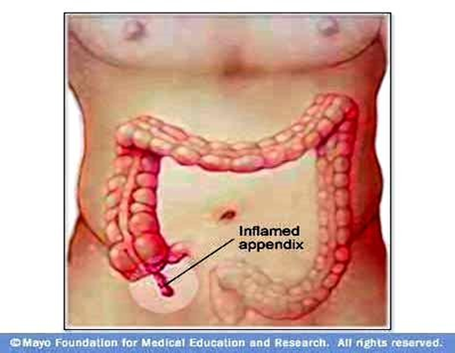**3-1: Acute appendicitis**

This is the most common surgical emergency. in which

Gut organisms invade the appendix wall (1).

**Clinical features**

**A-Symptoms (2)**

1-malaise, anorexia, and fever;

2-diarrhoea common and may be mistaken for acute (gastro)enteritis.

3-abdominal pain starts centrally and localizes to the right iliac fossa.

4-abdominal pain caused by coughing and moving.

**B-Signs (2)**

1-fever, tachycardia; 2-abdominal tenderness.

**C-Investigations** m ay be normal and none are diagnostic or exclusive (2).

**Establish a diagnosis**

The diagnosis is a clinical one in all but exceptional cases and investigations are usually unnecessary (2).

**Complications (1)**

1-**Perforation**

2-**Appendix mass** may result when an inflamed appendix becomes covered with omentum.

3-**Appendix abscess** may result if an appendix mass fails to resolve.

**Management**

**A-Acute appendicitis**

1- Appendicectomy (2).

2- IV antibiotics on induction; continued antibiotics only indicated for perforation.

**B-Appendix mass or appendix abscess (2)**

1-IV antibiotics (e.g. cefuroxime 750mg tds + metronidazole 500mg tds),

2-If symptoms settle: delayed (interval) appendicectomy after 6 weeks,

3-If symptoms fail to settle: may need acute appendicectomy.

4-Appendix abscess may be amenable to drainage.

**References**

**1-Longmore, Murray; Wilkinson, Ian B; Baldwin, Andrew: Wallin, Elizabeth. Oxford Handbook of Clinical Medicine, 9th Edition. Copyright 2014 © Oxford University Press.**

**2-McLatchie, Greg; Borley, Neil; Chikwe, Joanna. Oxford Handbook of Clinical Surgery, 4th Edition. Copyright. 2014 © Oxford University Press.**

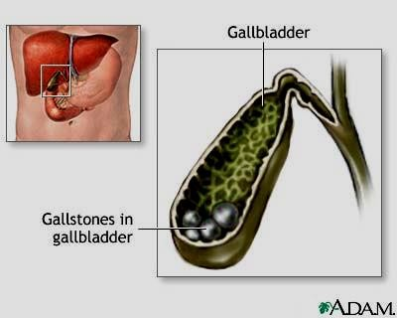**3-2: Gallstones:**

**Pathological features (1)**

Bile has three major constituents:

1-bile salts (primary: cholic and chenodeoxycholic acids; secondary:

deoxycholic and lithocholic acids).

2-Phospholipids (90% lecithin).

3-cholesterol.

Bile containing excess cholesterol relative to bile salts

and lecithin is predisposed to gallstone formation.

**Types of gallstones (1)**

1-Pure cholesterol (10%).

2-Pure pigment (bile salts; 10%).

3-Mixed (80%). Most common; usually multiple.

**Predisposing conditions** (1)

**1-Increasing age.**

**2-Female (pregnancy and use of the oral contraceptive).**

**3-Obesity.**

**4-Multiparity.**

**5-Chronic haemolytic disorders (only for pigment stones).**

**Clinical features (common presentations) (1)**

**A-Biliary colic**

Intermittent severe epigastric and right upper quadrant; usually associated with nausea and vomiting.

Resolves after a few hours.

**Acute cholecystitis(1)**

Severe continuous right upper quadrant pain; often radiates to right flank and back; associated with

anorexia and pyrexia.

**Complications of acute cholecystitis include (1)**

1-formation of an empyema or abscess of the gallbladder (rare)

2-perforation with biliary peritonitis (very rare);

3-jaundice due to compression of the adjacent common bile duct by pressure.

**Chronic cholecystitis (1)**

Repeated episode of infection causes thickening and fibrosis of gall bladder.

**Diagnosis and investigations(1,2,3)**

1-WCC 2-ultrasound (Ultrasound is the investigation of choice for diagnosing gallstones)

3-Abdominal x-ray (AXR) only shows ~10% of gallstones.

**Treatment:**

Asymptomatic gallstones found incidentally are not usually treated because the majority will never give symptoms. Symptomatic gallstones are best treated surgically (3).

**A-Surgical treatment**

**Cholecystectomy**

This is the treatment of choice for all patients fit for GA (general anesthesia) (1). If delayed, relapse

occurs in 18% and may be associated with more complications, so early surgery is generally recommended (2).

**B-Non-surgical treatments (1, 3)**

1-Dissolution therapy (chenodeoxycholic or ursodeoxycholic):

• Rarely used. Requires a functioning gall bladder, small stones.  
• Problems—requires prolonged treatment, <70% response, high rate of recurrence of stones, side effects of medication (diarrhoea, pruritus).

**2-Extracorporeal shock wave lithotripsy (ESWL) (1).**

Hardly ever used. Risk of visceral injury and high risk of stone recurrence.

**References:**

**1- McLatchie, Greg; Borley, Neil; Chikwe, Joanna. Oxford Handbook of Clinical Surgery, 4th Edition. Copyright. 2014 © Oxford University Press.**

**2-** **Longmore, Murray; Wilkinson, Ian B; Baldwin, Andrew: Wallin, Elizabeth. Oxford Handbook of Clinical Medicine, 9th Edition. Copyright 2014 © Oxford University Press.**

**3-Walker, Brian R.; Colledge, Nicki R.; Ralston, Stuart H.; Penman, Ian D. Davidson's Principles and Pracrtice of Medicines. 22 th Edition 2014.**

**3-3: Common bile duct stones**

**Key facts**

Types of stones as per gallbladder stones.

Common bile duct (CBD) stones about 10% of patients with gallstones. Most pass from the gallbladder into the CBD (secondary duct stones).Rarely form within the CBD (primary duct stones); almost always associated with partial duct obstruction.

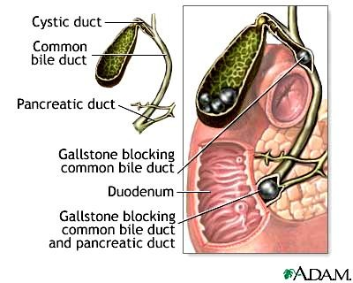

**Diagnosis and investigations**

1- (WCC in cholangitis and pancreatitis),

LFTs (conjugated bilirubin and alkaline

phosphatase), serum amylase (in

pancreatitis).

2-The most convenient method of

demonstrating obstruction to the common

bile duct is by transabdominal ultrasound **(2).**

**Management**

Cholangitis should be treated with analgesia,

intravenous ﬂuids and broad-spectrum antibiotics,

such as cefuroxime and metronidazole. Patients also

require urgent decompression of the biliary tree and stone

removal.

***Endoscopic Retrograde Cholangio-Pancreatography***

( ERCP )with biliary sphincterotomy and

stone extraction is the treatment of choice and is successful

in about 90% of patients. If ERCP fails, other approaches include percutaneous transhepatic drainage and combined endoscopic procedures, extracorporeal shock wave lithotripsy (ESWL) and surgery.

Surgical treatment of choledocholithiasis is performed less frequently than ERCP because it carries  
 higher morbidity and mortality.

**References:**

1- **McLatchie, Greg; Borley, Neil; Chikwe, Joanna. Oxford Handbook of Clinical Surgery, 4th Edition. Copyright. 2014 ©Oxford University Press.**

**2-Walker, Brian R.; Colledge, Nicki R.; Ralston, Stuart H.; Penman, Ian D. Davidson's Principles and Pracrtice of Medicines. 22 th Edition 2014.**

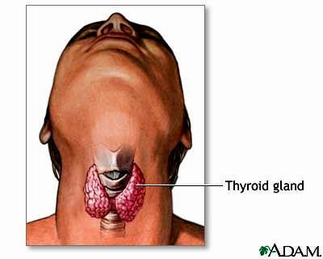**3-7: Thyroidectomy**

The surgical removal of part or all of the thyroid

gland, thyroidectomy allows treatment of hyperthyroidism, respiratory obstruction from goiter, and thyroid cancer.

**Subtotal thyroidectomy** used to correct hyperthyroidism when drug therapy fails or radiation therapy is contraindicated, reduces secretion of thyroid hormone. It also effectively treats diffuse goiter. After surgery, the remaining thyroid tissue usually supplies enough thyroid hormone for normal function.

**Total thyroidectomy** may be performed for certain types of thyroid cancers, such as

papillary, follicular, medullary, or anaplastic neoplasms. After this surgery, the patient requires lifelong thyroid hormone replacement therapy.

**Indications**

Pressure symptoms, relapse hyperthyroidism after >1 failed course of drug treatment, carcinoma, cosmetic reasons, symptomatic patients planning pregnancy.

**Pre-operative management:**

• Treat hyperthyroidism pre-operatively with antithyroid drugs until the patient is euthyroid (p210), eg

carbimazole up to 20mg/12h PO or propylthiouracil 200mg/12h PO. Potassium iodide also has a role.

• Propranolol up to 80mg/8h PO can be used to control tachycardia or tremor associated with

hyperthyroidism (continue for 5d post-op).

**Complications**

**1-Early**

Hoarseness, hemorrhage, hypoparathyroidism, thyroid storm (symptoms of severe).

**2-Late**

Hypothyroidism, recurrent hyperthyroidism.

**References:**

**1-Longmore, Murray; Wilkinson, Ian B; Baldwin, Andrew: Wallin, Elizabeth. Oxford Handbook of Clinical Medicine, 9th Edition. Copyright 2014 © Oxford Uni*ve*rsity Press.**

**3-8: Bowel Obstruction**

*A blockage prevents the contents of the intestines from passing normally through the digestive tract. The problem causing the blockage can be inside or outside the intestine. Inside the intestine, a tumor or swelling can fill and block the inside passageway of the intestine. Outside the intestine, it is possible for an adjacent organ or area of tissue to pinch, compress or twist a segment of bowel.

* A bowel obstruction can occur in the small bowel (small intestine) or large bowel (large intestine or colon). Also, a bowel obstruction can be total or partial, depending on whether any intestinal contents can pass through the obstructed area.

**\* In the small intestine, the most common causes of bowel obstruction are:**

**1- Adhesions —Adhesions develop on the outside of injured intestine or pelvic organs as they heal after surgery or infection. Gynecological surgeries and surgery involving the appendix or colon are particularly likely to result in adhesions.**

**2- Hernia**

**3- Tumors – Cancerous tumors**

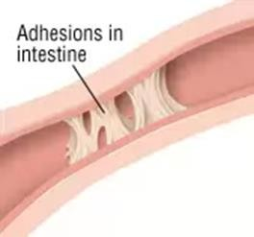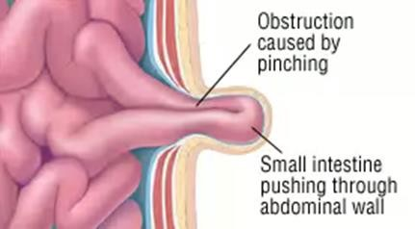

**\*In the large intestine, the most common causes of bowel obstruction are:**

**1-Colorectal cancer**

**2-Volvulus – Volvulus is an abnormal twisting of a segment of bowel around itself. This twisting motion typically produces a closed loop of bowel with a pinched base, leading to intestinal obstruction. In Western countries, volvulus is most common among people over age 65, and these patients often have a history of chronic (long-lasting) constipation.**

**3-Diverticular disease – In the large bowel, diverticula are small, balloon-shaped pouches that protrude from the wall of the intestine. If diverticula become infected this is called diverticulitis. During healing from infection, scars may form in the wall of the colon as it.**

**Symptoms**

**Symptoms of small-bowel obstruction can include:**

1-Cramping abdominal pain, generally coming in intense waves that strike at intervals of five to 15

minutes and sometimes center either on the navel or between the navel and rib cage (Pain that becomes constant may be a symptom of bowel strangulation)

2-Nausea and vomiting

3-No gas passing through the rectum

4-A bloated abdomen, sometimes with abdominal tenderness

5-Rapid pulse and rapid breathing during episodes of cramps

**Symptoms of large-bowel obstruction can include:**

1-A bloated abdomen.

2-Abdominal pain, which can be either vague and mild, or sharp and severe, depending on the cause of the obstruction

3-Constipation at the time of obstruction, and possibly intermittent bouts of constipation for several months beforehand.

**Exams and Tests**

Tests that show obstruction include:

1-Abdominal CT scan

2-Abdominal x-ray

3-Ultrasound

**Treatment**

Treatment involves placing a tube through the nose into the stomach or intestine to help relieve abdominal swelling (distention) and vomiting. Volvulus of the large bowel may be treated by passing a tube into the rectum. Surgery may be needed to relieve the obstruction if the tube does not relieve the symptoms, or if there are signs of tissue death.

**References:**

**1- McKenzie S, Evers BM. Small intestine. In: Townsend CM, Beauchamp RD, Evers BM, Mattox**

**KL, eds. Sabiston Textbook of Surgery. 19th ed. St. Louis, Mo: WB Saunders; 2012: chap 50.**

**2- Fry RD, Mahmoud N, Maron DJ, Bleier JIS. Colon and rectum. In: Townsend CM, Beauchamp RD, Evers BM, Mattox KL, eds. Sabiston Textbook of Surgery. 19th ed. St. Louis, Mo: WB Saunders;**

**2012: chap 52.**

**3-9: Pancreatitis**

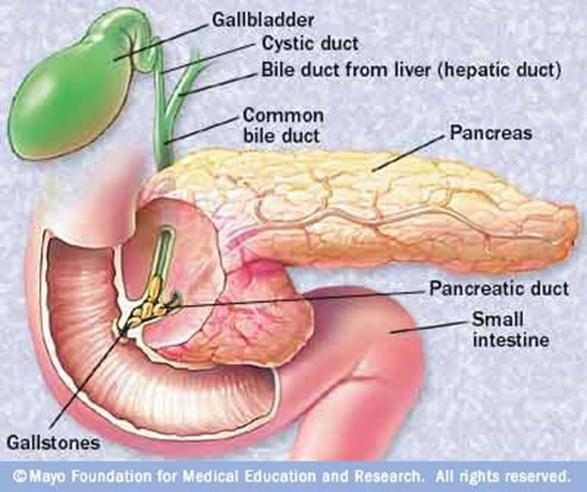Pancreatitis is an inflammation of the pancreas.

It has several causes and symptoms and requires

immediate medical attention. It occurs when pancreatic

enzymes (especially trypsin) that digest food are activated

in the pancreas instead of the small intestine. It may **be**

**acute—beginning suddenly and lasting a few days,**

**or chronic— occurring over many years.**

**Chronic pancreatitis can lead to diabetes or**

**pancreatic cancer (1)**.

**Causes**

Ethanol use accounts for 30% of cases and

gallstones about 30% to 40% of cases. Other common

causes include hypertriglyceridemia, endoscopic

retrograde cholangiopancreatography (ERCP), pregnancy,

and auto-digestion due to early activation of pancreatic

enzymes(2).

**Pathophysiology**

**1.** Ethanol abuse may cause precipitation of pancreatic enzymes in pancreatic ducts, leading to chronic inflammation and fibrosis or may be directly toxic to the pancreatic cells.

**2.** Gallstones can cause obstruction resulting pancreatic enzymes or bile to move in a retrograde fashion into the pancreas. This may be responsible for pancreatic autolysis.

**3.** Acute pancreatitis can result from the initial injury to the zymogen-producing cells (granules in which Pancreatic enzymes are produced and stored as inactive proenzymes) (2).

**Symptoms**

**1.** Sudden upper abdominal pain is the most common symptom.

**2.** Pain may radiate to the back, and ecchymosis may be present in the flank and periumbilical areas.  
**3.** Nausea and vomiting are other common symptoms.  
**4.** Tachycardia, hypotension, fever, and abdominal distention may be present (2).

**Diagnosis**

**1.** Diagnosis is based on patient history, signs and symptoms, and laboratory values. The history can identify  
risk factors for acute pancreatitis, including alcohol abuse and medications.

**2.** A serum lipase greater than three times the normal limit supports the diagnosis.

**3.** Abdominal ultrasound but has limited sensitivity.

**4.** Computed tomography (CT) may be more useful in staging pancreatitis or identifying complications.

**5.** Magnetic resonance imaging (MRI) and magnetic resonance cholangiopancreatography (MRCP) are more costly options that can be used to evaluate severity and pancreatic abnormalities (2).

**Treatment**

**Non Pharmacologic Therapy**

Therapy of acute pancreatitis is primarily supportive unless a specific etiology is identified. Supportive  
therapy involves fluid repletion, nutrition support, and analgesia*.* Patients with acute pancreatitis are administered IV fluids to maintain hydration and blood pressure. The total amount of fluids administered  
should be based on vital signs and urine output. Enteral nutrition is preferred, but if a patient is not meeting caloric goals, it may be supplemented with total parenteral nutrition. If pancreatic necrosis or abscesses are present, surgical or interventional procedures may be necessary.

**Pharmacologic Therapy**

***1. Analgesics:*** Meperidine, Hydromorphone, morphine, and fentanyl***.***

***2. Antibiotic*** (2).

**References:**

**1- "Pancreatitis". A.D.A.M., Inc. Retrieved 2013-01-05.**

**2- Alldredge, Brian K.; Corelli, Robin L.; Ernst, Michael E.; Guglielmo, B. Joseph; Jacobson, Pamala A.; Kradjan, Wayne A.; Williams, Bradley R., Applied Therapeutics: The Clinical Use of Drugs, 10th Edition. 2013.**

**Hernia**

A hernia occurs when an organ or fatty tissue squeezes through a weak spot in a surrounding muscle or

connective tissue called fascia. The most common types of hernia are inguinal (inner groin), incisional

(resulting from an incision), femoral (outer groin), umbilical (belly button), and hiatal (upper stomach).

In an **inguinal hernia**, the intestine or the bladder protrudes through the abdominal wall or into the

inguinal canal in the groin. About 96% of all groin hernias are inguinal, and most occur in men because

of a natural weakness in this area.

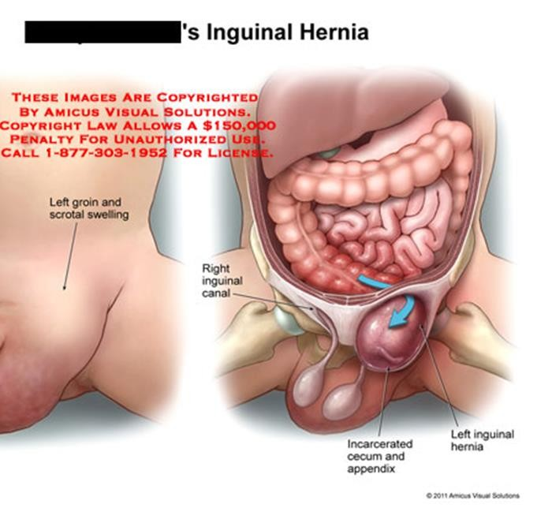

In an **incisional hernia**, the intestine pushes through the abdominal wall at the site of previous

abdominal surgery. This type is most common in elderly or overweight people who are inactive after

abdominal surgery.

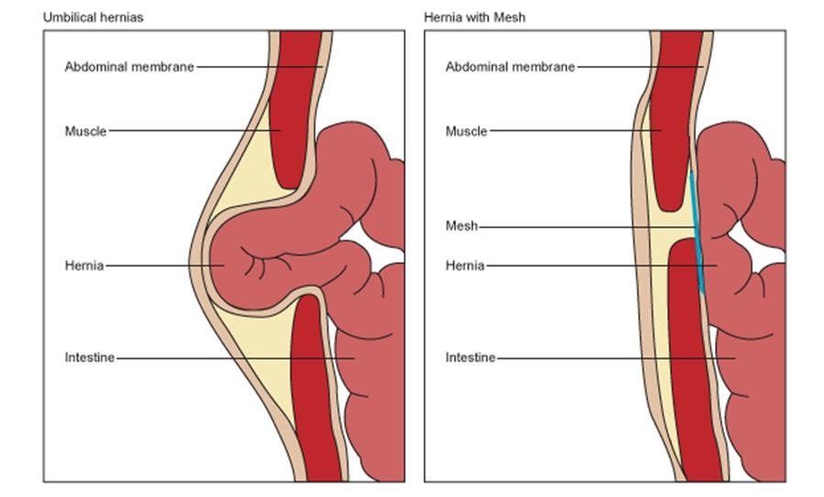

A **femoral hernia** occurs when the intestine enters the canal carrying the femoral artery into the upper

thigh. Femoral hernias are most common in women, especially those who are pregnant or obese.

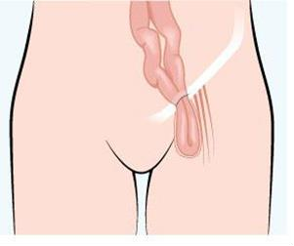

In an **umbilical hernia**, part of the small intestine passes through the abdominal wall near the navel.

Common in newborns, it also commonly afflicts obese women or those who have had many children.

A **hiatal hernia** happens when the upper stomach squeezes through the hiatus, an opening in

the diaphragm through which the esophagus passes.

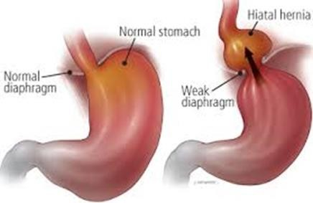

**Causes of Hernias:**

Ultimately, all hernias are caused by a combination of pressure and an opening or weakness of muscle or fascia; the pressure pushes an organ or tissue through the opening or weak spot. Sometimes the muscle weakness is present at birth; more often, it occurs later in life.

Anything that causes an increase in pressure in the [abdomen](http://www.webmd.com/digestive-disorders/picture-of-the-abdomen) can cause a hernia, including:

Lifting heavy objects without stabilizing the abdominal muscles

[Diarrhea or](http://www.webmd.com/digestive-disorders/digestive-diseases-diarrhea) [constipation](http://www.webmd.com/digestive-disorders/digestive-diseases-constipation)

Persistent [coughing or](http://www.webmd.com/first-aid/coughs) [sneezing](http://www.webmd.com/allergies/features/11-surprising-sneezing-facts)

In addition, obesity, poor [nutrition,](http://www.webmd.com/diet/default.htm) a[nd smoking,](http://www.webmd.com/smoking-cessation/default.htm) can all weaken muscles and make hernias more likely.

**3-11: Guidelines on Parenteral Nutrition in Surgery (1)**

Parenteral nutrition is a way of delivering, in the form of intravenous infusion, the nourishments

necessary for the maintenance of life, such as amino acids—a source of proteins, glucose, and lipids—a supply of energy; and water, electrolytes, microelements, and vitamins .

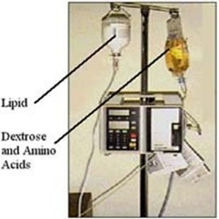

**\*Central Parenteral Nutrition: often called Total Parenteral**

**Nutrition (TPN); delivered into a central vein**

**\*Peripheral Parenteral Nutrition (PPN): delivered into a smaller or peripheral vein**

**\*Inadequate oral intake for more than 14 days is associated with a higher mortality.**

**\*Compounding Methods**

**A- Total nutrient admixture (TNA) or 3-in-1**

Dextrose, amino acids, lipid, additives are mixed together in one container.

Lipid is provided as part of the PN mixture on a daily basis and becomes an

important energy substrate.

**B- 2-in-1 solution of dextrose, amino acids, additives**

Typically compounded in 1-liter bags

Lipid is delivered as piggyback daily or intermittently as a source of EFA

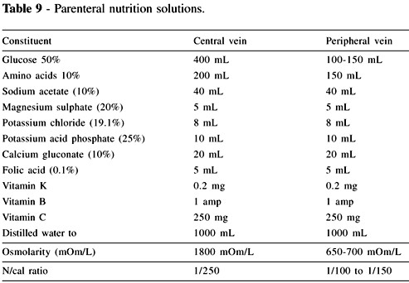

**Uses** Parenteral nutrition is used primarily in therapies of gastrointestinal patients after stomach resection, with short bowel syndrome, intestinal fistula, bowel obstruction, and absorption disorders (Crohn’s disease, acute pancreatitis) and as perioperative treatment in malnourished or depleted patients with extensive burns, and those in shock and during chemo- and radiotherapy

**The role of the pharmacist** should ensure the therapeutic safety of parenteral nutrition in all its aspects including parenteral nutrition mixture preparation, choice of an appropriate administration route and drug form for the ongoing medication, implementation of alternative treatment methods, monitoring therapeutic and toxic effects, and instructing the medical and nursing staff about possible interactions of drugs with parenteral nutrition.

**Type of formula**

The commonly used formula of 25 kcal/kg ideal body weight furnishes an approximate estimate of daily

energy expenditure and requirements. Under conditions of severe stress requirements may approach 30 kcal/kg ideal body weight.

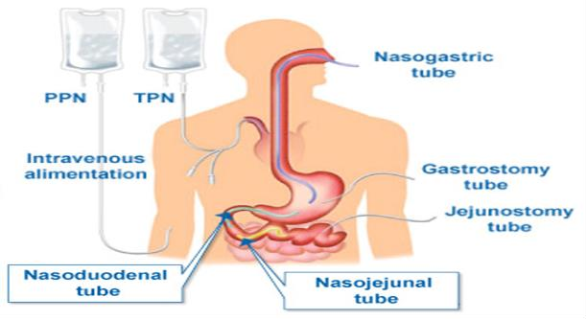*The Protein: Fat: Glucose caloric ratio should approximate to 20:30:50.

**Complications**

**1-infections**

TPN requires a chronic IV access for the solution to run through, and the most common complication is

infection of this catheter. Infection is a common cause of death in these patients, with a mortality rate of approximately 15% per infection, and death usually results from septic shock.

**2-Blood clots**

Chronic IV access leaves a foreign body in the vascular system, and blood clots on this IV line are common. Death can result from pulmonary embolism wherein a clot that starts on the IV line but breaks off and goes into the lungs.

Patients under long-term TPN will typically receive periodic heparin flush to dissolve such clots before they become dangerous.

**3-Fatty liver and liver failure**

Fatty liver is usually a more long term complication of TPN. The pathogenesis is due to using linoleic

acid (an omega-6 fatty acid component of soybean oil) as a major source of calories

**Reference:**

**1-M. Stawny,1 R. Olijarczyk,1 E. Jaroszkiewicz,2 and A. Jelińska. Pharmaceutical Point of View on**

**Parenteral Nutrition. The Scientific World Journal Volume 2013 (2013).**

**(Review of Antibacterial Agents)**

**Antibiotic Overview**

Questions to ask before selecting an antibiotic:

Host factors:

1. Normal or abnormal immune status?

2. Underlying disease that will affect selection &/or dosing? (e.g. renal failure)

3. Seriousness of the infection?

**Pathogen factors**

4. What are the most likely bugs based on the infection site?

5. Where was the infection acquired? (community or hospital setting?)

6. Local susceptibility patterns?

**Drug factors**

7. Bioavailability at infected site? (e.g. blood-brain barrier)

8. Broad or narrow spectrum?

9. Bactericidal or bacteriostatic?

10. Side effect profile?

**General Principles**

1. Be elegant. Use the antibiotic with the narrowest spectrum that covers the pathogen.

2. Be smart. If a patient is very sick or immunocompromised, it’s OK to cover broadly for the first 1-3 days while you identify the pathogen as long as you narrow your choice as soon as possible.

3. Follow the 3 day rule: Broad spectrum antibiotics markedly alter the normal host flora about 3 days into therapy AND cultures should be back in 3 days so always reassess your antibiotic choices and narrow it when possible.

4. New isn’t always better. When several antibiotics have similar coverage, select the least expensive.

**Antibiotic Classes by Coverage**

**Gram positive coverage**

1. Penicillins (ampicillin, amoxicillin) penicillinase resistant (Dicloxacillin, Oxacillin)

2. Cephalosporins (1st and 2nd generation)

3. Macrolides (Erythromycin, Clarithromycin, Azithromycin)

4. Quinolones (gatifloxacin, moxifloxacin, and less so levofloxacin)

5. Vancomycin (MRSA)

6. Sulfonamide/trimethoprim*(Increasing resistance limits use, very inexpensive)

7. Clindamycin

8. Tetracyclines

9. Chloramphenicol (§causes aplastic anemia so rarely used)

10. Other: Linezolid, Synercid (VRE)

**Pseudomonas coverage** Ciprofloxacin Aminoglycosides

Some 3rd generation cephalosporins

4th generation cephalosporins

Broad spectrum penicillins

**Gram negative coverage**

1. Broad spectrum penicillins (Ticarcillin-clavulanate, piperacillin-tazobactam)*

2. Cephalosporins (2nd, 3rd, and 4th generation)*

3. Aminoglycosides* (renal and ototoxicity)

4. Macrolides (Azithromycin)*

5. Quinolones (Ciprofloxacin)*

6. Monobactams (Azetreonam)*

7. Sulfonamide/trimethoprim*

8. Carbapenems (Imipenem)

9. Chloramphenicol

**Anaerobic coverage**

1. Metronidazole

2. Clindamycin

3. Broad spectrum penicillins

4. Quinolones (Gatifloxacin, Moxifloxacin)

5. Carbapenems

6. Chloramphenicol

**Atypical coverage**

1. Macrolides (Legionella, Mycoplasma, chlamydiae)

2. Tetracyclines (rickettsiae, chlamydiae)

3. Quinolones (Legionella, Mycoplasma, Chlamydia)

4. Chloramphenicol§ (rickettsiae, chlamydiae, mycoplasma)

5. Ampicillin (Listeria)

**Drugs most commonly used in surgical operations** (1)

**Tramadol hydrochloride**

An opioid analgesic indicated for Moderate to severe pain, Moderate to severe acute pain, Moderate to severe chronic pain and postoperative pain.

It produces analgesia by two mechanisms: an opioid effect and an enhancement of serotonergic and adrenergic pathways. It has fewer of the typical opioid side-effects (notably, less respiratory  
depression, less constipation and less addiction potential); psychiatric reactions have been reported.

SIDE-EFFECTS  
▶ Common or very common : Malaise.

**Acetaminophen (Paracetamol**

A Non-opioid analgesic indicated for Mild to moderate pain or Pyrexia.

**Ranitidine**

A H2-receptor antagonist heal gastric and duodenal ulcers by reducing gastric acid output as a result of  
histamine H2-receptor blockade; also used to relieve symptoms of gastro-esophageal reflux disease.

**Omeprazole**

A proton pump inhibitor inhibits gastric acid secretion by blocking the hydrogen-potassium adenosine triphosphatase enzyme system (the ‘proton pump’) of the gastric parietal cell.

It is effective short-term treatment for gastric and duodenal ulcers; also used in combination with antibacterials for the eradication of Helicobacter pylori. Following endoscopic treatment of severe peptic ulcer bleeding, an intravenous, high-dose proton pump inhibitor reduces the risk of rebleeding and the need for surgery. It can be used for the treatment of dyspepsia and gastro-oesophageal reflux disease, also used for the prevention and treatment of NSAID-associated ulcers, also be used to control  
excessive secretion of gastric acid in Zollinger–Ellison syndrome; high doses are often required.

**Ceftriaxone and Cefotaxime**

Are third generation’ cephalosporins with greater activity than the ‘second generation’ cephalosporins against certain Gram negative bacteria. However, they are less active than cefuroxime against Gram-positive bacteria, most notably Staphylococcus aureus.

Ceftriaxone has a longer half-life and therefore needs to be given only once daily. Indications include serious infections such as septicaemia, pneumonia, and meningitis.

Ceftriaxone SIDE-EFFECTS  
▶ Common or very common Calcium ceftriaxone precipitates in gall bladder—consider discontinuation if symptomatic. calcium ceftriaxone precipitates in urine (particularly in very young, dehydrated or those who are immobilised)—consider discontinuation if symptomatic.

▶Antibiotic-associated colitis Antibiotic-associated colitis may occur.

**Meropenem**

A carbapenem (beta-lactam antibacterial) have good activity against Pseudomonas aeruginosa, not active against meticillin-resistant Staphylococcus aureus and Enterococcus faecium. used for the treatment of severe hospital-acquired infections and polymicrobial infections including septicaemia, hospital-acquired pneumonia, intra-abdominal infections, skin and soft-tissue infections, and complicated urinary tract infections.

SIDE-EFFECTS  
▶ Common or very common Abdominal pain. diarrhoea. disturbances in liver function tests . headache. nausea. pruritus. rash. thrombocythaemia. vomiting.

**Vancomycin**

The glycopeptide antibiotic vancomycin has bactericidal activity against aerobic and anaerobic Gram positive bacteria including multi-resistant staphylococci. However, there are reports of Staphylococcus aureus with reduced susceptibility to glycopeptides. There are increasing reports of glycopeptide-resistant enterococci. Penetration into cerebrospinal fluid is poor. With intravenous use Vancomycin has a long duration of action and can therefore be given every 12 hours.

SIDE-EFFECTS  
▶ Common or very common: With intravenous use Blood disorders, including neutropenia . interstitial nephritis. nephrotoxicity. ototoxicity (discontinue if tinnitus occurs). renal failure.

**Metronidazole**

Metronidazole is an antimicrobial drug with high activity against anaerobic bacteria and protozoa..

**Metoclopramide**

A dopamine receptor antagonist indicated for Symptomatic treatment of nausea and vomiting, Nausea and vomiting in palliative care, and hiccup in palliative care.

SIDE-EFFECTS

▶Common or very common: Extrapyramidal effects (especially in children and young adults (15–19 years old). galactorrhoea. gynaecomastia. hyperprolactinaemia. menstrual changes.

▶Metoclopramide can induce acute dystonic reactions involving facial and skeletal muscle spasms and oculogyric crises. These dystonic effects are more common in the young (especially girls and young women) and the very old; they usually occur shortly after starting treatment with metoclopramide and subside within 24 hours of stopping it. Injection of an antiparkinsonian drug such as procyclidine will abort dystonic attacks.

**Ciprofloxacin**

A quinolone active against both Gram-positive and Gram-negative bacteria. It is particularly active against Gram-negative bacteria, including salmonella, shigella, campylobacter, neisseria, and pseudomonas. Ciprofloxacin has only moderate activity against Gram-positive bacteria such as Streptococcus pneumoniae and Enterococcus faecalis; it should not be used for pneumococcal pneumonia. It is active against chlamydia and some mycobacteria. Most anaerobic organisms are not susceptible.

Ciprofloxacin can be used for respiratory tract infections (but not for pneumococcal pneumonia), urinary-tract infections, infections of the gastro-intestinal system (including typhoid fever), bone and joint infections, gonorrhoea and septicaemia caused by sensitive organisms.

Although ciprofloxacin licensed for skin and soft-tissue infections, many staphylococci are resistant to and use should be avoided in MRSA infections.

SIDE-EFFECTS  
▶ Common or very common: Flatulence. diarrhoea .dizziness. headache. nausea. vomiting.  
▶ With intravenous use Pain at injection site. phlebitis at injection site.

**References:**

**1. BNF 73. 2017.**