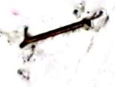


Experimental for
Instrumental analysis methods
The second course

University of Baghdad,Iraq
College science for women
Chemistry department
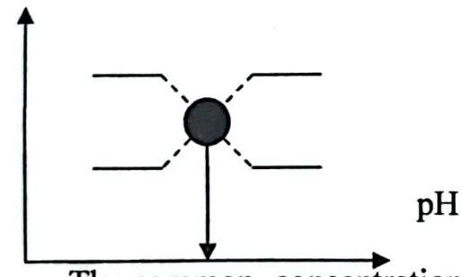
Experience(9)
Experiment name: Determination of dissociation thermodynamic constant indicator
Theoretical part: It is well known that indicator is the acids and bases identified the symbol (HI-n) or (HOIn), respectively, indicates (In) to the brief of the word indicator. The indicator is dissociate as the following equation when the indicator (HIn).

$$HIn→H^{+}+I^{-}n$$

It is dissociation constant
$$Ka=\frac{[H^{+}]I^{-}}{[HI]}$$
And can be extracted from the following equation PKa
pH=pKa+log$log⁡\frac{[I^{-n}]}{[I^{-n}}]$
It can be plotted pH versus log [In] [HI-n] should give a straight line intersects that [In] = [HI-n] is equal to pKa, can also use the spectral method to estimate PK indicator of acid base when plotted the values of absorption(A) for indicator Solution at different values of pH have the following format.
Amax

Amax

Amin

The common concentration at the values of Amax is the concentration of In ions,As Amin, the common concentration is the concentration of HI-n, and the average distance between the Amax, Amin represent absorb a solution containing the same concentration of In, HI-n.
$$[HI^{-}]=[I^{-}]$$

Materials and equipment
Equipment | S | Materials | S
Spectrophotometer | 1 | Bromo phenol Blue indicator | 1
Absorption cell | 2 | HCI Conc | 2
Volumetric flask | 3 | NaOH Conc | 3
Test tubs | 4 | Distilled water | 4
pipettes | 5 | Sodium acetate 0.2M | 5
Graduated cylinder | 6 | Acid anhydride 0.2M | 6


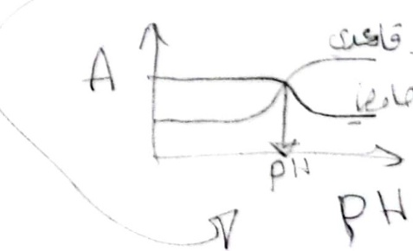
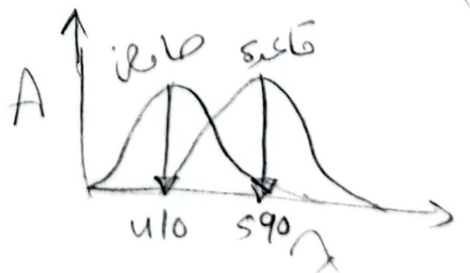
Procedure
1-Measure absorption of the solution prepared from indicator at the(350-700) nm,up 10 nm for each of the following solutions:-
A-Take exactly 0.5 ml of indicator solution and then add a drop of the HCI acid and dilute with distilled water to 25 ml Volumetric flask., with continuous addition until obtain yellow color.
B-Take exactly 0.5 ml of indicator solution and then add a drop of the ConC.NaOH and then dilute with distilled water to 25 ml Volumetric flask., with continuous addition until obtain violet color.
2-Choose the highest peak absorptionλ max which shows the highest wavelength absorption of the indicator in the acid and base medium and then prepare a series of buffer solutions to give a change in color from the color indicator to the other materials used are sodium acetate (0.2N) and acetic acid (0.2N), and then measure the absorption and pH for each of the solutions prepared.

pH | 3.42 | 3.72 | 4.05 | 4.27 | 4.45 | 4.63 | 4.8 | 4.99 | 5.23 | 5.37 | 5.57 | 5.89
0.2N Sodium Acetate (ml) | 0.5 | 1 | 2 | 3 | 4 | 5 | 6 | 7 | 8 | 8.5 | 9 | 9.5
0.2N acetic acid (ml) | 9.5 | 9 | 8 | 7 | 6 | 5 | 4 | 3 | 2 | 1.5 | 1 | 0.5
0.5 0.5 0.5 05
Accounts
1-plotted Absorption versus( λ max) and then determine the highest wavelength.
2-plotted chart between Absorption and pH and detected pKa indicator
Questions
·write formulas of indicator and the expected colors?
·What is absorption spectrum?
·What is the buffer solution

