Experimental for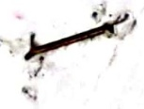

Instrumental analysis methods

The second course

University of Baghdad,Iraq

College science for women

Chemistry department

**No Experience (8)**

Figure above shows the spectrum of compounds x and y When the collection of these spectrums get a compound x+y To resolve this issue, has been chosen as the best two wavelengths showed the highest absorbance for two compounds represents λ 1 and λ2 and the total the absorption represents the sum of absorption for each, and can be in writing the following equations

$A_{T}=A_{1}+A_{2}+A_{3}+A_{n}$ c8

Although volumetric and gravimetric mass analyses are commonly used,spectroscopy is the technique most often used for modern chemical analysis.Spectroscopy is the study of electromagnetic radiation emitted or absorbed by a given chemical species. Since the quantity of radiation absorbed or emitted can be related to 0.04the quantity of the absorbing or emitting species present, this technique can be used 0.08for quantitative analysis. There are many spectroscopic techniques available from X- 0.42rays, ultraviolet, infrared,and visible light, to name a few. We will consider one form 0.16here which is based on the absorption of visible light. If a liquid is colored, it is 0.18because some component of the liquid absorbs visible light. In a solution, the greater the concentration of the light-absorbing substance, the more light absorbed and the more intense the color of the solution. The quantity of light

**Experiment name: spectroscopy in the visible region (absorption spectrum and** **Peer law and the analysis mixtures of two component at the same time).**

**Theoretical part**: -in most cases we can often determination each component in the mixture by the spectrometer even if when the overlap of the absorption spectrum of these compounds and the reason for this is that the values of absorption are to the gathering.

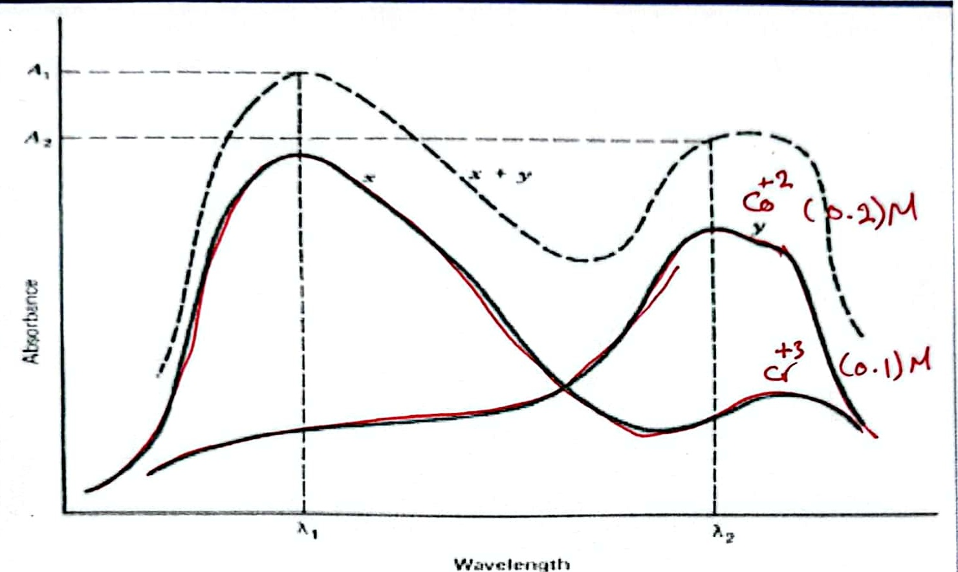

**A two-component mixture with significant spectral overlap**

Figure shows a simulated two-component mixture with significant overlap of the u1o spectra at the absorbance maxima. us0

510

540

575

630

When λ1 we get the **Multi-component mixture:** C5.2 Cさ3

$A_{T}=ϵbc_{X}+ϵbc_{Y}+.$.εnbcn

Where:n=x,y,z ,n-refer to absorbing Components 0.2 0-1

400-66010m원

absorbed by a substance can be measured using a spectrophotometer. The instrument consists of:(1) a source that emits all wavelengths of light in the visible region (wavelengths 400 to 700 nm); (2) a monochromator which selects a given wavelength of light; (3) a sample holder for the solution being measured; and (4) a detector which compares the intensity of incident light Io to the intensity of light after it has passed through the sample I. When a beam of light passes through a substance, some of the energy is often absorbed by the substance. This causes a decrease in the intensity of the transmitted beam. The ratio I/Io is called the transmittance, T, a measure of the fraction of light that passes through the sample holder (or cuvette) which contains the absorbing solution. The amount of light absorbed by the solution is given by the absorbance,A,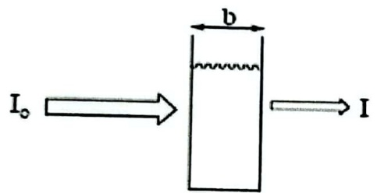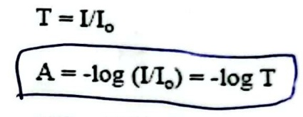

**where:**

A=-log(I/Io)=-logT (1)

Absorbing Solution %T=100%T

of concentration c

The distance, b, the light travels through the solution (in cm) and the concentration,c,of the absorbing species (in mol/L) are represented in the schematic above. A beam of parallel radiation with an intensity is shown before (Io) and after (I) it has passed through a layer of solution with a measured thickness at a certain concentration.The Beer-Lambert law is the basis for using spectroscopy in quantitative analysis which relates absorbance (A) to the concentration of the absorbing solution (c) and the path length of the cuvette (b). That is:

A=εbc **(2)**

where ε is the molar absorptivity or the molar extinction coefficient (in L/mol·cm).Each pure substance has its own unique extinction coefficient. Note that during the experiment, the same cuvette should be used for all measurements. With the same cuvette, the path length (b) and the extinction coefficient (ε) remain constant.Therefore, we can mathematically say that ε b = k (constant). If we write the concentration (c) as M for molarity, our new equation becomes:

**A=kM** (3)

Once absorption values for different concentrations are obtained, a Beer's law plot of absorbance (vertical axis) versus concentration (horizontal axis) is made. A best-fittingline of the data points is constructed, from which you can determine your equation in slope-intercept form

A=(εb)c+0orA=kM+0.

By measuring the path length of your cuvette, the extinction coefficient can then be calculated. In this experiment, there will be three basic tasks to accomplish using the spectrophotometer. First,students will collectively determine the wavelength at which 0.100 M Co(NO3)2 will absorb best. Next, a standard absorbance curve from which the

extinction coefficient can be calculated will be constructed. Finally, an unknown Co(NO3)2 solution will be analyzed for concentration determination.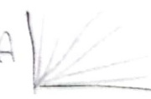

$S=OS_{Δ}E$ ≈0.605001230

**Materials and Equipment**

|  |  |  |  |
| --- | --- | --- | --- |
| Equipment | S | Materials | S |
| Spectrophotometer | 1 | (0.08M) Co+2 and (0.02M)Cr+*3 Nitrate solutions | 1 |
| Pipette | 2 | distilled water | 2 |
| Absorption cells | 3 |  |  |
| Conical Flasks | 4 |  |  |
| Volumetric flasks | 5 |  |  |

**Procedure**

**Experience(A):**Prepare the following solutions:- λ=uoo-630

1-Take 3ml from a stock solution Cr+3(0.02M) in 25 ml volumetric

2-Take 3ml from a stock solutionCO+2(0.08M) in 25 mal volumetric

3-put of the solutions in each cell and Read the absorption (A) of each solution.

4 -put rotary disk wavelength at 400 nm and thus carry an increase of 10 nm even reach to read 630 nm A

**Experience(b)**

1-Prepare series of chromium solutions (0.05,0.04,0.03,0.02,0.01 M) through take certain amount volumes of from chromium solutions in 25 ml volumetric flasks and dilute with distilled water.

2-Prepare series of cobalt solutions of( 0.18,0.16,0.12,0.08,0.04 M)) through take certain amount volumes from cobalt solutions in 25 ml volumetric flasks and dilute with distilled water.

3- Take stored solution as the blank solution (zeroing solution).

4-By returning to the forms obtained by the experiment (A) of the chromium Solution then choose wavelength to study absorption as a function of the concentration, Use the same wavelengths to study the solution of cobalt (II)

5-Use the same previous cells and the same arrangement of the first for distilled water and the second for chromium and third for cobalt.

**Experience (C)**

1-Take the values in the experiment (B) for the mixture Co".,Cr"

2-To determined the values of ε in Peers law schemes in experience (B) go back to the absorption spectrum of chromium and cobalt, and then find two wavelengths, to analyze the combination of Co and Cr, preferably to be between (510-575) nm, and then the determine the slope which equal of ε of chromium and cobalt..

A=abc+abc

d-abc+abc