Experimental for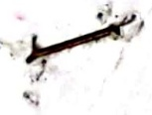

Instrumental analysis methods

The second course

University of Baghdad,Iraq

College science for women

Chemistry department

.

**No Experience (11)**

Molecular species (uncharged substances) do not contribute to the conductance of a solution.

Relative conductances of the species which are involved in the experiment.

After the end point, no H+ is available to react, and the conductance of the solution increases as a result of the addition of Na+ and OH-.Consequently the titration curve has a V-shape as shown in the figure. The end point of the titration corresponds to the intersection of the extrapolated linear portions of the titration curve.

**A-Name of Experiment: Conductometric Titration of Hydrochloric Acid with** **Sodium Hydroxide**

**B-Name of Experiment: Conductometric Titration of Hydrochloric Acid and** **Acetic Acid with Sodium Hydroxide**

**Theoretical part:**

Conductance (G) is the reciprocal of electrical resistance (R).G=1/R

It is a measure of the ability of a solution to conduct electricity. The conductance of a solution is the sum of the conductances of all of the ions that are in the solution.

G=ΣGi

The conductance of a particular ion in solution depends upon the concentration of the ion,the charge on the ion, and the size of the ion. As the concentration or the charge of the ion increases, the conductance of the solution increases. In general as the size of the solvated ion decreases, its mobility through the solution increases and consequently the conductance of the solution increases. In water the ion which has the greatest conductance is H+. of the common, negative ions, OH has the greatest conductance. The relative conductances (relative to acetate) of the species that are involved in the experiment are listed in the table.

|  |  |
| --- | --- |
| Species | Relative conduct |
| H+ | 8.5 |
| OH- | 4.8 |
| C1- | 1.9 |
| $$Na^{+}$$ | 1.2 |
| $$C_{2}H_{3}O_{2}^{-}$$ | 1.0 |
| $$HC_{2}H_{3}O_{2}$$ | 0 |
| $$H_{2}O$$ | 0 |

During the titration of hydrochloric acid with sodium hydroxide, the reaction that takes place in the titration vessel is

$H^{+}+Cl^{-}$ $\frac{Na+OH^{-}}{}>$ $H_{2}O+Cl^{-}+Na^{+}$

Before the end point, H+ is removed from the solution byreaction with OH,and Na+is added to the solution. Since the relative conductance of H+ is about seven times that of Na+, the conductance of the solution decreases prior to the end point.

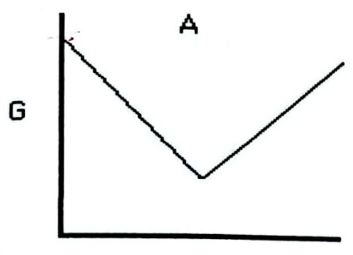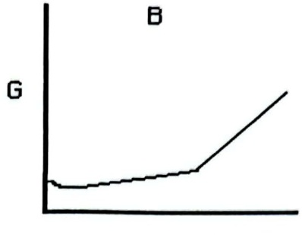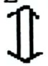

HCl

Volume (mL) **Volume(mL)**

Diagrams of the conductometric titrationcurves. A, the titration of HCI with NaOH; B, the titration of HC2H3O2 with NaOH. The slight decrease in conductance at the start of the acetic acid titration is due to suppression of the acid dissociation by the common-ion effect. Since acetic acid is dissociated slightly (Ka=1.8 x 10-5)in aqueous solution, the conductance of the acetic acid solution is initially small. As sodium hydroxide is added, the hydroxide reacts with the acid to form water and acetate

$HC_{2}H_{3}O_{2}$、 $H_{2}O+Na++C_{2}H_{3}O_{2}^{-}H^{+}+C_{2}H_{3}O_{2}^{-}$

The addition of C2H3O2- and Na+ to the solution causes the conductance of the solution to increase. After the end point, Na+ and OH- are added to the solution.Since the relative conductance of OH- is nearly five times that of C2H3O2-, the conductance of the solution after the end point increases more rapidly than it did before the end point. The end point corresponds to the intersection of the extrapolated linear portions of the curve.

Conductance is usually measured with an alternating current between two identical,platinized platinum electrodes. Use of an alternating current prevents the buildup of reaction products around either electrode and consequently prevents polarization of the solution. The electrodes must be rigidly held at a fixed distance apart during the titrations in order to prevent changes in conductance that result from an altered solution volume between the electrodes. The addition of C2H3O2- and Na+ to the solution causes the conductance of the solution to increase. After the end point, Na+and OH- are added to the solution. Since the relative conductance of OH- is nearly five times that of C2H3O2 -, the conductance of the solution after the end point increases more rapidly than it did before the end point. The end point corresponds to the intersection of the extrapolated linear portions of the curve.

Conductance is usually mneasured with an alternating current between two identical,platinized platinum electrodes. Use of an alternating current prevents the buildup of reaction products around either electrode and consequently prevents polarization of the solution. The electrodes must be rigidly held at a fixed distance apart during the titrations in order to prevent changes in conductance that result from an altered solution volume between the electrodes.