Experimental for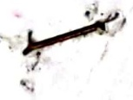

Instrumental analysis methods

The second course

University of Baghdad,Iraq

College science for women

Chemistry department

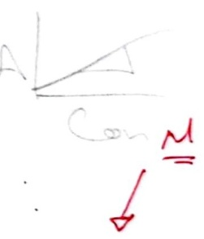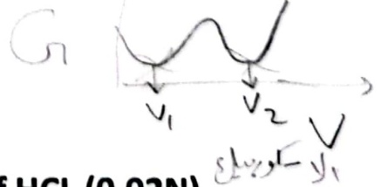

**Experience (10**) )

A-Quantative analysis of Ascorbic acid by using UV spectrum

B-Determine content of Vitamin C in tablets of two different manufacturers with conductometry.

Procedure $N_{1}V_{1}=N_{2}V_{2}$ MVN

100*1=N2x50Am

1-take 1ml of stock solution ascorbic acid 100 ppm and dilute to 50ml volumetric flask using distilled water.

200

2-Measured absorbance of solution extend record (200-300) nm 5nm up period to detected the max. $N_{1}V_{1}=N_{2}V_{2}$

yá $U_{1}=2^{1}×50$

3-prepare series of ascorbic acid by (1,2,3,4,6,8 ) ppm from the stoke solution (100) in the volumetric flask 50ml and complete to the mark with distilled water and measure the absorbance to each solution at max detected.

4-measure the absorbance of unknown sample at max detected.Account M eS PpmadSes?

1-draw absorption versus wave length and detectmax.PPm=Mx3/ykmdx10

2-draw absorption versus concentration and determine the concentration for unknown.

G

B-Determine content of Vitamin C in tablets of two different manufacturers with conductometry.

Procedure

1-take (1) table of vitamin C and dissolves in 20ml of HCL (0.02N) $N_{1}V_{1}=N_{2}V_{2}$ NaOH $N_{1}×50=0.1×(V_{2}-$

2-filter the solution and take the filterant then dilute in volumetric flask 50ml of distilled water.

3-Titrate the prepared solution in step (2) with 0.1M NaOH.

4-add the base (1ml)with conductivity reading when reach at the equivalent point.

Account

Draw the conductivity verse volume of NaOH and find the

concentration of ascorbic acid.

Calculation

Plot the measured conductivity (G) versus added base volume. All points can be plot on the same paper using different notation (four curves). Determine equivalence points. Calculate the exact concentration of NaOH solution. (Titration 1.) For Vitamin C samples consider that ascorbic acid is a weak organic acid. One of the samples contains sodium ascorbate, too. Molecular weight data for ascorbic acid and for sodium ascorbate are Mw= 176 g/mol and Mw=198g/mol, respectively.Compare the ascorbic acid content determined by the two different method and specification.