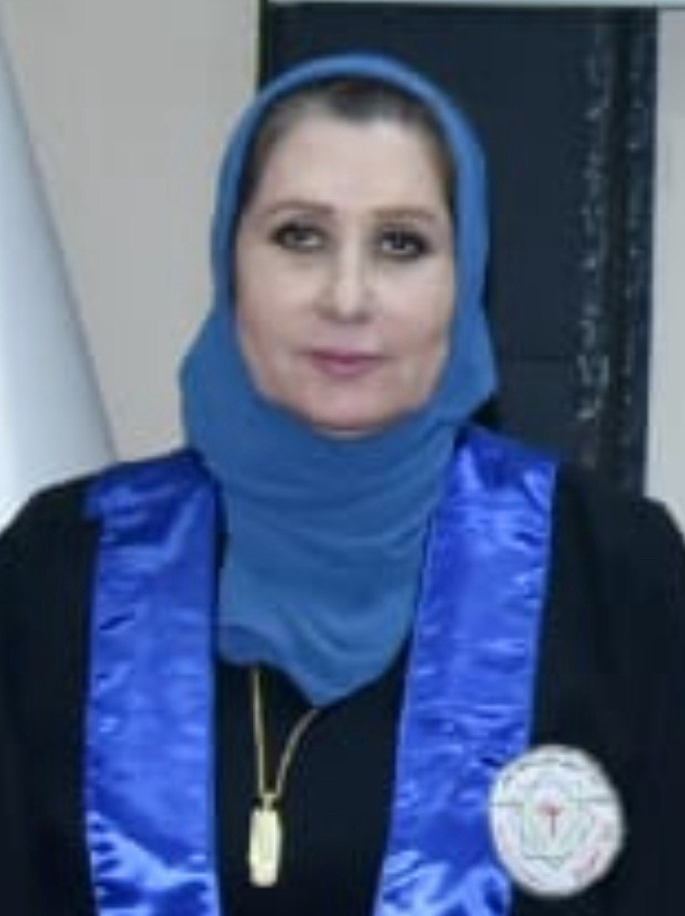

**Shatha Hussein Ali**

Professor Dr. in Clinical Biochemistry

Clinical laboratory Science Department

[shathahali@copharm.uobaghdad.edu.iq](mailto:shathahali@copharm.uobaghdad.edu.iq)

ORCID ID (0000-0002-3682-2386)

**Education**

* B.Sc. Pharmacy (1987), College of Pharmacy, University of Baghdad
* M.Sc. Clinical Pharmacy (1996), College of Pharmacy, University of Baghdad
* Ph.D. Clinical Biochemistry (2001), College of Pharmacy, University of Baghdad

**Training and Experience**

* Residency Pharmacist (1988) /Alwiya Gynecology Hospital -Baghdad

**Leaderships and Professionals**

* Head, Pharmcognosy & Medicinal plants Department, College of Pharmacy, University of Baghdad (2006-2008)
* Head, Clinical Laboratory Sciences Department, College of Pharmacy, University of Baghdad (2008-2011)
* Head, Clinical Laboratory Sciences Department, College of Pharmacy, University of Baghdad (2022-Now)
* Head of Promotions Unit , College of Pharmacy, University of Baghdad (2019-2021)
* Member, Iraqi Pharmacist Syndicate
* Member, Association of Diabetes(2018),Baghdad ,Iraq
* Member, Editorial board, Iraqi Journal of Pharmaceutical Sciences

**Teaching**

* Clinical Chemistry
* Training in Clinical Laboratories
* Advanced Clinical Chemistry II
* Advanced Clinical Chemistry III
* Advanced Clinical Chemistry IV
* Advanced Pharmaceutical Biochemistry

**Biography**

I graduated with Bachelor degree in Pharmacy from the University of Baghdad in 1987 , and then went to Alwiya Gynecology Hospital for a year as resident pharmacist .Later I came back to the College of Pharmacy –University of Baghdad , Department of Clinical laboratory sciences, specifically at the Biochemistry Laboratory .In 1992 I had the opportunity to study at the Clinical Pharmacy Department for a master Degree ,my thesis title was “ **Serum Trace Elements in Patients with Hyperthyroidism** “. Then I continue as a teacher in the college of Pharmacy until 1996 to do a Ph.D. on the "**Effects of Aspirin and Nicotinamide on Glycemic Control & Oxidative stress in Clinical and Experimental Diabetes** " under the supervision of Prof. Dr Wleed Raouf Sulaiman. Then I continued as a lecturer of biochemistry for the third stage students of the College of Pharmacy –University of Baghdad . In 2004 , I started teaching in the same College the fifth stage students ,both clinical biochemistry and Training in clinical laboratories , after my promotion to Assessment Professor Degree at the College of Pharmacy at University of Baghdad, I had been the head of the department of Pharmacognosy & Medicinal plants 2006-2008 ,then as the head of the department of Clinical laboratory sciences for the period 2008-2011 . At 2013 I’ve got promotion to a Professor of Clinical Biochemistry. At 2019 I took over as the Chief of the Scientific Promotion Unit at the College of Pharmacy –University of Baghdad .Later I had been honored as the head of the department of Clinical Laboratory Sciences at 2022-till now.

I had more than 75 published papers ,and supervised more than 15 PhD students and 27 MsC students in the specialty of Clinical Biochemistry.

**Research interest**

My research areas are mostly related to Diabetes mellitus & related complications , Thyroid disorders , ,Oxidative stress & I am also interested in most prevalent types of cancers in our community ,specifically to investigate their genetics bases.

**Publications**

**SCOPUS Profile Link** (https://www.scopus.com/authid/detail.uri?authorId=56452090300)

|  |  |
| --- | --- |
| [Title](https://scholar.google.com/citations?hl=en&user=5UD6xiIAAAAJ&view_op=list_works&sortby=title) | Year |
| **Impact of gene expression of NFE2L2 on serum superoxide dismutase and hemeoxygenase‑1 levels in patients with type 2 diabetes and retinopathy**  [Mhaibes, S.H.](https://www.scopus.com/authid/detail.uri?authorId=57217596825), [Ali, S.H.](https://www.scopus.com/authid/detail.uri?authorId=56452090300)  *World Academy of Sciences Journal*, 2024, 6(6), 65 | 2024 |
| **Role of rs2762934 and rs4809957 polymorphisms of CYP24A1 on outcomes of vitamin D treatment in postmenopausal osteoporotic women in Iraq**  [Abdulrahman, N.M.](https://www.scopus.com/authid/detail.uri?authorId=57221596986), [Ali, S.H.](https://www.scopus.com/authid/detail.uri?authorId=56452090300)  *Journal of Advanced Biotechnology and Experimental Therapeutics*, 2024, 7(1), pp. 65–73 | 2024 |
| **Impact of RAGE Gene rs80096349(C>T), rs1035798(C>T), and rs184003(G>T) Polymorphisms on Non-Response to Aspirin in Iraqi Patients with Coronary Artery Disease**  [Khudhair, F.A.](https://www.scopus.com/authid/detail.uri?authorId=57992347000), [Ali, S.H.](https://www.scopus.com/authid/detail.uri?authorId=56452090300), [Al-Zubeidi, K.A.](https://www.scopus.com/authid/detail.uri?authorId=58047040500)  *Journal of Medicinal and Chemical Sciences*, 2023, 6(7), pp. 1582–1597 | 2023 |
| **Integrin alpha-4 gene polymorphism in relation to natalizumab response in multiple sclerosis patients**  [Ahmed, F.T.](https://www.scopus.com/authid/detail.uri?authorId=57188588988), [Ali, S.H.](https://www.scopus.com/authid/detail.uri?authorId=56452090300), [Al Gawwam, G.A.](https://www.scopus.com/authid/detail.uri?authorId=57194689991)  *Neurology Asia*, 2023, 28(2), pp. 349–358 | 2023 |
| Correlation Between Integrin Alpha-4 Gene Polymorphisms And Failure To Respond To Natalizumab Therapy In Iraqi Multiple Sclerosis Patients  [Ahmed, F.T.](https://www.scopus.com/authid/detail.uri?authorId=57188588988), [Ali, S.H.](https://www.scopus.com/authid/detail.uri?authorId=56452090300), [Gawwam, G.A.A.](https://www.scopus.com/authid/detail.uri?authorId=57194689991)  *Farmacia*, 2023, 71(3), pp. 563–572 | 2023 |
| Study of Association between RAGE Gene Polymorphism rs2070600 (G82S) and Aspirin Resistance in Coronary Artery Disease Iraqi Patients with and without Type 2 Diabetes  [Khudair, F.A.](https://www.scopus.com/authid/detail.uri?authorId=57992347000), [Ali, S.H.](https://www.scopus.com/authid/detail.uri?authorId=56452090300), [Al-Nuaimi, A.A.M.](https://www.scopus.com/authid/detail.uri?authorId=57192201521)  *Journal of Pharmaceutical Negative Results*, 2022, 13(4), pp. 170–182 | 2022 |
| Role of PAD enzymes on histone citrullination in cancer  [Abdulrahman, N.](https://www.scopus.com/authid/detail.uri?authorId=57221596986), [Ali, S.](https://www.scopus.com/authid/detail.uri?authorId=56452090300)  *Medical Journal of Babylon*, 2022, 19(4), pp. 514–517 | 2022 |