

|  |  |
| --- | --- |
|  | Antidepressants |
|  | Lec: 8 |
|  | Asst. Prof. Dr. Ahmed Hamed jwaid  Pharmacology 1st  1/1/24 |

The symptoms of depression are feelings of sadness and hopelessness, as well as the inability to experience pleasure in usual activities, changes in sleep patterns and appetite, loss of energy, and suicidal thoughts. Mania is characterized by the opposite behavior: enthusiasm, anger, rapid thought and speech patterns, extreme self-confidence, and impaired judgment.

**MECHANISM OF ANTIDEPRESSANT DRUGS**

Most antidepressant drugs potentiate, either directly or indirectly, the actions of norepinephrine and/or serotonin (5-HT) in the brain. This, along with other evidence, led to the **biogenic amine theory**, which proposes that depression is due to a deficiency of monoamines, such as norepinephrine and serotonin, at certain key sites in the brain. Conversely, the theory proposes that mania is caused by an overproduction of these neurotransmitters. However, the biogenic amine theory of depression and mania is overly simplistic. It fails to explain the time course for a therapeutic response, which usually occurs over several weeks compared to the immediate pharmacodynamic effects of the agents, which are usually immediate. This suggests that decreased reuptake of neurotransmitters is only an initial effect of the drugs, which may not be directly responsible for the antidepressant effects.

**SELECTIVE SEROTONIN REUPTAKE INHIBITORS**

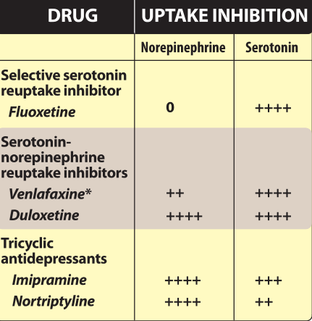 The selective serotonin reuptake inhibitors (SSRIs) are a group of antidepressant drugs that specifically inhibit serotonin reuptake, having 300- to 3000-fold greater selectivity for the serotonin transporter, as compared to the norepinephrine transporter. This contrasts with the tricyclic antidepressants (TCAs) and serotonin-norepinephrine reuptake inhibitors (SNRIs) that non-selectively inhibit the reuptake of norepinephrine and serotonin.

Moreover, the SSRIs have little blocking activity at muscarinic, α-adrenergic, and histaminic H, receptors. Because they have different adverse effects and are relatively safe in overdose, the SSRIs have largely replaced TCAs and monoamine oxidase inhibitors (MAOIs) as the drugs of choice in treating depression. The SSRIs include **fluoxetine** (the prototypic drug), **citalopram, escitalopram, fluvoxamine, paroxetine**, and **sertraline**. Escitalopram is the pure S-enantiomer of citalopram.

**A. Actions** The SSRIs block the reuptake of serotonin, leading to increased concentrations of the neurotransmitter in the synaptic cleft. Antidepressants, including SSRIs, typically take at least 2 weeks to produce significant improvement in mood, and maximum benefit may require up to 12 weeks or more.

**B. Therapeutic uses** The primary indication for SSRIs is depression. A number of other psychiatric disorders also respond favorably to SSRIs, including obsessive-compulsive disorder, panic disorder, generalized anxiety disorder, posttraumatic stress disorder, social anxiety disorder, premenstrual dysphoric disorder, and bulimia nervosa (only fluoxetine is approved for bulimia).

**C. Pharmacokinetics** Fluoxetine differs from the other members of the class by having a much longer half-life (50 hours), and the half-life of its active metabolite 5-norfluoxetine is quite long, averaging 10 days. Fluoxetine and paroxetine are potent inhibitors of a CYP450 isoenzyme (CYP2D6). Other CYP450 isoenzymes are involved with SSRI metabolism and may also be inhibited to various degrees by the SSRIs.

**D. Adverse effects** Although the SSRIs are considered to have fewer and less severe adverse effects than the TCAs and MAOIs, the SSRIs are not without adverse effects, such as headache, sweating, anxiety and agitation, hyponatremia, gastrointestinal (GI) effects (nausea, vomiting, and diarrhea), weakness and fatigue, sexual dysfunction, changes in weight, sleep disturbances (insomnia and somnolence)

**1. Sleep disturbances:** Paroxetine and fluvoxamine are generally more sedating than activating, and they may be useful in patients who have difficulty sleeping. Conversely, patients who are fatigued or complaining of excessive somnolence may benefit from one of the more activating SSRIs, such as fluoxetine or sertraline.

**2. Sexual dysfunction:** Sexual dysfunction, which may include loss of libido, delayed ejaculation, and anorgasmia, is common with the SSRIs.

**3. Use in children and teenagers:** Antidepressants should be used cautiously in children and teenagers, because of reports of suicidal ideation as a result of SSRI treatment. Pediatric patients should be observed for worsening depression and suicidal thinking with initiation or dosage change of any antidepressant. Fluoxetine, sertraline, and fluvoxamine are approved for use in children to treat obsessive-compulsive disorder, and fluoxetine and escitalopram are approved to treat childhood depression.

**4. Overdose:** Overdose with SSRIs does not usually cause cardiac arrhythmias, with the exception of citalopram, which may cause QT prolongation. Seizures are a possibility because all antidepressants may lower the seizure threshold. SSRIs have the potential to cause serotonin syndrome, especially when used in the presence of an MAO-I or other highly serotonergic drug. Serotonin syndrome may include the symptoms of hyperthermia, muscle rigidity, sweating, myoclonus (clonic muscle twitching), and changes in mental status and vital signs.

**5. Discontinuation syndrome:** SSRIs have the potential to cause a discontinuation syndrome after their abrupt withdrawal, particularly the agents with shorter half-lives and inactive metabolites. Fluoxetine has the lowest risk of causing an SSRI discontinuation syndrome due to its longer half-life and active metabolite. Possible signs and symptoms of SSRI discontinuation syndrome include headache, malaise and flu-like symptoms, agitation and irritability, nervousness, and changes in sleep pattern.

**SEROTONIN-NOREPINEPHRINE REUPTAKE INHIBITORS**

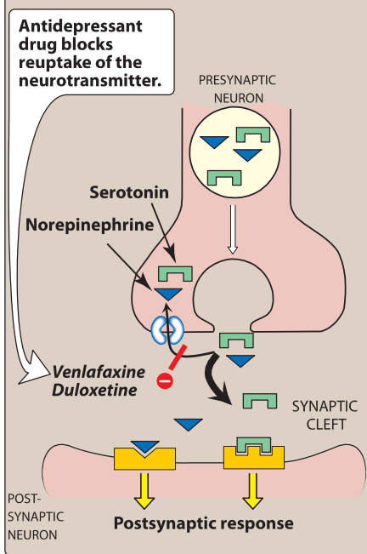**Venlafaxine, desvenlafaxine, levomilnacipran,** and **duloxetine** inhibit the reuptake of both serotonin and norepinephrine and, thus, are termed SNRIs.

Depression is often accompanied by chronic pain, such as backache and muscle aches, for which SSRIs are relatively ineffective. This pain is, in part, modulated by serotonin and norepinephrine pathways in the central nervous system. With dual inhibition of serotonin and norepinephrine reuptake, both the SNRIs and the TCAs may be effective in relieving pain. These agents are also used in the treatment of pain syndromes, such as diabetic peripheral neuropathy, postherpetic neuralgia, fibromyalgia, and low back pain. The SNRIs, unlike the TCAs, have little activity at α-adrenergic, muscarinic, or histamine receptors and, thus, have fewer receptor-mediated adverse effects than the TCAs. The SNRIs may precipitate a discontinuation syndrome if treatment is abruptly stopped.

**A. Venlafaxine and desvenlafaxine** Venlafaxine is an inhibitor of serotonin reuptake and, at medium to higher doses, is an inhibitor of norepinephrine reuptake. Venlafaxine has minimal inhibition of the CYP450 isoenzymes and is a substrate of the CYP2D6 isoenzyme. Desvenlafaxine is the active, demethylated metabolite of venlafaxine. The most common side effects of venlafaxine are nausea, headache, sexual dysfunction, dizziness, insomnia, sedation, and constipation. At high doses, there may be an increase in blood pressure and heart rate. The clinical activity and adverse effect profile of desvenlafaxine are similar to that of venlafaxine.

**B. Duloxetine** Duloxetine inhibits serotonin and norepinephrine reuptake at all doses. It is extensively metabolized in the liver to inactive metabolites and should be avoided in patients with liver dysfunction. Gl side effects are common with duloxetine, including nausea, dry mouth, and constipation. Insomnia, dizziness, somnolence, sweating, and sexual dysfunction are also seen. Duloxetine may increase blood pressure or heart rate. Duloxetine is a moderate inhibitor of CYP2D6 isoenzymes and may increase concentrations of drugs metabolized by this pathway, such as antipsychotics.

**C. Levomilnacipran** Levomilnacipran is an enantiomer of milnacipran (an older SNRI used for the treatment of depression in Europe and fibromyalgia in the United States). The adverse effect profile of levomilnacipran is similar to other SNRIs. It is primarily metabolized by CYP3A4, and, thus, activity may be altered by inducers or inhibitors of this enzyme system.

**ATYPICAL ANTIDEPRESSANTS**

The atypical antidepressants are a mixed group of agents that have actions at several different sites. This group includes **bupropion, mirtazapine, nefazodone, trazodone, vilazodone,** and **vortioxetine**.

**A. Bupropion** Bupropion is a weak dopamine and norepinephrine reuptake inhibitor that is used to alleviate the symptoms of depression. Bupropion is also useful for decreasing cravings and attenuating withdrawal symptoms of nicotine in patients trying to quit smoking. Side effects may include dry mouth, sweating, nervousness, tremor, and a dose dependent increased risk for seizures. It has a very low incidence of sexual dysfunction. Bupropion is metabolized by the CYP2B6 pathway and has a relatively low risk for drug-drug interactions, given the few agents that inhibit/induce this enzyme. Use of bupropion should be avoided in patients at risk for seizures or those who have eating disorders such as bulimia.

**B. Mirtazapine** Mirtazapine enhances serotonin and norepinephrine neurotransmission by serving as an antagonist at central presynaptic α2 receptors. Additionally, some of the antidepressant activity may be related to antagonism at 5-HT2 receptors. It is sedating because of its potent antihistaminic activity, but it does not cause the antimuscarinic side effects of the TCAs or interfere with sexual function like the SSRIs. Sedation, increased appetite, and weight gain frequently occur.

**C. Nefazodone and trazodone** These drugs are weak inhibitors of serotonin reuptake and are also antagonists at the postsynaptic 5-HT2a receptor. Both agents are sedating, probably because of their potent histamine H1-blocking activity. Trazodone is commonly used off-label for the management of insomnia. Trazodone has been associated with priapism, and nefazodone has been associated with a risk for hepatotoxicity. Both agents also have mild-to-moderate α1 receptor antagonism, contributing to orthostasis and dizziness.

**D. Vilazodone** Vilazodone is a serotonin reuptake inhibitor and a 5-HT1a receptor partial agonist. Although the extent to which the 5-HT1a receptor activity contributes to its therapeutic effects is unknown, this possible mechanism of action renders it unique from that of the SSRIs. The adverse effect profile of vilazodone is similar to the SSRIs, including a risk for discontinuation syndrome if abruptly stopped.

**E. Vortioxetine** Vortioxetine utilizes a combination of serotonin reuptake inhibition, 5-HT1a agonism, and 5-HT3 and 5-HT7 antagonism as its suggested mechanisms of action to treat depression. It is unclear to what extent the activities other than inhibition of serotonin reuptake influence the overall effects of vortioxetine. The common adverse effects include nausea, constipation, and sexual dysfunction, which may be expected due to its serotonergic mechanisms.

**TRICYCLIC ANTIDEPRESSANTS**

The TCAs inhibit norepinephrine and serotonin reuptake into the presynaptic neuron and, thus, if discovered today, might have been referred to as SNRIs, except for their differences in adverse effects relative to this newer class of antidepressants. The TCAs include the tertiary amines imipramine {the prototype drug), amitriptyline, clomipramine, doxepin, and trimipramine, and the secondary amines desipramine and nortriptyline {the N-demethylated metabolites of imipramine and amitriptyline, respectively) and protriptyline. Maprotiline and amoxapine are related "tetracyclic" antidepressant agents and are commonly included in the general class of TCAs.

**A. Mechanism of action**

1. Inhibition of neurotransmitter reuptake: TCAs and amoxapine are potent inhibitors of the neuronal reuptake of norepinephrine and serotonin into presynaptic nerve terminals. Maprotiline and desipramine are relatively selective inhibitors of norepinephrine reuptake.

2. Blocking of receptors: TCAs also block serotonergic, α-adrenergic, histaminic, and muscarinic receptors. It is not known if any of these actions produce the therapeutic benefit of the TCAs. However, actions at these receptors are likely responsible for many of their adverse effects. Amoxapine also blocks 5-HT2 and dopamine D2 receptors.

**B. Actions** The TCAs improve mood, in 50% to 70% of individuals with major depression. The onset of the mood elevation is slow, requiring 2 weeks or longer. Patient response can be used to adjust dosage. Tapering of these agents is recommended to minimize discontinuation syndromes and cholinergic rebound effects.

**C. Therapeutic uses** The TCAs are effective in treating moderate to severe depression. Some patients with panic disorder also respond to TCAs. Imipramine is used as an alternative to desmopressin or non-pharmacologic therapies (enuresis alarms) in the treatment of bed-wetting in children. The TCAs, particularly amitriptyline, have been used to help prevent migraine headache and treat chronic pain syndromes (for example, neuropathic pain) in a number of conditions for which the cause of pain is unclear. Low doses of TCAs, especially doxepin, can be used to 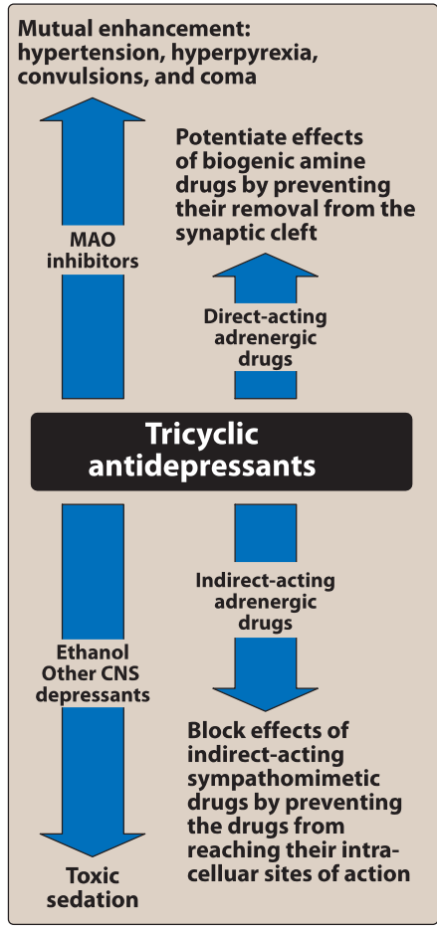treat insomnia.

**D. Pharmacokinetics** TCAs are well absorbed upon oral administration. As a result of their variable first-pass metabolism in the liver, TCAs have low and inconsistent bioavailability. These drugs are metabolized by the hepatic microsomal system (and, thus, may be sensitive to agents that induce or inhibit the CYP450 isoenzymes) and conjugated with glucuronic acid. Ultimately, the TCAs are excreted as inactive metabolites via the kidney.

**E. Adverse effects** Blockade of muscarinic receptors leads to blurred vision, xerostomia, urinary retention, sinus tachycardia, constipation, and aggravation of angle-closure glaucoma. These agents affect cardiac conduction similar to quinidine and may precipitate life-threatening arrhythmias in an overdose situation. The TCAs also block α-adrenergic receptors, causing orthostatic hypotension, dizziness, and reflex tachycardia. Sedation is related to the ability of these drugs to block histamine H1 receptors. Weight gain is a common adverse effect of the TCAs. Sexual dysfunction occurs in a minority of patients, and the incidence is lower than that associated with the SSRIs.

All antidepressants, including TCAs, should be used with caution in patients with bipolar disorder, even during their depressed state, because antidepressants may cause a switch to manic behavior. The TCAs have a narrow therapeutic index (for example, five- to sixfold the maximal daily dose of imipramine can be lethal). Depressed patients who are suicidal should be given only limited quantities of these drugs and be monitored closely.

The TCAs may exacerbate certain medical conditions, such as benign prostatic hyperplasia, epilepsy, and preexisting arrhythmias.

**MONOAMINE OXIDASE INHIBITORS**

Monoamine oxidase (MAO) is a mitochondrial enzyme found in nerve and other tissues, such as the gut and liver. In the neuron, MAO functions as a "safety valve" to oxidatively deaminate and inactivate any excess neurotransmitters (for example, norepinephrine, dopamine, and serotonin) that may leak out of synaptic vesicles when the neuron is at rest. The MAOIs may irreversibly or reversibly inactivate the enzyme, permitting neurotransmitters to escape degradation and, therefore, to accumulate within the presynaptic neuron and leak into the synaptic space. The four MAOIs currently available for the treatment of depression include **phenelzine, tranylcypromine, isocarboxazid, and selegiline**. [Note: Selegiline is also used for the treatment of Parkinson disease. It is the only antidepressant available in a transdermal delivery system.] Use of MAOIs is limited due to the complicated dietary restrictions required while taking these agents.

**A. Mechanism of action** Most MAOIs, such as phenelzine, form stable complexes with the enzyme, causing irreversible inactivation. This results in increased stores of norepinephrine, serotonin, and dopamine within the neuron and subsequent diffusion of excess neurotransmitter into the synaptic space. These drugs inhibit not only MAO in the brain but also MAO in the liver and gut that catalyzes oxidative deamination of drugs and potentially toxic substances, such as **tyramine,** which is found in certain foods. The MAOIs, therefore, show a high incidence of drug-drug and drug-food interactions. Selegiline administered as the transdermal patch may produce less inhibition of gut and hepatic MAO at low doses because it avoids first-pass metabolism.

**B. Actions** Although MAO is fully inhibited after several days of treatment, the antidepressant action of the MAOIs, like that of the SSRIs, SNRIs, and TCAs, is delayed several weeks. Selegiline and tranylcypromine have an amphetamine-like stimulant effect that may produce agitation or insomnia.

**C. Therapeutic uses** The MAOIs are indicated for depressed patients who are unresponsive or intolerant of other antidepressants. Because of their risk for drug-drug and drug-food interactions, the MAOIs are considered last-line agents in many treatment settings.

**D. Pharmacokinetics** These drugs are well absorbed after oral administration. **Enzyme regeneration,** when irreversibly inactivated, varies, but it usually occurs several weeks after termination of the drug. Thus, when switching antidepressant agents, a minimum of 2 weeks of delay must be allowed after termination of MAOI therapy and the initiation of another antidepressant from any other class. MAOIs are hepatically metabolized and excreted rapidly in urine.

**E. Adverse effects** Severe and often unpredictable side effects, due to drug-food and drug-drug interactions, limit the widespread use of MAOIs. For example, tyramine, which is contained in foods, such as aged cheeses and meats, liver, pickled or smoked fish, and red wines, is normally inactivated by MAO in the gut. Individuals receiving a MAOI are unable to degrade tyramine obtained from the diet. Tyramine causes the release of large amounts of stored catecholamines from nerve terminals, resulting in a hypertensive crisis, with signs and symptoms such as occipital headache, stiff neck, tachycardia, nausea, hypertension, cardiac arrhythmias, seizures, and, possibly, stroke. Patients must, therefore, be educated to avoid tyramine containing foods. Other possible adverse effects of treatment with MAOIs include drowsiness, orthostatic hypotension, blurred vision, dry mouth, and constipation. SSRIs should not be co-administered with MAOIs due to the risk of serotonin syndrome. Both SSRIs and MAOIs require a washout period of at least 2 weeks before the other type is administered, with the exception of fluoxetine, which should be discontinued at least 6 weeks before an MAOI is initiated. In addition, the MAOIs have many other critical drug interactions, and caution is required when administering these agents concurrently with other drugs.

**SEROTONIN-DOPAMINE ANTAGONISTS**

While 60% to 80% of patients respond favorably to antidepressants, 20% to 40% experience a partial or poor response to monotherapy. The serotonin-dopamine antagonists (SDAs), or atypical antipsychotics, are occasionally used as adjunctive treatments to antidepressants in partial responders. **Aripiprazole, brexpiprazole, quetiapine,** and the combination of fluoxetine and olanzapine are approved for use as adjuncts in major depressive disorder (MOD).

**MANIA AND BIPOLAR DISORDER**

The treatment of bipolar disorder has increased in recent years due to increased recognition of the disorder and also an increase in the number of available medications for the treatment of mania.

**A. Lithium** Lithium salts are used acutely and prophylactically for managing bipolar patients. Lithium is effective in treating 60% to 80% of patients exhibiting mania and hypomania. Although many cellular processes are altered by treatment with lithium, the mode of action is unknown. The therapeutic index of lithium is extremely low, and lithium can be toxic. Common adverse effects may include headache, dry mouth, polydipsia, polyuria, polyphagia, Gl distress, fine hand tremor, dizziness, fatigue, dermatologic reactions, and sedation. Adverse effects due to higher plasma levels may indicate toxicity and include ataxia, slurred speech, coarse tremors, confusion, and convulsions. Thyroid function may be decreased and should be monitored. Lithium is renally eliminated, and though caution should be used when dosing this drug in renally impaired patients, it may be the best choice in patients with hepatic impairment.

**B. Other drugs** Several antiepileptic drugs, including **carbamazepine, valproic acid,** and **lamotrigine** are approved as mood stabilizers for bipolar disorder. Other agents that may improve manic symptoms include the older (**chlorpromazine and haloperidol**) and newer antipsychotics. The atypical antipsychotics risperidone, olanzapine, aripiprazole and quetiapine are also used for the management of mania.