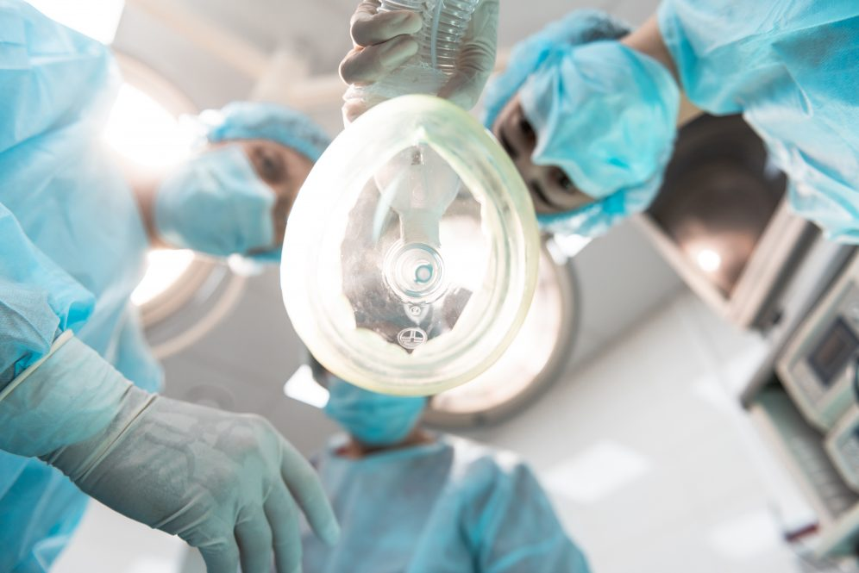

|  |  |
| --- | --- |
|  | **Anesthetic Drugs** |
|  |  |
|  | Assit. Prof. Dr. Ahmed Hamed Jwaid  Pharmacology 4th year students  1/1/24 |

**OVERVIEW** For patients undergoing surgical or medical procedures, different levels of sedation can provide important benefits to facilitate procedural interventions. These levels of sedation range from anxiolysis to general anesthesia and can create:

• Sedation and reduced anxiety

• Lack of awareness and amnesia

• Skeletal muscle relaxation

• Suppression of undesirable reflexes

• Analgesia

Because no single agent provides all desired objectives, several categories of drugs are combined to produce the optimum level of sedation required. Drugs are chosen to provide safe and efficient sedation based on the type and duration of the procedure and patient characteristics, such as organ function, medical conditions, and concurrent medications.

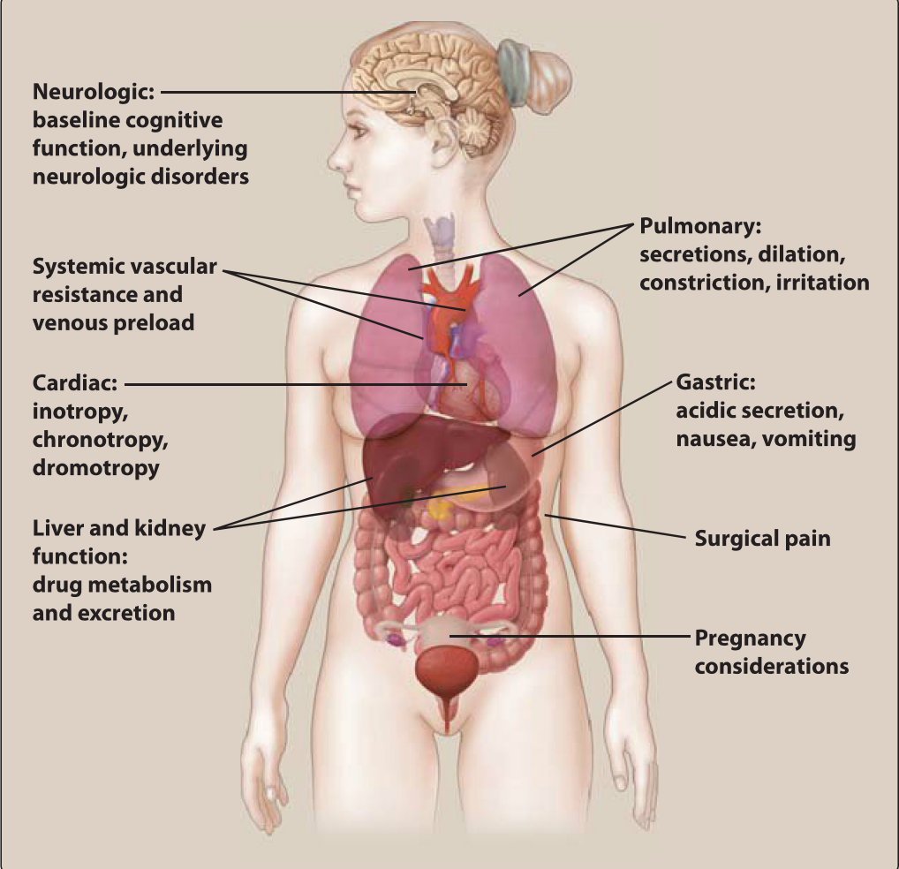

Preoperative medications provide anxiolysis and analgesia and mitigate unwanted side effects of the anesthetic or the procedure itself. Neuromuscular blockers enable endotracheal intubation and muscle relaxation to facilitate surgery. Potent general anesthetic medications are delivered via inhalation and/or intravenously. Except for nitrous oxide, inhaled anesthetics are volatile, halogenated hydrocarbons, while intravenous (IV) anesthetics consist of several chemically unrelated drug classes commonly used to rapidly induce and/ or maintain a state of general anesthesia.

**LEVELS OF SEDATION**

The levels of sedation occur in a dose-related continuum, which is variable and depends on individual patient response to various drugs. These "artificial" levels of sedation start with light sedation (anxiolysis) and continue to moderate sedation, then deep sedation, and finally a state of general anesthesia. The hallmarks of escalation from one level to the next are recognized by changes in mentation, hemodynamic stability, and respiratory competency.

**STAGES OF GENERAL ANESTHESIA**

General anesthesia is a reversible state of central nervous system (CNS) depression, causing loss of response to and perception of stimuli. The state of general anesthesia can be divided into three stages: **induction, maintenance, and recovery**. Induction is the time from administration of a potent anesthetic to development of unconsciousness, while maintenance is the sustained period of general anesthesia. Recovery starts with the discontinuation of the anesthetic and continues until the return of consciousness and protective reflexes. Induction of anesthesia depends on how fast effective concentrations of anesthetic reach the brain. Recovery is essentially the reverse of induction and depends on how fast the anesthetics diffuses from the brain. The depth of general anesthesia is the degree to which the CNS is depressed, as evident in electroencephalograms.

**A. Induction** General anesthesia in adults is normally induced with an IV agent like **propofol**, producing unconsciousness in 30 to 40 seconds. Often, an IV neuromuscular blocker such as **rocuronium, vecuronium, or succinylcholine** is administered to facilitate endotracheal intubation by eliciting muscle relaxation. For children without IV access, non-pungent volatile agents, such as **sevoflurane**, are administered via inhalation to induce general anesthesia.

**B. Maintenance of anesthesia** After administering the induction drug, vital signs and response to stimuli are vigilantly monitored to balance the amount of drug continuously inhaled or infused to maintain general anesthesia. Maintenance is commonly provided with volatile anesthetics, although total intravenous anesthesia (TIVA) with drugs like propofol can be used to maintain general anesthesia. Opioids such as **fentanyl** are used for analgesia along with inhalation agents, because the latter alter consciousness but not perception of pain.

**C. Recovery** After cessation of the maintenance anesthetic drug, the patient is evaluated for return of consciousness. For most anesthetic agents, redistribution from the site of action (rather than metabolism of the drug) underlies recovery. Neuromuscular blocking drugs are typically reversed after completion of surgery, unless enough time has elapsed for their metabolism. The patient is monitored to assure full recovery of all normal physiologic functions (spontaneous respiration, blood pressure, heart rate, and all protective reflexes).

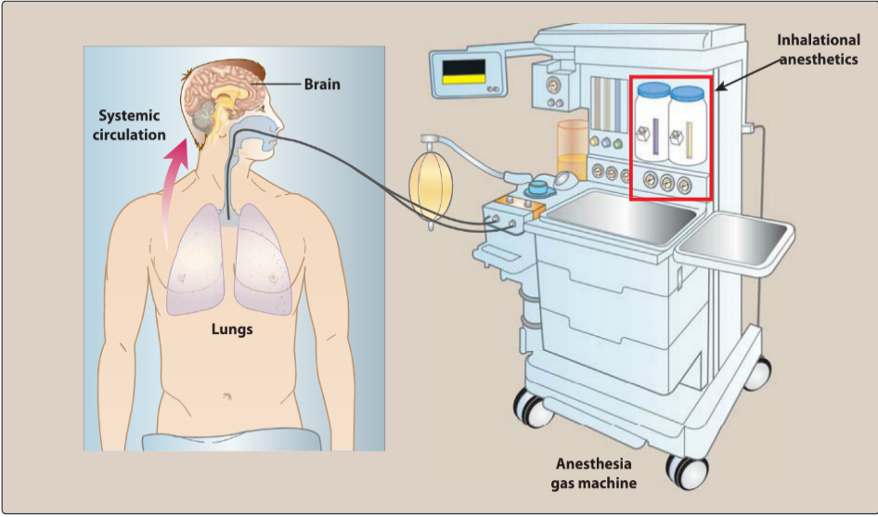**INHALATION ANESTHETICS**

Inhaled gases are used primarily for maintenance of anesthesia after administration of an IV drug.

Depth of anesthesia can be rapidly altered by changing the inhaled gas concentration. Inhalational agents have steep dose-response curves with very narrow therapeutic indices, so the difference in concentrations from eliciting general anesthesia to cardiopulmonary collapse is small. No antagonists exist. To minimize waste, inhaled gases are delivered in a recirculation system that contains absorbents to remove carbon dioxide and allow rebreathing of the gas.

**A. Common features of Inhalation anesthetics** Modern inhalation anesthetics are nonflammable, nonexplosive agents, which include **nitrous oxide** and volatile, halogenated hydrocarbons. These agents decrease cerebrovascular resistance, resulting in increased brain perfusion. The following factors play a role in induction and recovery:

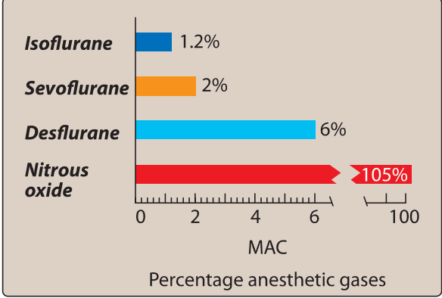**B. Potency** Potency is defined quantitatively as the minimum alveolar concentration (MAC), which is the end-tidal concentration of inhaled anesthetic needed to eliminate movement in 50% of patients exposed to a noxious stimulus. MAC is the median effective dose (ED50) of the anesthetic, expressed as the percentage of gas in a mixture required to achieve that effect. Numerically, MAC is small for potent anesthetics such as isoflurane and large for less potent agents such as nitrous oxide. Thus, the inverse of MAC is an index of potency.

Nitrous oxide alone cannot produce general anesthesia because any admixture with a survivable oxygen percentage cannot reach its MAC value. The more lipid soluble an anesthetic, the lower the concentration needed to produce anesthesia and, therefore, the higher the potency. Factors that can increase MAC (make the patient more resistant) include hyperthermia, drugs that increase CNS catecholamines, and chronic ethanol abuse. Factors that can decrease MAC (make the patient more sensitive) include increased age, hypothermia, pregnancy, sepsis, acute intoxication, concurrent IV anesthetics, and α2 adrenergic receptor agonists (clonidine and dexmedetomidine)

**C. Uptake and distribution of inhalation anesthetics**

The principal objective of inhalation anesthesia is a constant and optimal brain partial pressure (Pbr) of inhaled anesthetic (to create a part pressure equilibrium between alveoli [Pa1v] and brain (Pbr)Measuring the Pa1v is the most practical and feasible way to ascertain the Pbr, for the inhaled anesthetic concentration, but this necessitates adequate time for the two compartments to reach equilibrium. The partial pressure of an anesthetic gas that originates by pulmonary entry is the driving force moving the gas from the alveolar space into the bloodstream (Pa), which transports the drug to the brain and other body compartments. Because gases move from one body compartment to another according to partial pressure gradients, steady state is achieved when the partial pressure in each of these compartments is equivalent to that in the inspired mixture.

**Anesthetic uptake (removal to peripheral tissues other than the brain):** Uptake is the product of the gas solubility in the blood, cardiac output (CO), and gradient between alveolar and blood anesthetic partial pressures.

**a. Solubility in blood:** This is determined by a physical property of the anesthetic called the blood: gas partition coefficient (the ratio of the concentration of anesthetic in the liquid [blood] phase to the concentration of anesthetic in the gas phase when the anesthetic is in equilibrium between the two phases.

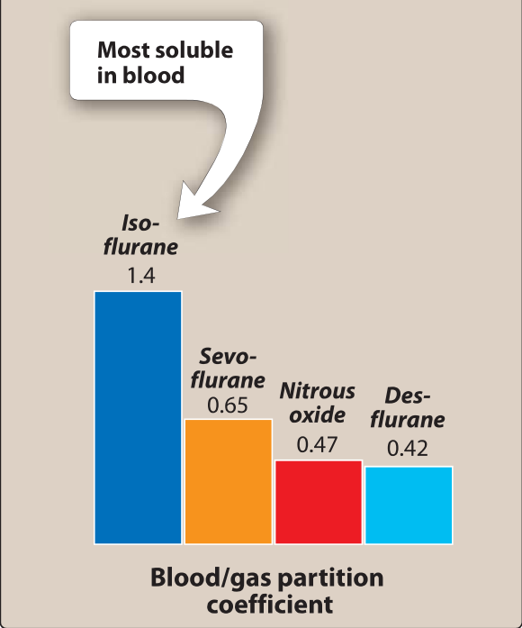

For inhaled anesthetics, think of the blood as a pharmacologically inactive reservoir. Drugs with low versus high blood solubility differ in their rate of induction of anesthesia. When an anesthetic gas with low blood solubility such as nitrous oxide diffuses from the alveoli into the circulation, little anesthetic dissolves in the blood. Therefore, equilibrium between the inspired anesthetic and arterial blood occurs rapidly with relatively few additional molecules of anesthetic required to raise the arterial anesthetic partial pressure. By contrast, anesthetic gases with high blood solubility, such as isoflurane, dissolve more fully in the blood; therefore, greater amounts of gas and longer periods of time are required to raise blood partial pressure. This results in longer periods for induction, recovery, and time to change in depth of anesthesia in response to changes in the drug concentration. The solubility in blood is ranked as follows: **isoflurane > sevoflurane > nitrous oxide > desflurane.**

**b. Cardiac output**: CO is inversely correlated with induction time for inhaled anesthetics. This counterintuitive phenomenon is explained by the threshold of drug concentration required to alter neuronal activity and the time neurons are exposed to the drug in the passing blood. During low CO, a longer period of time permits a larger concentration of gas to dissolve in the slowly moving bloodstream. Furthermore, this large bolus of drug has longer contact time to diffuse into neuronal tissue when it traverses the blood-brain barrier. Although a high CO will quickly transport the drug to the brain, a lower concentration of the drug with a shorter exposure time slows down the rate of induction.

**3. Effect of different tissue types on anesthetic uptake:** The time required for a tissue compartment to reach steady state with the partial pressure of the inspired anesthetic gas is inversely proportional to the blood flow to that tissue (greater flow equals less time to reach equilibrium). Time to steady state is directly proportional to the capacity of that tissue to store anesthetic (greater storage capacity equals longer time to reach equilibrium). Furthermore, capacity is directly proportional to the volume of tissue and the tissue: blood solubility coefficient of the gas. Four major tissue compartments determine the time course of anesthetic uptake: **a. Vessel-rich group (brain, heart, liver, kidney, and endocrine glands):** Highly perfused tissues rapidly attain steady state with the partial pressure of anesthetic in the blood.

**b. Skeletal muscles:** These tissues are moderately perfused with a large storage capacity, which lengthens the time required to achieve steady state.

**c. Fat:** Fat is poorly perfused but has a very large storage capacity for the highly lipophilic volatile anesthetics. This poor perfusion to a high-capacity compartment drastically prolongs the time required to achieve steady state.

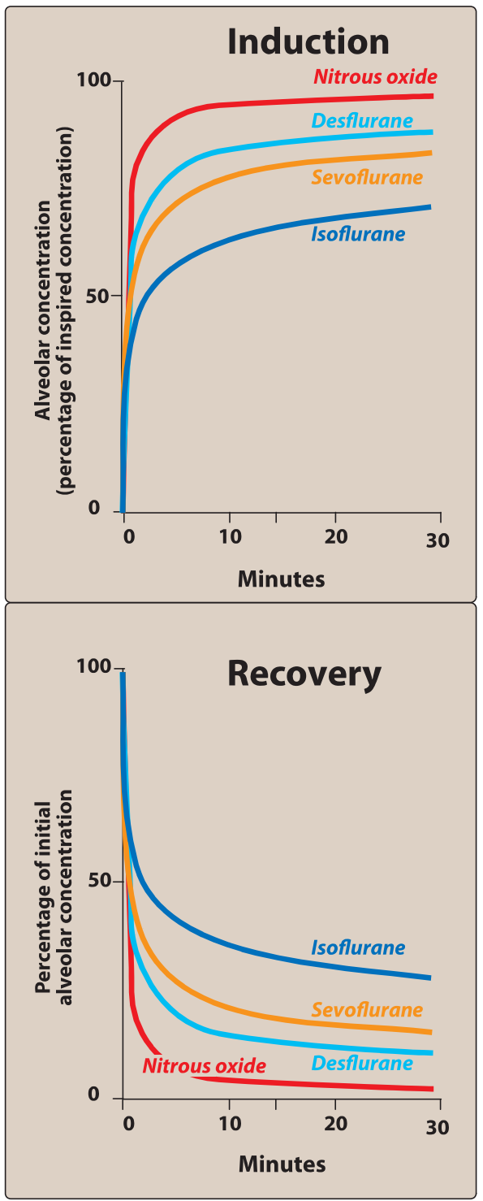**d. Vessel-poor group (bone, ligaments, and cartilage):** These are very poorly perfused and have a low capacity to store anesthetic gas. Therefore, these tissues have minimal impact on the time course of anesthetic distribution in the body. **4. Washout:** When an inhalation anesthetic gas is removed from the inspired admixture, the body becomes the repository of anesthetic gas to be circulated back to the alveolar compartment. The same factors that influence uptake and equilibrium of the inspired anesthetic determine the time course of its exhalation from the body. Thus, nitrous oxide exits the body faster than does isoflurane.

**D. Mechanism of action**

No specific receptor has been identified as the locus to create a state of general anesthesia. At clinically effective concentrations, general anesthetics increase the sensitivity of the gamma-aminobutyric acid (GABAA) receptors to the inhibitory neurotransmitter GABA. This increases chloride ion influx and hyperpolarization of neurons. Postsynaptic neuronal excitability and, thus, CNS activity are diminished.

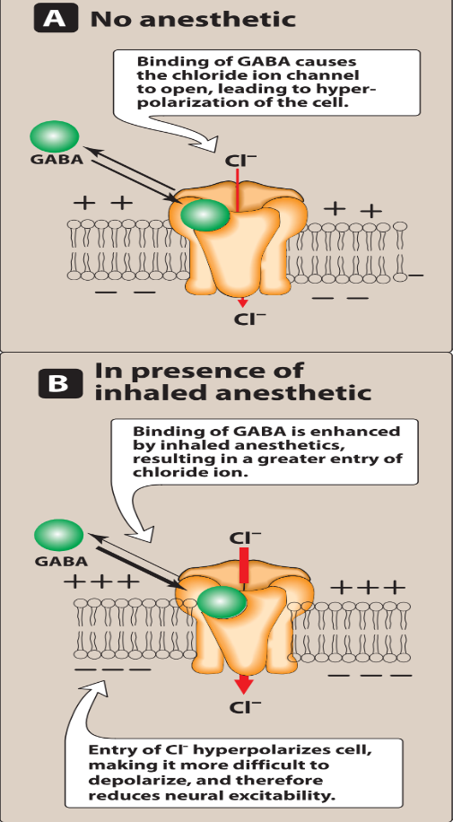

Unlike other anesthetics, nitrous oxide and ketamine do not have actions on GABAA receptors. Their effects are mediated via inhibition of N-methyl-D-aspartate (NMDA) receptors. [Note: The NMDA receptor is a glutamate receptor, which is the body's main excitatory neurotransmitter.] Receptors other than GABA that are affected by volatile anesthetics include the inhibitory glycine receptors found in the spinal motor neurons. Additionally, inhalation anesthetics block excitatory postsynaptic currents found on nicotinic receptors. However, the mechanisms by which anesthetics perform these modulatory roles are not fully understood.

**lsoflurane**

like other halogenated gases, produces dose-dependent hypotension predominantly from relaxation of systemic vasculature. Hypotension can be treated with a direct-acting vasoconstrictor, such as phenylephrine. Because it undergoes little metabolism, isoflurane is considered nontoxic to the liver and kidney. Its pungent odor stimulates respiratory reflexes (breath holding, salivation, coughing, laryngospasm), so it is not used for inhalation induction. With a higher blood solubility than desflurane and sevoflurane, isoflurane takes longer to reach equilibrium, making it less ideal for short procedures; however, its low cost makes it a good option for longer surgeries.

**Desflurane**

provides very rapid onset and recovery due to low blood solubility. This makes it a popular anesthetic for short procedures. It has a low volatility, which requires administration via a special heated vaporizer. Like isoflurane, it decreases vascular resistance and perfuses all major tissues very well. Desflurane has significant respiratory irritation like isoflurane so it should not be used for inhalation induction. Its degradation is minimal and tissue toxicity is rare.

**Sevoflurane**

has low pungency or respiratory irritation. This makes it useful for inhalation induction, especially with pediatric patients who do not tolerate IV placement. It has a rapid onset and recovery due to low blood solubility. Sevoflurane has low hepatotoxic potential.

**Nitrous oxide**

("laughing gas") is a nonirritating potent sedative that is unable to create a state of general anesthesia. It is frequently used at concentrations of 30% to 50% in combination with oxygen to create moderate sedation, particularly in dentistry. Nitrous oxide does not depress respiration, and maintains cardiovascular hemodynamics as well as muscular strength. Nitrous oxide can be combined with other inhalational agents to establish general anesthesia, which lowers the required concentration of the combined volatile agent. This gas admixture further reduces many unwanted side effects of the other volatile agent that impact cardiovascular output and cerebral blood flow. Nitrous oxide is poorly soluble in blood and other tissues, allowing it to move very rapidly in and out of the body.

**Malignant hyperthermia** In a very small percentage of susceptible patients, exposure to halogenated hydrocarbon anesthetics (or succinylcholine) may induce malignant hyperthermia (MH), a rare life-threatening condition. MH causes a drastic and uncontrolled increase in skeletal muscle oxidative metabolism, massive the body's capacity to supply oxygen, remove carbon dioxide, and regulate temperature, eventually leading to circulatory collapse and death if not treated immediately. Strong evidence indicates that MH is due to an excitation-contraction coupling defect. Susceptibility to MH is often inherited as an autosomal dominant disorder. Should a patient exhibit symptoms of MH, **dantrolene** is given as the anesthetic mixture is withdrawn, and measures are taken to rapidly cool the patient. **Dantrolene** blocks release of Ca 2+ from the sarcoplasmic reticulum of muscle cells, reducing heat production and relaxing muscle tone.

**INTRAVENOUS ANESTHETICS**

IV anesthetics cause rapid induction of anesthesia often occurring in 1 minute or less. It is the most common way to induce anesthesia before maintenance of anesthesia with an inhalation agent. IV anesthetics may be used as single agents for short procedures or administered as infusions (TIVA) to help maintain anesthesia during longer surgeries. In lower doses, they may be used solely for sedation.

**A. Induction** After entering the blood, a percentage of drug binds to plasma proteins, and the rest remains unbound or “free” The degree of protein binding depends upon the physical characteristics of the drug, such as the degree of ionization and lipid solubility. Like inhalational anesthetics, the exact mode of action of IV anesthetics is unknown; however, GABA likely plays a large role.

**B. Recovery** Recovery from IV anesthetics is due to redistribution from the CNS. After initial flooding of the CNS and other vessel-rich tissues with nonionized molecules, the drug diffuses into other tissues with less blood supply. With secondary tissue uptake, predominantly skeletal muscle, plasma concentration of the drug falls. This allows the drug to diffuse out of the CNS, down the resulting reverse concentration gradient. This initial redistribution of drug into other tissues leads to the rapid recovery seen after a single IV dose of induction agent.

**C. Effect of reduced cardiac output on IV anesthetics** When CO is reduced (for example, in certain types of shock, the elderly, cardiac disease), the body compensates by diverting more CO to the cerebral circulation. A greater proportion of the IV anesthetic enters the cerebral circulation under these circumstances. Therefore, the dose of the drug must be reduced.

**Propofol**

Is an IV sedative/hypnotic used for induction and/or maintenance of anesthesia. It is widely used and has replaced thiopental as the first choice for induction of general anesthesia and sedation. Because propofol is poorly water soluble, it is supplied as an emulsion containing soybean oil and egg phospholipid, giving it a milk like appearance.

**1. Onset:** Induction is smooth and occurs 30 to 40 seconds after administration. Plasma levels decline rapidly as a result of redistribution, followed by a more prolonged period of hepatic metabolism and renal clearance. The initial redistribution half-life is 2 to 4 minutes.

**2. Actions:** Although propofol depresses the CNS, it occasionally contributes to excitatory phenomena, such as muscle twitching, spontaneous movement, yawning, and hiccups. Transient pain at the injection site is common. Propofol decreases blood pressure without significantly depressing the myocardium. It also reduces intracranial pressure, mainly due to decreased cerebral blood flow and oxygen consumption. It does not provide analgesia, so supplementation with narcotics is required.

**Barbiturates**

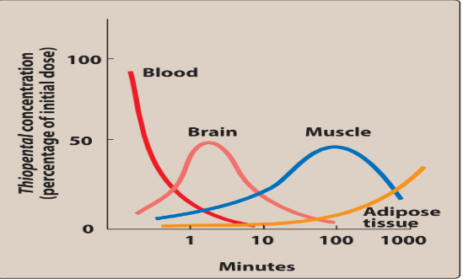 **Thiopental** is an ultra-short-acting barbiturate with high lipid solubility. It is a potent anesthetic but a weak analgesic. Barbiturates require supplementary analgesic administration during anesthesia. When given IV, agents such as thiopental and **methohexital** quickly enter the CNS and depress function, often in less than 1 minute. However, diffusion out of the brain can also occur very rapidly because of redistribution to other tissues.

Barbiturates tend to decrease blood pressure, which may cause a reflex tachycardia. They decrease intracranial pressure through reductions in cerebral blood flow and oxygen consumption.

**Benzodiazepines**

The benzodiazepines are used in conjunction with anesthetics for sedation and amnesia. The most commonly used is **midazolam**. **Diazepam** and **Lorazepam** are alternatives. All three facilitate amnesia while causing sedation, enhancing the inhibitory effects of various neurotransmitters, particularly GABA. Minimal cardiovascular depressant effects are seen, but all are potential respiratory depressants (especially when administered IV). Benzodiazepines can induce a temporary form of anterograde amnesia in which the patient retains memory of past events, but new information is not transferred into long-term memory.

**Opioids**

Because of their analgesic property, opioids are commonly combined with other anesthetics. The choice of opioid is based primarily on the duration of action needed. The most commonly used opioids are **fentanyl**, **sufentanil** and **remifentanil**, because they induce analgesia more rapidly than morphine. They may be administered intravenously, epidurally, or intrathecally (into the cerebrospinal fluid). Opioids are not good amnesties, and they can all cause hypotension and respiratory depression, as well as nausea and vomiting. Opioid effects can be antagonized by naloxone.

**Etomidate**

Etomidate is usually only used for patients with cardiovascular dysfunction or patients who are acutely critically ill. It inhibits 11-P hydroxylase involved in steroidogenesis, and adverse effects may include decreased plasma cortisol and aldosterone levels. Etomidate should not be infused for an extended time, because prolonged suppression of these hormones is dangerous.

**Ketamine**

Ketamine, a short-acting anti-NMDA receptor anesthetic and analgesic, induces a dissociated state in which the patient is unconscious (but may appear to be awake) with profound analgesia. Ketamine stimulates central sympathetic outflow, causing stimulation of the heart with increased blood pressure and CO. It is also a potent bronchodilator. Therefore, it is beneficial in patients with hypovolemic or cardiogenic shock as well as asthmatics. Conversely, it is contraindicated in hypertensive or stroke patients. The drug is lipophilic and enters the brain very quickly.

**Dexmedetomidine**

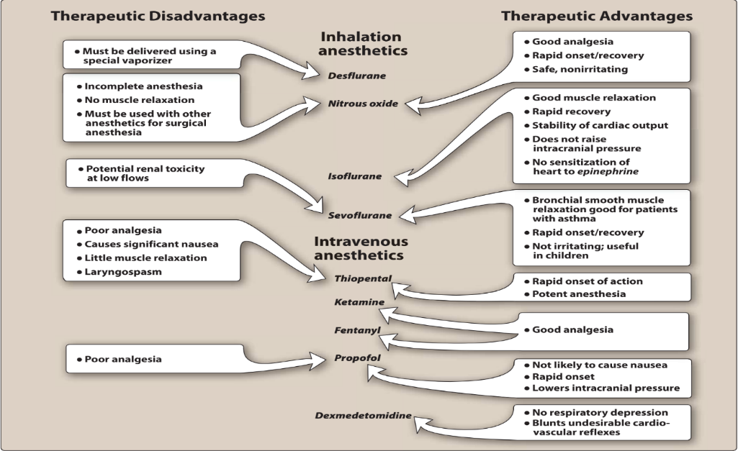 Dexmedetomidine is a sedative used in intensive care settings and surgery. Like clonidine, it is an α2 receptor agonist in certain parts of the brain. Dexmedetomidine has sedative, analgesic, sympatholytic, and anxiolytic effects that blunt many cardiovascular responses. It reduces volatile anesthetic, sedative, and analgesic requirements without causing significant respiratory depression.

**NEUROMUSCULAR BLOCKERS**

Their mechanism of action is via blockade of nicotinic acetylcholine receptors on the skeletal muscle cell membrane. These agents include **cisatracurium, mivacurium, pancuronium, rocuronium, succinylcholine, and vecuronium**.

**LOCAL ANESTHETICS**

Local anesthetics block nerve conduction of sensory impulses and in higher concentrations block motor impulses from the periphery to the CNS. Sodium ion channels are blocked to prevent the transient increase in permeability of the nerve membrane to Na+ that is required for an action potential.

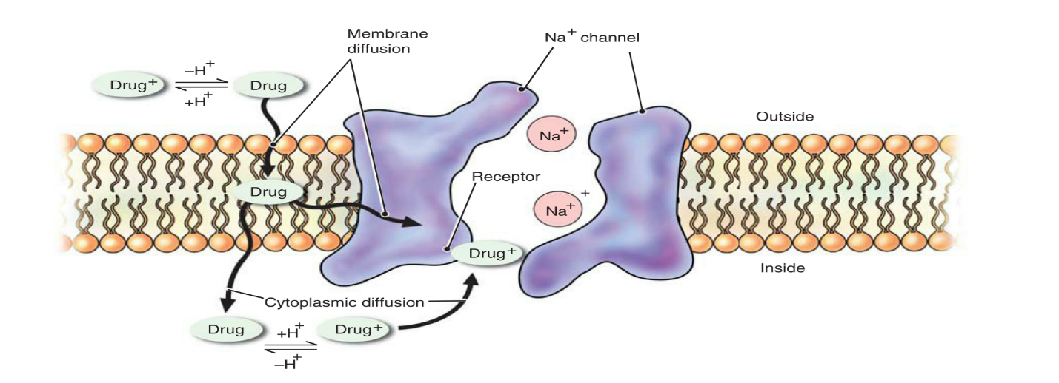

When propagation of action potentials is prevented, sensation cannot be transmitted from the source of stimulation to the brain. Structurally, local anesthetics all include a lipophilic group joined by an amide or ester linkage to a carbon chain, which, in turn, is joined to a hydrophilic group.

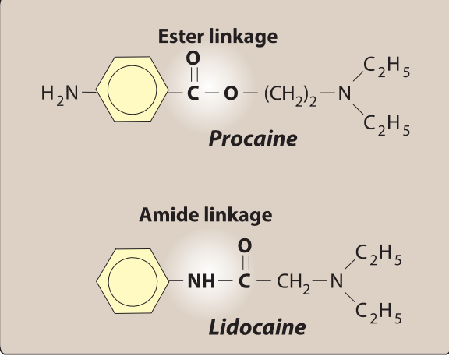

The most widely used local anesthetics **are bupivacaine, lidocaine, mepivacaine, ropivacaine, and tetracaine**.

**A. Actions** Local anesthetics cause vasodilation, which leads to a rapid diffusion away from the site of action and short duration when these drugs are administered alone. By adding the vasoconstrictor epinephrine, the rate of local anesthetic absorption and diffusion is decreased. This minimizes systemic toxicity and increases the duration of action. Hepatic function does not affect the duration of action of local anesthesia because that is determined by redistribution rather than biotransformation. Some local anesthetics have other therapeutic uses (for example, lidocaine is an IV antiarrhythmic).

**B. Onset, potency, and duration of action** The onset of action of local anesthetics is influenced by several factors including tissue pH, nerve morphology, concentration, pKa, and lipid solubility of the drug. Of these, the pKa is most important. Local anesthetics with a lower pKa have a quicker onset, since more drug exists in the unionized form at physiologic pH, thereby allowing penetration of the nerve cell membrane. Once at the nerve membrane, the ionized form interacts with the protein receptor of the Na+ channel to inhibit its function and achieve local anesthesia. The pH may drop in infected sites, causing onset to be delayed or even prevented. Potency and duration of these agents depend mainly on lipid solubility, with higher solubility correlating with increased potency and duration of action.