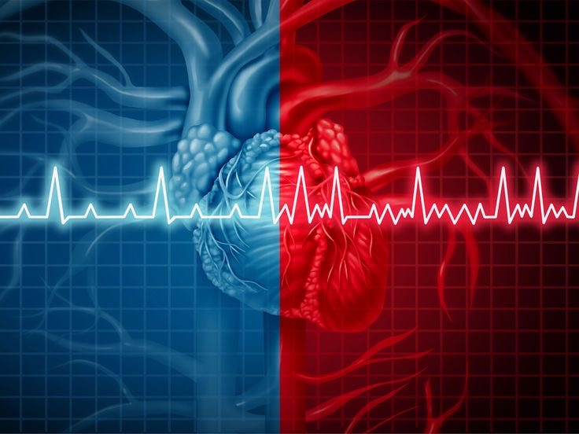

|  |  |
| --- | --- |
|  | **Antiarrhythmic drugs** |
|  | **Lec. 5 & 6** |
|  | Dr. Ahmed Hamed Jwaid  Lec. 4+ 5 Pharmacology 4th year students  1/1/24 |

**OVERVIEW**

In contrast to skeletal muscle, which contracts only when it receives a stimulus, the heart contains specialized cells that exhibit automaticity. That is, they intrinsically generate rhythmic action potentials in the absence of external stimuli. These "pacemaker" cells differ from other myocardial cells in showing a slow, spontaneous depolarization during diastole (phase 4), caused by an inward positive current carried by sodium and calcium ions. This depolarization is fastest in the sinoatrial (SA) node (the initiation site of the action potential), and it decreases throughout the normal conduction pathway through the atrioventricular (AV) node to the bundle of His and the Purkinje system. Dysfunction of impulse generation or conduction at any of a number of sites in the heart can cause an abnormality in cardiac rhythm.

***INTRODUCTION TO THE ARRHYTHMIAS***

Arrhythmias are caused by abnormalities in impulse formation and conduction in the myocardium. Arrhythmias present as a complex family of disorders with a variety of symptoms. To make sense of this large group of disorders, it is useful to organize arrhythmias into groups according to anatomic site of the abnormality: the atria, the AV node, or the ventricles.

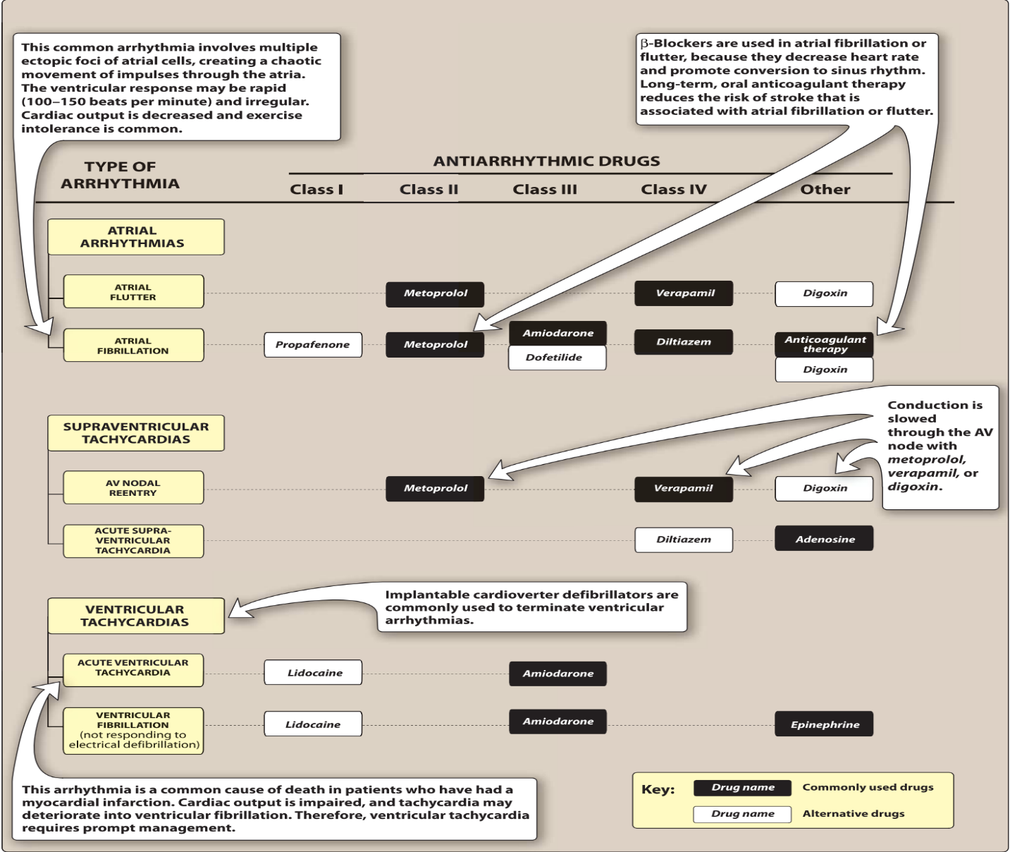

1. **Causes of arrhythmias**

Most arrhythmias arise either from aberrations in impulse generation (abnormal automaticity) or from a defect in impulse conduction**.**

**1. Abnormal automaticity:** The SA node shows a faster rate of discharge than do other pacemaker cells, and thus, it normally sets the pace of contraction for the myocardium. If cardiac sites other than the SA node show enhanced automaticity, they may generate competing stimuli, and arrhythmias may arise. Most of the antiarrhythmic agents suppress automaticity by blocking either sodium (Na+) or calcium (Ca2+) channels to reduce the ratio of these ions to potassium (K+). This decreases the slope of phase 4 (diastolic) depolarization and/or raises the threshold of discharge to a less negative voltage, leading to an overall decrease in frequency of discharge. This effect is more pronounced in cells with ectopic pacemaker activity than in normal cells.

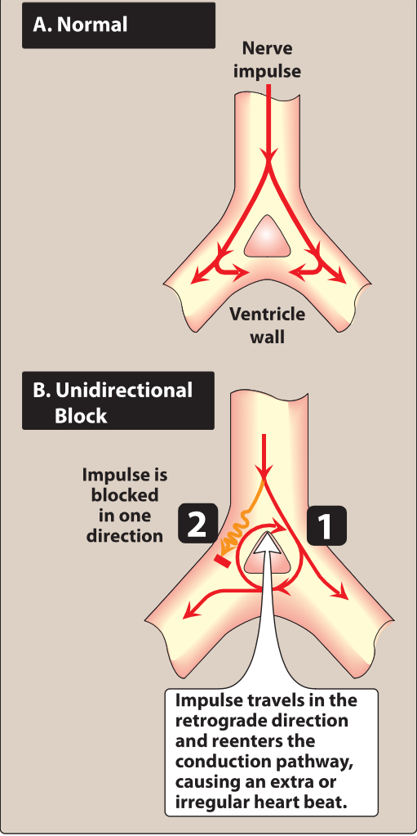**2. Abnormalities in impulse conduction:** Impulses from higher pacemaker centers are normally conducted down pathways that bifurcate to activate the entire ventricular surface.

A phenomenon called reentry can occur if a unidirectional block caused by myocardial injury or a prolonged refractory period results in an abnormal conduction pathway. Reentry is the most common cause of arrhythmias, and it can occur at any level of the cardiac conduction system. This short-circuits pathway results in re-excitation of cardiac muscle, causing premature contraction or a sustained arrhythmia. Antiarrhythmic agents prevent reentry by slowing conduction (class I drugs) and/or increasing the refractory period (class Ill drugs), thereby converting a unidirectional block into a bidirectional block.

**Antiarrhythmic drugs**

Antiarrhythmic drugs can modify impulse generation and conduction to prevent arrhythmias or to reduce symptoms associated with arrhythmias. Unfortunately, many of the antiarrhythmic agents are known to have dangerous proarrhythmic actions-that is, to cause arrhythmias. Inhibition of K+ channels widen the action potential and can, thus, prolong the QT interval. If prolongation is excessive, these drugs increase the risk of developing life-threatening ventricular tachyarrhythmias (torsade’s de pointes). The most common cause of QT prolongation is **drug-induced**, although other conditions (for example, **ischemia and hypokalemia**) and **genetic abnormalities** may contribute. In addition to antiarrhythmics, many other drugs are known to prolong the QT interval, such as **macrolide antibiotics** and **antipsychotics**. Caution should be employed when combining drugs with additive effects on the QT interval or when giving QT-prolonging antiarrhythmic agents with drugs known to inhibit their metabolism. Antiarrhythmic drugs can be classified **(Vaughan-Williams classification)** according to their predominant effects on the action potential.

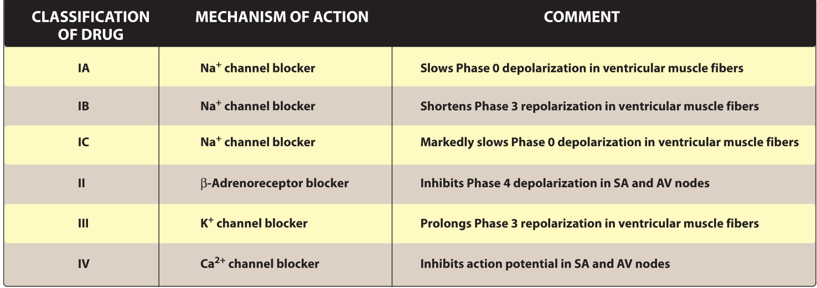

Although this classification is convenient, it has some limitations. Many antiarrhythmic drugs have actions relating to more than one class or may have active metabolites with a different class of action, or may have an action that does not meet any formal classification.

**CLASS I ANTIARRHYTHMIC DRUGS**

Class I antiarrhythmic drugs act by blocking voltage-sensitive Na+ channels. They bind more rapidly to open or inactivated Na+ channels than to channels that are fully repolarized. Therefore, these drugs show a greater degree of blockade in tissues that are frequently depolarizing. This property is called **use dependence (or state dependence),** and it enables these drugs to block cells that are discharging at an abnormally high frequency, without interfering with the normal beating of the heart.

The use of Na+ channel blockers has declined due to their proarrhythmic effects, particularly in patients with reduced left ventricular function and atherosclerotic heart disease. Class I drugs are further subdivided into three groups according to their effect on the duration of the cardiac action potential.

1. **Class IA antiarrhythmic drugs: Quinidine, procainamide, and disopyramide** Quinidine is the prototype class IA drug. Other agents in this class include procainamide and disopyramide. Because of their concomitant class III activity, they can precipitate arrhythmias that can progress to ventricular fibrillation.

**1. Mechanism of action:** Quinidine binds to open and inactivated Na+ channels and prevents Na+ influx, thus slowing the rapid upstroke during phase 0.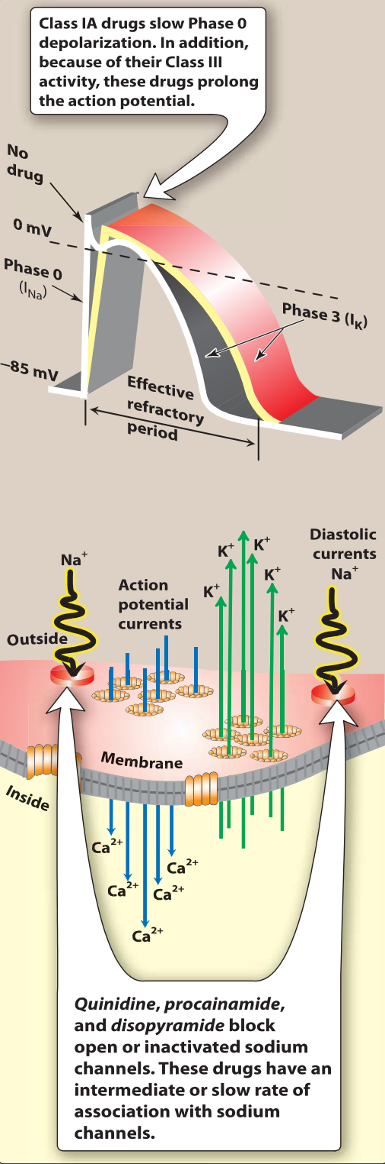

It decreases the slope of phase 4 spontaneous depolarization, inhibits K+ channels, and blocks Ca2 + channels. Because of these actions, it slows conduction velocity and increases refractoriness. Quinidine also has mild α-adrenergic blocking and anticholinergic actions. Although procainamide and disopyramide have actions similar to those of quinidine, there is less anticholinergic activity with procainamide and more with disopyramide. Neither procainamide nor disopyramide has α-blocking activity. Disopyramide produces a greater negative inotropic effect, and unlike the other drugs, it causes peripheral vasodilation.

**2. Therapeutic uses:** Quinidine is used in the treatment of a wide variety of arrhythmias, including atrial, AV junctional, and ventricular tachyarrhythmias. Procainamide is only available in an intravenous formulation and may be used to treat acute atrial and ventricular arrhythmias. However, electrical cardioversion or defibrillation and amiodarone have mostly replaced procainamide in clinical practice. Disopyramide can be used as an alternative treatment of ventricular arrhythmias and may also be used for rhythm control in atrial fibrillation or flutter. **3. Pharmacokinetics**: Quinidine sulfate or gluconate is rapidly and well absorbed after oral administration. It undergoes extensive metabolism primarily by the hepatic cytochrome P450 3A4 (CYP3A4) isoenzyme, forming active metabolites. A portion of procainamide is acetylated in the liver to N-acetylprocainamide (NAPA), which has the properties and adverse effects of a class III drug. NAPA is eliminated via the kidney; therefore, dosages of procainamide should be adjusted in patients with renal dysfunction. Disopyramide is well absorbed after oral administration and is metabolized in the liver by CYP3A4 to a less active metabolite and several inactive metabolites. About half of the drug is excreted unchanged by the kidneys.

**4. Adverse effects:** Due to enhanced proarrhythmic effects and ability to worsen heart failure symptoms, class IA drugs should not be used in patients with atherosclerotic heart disease or systolic heart failure. Large doses of quinidine may induce the symptoms of cinchonism (for example, blurred vision, tinnitus, headache, disorientation, and psychosis). Drug interactions are common with quinidine since it is an inhibitor of both CYP2D6 and P-glycoprotein. Intravenous administration of procainamide may cause hypotension. Disopyramide has the most anticholinergic adverse effects of the class IA drugs (for example, dry mouth, urinary retention, blurred vision, and constipation). Both quinidine and disopyramide should be used with caution with potent inhibitors of CYP3A4.

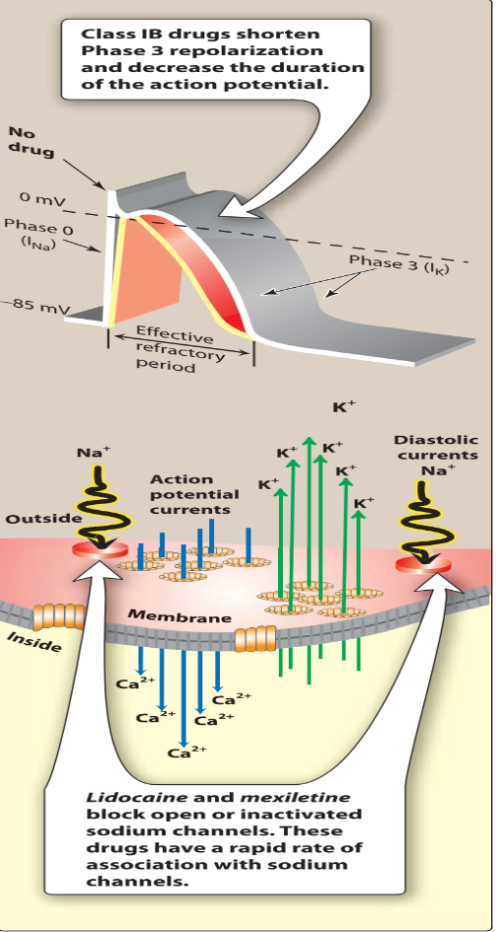**B. Class IB antiarrhythmic drugs: Lidocaine and mexiletine**

The class IB agents rapidly associate and dissociate from Na+ channels. Thus, the actions are greater when the cardiac cell is depolarized or firing rapidly. The class IB drugs lidocaine and mexiletine are useful in treating ventricular arrhythmias.

1. **Mechanism of action:** In addition to Na+ channel blockade, lidocaine and mexiletine shorten phase 3 repolarization and decrease the duration of the action potential.

Neither drug contributes to negative inotropy.

**2. Therapeutic uses:** Although amiodarone is the drug of choice for ventricular fibrillation or ventricular tachycardia (VT), lidocaine may be used as an alternative. Lidocaine may also be used in combination with amiodarone for VT storm. The drug does not markedly slow conduction and, thus, has little effect on atrial or AV junction arrhythmias. Mexiletine is used for chronic treatment of ventricular arrhythmias, often in combination with amiodarone.

**3. Pharmacokinetics:** Lidocaine is given intravenously because of extensive first-pass transformation by the liver. The drug is dealkylated to two active metabolites, primarily by CYP1A2 with a minor role by CYP3A4. Lidocaine should be monitored closely when given in combination with drugs affecting these CYP isoenzymes. Mexiletine is well absorbed after oral administration. It is metabolized in the liver primarily by CYP2D6 to inactive metabolites and excreted mainly via the biliary route.

**4. Adverse effects:** Lidocaine has a fairly wide therapeutic index. Central nervous system (CNS) effects include nystagmus (early indicator of toxicity), drowsiness, slurred speech, paresthesia, agitation, confusion, and convulsions, which often limit the duration of continuous infusions. Mexiletine has a narrow therapeutic index and caution should be used when administering the drug with inhibitors of CYP2D6. Nausea, vomiting, and dyspepsia are the most common adverse effects.

**C. Class IC antiarrhythmic drugs:** **Flecainide and propafenone**

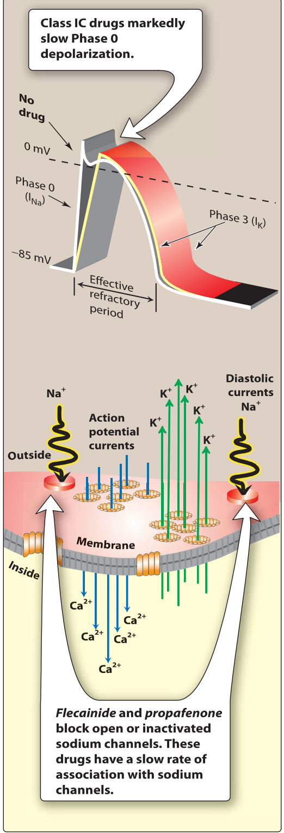 These drugs slowly dissociate from resting Na+ channels and show prominent effects even at normal heart rates. Due to their negative inotropic and proarrhythmic effects, use of these agents is avoided in patients with structural heart disease (left ventricular hypertrophy, heart failure, atherosclerotic heart disease).

1. **Mechanism of action:** Flecainide suppresses phase 0 upstroke in Purkinje and myocardial fibers.

This causes marked slowing of conduction in all cardiac tissue, with a minor effect on the duration of the action potential and refractoriness. Automaticity is reduced by an increase in the threshold potential, rather than a decrease in slope of phase 4 depolarization. Flecainide also blocks K+ channels, leading to increased duration of the action potential. Propafenone, like flecainide, slows conduction in all cardiac tissues but does not block K+ channels. It possesses weak β-blocking properties.

**2. Therapeutic uses:** Flecainide is useful in the maintenance of sinus rhythm in atrial flutter or fibrillation in patients without structural heart disease and in treating refractory ventricular arrhythmias. Use of propafenone is restricted mostly to atrial arrhythmias: rhythm control of atrial fibrillation or flutter and paroxysmal supraventricular tachycardia prophylaxis in patients with AV reentrant tachycardias.

**3. Adverse effects:** Flecainide is generally well tolerated, with blurred vision, dizziness, and nausea occurring most frequently. Propafenone has a similar side effect profile, but may cause bronchospasm and should be avoided in patients with asthma. Propafenone is also an inhibitor of P-glycoprotein. Both drugs should be used with caution with potent inhibitors of CYPp450.

**CLASS II ANTIARRHYTHMIC DRUGS**

Class II agents are β-adrenergic antagonists, or β-blockers. These drugs diminish phase 4 depolarization and, thus, depress automaticity, prolong AV conduction, and decrease heart rate and contractility. Class II agents are useful in treating tachyarrhythmias caused by increased sympathetic activity. They are also used for atrial flutter and fibrillation and for AV nodal reentrant tachycardia. In addition, β -blockers prevent life-threatening ventricular arrhythmias following a myocardial infarction. **Metoprolol** is the most widely used β -blocker for the treatment of cardiac arrhythmias. Compared to nonselective β -blockers, such as propranolol, it reduces the risk of bronchospasm.

**Esmolol** is a very short and fast-acting β -blocker used for intravenous administration in acute arrhythmias that occur during surgery or emergency situations. Esmolol is rapidly metabolized by esterase in red blood cells. As such, there are no pharmacokinetic drug interactions. Common adverse effects with β -blockers include bradycardia, hypotension, and fatigue.

**CLASS** **III ANTIARRHYTHMIC DRUGS**

Class III agents block K+ channels and, thus, diminish the outward K+ current during repolarization of cardiac cells. These agents prolong the duration of the action potential without altering phase 0 of depolarization or the resting membrane potential.

Instead, they prolong the effective refractory period, increasing refractoriness. All class Ill drugs have the potential to induce arrhythmias.

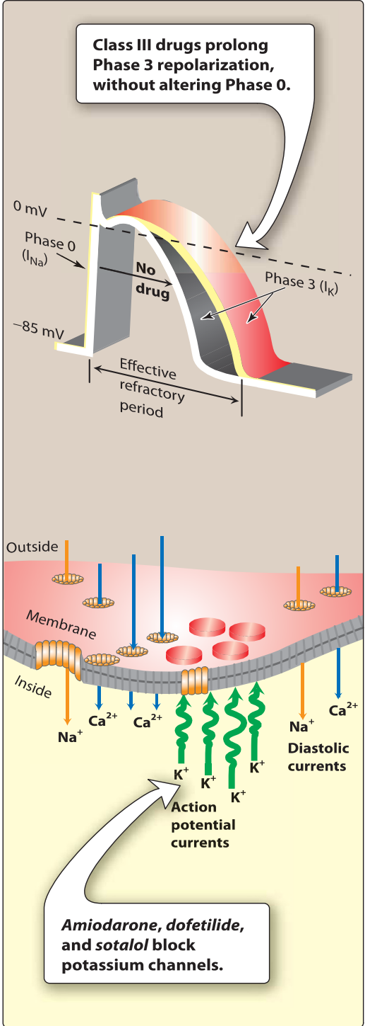**A. Amiodarone**

**1. Mechanism of action:** Amiodarone contains iodine and is related structurally to thyroxine. It has complex effects, showing class I, II, Ill, and IV actions, as well as α-blocking activity. Its dominant effect is prolongation of the action potential duration and the refractory period by blocking K+ channels.

**2. Therapeutic uses:** Amiodarone is effective in the treatment of severe refractory supraventricular and ventricular tachyarrhythmias. Amiodarone has been a mainstay of therapy for the rhythm management of atrial fibrillation or flutter. Despite its adverse effect profile, amiodarone is thought to be the least proarrhythmic of the class I and Ill antiarrhythmic drugs.

**3. Pharmacokinetics:** Amiodarone is incompletely absorbed after oral administration. The drug is unusual in having a prolonged half-life of several weeks, and it distributes extensively in tissues. Full clinical effects may not be achieved until months after initiation of treatment, unless loading doses are employed.

**4. Adverse effects:** Amiodarone shows a variety of toxic effects, including pulmonary fibrosis, neuropathy, hepatotoxicity, corneal deposits, optic neuritis, blue-gray skin discoloration, and hypo- or hyperthyroidism. However, use of low doses and close monitoring reduce toxicity, while retaining clinical efficacy. Amiodarone is subject to numerous drug interactions, since it is metabolized by CYP3A4 and serves as an inhibitor of CYP1A2, CYP2C9, CYP2D6, and P-glycoprotein.

**B. Dronedarone** Dronedarone is a benzofuran amiodarone derivative, which is less lipophilic and has a shorter half-life than amiodarone. It does not have the iodine moieties that are responsible for thyroid dysfunction associated with amiodarone. Like amiodarone, it has class I, II, Ill, and IV actions. Dronedarone has a better adverse effect profile than does amiodarone but may still cause liver failure. The drug is contraindicated in those with symptomatic heart failure or permanent atrial fibrillation due to an increased risk of death. Currently, dronedarone is used to maintain sinus rhythm in atrial fibrillation or flutter, but it is less effective than amiodarone.

**C. Sotalol** Sotalol, although a class Ill antiarrhythmic agent, also has nonselective β-blocker activity. The levorotatory isomer (L-sotalol has β -blocking activity and D-sotalol has class Ill antiarrhythmic action. Sotalol blocks a rapid outward K+ current, known as the delayed rectifier current. This blockade prolongs both repolarization and duration of the action potential, thus lengthening the effective refractory period. Sotalol is used for maintenance of sinus rhythm in patients with atrial fibrillation, atrial flutter, or refractory paroxysmal supraventricular tachycardia and in the treatment of ventricular arrhythmias. Since sotalol has β-blocking properties, it is commonly used for these indications in patients with left ventricular hypertrophy or atherosclerotic heart disease. This drug can cause the typical adverse effects associated with β-blockers but has a low rate of adverse effects when compared to other antiarrhythmic agents. The dosing interval should be extended in patients with renal disease, since the drug is renally eliminated. To reduce the risk of proarrhythmic effects, sotalol should be initiated in the hospital to monitor QT interval.

**D. Dofetilide** Dofetilide is a pure K+ channel blocker. It can be used as a first-line antiarrhythmic agent in patients with persistent atrial fibrillation and heart failure or in those with coronary artery disease. Because of the risk of pro-arrhythmia, dofetilide initiation is limited to the inpatient setting. The half-life of this oral drug is 10 hours. The drug is mainly excreted unchanged in the urine. Drugs that inhibit active tubular secretion are contraindicated with dofetilide.

**E. lbutilide** lbutilide is a K+ channel blocker that also activates the inward Na+ current (mixed class Ill and lA actions). lbutilide is the drug of choice for chemical conversion of atrial flutter, but electrical cardioversion has supplanted its use. It undergoes extensive firstpass metabolism and is not used orally. Initiation is also limited to the inpatient setting due to the risk of arrhythmia.

**VI. CLASS IV ANTIARRHYTHMIC DRUGS**

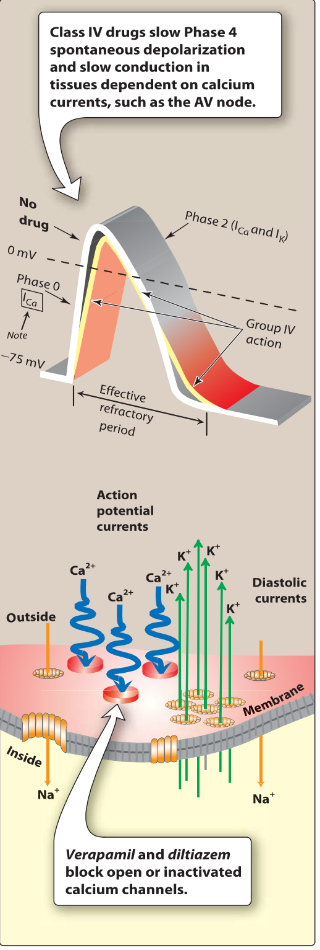Class IV drugs are the nondihydropyridine Ca2+ channel blockers **verapamil** and **diltiazem**. Although voltage sensitive Ca2 + channels occur in many different tissues, the major effect of Ca2+ channel blockers is on vascular smooth muscle and the heart. Both drugs show greater action on the heart than on vascular smooth muscle, but more so with verapamil. ln the heart, verapamil and diltiazem bind only to open depolarized voltage-sensitive channels, thus decreasing the inward current carried by Ca2+. These drugs are use dependent in that they prevent repolarization until the drug dissociates from the channel, resulting in a decreased rate of phase 4 spontaneous depolarization. They also slow conduction in tissues that are dependent on Ca2+ currents, such as the AV and SA nodes.

These agents are more effective against atrial than against ventricular arrhythmias. They are useful in treating reentrant supraventricular tachycardia and in reducing the ventricular rate in atrial flutter and fibrillation. Common adverse effects include bradycardia, hypotension, and peripheral edema. Both drugs are metabolized in the liver by CYP3A4. Dosage adjustments may be needed in patients with hepatic dysfunction. Both agents are subject to many drug interactions as they are CYP3A4 inhibitors, as well as substrates and inhibitors of P-glycoprotein.

**VII. OTHER ANTIARRHYTHMIC DRUGS**

**A. Digoxin** Digoxin inhibits the Na+/K+-ATPase pump, ultimately shortening the refractory period in atrial and ventricular myocardial cells while prolonging the effective refractory period and diminishing conduction velocity in the AV node. Digoxin is used to control ventricular response rate in atrial fibrillation and flutter; however, sympathetic stimulation easily overcomes the inhibitory effects of digoxin. At toxic concentrations, digoxin causes ectopic ventricular beats that may result in VT and fibrillation. [Note: Serum trough concentrations of 1.0 to 2.0 ng/ml are desirable for atrial fibrillation or flutter, whereas lower concentrations of 0.5 to 0.8 ng/ml are targeted for systolic heart failure.]

**B. Adenosine** Adenosine is a naturally occurring nucleoside, but at high doses, the drug decreases conduction velocity, prolongs the refractory period, and decreases automaticity in the AV node. Intravenous adenosine is the drug of choice for converting acute supraventricular tachycardias. It has low toxicity but causes flushing, chest pain, and hypotension. Adenosine has an extremely short duration of action (approximately 1 0 to 15 seconds) due to rapid uptake by erythrocytes and endothelial cells

**C. Magnesium sulfate** Magnesium is necessary for the transport of Na+, Ca2+, and K+ across cell membranes. It slows the rate of SA node impulse formation and prolongs conduction time along the myocardial tissue. Intravenous magnesium sulfate is the salt used to treat arrhythmias, as oral magnesium is not effective in the setting of arrhythmia. Most notably, magnesium is the drug of choice for treating the potentially fatal arrhythmia torsade’s de pointes and digoxin-induced arrhythmias. **D. Ranolazlne** Ranolazine is an antianginal drug with antiarrhythmic properties similar to amiodarone. However, its main effect is to shorten repolarization and decrease the action potential duration similar to mexiletine. It is used to treat refractory atrial and ventricular arrhythmias, often in combination with other antiarrhythmic drugs. It is well tolerated with dizziness and constipation as the most common adverse effects. Ranolazine is extensively metabolized in the liver.

*End of Arrhythmia lectures*