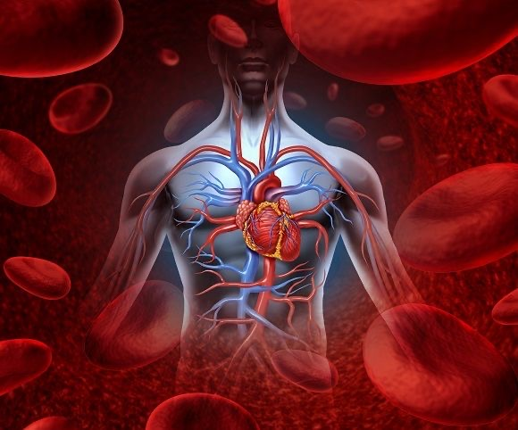

|  |  |
| --- | --- |
|  | Lec.1+2+3 pharmacology |
|  |  |
|  | Dr. Ahmed Hamed Jwaid  4th year students 1st sim.  1/1/24 |

**OVERVIEW**

Hypertension is defined as either a sustained systolic blood pressure of greater than 140 mm Hg or a sustained diastolic blood pressure of greater than 90 mm Hg. Hypertension results from **increased peripheral vascular arteriolar smooth muscle tone, which leads to increased arteriolar resistance and reduced capacitance of the venous system**. In most cases, the cause of the increased vascular tone is unknown. Elevated blood pressure is an extremely common disorder, affecting approximately 15 percent of the population of the United States (60 million people). Although many of these individuals have no symptoms, chronic hypertension (either systolic or diastolic) can lead to **cerebrovascular accidents (strokes), congestive heart failure, myocardial infarction, and renal damage**. The incidence of morbidity and mortality significantly decreases when hypertension is diagnosed early and is properly treated.

In recognition of the progressive nature of hypertension, hypertension is classified into four categories for the purpose of treatment management

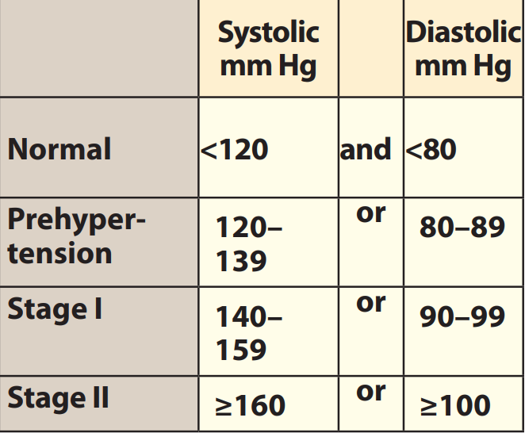

**ETIOLOGY OF HYPERTENSION**

Although hypertension may occur secondary to other disease processes, more than 90 percent of patients have **essential hypertension**,

A family history of hypertension increases the likelihood that an individual will develop higher than normal blood pressure and hypertensive disease. The incidence of essential hypertension is

1. **Four-fold more frequent among blacks than among whites**.
2. **It occurs more often among middle-aged males than among middle-aged females**,
3. **Increases with age and obesity**.
4. **Environmental factors, such as a stressful lifestyle, high dietary intake of sodium, and smoking, further predispose an individual to the occurrence of hypertension**.

**MECHANISMS FOR CONTROLLING BLOOD PRESSURE**

Arterial blood pressure is directly proportional to cardiac output and peripheral vascular resistance. Cardiac output and peripheral resistance, in turn, are controlled mainly by two overlapping control mechanisms: the **baroreflexes and the renin-angiotensin-aldosterone system**. Most anti-hypertensive drugs lower blood pressure by reducing cardiac output and/or decreasing peripheral resistance.

1. **Baroreceptors and the sympathetic nervous system**

Baroreflexes act by changing the activity of the sympathetic nervous system. Therefore, they are responsible for the rapid, moment-to moment regulation of blood pressure. A fall in blood pressure causes pressure-sensitive neurons (baroreceptors in the aortic arch and carotid sinuses) to send fewer impulses to cardiovascular centers in the spinal cord. This prompts a reflex response of increased sympathetic and decreased parasympathetic output to the heart and vasculature, resulting in vasoconstriction and increased cardiac output. These changes result in a compensatory rise in blood pressure.

1. **Renin-angiotensin-aldosterone system**

The kidney provides for the long-term control of blood pressure by altering the blood volume. Baroreceptors in the kidney respond to reduced arterial pressure (and to sympathetic stimulation of β1-adrenoceptors) by releasing the enzyme renin. Low sodium intake and greater sodium loss also increase renin release. This peptidase converts angiotensinogen to angiotensin I, which is converted, in turn to angiotensin II, in the presence of angiotensin-converting enzyme (ACE). Angiotensin II is a potent circulating vasoconstrictor, constricting both arterioles and veins, causing an increase in blood pressure. Angiotensin II exerts a preferential vasoconstrictor action on the **efferent arterioles** of the renal glomerulus, increasing glomerular filtration. Furthermore, angiotensin II stimulates aldosterone secretion, leading to increased renal sodium reabsorption and increased blood volume, which contribute to a further increase in blood pressure. These effects of angiotensin II are mediated by stimulation of angiotensin II–AT1 receptors.

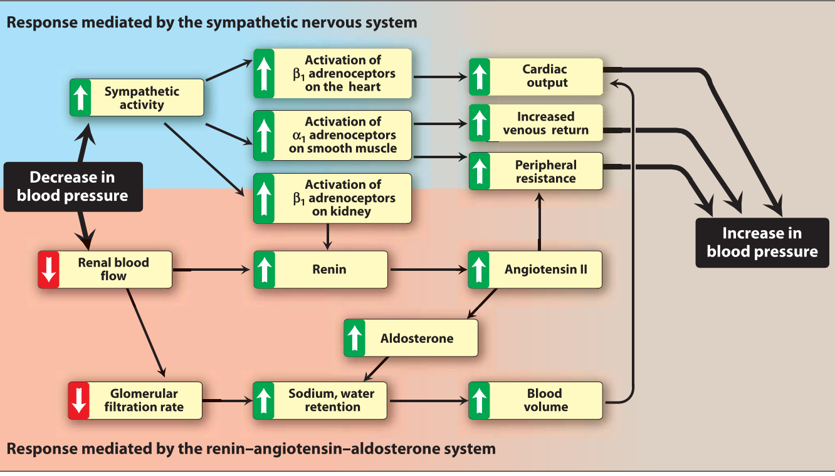

**TREATMENT STRATEGIES**

The goal of antihypertensive therapy is to reduce cardiovascular and renal morbidity and mortality. The relationship between blood pressure and the risk of a cardiovascular event is continuous, and, thus, lowering of even moderately elevated blood pressure significantly reduces cardiovascular disease. Mild hypertension can sometimes be controlled with a single drug, but most patients require more than one drug to achieve blood pressure control. Current recommendations are to initiate therapy with a **thiazide diuretic** unless there are compelling reasons to employ other drug classes. If blood pressure is inadequately controlled, a second drug is added, with the selection based on minimizing the adverse effects of the combined regimen and achieving goal blood pressure. A β-blocker may be added if the initial drug was a diuretic and vice versa. A vasodilator can be added as a third drug for those patients who still fail to achieve goal blood pressure. When angiotensin II–converting enzyme inhibitors or angiotensin II–AT1 receptor blockers are used to initiate therapy, a diuretic is the most common second drug added.

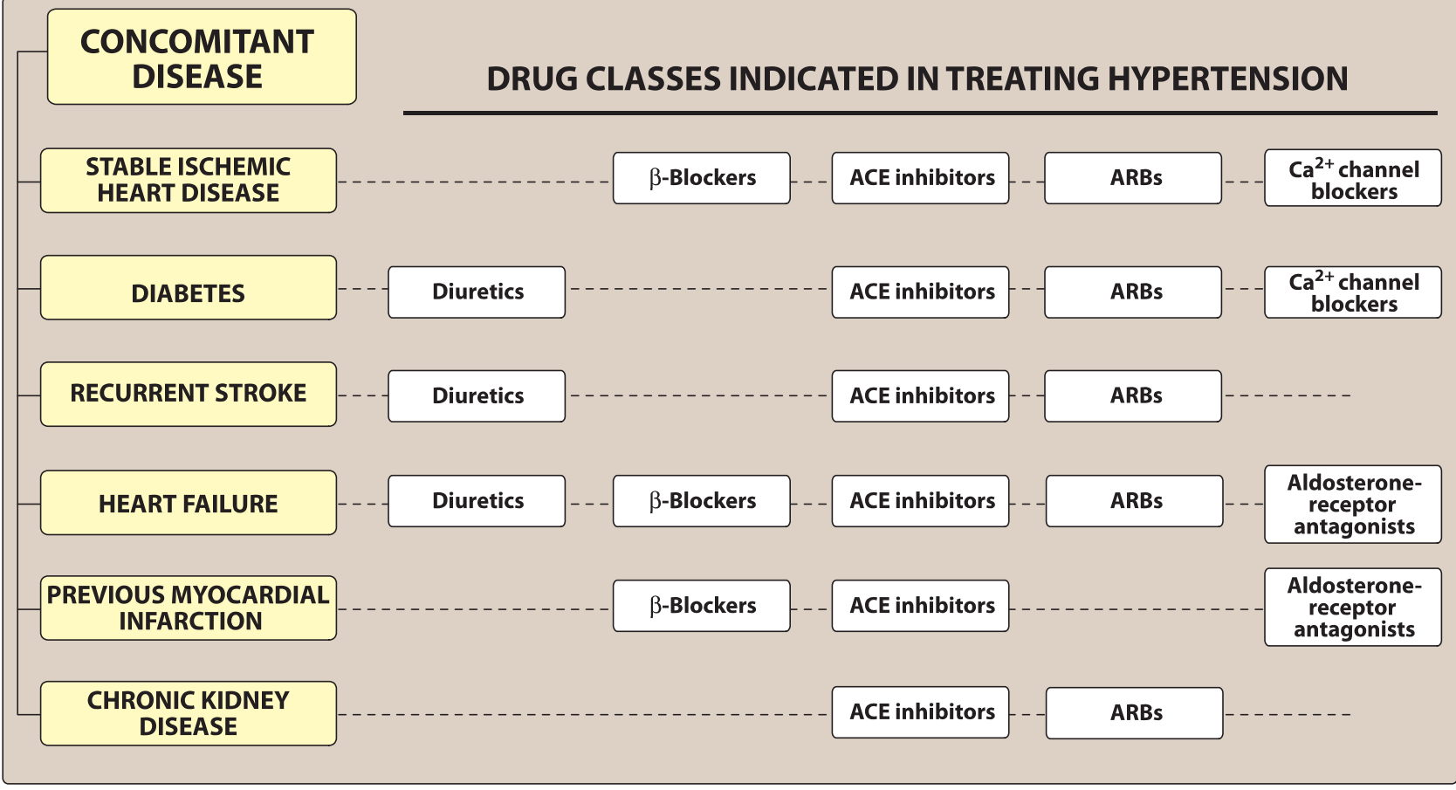

1. **Individualized care**

Certain subsets of the hypertensive population respond better to one class of drug than they do to another. For example, black patients respond well to diuretics and calcium-channel blockers, but monotherapy with β-blockers or ACE inhibitors is often less effective. Similarly, calcium-channel blockers, ACE inhibitors, and diuretics are favored for treatment of hypertension in elderly patients, whereas β-blockers and α-antagonists are less well tolerated. Furthermore, hypertension may coexist with other diseases that can be aggravated by some of the antihypertensive drugs. In such cases, it is important to match antihypertensive drugs to the particular patient.

1. **Patient compliance in antihypertensive therapy**

Lack of patient compliance is the most common reason for failure of antihypertensive therapy. The hypertensive patient is usually asymptomatic and is diagnosed by routine screening before the occurrence of overt end-organ damage. Thus, therapy is generally directed at preventing future disease sequelae rather than relieving the patient’s current discomfort. The adverse effects associated with the hypertensive therapy may influence the patient more than the future benefits. For example, β-blockers can decrease libido and induce erectile dysfunction in males, particularly middle-aged and elderly men. This drug induced sexual dysfunction may prompt the patient to discontinue therapy. Thus, it is important to enhance compliance by carefully selecting a drug regimen that both reduces adverse effects and minimizes the number of doses required daily. Combining two or three drug classes in a single pill, at a fixed-dose combination, has been shown to improve patient compliance and the number of patients achieving goal blood pressure.

**DIURETICS**

Diuretics can be used as first-line drug therapy for hypertension unless there are compelling reasons to choose another agent. Low-dose diuretic therapy is safe, inexpensive, and effective in preventing stroke, myocardial infarction, and congestive heart failure, all of which can cause mortality. Recent data suggest that diuretics are superior to β-blockers for treating hypertension in older adults.

Diuretics are drugs that increase the volume of urine excreted. Most diuretic agents are inhibitors of renal ion transporters that decrease the reabsorption of Na+ at different sites in the nephron. As a result, Na+ and other ions enter the urine in greater than normal amounts along with water, which is carried passively to maintain osmotic equilibrium. Diuretics, thus, increase the volume of urine and often change its pH, as well as the ionic composition of the urine and blood. The diuretic effect of the different classes of diuretics varies considerably with the site of action. In addition to the ion transport inhibitors, other types of diuretics include osmotic diuretics, aldosterone antagonists, and carbonic anhydrase inhibitors. While diuretics are most commonly used for management of excessive fluid retention (edema), many agents within this class are prescribed for non-diuretic indications or for systemic effects in addition to their actions on the kidney. Examples include use of thiazides in hypertension, use of carbonic anhydrase inhibitors in glaucoma, and use of aldosterone antagonists in heart failure.

**NORMAL REGULATION OF FLUID AND ELECTROLYTES BY THE KIDNEYS**

Approximately 16% to 20% of the blood plasma entering the kidneys is filtered from the glomerular capillaries into Bowman's capsule. The filtrate, although normally free of proteins and blood cells, contains most of the low molecular weight plasma components in concentrations similar to that in the plasma. These include **glucose, sodium bicarbonate, amino acids, and other organic solutes, as well as electrolytes, such as Na+, K+, and Cl-.** The kidney regulates the ionic composition and volume of urine by active reabsorption or secretion of ions and/or passive reabsorption of water at five functional zones along the nephron:

1) The proximal convoluted tubule,

2) The descending loop of Henle,

3) The ascending loop of Henle,

4) The distal convoluted tubule, and

5) The collecting tubule and duct

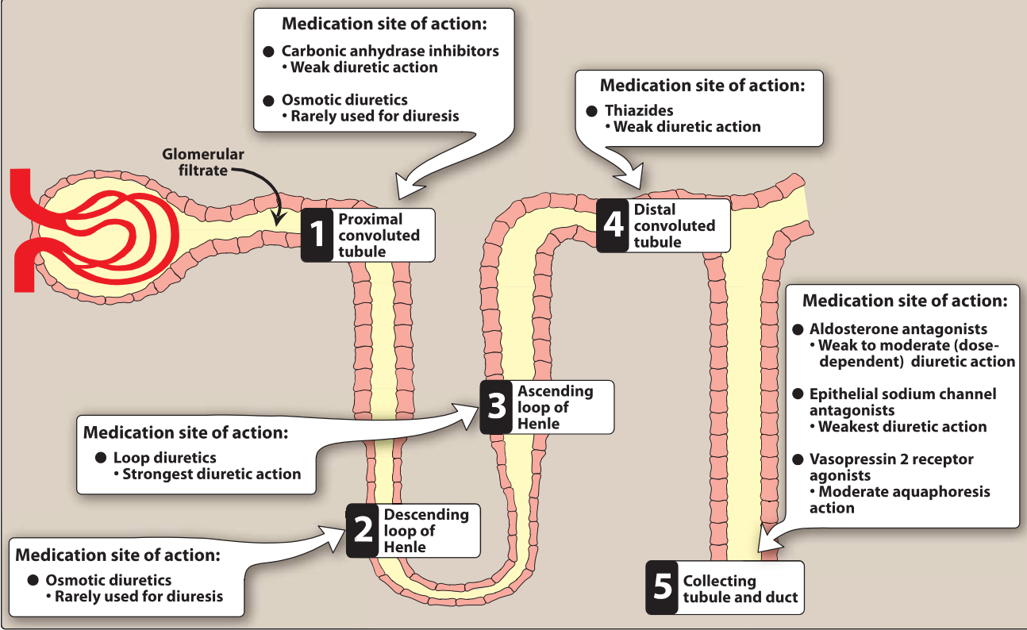

1. **Proximal convoluted tubule** In the proximal convoluted tubule located in the cortex of the kidney, almost all the glucose, bicarbonate, amino acids, and other metabolites are reabsorbed.

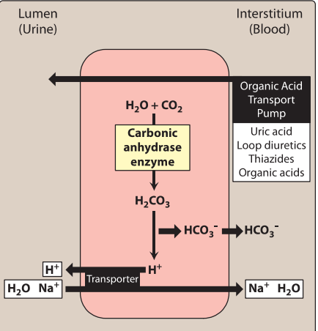

Approximately 65% of the filtered Na+ (and water) is reabsorbed. Given the high water permeability, about 60% of water is reabsorbed from the lumen to the blood to maintain osmolar equality. Chloride enters the lumen of the tubule in exchange for an anion, such as oxalate, as well as paracellularly through the lumen. The Na+ that is reabsorbed is pumped into the interstitium by the Na+/K+-adenosine triphosphatase (ATPase) pump. Carbonic anhydrase in the luminal membrane and cytoplasm of the proximal tubular cells modulates the reabsorption of bicarbonate. Despite having the highest percentage of filtered Na+ that is reabsorbed, diuretics working in the proximal convoluted tubule display weak diuretic properties. The presence of a high-capacity Na+ and water reabsorption area (loop of Henle) distal to the proximal convoluted tubule allows reabsorption of Na+ and water kept in the lumen by diuretics acting in the proximal convoluted tubule, and limits effective diuresis.

The proximal tubule is the site of the organic acid and base secretory systems. The organic acid secretory system, located in the middle third of the proximal tubule, secretes a variety of organic acids, such as uric acid, some antibiotics, and diuretics, from the bloodstream into the proximal tubular lumen. The organic acid secretory system is saturable, and diuretic drugs in the bloodstream compete for transfer with endogenous organic acids such as uric acid. A number of other interactions can also occur. For example, probenecid interferes with penicillin secretion. The organic base secretory system, located in the upper and middle segments of the proximal tubule, is responsible for the secretion of creatinine and choline.

**B. Descending loop of Henle** The remaining filtrate, which is isotonic, next enters the descending limb of the loop of Henle and passes into the medulla of the kidney. The osmolarity increases along the descending portion of the loop of Henle because of the countercurrent mechanism that is responsible for water reabsorption. This results in a tubular fluid with a three-fold increase in Na+ and Cl- concentration. Osmotic diuretics exert part of their action in this region.

**C. Ascending loop of Henle** The cells of the ascending tubular epithelium are unique in being impermeable to water. Active reabsorption of Na+, K+, and Cl- is mediated by a Na+/K+/2CI- cotransporter.

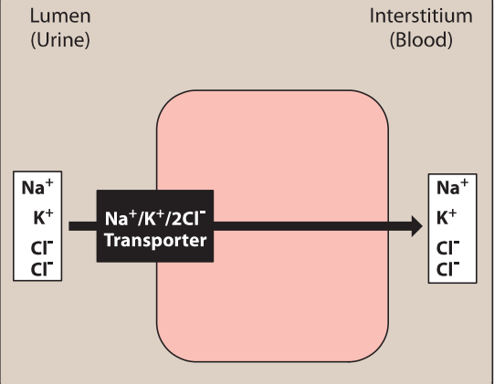

Both Mg2+ and Ca2+ are reabsorbed via the paracellular pathway. Thus, the ascending loop dilutes the tubular fluid and raises the osmolarity of the medullary interstitium. Approximately 25% to 30% of the filtered sodium chloride is absorbed here. Because the ascending loop of Henle is a major site for salt reabsorption and no segments distally are capable of significant Na+ and water reabsorption, drugs affecting this site, such as loop diuretics, have the greatest diuretic effect.

**D. Distal convoluted tubule** The cells of the distal convoluted tubule are also impermeable to water. About 5% to 10% of the filtered sodium chloride is reabsorbed via a Na+/CI-transporter, the target of thiazide diuretics.

Calcium reabsorption, under the regulation of parathyroid hormone, is mediated by an apical channel and then transported by a Na+/Ca2 -exchanger into the interstitial fluid.

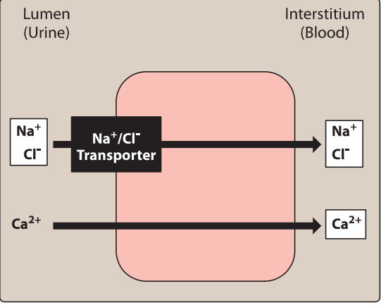

1. **Collecting tubule and duct** The principal cells of the collecting tubule and duct are responsible for Na+, K+, and water transport, whereas the intercalated cells affect H+ secretion.

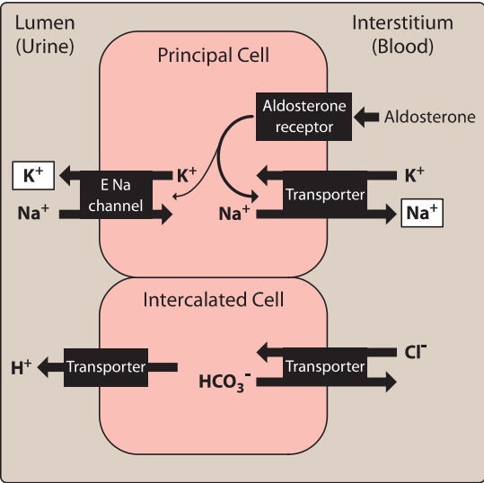

Approximately 1% to 2% of the filtered sodium enters the principal cells through epithelial sodium channels that are inhibited by amiloride and triamterene. Once inside the cell, Na+ reabsorption relies on a Na+/K+-ATPase pump to be transported into the blood. Aldosterone receptors in the principal cells influence Na+ reabsorption and K+ secretion. Aldosterone increases the synthesis of epithelial sodium channels and of the Na+/K+-ATPase pump to increase Na+ reabsorption and K+ excretion. Antidiuretic hormone (ADH; vasopressin) binds to V2 receptors to promote the reabsorption of water through aquaporin channels

***THIAZIDES***

The thiazides are the most widely used diuretics because of their antihypertensive effects. However, the efficacy of thiazides for hypertension is not entirely dependent on their diuretic actions. These agents also reduce peripheral vascular resistance with long-term therapy. Despite being sulfonamide derivatives, thiazides do not generally cause hypersensitivity reactions in patients with allergies to sulfonamide antimicrobials such as sulfamethoxazole. All thiazides affect the distal convoluted tubule, and all have equal maximum diuretic effects, differing only in potency. Thiazides are sometimes called "low ceiling diuretics: because increasing the dose above normal therapeutic doses does not promote further diuretic response.

1. **Thiazide& Chlorothiazide** was the first orally active thiazide, although **hydrochlorothiazide and chlorthalidone** are now used more commonly due to better bioavailability. Hydrochlorothiazide is more potent, so the required dose is considerably lower than that of chlorothiazide, but the efficacy is comparable to that of the parent drug. In all other aspects, hydrochlorothiazide resembles chlorothiazide. Chlorthalidone is approximately twice as potent as hydrochlorothiazide. Chlorthalidone, **indapamide, and metolazone** are referred to as thiazide-like diuretics because they lack the characteristic benzothiadiazine chemical structure; however, their mechanism of action, indications, and adverse effects are similar to those of hydrochlorothiazide.

1. **Mechanism of action:** The thiazide and thiazide-like diuretics act mainly in the distal convoluted tubule to decrease the reabsorption of Na+ by inhibition of a Na+/CI- cotransporter. As a result, these drugs increase the concentration of Na+ and Cl- in the tubular fluid. Thiazides must be excreted into the tubular lumen at the proximal convoluted tubule to be effective. Therefore, decreasing renal function reduces the diuretic effects. The antihypertensive effects of thiazides may persist even when the glomerular filtration rate is below 30 ml/min/1.73 m2 • However, hypertension at this level of renal dysfunction is often exacerbated by hypervolemia, requiring a change to loop diuretics for volume status and, therefore, blood pressure control. The efficacy of thiazides may be diminished with concomitant use of nonsteroidal anti-inflammatory drugs (NSAIDs), such as indomethacin, which inhibit production of renal prostaglandins, thereby reducing renal blood flow.

**2. Actions**

**a. Increased excretion of Na+ and Cl-:** Thiazide and thiazide like diuretics cause diuresis with increased Na+ and Cl- excretion, which can result in the excretion of very hyperosmolar (concentrated) urine. This latter effect is unique, as the other diuretic classes are unlikely to produce a hyperosmolar urine.

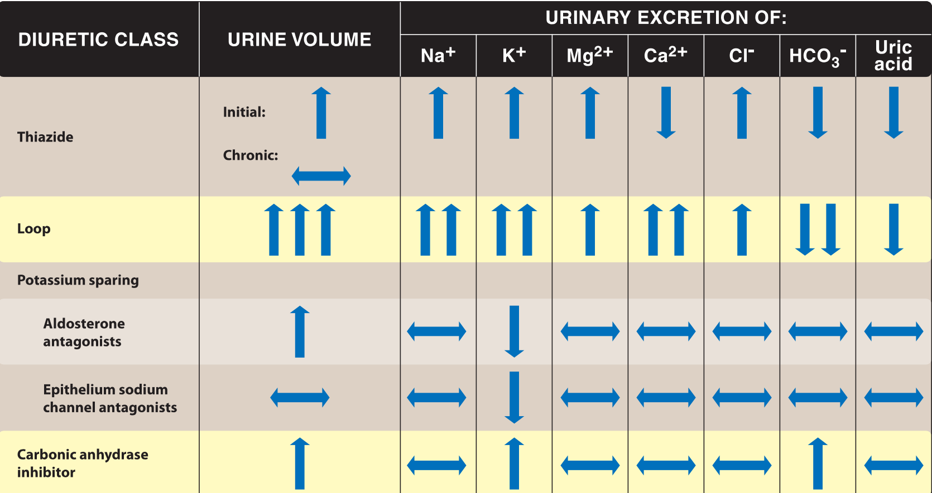

**b. Decreased urinary calcium excretion:** Thiazide and thiazide like diuretics decrease the Ca2+ content of urine by promoting the reabsorption of Ca 2 + in the distal convoluted tubule where parathyroid hormone regulates reabsorption. **c. Reduced peripheral vascular resistance:** An initial reduction in blood pressure results from a decrease in blood volume and, therefore, a decrease in cardiac output. With continued therapy, blood volume returns to baseline. However, antihypertensive effects continue, resulting from reduced peripheral vascular resistance caused by relaxation of arteriolar smooth muscle.

**3. Therapeutic uses**

**a. Hypertension**: Clinically, thiazides are a mainstay of antihypertensive treatment, because they are inexpensive, convenient to administer, and well tolerated. Blood pressure can be lowered with a daily dose of thiazide. At doses equipotent to hydrochlorothiazide, chlorthalidone is considered a preferred option by some clinicians because of its longer half-life (50 to 60 hours) and improved control of blood pressure over the entire day. However, current treatment guidelines for hypertension do not recommend any thiazide preferentially.

**b. Heart failure:** Loop diuretics (not thiazides) are the diuretics of choice in reducing extracellular volume in heart failure. However, thiazide diuretics may be added in patients resistant to loop diuretics, with careful monitoring for hypokalemia. **Metolazone** is most frequently utilized as an addition to loop diuretics.

**c. Hypercalciuria:** The thiazides can be useful in treating idiopathic hypercalciuria and calcium oxalate stones in the urinary tract, because they inhibit urinary Ca2+ excretion.

**d. Diabetes insipidus:** Thiazides have the unique ability to produce a hyperosmolar urine. Thiazides can be utilized as a treatment for nephrogenic diabetes insipidus. The urine volume of such individuals may drop from 11 to about 3 L/d when treated with thiazides.

**4. Pharmacokinetics:** As a class, thiazides are effective orally, with a bioavailability of 60% to 70%. Chlorothiazide has a much lower bioavailability (15% to 30%) and is the only thiazide with an intravenous dosage form. Most thiazides take 1 to 3 weeks to produce a stable reduction in blood pressure and exhibit a prolonged half-life (approximately 10 to 15 hours). **indapamide** differs from the class because it undergoes hepatic metabolism and is excreted in both the urine and bile. Most thiazides are primarily excreted unchanged in the urine.

**5. Adverse effects:** **a. Hypokalemia:** Hypokalemia is the most frequent problem with the thiazide diuretics. Because thiazides increase Na+ in the filtrate arriving at the distal tubule, more K+ is also exchanged for Na+, resulting in a continual loss of K+ from the body with prolonged use of these drugs Thus, serum K+ should be measured periodically. Potassium supplementation or combination with a potassium sparing diuretic may be required. **b. Hypomagnesemia:** Urinary loss of magnesium can lead to hypomagnesemia. **c. Hyponatremia:** Hyponatremia may develop due to elevation of ADH, as well as diminished diluting capacity of the kidney and increased thirst. **d. Hyperuricemia:** Thiazides increase serum uric acid by decreasing the amount of acid excreted through competition in the organic acid secretory system. Being insoluble, uric acid deposits in the joints and may precipitate a gouty attack in predisposed individuals. Therefore, thiazides should be used with caution in patients with gout or high levels of uric acid. **e. Hypovolemia:** This can cause orthostatic hypotension or light-headedness. **f. Hypercalcemia:** Thiazides inhibit the secretion of Ca2 +, sometimes leading to hypercalcemia (elevated levels of Ca2+ in the blood). **g. Hyperglycemia:** Therapy with thiazides can lead to mild elevations in serum glucose, possibly due to impaired release of insulin related to hypokalemia. Patients with diabetes still benefit from thiazide therapy, but should monitor glucose to assess the need for an adjustment in diabetes therapy if thiazides are initiated.

**LOOP DIURETICS**

**Bumetanide, furosemide, torsemide, and ethacrynic acid** have their major diuretic action on the ascending limb of the loop of Henle. Of all the diuretics, these drugs have the highest efficacy in mobilizing Na+ and Cl- from the body, producing copious amounts of urine. Similar to thiazides, loop diuretics do not generally cause hypersensitivity reactions in patients with allergies to sulfonamide antimicrobials such as sulfamethoxazole because of structural differences in their sulfonamide derivative. Furosemide is the most commonly used of these drugs. The use of bumetanide and torsemide is increasing, as these agents have better bioavailability and are more potent compared to furosemide. Ethacrynic acid is used infrequently due to its adverse effect profile.

**1. Mechanism of action:** Loop diuretics inhibit the cotransport of Na+/K+/2CI- in the luminal membrane in the ascending limb of the loop of Henle. Therefore, reabsorption of these ions into the renal medulla is decreased. By lowering the osmotic pressure in the medulla, less water is reabsorbed from water permeable segments, like the descending loop of Henle, causing diuresis. These agents have the greatest diuretic effect of all the diuretics because the ascending limb accounts for reabsorption of 25% to 30% of filtered NaCI and downstream sites are unable to compensate for the increased Na+ load. Loop diuretics must be excreted into the tubular lumen at the proximal convoluted tubule to be effective. NSAIDs inhibit renal prostaglandin synthesis and can reduce the diuretic action of loop diuretics.

**2. Actions** **a. Diuresis:** Loop diuretics cause diuresis, even in patients with poor renal function or lack of response to other diuretics. Loop diuretics display a sigmoidal ("S"-shaped) dose-response curve with three parts: a threshold effect, a rapid increase in diuresis with small changes in drug concentration, and a ceiling effect.

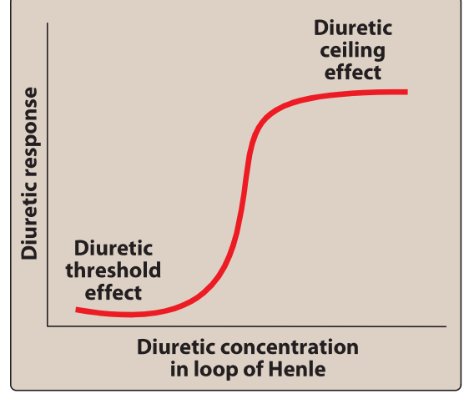

A dose must be selected to cross the response threshold, which is patient-specific. Reducing the effective dose with the intent of a reduction in diuresis can result in no diuresis, if the concentration of loop diuretic drops below the response threshold. Likewise, increasing the effective dose may not cause more diuresis because of the ceiling effect. Thus, after determination of an effective diuretic dose, the clinician should modify the frequency of administration to increase or decrease the daily diuresis. **b. Increased urinary calcium excretion:** Unlike thiazides, loop diuretics increase the Ca2+ content of urine. In patients with normal serum Ca2+ concentrations, hypocalcemia does not result, because Ca2+ is reabsorbed in the distal convoluted tubule. **c. Venodilation:** Prior to their diuretic actions, loop diuretics cause acute venodilation and reduce left ventricular filling pressures via enhanced prostaglandin synthesis.

**3. Therapeutic uses** **a. Edema:** Loop diuretics are the drugs of choice for treatment of pulmonary edema and acute/chronic peripheral edema caused from heart failure or renal impairment. Because of their rapid onset of action, particularly when given intravenously, the drugs are useful in emergency situations such as acute pulmonary edema. **b. Hypercalcemia:** Loop diuretics {along with hydration} are also useful in treating hypercalcemia, because they stimulate tubular Ca2+ excretion. **c. Hyperkalemia:** Loop diuretics can be used with or without replacement intravenous fluid for the treatment of hyperkalemia.

**4. Pharmacokinetics:** Loop diuretics are administered orally or parenterally. Furosemide has unpredictable bioavailability of 10% to 90% after oral administration. Bumetanide and torsemide have reliable bioavailability of 80% to 100%, which makes these agents preferred for oral therapy. The duration of action is approximately 6 hours for furosemide and bumetanide, and moderately longer for torsemide, allowing patients to predict the window of diuresis.

**5. Effects:**

**a. Acute hypovolemia:** Loop diuretics can cause a severe and rapid reduction in blood volume, with the possibility of hypotension, shock, and cardiac arrhythmias. **b. Hypokalemia:** The heavy load of Na+ presented to the collecting tubule results in increased exchange of tubular Na+ for K+, leading to hypokalemia, the most common adverse effect of the loop diuretics. The loss of K+ from cells in exchange for H+ leads to hypokalemic alkalosis. Use of potassium-sparing diuretics or supplementation with K+ can prevent the development of hypokalemia.

**c. Hypomagnesemia:** Urinary loss of magnesium can lead to hypomagnesemia.

**d. Ototoxicity:** Reversible or permanent hearing loss may occur with loop diuretics, particularly when infused intravenously at fast rates, at high doses, or when used in conjunction with other ototoxic drugs {for example, aminoglycoside antibiotics}. With current dosing and appropriate infusion rates ototoxicity is a rare occurrence. Ethacrynic acid is the most likely to cause ototoxicity. Although less common, vestibular function may also be affected, inducing vertigo. **e. Hyperuricemia:** Loop diuretics compete with uric acid for the renal secretory systems, thus blocking its secretion and, in turn, may cause or exacerbate gouty attacks.

**POTASSIUM-SPARING DIURETICS**

Potassium-sparing diuretics act in the collecting tubule to inhibit Na+ reabsorption and K+ excretion. Potassium levels must be monitored in patients treated with potassium-sparing diuretics. These drugs should be used cautiously in moderate renal dysfunction and avoided in patients with severe renal dysfunction because of the increased risk of hyperkalemia. Within this class, there are drugs with two distinct mechanisms of action with different indications for use: **aldosterone** antagonists and epithelial sodium channel blockers.

**A. Aldosterone antagonists: spironolactone and eplerenone**

**1. Mechanism of action:** **Spironolactone and eplerenone** are synthetic steroids that antagonize aldosterone receptors. This prevents translocation of the receptor complex into the nucleus of the target cell, ultimately resulting in a lack of intracellular proteins that stimulate the Na+/K+- exchange sites of the collecting tubule. Thus, aldosterone antagonists prevent Na+ reabsorption and, therefore, K+ and H+ secretion. Eplerenone is more selective for aldosterone receptors and causes less endocrine effects (gynecomastia) than spironolactone, which also binds to progesterone and androgen receptors.

**2. Actions:** Spironolactone and eplerenone antagonize aldosterone receptors at renal sites, which causes diuresis, and nonrenal sites, which causes other effects. In most edematous states, blood levels of aldosterone are high, causing retention of Na+. Spironolactone antagonizes the activity of aldosterone, resulting in retention of K+ and excretion of Na+.

**3. Therapeutic uses** **a. Edema:** Aldosterone antagonists are particularly effective diuretics when used in high doses for edema associated with secondary hyperaldosteronism, such as hepatic cirrhosis and nephrotic syndrome. Spironolactone is the diuretic of choice in patients with hepatic cirrhosis with fluid in the peritoneal cavity (ascites). By contrast, in patients who have no significant circulating levels of aldosterone, there is minimal diuretic effect with use of this drug. **b. Hypokalemia:** These agents are often given in conjunction with thiazide or loop diuretics to prevent K+ excretion that occurs with those diuretics. **c. Heart failure:** Aldosterone antagonists are employed at lower doses to prevent myocardial remodeling mediated by aldosterone. Use of these agents has been shown to decrease mortality associated with heart failure, particularly in those with reduced ejection fraction. **d. Resistant hypertension:** Resistant hypertension, defined by the use of three or more medications without reaching the blood pressure goal, often responds well to aldosterone antagonists. This effect can be seen in those with or without elevated aldosterone levels.

**e. Polycystic ovary syndrome**: Spironolactone is often used off-label for the treatment of polycystic ovary syndrome. It blocks androgen receptors and inhibits steroid synthesis at high doses, thereby helping to offset increased androgen levels seen in this disorder.

**4. Pharmacokinetics:** Both spironolactone and eplerenone are well absorbed after oral administration. Spironolactone is extensively metabolized and converted to several active metabolites, which contribute to the therapeutic effects. Eplerenone is metabolized by cytochrome P450 3A4.

**5. Adverse effects** **a. Hyperkalemia:** The most common side effect, hyperkalemia, is dose-dependent and increases with renal dysfunction or use of other potassium-sparing agents such as angiotensin-converting enzyme inhibitors and potassium supplements. **b. Gynecomastia:** Spironolactone, but not eplerenone, may induce gynecomastia in approximately 10% of male patients and menstrual irregularities in female patients.

**B. Triamterene and amiloride**

Triamterene and amiloride block epithelial sodium channels, resulting in a decrease in Na+/K+ exchange. Although they have a K+-sparing diuretic action similar to that of the aldosterone antagonists, their ability to block the Na+/K+-exchange site in the collecting tubule does not depend on the presence of aldosterone. Like the aldosterone antagonists, these agents are not very efficacious diuretics. Both triamterene and amiloride are commonly used in combination with other diuretics, almost solely for their potassium-sparing properties.

**CARBONIC ANHYDRASE INHIBITOR**

**Acetazolamide** and other carbonic anhydrase inhibitors are more often used for their other pharmacologic actions than for their diuretic effect, because they are much less efficacious than the thiazide or loop diuretics.

**A. Acetazolamide**

**1. Mechanism of action:** Acetazolamide inhibits carbonic anhydrase located intracellularly (cytoplasm) and on the apical membrane of the proximal tubular epithelium. [Note: Carbonic anhydrase catalyzes the reaction of C02 and H20, leading to H2C03, which spontaneously ionizes to H+ and HC03- (bicarbonate).] The decreased ability to exchange Na+ for H+ in the presence of acetazolamide results in a mild diuresis. Additionally, HC03- is retained in the lumen, with marked elevation in urinary pH. The loss of HC03- causes a hyperchloremic metabolic acidosis.

**Therapeutic uses a. Glaucoma**: Oral acetazolamide decreases the production of aqueous humor and reduces intraocular pressure in patients with chronic open-angle glaucoma, probably by blocking carbonic anhydrase in the ciliary body of the eye. Topical carbonic anhydrase inhibitors, such as **dorzolamide** and **brinzolamide**, have the advantage of not causing systemic effects. **b. Altitude sickness**: Acetazolamide can be used in the prophylaxis of symptoms of altitude sickness. Acetazolamide prevents weakness, breathlessness, dizziness, nausea, and cerebral as well as pulmonary edema characteristic of the syndrome.

**3. Pharmacokinetics:** Acetazolamide can be administered orally or intravenously. It is approximately 90% protein bound and eliminated renally by both active tubular secretion and passive reabsorption.

**4. Adverse effects:** **Metabolic acidosis (mild),** **potassium depletion, renal stone formation, drowsiness, and paresthesia** may occur. The drug should be avoided in patients with hepatic cirrhosis, because it could lead to a decreased excretion of NH4+.

**OSMOTIC DIURETICS**

A number of simple, hydrophilic chemical substances that are filtered through the glomerulus, such as **mannitol**, result in diuresis. Filtered substances that undergo little or no reabsorption result in a higher osmolarity of the tubular fluid. This prevents further water reabsorption at the descending loop of Henle and proximal convoluted tubule, resulting in osmotic diuresis with little additional Na+ excretion (aquaresis). Therefore, these agents are not useful for treating conditions in which Na+ retention occurs. They are used to maintain urine flow following acute toxic ingestion of substances capable of producing acute renal failure. Osmotic diuretics are a mainstay of treatment for patients with increased intracranial pressure. [Note: Mannitol is not absorbed when given orally and should be given intravenously.] Adverse effects include dehydration and extracellular water expansion from the osmotic effects in the systemic circulation..

***β-ADRENOCEPTOR–BLOCKING AGENTS***

β-Blockers are a treatment option for hypertensive patients with concomitant heart disease or heart failure.

**A. Actions** The β-blockers reduce blood pressure primarily by decreasing cardiac output. They may also decrease sympathetic outflow from the central nervous system (CNS) and inhibit the release of renin from the kidneys, thus decreasing the formation of angiotensin II and the secretion of aldosterone. The prototype β-blocker is **propranolol** which acts at both β1 and 2 receptors. Selective blockers of β 1 receptors, such as **metoprolol** and **atenolol**, are among the most commonly prescribed β-blockers. **Nebivolol** is a selective blocker of β1 receptors, which also increases the production of nitric oxide, leading to vasodilation. The selective β-blockers may be administered cautiously to hypertensive patients who also have asthma. The non-selective β-blockers are contraindicated in patients with asthma due to their blockade of β-mediated bronchodilation(β2). Blockers should be used cautiously in the treatment of patients with acute heart failure or peripheral vascular disease.

**B. Therapeutic uses** The primary therapeutic benefits of β-blockers are seen in hypertensive patients with concomitant heart disease, such as supraventricular tachyarrhythmia {for example, atrial fibrillation), previous myocardial infarction, stable ischemic heart disease, and chronic heart failure. Conditions that discourage the use of β-blockers include reversible bronchospastic disease such as asthma, second- and third-degree heart block, and severe peripheral vascular disease.

**C. Pharmacokinetics** The β-blockers are orally active for the treatment of hypertension. Propranolol undergoes extensive and highly variable first-pass metabolism. Oral β-blockers may take several weeks to develop their full effects. **Esmolol, metoprolol, and propranolol** are available in intravenous formulations. **D. Adverse effects**

1. The β-blockers may decrease libido and cause erectile dysfunction, which can severely reduce patient compliance.

2. Alterations in serum lipid patterns: Noncardioselective β-blockers may disturb lipid metabolism, decreasing high-density lipoprotein cholesterol and increasing triglycerides.

3. Drug withdrawal: Abrupt withdrawal may induce severe hypertension, angina, myocardial infarction, and even sudden death in patients with ischemic heart disease. Therefore, these drugs must be tapered over a few weeks in patients with hypertension and ischemic heart disease.

**ACE INHIBITORS**

ACE inhibitors such as **captopril**, **enalapril, and lisinopril** are recommended as first-line treatment of hypertension in patients with a variety of compelling indications, including high coronary disease risk or history of diabetes, stroke, heart failure, myocardial infarction, or chronic kidney disease.

**A. Actions** The ACE inhibitors lower blood pressure by reducing peripheral vascular resistance without reflexively increasing cardiac output, heart rate, or contractility. These drugs block the enzyme ACE, which cleaves angiotensin I to form the potent vasoconstrictor angiotensin II.

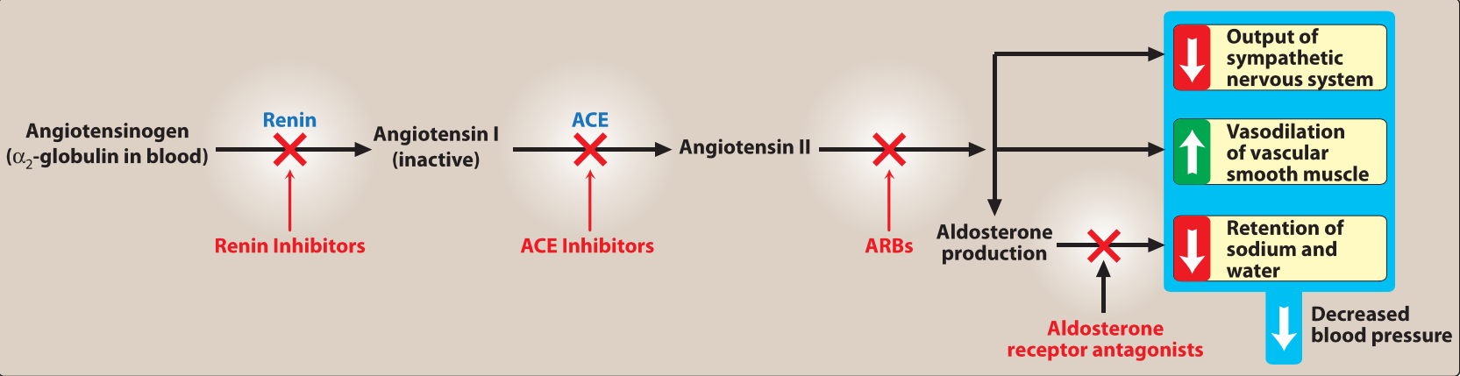

ACE is also responsible for the breakdown of bradykinin, a peptide that increases the production of nitric oxide and prostacyclin by the blood vessels. Both nitric oxide and prostacyclin are potent vasodilators. Vasodilation of both arterioles and veins occurs as a result of decreased vasoconstriction (from diminished levels of angiotensin II) and enhanced vasodilation (from increased bradykinin). By reducing circulating angiotensin II levels, ACE inhibitors also decrease the secretion of aldosterone, resulting in decreased sodium and water retention. ACE inhibitors reduce both cardiac preload and afterload, thereby decreasing workload on the heart. **B. Therapeutic uses** ACE inhibitors slow the progression of diabetic nephropathy and decrease albuminuria and, thus, have a compelling indication for use in patients with **diabetic nephropathy.** Beneficial effects on renal function may result from decreasing intraglomerular pressures, due to efferent arteriolar vasodilation. ACE inhibitors are a standard in the care of a patient following a myocardial infarction and first-line agents in the treatment of patients with systolic dysfunction. Chronic treatment with ACE inhibitors achieves sustained blood pressure reduction, regression of left ventricular hypertrophy, and prevention of ventricular remodeling after a myocardial infarction. ACE inhibitors are first-line drugs for treating heart failure, hypertensive patients with chronic kidney disease, and patients at increased risk of coronary artery disease. All of the ACE inhibitors are equally effective in the treatment of hypertension at equivalent doses.

**C. Pharmacokinetics** All of the ACE inhibitors are orally bioavailable as a drug or prodrug. All but captopril and lisinopril undergo hepatic conversion to active metabolites, so these agents may be preferred in patients with severe hepatic impairment. **Fosinopril** is the only ACE inhibitor that is not eliminated primarily by the kidneys. Therefore, it does not require dose adjustment in patients with renal impairment. **Enalapril** is the only drug in this class available intravenously.

**D. Adverse effects**. The **dry cough**, which occurs in up to 10% of patients, is thought to be due to increased levels of bradykinin and substance P in the pulmonary tree, and it occurs more frequently in women. The cough resolves within a few days of discontinuation. **Angioedema** is a rare but potentially life-threatening reaction that may also be due to increased levels of bradykinin. **Potassium levels must** be monitored while on ACE inhibitors, and potassium supplements and potassium-sparing diuretics should be used with caution due to the risk of hyperkalemia. Serum creatinine levels should also be monitored, particularly in patients with underlying renal disease. However, an increase in serum creatinine of up to 30% above baseline is acceptable and by itself does not warrant discontinuation of treatment. ACE inhibitors can induce **fetal malformations** and should not be used by pregnant women.

**ANGIOTENSIN II RECEPTOR BLOCKERS**

The ARBs, such as **losartan** and **irbesartan**, block the AT1 receptors, decreasing the activation of AT1 receptors by angiotensin II. Their pharmacologic effects are similar to those of ACE inhibitors in that they produce arteriolar and venous dilation and block aldosterone secretion, thus lowering blood pressure and decreasing salt and water retention. ARBs do not increase bradykinin levels. They may be used as first-line agents for the treatment of hypertension, especially in patients with a compelling indication of diabetes, heart failure, or chronic kidney disease. Adverse effects are similar to those of ACE inhibitors, although the risks of cough and angioedema are significantly decreased. ARBs should not be combined with an ACE inhibitor for the treatment of hypertension due to similar mechanisms and adverse effects. These agents are also teratogenic and should not be used by pregnant women.

**RENIN INHIBITOR**

A selective renin inhibitor, **Aliskiren**, is available for the treatment of hypertension. Aliskiren directly inhibits renin and, thus, acts earlier in the renin-angiotensin-aldosterone system than ACE inhibitors or ARBs. Aliskiren should not be combined with an ACE inhibitor or ARB in the treatment of hypertension. Aliskiren can cause diarrhea, especially at higher doses. It also causes cough and angioedema but less often than ACE inhibitors. As with ACE inhibitors and ARBs, aliskiren is contraindicated during pregnancy. Aliskiren is metabolized by CYP3A4 and is subject to many drug interactions.

**CALCIUM CHANNEL BLOCKERS**

Calcium channel blockers are a recommended first-line treatment option in black patients. They may also be useful in hypertensive patients with diabetes or stable ischemic heart disease. High doses of short-acting calcium channel blockers should be avoided because of increased risk of myocardial infarction due to excessive vasodilation and marked reflex cardiac stimulation.

**A. Classes of calcium channel blockers** The calcium channel blockers are divided into three chemical classes, each with different pharmacokinetic properties and clinical indications.

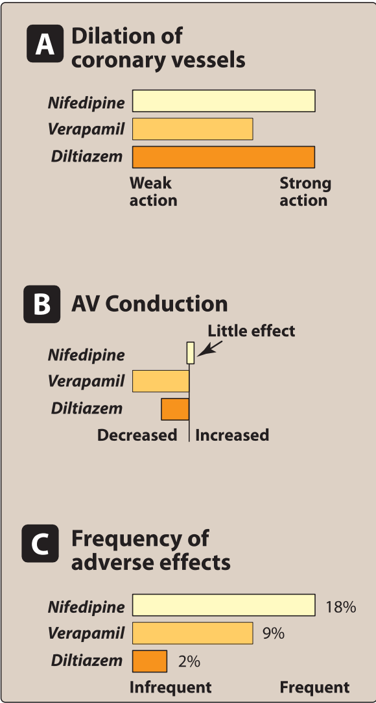

1. **Diphenylalkylamines: Verapamil** has significant effects on both cardiac and vascular smooth muscle cells. It is also used to treat angina and supraventricular tachyarrhythmias and to prevent migraine and cluster headaches.
2. **Benzothiazepines:** **Diltiazem**. Like verapamil, diltiazem affects both cardiac and vascular smooth muscle cells, but it has a less pronounced negative inotropic effect on the heart compared to that of verapamil. Diltiazem has a favorable side effect profile.
3. **Dihydropyridines:** This class of calcium channel blockers includes **nifedipine** (the prototype), **amlodipine**, **felodipine**, **isradipine**, **nicardipine**, and **nisoldipine**. These agents differ in pharmacokinetics, approved uses, and drug interactions. All dihydropyridines have a much greater affinity for vascular calcium channels than for calcium channels in the heart. They are, therefore, particularly beneficial in treating hypertension. The dihydropyridines have the advantage in that they show little interaction with other cardiovascular drugs, such as digoxin or warfarin, which are often used concomitantly with calcium channel blockers.
4. **Actions** The intracellular concentration of calcium plays an important role in maintaining the tone of smooth muscle and in the contraction of the myocardium. Calcium channel antagonists block the inward movement of calcium by binding to L-type calcium channels in the heart and in smooth muscle of the coronary and peripheral arteriolar vasculature. This causes vascular smooth muscle to relax, dilating mainly arterioles. Calcium channel blockers do not dilate veins.
5. **Therapeutic uses** In the management of hypertension, CCBs may be used as an initial therapy or as add-on therapy. They are useful in the treatment of hypertensive patients who also have asthma, diabetes, and/or peripheral vascular disease, because unlike beta-blockers, they do not have the potential to adversely affect these conditions. All CCBs are useful in the treatment of angina. In addition, diltiazem and verapamil are used in the treatment of atrial fibrillation.
6. **Pharmacokinetics** Most of these agents have short half-lives (3 to 8 hours} following an oral dose. Sustained-release preparations are available and permit once-daily dosing. Amlodipine has a very long half-life and does not require a sustained-release formulation.
7. **Adverse effects** First-degree atrioventricular block and constipation are common dose-dependent side effects of verapamil. Verapamil and diltiazem should be avoided in patients with heart failure or with atrioventricular block due to their negative inotropic (force of cardiac muscle contraction} and dromotropic (velocity of conduction) effects. Dizziness, headache, and a feeling of fatigue caused by a decrease in blood pressure are more frequent with dihydropyridines. Peripheral edema is another commonly reported side effect of this class. Nifedipine and other dihydropyridines may cause gingival hyperplasia.

**Alpha -ADRENOCEPTOR-BLOCKING AGENTS**

Alpha-Adrenergic blockers used in the treatment of hypertension include **prazosin**, **doxazosin**, and **terazosin**. These agents produce a competitive block of α1-adrenoceptors. They decrease peripheral vascular resistance and lower arterial blood pressure by causing relaxation of both arterial and venous smooth muscle. These drugs cause only minimal changes in cardiac output, renal blood flow, and glomerular filtration rate. Therefore, long-term tachycardia does not occur, but salt and water retention does. Reflex tachycardia and postural hypotension often occur at the onset of treatment and with dose increases, requiring slow titration of the drug in divided doses. Due to weaker outcome data and their side effect profile, α -blockers are no longer recommended as initial treatment for hypertension but may be used for refractory cases. Other α 1-blockers with greater selectivity for the prostate are used in the treatment of benign prostatic hyperplasia.

**α/****β-ADRENOCEPTOR-BLOCKING AGENTS**

**Labetalol and carvedilol** block α1, β1, and β2 receptors. Carvedilol is indicated in the treatment of heart failure and hypertension. It has been shown to reduce morbidity and mortality associated with heart failure. Labetalol is used in the management of gestational hypertension and hypertensive emergencies.

**CENTRALLY ACTING ADRENERGIC DRUGS**

1. **Clonidine**

Clonidine acts centrally as an α2 agonist to produce inhibition of sympathetic vasomotor centers, decreasing sympathetic outflow to the periphery. This leads to reduced total peripheral resistance and decreased blood pressure. Clonidine is used primarily for the treatment of hypertension that has not responded adequately to treatment with two or more drugs. Clonidine does not decrease renal blood flow or glomerular filtration and, therefore, is useful in the treatment of hypertension complicated by renal disease. Clonidine is well absorbed after oral administration and is excreted by the kidney. It is also available in a transdermal patch. Adverse effects include sedation, dry mouth, and constipation. Rebound hypertension occurs following abrupt withdrawal of clonidine. The drug should, therefore, be withdrawn slowly if discontinuation is required.

1. **Methyldopa**

Methyldopa is an α2 agonist that is converted to methyl-norepinephrine centrally to diminish adrenergic outflow from the CNS. The most common side effects of methyldopa are sedation and drowsiness. Its use is limited due to adverse effects and the need for multiple daily doses. It is mainly used for management of hypertension in pregnancy, where it has a record of safety.

**VASODILATORS**

The direct-acting smooth muscle relaxants, such as **hydralazine** and **minoxidil**, used as primary drugs to treat hypertension. These vasodilators act by producing relaxation of vascular smooth muscle, primarily in arteries and arterioles. This results in decreased peripheral resistance and, therefore, blood pressure. Both agents produce reflex stimulation of the heart, resulting in the competing reflexes of increased myocardial contractility, heart rate, and oxygen consumption. These actions may prompt angina pectoris, myocardial infarction, or cardiac failure in predisposed individuals. Vasodilators also increase plasma renin concentration, resulting in sodium and water retention. These undesirable side effects can be blocked by concomitant use of a diuretic (to decrease sodium retention) and a β-blocker (to balance the reflex tachycardia). Together, the three drugs decrease cardiac output, plasma volume, and peripheral vascular resistance. Hydralazine is an accepted medication for controlling blood pressure in pregnancy induced hypertension. Adverse effects of hydralazine include headache, tachycardia, nausea, sweating, arrhythmia, and precipitation of angina. A lupus-like syndrome can occur with high dosages, but it is reversible upon discontinuation of the drug. Minoxidil treatment causes hypertrichosis (the growth of body hair). This drug is used topically to treat male pattern baldness. **HYPERTENSIVE EMERGENCY**

Hypertensive emergency is a rare but life-threatening situation characterized by severe elevations in blood pressure (systolic greater than 180 mm Hg or diastolic greater than 120 mm Hg) with evidence of impending or progressive target organ damage (for example, stroke, myocardial infarction). [Note: A severe elevation in blood pressure without evidence of target organ damage is considered a hypertensive urgency.] Hypertensive emergencies require timely blood pressure reduction with treatment administered intravenously to prevent or limit target organ damage. A variety of medications are used, including calcium channel blockers (nicardipine and clevidipine), nitric oxide vasodilators (nitroprusside and nitroglycerin), adrenergic receptor antagonists (phentolamine, esmolol, and labetalol. the vasodilator hydralazine, and the dopamine agonist fenoldopam. Treatment is directed by the type of target organ damage and/or comorbidities present.

**RESISTANT HYPERTENSION**

Resistant hypertension is defined as blood pressure that remains elevated (above goal) despite administration of an optimal three-drug regimen that includes a diuretic. The most common causes of resistant hypertension are poor compliance, excessive ethanol intake, concomitant conditions (diabetes, obesity, sleep apnea, hyperaldosteronism, high salt intake, and/or metabolic syndrome), concomitant medications (sympathomimetics, nonsteroidal anti-inflammatory drugs, or corticosteroids), insufficient dose and/or drugs, and use of drugs with similar mechanisms of action.

***End of Hypertension lectures***