Methods of expression of concentrations

:M)) Molarity-1
Number of grams molecular weight (moles) of solute per liter of solution.
 (where n= $\frac{Wt}{Mwt}$ )
𝑽(𝒍𝒊𝒕𝒆𝒓)

M = $\frac{no. of millimoles}{V mL}$

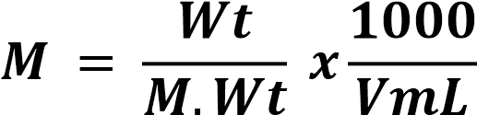
Units: mole/L , 𝐦𝐦𝐨𝐥𝐞/𝐦𝐋

Ex: How many grams of 0.125 M AgNO₃ used to prepare 500ml of its solution.

( M.Wt= 169.9 g/mole)
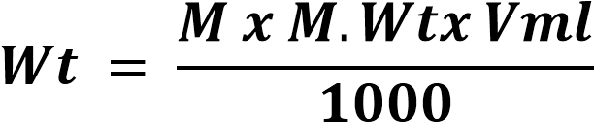
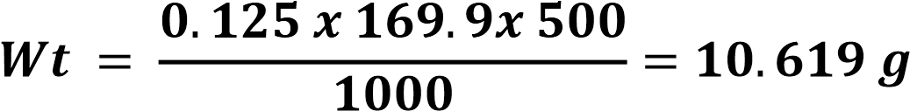

Ex: Calculate the Molarity (M) of solution result from dissolving 20 g of Sodium hydroxide in 2 Litters of solution. Na = 23 , O = 16 , H = 1

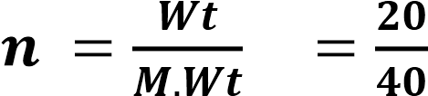 = 0.5 mole 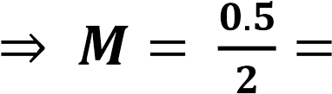 0.25M

(or) = 0.25M

(or) = 0.25M

:Normality(N)-2

Number of gram equivalent weight of solute per liter of solution .
, N = $\frac{no. of meq}{V mL}$ , N = $\frac{no. of eq }{V( liter)}$ N = $\frac{number of equialent}{V(liter)}$
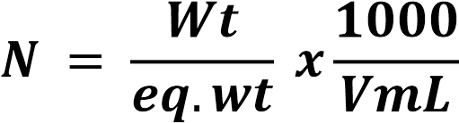
Units: eq /L , meq/mL

Ex: How many grams of 0.2 N Sodium carbonate in 250 ml solution. (M.Wt =106g / mole)

$eq.wt{Na}_{2}{co}_{3}\frac{106}{2×1}=53 g/eq$

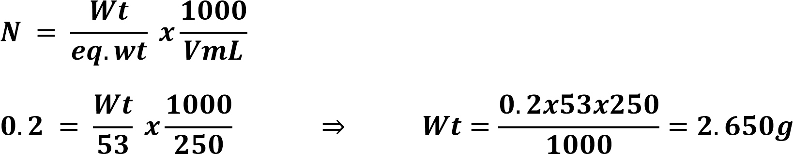
Ex: Calculate the normality (N) of solution result from dissolving 0.5 g of Cu(OH)₂ in 100 mL of distilled water. ( Cu =63.5 O=16 H=1)
SOL)
Cu(OH)₂e
$eq.wt=\frac{97.5}{2}$ = 48.75 g/eq
:Formality (F)-3

Number of gram formula weight of solute per liter of solution .
F= $\frac{number of formula weight }{V (liter)}$

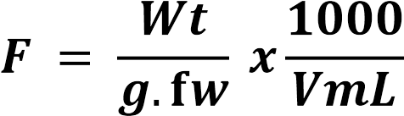

Units: fw/L , mfw/mL

:Molality(m)-4

Number of Moles of solute per Kilogram (1000g) of solvent.
𝒎

=

𝒏𝒖𝒎𝒃𝒆𝒓 of solute moles solute moles sososolutemoles moles

𝑾𝒕
.
𝒔𝒐𝒍𝒗𝒆𝒏𝒕
.
(
𝑲𝒈
)

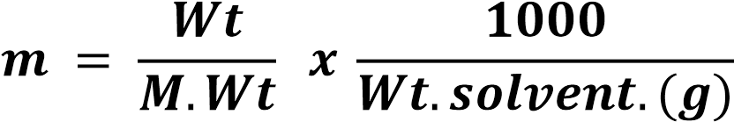
Units: Mole/kg or mmole/g
Ex: Calculate the molality (m) of solution result from dissolving 5 g of Sodium hydroxide in 250 g of distilled water. (M.Wt=40g/mole)
$n_{NaOH}=\frac{wt }{M.wt}=\frac{5g }{40\frac{g}{mole}}=0.125 mole$

or: m

5- Mole Fraction:

The ratio between the number of moles of solute or solvent to the total number of moles of solute or solvent .
n₁ n₂

X₁ = X₂ =

n₁ + n₂ n₁ + n₂

X1 + X2 =1

Ex: Calculate the mole fraction for A and B in its mixture if you know number of Moles of A = 18 moles and B= 40 moles
18 40
X₁ = = 0.310 X₂ = = 0.690 18 + 40 18 + 40

:Percentage Ratio -6
- Weight Volume Percentage Concentration (weigh to volume percent ratio):

lt is the number of grams of solute in 100ml of solution .
Wtgof solute
%W/V = x100
VmL of solution

Volume Percentage Concentration(volume percent ratio) :

lt is the number of milliliters of solute in 100 mL of solution

VmL of solute
% V/V= x100
VmL of solution

- Weight Percentage Concentration (weight percent ratio):
lt is the number of grams of solute 100 g of solution.

Wtg of solute
%W/W= x100 Wt_{g} of solution

Ex: Calculate the percentage ratio for solution result from dissolving 5 g of Sodium hydroxide in 0.25 L of solution
Wtg of solute 5
%W/V= x100 = x100 = 2%
VmL of solution 250

Ex: Calculate the percentage ratio for solution result from addition of 200 mL of Methanol to 400 mL distilled water.

VmL of solute
% V/V= x100
VmL of solution

200
% V/V= x100 = 33.333%
200 + 400

Ex: Calculate the No. of g of glucose solution in 800 mL industrial solution, if its percentage ratio is 15%

Wtg of solute
%W/V= x100
VmL of solution

Wt_{g} of glucose
15 = x 100 = 120g
800

7-Parts per thousand (ppt )

ppt = $\frac{Wt of solute}{Wt of solution}$ × 10³ ( or) ppt = $\frac{Wt of solute (g)}{Volume of solution(L)}$ = $\frac{mg}{mL}$

ppt= Wt. of solute / Wt. of solution)× 10³

8-Parts per million (ppm)

ppm=$\frac{Wt.of solute}{Wt.of solution}$ ×10⁶ (or) ppm = $\frac{Wt of solute (mg)}{Volume of solution (L)}$ = $\frac{µg}{mL}$

9-Parts per billion )ppb

ppb = $\frac{Wt of solute }{Wt of solution}$ × 10⁹ (or ) ppb =$\frac{Wt of solute(µg)}{Volume of solution(L)}$ =$\frac{ng}{mL}$
Gram (g) = 1000 Milligram (mg)
Milligram (mg) =1000 Microgram (μg)
Microgram (μg) = 1000 Nangram(ng)
Liter (L) = 1000 Milliliter (mL)
Milliliter (mL) = 1000 Microliter(μL)
Microliter(μL) = 1000 Nanoliter(nL)

part | iquid in liquid | Solid in liquid | Solid in solid
ppt | mL/L = μL/mL | g/L = mg/mL | g/kg = mg/g
ppm | μL/L = nL/mL | mg/L = μg/mL | mg/kg = μg/g
ppb | nL/L | μg/L = ng/mL | μg/kg = ng/g

$M=\frac{\%×sp.gr ×1000}{Mwt}$

$N=\frac{\%×sp.gr ×1000}{eg.wt}$
$F=\frac{\%×sp.gr ×1000}{g.fw}$
Also these laws:

N₁ V₁ = N₂ V₂ , M₁ V₁ = M₂ V₂ , F₁ V₁ = F₂ V₂

_{Density (d) =} $\frac{Wt (g)}{V(mL)}$ _{(UNIT : g / mL or Kg /L)}

Specific gravity (sp. gr) = $\frac{density of substance}{density of water}$

Ex: Calculate the normality (N) of solution result from dilution 100mL of 0.25 N Nitric Acid to 250mL

N₁V₁ = N₂V₂
0.25 x 100 = N₂ x 250 ⇒ N₂ = 0.1N
Ex: How can you prepare 0.1 N of 250 mL Sulfuric Acid if you know Sp. Gr.
1.84, percentage ratio 96% and M.Wt. 98 g/mole

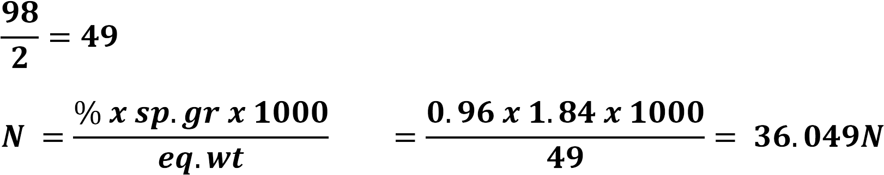

N₁ V₁ = N₂ V₂
36.049 x V₁ = 0.1 x 250
V₁ = 0.694 mL

By add 0.694 mL of acid and in 250 mL volumetric flask then complete the volume up to the mark with distilled water.
Q) How can you prepare 0.5 N of 500 mL Hydrochloric Acid if you know
Sp. Gr. 1.184, percentage ratio 37% and A.Wt. H=1 Cl=35.5

Solved questions on concentrations
Q1- What is the formal concentration of NaCl solution (M.Wt 58.5 g/mole) if 0.1753 g of the salt dissolved in sufficient amount of water to give 240mL of solution?

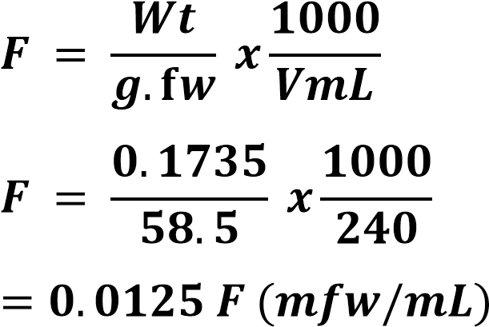

Q2- Calculate the molality (m) of a solution which is 10% by weight NaOH (M.Wt 40g/mole), supposing that we take 100gm of solution.

In 100 g of solution: 10g NaOH + 90 g H₂O
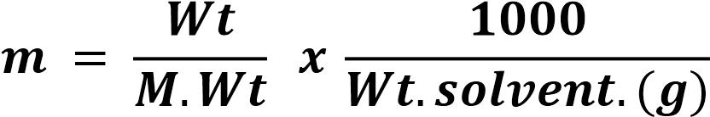

$\frac{10}{40}×\frac{1000}{90}=2.778 m(mmole/g)$
Q3- Calculate the molarity and normality of a solution containing 10.6g of sodium carbonateNa₂CO₃(M.Wt 106g/mole) in one liter of aqueous solution?

M= $\frac{n}{V\left(Liter\right)}$ , $n=\frac{wt}{Mwt}= \frac{10.6}{106}=0.1 mole$
$$M=\frac{0.1}{1}=0.1 m(\frac{mole}{l})$$

(or)

$$M= \frac{wt}{Mwt}×\frac{1000}{V\left(ml\right)}= \frac{10.6}{106}×\frac{1000}{1000}=0.1 M \left(mole/L\right)$$

eq.wt(${Na}_{2}{co}_{3})=\frac{106}{2×1}=53g/eq$

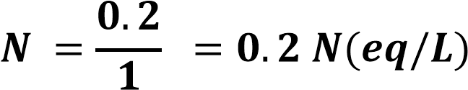
(or)

Q4- 16 gram of KNO₃ is dissolved in 84 g of water to give 16%(w/w) KNO₃ solution express the concentration in ppm.
$$ppm= \frac{wt of soluute}{wt of solution }×{10}^{6}$$
$$ppm= \frac{16}{84 }×{10}^{6}=0.1905 ppm(\frac{μg}{g} )$$

Q5- Calculate the number of grams of solute in:
- 1 liter of 0.2 N Ba(OH)₂ solution.
- 5 liter of 0.2 N (NaOH) solution.
a- eq. Wt (Ba(OH)₂ ₌ $\frac{171}{2}$ = 85.5 g / eg
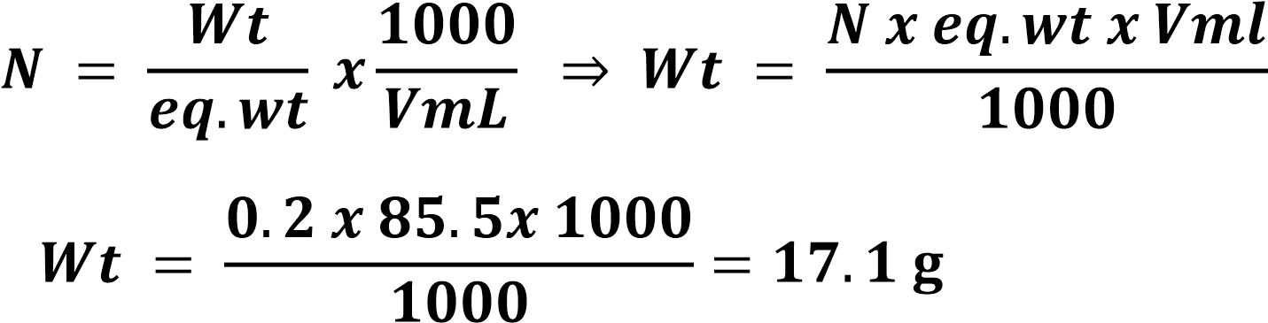

b ) eq.wt NaOH = $\frac{40}{1} = 40$g/eq
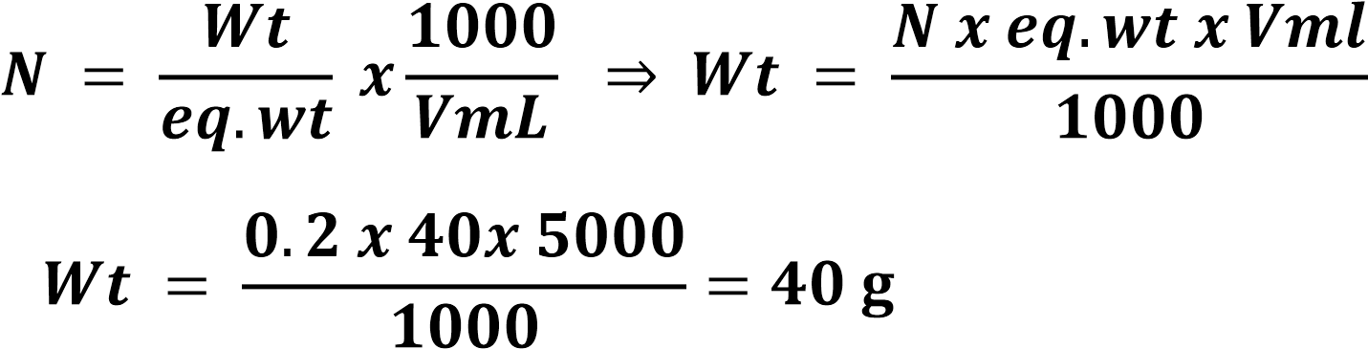
Q6- How can you prepare:
a- 250 mL of 0.25 F HCl, if sp. gravity of HCl a=1.184 and containing about 37% HCl by weight.
b- 250 ml of 0.1M H₂SO₄. if sp. Gravity = 1.84 and containing about
96% H₂SO₄.
a-

F₁V₁ = F₂V₂ ,
12.002 × V₁ = 0.25 × 250 , $v_{1}=\frac{0.25×250}{12.002}=5.207 mL$
By add 5.207 mL of acid and in 250 mL volumetric flask then complete the volume up to the mark with distilled water. b-

M₁V₁ = M₂V₂ , 18.024 × V₁ = 0.1 × 250 , $v_{1}=\frac{25×250}{18.024}=1.387 mL$

By add 1.378mL of acid and in 250 mL volumetric flask then complete the volume up to the mark with distilled water.

Q7- Calculate the normality (N) of a 500 ml solution containing 20gms of NaOH (M.Wt 40 g/mole).

Q8- Find the molarity (M) of NaCl solution if 1.17 %( W/V), M.Wt=58.5.

% W/V = No. of grams of solute(1.17g) in 100 ml 0f solution
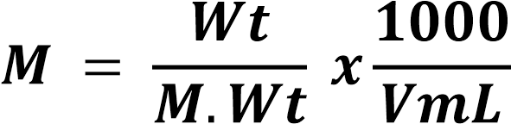

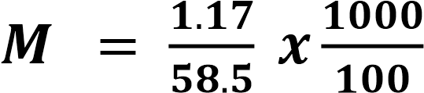= 0.2M (mmole/mL)

Q9- Calculate the mole fraction of 15% by weight aqueous sugar solution (15% (w/w) C₆H₁₂O₆).
M.Wt: C₆H₁₂O₆ = 180 g/mole, H₂O = 18 g/mole

In 100 g of solution: 15g C₆H₁₂O₆ + 85 g H₂O
No. of moles of sugar
mole fractoin of sugar(X1) =
No. of moles of sugar + No. of moles of water
No. of moles of water
mole fraction of water(X2) =
No. of moles of sugar+ No. of molesof water

Numbers of mole of C₆H₁₂O₆ (n₁) =
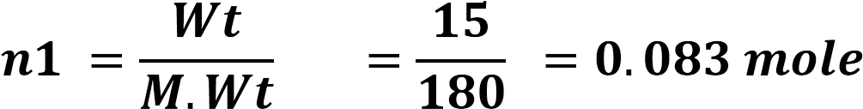

Numbers of mole of water (n₂) =
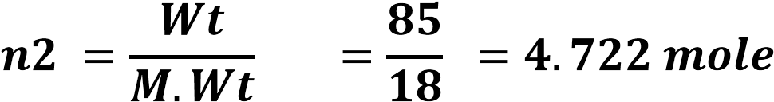
n1 0.083

X₁ = = = 0.017 (mole fraction of sugar)
n1 + n2 4.805

n2 4.722

X₂ = = = 0.983 (mole fraction of water)
n1 + n2 4.805
X1 + X2 =1

0.017 + 0.983 =1

