Analytical Chemistry
Chemistry: is a science concerned with the study of properties, structure, components of the materials changes occur to it and emitted or absorbed energies accompany these changes.
Chemistry science is classified according to the type of materials and the purpose of their studies into these general branches:
Analytical Chemistry, Organic Chemistry, Inorganic Chemistry and Physical Chemistry. Other branches are Theoretical Chemistry, Quantum Chemistry, and Nuclear Chemistry etc.

ANALYTICAL CHEMISTRY
It is a chemistry branch deals with the study on the identification of material composition and the determination of the amount of each component presented by an expression of concentration directly or indirectly (after separation). Analytical chemistry includes three types of analysis. Analytical chemistry helped in understanding the natural phenomena through providing the knowledge about quantitative relations of the phenomena. It develops chemistry science and other sciences since most of the laws based on the quantitative analysis.
1- QUALITATIVE ANALYSIS:
It is process of many steps that through which material, compounds or elements or elements forming certain material or a mixture of materials can be identified at liquid, gas or solid phases. This process is the first step in analysis.
2-QUANTITATIVE ANALYSIS
It is a process deals with the determination of elements or other components that form the analyzed material (compound or mixture). It tell us what is the amount of the components of the materials or their components. Quantitative analysis can not be preceded without processing qualitative analysis.

QUANTITATIVE ANALYSIS :- divided into
- GRAVIMETRICANALYSIS
Gravimetric analysis includes the processes that enable us to determine the weight of the material under consideration or some of the material components and can be done by one of two methods.

- Direct method: by measuring the weights of the analytical process products which should be of definite and defined composition or structure.
- Indirect method: follows the weight losses of the materials or their components.
- VOLUMETRIC ANALYSIS:
Indirect methods are used in this process to determine the weights of the materials or their components and include the following:
1)Titration methods:
In these methods the volume of solutions of defined concentrations which is required to complete the reaction with the materials or their components is measured . From this volume of defined concentration and the knowledge of the balanced reaction equation one can estimate the concentration (or) the amount of the materials (or) their components. Indicators ( Pigments such as phenolphthalein ) are used to define the end point of the reaction (equivalent point) . These indicators show sudden and sharp change in physiochemical properties such as turbidity or color at the end point.
2)Gas analysis:
In this method the amounts of consumed gases or the amounts of gas product as a result of the gas material reaction with other material are determined.

3) INSTRUMENTAL METHODS OF ANALYSIS
(Physiochemical methods of analysis):
Determination of materials or their components can be performed using instruments that their measurements of certain properties such as conductivity, turbidity, potentiometry, color, refractive index, absorption at UV or visible region etc…provided these measurements depend on and relate to the concentration of the material or its components directly or indirectly.
A- Using of Conductivitimeter to measure the conductivity of sample solution which is changing with variation in the component concentration.
B- Using of potentiometer to measure the potential of an electrode which is in equilibrium with the sample solution.
C- Using of UV-visible spectrometer to measure the absorbance of radiation at a wave length that relate to the component directly or to the compound formed by its reaction with a reagent.
STEPS OF CHEMICAL ANALYSIS:
There are a general steps for any analysis process, a modifications in these steps depend on nature, size, and complicity of the sample, the accuracy required and availability of reagents chemicals equipments and apparatus

STEP 1: CHOICE OF THE METHOD
The selected method should be suitable to the nature of the sample, number of samples and accuracy required. Some samples like archaeological or forensic samples need a nondestructive method to keep the samples without destruction.

STEP 2: SAMPLING
Sampling is a very important criterion. It is the fraction of the material with which he plans to work. It is truly representative the whole of it. If the material is big many samples are selected and collected.
STEP 3: PREPARING OF LABORATORY SAMPLE:
The field sample is treated to prepare the laboratory sample required for the analysis.
- Producing a homogenized sample by crashing, grinding and mixing.
- Decreasing the size of the material sample granules.
- Turning the sample into a phase and formula can be attacked by reagent.
- Care should be taken to avoid the interferences or any other factors affecting the estimation such as contamination.

STEP 4: PROCUREMENT OF MEASURED QUANTITY OF THE SAMPLE:
If the sample is solid certain weight of the dried homogenized sample is taken using calibrated balance. If it is liquid certain volume is taken.
STEP 5: DISSOLUTION OF THE MEASURED SAMPLE:
A suitable solvent is selected to dissolve the sample completely and within short time. The sample should not interfere in the analysis. Water is a magic solvent for almost all the inorganic materials and some of the organic materials. Organic materials require organic solvents like alcohols, carbon tetrachloride and chloroform. Fusion is used for melting samples do not dissolve in solvents.
STEP 6: SEPARATION OF THE INTERFERING SUBSTANCES.
To measure the sample freely from interferences by other components certain steps should be taken such as separation or using masking agents.
STEP 7: COMPLETION OF THE ANALYSIS
This step concern with the measurement of the substance or component under consideration precisely using a suitable method by precipitation or color formation, titration etc.

STEP 8: CALCULATIONS AND DATA ANALYSIS:
From the numeric results obtained by measurements the final result is calculated using the weight of the analyzed sample. The final results may be evaluated by statistic analysis.

Calculation of Equivalent weight

Acids: -1

eq.wt(acid) =$\frac{M.Wt}{no.of hydrogen atoms ionized (H)}$

Ex. Calculate the Equivalent weight for hydrochloric and Sulfuric acid
(Atomic Weight = Cl= 35.5 H=1 O=16 S= 32 )
Sol)

eq.wt(acid) =$\frac{M.Wt}{no.of hydrogen atoms ionized (H)}$

HCl
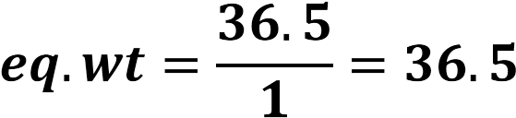
H₂SO4
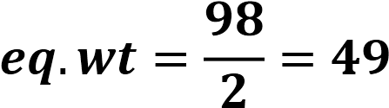

:Bases -2

eq.wt(Base) = $\frac{M.Wt}{no.of hydroxide atioms ionized (OH)}$

Ex: Calculate the Equivalent weight for Sodium hydroxide
(Atomic Weight =H=1 O=16 Na= 23 )

Sol) eq.wt(Base) = $\frac{M.Wt}{no.of hydroxide atioms ionized (OH)}$

NaOH 
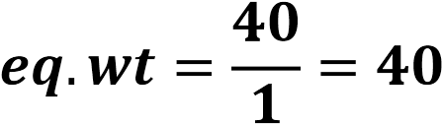
Al(OH)₃ 
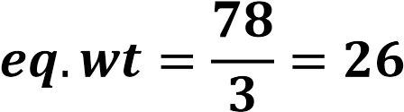

:Salts -3

Ex: Calculate the Equivalent weight for Calcium chloride and Ferric sulfate. Atomic Weight: Ca=40 Cl=35.5 S = 32 Fe= 56 O=16 H=1
CaCl₂ e
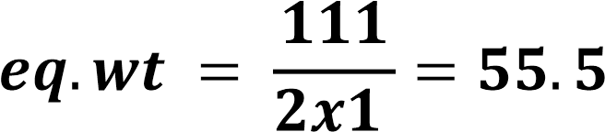

Fe₂ (SO₄)₃
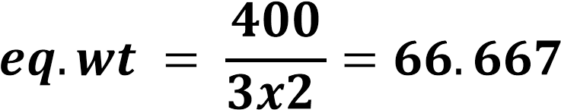

:Oxidizing and Reducing Agent -4

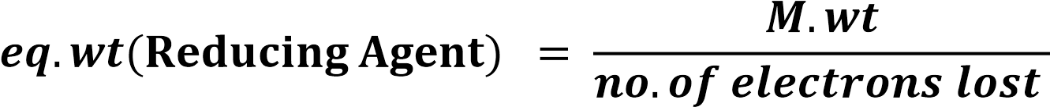

Ex: Calculate the Equivalent weight for KMnO₄
Atomic Weight = K= 39 , Mn =55 , O=16
8H⁺ + 5 e⁻ <====Mn²⁺ + 4H₂O MnO₄⁻ +
KMnO4
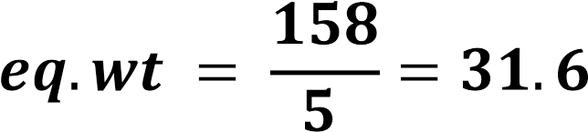

Ex: Calculate the Equivalent weight for Compounds below.
HCl – H₂SO₄ – NaOH – Fe(OH)₂ – Fe(OH)₃ – NH₄OH – K₂CrO₄ – NaF – H₃PO₄ - ZnCl₂ – MgSO₄ – AgNO₃ – Pb(OH)₂ – CH₃COOH – Na₂CO₃ – Hg₂(NO₃)₂ – HI

