Oxidation-Reduction Titration

Chemical reactions in which transfer of electrons occurs are known Oxidation reduction reactions (Redox Reactions). More volumetric analytical methods are based upon this type of reactions, such as oxidation-reduction titration.
Oxidation, involves the loss of electrons by the substance, and reduction, the gain of electrons by the substance. In any oxidation reduction, the ratio of moles of to moles of substance reduced is identical to the ratio of the number of lost electrons from one species. .to the number of accepted electrons by the other
The oxidizing agent is the material having the ability of withdrawing electrons, and is itself reduced.

MnO₄⁻ + 8H⁺ + 5e⁻ Mn²⁺ + 4H₂O

The reducing agent is the material having the ability of loosing electrons , and is itself reduced oxidized.

Fe²⁺> Fe³⁺ + 1e
Most of the oxidation –reduction reactions that we shall consider are reversible and needed suitable indicators for detection of end point.
Example: when a piece of zinc is immersed in copper solution (CuSO₄), separation of an oxidation –reduction reaction into its two component part each part called half-reaction the overall reaction will be.
Zn + Cu²⁺ Zn²⁺ + Cu Redox reaction
Zn Zn²⁺ + 2e⁻ Oxidation
Cu²⁺ + 2e Cu Reduction

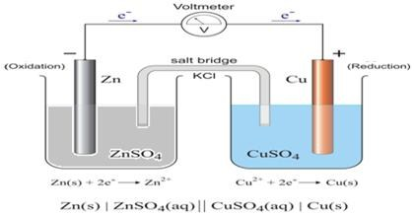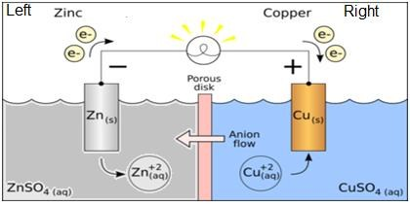

Other example:
Zn (s) + 2H⁺ (aq) → Zn²⁺ (aq) + H₂ (g) Redox reacton
Zn (s) → Zn²⁺ (aq) + 2e⁻ Oxidation
2H⁺ (aq) + 2e⁻ → H₂ (g) Reduction

Nernst equation
Consider the reversible reaction: aA + bB cC + dD
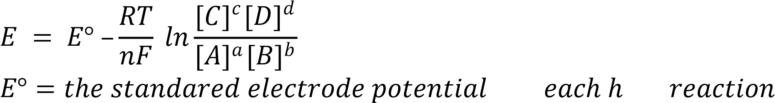
R = the ideal gas constant (8.314 JK⁻¹ mol⁻¹)
T = temperature, K
N = number of electrons that appears in the half reaction
F =the faraday number (96.485 coulombs /mole of electron
Ln = 2.303 log
At 25 ⁰C

Ecell = E _{Right} - E Left
or: Ecell = E _{Reduction} - E _{Oxidation}

Calculation of Equilibrium Constant: Keq

E°cell = E° Right - E° Left
At equilibrium E°_{cell} = 0
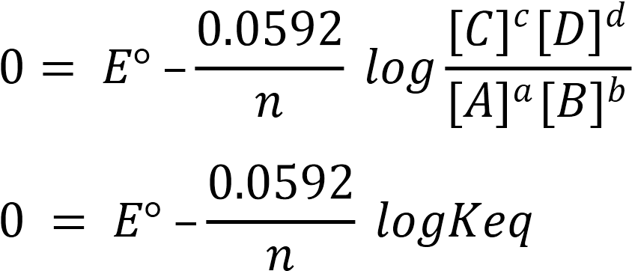
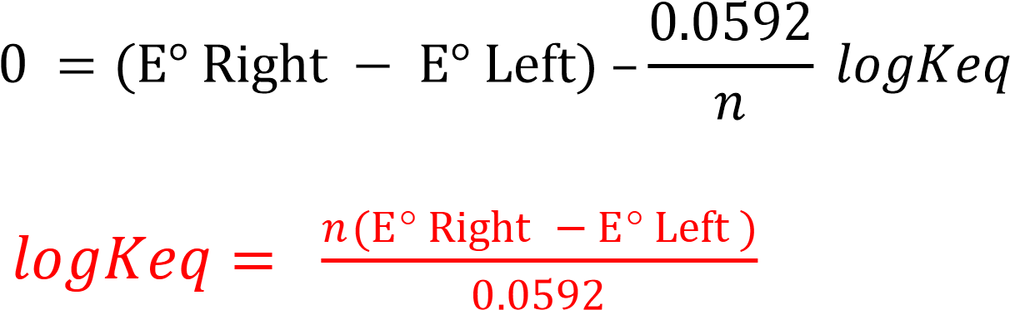

Ex: Calculate the electrode potential for the for the following Cell if you know [Br₂(aq)]=0.001M [Br⁻]=0.01M

Br_{2(aq)} + 2e 2Br 𝐸° = +1.087
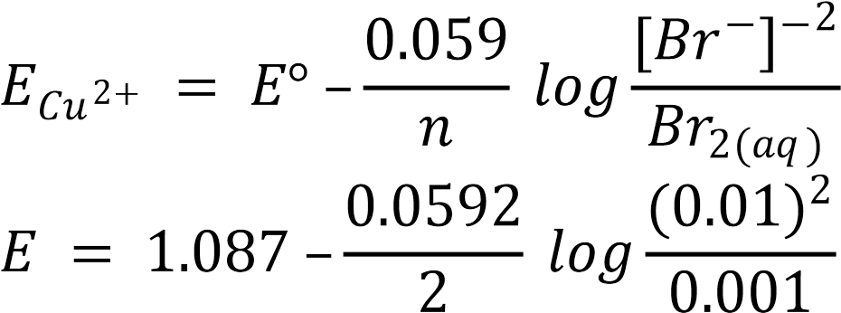

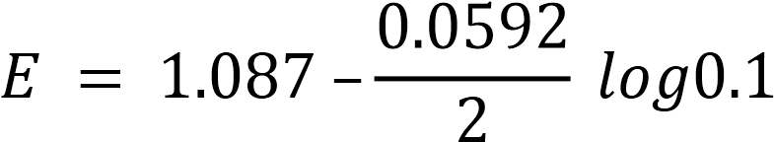

𝐸 = 1.117 𝑉

Ex: Calculate Equilibrium Constant for the for the following Cell
𝐸° Cu = +0.337 𝐸° 𝐴𝑔 = +0.799

Cu_{(S)} + 2Ag⁺ Cu²⁺ + 2Ag_{(S)}

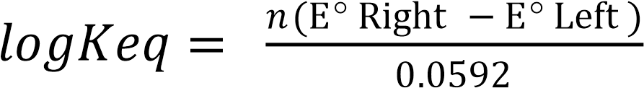

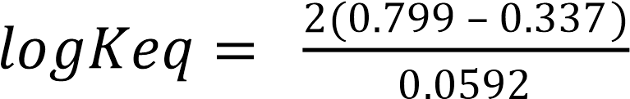

𝑙𝑜𝑔𝐾_{𝑒𝑞} = 15.608

K_{eq} = 10 ^{15.608} = 4.055x10¹⁵

Ex: Calculate the electrode potential for the following Cell if you know [Fe²⁺]=0.1M , [Cu²⁺]=0.3M.

Fe(s) + Cu
Cu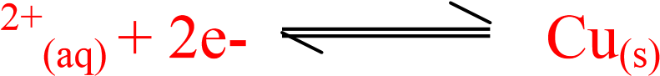 E°= 0.34 V Fe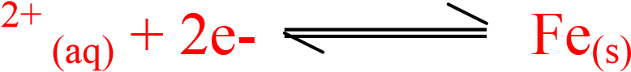 E° = -0.44 V
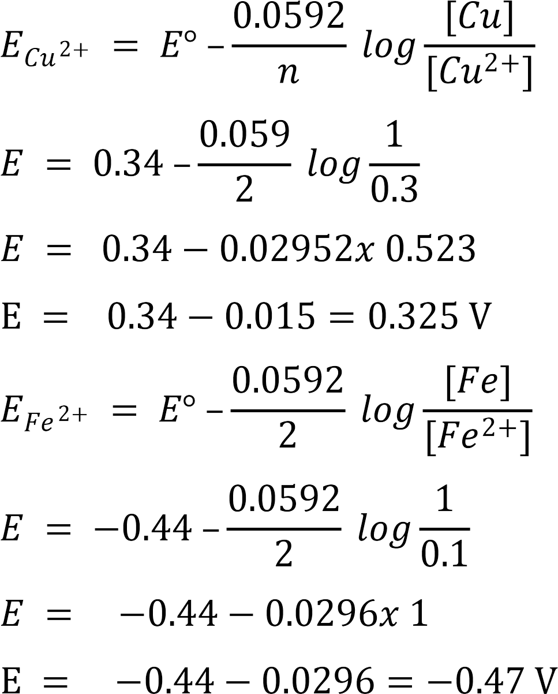
Ecell = E Right - E Left
E_{cell} = 0.325 – (- 0.47) = 0.795V
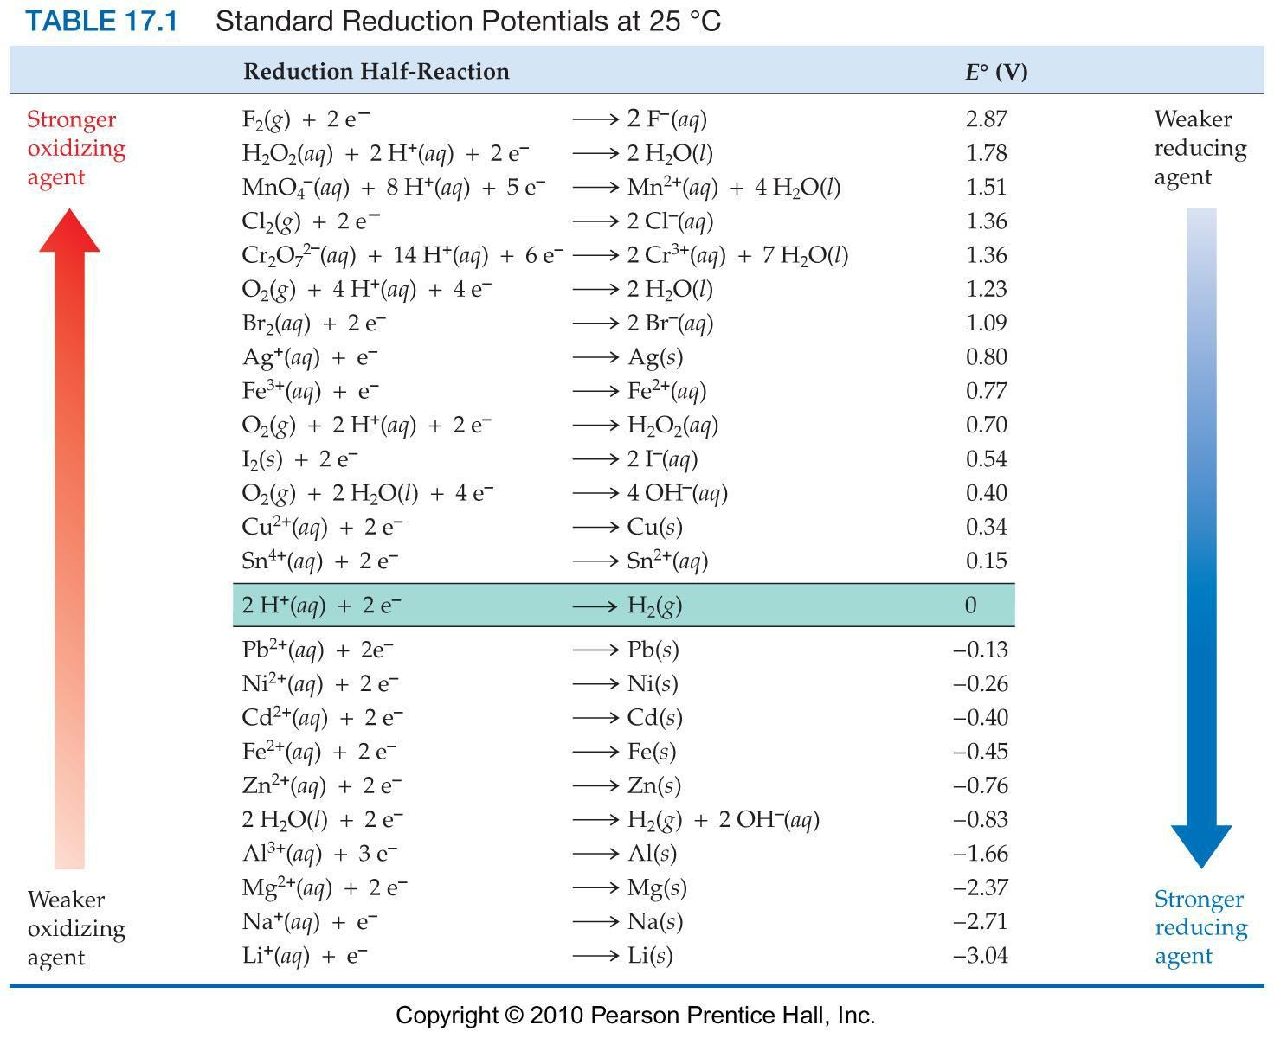

Titration curves
In the curves the logarithm of the concentration of one of the species is drawn against the volume of the reagent and the more sensitive to the indicator species is selected. The indicators itself is either oxidizing or reducing agent response to the system potential instead of to the change in reactants concentrations.

Let take this redox reaction: Ce⁴⁺ + Fe²⁺ Ce³⁺ + Fe³⁺ It is expressed either by reduction potential of Ce (IV) to Ce (III) or reduction potential of Fe (III) to Fe (II) and these values is drawn against the volume of the reagent and called as half cell potential. The two species will be in equilibrium during titration process. The values of reduction potential of the two systems are numerically equal at any point of the curve. The most important value is the value of potential at equivalent point.

Ce⁴⁺ + Fe²⁺ Ce³⁺ + Fe³⁺ redox reaction
Ce⁴⁺ + 1e⁻ Ce³⁺ reduction(oxidized agent)
Fe²⁺ Fe³⁺ + 1e⁻ oxidation(reduced agent)
Ce⁴⁺ + 1e⁻ Ce³⁺
Fe³⁺ + 1e⁻ Fe²⁺

$E= E_{{Ce}^{4+/{ce}^{3+}}}^{0}-\frac{0.0592}{1}\log{\frac{[{Ce}^{3+} ]}{{[Ce}^{4+}]}}$
$E= E_{{Fe}^{3+/{Fe}^{2+}}}^{0}-\frac{0.0592}{1}\log{\frac{[{Fe}^{2+} ]}{{[Fe}^{3+}]}}$

[Fe³⁺] = [Ce³⁺]
[Fe²⁺] = [Ce⁴⁺]
E= Eº_{Ce}⁴⁺ _{/Ce}³⁺ + Eº _{Fe}³⁺ _{/Fe}²⁺ - 0.059 log$\frac{\left[{Ce}^{3+} \right][ {Fe}^{2+} ]}{\left[ {Ce}^{4+} \right][ {Fe}^{3+} ]}$2

E= Eº_{Ce}⁴⁺ _{/Ce}³⁺ + Eº _{Fe}³⁺ _{/Fe}²⁺ - 0.059 log 12

E= Eº_{Ce}⁴⁺ _{/Ce}³⁺ + Eº _{Fe}³⁺ _{/Fe}²⁺ - 02

Eº_{Ce}⁴⁺ _{/Ce}³⁺ + Eº _{Fe}³⁺ _{/Fe}²⁺ ) /2) E =
- 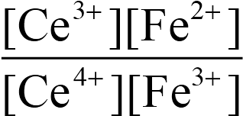
Example: consider the titration of 100ml of 0.1 N iron (II) with
0.1N cerium (IV), calculate the potential at:

Ce⁴⁺ + Fe²⁺ Ce³⁺ + Fe³⁺ redox reaction
Ce⁴⁺ + 1e⁻ Ce³⁺ 𝐸 ° =1.44
Fe³⁺ + 1e⁻ Fe²⁺ 𝐸 ° = 0.77
- Initial potential.
At the outset the solution contains no cerium ions, in addition to the iron (II) ions a small but finite quantity of iron (III) will be present as a consequence of air oxidation. Because the concentration of the latter is uncertain. We cannot calculate the initial potential that has significance.

- Potential after addition of 10 mL of oxidizing agent(ce⁴⁺) With the introduction of a volume of the oxidizing agent, the solution acquires appreciable concentrations of three of the participating ions, that for the fourth, the cerium (IV) ion, will be small. Setting this last quantity equal to X. we may write:
[Ce⁴⁺] = X

[Ce³⁺] = $\frac{10×0.1}{110}$ - X = 9.091x10⁻³ mole/L X is negligibly (small)

[Fe³⁺] =$\frac{10×0.1}{110}$ - X = 9.091x10⁻³ mole/L X is negligibly (small) 110
[Fe²⁺] =$\frac{10×0.1-10×0.1}{110}$ -X = 0.082 mole/L
E= Eo Fe3+/Fe2+ - 0.0592 log $\frac{[ {Fe}^{2+} ]}{[ {Fe}^{3+} ]}$
E= + 0.77 – 0.0592 log $\frac{[0.082 ]}{[ 9.090×{10}^{-3} ]}$
= + 0.77 – 0.0592 log 9.021 = + 0.71 V

3. At equivalence- point potential ( after addition of 100 mL of the reagent)
We have seen that the potential at the equivalence point in this titration is given by:
E = (Eº_{Ce}⁴⁺ _{/Ce}³⁺ + Eº _{Fe}³⁺ _{/Fe}²⁺ ) /2
$$E=\frac{1.44+0.77}{2} =1.11 V$$

4. Potential after addition of 100.1 ml of reagent.
The solution now contains an excess of Ce(IV) in addition to equivalent quantities of iron (III) and cerium (III) ions.
The concentration of iron(II) will now be very small; if we set its value equal to y.
[Fe²⁺] = y

[Fe³⁺] = $\frac{100×0.1}{200.1}$- y = 0.05mole/L y is negligibly (small)

[Ce³⁺] = $\frac{100×0.1}{200.1}$ - y = 0.05mole/L y is negligibly (small)
[Ce⁴⁺] = $\frac{100×0.1-100×0.1}{200.1}$ + y = 4.998x10⁻⁵mole/L y is negligibly (small)
E= Eº_{Ce}⁴⁺ - 0.0592 log $\frac{{[Ce}^{3+}]}{[{Ce}^{4+}]}$
E= + 1.44 – 0.0592 log$\frac{0.05}{4.998×{10}^{-5}}$
= + 1.26 V
Example: consider the titration of 100ml of 0.1 N iron (II) with
0.1N potassium permanganate, calculate the potential at:

5Fe²⁺ + MnO⁻₄ + 8H⁺ Fe²⁺ + Mn²⁺ + 4H₂O redox reaction

Fe³⁺ + 1e⁻ Fe²⁺ 𝐸 ° =0.77
MnO⁻₄ + 8H⁺ + 5e⁻ Mn²⁺ + 4H₂O 𝐸 ° =1.51

- Initial potential.
At the outset the solution contains no cerium ions; in addition to the iron (II) ions a small but finite quantity of iron (III) will be present as a consequence of air oxidation, because the concentration of the latter is uncertain. We cannot calculate an initial potential that has significance.

- Potential after addition of 10ml of oxidizing agent(MnO⁻₄)
With the introduction of a volume of the oxidizing agent, the solution acquires appreciable concentrations of three of the participating ions that for the fourth, the(MnO⁻₄) ion, will be small.
Setting this last quantity equal to X. we may write:

[Mn²⁺] = $\frac{10×0.1}{110}$- X = 9.091x10⁻³ mole/L X is negligibly
[Fe³⁺] = $\frac{10×0.1}{110}$- X = 9.091x10⁻³ mole/L X is negligibly (small)
[Fe²⁺] = $\frac{100×0.1-100×0.1}{110}$-X = 0.082 mole/L
E= Eº _{Fe}³⁺/Fe²⁺ - 0.0592 log $\frac{[{Fe}^{2+} ]}{[{Fe}^{3+}]}$
E= + 0.77 – 0.0592 log $\frac{0.082}{9.090×{10}^{-3}}$

= + 0.77 – 0.0592 log 9.021 = +0.71

3. At equivalence- point potential.
We have seen that the potential at the equivalence point in this titration is given by:
$$E=\frac{E_{ MnO_{4/{Mn}^{2+ }}^{-}}^{ 0 }+E_{+ {Fe}^{3+/{Fe}^{2+}}}^{0} }{6}-\frac{0.0592}{6} log\frac{1}{[H^{+} ]^{ 8}}$$

- Potential after addition of 100.1 ml of reagent.

The solution now contains an excess of Mn²+ in addition to equivalent quantities of iron (III) and permanganate ions.
The concentration of iron(II) will now be very small; if we set its value equal to y.

[Fe²⁺] =y

[Fe³⁺] = $\frac{100×0.1}{200.1}$- y = 0.05mole/L y is negligibly

[Mn²⁺] = $\frac{1}{5} (\frac{100×0.1}{200.1}$ )-y) = 9.995x10⁻³mole/L y is negligibly

[MnO⁻₄] =$\frac{1}{5} ( \frac{100.1×0.1-100×0.1}{200.1}+y)$ =9.995x10^{6} mole/L
□
E= E MnO^{-}₄ /Mn⁺² ₋ $\frac{0.0592}{5} log\frac{[{Mn}^{2+} ]}{\left[MnO^{-4} \right][H^{+} ]^{ 8}}$

E= 1.51 ₋ $\frac{0.0592}{5} log\frac{9.995×{10}^{-3}}{9.995×{10}^{-3}[1 ]^{ 8}}=+1.47$

Reducation potentials during titrations of iron (II) solutions.
Volume of 0.1N reagents (mL) | Potential volts Vs electrode titration with Ce⁴⁺ | Standard hydrogen titration with MnO₄⁻
0.0 | - | -
10 | +0.71 | +0.71
30 | +0.75 | +0.75
70 | +0.79 | +0.79
99 | +0.89 | +0.89
99.9 | +0.95 | +0.95
100 | +1.11 | +1.39
100.1 | +1.26 | +1.47
101 | +1.32 | +1.48
110 | +1.38 | +1.49
130 | +1.40 | +1.50

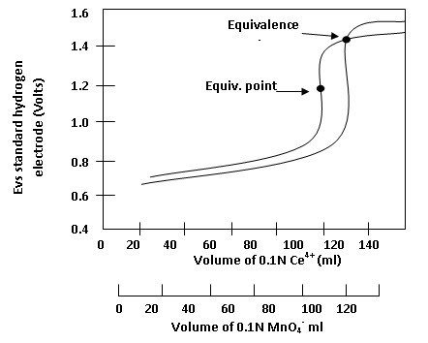

Titration of 100 mLof 0.1N iron (II) solution with (a) Cerium (IV)
(b) Permanganate.

Q: Consider the titration of 50 mL of 0.05 N iron (II) with 0.1N cerium (IV), calculate the potential at:
- Zero addition of Ce⁺⁴
- After addition of 5mL of reagent
- after addition of 25 mL of reagent
- After addition of 50 mL of reagent

Ce⁴⁺ + Fe²⁺ Ce³⁺ + Fe³⁺ redox reaction
Ce⁴⁺ + 1e⁻ Ce³⁺ 𝐸 ° =1.44
Fe³⁺ + 1e⁻ Fe²⁺ 𝐸 ° = 0.77

- Initial potential.
At the outset the solution contains no cerium ions, in addition to the iron (II) ions a small but finite quantity of iron (III) will be present as a consequence of air oxidation. Because the concentration of the latter is uncertain. We cannot calculate ant initial potential that has significance.

- Potential after addition of 5 mL of oxidizing agent(ce⁴⁺)
With the introduction of a volume of the oxidizing agent, the solution acquires appreciable concentrations of three of the participating ions, that for the fourth, the cerium (IV) ion, will be small. Setting this last quantity equal to X. we may write:
[Ce⁴⁺] = X
[Ce³⁺] = $\frac{5×0.1}{55}$- X = 9.091x10⁻³ mole/L X is negligibly (small)
[Fe³⁺] = $\frac{100×0.05}{55}$- X = 9.091x10⁻³ mole/L X is negligibly(small)

[Fe²⁺] = $\frac{50×0.05-5 ×0.1}{55}$-X = 0.036 mole/L
E= Eº _{Fe}³⁺_{/Fe}²⁺ - 0.0592 log $\frac{\left[{Fe}^{2+} \right]}{[ {Fe}^{3+}]}$
E= +0.77 - 0.0592 log $\frac{\left[0.036 \right]}{[ 9.090 ×{10}^{-3}]}=+0.77-0.0592 log3.960$
= + 0.77 -0.036 = 0.734 V

3. After addition of 25 mL of reagent (At equivalence-point potential.
The potential at the equivalence point in this titration is given by:
E = Eº_{Ce}⁴⁺ _{/Ce}³⁺ + Eº _{Fe}³⁺ _{/Fe}²⁺ ) /2
$$E= \frac{1.44+0.77}{2}=1.11$$
4. Potential after addition of 50 ml of reagent.
The solution now contains an excess of Ce(IV) in addition to equivalent quantities of iron (III) and cerium (III) ions.

The concentration of iron(II) will now be very small; if we set its value equal to y.
[Fe²⁺] =y
[Fe³⁺] = $\frac{50 ×0.05}{100}-y=0.025 mol/L$ y is negligibly (small)

[Ce³⁺] = $\frac{50 ×0.05}{100}-y=0.025 mol/L$ y is negligibly (small)
[Ce⁴⁺] = $\frac{30×0.1-50×0.05}{100}+ y = 5x{10}^{-3}mole/L$ y is negligibly
E= Eº_{Ce4}⁺ - 0.0592 log $\frac{[{Ce}^{3+} ]}{[ {Ce}^{4+}]}= +1.44-0.0592 log\frac{[0.025]}{[5×{10}^{-3}]}$
= + 1.44- 0.041 = 1.399 V

. KMnO₄, Ce⁴⁺, K₂Cr₂O₇, KIO₃, NH₄VO₃, I₃⁻ ( oxidant )
Ag, Ni, Al, Cd, Zn, Cr(III), Na₂S₂O₃, As(III), Fe(II) (reduction)

Detection of end point

Many types of indicators are used for end point detection in redox reactions such as:

1- Self indicators
The species ready to be oxidized can be determined by titration with an oxidizing agent like KMnO₄. KMnO₄ is not standard materials since it contains reduced products like MnO₄ and therefore it should be calibrated before using.

Specific indicators -2
Specific indicators specifically react with one of the reactant to make color change. One of them is the starch which form deep blue complex with I₃⁻ and thiocyanate(SCN⁻) which form red complex with ferric ion (Fe³⁺) and becomes colorless with ferrous ion(Fe²⁺)
3- Oxidation-reduction indicators
Some indicators depend on the change in the system potential at the potential at which the color changes depend on E_{in} value (standard value for each indicator).
In⁺ + 1e In
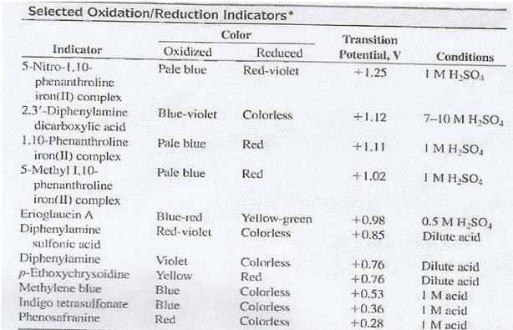
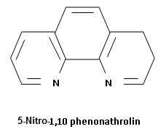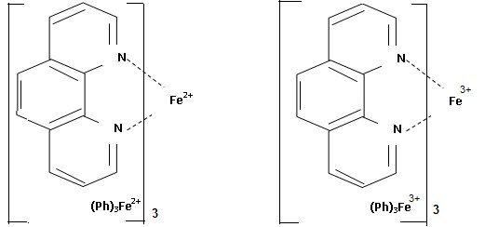 Red Violet Pale Blue

