Theory of neutralization titrations of simple systems

Acid-Base Indicators
Indicators are weak organic acids or weak organic bases show color change or emit luminescence at certain pH value when an acid or a base are added. For most of these indicators two different colors or even more one of them appears at acidic media and the other at acidic media, therefore they are called double color indictors. Some of these indicators are of one color such as phenolnaphthalen as it is colorless in acidic media and pink in alkaline media.
. 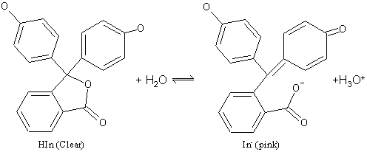 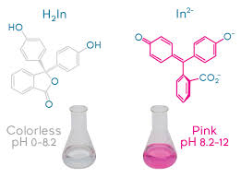

The acidic indicter HIn has a yellow color in acidic media and blue
color in alkaline media and dissociates as follows
HIn ↔ H⁺ + In⁻
Or:
HIn + H₂O H₃O+ + In⁻
Acid (yellow) Base (Blue)
If acid is added the reaction goes to the left and if a base is added then the reaction goes to the right according to Leshatlais law.
$K_{a}=\frac{\left[H^{+}\right][{In}^{-}]}{[HIn]}$ (or) $K_{a}=\frac{\left[{H_{3}O}^{+}\right][{In}^{-}]}{[HIn]}$

The alkaline indicator is referred to as (In )and its color differ than the its conjugate base (lnOH) ;-
ln +H₂O ↔ lnH⁺ + OH⁻
^{base color} ^{acid color}

$$Kb=\frac{\left[lnH^{+}\right][{OH}^{-}]}{[\ln^{-}]}$$

$$\frac{[\ln^{-}]}{[HIn]}=\frac{Ka}{\left[{H_{3}O}^{+}\right]}$$

$$Ka= \frac{Kw}{Kb}$$
$$\frac{[HIn]}{[\ln^{-}]}=Kb\frac{\left[{H_{3}O}^{+}\right]}{Kw}$$

Practically the eyes can not distinguish a color in the presence of other color only if its concentrations is at least tenfold the other one, and therefore the alkaline color and the acidic color will not be seen unless achieving these relations.

$\frac{[\ln^{-}]}{[HIn]} ≤ \frac{1}{10} acidic color$

$\frac{[\ln^{-}]}{[HIn]} ≥ \frac{1}{10} basic color$

Calculating the indicator pH:

$K_{a}=\frac{\left[{H_{3}O}^{+}\right][{In}^{-}]}{[HIn]} → K_{a}=\frac{\left[{H_{3}O}^{+}\right]}{10} →\left[{H_{3}O}^{+}\right]=K_{a}×10 (or) {[H}^{+}]=K_{a}×10$
pH = pKa - 1

This acid color appear

$K_{a}=\frac{\left[{H_{3}O}^{+}\right]×10}{1}$ → $\left[{H_{3}O}^{+}\right]=\frac{Ka}{10}$ → $\left[H^{+}\right]=\frac{Ka}{10}$
pH = pKa + 1

This base color appear

So the difference between the two cases regarding pH is;-

pH(Basic) – pH(Acidic) = (pKa+1) –(pKa-1) = 2

Suppose that pKa=5 then change in indicator color will occur when the pH value varies between (5-1) and (5+1), that is between 4 and 6. This pH range is called indicator transition range. Below is the range of some indicators utilized in acid base titration.

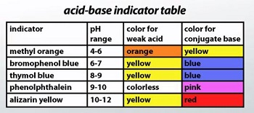
Selection of the suitable indicator for acid base titrations
The selection of indicator is done through neutralization curves or titration curves. The curves can be obtained by drawing pH values (X axis) against the number of militaries of standard reagent solution added (Y axis). These curves are very important in indictor selection processes, the indictor who will decide the equivalent point. From this
curve we can obtain the indicator pH transition range, and then we can select the indictor of matching range and give sharp color change at
- Initial point before dropping
- dropping stage before equivalent point
- equivalent point
- dropping stage after equivalent point

1-Titration of strong acid with strong base

Ex. 25mL of 0.1 N HCl solution is titrated with 0.1 N NaOH solution. Find the pH values at
1. At initial point.
2-After addition of 5, 20, 24, 24.5, 24.9 and 24.49mL of 0.1N NaOH solution.
3-At equivalent point.
4-After addition of 25.05mL of 0.1 N NaOH solution.

1. At initial point
Notice ) HCl mono proton and so N=M
HCl → H⁺ + Cl⁻
before ionization 0. 1 0 0
after ionization 0 0. 1 0. 1

pH= log [H⁺] = - log 0.1 = 1

2. After addition of 5 mL NaOH

NaOH+HCl→NaCl+H₂O

NaCl is a salt derived from strong acid and strong base then it will not affect the pH

No. of meq =VxN
No. of meq_{(HCl)} = 25x0.1=2.5meq
No. of meq_{(NaOHl)} 5x0.1=0.5meq
Total volume =25+5=30mL
HCl mono proton and so N=M
$$\left[H^{+ }\right]=\frac{25×0.1-5×0.1}{30}=0.067 mol/L$$
pH = - log [H⁺] = - log o.o67 = 1.17

3. After addition of 24.95 mL NaOH
No. of meq =VxN
No. of meq_{(HCl}) = 25x0.1
No. of meq_{(NaOHl)}= 24.95x0.1
V total -25+24.95=49.95mL
HCl mono proton and so N=M

$$\left[H^{+ }\right]=\frac{25×0.1-24.95×0.1}{49.95}=1.001×{10}^{-4} mol/L$$
pH = - log [H⁺] = - log 1.001 = 1.17$×{10}^{-4}$= 3.999
After addition (mL) | pH
0 | 1.00
5 | 1.17
20 | 1.955
24 | 2.69
24.5 | 2.99
24.9 | 3.7
24.95 | 3.999

4. At Equivalent Point:
When 25ml of 0.1 N NaOH solution is added then the neutralization reaction is complete and the solution become as a solution of NaCl which is not hydrolyzed and hence the only source of [H⁺] is the dissociation of water, that is pH=7. We may notice that there is a jump by 3 units by adding one drop of NaOH solution.
pH = pOH =7

5. After addition of 25.05 mL of 0.1 N NaOH solution

After the equivalent point there are NaCl and excess OH ions in the solution and hence we calculate pOH

No. of meq =VxN
No. of meq_{(HCl}) = 25x0.1
No. of meq_{(NaOHl)}= 25.05x0.1
Total volume =25+25.05=50.05mL
NaOH mono hydroxide Base so N=M

$$\left[OH^{- }\right]=\frac{25.05×0.1-25×0.1}{50.05}=9.99×{10}^{-5} mol/L$$
pOH = - log 9.99 $×{10}^{-5}=4.00$
pKw = pH+ pOH → pH=14 - 4=10

After addition (mL) | pH
25.05 | 10
25.1 | 10.3
25.5 | 11
26 | 11.29
30 | 11.95
45 | 12.46

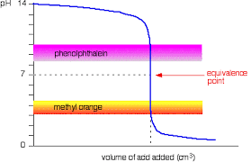
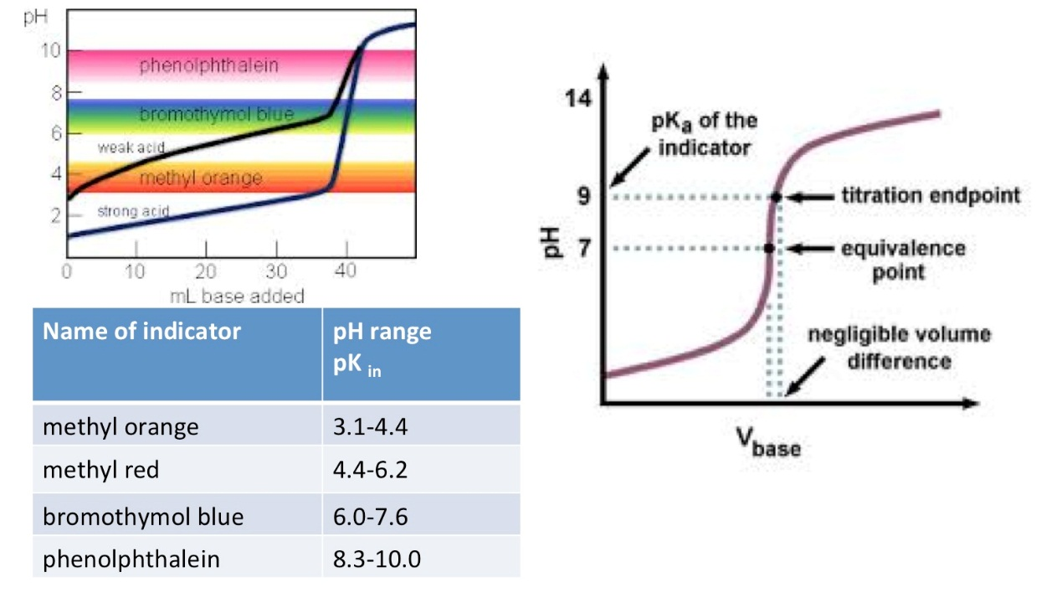

Ex2. 50mL of 0.1 M HCl solution is titrated with 0.1 M NaOH
solution. Find the pH values at:

- Initial (before adding) NaOH:
HCl → H⁺ + Cl⁻
before ionization 0. 1 0 0
after ionization 0 0. 1 0. 1
[H⁺]= 0.1M
pH=-log 0.1=1
- After adding of 10 mLof 0.1 M NaOH

NaOH+HCl→NaCl+H₂O
no. mmole = M x V
no. mmole _{(HCl)} = 0.1x50 = 5 mmole
no. mmole_{(NaOH)}= 0.1x10 =.1mmole
V total =50+10=60 mL
pH=-log 0.067 =1.18

- After adding 49 ml of NaOH
- no. mmole = M x V
- no. mmole _{(HCl)} = 0.1x50
- no. mmole_{(NaOH)}= 0.1x49
V total =50+10=99 mL
$$\left[H^{+ }\right]=\frac{50×0.1-49×0.1}{99}=1.010×{10}^{-4} mol/L$$

pH=-log[H⁺]= -log1.010x10⁻³ = 3.00

4-After addition of 50 mLof 0.1 M NaOH solution
No. of mmole =MxV
No. of mmole_{(HCl)} = 0.1 x 50= 5meq
No. of mmole_{(NaOHl)} 0.1x50 = 5meq
No. of mmole_{(HCl)} = No. of mmole_{(NaOHl)}
So this is equivalent point → pH = pOH = 7

When 50 mL of 0.1 M NaOH solution is added then the neutralization reaction is complete and the solution become as a solution of NaCl which is not hydrolyzed and hence the only source of [H⁺] is the dissociation of water, that is pH=7. We may notice that there is a jump by 3 units by adding one drop of NaOH solution.
pH = pOH =7

ٟ
5- After adding of 50.01 mL of 0.1 M NaOH
After the equivalent point there are NaCl and excess OH⁻ ions in the solution and hence we calculate pOH
no. mmole _{(HCl)} = M.V = 0.1x50
no. mmole_{(NaOH)}= M.V = 0.1x50.01
V total =50+50.01=100.01
$$\left[OH^{- }\right]=\frac{50.01×0.1-50×0.1}{100.1}=9.999×{10}^{-6} mol/L$$
pH=-log 9.999x10⁻⁶=5.000 → pKw = pH+ pOH → pH=14 - 5=9

mL(NaOH) | pH | mL(NaOH) | pH | mL(NaOH) | pH
0 | 1 | 49.9 | 4.0 | 51 | 11.0
10 | 1.18 | 49.99 | 5.0 | 60 | 11.88
25 | 1.48 | 50 | 7.0 | 75 | 12.30
40 | 1.95 | 50.01 | 9.0 | 100 | 12.92
49 | 3.0 | 50.1 | 10.0

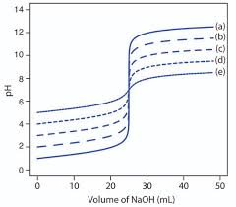

2- Titration of strong base with strong acid

Ex1. 50mL of 0.1 M NaOH solution is titrated with 0.1 M HCl solution.
Find the pH values at:
1- Initial (before adding) HCl:
NaOH  Na⁺ + OH⁻
before ionization 0. 1 0 0
after ionization 0 0. 1 0. 1
[OH⁻]= 0.1M pOH=-log 0.1=1
pKw = pH+ pOH
pH=14 - 1=13

2- After adding 40mL of HCl
HCl + NaOH NaCl + H₂O
no. mmole = M x V
no. mmole _{(NaOH)} = M.V = 0.1x50
no. mmole_{(HCl)}= M.V = 0.1x40
V total =50+40=90mL
$$\left[OH^{- }\right]=\frac{50.0×0.1-40×0.1}{90}=0.011 mol/L$$
pOH=-log 0.011 = 1.959 → pKw = pH+ pOH → pH=14 – 1.959=12.041

3- After addition of 50 mLof 0.1 M HCl solution
No. of mmole =MxV
No. of mmole_{(HCl)} = 0.1 x 50= 5meq
No. of mmole_{(NaOHl)} 0.1x50 = 5meq
No. of mmole_{(HCl)} = No. of mmole_{(NaOHl)}
So this is equivalent point
pH = pOH = 7

When 50 mL of 01 M HCl solution is added then the neutralization reaction is complete and the solution become as a solution of NaCl only. which is not hydrolyzed and hence the only source of [H⁺] is the dissociation of water, that is pH=7.
pH = pOH =7

4- After adding of 60 mL of 0.1 M HCl
After the equivalent point there are NaCl and excess H⁺ ions in the solution and hence we calculate pH
no. mmole = M x V
no. mmole _{(NaOH)} = 0.1x50
no. mmole_{(HCl)}= 0.1x60
V total =50+60=110 mL
$$\left[H^{+ }\right]=\frac{60×0.1-50×0.1}{110}=9.091×{10}^{-3} mol/L$$
pH=-log[H⁺]= -log 9.091x10⁻³= 2.041

Ex2. 50mL of 0.01 N NaOH solution is titrated with 0.02 N HCl solution. Calculate the pH values after addition of: 0, 15, 25 and
50 mL of HCl solution
- At zero (Initial or before adding HCl solution):
NaOH mono hydroxide Base so N=M
NaOH → Na⁺ + OH⁻
before ionization 0.0 1 0 0
after ionization 0 0.0 1 0.0 1
[OH⁻]= 0.1M
pOH=-log 0.01= 2
pKw = pH+ pOH
pH=14 – 2=12

- After addition of 15 mL of HCl solution

HCl + NaOH NaCl + H₂O

No. of meq =VxN
No. of meq_{(HCl)} = 15 x 0.02= 0.3meq
No. of meq_{(NaOHl)} 50x0.01=0.5meq
Total volume =50+15=65mL
NaOH mono hydroxide Base so N=M
$$\left[OH^{- }\right]=\frac{50.0×0.01-15×0.02}{65}=3.077×{10}^{-3} mol/L$$

pOH=-log [OH⁻]=-log 6.667x10⁻³ = 2.512
pKw = pH+ pOH
pH=14 – 2.512=11.488

3- After addition of 25mL of HCl solution:
NaOH mono hydroxide Base so N=M
No. of meq =VxN
No. of meq_{(HCl)} = 25 x 0.02= 0.5meq
No. of meq_{(NaOHl)} 50x0.01=0.5meq
No. of meq_{(HCl)} = No. of meq_{(NaOHl)} So this is equivalent point
pH = pOH = 7
When 25 mL of 0.02 M HCl solution is added then the neutralization reaction is complete and the solution become as a solution of NaCl which is not hydrolyzed and hence the only source of [H⁺] is the
pH = pOH =7

4- After addition of 50mL of HCl solution:
After the equivalent point there are NaCl and excess H⁺ ions in the solution and hence we calculate pH
No. of meq =VxN
No. of meq_{(HCl)} = 50 x 0.02= 1.0 meq
No. of meq_{(NaOHl)} 50x0.01=0.5meq
Total volume =50+50 = 100mL
NaOH mono hydroxide Base so N=M
$$\left[H^{+ }\right]=\frac{50×0.02-50×0.01}{100}=5×{10}^{-3} mol/L$$

pH=-log[H⁺]= -log 1. 9.091x10⁻³= 2.301

