Titration of weak acid with strong base

Ex. Titration of 100 mL of 0.1M CH₃COOH with 0.1 M NaOH Calculate the pH at: Ka_{(CH3COOH)} = 1.8x10⁻⁵

1- Before addition of NaOH (Initial point):

CH₃COOH <, > CH₃COO⁻ + H⁺

$$Ka= \frac{\left[CH_{3 }COO^{-}\right][ H^{+ }]}{[ CH_{3}COOH]}$$

CH₃COOH CH₃COO⁻ + H⁺
Before ionization 0.1 0 0
After ionization 0.1 - X X X
Ka = 1.8 ×${10}^{-5}=\frac{x.x}{0.1-x}=\frac{x^{2}}{0.1} →x^{2}=1.8×{10}^{-6}$
$$x=\sqrt{1.8 ×{10}^{-6}} =1.342×{10}^{-3}=[H^{+}]$$
pH = -log [H⁺] = -log 1.342 × 10⁻³ = 2.872

2- After addition of 10 mL NaOH

CH₃COOH + NaOH < > CH₃COONa + H₂O
CH₃COOH < > CH₃COO⁻ + H⁺

$$\left[salt\right]= \frac{no.of mmoles}{VmL} \frac{0.1 ×10}{110}= 9.091×{10}^{-3} M$$

$$\left[acid\right]= \frac{no.of mmoles}{VmL} \frac{0.1 ×100-0.1×10}{110}= 0.082 M$$

$$pH=pKa+log \frac{[salt]}{[acid]}=4.745+log\frac{9.091×{10}^{-3}}{0.082}=3.790$$

3- After addition of 50 mL of NaOH

$$\left[salt\right]= \frac{no.of mmoles}{VmL} \frac{0.1 ×50}{150}= 0.033 M$$

$$\left[acid\right]= \frac{no.of mmoles}{VmL} \frac{0.1 ×100-0.1×50}{150}= 0.033 M$$

$$pH=pKa+log \frac{[salt]}{[acid]}=4.745+log\frac{0.033}{0.033}=4.745$$

4- After addition of 99 mL of NaOH

$$\left[salt\right]= \frac{no.of mmoles}{VmL} \frac{0.1 ×99}{199}= 0.05 M$$

$$\left[acid\right]= \frac{no.of mmoles}{VmL} \frac{0.1 ×100-0.1×99}{199}= 5.025×{10}^{-4} M$$

$$pH=pKa+log \frac{[salt]}{[acid]}=4.745+log\frac{0.05}{5.025×{10}^{-4}}=6.743$$

5- At equivalent point ( After addition of 100 mL of NaOH )

CH₃COOH + NaOH CH₃COONa + H₂O
When 100 mL of 0.1 M NaOH solution is add to 100 mL of 0.1 M acetic acid solution the end point is reached. The solution will be containing 200 mL of 0.05 N sodium acetate (salt). This salt is derived from strong base and weak acid then pH is calculated using the following relation:
no. of mmoles of CH₃COOH = no. of mmoles of NaOH = 0.1 x 100
$$\left[salt\right]= \frac{no.of mmoles}{VmL}= \frac{0.1 ×100}{200}= 0.05 M$$

$$pH=\frac{1}{2} \left( pKw+pKa+iog C_{S }\right]=\frac{1}{2} (14+4.745+\log{0.05)=8.722}$$
6 -After addition of 120 mL of NaOH
After equivalent point, the solution containing hydroxide ions from NaOH solution and from hydrolysis of acetate ions. For simplicity the later is ignored due to its low concentration compared with OH⁻ from NaOH.
$$\left[OH^{-}\right]= \frac{no.of mmoles}{VmL}= \frac{0.1 ×120-0.1×100}{220}= 9.091×{10}^{-3} M$$

NaOH -------→ Na⁺ + OH⁻
0 0 9.091×10⁻³
9.091×10⁻³ 9.091×10⁻³ 0
pOH = - log [OH⁻ ] = - log 9.091×10⁻³ = 2.041
pH = pKw – pOH = 14 – 2.04 = 11.959

7 -After addition of 150 mL of NaOH
$$\left[OH^{-}\right]= \frac{no.of mmoles}{VmL}= \frac{0.1 ×150-0.1×100}{250}= 0.02 M$$

pOH = - log [OH⁻ ] = -log 0.02 = 1.699
pH = pKw – pOH = 14 –1.699 = 12.301

V NaOH(mL) | pH
0 | 2.872
10 | 3.790
50 | 4.745
99 | 6.743
99.9 | 7.745
100 | 8.722
120 | 11.959
150 | 12.301

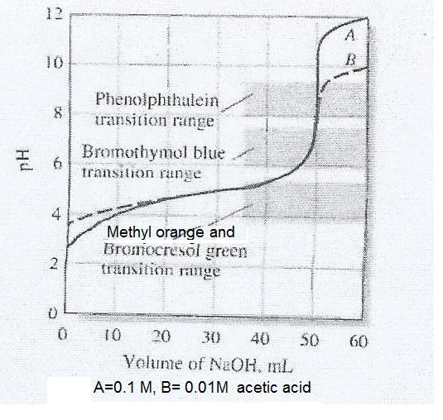

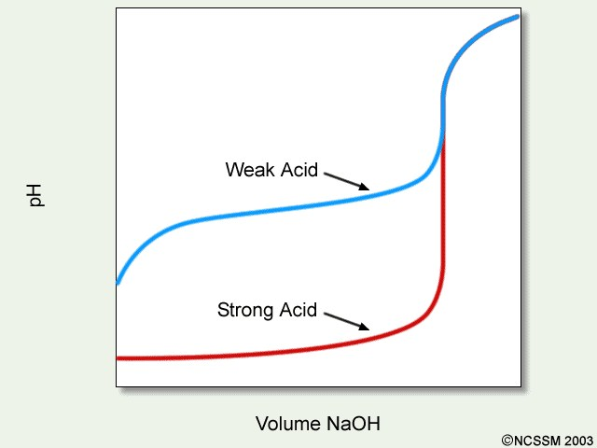

Q: Consider the titration of 50 mL of 0.2N HCN with 0.2 N KOH.
Calculate the pH after addition of: 0, 10, 25, 50, 75, 100 mL of KOH.
Ka(HCN) = 6.2 ×10⁻¹⁰

Titration of weak base with strong acid

Q: Ex. Consider the titration of 100 mL of 0.1N NH₄OH against 0.1 N
HCl. Calculate the pH at: Kb_{(NH4OH)} = 1.8x10⁻⁵

1- Before addition of HCl (Initial point):

NH₄OH mono hydroxide Base so N=M

NH₄OH < > NH₄⁺ + OH⁻
$$Kb= \frac{\left[ NH_{4}^{+ }\right][ OH^{-}]}{[NH_{4}OH]}$$
NH₄OH < > NH₄⁺ + OH⁻

Before ionization 0.1M 0 0
After ionization 0.1- X X X
$$Kb= \frac{X .X}{0.1-X}=1.8 ×{10}^{-5}=\frac{X^{2}}{0.1} →X=\left[ OH^{-}\right]=1.342×{10}^{-3} M$$
X is ignored
pOH = -log[OH⁻] = -log 1.342 ×10⁻³ = 2.872
pH = 14- pOH = 14 – 2.872 = 11.128
2- After addition of 10 mL of HCl
NH₄OH + HCl < > NH₄Cl + H₂O
NH₄OH < > NH₄⁺ + OH⁻
NH₄OH mono hydroxide Base so N=M
HCl mono proton so N=M no. of meq(salt) = 0.1 x 10 no. of meq(base) = 0.1 x90

$$\left[salt\right]=\frac{0.1×10}{110}=9.091×{10}^{-3}M$$

$$\left[base\right]=\frac{0.1×100-0.1×10}{110}=0.082M$$

$$pOH=pK_{b}+log\frac{[salt]}{[base]}=4.745+log\frac{9.091×{10}^{-3}}{0.082}=3.790$$

PKw = pH + pOH →pH = pKw – pOH = 14-3.790= 10.21

3- After addition of 50 mL of HCl

NH₄OH mono hydroxide Base so N=M HCl mono proton so N=M

$$\left[salt\right]=\frac{0.1×50}{150}=0.033M$$

$$\left[base\right]=\frac{0.1×100-0.1×50}{150}=0.033M$$
$$pOH=pKb+log\frac{[salt]}{[base]}=4.745+log\frac{0.033}{0.033}=4.745$$

pKw = pH + pOH →pH = pKw – pOH = 14-4.745= 9.255

4- At End point ( After addition of 100 mL of HCl )

NH₄OH + HCl NH₄Cl + H₂O
When 100 mL of 0.1 N HCl solution is add to 100 mL of 0.1 N NH₄OH solution equivalent point or end point is reached. The solution will be containing 200 mL of NH₄Cl (salt) which means 0.05 N instead of 0.1N. This salt is derived of strong acid and weak base then pH is calculated using the following relation:
NH₄OH mono hydroxide Base so N=M
no. of meq of NH₄OH = no. of meq of HCl = 0.1 x 100 meq
$$\left[salt\right]=\frac{0.1×100}{200}=0.05M$$
$$pH=\frac{1}{2}( pKw-pK_{b}-logCs)=\frac{1}{2}\left( 14-4.745-log0.05\right)=5.278$$

5- After addition of 110 mL of HCl
After equivalent point, the solution containing hydrogen ion H⁺ from dissociation of HCl solution and from hydrolysis of ammonium ion NH₄⁺ . For simplicity the later is ignored due to its low concentration compared with H⁺ from HCl.
HCl mono proton and so N=M
$$\left[H^{+}\right]= \frac{no.of mmoles}{VmL}= \frac{0.1 ×10-0.1×100}{210}= 4.762×{10}^{-3} M$$

HCl → H⁺ + Cl⁻¹
4.762×10⁻³ 0 0
O 4.762×10⁻³ 4.762×10⁻³
pH = - log [ H⁺] = - log 4.762×10⁻³ = 2.322

6- After addition of 140 mL of HCl
HCl mono proton and so N=M
$$\left[H^{+}\right]= \frac{no.of mmoles}{VmL}= \frac{0.1 ×40-0.1×100}{240}= 0.017 M$$

HCl H⁺ + Cl⁻
0.017 0 0
0 0.017 0.017
pH= -log [H⁺] =-log 0.017 = 1.770

V HCl(mL) | pH
0 | 11.128
10 | 10.210
50 | 9.255
100 | 5.278
110 | 2.322
140 | 1.770

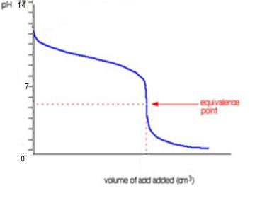
Ex: 10 mL of 0.02M of pyridine (C₅H₅N) is titrated with 0.01 M of
HBr. Calculate the pH after addition of: 0, 10, 20 and 30 mL of HBr,
Draw the Approximate curve. Kb (pyridine) =1.695 x10⁻⁹
1- At zero addition of HBr solution:

C₅H₅N + H₂O C₅H₅NH⁺ + OH⁻

$$Kb= \frac{\left[C_{5}H_{5}NH^{+}\right]\left[ OH^{-}\right]}{\left[C_{5}H_{5}N\right]\left[ H_{2}O\right]} , since \left[ H_{2}O\right]=constant$$

C₅H₅N +H₂O < > C₅H₅NH⁺ + OH⁻
Before ionization 0.02 0 0
After ionization 0.02- x x x

$Kb= 1.695 ×{10}^{-9}=\frac{x.x}{0,02}$ = $1.695 ×{10}^{-9}=\frac{x^{2}}{0.02}$ x is ignored

X²= 3.39×10⁻¹¹ →x = [OH⁻] =5.822x10⁻⁶ M
pOH = -log[OH⁻] = -log 5.822x10⁻⁶ = 55.235
pH = 14- pOH = 14 – 5.235 = 8.765

2- After addition of 10 mL of Acid:

C₅H₅NH⁺OH⁻ + HBr < > C₅H₅NHBr + H₂O
C₅H₅N + H₂O < > C₅H₅NH⁺ + OH⁻

$$\left[salt\right]=\frac{0.01×10}{20}=5.0 ×{10}^{-3}M$$

$$\left[base\right]=\frac{0.02×10-0.01×10}{20}=5.0 ×{10}^{-3}M$$
$$pOH=pKb+log\frac{[salt]}{[base]}=8.771+log\frac{5.0 ×{10}^{-3}}{5.0 ×{10}^{-3}}=8.771$$

pKw = pH + pOH →pH = pKw – pOH = 14-8.771= 5.229

3- After addition of 20 mL of Acid:

C₅H₅NHOH + HBr C₅H₅NHBr + H₂O
no. of mmole of C₅H₅NHOH= no. of mmole of HBr
0.02 x 10 = 0.01 x 20

So this is equivalent point

$$\left[salt\right]=\frac{0.01×20}{30}=6.667 ×{10}^{-3}M$$

$$pH=\frac{1}{2}\left( pKw-pKb-logCs\right)=\frac{1}{2}\left( 14-8.771-log6.667 ×{10}^{-3}\right)=3.703$$

4- After addition of 30 mL of Acid:
$$\left[H^{+}\right]= \frac{no.of mmoles}{VmL}= \frac{0.1 ×30-0.02×10}{40}= 2.5×{10}^{-3} M$$
HBr H⁺ + Br ⁻
2.5x10⁻³ 0 0
0 2.5x10⁻³ 2.5x10⁻³
pH= -log [H⁺] = -log 2.5x10⁻³ = 2.602

Titration weak Base with weak Acid or weak Acid with weak Base
It is difficult to determine the end point of such a titration, because no sharp change in pH is detected at the equivalent point, none of the indicator suits for it. the pH change involved is very small and it is generally difficult to find the end point.

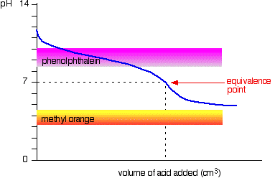

Titration curve for weak base with weak acid

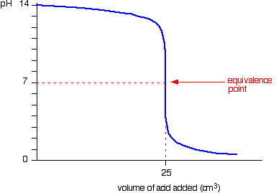

Titration curve of 25mL of strong base with strong acid

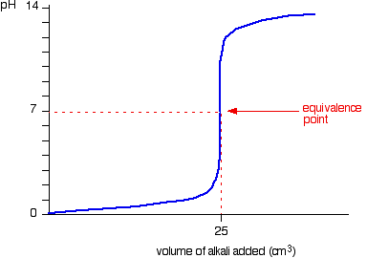
Titration curve of 25 mL of strong acid with strong base

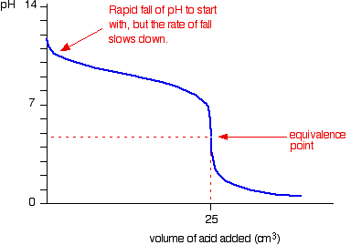

Titration curve of 25mL of weak base with strong acid
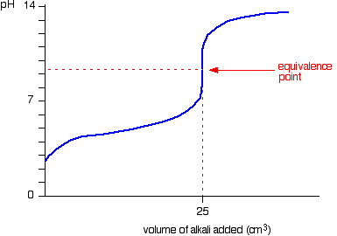

Titration curve of 25mL of weak acid with strong base

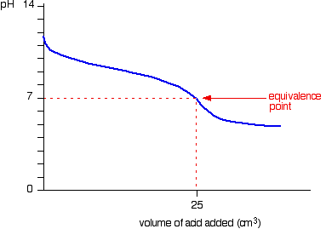

Titration curve of 25mL of weak base with weak acid

Q: 25 mL of 0.05M of Aniline (C₆H₅NH₂) is titrated with 0.05 M of HNO₃. Calculate the pH after addition of: 0, 5, 10, 25 and 30 mL of
HNO₃, Draw the Approximate curve. Kb (Aniline) =3.984 x10⁻¹⁰

