Volumetric Methods of Analysis
A volumetric method is one in which the analysis is completed by measuring the volume of solution of established concentration needed to react completely with solution of the substance being determined. These methods of analysis are widely used by employing one or more than one standard solution of reagents whose concentrations are or more exactly.
A quantitative determination based on the combining capacity of an analyte with a reagent is called titrimetric analysis. The most common way of performing a determination of this kind is to find the volume of a standard solution of a reagent.
Standard solution is used to perform titration in which the quantity of analyte in a solution is determined from the volume of standard solution which is consumes. It is done by carefully addition of the standard solution until the reaction with the analyte is judged to be complete; the volume of the standard solution is then measured. Sometimes it is necessary to add excess of the reagent standard solution then the excess amount of it is determined by back titration with a second standard reagent solution.

Standard Solution

The solution of exactly known composition and concentration used in titration is called Standard Solution.
Care should be taken in preparing the precise standard solution in order to avoid errors in the estimation. These solutions are prepared by one of two methods:
- Direct dissolving a carefully weighed quantity of a pure compound and diluting into the required volume using volumetric flasks.
- Indirectly by titrating a solution of weighed quantity of pure compound with standard reagent solution.
- Requirements of a Primary Standard Substance
- It must be of the highest purity.
- It should be stable and not be attacked by constituents of atmosphere.
- It should not be hygroscopic and not be efflorescent.
- It should be available and not too expensive.
- It should be have high molecular weight (or high equivalent weight). Since the relative error in weighing decreases directly with molecular weight (or high equivalent weight).
Factors affecting End point
- Reagent concentration: with the increase in reagent and analyte concentration the end point will be more clear.
- Reaction completion: more insolubility of the precipitate more
sharpness and clearance of the end point.

Detection of end point involves changes of some properties of the solution such as:
- Color due to the reagent or an indicator substance.
- Electric conductivity of the solution.
- Electric potential between a pair of electrodes immersed in the
solution.
- Electric current passing through the solution.
- Refractive index of the solution.
- Temperature of the solution.

Concentration units used in volumetric calculations
In addition to Methods of expression of concentrations which explained ago. Normality, usually use in volumetric analysis.
0.2N HCl = 0.2 meq/mL = 0.2 eq/L

Weight – Volume relationships
Volumetric calculations involve conversion of volumetric data into units of mill equivalents followed by reconversion into a metric weight of the desired chemical species.

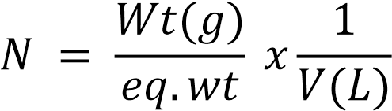
$$N×V_{L}=\frac{Wt}{eq.wt}$$
$No. eq \left(A\right)= \frac{wt \left(A\right)(g)}{eq.wt (A)(g/ eq)}$-------------------(1)
$No$.eq (A) = N(A) (eq /L) × V (A) (L) -----------------(2)
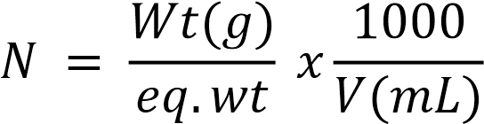
N x V(mL) = $\frac{1000}{V(mL)}$

$No.meq \left(A\right)=\frac{wt (A)(g)×1000}{eq.wt\left(A\right)\left(\frac{g}{meq}\right)}=\frac{wt(A)(g)}{meq.wt(A)(\frac{g}{meq})}$ ----------1
No. meq (A) = N(A)(meq/mL) × V(A)(mL)-----------------2
Ex.1: Calculate the number of meq of H₂C₂O₄. 2H₂O (M.Wt=126) in 0.5g of the pure compound assuming that two hydrogen ions to be titrated with standard base
$eq.wt\left(Acid\right)=\frac{M.Wt}{no.of hydrogen atoms ionized(H^{+})}$ $$eq.wt=\frac{126}{2}=63$$
$$No.meq \left(H_{2} C_{2}O_{4}.2H_{2}O\right)=\frac{wt (g)×1000}{eq.wt\left(\frac{g}{eq}\right)}$$

$No.meq \left(H_{2} C_{2}O_{4}.2H_{2}O\right)=\frac{0.5×1000}{63}$ = 7.937
(or)
$eq.wt\left(Acid\right)=\frac{M.Wt}{no.of hydrogen atoms ionized(H^{+})}$
$$N0.meq \left(H_{2} C_{2}O_{4}.2H_{2}O\right)=\frac{wt (g)×1000}{eq.wt\left(\frac{g}{meq}\right)}$$

= $\frac{0.5 g}{\frac{126}{2}×1000}=7.937 meq$

Ex.2: Calculate molar concentration of the salt formed at equivalent point by titrating 40 ml of 0.1025 N HCl solution with 0.205 N Ba(OH)₂ solution.
Sol)

2HCl + Ba(OH)₂ BaCl₂ + 2H₂O 1. at equivalent point:

meq of the titrant solution = meq of the titrated solution

meq of salt (BaCl₂) =V(mL) × N= 40 × 0.1025 meq/mL = 4.1meq
$$V\left(mL\right)=\frac{No.meq}{N}= \frac{4.1}{0.205} 20mL( volume of required base .$$

Total volume of the solution = 40 + 20 = 60mL

$N salt \left(Ba {Cl}_{2}\right)=\frac{No.meq}{V(mL)}=\frac{4.1}{100}=0.041N$
2. By dilution using 20 mL of water

Total volume = 60 + 20 = 80 mL

$N salt \left(Ba {Cl}_{2}\right)=\frac{No.meq}{V(mL)}=\frac{4.1}{60}=0.051 N$
3. By dilution to 100 ml with water

$N salt \left(Ba {Cl}_{2}\right)=\frac{No.meq}{V(mL)}=\frac{4.1}{100}=0.041N$

- $M\left(salt\right)= \frac{0.068}{2}=0.035 M (mol /L)$

- $M\left(salt\right)= \frac{0.051}{2}=0.026 M (mol /L)$
- $M\left(salt\right)= \frac{0.041}{2}=0.021 M (mol /L)$

Ex.3: A quantity of BaCl₂. 2H₂O is to be titrated with AgNO3 solution. What is the number of meq contained in 0.367g of pure BaCl₂. 2H₂O
(M. Wt = 244).

$$eq.wt=\frac{244}{1×2}=122$$
$$No.meq \left(salt\right)=\frac{wt\left(g\right)×1000}{eq.wt (\frac{g}{eq})} =\frac{0.367×1000}{122}=3.01 meq$$
(or) second method
$$eq.wt=\frac{244}{1×2}=122$$

$No.meq of BaCl_{2}=\frac{wt\left(g\right)}{meq.wt (\frac{g}{meq})}= \frac{0.367}{\frac{244}{2}×1000}=3.01 meq$

Ex.4: The number of meq involved in a titration that required
27.3 ml of 0.200 N KMnO₄ solution is given by:

No. of meq of KMnO₄ =N×V=0.200meq/mL × 27.3mL=5.46meq

Ex.5: Solution of Ba(OH)₂ is standardized by titration against 0.128N HCl solution. 31.76ml of the base is required to neutralize 46.25 of acid. What is the normality of Ba(OH)₂ solution.

Sol) No. of meq Ba(OH)₂ = No. of meq HCl
N₁ × V₁ = N₂ × V₂
N₁ × 31.76 = 0.128 × 46.25
N₁ (Ba(OH)₂) = 0.186 N (meq/mL)
Ex.6: What is the weight of primary standard of potassium dichromate K₂Cr₂O₇ needed to prepare 2.0 liter solution of 0.1 N reagent.

Cr₂O₇²⁻ + 14H⁺ + 6e⁻ 2Cr³⁺ + 7H₂O

No. of eq of K₂Cr₂O₇ = N K₂Cr₂O₇ ؟×V(L) K₂Cr₂O₇

No. of eq of K₂Cr₂O₇ = 0.1N × 2L = 0.2 eq

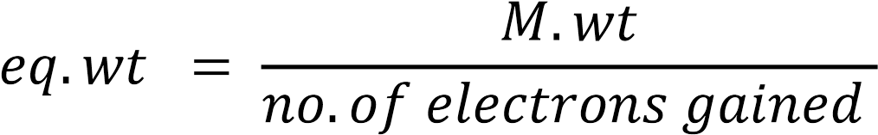
eq .wt = $\frac{294}{6}$ =49
$No. of eq=\frac{wt}{eq.wt} →wt= No. of eq×eq.wt=0.2×49=9.8 g$

Ex.7: Calculate the normality of iodine solution that was standardized against As₂O₃ (M.wt 198), 37.34 mL being required to titrate 0.204 g sample of primary standard oxide.

I₂ + H₂A_{S}O₃⁻ + H₂O 2I⁻ + H₂AsO₄⁻ + 2H⁺

No. meq I₂ = No. meq As₂O₃
N ($I_{2}) ×V\left(mL\right)\left(I_{2}\right)= \frac{wt ( {As}_{2}o_{3)}}{meq.wt ({As}_{2}o_{3)} )}$
N ($I_{2}) ×37.34\left(mL\right)= \frac{0.204}{\frac{0.198}{4}}$
N ($I_{2}) ×37.34\left(mL\right)= 4.121$

N ($I_{2}) = \frac{4.121}{37.34}=0.110 meq /mL$
(or)
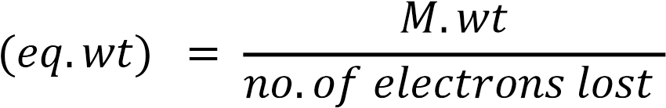
$$eq.wt=\frac{198}{4}=49.5$$
No. meq I₂ = No. meq As₂O₃
N ($I_{2}) ×V\left(mL\right)\left(I_{2}\right)= \frac{wt \left(g\right)×1000}{eq.wt (g/eq )}$
N ($I_{2}) ×37.34= \frac{wt \left(g\right)×1000}{eq.wt (g/eq )}$
N ($I_{2}) ×37.34=N0.meq({As}_{2}O_{3})= \frac{0.204×1000}{49.5}$
N ($I_{2}) = \frac{4.121}{37.34}=0.110 meq /mL$

Ex.8: What volume of 0.1 N HCl solution can be produced by diluting 150 ml sample of 1.24 N acid.

No. meq of acid in diluted solution = No.meq of acid in concentrated solution.
N ₁× V ₁ = N ₂ $×$ V ₂
Diluted solution Concentrated solution
0.100 ×V₁ = 1.24× 150

$$v_{1}= \frac{150×1.24}{0.1} =1861 mL=1.86 ×{10}^{3} mL$$

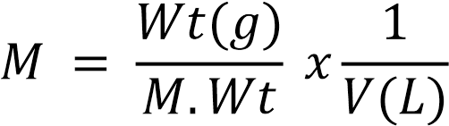
M x V(L) = $\frac{wt}{M.wt}$

$No. mole\left(A\right)=\frac{wt\left(A\right)(g)}{M.wt\left(A\right)(g/mole)}$ ------------(1)

$No. mole\left(A\right)=M\left(A\right)\left(mole/L\right)×V(A)(L)$ ---------------(2)

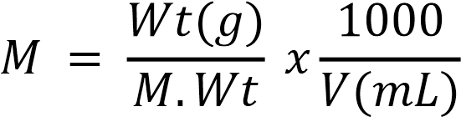

$$M×V\left(mL\right)= \frac{wt ×1000}{M.wt}$$
$No. mole\left(A\right)=\frac{wt\left(A\right)\left(g\right)×1000}{M.wt\left(A\right)(g/mole)}$ ----------------(1)

$No.m mole\left(A\right)=M\left(A\right)\left(mmole/mL\right)×V(A)(mL)$ ---------------(2)
$$F=\frac{wt(g)}{g.fw} ×\frac{1000}{V(L)}$$
$F×V\left(L\right)= \frac{wt }{g.fw}$

$No. fw\left(A\right)=\frac{wt\left(A\right)\left(g\right)}{g.fw\left(A\right)(g/fw)}$ ----------------(1)
$No.fw\left(A\right)=F\left(A\right)\left(fw/L\right)×V(A)(L)$ --------------(2)
$$F=\frac{wt(g)}{g.fw} ×\frac{1000}{V(mL)}$$
$$F×V(mL)=\frac{wt\left(A\right)\left(g\right)×1000}{g.fw}$$
$No. mfw\left(A\right)=\frac{wt\left(A\right)\left(g\right)×1000}{gfw\left(A\right)(g/fw)}$ ----------------(1)

$No.mfw\left(A\right)=F\left(A\right)\left(mfw/mL\right)×V(A)(mL)$ ---------------(2)

Ex: Calculate the number of mmole for 0.5 g KMnO₄ in pure compound assuming. (Atomic Weight = K= 39 Mn =55 O=16 )
Sol)

$$No.m mole\left(KMnO4\right)=\frac{wt\left(g\right)×1000}{M.wt\left(\frac{g}{mole}\right)} = \frac{0.5 ×1000}{158}=3.165 mmole$$

Reaction types in volumetric analysis

1. Precipitation reactions

2. Acid-base reactions (neutralization reactions)

Oxidation – reduction reactions .3

4. Complex formation reactions

