Volumetric methods based on complex formation reactions

Complexation reactions are widely used in analytical chemistry, one of the first uses of these reactions was for titrating cations. In addition, many complexes are colored. Some complexes are sparingly soluble and can be used in gravimetric analysis or for precipitation, in the other hand these complexes are widely used to extract cations from one solvent to another and to dissolve insoluble precipitates. The most useful complex forming reagents are organic compounds containing several electron-donor groups that form multiple covalent bonds with metal ions. Inorganic complexing agents are also used to control solubility and to form colored species or precipitates.

The Formation of Complexes

Many metal ions react with electron pair donors to form coordination compounds or complex ions. The donor chemical species, called ligands, must have at least one free of electrons (unshared) available for bond formation. Water molecule, ammonia, halide ions are common ligands. The metal ion will be having two numbers the first is the oxidation number and the other number is coordination number. Typically values for coordination numbers are 2, 4, and 6. The coordination number expresses the maximum number of ligands can be attached to the metal ion for example cationic complex ion [Cu(NH₃)₄]²⁺, anionic complex ion [CuCl₄]²⁻, neutral complex Cu(NH₂CH₂COO)₂ all having a coordination number of 4.

Complex Formation Titration
Titrimetric methods based on the complex formation (called complexo-metric titration) has been used since at least a century. A chelates is produced when a metal ion coordinates with two or more donor groups of a single ligand to form cyclic structure. Copper complex with glycine is an example. Copper is bonded to both oxygen of the carboxylic group and nitrogen of the amine group of glycine.
A ligand that has a single donor group, such as ammonia, is called unidentate, whereas one such as glycine. which has two groups available for covalent bonding, is called bidentate. Tridentate.
tetradentate, pentadentate, and hexadentate chelating agents are also
known.

.
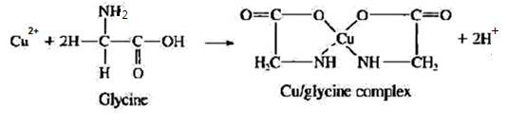

Fig. complex between copper (ll) with glycine

Complexation Equilibria:
Complexation reactions involve a metal ion M reacting with a ligand L to form a complex ML. as shown in Equation below:

M + L ML
ML + L ML₂
ML₂ + L ML₃
ML_{n-1} + L ML_{n}
Unidentate ligands invariably add in a series of steps. As shown here. With multidentate ligands, the maximum coordination number of the cation may be satisfied with only one ligand or a few added ligands. For example. Cu(II). with a maximum coordination number of 4, can form complexes with ammonia that have the formulas Cu(NH₃)²⁺, Cu(NH₃)₂²⁺, Cu(NH₃)₃²⁺, and Cu(NH₃)₄²⁺. With the bidentate ligand glycine (gly). the only complexes that form arc Cu(gly)²⁺ and Cu(gly)₂²⁺. The equilibrium constants for complex formation reactions (formation constant) are generally associated with a stepwise formation constant, K₁ through K₄ For example. K₁ = [ML]/[M][L], K₂ = [ML₂]/[ML][L], and so on. We can also write the equilibria as the sum of individual steps. These have over all formation constants.
M + L ML $K_{1}=\frac{[ML]}{\left[M\right][L]}$
M + 2L ML₂ $K_{1 }K_{2}= \frac{\left[ML_{2}\right] }{\left[M\right][{L]}^{2}}$
M + 3L ML₃ $K_{1} K_{2}K_{3}=\frac{[ML_{3}]}{\left[M\right][{L]}^{3}}$
M + nL ML_{n} $K_{1}K_{2 }…..=\frac{[ ML_{n}]}{\left[M\right][{L] }^{n}}$
In complex titration, multidentate ligands, particularly those having four or six donor groups, have two advantages over their unidentate counterparts. First, they generally react more completely with cations and thus provide sharper end points. Second. They ordinarily react with metal ions in a single step process. Whereas complex formation with unidentate ligands usually involves two or more intermediate species.
The advantage of a single-step reaction is illustrated by the titration curves shown in Figure below. Each of the titrations involves a reaction that has an overall equilibrium constant of l0²⁰. Curve A is derived for a reaction in which a metal ion M having a coordination number of 4 reacts with a tetradentate ligand L to form the complex of ML.Curve B is for the reaction of M with bidentate ligand L to give ML₂ in two steps. The formation constant for the first step is 10¹² and for the second 10⁸. Curve C involves a unidentate ligand L that forms ML₄ in four steps with successive formation constants of 10⁸, 10⁶, ·10⁴, and 10².
These curves demonstrate that a much sharper end point is obtained with a reaction that takes place in a single step. For this reason. multidentate ligands are ordinarily preferred for complexometric titrations.

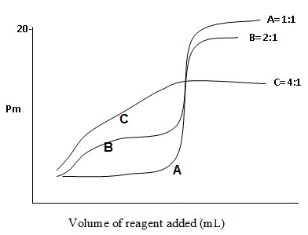
Inorganic complexing agents ا
Many Different inorganic complexing agents have become important in analytical chemistry. In complexometric titrations, a metal ion reacts with a suitable ligand to form a complex, and the equivalence point is determined by an indicator or an appropriate instrumental method. The formation of soluble inorganic complexes is not widely used for titrations, but the formation of precipitates, particularly with silver nitrate as the titrant, is the basis for many important determinations of another elements. The progress of a complexometric titration is generally illustrated by a titration curve, which is usually a plot of pM = - log [M] as a function of the volume of titrant added.. Many precipitation titrations, use the metal ion ac; the titrant. Most simple inorganic ligands are unidentate; which can lead to low complex stability and indistinct titration end point. The table below showed some typical inorganic complex reagent titrate. With different cations and anions.

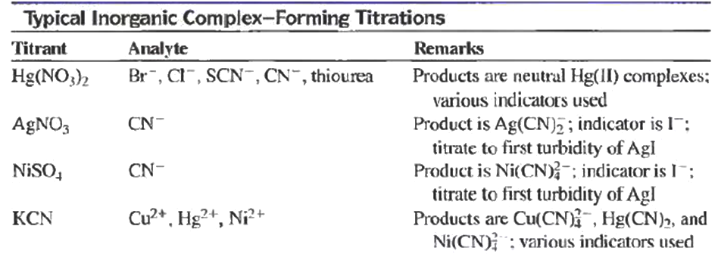

Ex: Determination of Cyanide in aqueous solution:
Cyanide is commonly determined by titration with AgNO₃. The
titration reaction is
Ag⁺ + 2CN⁻ Ag(CN)⁻
To determine the end point of the titration, the aqueous sample is mixed with a basic solution of potassium iodide before the titration.
Before the equivalent point, cyanide is in excess and all the Ag⁺ is complexed. As soon as all the cyanide has been reacted, the first excess of Ag⁺ causes a permanent turbidity to appear in the solution because of the formation of the Agl precipitate, according to this equation:

Ag⁺ + I⁻ AgI(s)

Organic complexing agents
Many different organic complexing agents; become important in analytical chemistry because of their sensitivity and selectivity in reacting with metal ions. Such reagents are useful in precipitating metals, in binding metals to prevent interferences, in extracting metals from one solvent to another. The most useful organic reagents form chelate complexes with metal ions. Many organic reagents are used to convert metal ions into forms that can be readily extracted from water into an immiscible organic phase. Extractions are widely used to separate metals (analyte) from interfering ions and to increase concentration (analyte) by extracting into a phase of smaller volume. Several of the most widely used organic complexing agents for extractions are listed in Table below some of these reagents normally form insoluble species with metal ions in aqueous solution. In extraction applications. However, the solubility of the metal chelate in the organic phase keeps the complex from precipitating in the aqueous phase. In many cases, the pH of the aqueous phase has some control over the extraction process, since most or the reactions are pH dependent, as shown in Equation below:
nHX(org) + M^{n+} (aq) MX_{n}(org) + nH⁺(aq)

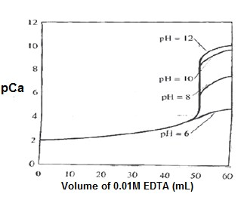
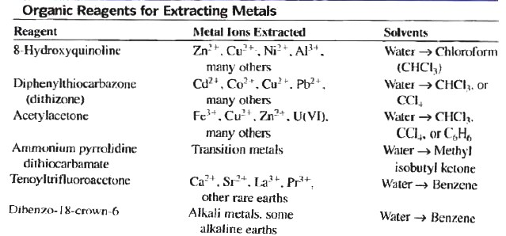

The Formation of Insoluble and soluble Species:
In some cases, the addition of ligands to a metal ion may result in insoluble species, such as the formation of nickel-dimethylglyoxime precipitate. In many cases, its form uncharged complexes may be sparingly soluble. Whereas the addition of more ligand molecules may result in soluble species. For example. Adding Cl⁻ to Ag+ results in the insoluble AgCl precipitate. Addition of a large excess of Clproduces soluble species AgCI₂⁻. AgCl₃²⁻, and AgCl₄³⁻.

Complexes with amino poly carboxylic acids
Numerous tertiary amines that also contain carboxylic acid groups form stable chelates complexes with many metal ions. One compound is Ethylenediaminetetraacetic acid (EDTA) has a particularly valuable property as a titrant is that it combines with metal ions in 1:1 ratio regardless of charge of the cation.
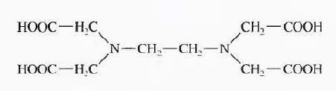

Chemical Structure of Ethylenediaminetetraacetic acid (EDTA)

Ag⁺ + Y⁴⁻ AgY³⁻
Al³⁺ + Y⁴⁻ AlY⁻
It forms chelate with nearly all cations and form stable complexes. This stability is a result of several complexing sites within the molecule which surround the cation and isolate it. All six ligands groups in EDTA are involved in bonding.
M¹⁺ + Y⁴⁻ MY³⁻
M²⁺ + Y⁴⁻ MY²⁻
M³⁺ + Y⁴⁻ MY¹⁻
M⁴⁺ + Y⁴⁻ MY
M^{n+} + Y⁴⁻ MY^{(n-4)+}
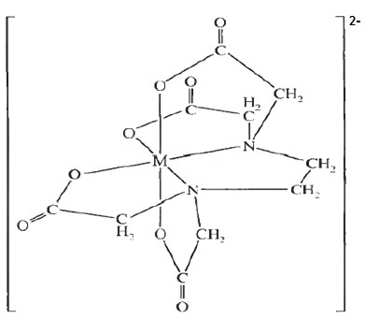
K
(
MY
)

=

]
Y
][
M
[
]
MY
[
4
n
)
4
n
(
-
+
+
-

Structure of Metal-EDTA(MY²⁻) Complex.

Conditional (Effective) Formation Constant (K'_{f}).

M²⁺ + Y⁴⁻ MY²⁻
K'f (_{MY}²⁻₎ = Kf(_{MY}²⁻₎ . α₄
(or) K'f (_{MY}²⁻₎=$\frac{ [ MY^{2-} ]}{\left[ M^{2+} \right]C_{T}}$
K'f _{(MY}²⁻₎ = Conditional (Effective) Formation Constant for MY²⁻
CT = The total concentration of uncomplex EDTA
α₄ = The fraction of the total concentration of uncomplex reagent that is in the form of Y⁴⁻
[Y⁴⁻]
α₄ = $\frac{[ Y^{4-}]}{C_{T}}$
Ex: Calculate Conditional Formation Constant for ZnY²⁻ at pH 6 K_{f} _{(ZnY}²⁻₎ = 3.2x10¹⁶, α₄ at pH 6 = 2.2x10⁻⁵
K'f_{(ZnY}²⁻₎= Kf_{(ZnY2-)} . α₄
K'_{f} _{(ZnY}²⁻₎ = 3.2x10¹⁶ x 2.2x10⁻⁵
K'f_{(ZnY}²⁻₎ = 7.04x10¹¹
Ex: Calculate the molar concentration of Y⁴⁻ in 0.02M EDTA solution at pH 8 and pH 11 (α₄ at pH 8 = 5.4x10⁻³), (α₄ at pH 11 = 0.85)
α₄ = $\frac{[ Y^{4-}]}{C_{T}}$
5.4×${10}^{-3}$ = $\frac{[ Y^{4-}]}{0.02}$
[Y⁴⁻] = 5.4x10⁻³ x 0.02
[Y⁴⁻] = 1.08x10⁻⁴ M at pH 8

α₄ = $\frac{[ Y^{4-}]}{C_{T}}$
0.85 = $\frac{[ Y^{4-}]}{0.02}$

[Y⁴⁻] = 0.85 x 0.02
[Y⁴⁻] = 0.017 M at pH 11

Ex; Consider the titration curve for 50 mL of 0.01 M Ca²⁺ with 0.01 M EDTA (α₄ at pH 10= 0.35, KCay =5.0 ×10¹⁰).Calculate, PCa at :Conditional (effective) Formation Constant(K,)
K'f (CaY) = Kf (CaY) . α4
K'f _{(CaY)} = 5.0 x10¹⁰ x 0.35 K'f (CaY) = 1.75x10¹⁰

1- Initial Point(before addition of EDTA or at zero addition):
[Ca²⁺] = 0.01 M pCa = -log [Ca²⁺] pCa = -log 0.01 = 2

2- After addition of 10 mL of EDTA
[Ca²⁺] = $\frac{50×0.01-10×0.01}{60 }$+ C_{T} = 6.667x10⁻³ mole/L

pCa =-log [Ca²⁺]
pCa =-log [6.667x10⁻³] pCa =2.176

3- After addition of 25 mL of EDTA
[Ca²⁺] = $\frac{50×0.01-25 ×0.01}{75}$ + C_{T} = 3.333x10⁻³ mole/L

pCa =-log [Ca²⁺] pCa = -log [3.333x10⁻³]
pCa =2.477

4- After addition of 50 mL of EDTA( at equivalent point)
K'f (CaY) =$\frac{[ CaY^{-2}]}{\left[{Ca}^{2+}\right]C_{T}}$
[Ca²⁺] = C_{T}
[CaY²⁻] = $\frac{50×0.01 }{100}-\left[{Ca}^{2+}\right]=0.005 M$
K'f (CaY) =$\frac{[ CaY^{-2}]}{\left[{Ca}^{2+}{ ]}^{2} \right]} → 1.75×{10}^{10}= \frac{0.005}{\left[{Ca}^{2+}{ ]}^{2} \right]}$

[Ca²⁺]² = 2.875 x10⁻¹³
[Ca²⁺] = ² 2.875×10⁻¹³ [Ca²⁺] = 5.362x10⁻⁷ pCa =-log [Ca²⁺]
pCa =-log [5.362x10⁻⁷] pCa =6.271

5- After addition of 60 mL of EDTA
K'f (CaY) =$\frac{[ CaY^{-2}]}{\left[{Ca}^{2+}\right]C_{T}}$
[CaY²⁻] = $\frac{50×0.01 }{110}-\left[{Ca}^{2+}\right]=4.545×{10}^{-3} M$
C_{T =}[EDTA] = $\frac{60 ×0.01-50 ×0.01}{110}+\left[ {Ca}^{2+}\right]=9.091 ×{10}^{-4}M$
$$1.75 ×{10}^{10}= \frac{4.545×{10}^{-3}}{[{Ca}^{2+}]×9.091 ×{10}^{-4}}$$
$\left[{Ca}^{2+}\right]=\frac{4.545×{10}^{-3}}{1.75 ×{10}^{10}×9.091 ×{10}^{-4}}$

[Ca²⁺]² = 2.875 x10⁻¹⁰
pCa =-log [Ca²⁺]
pCa =-log [ 2.875 x10⁻¹⁰]
pCa =9.544
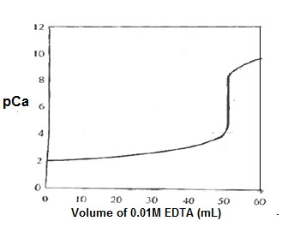
Fig .Titration calcium ion with EDTA at pH 10

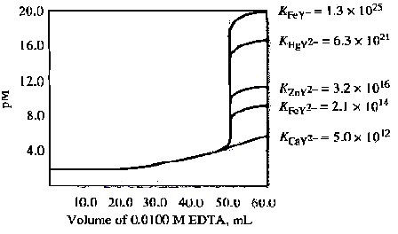
Fig. Titration different ions with EDTA at pH 6

Indicators for EDTA titration
Eriochrome black T is an organic important dye, used in complex titration with EDTA, the Chemical of Structure shown below.
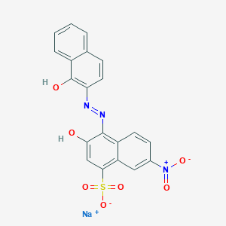

Chemical of Structure of Eriochrome black T

Eriochrome Black Tis a typical metal ion indicator that is used in the titration of many cations. Its behavior as a weak acid is described by the equations:

H₂In⁻ + H₂O HIn²⁻ + H₃O⁺ Ka₁ = 5×10⁻⁷ red blue
HIn²⁻ + H₂O In³⁻ + H₃O⁺ Ka₂ = 2.8×10⁻¹² blue orange

Note that the acids and their conjugate bases have different colors. Thus, Eriochrome Black T work as an acid-base indicator as well as a metal ion indicator. The metal complexes of Eriochrome Black T, are generally red. As is H₂In⁻ Thus, for metal ion detection. It is necessary to adjust the pH to 7 or above so that the blue form of the species, Hln²⁻, predominates in the absence of a metal ion. Until the equivalence point in a titration, the indicator complexes the excess metal ion so that the solution is red. With the first slight excess of EDTA, the solution turns blue as a consequence of the reaction.
HIn²⁻ + M²⁺ MIn⁻ + H⁺ blue red
MIn⁻ + HY³⁻ HIn²⁻ + MY²⁻
red blue

Ex: Determine the transition range for Eriochrome Black T in titration
of Mg²⁺ at pH 10, (Ka2(HIn²⁻) = 2.8x10⁻¹², Kf(MgIn⁻) = 1.0x10⁷

HIn²⁻ + H₂O In³⁻ + H₃O⁺ Ka2 = 2.8x10⁻¹²
Mg²⁺ + In³⁻ MgIn⁻ Kf = 1.0x10⁷
$$Ka_{2}=\frac{\left[{In}^{3-}\right][H_{3} O^{+}]}{\left[H{In}^{2-} \right][H_{2}O]}$$
$$K_{f=}\frac{\left[Mg{In}^{-}\right]}{\left[{Mg}^{2+} \right][{In}^{3-} ]}$$
$$K_{a_{2} × }K_{f }=\frac{\left[{In}^{3-}\right][H_{3} O^{+}]}{\left[H{In}^{2-} \right][H_{2}O]} ×\frac{\left[Mg{In}^{-}\right]}{\left[{Mg}^{2+} \right][{In}^{3-} ]}$$
$$2.8×{10}^{-12}×1.0×{10}^{7}=\frac{\left[Mg{In}^{-}\right][H_{3} O^{+}]}{\left[{Mg}^{2+} \right]\left[H{In}^{2-} \right]}$$
$$\left[{Mg}^{2+} \right]=\frac{\left[Mg{In}^{-}\right][H_{3} O^{+}]}{2.8×{10}^{-5}\left[H{In}^{2-} \right]}$$
pH = -log [H⁺], [H⁺] = 10^{-pH}
[H⁺] = [H₃O⁺] = 10⁻¹⁰
When ; $\frac{\left[Mg{In}^{-}\right]}{\left[H{In}^{2-} \right]}= \frac{10}{1}$
$$\left[{Mg}^{2+} \right]=\frac{10×{10}^{-10}}{1×2.8×{10}^{-5}}=3.571 ×{10}^{-5}$$

pMg= -log [Mg²⁺] = -log [3.571x10⁻⁵] = 4.447
When ; $\frac{\left[Mg{In}^{-}\right]}{\left[H{In}^{2-} \right]}= \frac{1}{10}$
$$\left[{Mg}^{2+} \right]=\frac{1×{10}^{-10}}{10×2.8×{10}^{-5}}=3.571 ×{10}^{-7}$$
pMg= -log [Mg²⁺] = -log [3.571x10⁻⁷] =6.447
the transition range = 4.447 6.447 = 5.447 ± 1.0

Titration Methods Employing EDTA
Several different types of titralion methcxls can be used with EDTA, as described next.

1- Direct Titration
Many of the metals in the periodic table can be determined by titration with standard EDTA solutions.

a- Methods Based on Indicators for the Analyte
Nearly 40 metal ions that can be determined by direct titration with
EDTA using metal ion indicators. It is cannot be used in all cases,
because no indicator with an appropriate transition range is available or because the reaction is so slow.

b- Methods Based on Indicators for an Added Metal Ion
When direct analyte indicator is unavailable. For example, indicators for calcium ion are generally less satisfactory then a small amount of magnesium chloride is often added to an EDTA solution that is to be used for the determination of calcium using, Eriochrome Black T as indicator.

2- Back-titration Methods
Back-titration is useful for the determination of cations that form stable EDTA complexes and for which a satisfactory indicator is not available. The method is also useful for cations such as Cr)lII) and Co(III) thar react only slowly with EDTA. the excess EDTA is back- titrated with a standard magnesium or zinc ion solution (form less stable complex) using Eriochrome Black for as indicator. also useful for analyzing samples that contain anions that would otherwise form sparingly soluble precipitates.

3- Displacement Methods
In this titrations, an unmeasured excess of a solution containing the magnesium or zinc complex of EDTA is introduced into the analyte solution. If the analyte forms a more stable complex than that of magnesium or zinc. The following displacement reaction occurs:
⁺²MgY²⁻ + M²⁺ MY²⁻ + Mg

4- Alkalimetric titration:
Adding of excess of Na₂H₂Y to a neutral solution of maleic ion, then the librated hydrogen ions are titrated with standard base solution.

5- Potentiometric Methods
Potential measurements can be used for end point detection in the EDTA titration with many metal ions for .In addition. a mercury electrode can be made sensitive to EDTA ions and used in titration with this reagent.

6- Spectrophotometric Methods
Measurement of UV/visible absorption can also be used to determine the end points of titrations. ln these cases, an instrument responds to rather than relying the color change in the titration on a visual determination of the end point.

