**INTRODUCTION**

In this lesson, you will investigate some properties of skeletal muscle. Physiological phenomena associated with other kinds of muscle, such as electrophysiology of the heart, will be studied in subsequent lessons.

The human body contains three kinds of muscle tissue and each performs specific tasks to maintain homeostasis: **Cardiac muscle, Smooth muscle**, and **Skeletal muscle.**

**Cardiac muscle** is found only in the heart. When it contracts, blood circulates, delivering nutrients to cells and removing cell waste.

**Smooth muscle** is located in the walls of hollow organs, such as the intestines, blood vessels or lungs. Contraction of smooth muscle changes the internal diameter of hollow organs, and is thereby used to regulate the passage of material through the digestive tract, control blood pressure and flow, or regulate airflow during the respiratory cycle.

· **Skeletal muscle** derives its name from the fact that it is usually attached to the skeleton. Contraction of skeletal muscle moves one part of the body with respect to another part, as in flexing the forearm..

Contraction of several skeletal muscles in a coordinated manner moves the entire body in its environment, as in walking or swimming.

**The primary function of muscle, regardless of the kind, is to convert chemical energy to mechanical work, and in so doing, the muscle shortens or contracts.**

Human skeletal muscle consists of hundreds of individual cylindrically shaped cells (called fibers) bound together by connective tissue.

In the body, skeletal muscles are stimulated to contract by somatic motor nerves that carry signals in the form of nerve impulses from the brain or spinal cord to the skeletal muscles (Fig. 1.1). **Axons** (or nerve fibers) are long cylindrical extensions of the neurons. Axons leave the spinal cord via spinal nerves and the brain via cranial nerves and are distributed to appropriate skeletal muscles in the form of a peripheral nerve, which is a cable-like collection of individual nerve fibers. Upon reaching the muscle, each nerve fiber branches and innervates several individual muscle fibers.

Although a single motor neuron can innervate several muscle fibers, each muscle fiber is innervated by only one motor neuron. The combination of a single motor neuron and all of the muscle fibers it controls is called a motor unit (Fig1.1)

When a somatic motor neuron is activated, all of the muscle fibers it innervates respond to the neuron’s impulses by generating their own electrical signals that lead to contraction of the activated muscle fibers.

Physiologically, the degree of skeletal muscle contraction is controlled by:

1. Activating a desired number of motor units within the muscle, and

2. Controlling the frequency of motor neuron impulses in each motor unit

When an increase in the strength of a muscle’s contraction is necessary to perform a task, the brain increases the number of simultaneously active motor units within the muscle. This process is known as motor unit recruitment.

Resting skeletal muscles in vivo exhibit a phenomenon known as tonus, a constant state of slight tension that serves to maintain the muscle in a state of readiness. Tonus is due to alternate periodic activation of a small number of motor units within the muscle by motor centers in the brain and spinal cord. Smooth controlled movements of the body (such as walking, swimming or jogging) are produced by graded contractions of skeletal muscle. Grading means changing the strength of muscle contraction or the extent of shortening in proportion to the load placed on the muscle.

Skeletal muscles are thus able to react to different loads accordingly. For example, the effort of muscles used in walking on level ground is less than the effort those same muscles expend in climbing stairs.

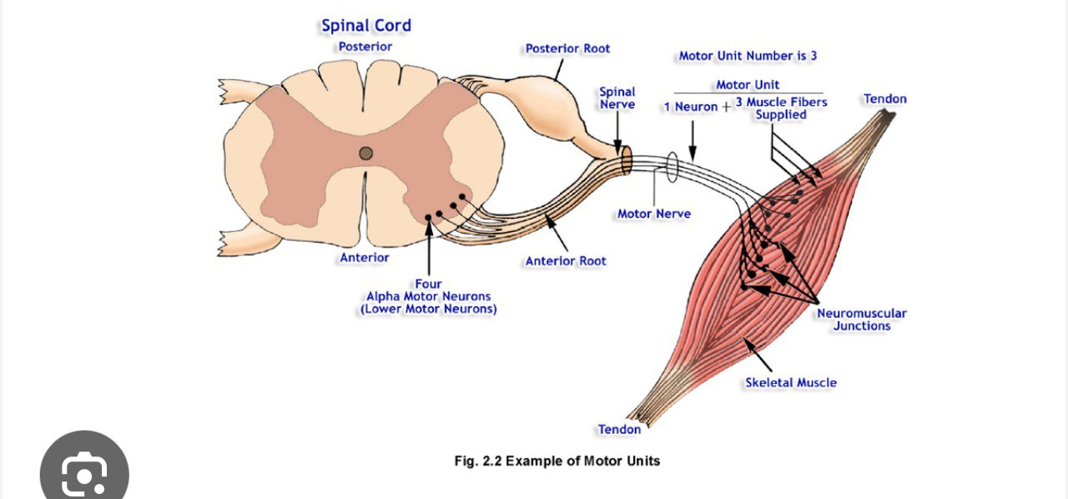

When a motor unit is activated, the component muscle fibers generate and conduct their own electrical impulses that ultimately result in contraction of the fibers. Although the electrical impulse generated and conducted by each fiber is very weak (less than 100 microvolts,) many fibers conducting simultaneously induce voltage differences in the overlying skin that are large enough to be detected by a pair of surface electrodes. The detection, amplification, and recording of changes in skin voltage produced by underlying skeletal muscle contraction is called **electromyography**.

The recording thus obtained is called an **electromyogram (EMG).**

The EMG signal is the recorded consequence of two principal bioelectric activities: 1) propagation of motor nerve impulses and their transmission at the neuromuscular junctions of a motor unit, and 2) propagation of muscle impulses by the sarcolemma and the T-tubular systems resulting in excitation-contraction coupling.

The magnitudes of the action potentials of active motor units are not all the same nor are they in phase with one another. Furthermore, the timing sequence of motor unit activation is variable. The net result of these and other factors is a complex EMG signal.

Remember we are recording all of this activity as it is detected by surface electrodes, and propagation of muscle and nerve impulses involves both depolarization and repolarization phenomena. The **"spikes"** therefore, will have a negative and a positive component and the amplitudes will be influenced by the location of the recording electrodes with respect to the number of active underlying skeletal muscle and motor nerve fibers.

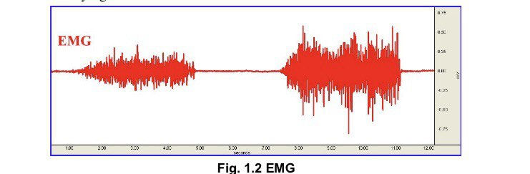

Integrated EMG is an alternative view of the EMG signal

that clearly shows the pattern of muscle activity. Integrated

EMG “averages out” noise spikes in the raw EMG data to

provide a more accurate indication of the EMG output level.

Integrated EMG calculates a moving average (mean) of the

EMG data by first rectifying each point in the sample range

(inverting all negative values) and then computing the

mean. In this lesson, each data point of Integrated EMG is

calculated using 100 samples of data from the EMG source,

so the first 100 sample points should be ignored since they

reflect the number of zero values being averaged in with the

first few samples of data.

