Development of the placenta and its function

The fertilized ovum reaches the uterine cavity at 5-6days after ovulation and start to divide until it reaches the blastocyst stage when a cavity appears among the morula cells.
The outermost cells of blastocyst form the trophoblast which has the power to erode the surface epithelium of the decidua sinking to its thickness between the endometrial glands. The zygote implants to the decidua , the most frequent site upper and posterior part of uterine cavity
Maternal blood vessels are invaded and eroded by trophoblast and extravasation of maternal blood occurs around the zygote providing the primitive utero-placental circulation within the first two weeks after conception.
Very soon the trophoblast become arranged in projecting masses as villi which grow and branch.
Maternal blood vessels are opened by the cytolytic action of trophoblast , so that maternal blood lies in the intervillous spaces from which embryo takes nutrition.
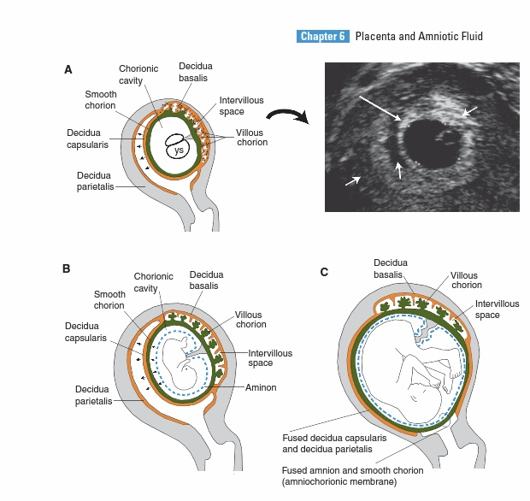
The trophoblast become differentiated into two layers:
- Thicker outer layer : syncytiotrophoblast , in which the nuclei are scattered in a mass of cytoplasm so that no evident division into separate cells.
- Thinner inner layer : cytotrophoblast ( single layer of rounded cells ).
The blastocyst is lined with extraembryonic mesoderm which continues with the mesoderm of the embryo itself , it will continue with the central tissue of the villi , so each villous has an outer covering of trophoblast and central mesodermal core.
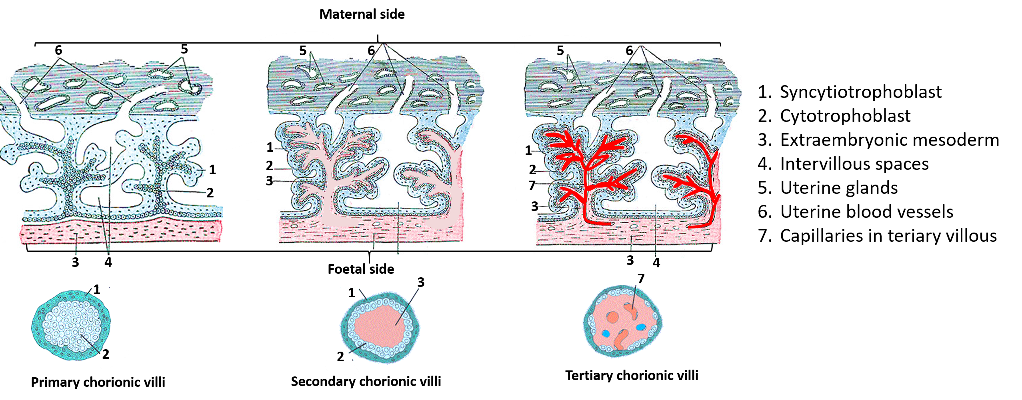
Lacunae appear in mesoderm and gradually become joined to form primitive blood vessels extend through extraembryonic mesoderm .
The combined layer of tropohoblast and underlying mesoderm is called the chorion within it is the amniotic membrane that bound the amniotic cavity.
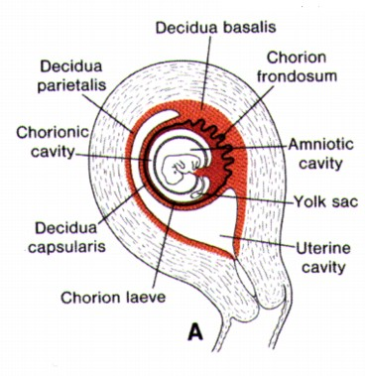

According to the relation to embryo , three parts of deciduas are distinguished :
- Decidua basalis :between the embryo and the muscular wall of the uterus , later forms the site of attachment of the definitive placenta.
- Decidua capsularis : intervenes between the embryo and uterine cavity and bound the superficial half of the implantation cavity. As ovum grow it bulges into the cavity and by 12 weeks the growing embryo fills the cavity and it will be found with deciduas vera.
- Deciduas vera : not related to the site of implantation and line the rest of uterine cavity.
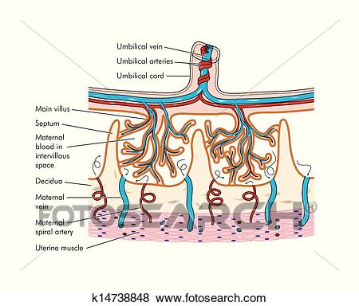

The syncytiotrophoblast form an opened reticulated network whose lacunae are filled with maternal blood , so that the trophoblast replace , in part , maternal endothelium.
The trophoblast soon become arranged in trabeculae which are covered by syncytiotrophoblast and have a core of cytotrophoblast ( primary main stem chorionic villi ) then embryonic mesoderm extend to each of these trabeculae (secondary villi ) and finally vascularization of the mesoderm completes the formation of the chorionic villi ( tertiary ) by 16 days after fertilization .
Chorionic villi appear all around the surface of conceptus covering the entire surface till 8weeks. The villi underneath deciduas capsularis become compressed as the conceptus grows and then degenerate and become avascular to produce :chorionic leave.
Fetal component of placenta is formed from villi contiguous with deciduas basalis.
Primary villi quickly branch extensively to secondary and tertiary villi and form chorion frondosum.
Further invasion into deciduas basalis take place at number of points each is separated by a wedge-shaped islands of decidua which will become the placental septa which divide the fetal side of placenta into 15-20 cotyledons , each contain varying number of main stem villi with their branches referred to fetal lobules.
Intervillous space arise from blood –filled lacunae which develop in the syncytiotrophoblast by the second week. These later enlarge and communicate then form the intervillous space into which the new villi grow.
The space is supplied with blood from 80-100 spiral arteries which have been invaded by the trophoblast causing fibrinoid necrosis of the musculo-elastic coat of these vessels , which make their walls thin and become dilated as they enter the intervillous space , the resulting decrease in arterial pressure leads to streaming of blood into the intervillous space, the resistance of the space is so low that the pressure is sufficient to carry the blood towards the chorionic plate and bathe the villi before leaving via the veins penetrating deciduas basalis .
The trophobast extends for a variable distance into the maternal spiral arteries where they enter the intervillous space , partly replacing the vascular endothelium , the vessels in the trophoblast are converted into a funnel-shaped deltas so that the peripheral resistance to maternal blood is reduced and the flow to placental blood is increased. If this extention of the trophoblast does not occur , there is a reduction in placental bed blood flow which may lead to IUGR , pre-eclampsia or hypxia in labor.
Tertiary chorionic villi have an outer layer of syncytiotrophoblast with microvilli on the suface and an inner layer of cytotrophoblast , within the villi , the stromal core derived from the mesenchyme of extra-embryonic ectoderm contain a capillary network.
As pregnancy porogresses the villi become more numerous and smaller . The inner cytotrophoblast layer become attenuated and anuclear and even disappear, syncytial cells thin out and become irregular. In the mature placenta many villi have areas where syncytial cells and attenuated , fetal capillaries can overlie these areas in close approximatiom and the surface over these areas show loss of microvilli , these areas are suggested areas of gas transfer.

Stucture of chorionic villi :
It has a core of mesoderm and a covering trophoblast with numerous blood vessels in the mesodermal core.
In the main villois stem , the artery and vein have connective tissue walls but in the terminal villi only capillaries are present . The arteries are branches of umbilical arteries , they end as capillaries in the terminal villi from where oxygenated blood is collected into the venous radicals and pass back into the veins of the main villous stem from which to the umbilical vein of the cord.
From the time of their formation in 3rd week until the end of the 1st trimister , the villi are covered by a single layer of cytotrophblast and an outer layer of syncytiotrophoblast which is in immediate contact with blood in the intervillous space , after 20weeks the cytotrophblast begin to disappear until finally only a thin layer of syncytium remains.

Further development of placenta :
At 1st villi are formed allover the surface of the gestational sac , as growth proceeds the deciduas capsularis become thinner , between 12-16 weeks the villi on the capsular surface of the embryo degeneratr rapidly leaving this side of the chorion smooth ( chrion leave ), in compensation the villi on the surface opposed to the decidua basalis hypertrophies ( chorion frondosum ) and become matted into a solid disc which is the fully developed placenta by 12 weeks.

Increase in size of placenta :
From the end of the 4th week when the villi have penetrated towards deciduas basalis , there is no further invasion , further growth in thickness is now due to growth of chorionic villi with an accompanying expansion of intervillous sinuses.
Until the end of the 16th week placenta grows both in thickness and circumference . Subsequently continue to increase in size circumferentially until near term .

Placental bed :
Placental bed is covered with deciduas which spiral arteries pierce to deliver blood to the maternal lake , which bathes the villi , the ends of the arteries are narrow at first but from about 6weeks after conception trophoblastic cells invade their walls , the arterial ends open out like river deltas .By 16th week , in normal women , this process of invasion is complete and each of the spiral arteries ends in a funnel-like delta which result in a much lower pressure at the distal end of the blood vessel allowing greater flow.
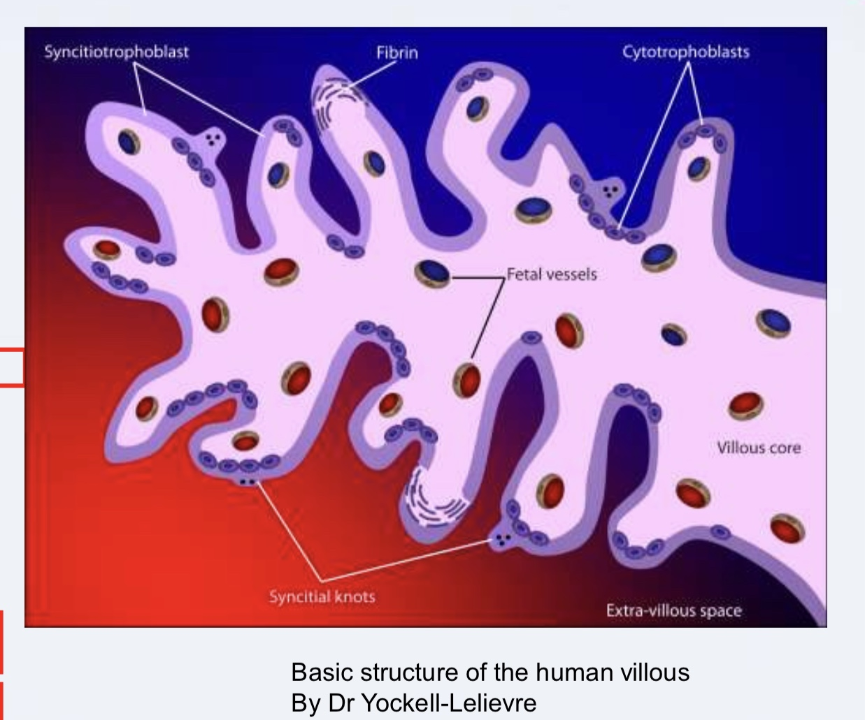

Placenta at term :
It is circular in shape , 20cm in diameter , 3cm thickness , 500gm weight ( directly related to fetal weight ) .
It has a fetal surface which is covered by smooth amnion underneath the chorion , the blood vessels are visible beneath this as they radiate from the insertion of the umbilical cord .
The maternal surface is rough and spongy and presents a number of polygonal areas : cotyledons ( each formed by and corresponds to a main villous stem and its branching villi.
Number of cotyledons 15-20 depending on the number of end arteries into which the umbilical artery divides. A cotyledon is made of 10-20 lobule each corresponds to the opening of a maternal utero-placental vessel.
The chorion spreads away from the edge of the placenta to form the outer layer of the tow membranes which enclose the fetus and liqour amnii.
The umbilical cord usually reaches the fetal surface of the placenta at about the middle of its disc , it brings with it 2 umbilical arteries and one vein.
The substance of the placenta is made up almost of chorionic villi which protrudes into ivtravenous blood spaces .
The placenta can be described as a space containing maternal blood which is bounded on the maternal side by a decidual plate and on the fetal side by chorionic plate from which the chorionic villi branch into the maternal blood.

Functions of the placenta:
The placenta is essentially a fetal organ , it is the main interference between the fetus and the outside world.
- It enables the fetus to exchange oxygen and CO2 from maternal blood , acting as a fetal lungs.
- Nutrient function of the placenta completely replaces that of GIT during fetal life , enabling the fetus to take nutrients from the mother.
- Excretion of hydrogen ions and the breakdown products of other substances is the role of the placenta not the kidney.
- Forms a barrier agaist trasfer of infections to the fetus although some organisms ( Rubella , HIV )can cross it.
- It act as an endocrine gland , producing numerous hormones necessary for maintenance of pregnancy .
- It plays a role in the immune system of the fetus by providing it with immunoglobulins through trnansferring them from maternal circulation .
- Some of the functions of the liver as detoxification of drugs and other substances presented to it by the maternal circulation.

Placental transport:
The trophoblast and underlying endothelium of fetal vessels behave as a semi-permeable membrane allowing the free passage of water and soluble substances of relatively low molecular weight,
- O2 and Co 2 cross the placenta by simple diffusion .
- Glucose by facilitated diffusion and its concentration is higher in maternal than fetal blood.
- Amino acids are actively transported leading to higher levels in the fetus than the mother.
- Free fatty acids cross by simple diffusion from which the fetus forms lipids.
- Placenta is relatively impermeable to plasma proteins except IgG . All proteins transportes by pinocytsis.
- Substances with molecular weight less than 1000 are able to pass the placenta as most anesthetic agents and drugs.
- Concentration of water , sodium chloride , magnesium urea and uric acid are equal in maternal and fetal blood.
- Amino acids , nucleic acids , calcium and inorganic phosphorous have higher concenration in fetal than matrrnal blood ( selectively transported ) , serum iron concentration in fetus higher .
- Oestrogens , androgens and thyroxine cross the placenta but insulin , parathyroid hormones and posterior pituitary hormones do not.
- Fetal red cells may sometimes escape into maternal circulation despite the seperation of nucleated RBC in the vessels in the villi from the maternal RBC in the intervillous space.
Placental permeability increases as pregnancy progresses because the tophoblast become thinner and villi become finer and more branched.

Functional efficacy of the placenta:
Maternal blood flow through placenta is about 1000m/Lminute . At term the intervillous space contain 150ml of blood exchanged over 2-3times/min.

Placental hormones:
The plaenta secretes large number of hormones , the most important are :
- Estrogen : progressively increases during pregnancy reaching the peak before oncet of labor.
- Progesterone : until the end of the 8th week the corpus lutium continues to secrete progesterone , with gradual cessation of corpus lutium function the placenta become responsible for its secretion which reaches the peak just before labor.
- Human chorionic gonadotrophin : detected in maternal plasma by radioimmunoassay at 6days after fertilization and in urine soon after that and this forms the basis of the pregnancy test. It reaches the peak at 10-11weeks of gestation .
- Human placental lactogen : its main action is to reset the CHO and fat metabolism of the mother and ensure adequate supply of energy and glucose to the fetus.
- Relaxin : detected in maternal plasma 8-10 days after ovulation , its important to inhibit uterine contraction in early pregnancy .

